# Important Display Patents

Patent classification of interest: <https://patents.google.com/patent/US1651275A/en?q=electric&q=sign&q=G09G3%2f004>

The New York Times famous "zipper" (Motograph News Bulletin) is patent 1,626,899 from 1925

The fancy “monogram” display is from the Lippincott patent.

|  |  |
| --- | --- |
| Google | <https://patents.google.com/patent/US744923A/en> |
| Patent office | USA100744923 |
| Patent link | [link](http://pdfpiw.uspto.gov/.piw?PageNum=0&docid=00744923&IDKey=CB4B03DF8F37%0D%0A&HomeUrl=http%3A%2F%2Fpatft.uspto.gov%2Fnetacgi%2Fnph-Parser%3FSect1%3DPTO1%2526Sect2%3DHITOFF%2526d%3DPALL%2526p%3D1%2526u%3D%25252Fnetahtml%25252FPTO%25252Fsrchnum.htm%2526r%3D1%2526f%3DG%2526l%3D50%2526s1%3D0744923.PN.%2526OS%3DPN%2F0744923%2526RS%3DPN%2F0744923) |
| Patent data | R. E. Lippincott  Means for controlling illuminated announcement and display signals  Application filed Aug 15, 1902  Patent granted Nov 24, 1903 |
| Inventor | Robert E. Lippencott or Worcester MA. |
| Witness #1 | Chas. H. Burleigh (Chas is often short for Charles) |
| Witness #2 | Simeon E. King |

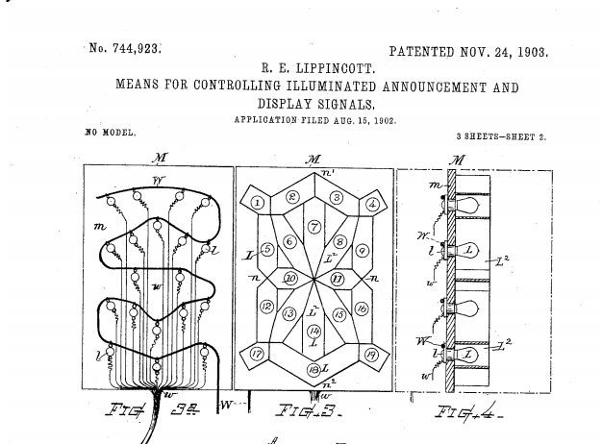

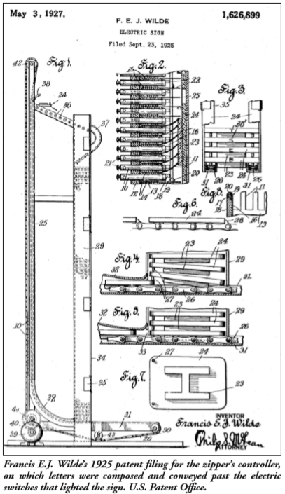

# Essentials of Electricity

Essentials of Electricity: a textbook for Wiremen and the Electrical Trades: Direct Currents. Author is William Henry Timbie. First Edition, 1915, John Wiley and Sons

Chapter IX (9), Wiring Diagrams (for Electric Bells and Annunciators)

Diagram of a sign flasher (figure 215 on page 254)

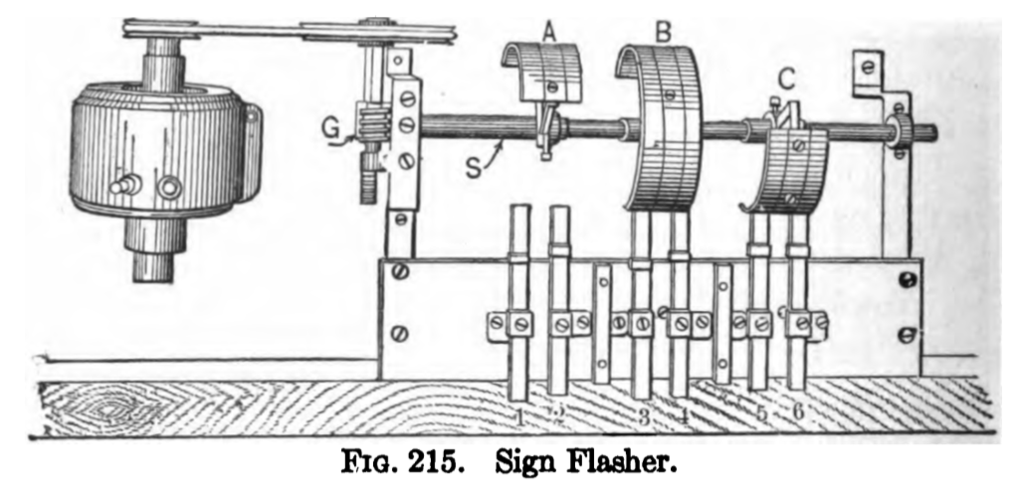

Picture of the Reynolds sign flasher (figure 216, page 255)

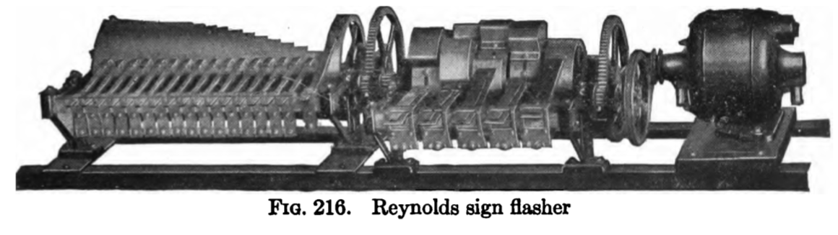

Three figure carriage call (figure 217, page 256). The text says, “A most interesting device use for flashing the carriage number at hotel or theatre entrances is show in Fig. 217.

The lamps labeled (a) are all on one circuit, those labeled (b) are on another, etc. By closing the proper number of circuits any figures except 2 and 5 can be flashed by the sign For instance, if the circuit containing the lamps marked (a) is closed, the figure 1 is made. By closing the three circuits containing the lamps marked (a), (e) and (r), the figure 4 is make.

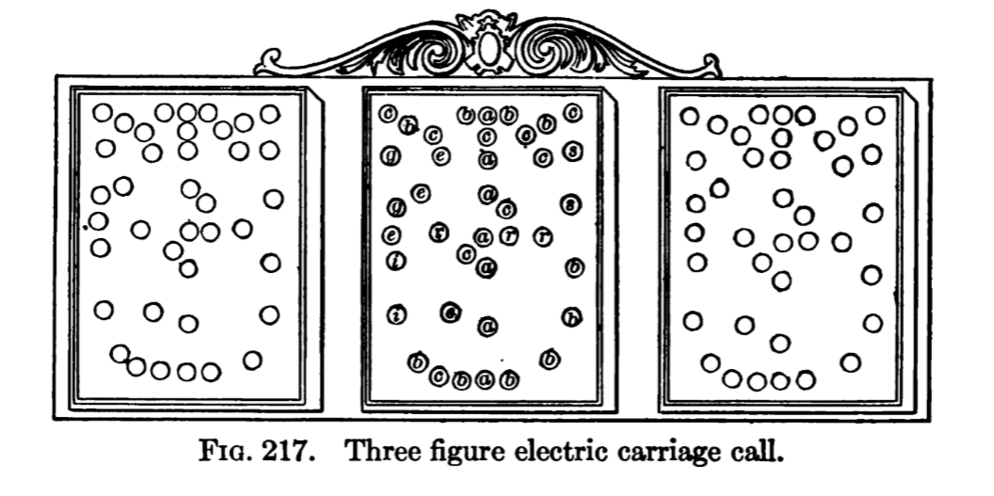

For automatically closing the proper circuit, when the switch in Fig. 218 is thrown, an ingenious device is used. Each of the several circuits in the sign ends in a metal finger for one terminal, all the circuits end in a common plate for the other terminal. In order to make the figure 1 flash, it is necessary merely to push down against the plate that finger which is the terminal of one side of the (a) circuit. This closes the circuit and lights up all the lamps on this circuit. In order to flash the number 4, it would be necessary merely to push down against the plate the finger terminals of the (a), (e) and (r) circuits. This would close the three circuits and light up all the lamps connected to these circuits.

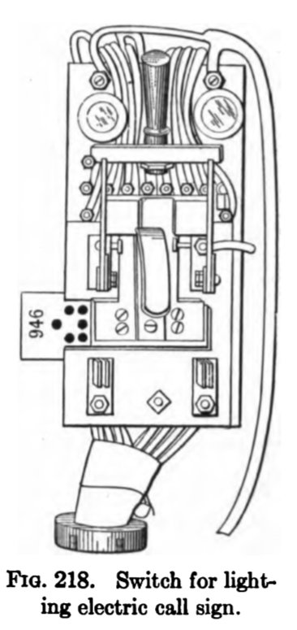

This is easily accomplished by placing a card, Fig. 219, having holes punched in it, between the plate and the fingers. Now when the switch is thrown, the fingers are all pressed against the card, but only those opposite the holes go through and make contact with the plate. Thus only the proper circuits are lighted. If the card in Fig. 218, for in stance, were placed in the slot be tween the plate and the fingers, only fingers (b), (r), (g) and (s), would make contact for circuit to the first panel and form the figure 9. The fingers (a), (r) and (e) of the circuit to the second panel would go through the holes in the card and form the figure 4 in that panel. In the third panel, the figure 6 would be formed by the fingers (b), (0). (i) and (r) going through the holes in the card and making contact with the plate. Thus the number 946 would show in the flasher.

Figure 219, page 258. Punched carriage check for electric carriage call.

The ticket says:

Left side: Herald Sq. Theatre. Watch for electric no. 170 Drivers’ check

Right side: Herald Sq. Theatre 170 Carriage Check. Dont fold this card / Patents Pending / The Norden-Bittner-Crandall Electric Call / Leased from The Electic Carriage Call Co, 1402 Bdway New York

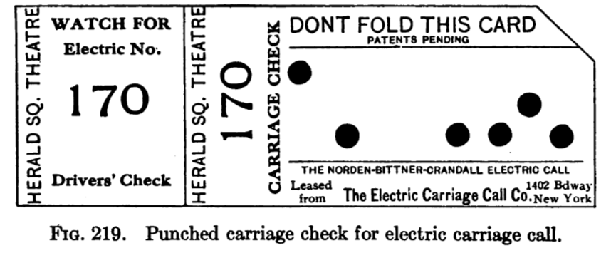

|  |  |  |  |  |  |  |  |  |
| --- | --- | --- | --- | --- | --- | --- | --- | --- |
| **Number** | **A** | **B** | **C** | **D** | **E** | **F** | **G** | **H** |
| 1 | A |  |  |  |  |  |  |  |
| 7 |  |  |  |  |  |  | G |  |
| 0 |  | B |  |  | E | F |  | H |

# Hawkins Electrical Guide

Hawkins Electrical Guide Number Three / Questions Answers & Illustrations / A progressive course of study for engineers, electricians, students and those desiring to acquire a working knowledge of Electricity and its applications / A practical treatise. Copyright, 1917

Sign flashers are items 865 to 884.

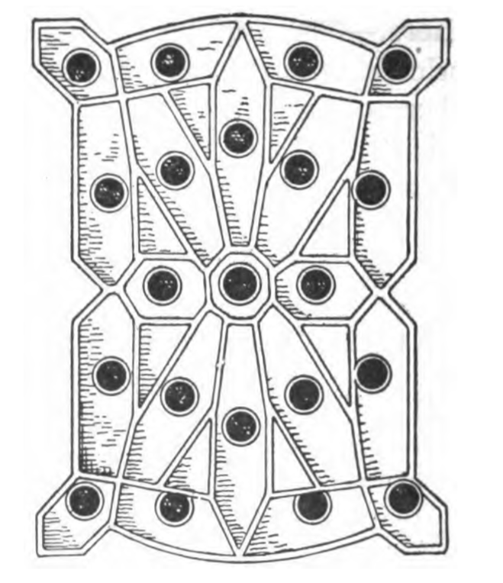

Carriage Calls.—These are used to avoid the confusion and noise at the theatre, club house or department store when vehicles are called by a megaphone.

PlG. 1,032.—Monogram or unit for carriage call or talking sign. It consists of a collection of metal compartments each arranged to receive an incandescent lamp. The purpose of these compartments is to confine the light to a certain space, thus forming a clearly defined number or letter which can be read from a distance.

[later note: this is the Lippencott display]

PlG. 1,033 and 1,034.—Wiring diagrams showing proper methods of wiring for Illuminating painted sign. The lamps are placed about one foot apart in an overhead inverted trough. They should project out in front of the sign one-half its width, but no sign should be more than eight feet wide, as ordinary 16 c.p. lamps will not carry any farther. Black and white paint only should be used. The lamps may be flashed on and off as a whole, saving one-half the current, or they can be flashed in different colors as desired. For flashing in colors, only red and amber should be used. No other colors, such as green, blue, etc., will give sufficient light to produce a good effect.

SIGN FLASHERS 881

The call itself consists of two or more sheet steel boxes, one of which is shown in fig. 1,032, with incandescent lamps arranged in metal compartments in such order that any number may be produced by lighting the proper lamps. The flashing of the number is controlled by a keyboard or switch which may be placed in any convenient location. When

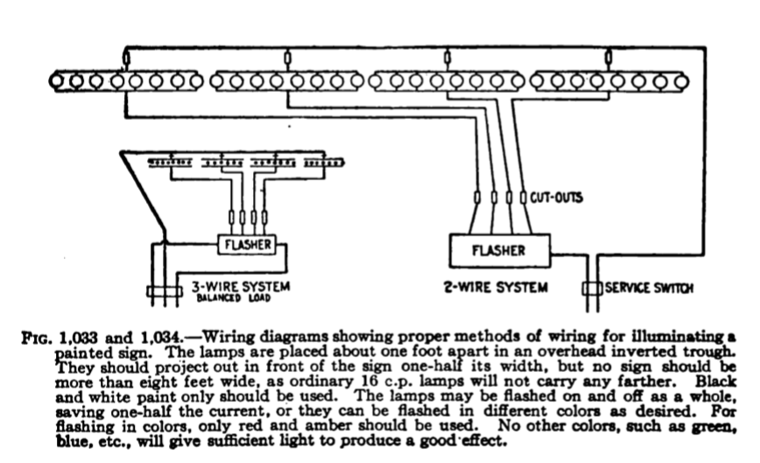

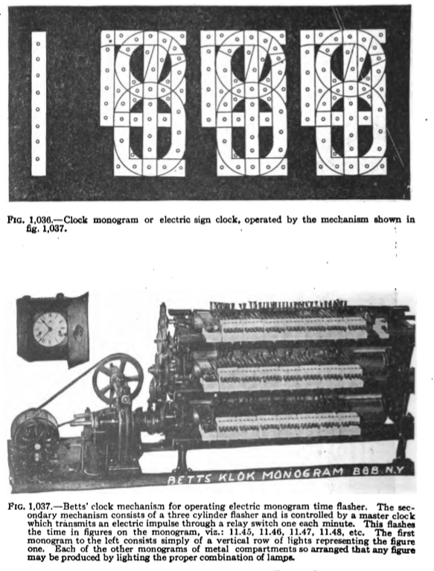

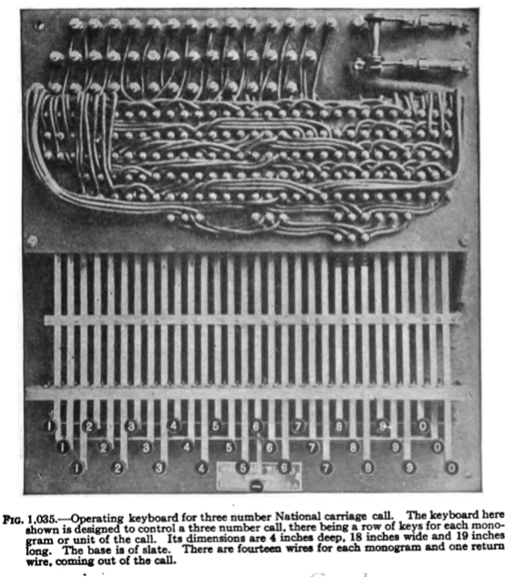

FIG 1 035 —Operating keyboard for three number National carriage call. The keyboard here shown is designed to control a three number call, there being a row of keys for each mono gram or unit of the call. Its dimensions are i inches deep, 18 inches wide and 19 inches long. The base is of slate. There are fourteen wires for each monogram and one return wire, coming out of the ca

# Litrontix

From the Litronix Optoelectronics Catalog 1982

<https://archive.org/stream/bitsavers_litronixdaOptoelectronicsCatalog_31011858/1982_Litronix_Optoelectronics_Catalog#page/n83/mode/2up>

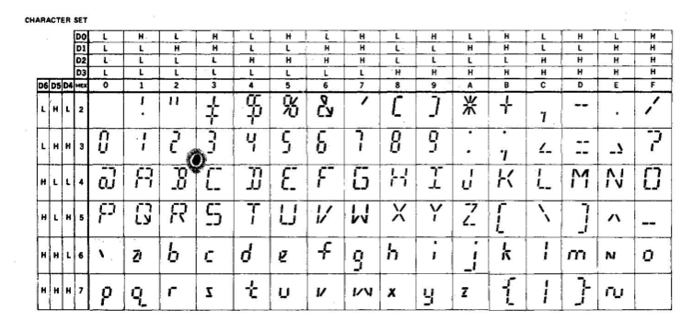

The chart demonstrates a common way to make letters

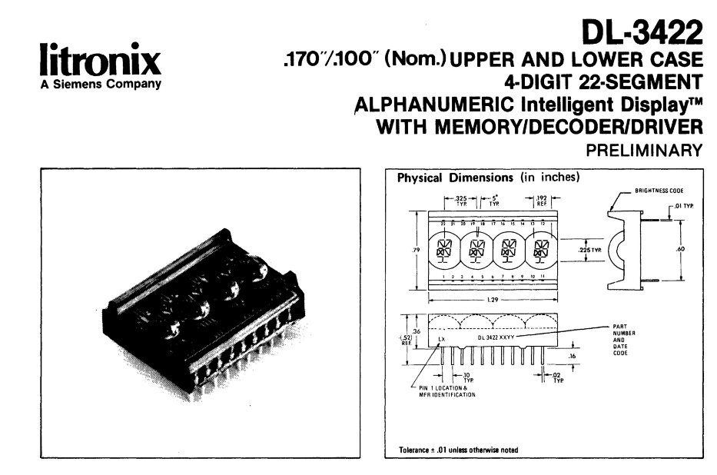

# Popular Electricity and the World’s Advance

Popular Electricity in Plain English Volume II, No 1 May 1909. Waldon Fawcett c 1909 “Chauffeur to the Senate”

Page 577:

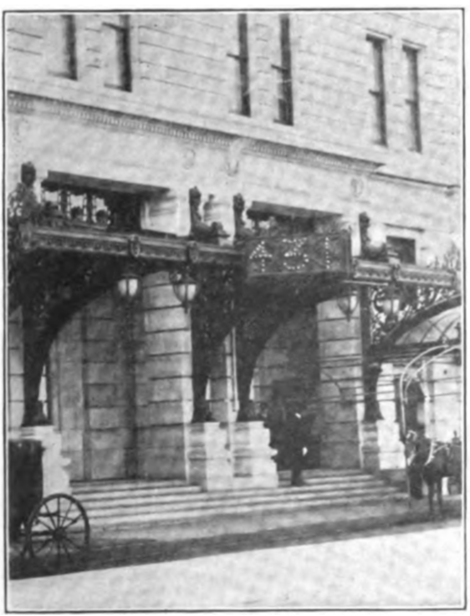

The corresponding check

wor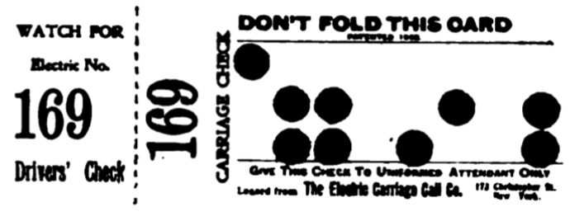

The words on the carriage check are

LEFT: Watch for Electric No. 169 Drivers’ Check

RIGHT: 169 Carriage Check Don’t fold this card Give this check to the uniformed attendant only. Leased from The Electric Carriage Call Co. 173 Christopher Place (?) New York

|  |  |  |  |  |  |  |  |  |
| --- | --- | --- | --- | --- | --- | --- | --- | --- |
| **Number** | **A** | **B** | **C** | **D** | **E** | **F** | **G** | **H** |
| 1 | A |  |  |  |  |  |  |  |
| 6 |  | B | D |  |  | F |  | H |
| 9 |  | B | C |  | E |  |  | H |

The text of the article:

Electric light has played an important part in modern "society functions," from the time when it was first introduced, brilliantly illuminating the ballroom and theater, and adding beauty to decorative effects at dinner parties and receptions. The electric carriage call is an application of the incandescent lamp that serves a useful purpose at some of the theaters and opera houses in our big cities.

Before this system was introduced, the dispersal of a Grand Opera audience, for example, was often the occasion of much delay and annoyance. The "carriage folk" attending the performance, especially ladies wearing costly evening gowns and jewels, naturally wished to step directly from the door into their conveyances, and in inclement weather the prompt appearance of each party's carriage became still more important.

The custom formerly was to call the carriages by shouting loudly at the door for the coach man. This primitive method of summoning one's conveyance, whether hired or private, was a time-honored one dating back to the period before the introduction of wheeled vehicles, when "chairs," slung on poles and carried bodily by burly servants, were in vogue. But the resulting din and confusion, often made more vociferous by the necessity of repeating the name or number down the long line of waiting carriages, was a serious offset to the pleasure of the performance that had just been enjoyed.

The electric carriage call obviates all this annoyance, saves the time of the patrons of the house, and greatly facilitates the work of the attendants and police. It is not an audible "call," but a purely visual system; that is, it operates by displaying one carriage number after another, outlined in incandes cent lamps in a panel electric sign placed over the carriage entrance where all the coachmen waiting in line can see it. There are usually three panels, each consisting of a group of lamps so arranged that **any figure from 1 to 9, and 0**, may be formed by lighting up certain lamps of the group. The sign is operated by the doorman, from an ingenious switchboard which is connected to the sign by a cable of wires.

The operation of the system is simple. At the switchboard, the wires coming from the sign—one wire for each lamp—terminate in a set of movable contact pins. By means of a lever, the entire group of pins may be brought into contact with a copper plate which completes the circuit to the lamps. But by the use of a pasteboard "ticket," punched with holes, certain particular pins only are allowed to make this contact, the arrangement and location of the perforations in the ticket allowing certain lamps to light. Each ticket used is punched in a different way, so as to cause a different number, of one, two or three figures, to light up in the sign, and this number is printed on the ticket and on a stub which may be detached.

One of these tickets is assigned to each carriage as it drives up to the door before the performance, the doorman tearing off the numbered stub and handing it to the coachman as a memorandum of the number that will be shown on the sign to call him.

# Storage Batterie and Lighting

International Library of Technology / A series of textbooks for persons engaged in the engineering professions and trades or for those who desire information concerning them. Fully illustrated and containing numerous practical examples and their solutions

Storage Batteries / Incandescent Lighting / Arc Lighting / Interior Wiring / Modern Electric-Lighting Devices / Electric Signs / Electric Heating

Copyright 1905, 1908 International Textbook Company

Signs are in section 56

Monogram Sign

Monogram Letters. —Various other devices are in use by which the positions of the lamps in a sign may be changed so as to display different letters; but to make such changes requires considerable time and trouble. Fig. 22 shows a group of twenty-one lamps arranged in metal troughs, or boxes, whose inside surfaces are whitened with a vitreous substance like enamel, so that they reflect the light outwards. This device, including the lamps and boxes, is called a monogram letter, or simply a monogram; with it, by lighting different groups of lamps, may be displayed any letter of the alphabet. In order to show any desired letter, it must be possible to control the lighting of each lamp independently of the others (with one exception). This necessitates a separate wire from one side of each lamp socket to a suitable controlling device, but the other side of each socket is connected to a common wire that leads directly to the supply circuit. The controlling device, or commutator, automatically changes connections so as to display letters in any desired order.

24. Fig. 23 shows the complete wiring of one monogram, with the exception of the lamp connections of the wire a common to all lamp sockets; these connections are omitted for the sake of clearness. The individual wires from the lamps lead to a series of binding posts 1 to 20 on the commutator. The two lamps numbered 5 in the monogram are never lighted separately; hence, a common wire connects them with finger number 5 on the commutator. This is the exception previously referred to. Including the wire a common to all lamp sockets, there are twenty-one wire leading to each monogram. A wire a' connects the commutator with the side of the supply circuit opposite that with which the common wire a is connected. Circuits b lead to other monograms in the same sign; one wire of each circuit connects with one terminal of each lamp in a monogram and the other with the commutator belonging to that monogram. Each monogram circuit is connected to the supply circuit through double-pole cut-outs c. Another branch circuit leads to the motor that operates the commutator.

25. The commutator consists of a series of contact fingers, or springs, and a device for forcing them into a position where they close the circuits through the lamps.

Fig. 24 is a view of two commutators, one having a letter bar a in position. The contact fingers are arranged underneath the slate top b. The rolled-steel letter bars, each having projections for raising the fingers necessary to light a letter, are slipped into slots in the rims of the wheels c, and are held in place by spiral springs d around the end wheels of each commutator. On the left hand commutator these springs are shown off the slotted wheels and hanging on the shaft. The shaft is rotated by means of a motor, not shown, so that successive letter bars are brought under the fingers.

26. Fig. 25 is a diagram showing a cross-section of the commutator; (a) shows a projection on a letter bar a just as it begins to raise a finger d, and (b) shows the finger raised to its full height. The letter bars do not make electrical contact with the fingers, but strike against metal shoulders e that are insulated from the fingers.

The fingers are phosphor-bronze springs clasped loosely about a bar / running lengthwise of the commutator. When a finger is raised, one end makes firm contact with a brass strip g on the under side of the slate cover. A single binding post h in connection with this brass strip serves for the copper wire a', Fig. 23, connecting the commutator to the supply circuit. The other end of the spring d, Fig. 25 (b), makes contact with the round head i of a binding post /, one of the twenty posts with which the lamps of the monogram are connected.

27. In Fig. 26 is shown a diagram of the connections that are active when the letter H is displayed. The letter bar a has projections that lift the fingers corresponding to the lamps needed. The lamps are numbered, and correspond ing numbers are shown on the bar projections. This diagram represents conditions at one instant while the commutator is turning; as this bar passes out from under the springs, all the lamps go out, but immediately another bar with other projections moves under and another letter is displayed.

28. Each commutator holds forty bars; hence, each monogram can be made to display forty separate characters. A number of monograms arranged side by side with all their commutators operated by a single motor constitutes a talking sign, and may be made to flash forty words or sentences in succession. The same series of expressions may be flashed a whole evening without any supervision whatever from an attendant, or the attendant may substitute other bars as often as desired so that new expressions will be displayed. Fig. 27 shows four of the forty expressions one sign may be made to flash every night.

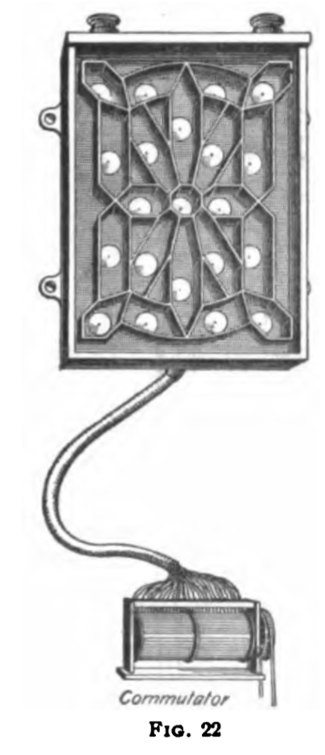

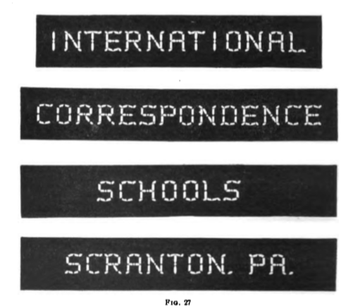

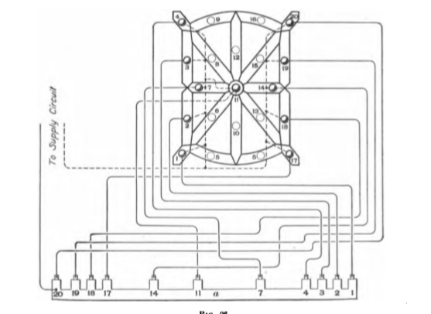

Talking Clock. —Fig. 28 shows an arrangement of electric lamps for displaying time; (a) and (b), respectively, show two successive displays. The lamps are differently arranged than in the letter monograms previously described, and each group contains only the number of lamps needed for the figures it must display. For example, the first group displays only the figure 1, and hence contains but a single row of lamps; the second and fourth groups must be capable of displaying any numeral from 0 to 9, inclusive, and the third group any numeral from 0 to 5, inclusive. A commutator operated in synchronism with the movements of a clock changes the contacts so that the time display is changed once every minute.

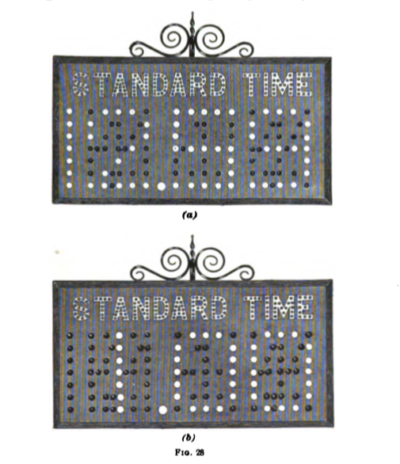

Carriage Calls. —Fig. 29 shows a carriage call that is very useful where a number of carriages are waiting for persons emerging from large assemblies, as at theaters. This call consists of three groups of lamps arranged in boxes with reflecting interiors and frosted-glass covers. The lighting of the lamps is controlled by a device some what similar to the commutator used with the talking sign, except that the carriage-call controlling device is operated by an attendant. **Any number from 0 to 999,** inclusive, may be displayed on the call shown. On arrival, each carriage occupant and driver is given a number, and when the carriage is wanted this number is displayed on the carriage call, which is in plain view of all the drivers.

