AI ASSISTED CODING LAB 13

ENROLLMENT NO: 2403A52008
NAME: P.Sharath
COURSE: CSE(AI/ML)
BATCH: 2

Task Description 1 – Remove Repetition
Task: Provide AI with the following redundant code and ask it to refactor.

Used Prompt:
Refactor the given code, convert into separate functions and make it modular and cleaner. Take input from user.
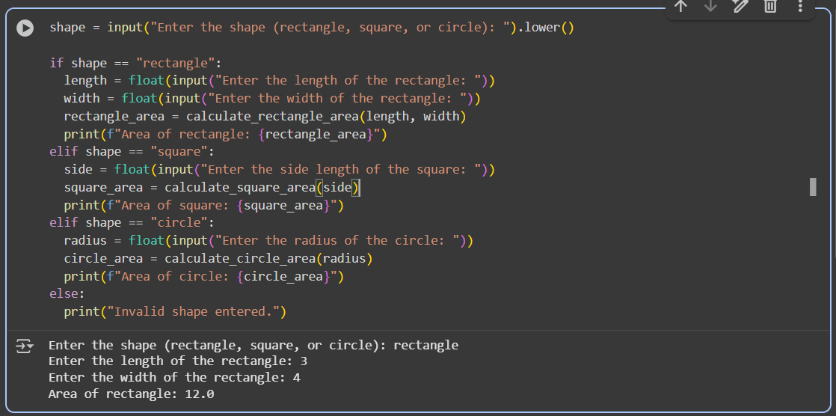

Task Description 2 – Error Handling in Legacy Code
Task: Legacy function without proper error handling

Used Prompt:
refactor the code with with open() and try-except.
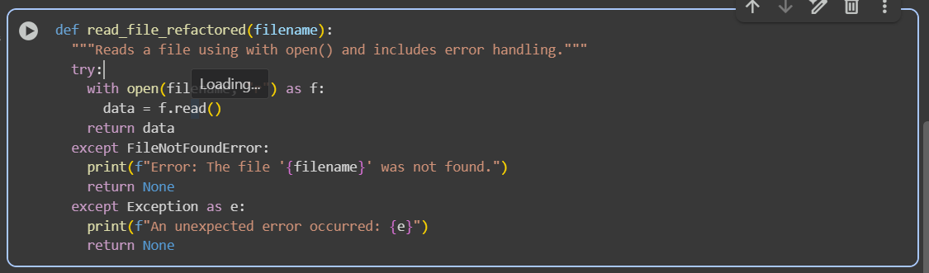

Task Description 3 – Complex Refactoring
Task: Provide this legacy class to AI for readability and modularity improvements:

Used Prompt:
in the given code make more readability and cleaner by givingnames such as(name, age,marks), add docstrings, improve print readability and use sum(self.marks) if marks are stored in a list and take input from the user
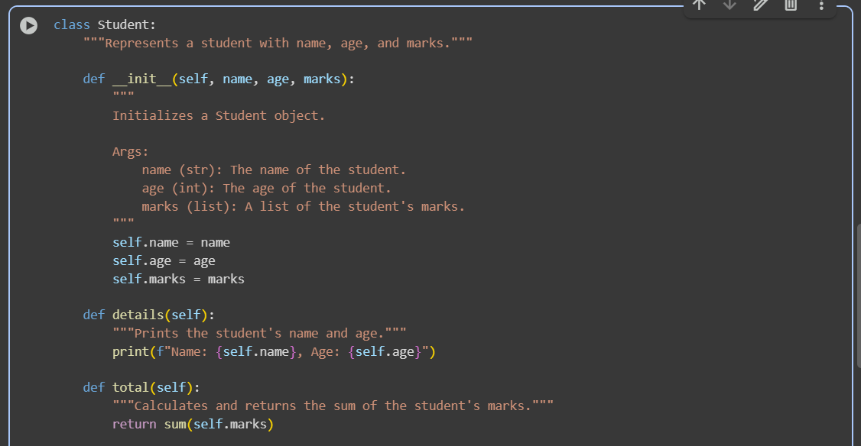
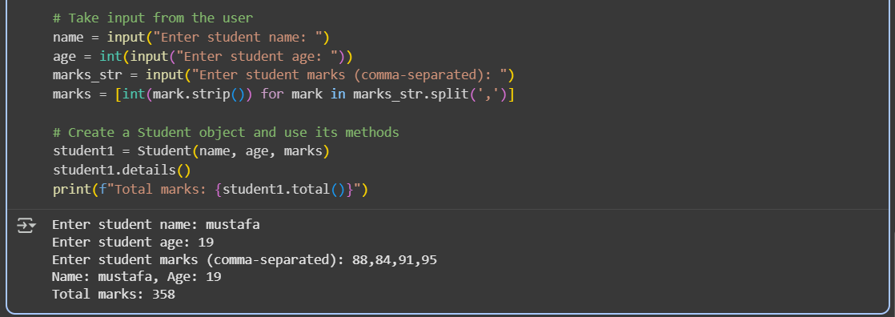

Task Description #4 – Inefficient Loop Refactoring
Task: Refactor this inefficient loop with AI help

Used Prompt: refactor this inefficient loop.
