Replication value coding form

# Dataset A

## Data exclusion and refinement

Dataset A has been randomly sampled from a larger set of studies that has been filtered on specific exclusion criteria related to the authors’ research interests and expertise (see filtering scripts in the analysis directory). However, some further refinement of the dataset will be needed. Articles that will be excluded includes (but is not limited to):

* Duplicate articles
* Any non-empirical article (e.g. opinion pieces, theoretical papers, review articles, meta-analyses)
* Methodological reanalyses of existing data (e.g. using Connectome data to validate a novel procedure).
* Articles that obviously would meet the initial interest/expertise exclusion criteria (e.g. any article that does not contain an fMRI study).

Any excluded article will be marked as such in a separate column of the dataset. For any excluded article, a new random article will be drawn from the same filtered data that dataset A was sampled from, and added to dataset A. This evaluation process is then repeated for all added studies until dataset A contains 1000 non-excluded articles.

## Variables to code for dataset A

**Study number:**

For each article, code each reported study on a separate row if the studies use unique participant samples. For each row, code a study number, which should be coded as integer values starting at 1 for the first listed study in the article and increasing for each subsequent study listed in the article.

**Total sample size:**

For each study, code the total sample size (across groups) of all participants that were not excluded and for which fMRI data was collected.

Authors usually report both how many subjects participated in the study, as well as the total sample size available for analysis after all exclusion criteria has been applied. In order to ensure that the number of participants available *after exclusion* is coded for each study, the following steps should be implemented:

1. Do not quote sample size directly from the abstract, even if mentioned there, since it will be unclear whether this refers to sample size before or after exclusion criteria were applied. Sample size information should always be extracted from either the methods section or results section.
2. Search for the pattern “exclud*” in every reported study to locate information about the exclusion procedure. If a direct mention of the post-exclusion sample size cannot be located (e.g. if no participants were excluded), take the following precautions:
   * Read the entire “participants” subsection of the methods section, scanning for potential (dis)confirmations of an exclusion process.
   * If possible, compare the quoted sample size with the degrees of freedom of fMRI-related tests in the results section. The degrees of freedom should roughly correspond to the number of subjects. For example, a t-test should report number of subjects minus one.
3. Some studies conduct behavioral testing on a large sample and perform fMRI measurements only on a smaller subset of this sample. Make sure that the extracted sample size actually refers to the number of subjects who underwent fMRI scanning. Two useful sources of information are:
   * Details about the sample mentioned in the “participants” subsection, which is usually placed in the beginning of the methods section. If only a subset of the sample has undergone fMRI scanning, this will usually be mentioned explicitly here.
   * Context clues from the abstract. For example, do the research questions completely depend on information from the fMRI data?

## Dataset A – example table of coded information

|  |  |  |  |  |  |  |  |  |
| --- | --- | --- | --- | --- | --- | --- | --- | --- |
| AU | TI | PY | DI | UT | exclusion_flagged | study_number | sample_size | coder_comment |
| Author1 | Title1 | 2019 | doi | wos | yes1 | 1 |  | review article |
| Author2 | Title2 | 2019 | doi | wos |  | 1 | 20 |  |
| Author2 | Title2 | 2019 | doi | wos | yes2 | 2 |  | not fmri |

1. “Title1” is flagged for exclusion, which means it is not necessary to code sample size. A brief comment detailing the reason for flagging is left in the “coder_comment” cell.
2. “Title2” contains two studies.
   1. The first is an fmri study and is coded. The “exclusion_flagged” column can be left blank.
   2. The second is a purely behavioral study, which is flagged for exclusion, and no sample size needs to be coded.

**Tips :**

1. Read the title and the abstract. Usually this is the easiest way to tell if the study will have to be excluded: this is where you will be able to tell if it is a non-fMRI, non-experimental paper  
     
   - Keep an eye on the keywords by the abstract, if the word ‘fMRI’ or equivalent is written there, chances are the paper is appropriate. Not a hard rule, just a hint if coder is suspicious
2. Usually the most important information about sample size is at the beginning of the **methods** section, however, exclusions are not always mentioned at this stage:  
     
   - sometimes exclusions are mentioned in the **fMRI data cleaning** paragraph  
   - a good way to confirm the number of participants mentioned in the methods section is to look at the degrees of freedom of the descriptive stats in the **results** section. Usually the best place to look is after a **t-statistic or F-statistic** is mentioned

*eg. F(1,18)=50.97, P < 0.001, d=3.3  
  
in the above, 18 indicates the degrees of freedom*

1. Searching for keywords (**Ctrl F**) can be used as something of a last resort. Usually a somewhat successful search term is ‘exclu’, as this includes the possibility of the words exclu**sion** or exclu**ded.** another term is “remove”.

**Common Issues encountered**

* Confusing phrasing of exclusions:

“139 participants were recruited for the study. An additional 14 were recruited and excluded due to …”  
  
Generally this indicates that 139 participants were used in the final analysis, however the easiest solution is to check the degrees of freedom used.

* When pairs are recruited – important to check whether each individual is getting scanned, differences are calculated etc.
* When the topic is not evidently ‘social neuroscience’   
  - we have decided to be liberal with inclusion here, as long as the study is something that someone studying neuroscience might be interested in, it counts

**Unifying different spreadsheets**

Consider the main spreadsheet (dataset_A_coded.tsv) the central one, and the other spreadsheets secondary. Imagine the coder has been tasked to work on all the articles starting with “A” until “C” (up until D).

1. Work by chunks of articles (ie. articles beginning with a given letter)
2. In the central spreadsheet, check how many articles begin with the letter ‘A’  
   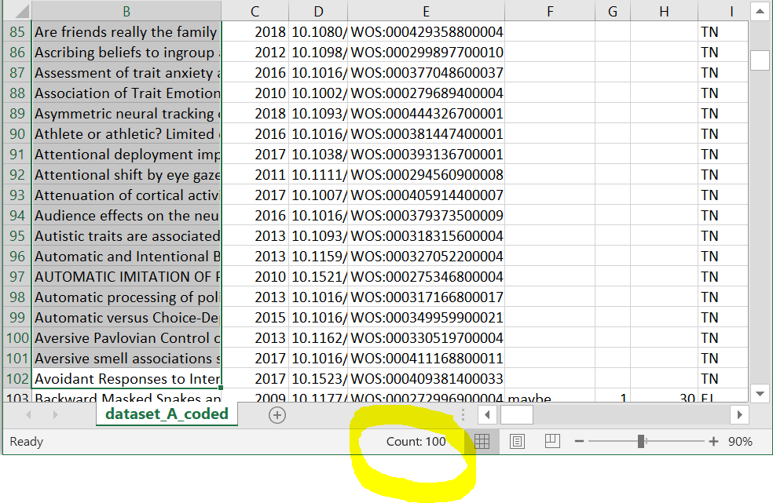
3. Compare this with the secondary spreadsheet from the coder   
   (usually there are more in the secondary, since some studies have more than one group of participants, ie, more rows)  
   -in our example, the secondary has 110, while the central has 100
4. Select all the information of the chunk (A) in the central spreadsheet, by clicking on the row numbers in Excel  
   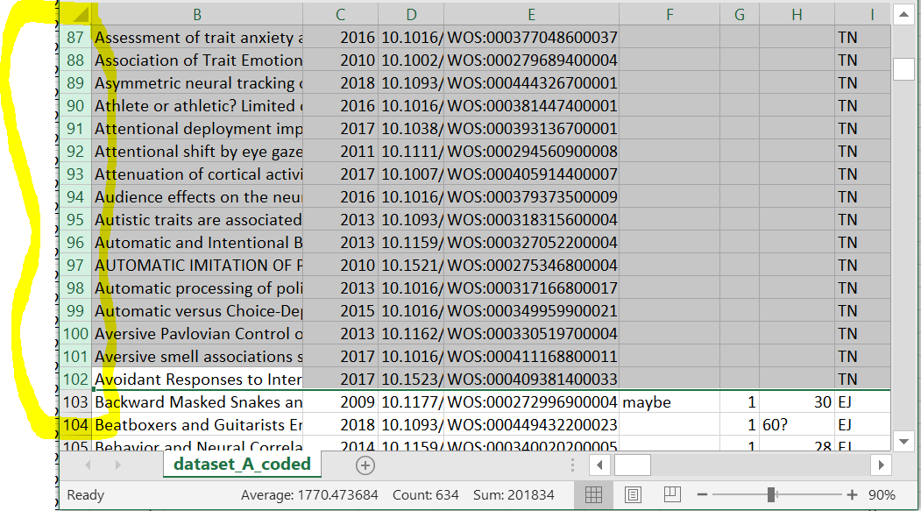  
     
    **remember the row number of the end of your chunk (102 in the example)**
5. Switch over to the secondary, and in the same way, highlight all the information within the chunk, from the secondary
6. Copy the information from the secondary (ctrl-C)
7. Switch over to the central spreadsheet, and:   
   **right click** [within the selected area] **🡪 insert copied cells**
8. After inserting, pay attention to the row number, this number should have increased, since the secondary spreadsheet had more rows containing articles beginning with A  
   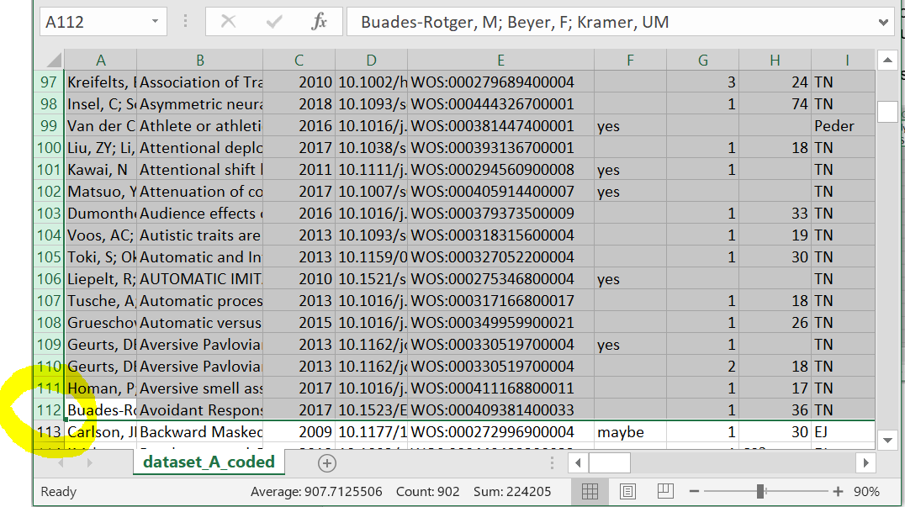
9. If the row number has increased: all went well, and the information from the secondary is now in the central spreadsheet. All that remains is to remove the (empty) chunk that is below what you’ve pasted.

# Dataset B

## Variables to code for dataset B

Factor between or within subject:

Number of conditions per factor:

Number of factors:

Number of participants in each between-subject group:

Open data URL:

Open materials URL:

**Participant characteristics:**

For each study, code any major participant characteristics that defines the population being studied, such as gender (if only one is included), age group (if only particular ones are included), diagnosis if a patient group is included, etc.

Default value: “healthy”. Healthy participants imply a sample where no specified population of interest was target during recruitment. A convenience sample of healthy subjects should be coded as “healthy” even if it happens be restricted on certain characteristics, such as age, ethnicity, or other demographics. In other words, “healthy” indicates that the authors’ intention was to sample from a population of healthy human beings, with no additional population characteristics restricting recruitment.

If any population characteristics are specified for any group, these should be coded instead of the default value. If a study contains a group from a specified population of interest and a group of healthy controls, the characteristics of the sample from the population of interest should be coded.

If more than one participant characteristic is defined for the population of interest (e.g. adolescent males diagnosed with autism spectrum disorder), each characteristic should be listed in the same cell, with a comma “,” separating each characteristic.

**Imaging techniques:**

For each study, code any neuroimaging/neurostimulation techniques utilized as part of the study design.

Specified variable values and their meaning:

* “eeg”: electroencephalography
* “fmri”: functional magnetic resonance imaging
* “fnir: functional near-infrared spectroscopy
* “meg”: magnetoencephalography
* “pet”: positron emission tomography
* “tdcs”: transcranial direct-current stimulation
* “tms”: transcranial magnetic stimulation

If other potentially relevant techniques are discovered during coding, the research team should be notified and discuss their relevance on a case-by-case basis. For example, even though electromyography is not a neuroimaging technique per se, it is a commonly used imaging technique in social neuroscience, and we may want to consider adding it to the list of specified values depending on the context of the study it is applied in.