Experiment 1

## Methods

*Approval:*

This study was approved by the internal review board of the Department of Psychology at University of Oslo.

*Participants:*

Thirty students From the University of Oslo, and Oslo and Akershus University College, (18 female and 12 male, mean age = 22.9 SD = 2.5) took part in the experiment. Some participated as part of an obligatory course requirement, with the option of withdrawing consent at any point without being penalized. The rest were recruited from the university campus on a voluntary basis. All gave written consent prior to participation.

*Material:*

Three social hierarchies, presented in written form were used. One consisted of catholic religious ranks, one of medieval political ranks, and one of military ranks (see list of Hierarchy contents in the appendix). Each hierarchy contained six status levels, all intended to be familiar to the participants, and all intended to be related to all the other levels on the same hierarchy (see figure 1).

*Procedure:*

The experiment was conducted on computer in a lab at the institute of psychology, UIO. I programmed the experiment in E-Prime 2.0 and conducted a proceeding questionnaire on the Qualtrics Online survey Software & Insight Platform. Response latencies were measured. The screen-size and resolution were thus the same for all participants. All participants were presented with every hierarchy, one at a time. This was done after acknowledging that no hierarchy would be equally familiar to all participants. All participants were therefore tested on all hierarchies, to minimize the chance that anyone was presented with no familiar hierarchies. Each hierarchy was presented on the screen in vertical linear order (figure 1) and participants were given as long as they wanted to memorize them, although they were told that they did not need to spend a long time if the hierarchy was familiar.

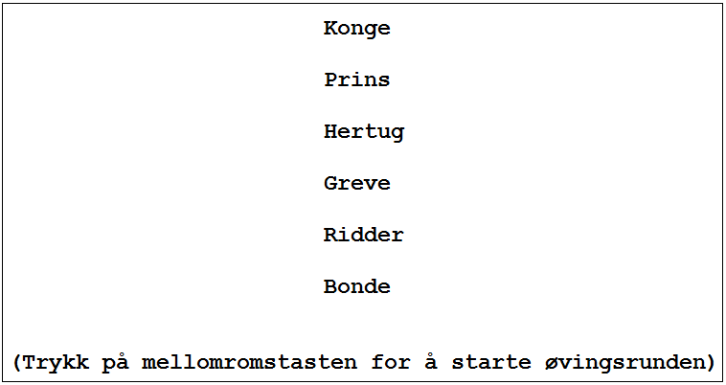

*Figure 1 – hierarchy display on screen. Levels were always shown in rank order with the highest on the top of the screen.*

After each hierarchy came 30 trials with, and then 60 trials without, feedback. The task was to indicate which of two status levels was the higher or lower in a pair (counterbalanced over participants). The participants used the keyboard to indicate whether the word was on the left or right side of the screen. The feedback consisted of a screen displayed for 2 seconds after each practice trial, telling the participant if the answer was correct, the percentage of trials he/she had answered correct up until that point, and how fast he/she responded. All trials consisted of two levels from the previously displayed hierarchy on each side of the screen (see figure 2). Every combination of levels was presented four times to each participant; two times with the higher status on the right side, and two with the higher on the left side. All the possible combinations were shown once (all word combinations with the higher status once on the left and once on right side) before any was repeated. In other words, participants never saw the same words in the same place two times in a row. The spatial position of the words (right vs left side) was otherwise randomized.

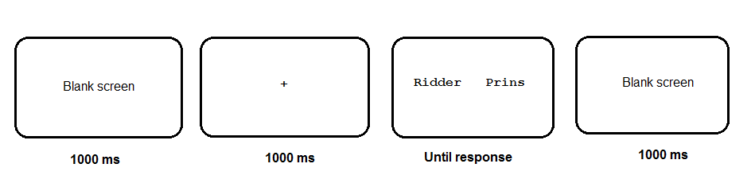 *Figure 2- Singe trial screen displays for all comparison tasks. On practice trials there were also a feedback screen displayed for two seconds.*

After all trials were completed participants were given a short break and then the next hierarchy was introduced. After all three hierarchies were presented the participants were given a short questionnaire about some demographic questions. They also indicated their subjective understanding of the rank ordering of the hierarchies, and they were asked about their familiarity with each hierarchy and its levels. The entire experiment took about 30 minutes to complete, including debriefing.

*Design:*

The manipulated variables were word-pair status distance (1 – 5) and word-pair height in the hierarchy (1 – 5). Pair Height was defined as the status-level of the lower status word in the pair, in accordance with previous definitions (E.g. Buckley & Gillman, 1974; Parkman & Groen, 1971). This created a 5x5 factorial design. Also, whether participants responded to the higher or the lower was counterbalanced between participants. The presentation-order of the hierarchies and the presentation-order of all pairs were randomized.

## Results

One participant knew the research hypothesis prior to participating and was therefore excluded. Then, all incorrect answers were excluded. Response latencies were trimmed such that all responses above 5000 or below 400 were considered outliers and excluded. If a participant was incorrect over 20 percent of the time for any hierarchy then all trials on that hierarchy was excluded for that participant (happened in one instance). In summary, 398out of 5220 correct trials were excluded from analysis.

After trimming, the data were submitted to a linear mixed model 2 (Search condition: “find higher” vs “find lower”) x 2 (presentation order: “pair presented for the first time” vs “pair presented for the second time”) x 5 (Pair Distance: 1…. 5) x 5 (Pair Height, defined as the lower status in each pair: 1…. 5). Participants (1-30) and hierarchies (1-3) were added as random groupings, such that intercepts were allowed to vary randomly across these groupings (for a discussion of mixed model-analysis applied to response latencies, see Baayen & Milin 2010). An identical analysis was also performed for log transformed response latencies to adjust for skew in the latency distribution. But since the results were overall identical, the following effects are reported for actual response latencies (see the appendix for a summary of the SPSS syntax for the mixed model).

*Figure 3: Distance effect. Average response latencies for every level of status distance.*

*Figure 4: Size effect. Average response latencies for every level of comparison height in the hierarchies.*

I first tested whether there was variation in intercept of response latencies for each participant and each hierarchy, and if the size and distance effect varied as a function of participant or hierarchy. Intercept did vary across subject, *Wald Z* = 3.404, *p* = .001, suggesting that participants varied in their mean response latencies. Intercept did not vary as a function of hierarchy, *Wald Z* = .981, *p* = .327. There was no significant variation in the effect of Pair Height between hierarchies, *Wald Z* = 1.769, *p* = .077. The same applies for Pair Distance, *Wald Z* = 1.114, *p* = .265. Pair Height did vary significantly between subjects, *Wald Z* = 3.702, *p* < .001. This was not the case for Pair Distance, *Wald Z* = 1.668, *p* = .095.

There was a main-effect of Pair Distance, *F*(4, 4733.1) = 122.83, *p* < .001. Pairs with adjacent status-levels (*M*1 = 1078 ms) required more time to respond to than pairs with larger status-difference (*M*2= 980 ms; *M*3= 904 ms; *M*4= 816 ms; *M*5= 722 ms). All differences between means were significant (*p* < .001 for all) displaying a clear distance effect (see figure 3).

There was also a main effect of Pair Height, *F*(4, 4733.2) = 105.93, *p* < .001. This effect was not at all behaving like the size effect predicted by the hypothesis though (see figure 4). It had no clear upward trend, and pairwise comparisons for level 1-5, 2-3, and 2-4 were not significant.

*Figure 5: Size*Search Condition Interaction. Average response latencies for every level of status height, comparing participants who searched for lower vs higher status targets.*

*Figure 6 Distance*Search Condition Interaction. Average response latencies for every level of status distance, comparing participants who searched for lower vs higher status targets.*

There was no main effect of search condition. However, the interaction between Search Condition and Pair Height was highly significant, *F*(4, 4733.2) = 46.25, *p* < .001. There appeared to be a general decrease in response latencies for comparisons high in the hierarchy, but only for participants who were looking for the higher status word (see figure 5).

There was also a smaller but still significant interaction between Pair Distance and Search condition, *F*(4, 4733.1) = 2.79, *p* = .025. Participants who searched for the lower status words were on average more influenced by status distance increases (see figure 6). As in the study of von Hecker (2013) search condition influences status-judgments.

*Figure 7: Size*Distance Interaction. Average response latencies for every level of comparison height, comparing every level of status distance.*

Finally, there was a significant interaction between Pair Height and Pair Distance, *F*(6, 4733) =43,32*, p <* .001*.* There seems to be a growing effect of status distance as people make comparisons higher up in a hierarchy (see figure 7). The reason why some Pair Height levels are missing for Distance levels above 1 is that if the lower in a pair is, say 2, it cannot have a distance of 5 in a six level hierarchy.

No other effects were significant (see table of effects in the appendix for summary).

Experiment 2

# Method

## Participants

The study was approved by the internal review board of the Department of Psychology at University of Oslo. 30 students (16 female, 14 male, mean age 22.5) at the University of Oslo participated in the experiment. 5 of them participated in the experiment as a mandatory part of a course. They were given the option to have their data excluded from the experiment, but none did.

## Materials

In the present study, six stories were used to teach the participants six status hierarchies. The stories were based on Von Hecker and colleagues’ (2013) materials, and were translated and adapted from German to Norwegian[1]. Each story consisted of 16 sentences. The first sentence in each story was always an introduction to the topic of the story. The following 15 sentences in each story illustrated the status of six persons in each story referred to by name. Each sentence described an interaction between two of the people in the story, corresponding to the 15 possible pairings between the six persons. For example, in one of the stories, about the members in a fishing club, a sentence would read “Frank, the chairman, has a short talk with Richard, a newly appointed member, to teach him the most important nature conservation rules on fishing grounds.” The names for each story were randomly selected for each participant out of a pool of 42 names of approximately equal popularity and without a priori social status implications (e.g. common names among cultural minorities).

## Procedure

I programmed the experiment in E-Prime 2.0. The participants read each story sentence by sentence on a computer screen, using the spacebar to proceed when they were ready. The first sentence was always the same for all participants, presenting the topic of each story. The other 15 sentences were presented in randomized order. The participants were encouraged to think about the status implication between the persons in each story as they read. After each story the participants were presented with a fixation cross, followed by pairs of names side by side from the story they just read. The participants were to select the person with higher or lower status, depending on the counterbalance search condition, by pressing on a keyboard the “a” key to select the left target or the “l” key to select the right target. The 15 possible pairs were presented in the two possible configurations for each (AB and BA). After one cycle of these 30 configurations had been presented, they were immediately presented once more, to a total of 60 trials in a block corresponding to each story. The blocks were presented in a randomized order. The participants had five seconds to respond, automatically proceeding to the next trial if no response was given. At the end of the experiment, information about each subject (age, gender, etc.) was collected with the survey software Qualtrics. The experiment lasted about 45 minutes debriefing included.

# Results

All responses ≤ 400ms were removed from analysis, as responses this quick are unlikely to be genuine responses. Additionally, any block with ≥ 20% incorrect trials and participants with > 3 excluded blocks were excluded from analysis. These criteria were set before data were analyzed. Twenty three blocks but no participants were excluded by these criteria. Finally, all additional incorrect trials were excluded from analysis. 780 trials were excluded by this criterion. In total, 2160 trials (20.0%) were not included in the analysis according to all these criteria.

Data were analyzed in a multilevel model (also known as a mixed model; see Figure 4 in the appendix for SPSS Syntax). The design was 5 (Distance) x 5 (Height) x 2 (Target Location) x 6 (Block Order) x 2 (Search Condition). All interactions were included. Individual reaction times of correct answers were the units of analysis. Subject was added as a random factor, letting intercepts vary across it. In initial models, Story was added as a random factor as well, again letting intercepts vary across it. However, it explained no random variance, and caused errors in the model estimation (Hessian matrix was not positive definite), and was therefore removed from the analysis.

For H1 the independent variable of interest was Pair Distance, the distance in rank between the members of each pair. For H2 the independent variable of interest was Pair Height, the rank of the lowest ranking member of the pair. Firstly, a main effect of Pair Distance was found, *F*(4, 8035) = 197.325, *p* < .001, replicating the findings of von Hecker and colleagues (2013), and illustrating the *distance effect*. Participants spent more time on pairs with adjacent members than members with a larger status difference (*Mdist* 1 = 1719ms; *Mdist* 2 = 1492ms; *Mdist* 3 = 1279ms; *Mdist* 4 = 1123ms; *Mdist* 5 = 982ms; see Table 1 in the appendix). In a pairwise comparison, all adjacent data points were significantly different from each other, *p* < .001 (see Table 2 in the appendix). Secondly, a main effect of Pair Height was found, *F*(4, 8035) = 94.88, *p* < .001, illustrating the *size effect*. The effect was non-linear, with an overall downward direction (*Mheight* 1 = 1471; *Mheight 2* = 1621; *Mheight 3* = 1619; *Mheight* 4 = 1495; *Mheight* 5 = 1310). A pairwise comparison showed that all adjacent data point were significantly different from each other (*p* < .001), with the exception of level 2 to level 3, *p* = .92*.* Block Order also had a significant main effect, *F*(5, 8043) = 3,71, *p* < .01. There was no main effect of Search Condition (*F*[1, 28] = 1.07, *p* = .31) or Target Location (*F*[1, 8042] = 0.01, *p* = .93).

Additionally, several interaction effects were significant. Pair Height interacted significantly with Search Condition, *F*(4, 8035) = 7.22, *p* < .001 (see Table 3 in the appendix). For both conditions, a pairwise comparison showed that all adjacent data points were significantly different from each other (*p* < .05), again with the exception of between level 2 and level 3 for both conditions, *p* > .05 (see Table 4 in the appendix). Pair Height also interacted significantly with Pair Distance, *F*(6, 8035) = 4.88, *p* < .001 (see Table 5 in the appendix). Search Condition and Target Location interacted significantly, *F*(1, 8042) = 8.62, *p* < .01 (see Table 6 in the appendix). Finally, three 3-way interactions were significant: Pair Height by Search Condition by Block Order, *F*(20, 8035) = 1.73, *p* < .05; Pair Height by Target Location by Block Order, *F*(20, 8035) = 1.93, *p* < .01; and Pair Distance by Search Condition by Block Order, *F*(20, 8035) = 2.14, *p* < .01. All other interactions were non-significant, *p* > .05.

Finally, intercepts varied significantly across Subject, *Wald Z* = 3.67, *p* < .001, indicating that there were individual differences in mean response times.

Experiment 3

# Methods

Participants:

55 students From the University of Oslo, and Oslo and Akershus University College, (?? female and ?? male, mean age = ?? SD = ??) took part in the experiment. Most participated as part of an obligatory course requirement, with the option of withdrawing consent at any point without being penalized. The rest were recruited from the university campus on a voluntary basis. All gave written consent prior to participation.

Material:

The catholic and the medieval hierarchy from experiment one was used, since they were consistently reported to be the most familiar to participants. One more level was added to each hierarchy. “Monk” was added to the catholic hierarchy, and represented a level between altar boy and priest. “Baron” was added to the medieval hierarchy, and represented a level between knight and count. Thus, both hierarchies now had seven status levels (see Appendix for details).

Procedure:

The procedure was identical to experiment one, except that there now was ?? practice trials

1. In a pilot study, von Hecker et al. (2013) found that participants consistently found the intended high-status targets to be of higher status. For details, see von Hecker et al. (2013).