AaP3Km → AppEEARS
Landsat U.S. ARD Sampling Workflow
Required PSU-00 web-tool pilot, 37-PSU expansion, and July 1–September 1 SWIR-1 surface-reflectance trajectory for 1982–2026

Purpose. Use an AaP3Km Traveling Archive to submit fixed Primary Sample Unit centers and 100 m × 100 m support polygons to NASA AppEEARS, retrieve current Landsat Collection 2 U.S. Analysis Ready Data, and build reproducible per-band, QA, cloud, and long-term seasonal statistics.
Primary rule. The Traveling Archive is the frozen geographic source. AppEEARS requests may inspect and extract from the archived geometry, but must not redefine the anchor, PSU identities, support polygons, or MGRS-derived lineage.
Prepared as a field/laboratory SOP with request checklists, schemas, examples, and quality gates.

1. Scope and outputs
This SOP has two linked investigations. The recent-observation investigation retrieves all currently available Landsat ARD science and quality layers for the most recent usable acquisition. The historical investigation builds one sensor-consistent SWIR-1 surface-reflectance trajectory for each annual July 1–September 1 window from 1982 through 2026. Use TM/ETM+ Band 5 and OLI/OLI-2 Band 6 because those layers measure the corresponding first shortwave-infrared region across Landsat sensor eras. Both investigations begin with PSU-00 and then expand to PSU-01 through PSU-36.
Stage | Spatial support | Time window | Layers | Required result
Pilot 1 | PSU-00 center point | Recent: initially 90 days | All available science + QA/cloud | Point values and acquisition/QA record
Pilot 2 | PSU-00 100 m × 100 m polygon | Same recent window | All available science + QA/cloud | Pixel-pool statistics by layer
Expansion | All 37 PSU centers and polygons | Same recent window | Same products/layers | 37-PSU comparable sample pool
Historical | All 37 PSU centers and polygons | July 1–September 1, annually, 1982–2026 | SWIR-1 surface reflectance + QA/cloud/saturation | Annual seasonal statistics and important-year flags

Primary spectral rule. The long-term variable is SWIR-1 surface reflectance, not a fixed band number. Use Landsat 4–5 TM Band 5, Landsat 7 ETM+ Band 5, and Landsat 8–9 OLI/OLI-2 Band 6. These are corresponding heritage SWIR-1 measurements, but their relative spectral responses are not perfectly identical. Preserve sensor, product, layer, scale/offset, and acquisition lineage so any cross-sensor normalization can be evaluated rather than hidden. [5–7]
1982 coverage. Landsat Collection 2 U.S. ARD is described as available from 1982 to present, but an individual place may have no valid July 1–September 1 observation in some years. Record zero-observation, fill-only, and no-QA-accepted years explicitly rather than interpolating or silently dropping them. [3–4]

1.1 Create your own AOI and Traveling Archive
Open the current AaP3Km STEP00 tool: https://pedernelson.github.io/Adopt-a-Pixel3km/steps/STEP00/AaP3Km_STEP00_ExplorePlace_MapFirst.html
Each participant must select and document the participant’s own Area of Interest (AOI) in STEP00. Do not use the demonstration AOI or another participant’s Traveling Archive for the AppEEARS requests.
- Use STEP00 to choose a real place and establish the AOI center. Review the mapped 3 km × 3 km AOI, PSU-00 center, surrounding PSU-01 through PSU-36 array, and support geometries before export.
- Complete the STEP00 identity, geography, and readiness checks. Resolve any blocking geometry error rather than editing coordinates or polygons outside STEP00.
- Choose Create my Traveling Archive or Export current AOI to Traveling Archive, as presented by the current interface. Download the resulting Traveling Archive HTML and retain its generated MGRS Place Code, timestamp, STEP, and version in the filename.
- Reopen the participant’s downloaded Traveling Archive locally in a current browser. Confirm that the archive shows the selected AOI, the expected MGRS Place Code, PSU-00, all 37 PSU identities, and valid support geometry.
- From that Traveling Archive, download the archive-generated CSV and GeoJSON files required below. These files, not manually recreated coordinates or polygons, are the authoritative AppEEARS inputs for the remainder of the exercise.
- Keep the Traveling Archive and every downloaded CSV, GeoJSON, audit, and AppEEARS result together as one place-based working package. Continue using this same Traveling Archive lineage throughout the exercise.
Required handoff. STEP00 creates the participant-selected AOI and its Traveling Archive. The participant then opens that archive and uses its CSV point files and GeoJSON support polygons for the PSU-00 pilot and the 37-PSU expansion. AppEEARS extracts measurements for the archived place; AppEEARS does not create or redefine the place.
Stop if the Traveling Archive cannot be created, reopened, or verified, or if the required CSV or GeoJSON export is missing. Report the archive or export problem. Do not redraw, buffer, shift, manually type, or substitute the geography.

2. Authoritative inputs from your Traveling Archive
- 37 PSU Center Coordinates CSV downloaded from your Traveling Archive: exact center latitude/longitude for your AOI’s PSU-00 through PSU-36.
- PSU Support Geometry GeoJSON downloaded from your Traveling Archive: 37 frozen 100 m × 100 m polygons for your selected AOI.
- AOI Anchor + Boundary Coordinates CSV and AOI Support Geometry GeoJSON: lineage and geographic checks.
- Geometry Audit JSON: expected counts, geometry status, and hash.
- GLOBE evidence outputs, if present: field-evidence context only; do not use GLOBE coordinates to replace PSU centers.

2.1 Required identity fields
Field | Example | Use
Archive_ID | AaP3Km_TravelingArchive_... | Parent evidence object
AOI_ID | AOI-01 | Nested sampling parent
MGRS_Place_Code | 10TEQ000829 | Durable place namespace
PSU_ID | PSU-00 | Zero-based PSU identity
Support_Type | center_point / 100m_polygon | Separates point and area evidence
Geometry_Hash | stored archive hash | Confirms geometry lineage

3. Product discovery before submission
AppEEARS product names, versions, layer availability, and current mission offerings can change. On the request date, use the AppEEARS Available Products page or product metadata endpoint to record the exact product/version and every selected layer. AppEEARS supports point and area samples, temporal and layer subsetting, quality values, and request-level exploration/statistics. [1–2, 8]
- Sign in with Earthdata Login and open AppEEARS Available Products.
- Search for “Landsat,” “U.S. ARD,” “Surface Reflectance,” and current Landsat 4–9 mission products.
- Record exact product identifier, version, temporal coverage, layer descriptions, units, scale factor, offset, fill value, valid range, and associated QA layers.
- Select the current products that jointly cover the requested 1982–2026 interval. Do not assume a single product spans all missions.
- Retain a dated screenshot or product metadata JSON in the request package.
Catalog field | Record exactly | Why
Product / version | Current AppEEARS text | Prevents old tutorial identifiers from becoming method assumptions
Layer | Native layer identifier + description | Separates analytical SWIR-1 variable from native layer number
Sensor / mission | TM, ETM+, OLI, OLI-2 | Supports era-aware analysis
Scale / offset | Metadata value | Needed for physical reflectance/temperature
Fill / valid range | Metadata value | Separates absent data from measurements
Quality layers | QA_PIXEL, saturation, aerosol, etc. as offered | Defines clear/usable populations

4. Phase 1: PSU-00 recent-observation pilot
1. Download from archive | 2. Submit PSU-00 point | 3. Submit PSU-00 area | 4. Plot spectral profile | 5. Review and unlock 37 PSUs

4.0 Required web-tool learning and methods-readiness gate
The first PSU-00 point request and PSU-00 area request must be completed in the AppEEARS graphical web tool. This is a required methods-readiness exercise, not a separate course point scheme. Participants proceed to the 37-PSU workflow after documenting both requests, checking QA and scaling, completing the point–area spectral-profile comparison, and resolving any critical error.
Required preparation. Complete the official Landsat point tutorial and review the current AppEEARS point/area interface before beginning. The instructional goal is to understand the request object, product/layer selection, QA, result inspection, and download lineage before automating repeated requests.
Required point tutorial: Access Landsat 8 Surface Reflectance Point Data with AppEEARS
Useful current overview: Efficient Geospatial Data Access with NASA’s AppEEARS (recommended segments: point/area extraction, interface walkthrough, and point demonstration).
Readiness rule. Course grades remain defined by the course assessment system. This SOP uses a complete / revise / ready decision. Revision is required if the wrong location is used, PSU-01 is substituted for PSU-00, the 3 km AOI is submitted instead of the 100 m PSU, archived geometry is changed, required QA/cloud layers are omitted, or fill/unscaled values are interpreted as measurements.

4.1 Prepare the point file
Retain the header and only the PSU-00 row from the PSU center CSV. Preserve the exact archived coordinates.
ID | Latitude | Longitude | AOI_ID | Support_Type
PSU-00 | 44.123456 | -123.123456 | AOI-01 | center_point

Example coordinates are placeholders. Replace them with the exported archive values.

4.2 Prepare the polygon file
The Traveling Archive now provides a ready-to-submit, one-feature PSU-00 GeoJSON. Participants should not manually edit the 37-feature PSU file or use separate GIS software for this activity.
- Open the frozen Traveling Archive and select the Archive tab.
- Under Support Geometry, choose Download PSU-00 100 m Support Polygon GeoJSON.
- Save the file without editing it. The expected filename identifies the MGRS place and PSU-00 support.
- Open or preview the downloaded file only to confirm that it contains one FeatureCollection, one Polygon feature, and the zero-based PSU-00 identity.
- Upload that exact file to the AppEEARS Area request.
Expected archive-generated result. One GeoJSON FeatureCollection containing exactly one source-faithful 100 m × 100 m PSU-00 polygon in longitude/latitude exchange coordinates, with AOI, MGRS, PSU identity, support, CRS, and geometry-hash lineage retained.
Do not substitute. Do not use the 3 km AOI polygon, a center point, PSU-01, an SSU footprint, or a polygon redrawn from the map. If the PSU-00 download is missing or fails, stop and report the Traveling Archive problem rather than recreating the geometry manually.

4.3 Submit the point request
- Extract → Point → Start a new request.
- Upload the PSU-00 center CSV and confirm one mapped point.
- Use an initial 90-day window ending on the request date. If no usable result appears, expand to 180 days and then one year; log every attempt.
- Select all available science bands and all quality/cloud/saturation layers for current Landsat ARD products.
- Name the request AaP3Km_<MGRS>_PSU-00_CENTER_LandsatARD_latest.
- Submit, then record request ID, submission time, completion time, product/version, and layer list.

4.4 Submit the polygon request
- Extract → Area → Start a new request.
- Upload the one-feature PSU-00 GeoJSON and confirm the displayed 100 m × 100 m support.
- Use the same dates, products, and layers as the point request.
- Request GeoTIFF and metadata outputs where offered.
- Name the request AaP3Km_<MGRS>_PSU-00_AREA_LandsatARD_latest.
Support accounting. A 100 m × 100 m PSU intersects multiple Landsat grid cells, but the count depends on ARD grid alignment, native resolution, edge inclusion, and fill. Record total intersecting, valid, QA-accepted, and partial-support pixels. Do not assume a fixed pixel count.

4.5 PSU-00 most-recent spectral profile measurement
Use the most recent acquisition that is usable under the documented QA rule and is common to both the point and area requests. Record every returned surface-reflectance band for that one acquisition. The result is a spectral profile: reflectance changes across wavelength at one observation time. This is different from the later SWIR-1 temporal trajectory, which follows one spectral measurement across many years.
Support comparison. Plot the PSU-00 center-point value and the PSU-00 area median on the same axes. Where available, show the area Q1–Q3 range. Keep the area mean and pixel count in the accompanying table. A point–area difference is evidence about spatial support and heterogeneity, not automatically an error.
Native layer | Spectral meaning | Wavelength / metadata | Point scaled value | Area median | Area mean | Area Q1–Q3 | n QA accepted | QA note
Band 1
Band 2
Band 3
Band 4
Band 5
Band 6
Band 7
Figure 1. Blank PSU-00 spectral-profile worksheet. Enter scaled surface reflectance for the point and the area median for the same acquisition and bands. Label any band omitted because it was not offered, invalid, fill, saturated, or rejected by QA.
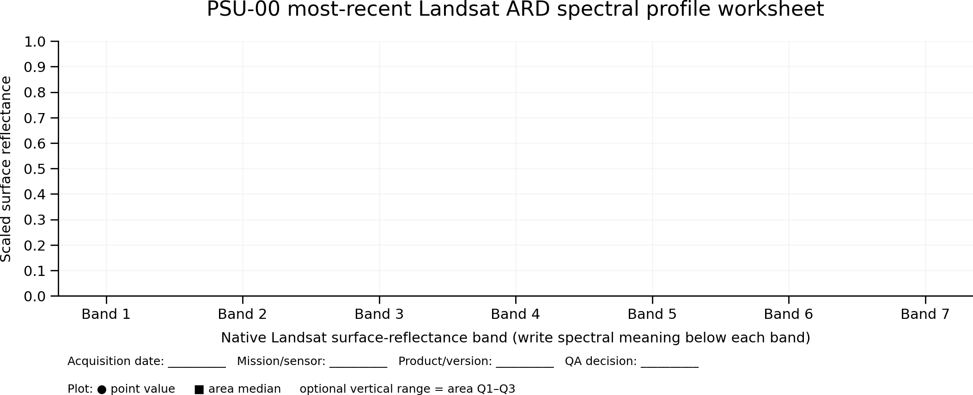
Interpretation prompts: (1) Which spectral regions have the strongest point–area agreement? (2) Is the point within the area Q1–Q3 range? (3) Which band shows the largest support difference? (4) Could cloud, shadow, water, saturation, mixed pixels, or polygon-edge support explain the pattern? (5) What does the SWIR-1 position contribute before the annual time-series analysis?

5. Recent-observation statistics

5.1 Continuous science layers
Statistic | Population A: all returned | Population B: valid measured | Population C: QA accepted
n | All intersecting values | Excludes fill/out-of-range | Excludes fill and rejected QA
Minimum / maximum | Report if meaningful | Required | Required
Mean / median | Report if meaningful | Required | Required
SD / variance | Report if meaningful | Required | Required
Q1 / Q3 / IQR | Report if meaningful | Required | Required
Fractions | Fill fraction | Valid fraction | Usable fraction

Apply the layer-specific scale factor and offset before reporting physical values unless AppEEARS states that the delivered values are already scaled. Preserve raw values and scaled values in separate fields. Product metadata exposes fill, valid range, units, scale, offset, and QA relationships. [2]

5.2 QA and cloud layers
Do not average bit-packed QA codes. Decode flags/categories and report counts and percentages. Collection 2 QA commonly includes pixel quality, radiometric saturation, and, for OLI/TIRS products, surface-reflectance aerosol QA. [8]
Metric | Definition
clear_fraction | Clear pixels / total relevant pixels
cloud_fraction | Cloud-flagged pixels / total
cloud_shadow_fraction | Cloud-shadow pixels / total
cirrus_fraction | Cirrus pixels / total, when supported
snow_ice_fraction | Snow/ice pixels / total
water_fraction | Water pixels / total
saturated_fraction | Radiometrically saturated pixels / total
fill_fraction | Fill pixels / total
usable_fraction | Pixels satisfying the documented QA acceptance rule / total

Example QA rule. usable = valid measurement AND not fill AND not cloud AND not cloud shadow AND not cirrus AND not radiometrically saturated. Adjust only when the product guide requires a sensor-specific interpretation; record the rule and version.

5.3 Optional automation preparation after passing PSU-00
Participants who complete the PSU-00 methods-readiness gate may review the official AppEEARS API point notebook before automating the 37-PSU point workflow. The notebook demonstrates authentication, product and layer discovery, request JSON construction, task submission, status polling, bundle download, Quality API use, QA decoding, and result visualization. Automation is optional and does not replace the required graphical pilot.
Optional notebook: Getting Started with the AppEEARS API: Submitting and Downloading a Point Request
Automation boundary. The API notebook is for the 37-PSU point workflow after the web-tool gate. Area automation, product-era batching, retries, and download manifests require their own tested implementation. Never automate from manually retyped coordinates when the Traveling Archive exports are available.

6. Phase 2: expand to all 37 PSUs
- Submit the complete 37-row center CSV as one point request when current AppEEARS limits allow.
- Submit the complete 37-feature PSU GeoJSON as one area request when current limits allow.
- If batching is required, use deterministic batches: PSU-00–09, PSU-10–19, PSU-20–29, PSU-30–36.
- Hold dates, products, versions, layers, output projection, QA rule, and summary methods constant.
- Keep point and polygon results separate. A center value and a polygon pixel distribution represent different spatial supports.

7. Phase 3: annual July 1–September 1 record, 1982–2026
The historical task comprises 45 named annual windows (1982 through 2026 inclusive). Use July 1 at 00:00 through September 1 at 23:59:59, or the exact inclusive-date convention used by the current AppEEARS interface. Record that convention once and use it for every request.

7.1 Required SWIR-1 surface-reflectance trajectory
- For every mission/product era, select the sensor-appropriate SWIR-1 surface-reflectance layer: TM/ETM+ Band 5 and OLI/OLI-2 Band 6.
- Select the matching pixel QA, radiometric saturation QA, cloud-related flags, and aerosol QA where available.
- Preserve sensor, mission, product, native layer identifier, spectral description, scale, offset, and QA on every row. The analytical variable name is SWIR1_Surface_Reflectance; the native band number remains provenance.

7.2 LandTrendr-oriented companion measurements
- Required primary trajectory: SWIR-1 surface reflectance from TM/ETM+ Band 5 and OLI/OLI-2 Band 6.
- Recommended companion inputs: NIR and SWIR-2, retained by sensor-appropriate layer, so NBR and related disturbance indices can be calculated consistently.
- Name the primary variable SWIR1_Surface_Reflectance. Do not call the cross-era variable Band5.
- Treat band correspondence, radiometric scaling, and optional cross-sensor normalization as explicit analytical steps. Matching the spectral region does not make the sensor response functions numerically identical.
Mission/sensor era | Required SWIR-1 native layer | Analytical variable | Recommended companion inputs
Landsat 4–5 TM | Band 5 / SWIR-1 | SWIR1_Surface_Reflectance | NIR Band 4 + SWIR-2 Band 7
Landsat 7 ETM+ | Band 5 / SWIR-1 | SWIR1_Surface_Reflectance | NIR Band 4 + SWIR-2 Band 7
Landsat 8 OLI | Band 6 / SWIR-1 | SWIR1_Surface_Reflectance | NIR Band 5 + SWIR-2 Band 7
Landsat 9 OLI-2 | Band 6 / SWIR-1 | SWIR1_Surface_Reflectance | NIR Band 5 + SWIR-2 Band 7

USGS and NASA document that Landsat sensors have different band designations and that OLI added/repositioned bands while retaining heritage spectral coverage. [5–7]

7.2.1 Annual trajectory design for segmentation
The output of this activity is a quality-screened annual summer trajectory suitable for later spectral-temporal segmentation. Retain acquisition-level observations first, then produce one documented annual value per PSU support and variable. A robust default is the median of QA-accepted July 1–September 1 observations, accompanied by accepted-observation count, dispersion, clear fraction, representative date, sensor, and missing-year status.
LandTrendr relationship. LandTrendr segments an annual spectral trajectory into periods of stability, abrupt disturbance, and recovery. The first input band controls breakpoint detection, while additional bands can be fitted to those breakpoints. This SOP prepares the annual SWIR-1 trajectory and recommended NIR/SWIR-2 inputs; it does not claim that the descriptive high/low flags are themselves LandTrendr segments.
No silent interpolation. Do not invent annual values when no QA-accepted observation exists. Preserve missing years and observation counts. Any later segmentation implementation must document its minimum-observation rule and treatment of gaps.

7.3 Request construction
Seasonal-window rule. Submit only the July 1–September 1 window for each year from 1982 through 2026. Do not submit one continuous 1982-01-01 through 2026-12-31 request; that would retrieve ten unnecessary months per year and could make the request excessively large and slow. Use one request per annual summer window, or deterministic multi-year batches only when the request method can preserve the separate July 1–September 1 windows. If the current AppEEARS interface accepts only one continuous date range per request, submit the years separately. Where batching is needed, group requests by mission/product era or fixed year blocks, never by observed conditions or expected “good” and “bad” years.
- Run the PSU-00 center and polygon historical pilot first.
- Confirm that each returned record includes date, product, mission/sensor, native layer, scaled value, and QA.
- Expand to all 37 centers and polygons using the same mission/product selections and the same annual July 1–September 1 windows.
- Record years with zero returned acquisitions, returned-but-fill-only data, and no QA-accepted observations.
- Do not fill missing years with interpolation in the evidence table.

8. Annual and seasonal statistics

8.1 Within each PSU-year
For each PSU, support type, sensor/product, year, and acquisition, compute the same three populations used in the recent pilot. When multiple acquisitions fall in the July 1–September 1 window, retain acquisition-level rows and add an annual seasonal summary.
Annual field | Definition / example
Acquisition_Count | Number of returned acquisitions in the seasonal window
Valid_Acquisition_Count | Acquisitions with at least one valid measurement
QA_Accepted_Acquisition_Count | Acquisitions with at least one accepted pixel
Seasonal_Median | Median across QA-accepted acquisition values; robust default
Seasonal_Mean | Mean across QA-accepted acquisition values
Seasonal_Min / Max | Annual low/high among accepted acquisitions
Seasonal_SD / IQR | Within-window variability
Best_Clear_Fraction | Highest clear fraction among acquisitions
Median_Clear_Fraction | Typical cloud condition in the window
Selected_Representative_Date | Date chosen by documented selection rule, if needed

8.2 Point support
For a point, each acquisition usually contributes one sampled cell per layer. Compute temporal statistics across the accepted acquisitions in that year. Keep point QA attached to the same date and cell as the SWIR-1 measurement.

8.3 Polygon support
For a polygon, first summarize native pixels within each acquisition, then summarize acquisition-level statistics across the seasonal window. Do not pool every pixel from every date without also retaining the nested structure: pixel → acquisition → PSU-year.

9. Flagging important years
Highlighting should identify investigation targets, not automatically label land-cover change. Apply the rules separately by PSU, support type, and spectrally comparable sensor/variable series.
Flag | Suggested rule | Interpretation boundary
High year | Seasonal median ≥ series Q3 + 1.5×IQR, or standardized score ≥ +2 | Candidate high reflectance; inspect QA and imagery
Low year | Seasonal median ≤ series Q1 − 1.5×IQR, or standardized score ≤ −2 | Candidate low reflectance; inspect QA and imagery
Largest positive change | Maximum year-to-year difference among comparable valid years | Possible process or sensor/coverage effect
Largest negative change | Minimum year-to-year difference among comparable valid years | Possible process or sensor/coverage effect
Cloud-limited year | Usable fraction below chosen threshold, e.g., 0.50 | Do not interpret as a spectral extreme
Sparse year | Fewer than minimum accepted acquisitions, e.g., 1 | Elevated uncertainty
Missing year | No valid or QA-accepted acquisition | Explicit evidence gap
Sensor transition | First year of a different sensor/product series | Do not treat as physical change without harmonization

Cross-sensor interpretation rule. Run important-year detection on the sensor-appropriate SWIR-1 trajectory. Retain sensor-transition flags and inspect apparent breakpoints near mission transitions. If a transition-year step is comparable in magnitude to a candidate disturbance, test cross-sensor normalization or overlapping-sensor observations before attributing physical change.

10. Required result tables

10.1 Acquisition-level table
Field group | Required fields
Lineage | Archive_ID, AOI_ID, MGRS, PSU_ID, Support_Type, Geometry_Hash
Request | Request_ID, Request_Name, Request_Type, Submitted_UTC, Product, Version
Observation | Mission, Sensor, Acquisition_DateTime, Year, DOY, Native_Layer, Spectral_Meaning
Measurement | Raw_Value, Scaled_Value, Units, Scale_Factor, Add_Offset, Fill_Value
QA | QA_PIXEL_Raw, decoded flags, clear/cloud/shadow/cirrus/snow/water/saturation/aerosol
Support | N_Total, N_Valid, N_QA_Accepted, partial-pixel rule
Files | Source_File, Metadata_File, Processing_UTC, checksum

10.2 PSU-year summary example
PSU | Year | Sensor / variable | Support | n acq. | Seasonal median | Clear frac. | Flag
PSU-00 | 1987 | TM Band 5 / SWIR-1 | area | 4 | 0.214 | 0.82 | —
PSU-00 | 2002 | ETM+ Band 5 / SWIR-1 | area | 3 | 0.119 | 0.91 | Low year
PSU-00 | 2018 | OLI Band 6 / SWIR-1 | area | 5 | 0.403 | 0.76 | SWIR-1 trajectory
PSU-00 | 2018 | OLI Band 6 / SWIR-1 | area | 5 | 0.173 | 0.76 | Primary SWIR-1 trajectory
PSU-00 | 2024 | OLI/OLI-2 Band 6 / SWIR-1 | area | 2 | 0.521 | 0.28 | Cloud-limited

Values are illustrative only. Do not use them as expected results.

10.3 Scored PSU-00 sample results table
The following synthetic example shows the minimum style of result expected after QA screening. Participants must provide both the point record and area statistics, then explain whether the point is representative of the polygon distribution.
PSU | Year | Sensor / variable | Support | n acq. | Seasonal median | Clear fraction | Flag
PSU-00 | 1992 | TM Band 5 / SWIR-1 | area | 3 | 0.146 | 0.96 | Low candidate
PSU-00 | 2002 | ETM+ Band 5 / SWIR-1 | area | 3 | 0.122 | 0.70 | Low candidate
PSU-00 | 2015 | OLI Band 6 / SWIR-1 | area | 4 | 0.224 | 0.76 | High candidate
PSU-00 | 2021 | OLI/OLI-2 Band 6 / SWIR-1 | area | 5 | 0.219 | 0.92 | High candidate
PSU-00 | 2024 | OLI/OLI-2 Band 6 / SWIR-1 | area | 2 | 0.185 | 0.28 | Cloud-limited
Synthetic values only. They demonstrate table structure and flag logic; they are not expected values for the actual AOI.
Synthetic worked example. PSU-00 July 1–September 1 annual summary. The line shows illustrative QA-accepted seasonal SWIR-1 medians and the bars show clear-pixel fraction. Use this example to understand the display, not as an expected trajectory for the actual place.
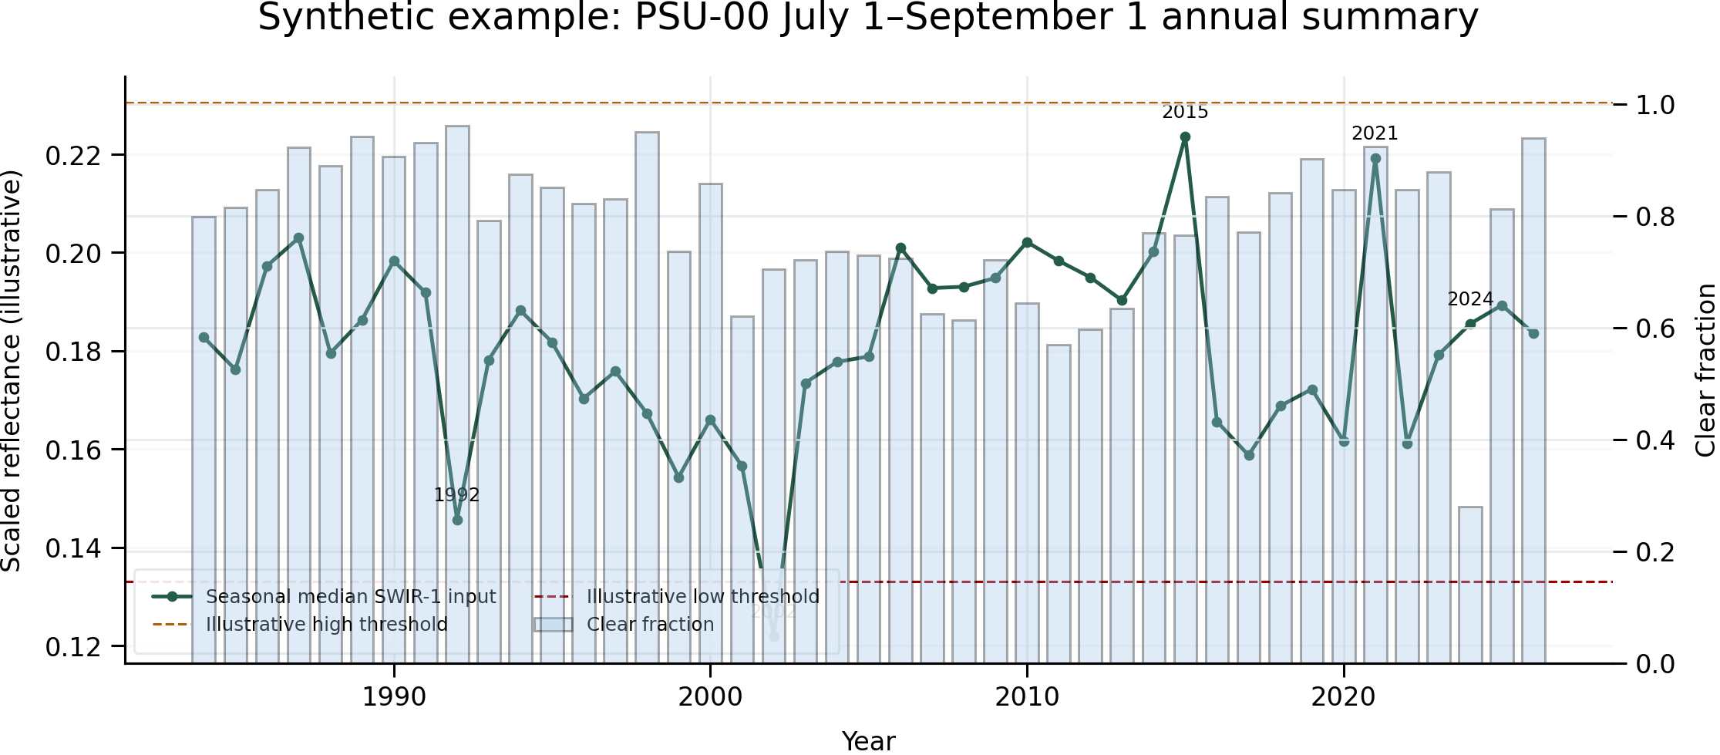
Expected interpretation: 1992 and 2002 are low candidates; 2015 and 2021 are high candidates; 2024 is cloud-limited and should not be promoted as an important spectral year without additional evidence. The worked example is synthetic and is included only to demonstrate reporting. Complete Figure 2 with actual PSU-00 results.

10.4 PSU-00 blank annual trajectory worksheet
After reviewing the synthetic PSU-00 example, plot the actual QA-accepted July 1–September 1 annual SWIR-1 result below. Plot point and area support separately or distinguish them clearly; mark cloud-limited, sparse, missing, and sensor-transition years rather than drawing through them as if they were measured values.
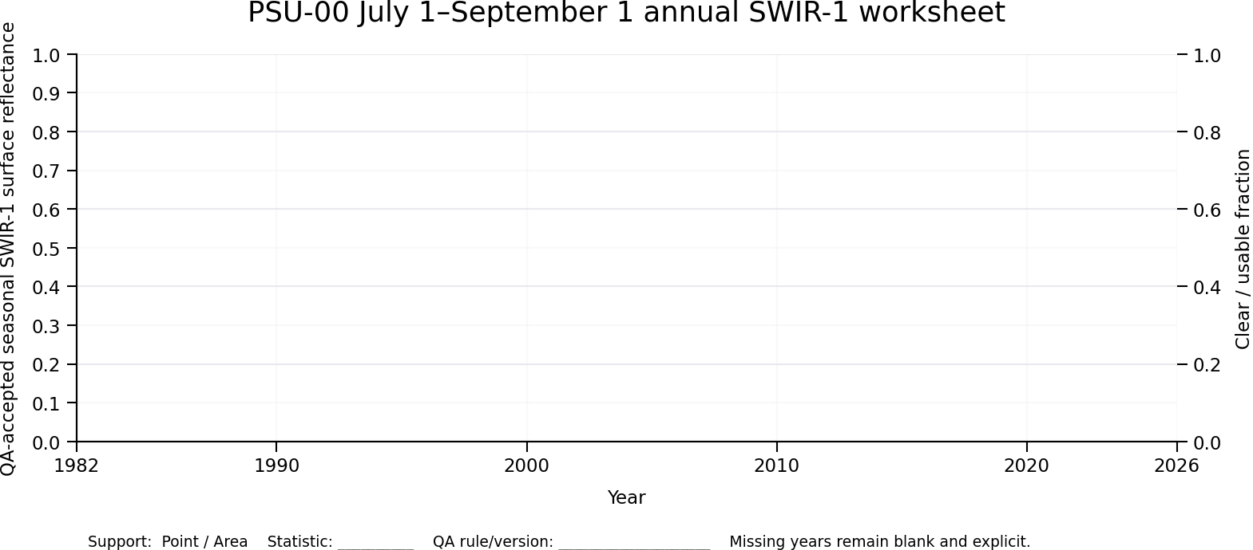
Figure 2. Blank PSU-00 annual SWIR-1 trajectory worksheet. Enter actual seasonal values for 1982–2026, retain missing years as explicit gaps, and annotate QA-limited and sensor-transition years.

10.5 37-PSU graph-matrix expansion
Keep PSU-00 as the separately documented center pilot. The following two 6 × 6 matrices represent the surrounding PSU-01 through PSU-36 array in zero-based AaP3Km identity order. Preserve this same cell position in both matrices so spatial spectral differences can be compared directly with long-term temporal differences. These matrices are summary displays; the CSV tables remain the quantitative evidence of record.

Spectral-profile matrix: PSU-01 through PSU-36
For a common QA-accepted acquisition, plot each PSU center value and area median across all returned surface-reflectance bands. Use the same acquisition, products, scales, band order, and y-axis convention across all 36 cells.
PSU-01  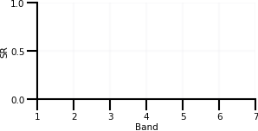 | PSU-02 | PSU-03 | PSU-04 | PSU-05 | PSU-06
PSU-07 | PSU-08 | PSU-09 | PSU-10 | PSU-11 | PSU-12
PSU-13 | PSU-14 | PSU-15 | PSU-16 | PSU-17 | PSU-18
PSU-19 | PSU-20 | PSU-21 | PSU-22 | PSU-23 | PSU-24
PSU-25 | PSU-26 | PSU-27 | PSU-28 | PSU-29 | PSU-30
PSU-31 | PSU-32 | PSU-33 | PSU-34 | PSU-35 | PSU-36
Figure 3. Blank 6 × 6 spectral-profile matrix for PSU-01 through PSU-36. Each cell preserves the surrounding-array position and PSU identity.

Annual temporal matrix: PSU-01 through PSU-36
For each PSU, plot the QA-accepted July 1–September 1 annual SWIR-1 trajectory from 1982 through 2026. Use common axes and preserve gaps, QA limitations, sensor transitions, and support type. Do not replace missing years with a connecting estimate.
PSU-01  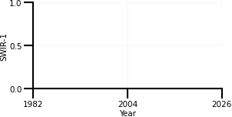 | PSU-02 | PSU-03 | PSU-04 | PSU-05 | PSU-06
PSU-07 | PSU-08 | PSU-09 | PSU-10 | PSU-11 | PSU-12
PSU-13 | PSU-14 | PSU-15 | PSU-16 | PSU-17 | PSU-18
PSU-19 | PSU-20 | PSU-21 | PSU-22 | PSU-23 | PSU-24
PSU-25 | PSU-26 | PSU-27 | PSU-28 | PSU-29 | PSU-30
PSU-31 | PSU-32 | PSU-33 | PSU-34 | PSU-35 | PSU-36
Figure 4. Blank 6 × 6 annual SWIR-1 temporal matrix for PSU-01 through PSU-36. Compare temporal behavior with the matching spatial cell in Figure 3.

10.6 Final Landsat–GLOBE evidence reflection
Write one final paragraph that brings the Landsat and GLOBE evidence into the same place-based interpretation without treating either source as automatically decisive. Identify the Landsat spectral and temporal pattern used, including date or seasonal window, sensor, bands or index, spatial support, QA, point–area behavior, and any important-year or missing-data limitations. Then describe what the GLOBE photos and observation metadata show at their actual measurement location and observation time, including viewing direction and visible surface or vertical structure where relevant. Explain whether the sources corroborate one another, describe different spatial or temporal supports, or leave a disagreement or evidence gap. Finish with the most defensible current interpretation and one specific next observation or check that would reduce uncertainty.
Final reflection: ____________________________________________________________________________________
________________________________________________________________________________________________________
________________________________________________________________________________________________________
________________________________________________________________________________________________________
________________________________________________________________________________________________________

11. Across-PSU summaries
Produce both equal-weight PSU summaries and pooled-native-pixel summaries. These answer different questions and must remain separate.
Aggregation | Method | Required statistics
Equal-weight PSU | Each PSU contributes one annual seasonal statistic | min, max, mean, median, SD, Q1, Q3, IQR across 37 PSUs
Pooled pixels | Pool accepted native pixels with explicit support/date lineage | same statistics plus pixel counts and QA fractions
Completeness | Count PSU-years meeting validity thresholds | PSUs returned, valid, QA accepted, cloud limited, missing
Spatial extremes | Rank PSU annual values within comparable series | highest/lowest PSUs with QA context

12. Quality gates and checklists

12.1 PSU-00 methods-readiness gate
- ☐ Point request documented and checked: complete / revise.
- ☐ Area request documented and checked: complete / revise.
- ☐ Point–area spectral-profile interpretation completed.
- ☐ Spectral profile uses the same acquisition date and layers for point and area support.
- ☐ No unresolved critical-error item occurred.
- ☐ Reviewer decision: ready for 37 PSUs / revise PSU-00 workflow.
- ☐ Point and polygon geometry came directly from the same Traveling Archive.
- ☐ Product/version and all selected layers were recorded.
- ☐ All available science and QA/cloud/saturation layers were requested.
- ☐ Raw and scaled values are distinct.
- ☐ QA codes were decoded rather than averaged.
- ☐ Point and polygon supports remain separate.
- ☐ Recent requests and 1982–2026 seasonal requests completed or explicit zero-result states were recorded.
- ☐ SWIR-1 was assembled with TM/ETM+ Band 5 and OLI/OLI-2 Band 6; native band numbers remain provenance.

12.2 Full 37-PSU gate
- ☐ PSU-00 through PSU-36 are present exactly once in each intended input.
- ☐ Constant date, product, layer, projection, and QA rules were applied.
- ☐ Every missing or cloud-limited PSU-year remains explicit.
- ☐ Important-year flags were quality-screened and sensor-aware.
- ☐ Equal-weight PSU and pooled-pixel summaries are separate.
- ☐ Request JSON, downloaded files, metadata, checksums, and summaries are preserved.
- ☐ Results are attached as descendant evidence; the parent Traveling Archive is not overwritten.

13. File package returned to reSearch
This package is the organized descendant evidence returned to reSearch after the AppEEARS downloads have been checked, scaled, QA-decoded, and summarized. These are not nine additional AppEEARS requests, and AppEEARS may not generate files with these exact names. The participant or analysis workflow creates the CSVs from the downloaded point and area results, replaces <MGRS> with the archive MGRS Place Code, and keeps the original AppEEARS files and metadata listed in the file manifest.
- <MGRS>_AppEEARS_RequestManifest.csv — one row per submitted point or area request, including request ID, request name, support type, date window, products, versions, layers, status, and submission/completion times.
- <MGRS>_AppEEARS_PointResults.csv — acquisition-level values returned for PSU center points, with raw and scaled measurements, sensor/product lineage, and QA attached to the same date and sampled cell.
- <MGRS>_AppEEARS_PSU_AcquisitionStatistics.csv — per-acquisition statistics for each 100 m PSU polygon and layer, including total, valid, and QA-accepted pixel populations and their descriptive statistics.
- <MGRS>_AppEEARS_PSU_AnnualSWIR1Statistics_1982_2026.csv — one sensor-aware July 1–September 1 SWIR-1 summary per PSU, support type, and year, including missing, fill-only, cloud-limited, and no-QA-accepted years.
- <MGRS>_AppEEARS_PSU_AnnualLandTrendrInputs_1982_2026.csv — the annual trajectory input table prepared for later segmentation, retaining SWIR-1 and recommended NIR/SWIR-2 companion variables, observation counts, dispersion, QA, sensor transitions, and missing-year status. This is an input table, not a LandTrendr result.
- <MGRS>_AppEEARS_QA_CategoryCounts.csv — decoded QA category counts and fractions by PSU, support, acquisition, and QA layer; bit-packed QA codes are retained but are not averaged.
- <MGRS>_AppEEARS_ImportantYears.csv — quality-screened candidate high, low, abrupt-change, sparse, cloud-limited, missing, and sensor-transition years, with the rule and evidence used for each flag.
- <MGRS>_AppEEARS_AOI_SamplePoolSummary.csv — across-PSU summaries for the full AOI, keeping equal-weight PSU statistics separate from pooled-native-pixel statistics and reporting completeness.
- <MGRS>_AppEEARS_FileManifest.csv — inventory of every original AppEEARS download and every derived file returned to reSearch, including filename, role, source request ID, processing date, checksum, and storage or relative-path reference.

14. Participant worksheets and submission record
Complete these blank tables with the actual AppEEARS request and result values. The preceding populated tables are examples only. Add rows in Word or continue in the required CSV outputs when more space is needed.

14.1 PSU-00 request record
Record the actual web-tool requests before scoring. Do not paste example values.
Request type | Request ID | Request name | Product / version | Date range | Layers selected | Submitted UTC | Completed UTC
Point / Area |  |  | Exact catalog text |  | Science + QA

14.2 PSU-00 point-result entry
Enter one row per retained acquisition and layer. Keep the QA record attached to the same acquisition.
Date | Mission / sensor | Layer | Raw value | Scaled value | Units | QA status | Notes
YYYY-MM-DD |  |  |  |  |  | Clear / cloud / fill / ...

14.3 PSU-00 area statistics entry
Enter one row per acquisition, layer, and statistical population. Add rows for all returned, valid measured, and QA accepted.
Date / layer | Population | n | Min | Max | Mean | Median | SD | Q1 / Q3 | Usable fraction
YYYY-MM-DD / layer | All / Valid / QA

14.4 QA and cloud-category entry
Do not average QA codes. Enter decoded counts and fractions.
Date | QA layer | Total pixels | Clear | Cloud | Shadow | Cirrus | Snow / ice | Saturated | Fill | Usable fraction
YYYY-MM-DD

14.5 Annual July 1-September 1 entry
Enter actual PSU-year summaries. Important-year flags must remain sensor-aware and QA-screened.
PSU | Year | Sensor / variable | Support | n acq. | Seasonal median | Clear fraction | QA status | Important-year flag
PSU-00 |  | TM/ETM+ B5 or OLI/OLI-2 B6 / SWIR-1 | Point / Area

14.6 Point-area comparison and interpretation
Complete this before unlocking the 37-PSU stage.
Date / variable | Point value | Area median | Area mean | Area SD | Point-area difference | Point percentile | Interpretation
 |  |  |  |  |  |  | Representative? Explain.

14.7 PSU-00 methods-readiness review
Reviewer records completion evidence and any required revision. Course scoring is handled separately.
Readiness check | Complete | Revise | Reviewer evidence / required action
Correct PSU-00 point and archive-generated 100 m polygon
Matching acquisition date, product, version, and layers
Raw/fill values separated from scaled measurements
QA/cloud/saturation information decoded and retained
Point and area spectral profiles plotted
Point-area differences interpreted with support context
Request JSON/README, outputs, and metadata retained
Decision: ready for 37 PSUs / revise PSU-00

15. Sources and current-product verification
Reference | URL / use
[1] NASA AppEEARS landing page | https://appeears.earthdatacloud.nasa.gov/  Point and area samples, subsetting, quality data, and interactive statistics.
[2] AppEEARS API documentation | https://appeears.earthdatacloud.nasa.gov/api/  Product metadata fields including scale, offset, fill, valid range, units, and quality relationships.
[3] USGS Landsat Collection 2 U.S. ARD | https://www.usgs.gov/landsat-missions/landsat-collection-2-us-analysis-ready-data  ARD processing, Level-2 basis, mission and temporal coverage.
[4] USGS Landsat U.S. ARD overview | https://www.usgs.gov/landsat-missions/landsat-us-analysis-ready-data  Landsat 4–9 ARD context and availability.
[5] USGS band-designation FAQ | https://www.usgs.gov/faqs/what-are-band-designations-landsat-satellites  Sensor-specific band designations.
[6] USGS TM/ETM+ bands and uses | https://www.usgs.gov/media/images/landsat-4-5-tm-and-landsat-7-etm-bands-and-their-uses  TM and ETM+ spectral-band context.
[7] NASA Landsat spectral bands | https://science.nasa.gov/mission/landsat/spectral-bands-and-applications/  Evolution and heritage-band context across missions.
[8] AppEEARS point-results help | https://appeears.earthdatacloud.nasa.gov/help?section=point%2Finteracting-with-results  Request details, time series, layer comparison, categorical QA exploration.

