**READ THIS BEFORE USING THE TEMPLATE:**

* **The intent of this template is to provide a taxonomy with an organized list of topics we normally cover as part of the Solution Design of use cases (with their respective APIs/Integrations)**
* **Based on your customer, industry and type of engagement; the topics might vary; this is not a “silver bullet” document or taxonomy, it is just an aid for the delivery.**
* **The content provided for each topic, including diagrams, catalogues and matrices, is just a reduced example of a fictional project; replace it with significant content that makes sense for your project and create your own diagrams; do not try to fit your project to the examples provided.**
* **The content of this document should provide principles and specifications for the design of a solution, including decisions for each API specification (if needed) and API/Integrations implementations specifications, not AnypointPoint Studio or Mule Development how-tos and duplication of information that can be found in our public documentation.** 
  + **DO: Include the list of API resource-method pairs to be included as part of the API Design with its main decisions and rationales**
  + **DO: Include implementation patterns, principles and decisions**
  + **DO: Include deployment details and how to promote APIs/applications**
  + **DO: Include references to external sites, including MuleSoft public documentation or any other relevant site, e.g Maven, Git, etc**
  + **DO NOT: Explain the concept of RAML or Mule components/processors**
  + **DO NOT: Include screenshots on how to create a project in Anypoint Studio or how to access Design Center, this information can be found in our public documentation**
  + **DO NOT: Include definitions of our products/features like CloudHub, Exchange, Design Center. All these concepts can be found in our public documentation**

**This template was created using formatting guidelines from our MuleSoft brand-central (June-2020), standardizing the font, font-size, headers, links, etc**

|  |  |  |  |
| --- | --- | --- | --- |
| **Change Record** | | | |
| **Template Version** | **Date** | **Author** | **Description** |
| 0.1 | 07-15-2020 | PK Reddy | Initial Draft |
|  |  |  |  |

|  |  |
| --- | --- |
| **Reviewers** | |
| **Name** | **Position** |
| David Cisneros | Senior Solution Architect, MuleSoft |
| Benjamin Currier | Technical Architect Director, MuleSoft |

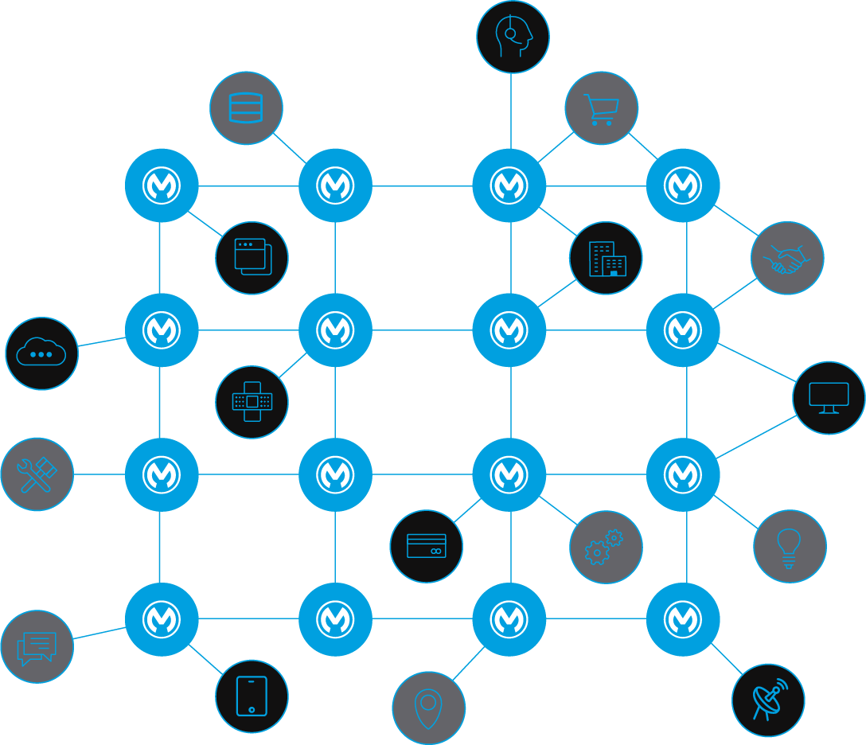Solution Design Template

|  |  |  |  |
| --- | --- | --- | --- |
| **Version** | **Date** | **Author** | **Description** |
| 0.1 | <date> | <name> | Initial version |
| 1.0 | <date> | <name> | Delivered version |

Table of contents

Introduction 7

Audience 7

Glossary 7

References 7

Anypoint Platform Architecture 7

Others 7

Use-case overview 9

Business Process Overview 9

Order Processing - Process View 9

Assumptions 9

Prerequisites 10

Business Requirements 10

Technical Design 11

Overview 11

Logical View 11

API-Led or Solution Architecture Diagram 11

Sequence Diagram 12

Components/Mule Applications 13

Non-Functional Requirements 14

Security 14

SLA/Performance 15

Response Times 15

Throughput 15

Policies related to performance 16

Logging 16

Audit Requirements 16

Monitoring 17

Availability 18

Scalability 18

Reliability 18

Caching 18

Reuse Considerations 18

Support and Maintenance Considerations 18

Other Information 18

<XYZ API> 19

Mule Application Details 19

Resources 20

Resource Details 21

Flow Diagram/Activity Diagram 23

Common Library or Services 24

Unit Test Cases 24

Positive Test Cases 24

Negative Test Cases 24

<XYZ Integration> 25

Mule Application Details 25

Integration Flows 26

Flow Diagram/Activity Diagram 29

Common Library or Services 29

Unit Test Cases 30

Positive Test Cases 30

Negative Test Cases 30

<XYZ API Proxy> 31

Mule Application Details 31

API End-point 32

Unit Test Cases 33

Positive Test Cases 33

Negative Test Cases 33

<XYZ Batch> 34

Mule Application Details 34

Flow Diagram/Activity Diagram 35

Common Library or Services 36

Unit Test Cases 36

Positive Test Cases 36

Negative Test Cases 36

Quality Assurance 37

Integration Test Cases 37

Positive Integration Test Cases 37

Negative Integration Test Cases 37

Integration Test Guidance 38

Installation Requirements 39

Mule Components 39

Non-Mule Components 39

Interdependencies 40

# Introduction

This document defines the technical components required to implement the proposed API/Integration solution.

## Audience

This document’s audience primarily includes architects, consultants, and developers and testers engaged in architecting, designing, developing, and testing API-based solutions.

## Glossary

The general terms and acronyms referenced in this document

## References

*<Provide references to all relevant documents such as Anypoint platform architecture, overall reference architecture, best practices, etc.>*

### Anypoint Platform Architecture

o [*Anypoint Platform Architecture*](https://catalyst.mulesoft.com/display/OBD/Platform+Architecture+Template)

### Others

o [*Naming Strategy*](https://catalyst.mulesoft.com/display/OBD/API+Discovery+and+Naming+Strategy)

o [*Mule Versioning*](https://catalyst.mulesoft.com/display/OBD/API+Versioning+Recommendations) *Recommendations*

o [*API Design Considerations*](https://catalyst.mulesoft.com/display/OBD/API+Design+Recommendations)

o [*Coding Standards*](https://catalyst.mulesoft.com/display/OBD/Mule+Code+Style+Guide)

# Use-case overview

*<Describe the use-case(s) and general overview of the applications/system involved.>*

## Business Process Overview

*<Provide an illustration of high-level business process view>*

### Order Processing - Process View

* Illustration purpose only

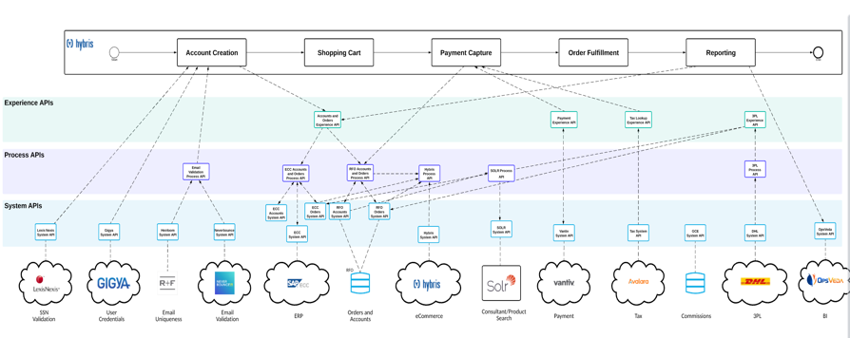

## Assumptions

This section covers any assumptions that have been made in the process of designing the solution.

* Assumption 1
* Assumption 2

## Prerequisites

This section covers any prerequisites that are required as part of the solution.

* Prerequisites 1
* Prerequisites 2

## Business Requirements

This section captures high-level requirements as part of the solution.

* Requirements 1
* Requirements 2

# 

# Technical Design

This section captures technical design details of the solution.

## Overview

<Provide a high-level technical overview of the use-case(s)/solution.>

## Logical View

<Provide a logical structure of the solution and how it interacts with other systems>

### API-Led or Solution Architecture Diagram

*Illustration purpose only

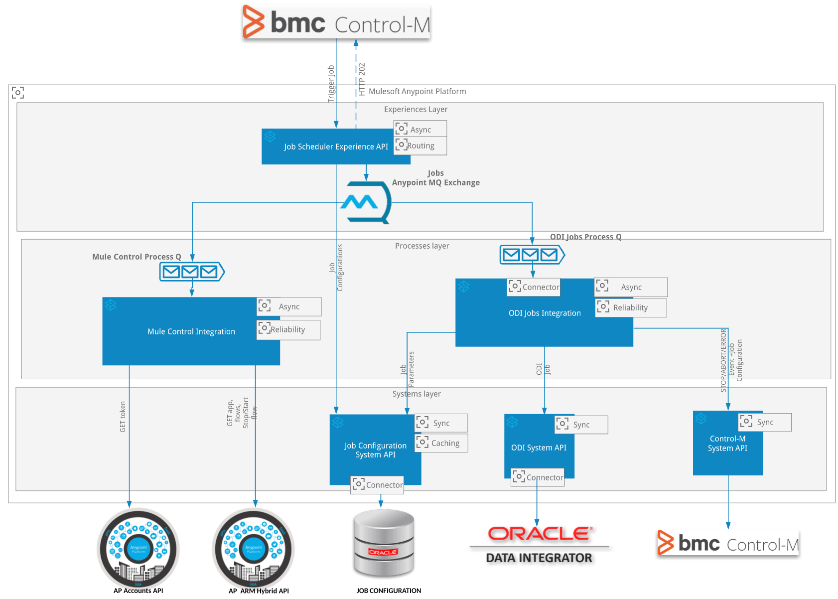

### Sequence Diagram

*Illustration purpose only

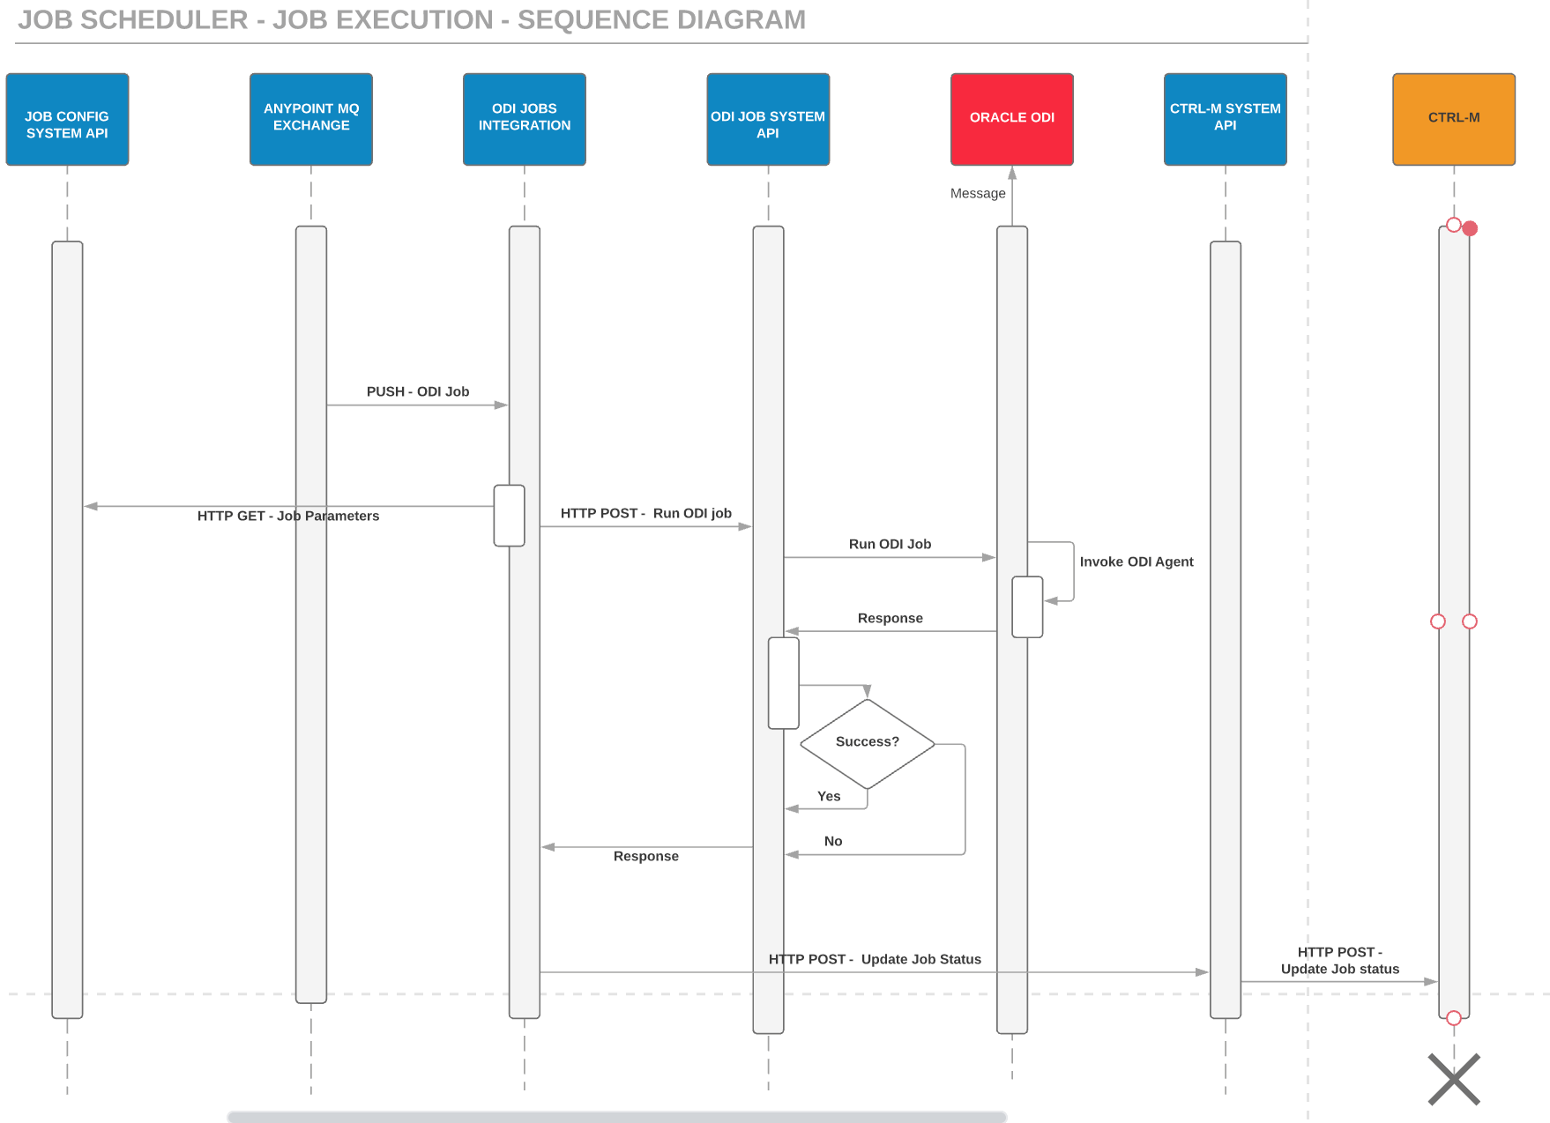

## Components/Mule Applications

*<Capture the list of Mule Applications part of this solution>*

|  |  |  |  |
| --- | --- | --- | --- |
| **Mule Applications** | | | |
| S.No | Application Name | Type | Description |
| 1 |  | *<e.g. API, Integration, Batch Application, API Proxy>* |  |
|  |  |  |  |

# 

# Non-Functional Requirements

This section captures the non-functional requirements of all APIs related to the use-case(s)/solution.

## Security

*<Describe the security related details such as policies, etc. for All Components/Applications>*

|  |  |  |
| --- | --- | --- |
| **Authentication** | | |
| S.No | Application Name | Authentication Type/Policy |
| 1 |  | *<e.g. OAuth 2.0 access token enforcement , Client ID Enforcement>* |
| 2 |  |  |

|  |  |  |
| --- | --- | --- |
| **Authorization** | | |
| S.No | Application Name | Authorization Scopes |
| 1 |  | *<e.g. write:job>* |
| 2 |  |  |

|  |  |  |
| --- | --- | --- |
| **Other Security Policies** | | |
| S.No | Application Name | Policy |
| 1 |  | *<e.g. JSON Threat Protection,IP Whitelisting>* |
| 2 |  |  |

|  |  |  |
| --- | --- | --- |
| **Encryption** | | |
| S.No | Application Name | Encryption Requirements |
| 1 |  | *<e.g. PGP, JCE and XML Encryption >* |
| 2 |  |  |

## SLA/Performance

*<Describe the SLA/Performance related details such as response times, throughput, etc. for all Components/Applications>*

### Response Times

*<Target times for average or maximum response times, expressed as a percentile: e.g., 95% within 2 seconds>*

|  |  |  |
| --- | --- | --- |
| **Response Times** | | |
| S.No | Application Name | Response Time (95%) |
| 1 |  | *<expressed as a percentile: e.g., 95% within 2 seconds>* |
| 2 |  |  |

### Throughput

*<Provide an indication of likely traffic volumes. For example:*

* *Number of transactions to be processed*
* *Number of concurrent users*
* *Amount of data to be transmitted>*

|  |  |  |
| --- | --- | --- |
| **Throughput** | | |
| S.No | Application Name | TPS |
| 1 |  | *<Provide details such as Number of transactions to be processed,Number of concurrent users, Amount of data to be transmitted>* |
| 2 |  |  |

### Policies related to performance

*<Provide list of all policies related to performance such as Spike Control, Rate limiting etc.>*

|  |  |  |  |
| --- | --- | --- | --- |
| **Policies** | | | |
| S.No | Application Name | Policy | Details |
| 1 |  | *<Spike Control, Rate-Limiting SLA Based etc. >* | *<Provide details such as Time Period, Number of Reqs, Delay Time, Delay Attempt, Queuing Limit etc. >* |
| 2 |  |  |  |

## Logging

*<Define or provide links to Logging Formats, Common Logging Library/Framework used and capture sensitive data logging considerations such as Data Masking, Redaction etc.>*

## Audit Requirements

*<Capture and provide any audit related requirements here :->*

* *Requirement1*
* *Requirement2*

## Monitoring

*<Provide Monitoring details for all Mule Applications>*

|  |  |  |  |
| --- | --- | --- | --- |
| **Alerts** | | | |
| S.No | Alert Name | Alert Type | Details |
| 1 |  | *<Runtime/Monitoring>* | *<Provide details such as Criticality, Condition, Application name etc. >* |
| 2 |  |  |  |

|  |  |  |  |
| --- | --- | --- | --- |
| **Anypoint Functional Monitoring** | | | |
| S.No | Monitor Name | Type | Details |
| 1 |  | *<Runtime/Monitoring>* | *<Provide details such as Criticality, Condition, Application name etc. >* |
| 2 |  |  |  |

|  |  |  |  |
| --- | --- | --- | --- |
| **Health-check/Ping end-point** | | | |
| S.No | API Name | Type | End-point URL |
| 1 |  | *<Ping/Health-Check>* | *<Provide end-point details >* |
| 2 |  |  |  |

## Availability

*<Define details related to availability such as server redundancy,# CloudHub Workers.>*

## Scalability

*<Capture Sizing considerations – Veridical/Horizontal Scaling>*

## Reliability

*<Capture reliability related details such as usage of Queues, retry mechanism etc.>*

## Caching

*<Capture caching requirement and implementation related details here .>*

## Reuse Considerations

*<Define reuse considerations>*

## Support and Maintenance Considerations

*<Capture details related to error recovery, message retry processing steps, Application restart procedures etc. which will aid support team.>*

## Other Information

*<Any items that are not covered above and additional notes or reference docs.>*

# 

# <XYZ API>

*<Repeat this section for every API which are part of the solution>*

## Mule Application Details

|  |  |  |
| --- | --- | --- |
| **API Overview** | | |
| S.No | Property | Details |
| 1 | Application Technical Name | *API Name (e.g. order-sys-api)* |
| 2 | Application Business Name | *Natural language name that the Business will use for the API. (e.g. Order System API)* |
| 3 | Aliases | *Other names for the API, which might be used by someone searching for the API.* |
| 4 | Mule Application Type | *(e.g. API, Integration, Batch)* |
| 5 | API Type | *(e.g. System, Process, Experience)* |
| 6 | Business Domain | *Domain (e.g. eCommerce)* |
| 7 | Purpose of API | *Description of API (e.g. The Process Order API processes the incoming order and validates input payment information.)* |
| 8 | API Owner | *Provider (individual or team) that owns the and maintains the API.* |
| 9 | Version(s) | *(e.g. 1.0.0)* |
| 10 | Initial Release Date (optional) | *(e.g. October 1st, 2019)* |
| 11 | Target Consumers (optional) | *Organizations or developer roles the API is intended for...* |
| 12 | Critical Success Factors (optional) | *Identify one or more key criteria which can be used to gauge whether this API, once in production, represents a successful investment.* |
| 13 | Execution Frequency (optional) | *An order-of-magnitude estimate of the number of times the API will perform any of these operations in a given time period. (e.g. 100’s per month, 1000+ per day, 100 per second.)* |
| 14 | Consuming Applications/Processes (optional) | *List of dependent APIs and/or dependent applications which invoke this API.*  *Add reference to the repository/catalog which holds this information.* |
| 15 | Expected Benefits (optional) | *How the API benefits the enterprise.* |
| 16 | Source Code Repo | *e.g. https://github.com/<xxxxxx>/Order-sys-api* |

## Resources

<This section defines the resources and the HTTP methods supported for each resource as well as the media types and representation formats for resources in requests and responses.>

|  |  |  |  |
| --- | --- | --- | --- |
| **Resources** | | | |
| S.No | Resource Name | Supported Methods | Description |
| 1 |  | *<GET/PUT/POST/PATCH/DELETE etc.>* | *<Description of the resource (e.g. This resource is/contains…). Also list all media types that apply to the resource and URI>* |
| 2 |  |  |  |

### Resource Details

<Repeat this section by <Resource> and <Method> >

|  |  |  |  |
| --- | --- | --- | --- |
| **Input - <Resource>, <Method>** | | | |
| Field | Type | Mandatory | Validation |
|  | *<Query Parameter/URI Parameter/Body>* | *<Yes/No>* | *<Validation like Number only, Not Null, etc. >* |
|  |  |  |  |

|  |  |
| --- | --- |
| **Input Body Structure - <Resource>, <Method>** | |
| Format | Structure |
| *<text/plain, application/json, application/xml, etc.>* | *{*  *"order_number" : "Order Number",*  *"odate" : "<ODATE YYYYMMDD>",*  *"amount" : "1000.00",*  *"currency" : "USD",*  *"email" : "Email Address"*  *}* |

|  |  |  |  |  |
| --- | --- | --- | --- | --- |
| **Mapping - Mule to 3rd Party system (e.g. SAP) - <Resource>, <Method>** | | | | |
| Mule Field | Data Type | Target System Field | Data Type | Defaulting/Transformation Logic |
|  | *<Number/String/Date>* |  | *<Number/String/Date>* | *<Provide Default Values. Transformation logic such as formatting, truncation etc.. >* |
|  |  |  |  |  |

|  |  |  |  |  |
| --- | --- | --- | --- | --- |
| **Mapping - 3rd Party system (e.g. SAP) to Mule - <Resource>, <Method>** | | | | |
| Target System Field | Data Type | Mule Field | Data Type | Defaulting/Transformation Logic |
|  | *<Number/String/Date>* |  | *<Number/String/Date>* | *<Provide Default Values. Transformation logic such as formatting, truncation etc.. >* |
|  |  |  |  |  |

|  |  |  |  |  |
| --- | --- | --- | --- | --- |
| **Output Details - <Resource>, <Method>** | | | | |
| Field | Type | Format | Mandatory | Validation |
|  | *<HTTP Code/ Body>* | *<text/plain, application/json, application/xml, etc.>* | *<Yes/No>* | *<Validation like Number only, Not Null, etc. >* |
|  |  |  |  |  |

|  |  |
| --- | --- |
| **API Output Body Structure - <Resource>, <Method>** | |
| Format | Type |
| *<text/plain, application/json, application/xml, etc.>* | *Success Example :-*  *{*  *"order_id" : "Order internal reference ID",*  *"message" : "Created Successfully"*  *}*  *Exception Example :-*  *{*  *"error_code" : 400,*  *"message" : "Some Bad Request"*  *}* |

## Flow Diagram/Activity Diagram

*<Provide the flow details on a high level (by resource by method)>*

*Illustration purpose only

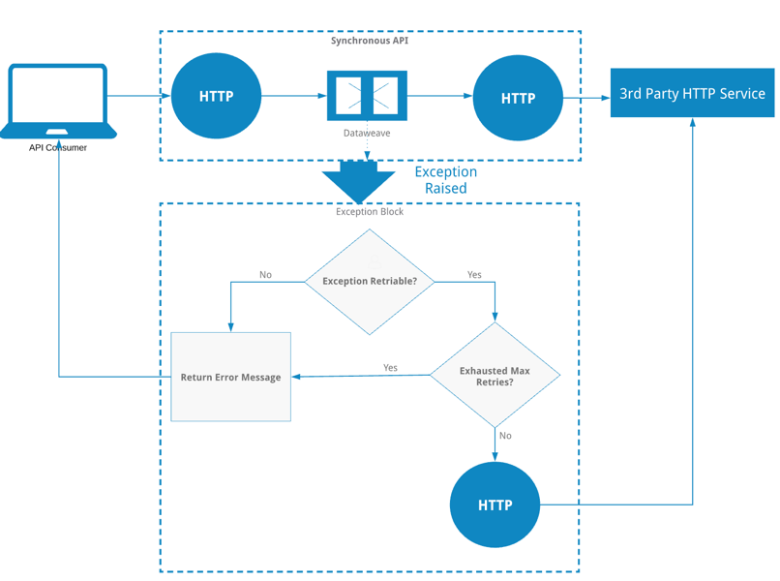

## Common Library or Services

*List of common services or libraries or Tooling Applications used (e.g.):-*

* *Notification System API*
* *Logging Library*
* *Exception Library*

## Unit Test Cases

*<This section covers any unit test associated with this particular application. The focus of this section is to perform basic developer level unit test case execution, can be complemented with MUnit test cases.>*

### Positive Test Cases

|  |  |  |  |  |
| --- | --- | --- | --- | --- |
| **Test Case - <Scenario 1>** | | | | |
| S.No | Navigation | Step | Expected Result | Actual Result |
|  |  |  |  |  |
|  |  |  |  |  |

### Negative Test Cases

|  |  |  |  |  |
| --- | --- | --- | --- | --- |
| **Test Case - <Scenario 1>** | | | | |
| S.No | Navigation | Step | Expected Result | Actual Result |
|  |  |  |  |  |
|  |  |  |  |  |

# <XYZ Integration>

*<Repeat this section for every Mule Integration which are part of the solution>*

## Mule Application Details

|  |  |  |
| --- | --- | --- |
| **Integration Overview** | | |
| S.No | Property | Details |
| 1 | Application Technical Name | *Integration Name (e.g. order-integration)* |
| 2 | Application Business Name | *Natural language name that the Business will use for the Integration. (e.g. Order Integration)* |
| 3 | Aliases | *Other names which might be used by someone searching for the Integration.* |
| 4 | Mule Application Type | *Integration* |
| 5 | Integration Type | *(e.g. Scheduled, Event-Based)* |
| 6 | Business Domain | *Domain (e.g. eCommerce)* |
| 7 | Purpose of Integration | *Description of Integration* |
| 8 | Integration Owner | *Provider (individual or team) that owns the and maintains the Integration.* |
| 9 | Version(s) | *(e.g. 1.0.0)* |
| 10 | Initial Release Date (optional) | *(e.g. October 1st, 2019)* |
| 11 | Target Consumers (optional) | *Organizations or developer roles the Integration is intended for...* |
| 12 | Critical Success Factors (optional) | *Identify one or more key criteria which can be used to gauge whether this Integration, once in production, represents a successful investment.* |
| 13 | Execution Frequency (optional) | *An order-of-magnitude estimate of the number of times the Integration will be executed in a given time period. (e.g. 100’s per month, 1000+ per day, 100 per second.)* |
| 14 | Consuming Applications/Processes (optional) | *List of dependent APIs and/or dependent applications which leverages this Integration.*  *Add reference to the repository/catalog which holds this information.* |
| 15 | Expected Benefits (optional) | *How Integration benefits the enterprise.* |
| 16 | Source Code Repo | *e.g. https://github.com/<xxxxxx>/Order-integration* |

## Integration Flows

*<This section defines the Integration Flows with a inbound listener>*

|  |  |  |
| --- | --- | --- |
| **Inbound Listeners** | | |
| S.No | Listener Type | Description |
| 1 | *<*JMS, SFTP, File,, SAP JCo, Anypoint MQ Listener, Salesforce Push Topic, etc*.>* | *<Description of the flow (e.g. This flow is/contains…). >* |
| 2 |  |  |

|  |  |  |  |
| --- | --- | --- | --- |
| **Input Field Details- <Listener>** | | | |
| Field | Type | Mandatory | Validation |
|  | *<Query Parameter/URI Parameter/Body>* | *<Yes/No>* | *<Validation like Number only, Not Null, etc. >* |
|  |  |  |  |

|  |  |
| --- | --- |
| **Input Structure - <Listener>** | |
| Format | Structure |
| *<text/plain, application/json, application/xml, etc.>* | *{*  *"order_number" : "Order Number",*  *"odate" : "<ODATE YYYYMMDD>",*  *"amount" : "1000.00",*  *"currency" : "USD",*  *"email" : "Email Address"*  *}* |

|  |  |  |  |  |
| --- | --- | --- | --- | --- |
| **Mapping - Mule to 3rd Party system (e.g. SAP) - <Listener>** | | | | |
| Mule Field | Data Type | Target System Field | Data Type | Defaulting/Transformation Logic |
|  | *<Number/String/Date>* |  | *<Number/String/Date>* | *<Provide Default Values. Transformation logic such as formatting, truncation etc.. >* |
|  |  |  |  |  |

|  |  |  |  |  |
| --- | --- | --- | --- | --- |
| **Mapping - 3rd Party system (e.g. SAP) to Mule - <Listener>** | | | | |
| Target System Field | Data Type | Mule Field | Data Type | Defaulting/Transformation Logic |
|  | *<Number/String/Date>* |  | *<Number/String/Date>* | *<Provide Default Values. Transformation logic such as formatting, truncation etc.. >* |
|  |  |  |  |  |

*<Note : Output section for Integration is usually not relevant as there is no caller involved, but if needed please copy the Output section from API>*

## Flow Diagram/Activity Diagram

*<Provide the flow details on a high level (by listener)>*

*Illustration purpose only

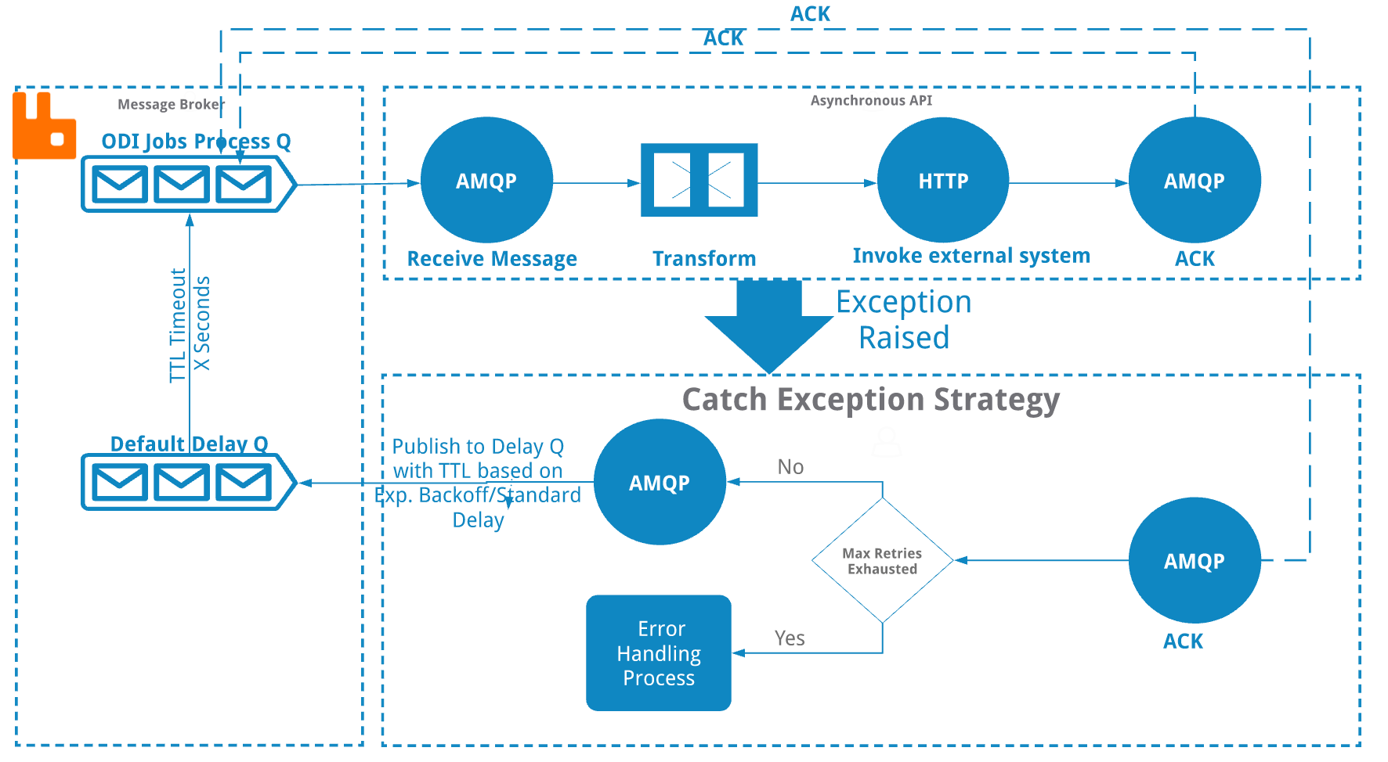

## Common Library or Services

*List of common services or libraries or Tooling Applications used (e.g.):-*

* *Notification System API*
* *Logging Library*
* *Exception Library*

## Unit Test Cases

*<This section covers any unit test associated with this particular application. The focus of this section is to perform basic developer level unit test case execution, can be complemented with MUnit test cases.>*

### Positive Test Cases

|  |  |  |  |  |
| --- | --- | --- | --- | --- |
| **Test Case - <Scenario 1>** | | | | |
| S.No | Navigation | Step | Expected Result | Actual Result |
|  |  |  |  |  |
|  |  |  |  |  |

### Negative Test Cases

|  |  |  |  |  |
| --- | --- | --- | --- | --- |
| **Test Case - <Scenario 1>** | | | | |
| S.No | Navigation | Step | Expected Result | Actual Result |
|  |  |  |  |  |
|  |  |  |  |  |

# <XYZ API Proxy>

*<Repeat this section for every API Proxy which are part of the solution>*

## Mule Application Details

|  |  |  |
| --- | --- | --- |
| **API Proxy Overview** | | |
| S.No | Property | Details |
| 1 | Application Technical Name | *Proxy Name (e.g. employee-proxy)* |
| 2 | Application Business Name | *Natural language name that the Business will use for the Proxy. (e.g. Employee API Proxy)* |
| 3 | Aliases | *Other names which might be used by someone searching for the proxy.* |
| 4 | Mule Application Type | *API Proxy* |
| 5 | API Proxy Type | *(e.g. HTTP, WSDL, RAML)* |
| 6 | Business Domain | *Domain (e.g. eCommerce)* |
| 7 | Purpose | *Description of API proxy* |
| 8 | API Proxy Owner | *Provider (individual or team) that owns the and maintains the API Proxy.* |
| 9 | Version(s) | *(e.g. 1.0.0)* |
| 10 | Initial Release Date (optional) | *(e.g. October 1st, 2019)* |
| 11 | Target Consumers (optional) | *Organizations or developer roles the API proxy is intended for...* |
| 12 | Critical Success Factors (optional) | *Identify one or more key criteria which can be used to gauge whether this API proxy, once in production, represents a successful investment.* |
| 13 | Execution Frequency (optional) | *An order-of-magnitude estimate of the number of times the proxy will be executed in a given time period. (e.g. 100’s per month, 1000+ per day, 100 per second.)* |
| 14 | Consuming Applications/Processes (optional) | *List of dependent APIs and/or dependent applications which leverages this proxy.*  *Add reference to the repository/catalog which holds this information.* |
| 15 | Expected Benefits (optional) | *How API proxy benefits the enterprise.* |
| 16 | Source Code Repo | *e.g. https://github.com/<xxxxxx>/Employee-proxy* |

### API End-point

|  |  |  |  |
| --- | --- | --- | --- |
| **API End-point** | | | |
| S.No | API End-point Type | API End-point | Description |
| 1 | *<WSDL/REST/HTTPS etc.>* |  | *<Brief description of the API which we are proxying>* |
| 2 |  |  |  |

## Unit Test Cases

*<This section covers any unit test associated with this particular application. The focus of this section is to perform basic developer level unit test case execution, can be complemented with MUnit test cases.>*

### Positive Test Cases

|  |  |  |  |  |
| --- | --- | --- | --- | --- |
| **Test Case - <Scenario 1>** | | | | |
| S.No | Navigation | Step | Expected Result | Actual Result |
|  |  |  |  |  |
|  |  |  |  |  |

### Negative Test Cases

|  |  |  |  |  |
| --- | --- | --- | --- | --- |
| **Test Case - <Scenario 1>** | | | | |
| S.No | Navigation | Step | Expected Result | Actual Result |
|  |  |  |  |  |
|  |  |  |  |  |

# 

# <XYZ Batch>

*<Repeat this section for every Mule Batch Application which are part of the solution>*

## Mule Application Details

|  |  |  |
| --- | --- | --- |
| **Batch Application Overview** | | |
| S.No | Property | Details |
| 1 | Application Technical Name | *Batch Name (e.g. leads-batch-app)* |
| 2 | Application Business Name | *Natural language name that the Business will use for the Proxy. (e.g. Leads Batch Application)* |
| 3 | Aliases | *Other names which might be used by someone searching for the proxy.* |
| 4 | Mule Application Type | *Batch Application* |
| 5 | Business Domain | *Domain (e.g. eCommerce)* |
| 6 | Purpose | *Description of Batch Application.* |
| 7 | Owner | *Provider (individual or team) that owns the and maintains the Batch Application.* |
| 8 | Version(s) | *(e.g. 1.0.0)* |
| 9 | Initial Release Date (optional) | *(e.g. October 1st, 2019)* |
| 10 | Target Consumers (optional) | *Organizations or developer roles the Batch Application is intended for...* |
| 11 | Critical Success Factors (optional) | *Identify one or more key criteria which can be used to gauge whether this Batch Application, once in production, represents a successful investment.* |
| 12 | Execution Frequency (optional) | *An order-of-magnitude estimate of the number of times the batch will be executed in a given time period. (e.g. 100’s per month, 1000+ per day, 100 per second.)* |
| 13 | Consuming Applications/Processes (optional) | *List of dependent APIs and/or dependent applications which leverages this Batch Application*  *Add reference to the repository/catalog which holds this information.* |
| 14 | Expected Benefits (optional) | *How Batch Application benefits the enterprise.* |
| 15 | Source Code Repo | *e.g. https://github.com/<xxxxxx>/Leads-batch-app* |

## Flow Diagram/Activity Diagram

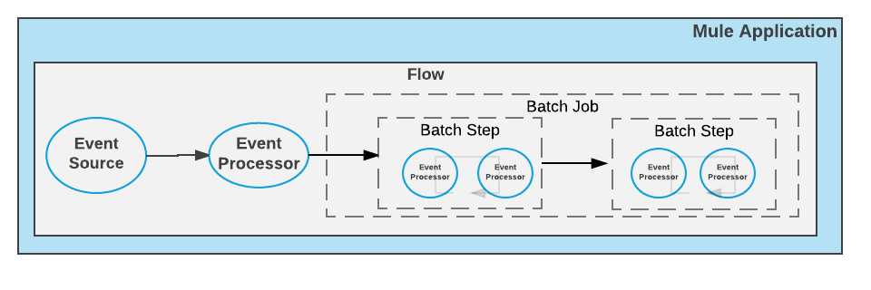

## Common Library or Services

*List of common services or libraries or Tooling Applications used (e.g.):-*

* *Notification System API*
* *Logging Library*
* *Exception Library*

## Unit Test Cases

*<This section covers any unit test associated with this particular application. The focus of this section is to perform basic developer level unit test case execution, can be complemented with MUnit test cases.>*

### Positive Test Cases

|  |  |  |  |  |
| --- | --- | --- | --- | --- |
| **Test Case - <Scenario 1>** | | | | |
| S.No | Navigation | Step | Expected Result | Actual Result |
|  |  |  |  |  |
|  |  |  |  |  |

### Negative Test Cases

|  |  |  |  |  |
| --- | --- | --- | --- | --- |
| **Test Case - <Scenario 1>** | | | | |
| S.No | Navigation | Step | Expected Result | Actual Result |
|  |  |  |  |  |
|  |  |  |  |  |

# Quality Assurance

This section captures the QA related details for all the Mule Applications related to the use-case(s)/solution.

## Integration Test Cases

This section covers integration tests associated with the overall solution/use-case.

### Positive Integration Test Cases

|  |  |  |  |  |
| --- | --- | --- | --- | --- |
| **Test Case - <Scenario 1>** | | | | |
| S.No | Navigation | Step | Expected Result | Actual Result |
|  |  |  |  |  |
|  |  |  |  |  |

### Negative Integration Test Cases

|  |  |  |  |  |
| --- | --- | --- | --- | --- |
| **Test Case - <Scenario 1>** | | | | |
| S.No | Navigation | Step | Expected Result | Actual Result |
|  |  |  |  |  |
|  |  |  |  |  |

## Integration Test Guidance

*<This section covers any test associated with this particular application/use case that will need to be done in the SIT and other environments (not test cases but a guideline/overview of how to test it or what a typical tester will not cover like nonfunctional aspects mentioned above – caching, switching in case of DR etc.).>*

# Installation Requirements

This section covers the Mule Application Installation Requirements.

## Mule Components

*<Capture details related to Mule and Anypoint Platform setups required for the APIs identified such as, but not limited to: -*

* *SSL Certificates*
* *MQ Topics/Exchanges setup*
* *Static IP*
* *Anypoint Security*
* *Generation of OAuth Clients etc.>*

## Non-Mule Components

*Capture details related to external system dependencies such as, but not limited to: -*

* *Database Tables, Procedures*
* S*taging Folders (for file-based transfers)*
* *External Queue Setup*
* *System/Service Accounts*
* *Whitelisting Mule IPs on external systems etc.*

## Interdependencies

*<Capture any interdependencies between Mule Applications/APIs, Common Services and Libraries, which helps in determining the installation/deployment sequence.>*

About MuleSoft

MuleSoft, a Salesforce company

MuleSoft’s mission is to help organizations change and innovate faster by making it easy to connect the world’s applications, [data](https://www.mulesoft.com/integration-solutions/dataweave-integration), and [devices](https://www.mulesoft.com/integration-solutions/api/iot). With its API-led approach to connectivity, MuleSoft’s market-leading Anypoint Platform™ empowers over 1,600 organizations in approximately 60 countries to build application networks. By unlocking data across the enterprise with application networks, organizations can easily deliver new revenue channels, increase operational efficiency, and create differentiated customer experiences.

For more information, visit mulesoft.com

*MuleSoft is a registered trademark of MuleSoft, LLC, a Salesforce company. All other marks are those of respective owners.*