**Method One: command line option 1**

Consult the table at the beginning of this section for the tested models that use **Method**

**Two**. Note that they all use the same RTL8188CUS chipset. This means that you will

likely be able to use other dongles with the following steps as long as they use the

aforementioned chipset. Now to the steps:

1. From your BBB’s desktop, open up **LXTerminal**.

2. In the command prompt window, open the file in the directory specified in the

following path:

**$ sudo nano /etc/network/interfaces**

Among other settings, you should see the following lines in the file’s open window:

**## WiFi Example**

**#auto wlan0**

**#iface wlan0 inet dhcp**

**# wpa-ssid "mynetworkname"**

**# wpa-psk "mypassphrase"**

3. With the exception of the first explanatory line, uncomment (which means remove)

the # sign at the beginning of each line. To clarify, it should look similar to this:

**## WiFi Example**

**auto wlan0**

**iface wlan0 inet dhcp**

**wpa-ssid "mynetworkname"**

**wpa-psk "mypassphrase"**

4. Change mynetworkname to your Wi-Fi network’s name, and mypassphrase to your

Wi-Fi password.

**Note**

If your network name uses spaces or other odd characters, some dongles may not

recognize the name and establish a connection.

5. Close the file by pressing *Ctrl* + *x*; when prompted, type y for yes and then press the

return (*Enter*) key.

6. Power down the BBB in the terminal window with the following command:

**$ sudo poweroff**

7. Power up the board again and log in to your BBB desktop.

8. You will now get a solid Wi-Fi connection. Test it via the command shell with this

command:

**$ ping www.google.com**

If all went well, you should see a steady screen output from the ping.

**Method Two: command line option 2**

Consult the table for the tested models that use the following steps. The main difference

between these steps and the previous recipe is that the drivers in these dongles require a

different interface—a wireless supplicant—with the BBB to function properly. Before

starting the steps, be sure to remove any Wi-Fi dongles you may have inserted into the

USB hub:

1. We need to create a .conf file for wpa_supplicant, a tool that comes preloaded on

the current Debian distribution. The following command line will be useful for this:

**$ sudo nano /etc/wpa_supplicant/wpa_supplicant.conf**

2. Paste in the open file the following information:

**ctrl_interface=DIR=/var/run/wpa_supplicant GROUP=netdev**

**update_config=1**

**network={**

**ssid="my-ssid"**

**scan_ssid=1**

**psk="my-psk"**

**proto=RSN**

**key_mgmt=WPA-PSK**

**pairwise=CCMP**

**auth_alg=OPEN**

**}**

3. Two things need to be modified (just as in **Method Two**): my-ssid, which you will

replace with your network’s name, and my-psk, which will be your network’s

password.

4. We now need to figure out the Wi-Fi dongle’s interface name. To do this, we will first

examine which interfaces are present using the following command:

**$ ifconfig -a**

This command outputs the currently active interfaces, which may include eth0, lo,

and usb0.

5. Reboot your board.

6. Plug in your dongle and run the same command again:

**$ ifconfig -a**

The output should now show the new device’s interface name, which could be ra0,

wlan0, or so on.

7. Open the file in the directory specified in the following path:

**$ sudo nano /etc/network/interfaces**

8. At the top of the file, paste the following code, replacing interfacename with the

name that appeared in Step 6:

**allow-hotplug ra0**

**iface interfacename inet manual**

**wpa-roam /etc/wpa_supplicant/wpa_supplicant.conf**

**iface default inet dhcp**

http://freepdf-books.com

9. Close the file by pressing *Ctrl* + *x*; when prompted, type y for yes, then press the

return (*Enter*) key.

10. Assuming your dongle is still plugged in, run a command that brings up the interface:

**$ ifup interfacename**

11. Power down the BBB by running this:

**$ sudo poweroff**

12. Make sure your Wi-Fi dongle is plugged into a powered USB hub with the hub’s

USB cable inserted into the BBB’s USB port.

13. Restart the board; this time, plug into the DC power supply.

14. You will now get a solid Wi-Fi connection. Test it via the command shell using the

following command:

**$ ping www.google.com**

If all went well, you should see a steady screen output from the ping.

**Note**

Sometimes you may need to power off, unplug the 5V input, and then plug in again

as the dongle isn’t always recognized through the S1 (Reset) or the S3 (Power)

buttons.

**Method Three: Debian Jessie**

Using Jessie is the easiest and fastest route to a reliable Wi-Fi connection. Here is how to

do this:

1. Plug an Ethernet cable connected to your router into the BBB’s Ethernet port.

2. Boot up and log in to your BBB connected to a monitor.

3. Open a terminal window and log in as root with the following command:

**$sudo -i**

**#**

4. Install the package network manager. Before installing a new package, always begin

by updating your repositories as follows:

**# apt-get update**

**# apt-get install network-manager**

5. Now, open up the new package with this command:

**# nmtui**

A rudimentary interface should open up in the terminal window, similar to the

following image:

6. Select **Activate a connection**.

7. In the next window, select your network, and you will be prompted for the password.

8. Quit the network manager screen after putting in your password. Then, check to

verify that your dongle now has an IP address in the wlanX interface with this

command:

**# ifconfig -a**

9. Now, power down, remove the Ethernet cable, and reboot using this command:

**# reboot**

10. Run the magical ping command to check how we did:

**$ ping www.google.com**

Voila! Your BBB should now be connected wirelessly.

Interfaces File Backup

**auto eth1**

**allow-hotplug eth1**

**iface eth1 inet static**

**address 10.0.0.1**

**netmask 255.255.255.0**

**post-up /etc/init.d/isc-dhcp-server restart**

**Setting up servers**

**Installing The Web Server**

1. 1

**To install Apache and PHP, execute the following commands:**

sudo apt-get install apache2 php7.2 libapache2-mod-php7.2

1. 2

**Now restart the service:**

sudo service apache2 restart

OR

sudo /etc/init.d/apache2 restart

1. 3

**Enter the I.**P. address of your Raspberry Pi into your web browser. You should see a simple page that says "It Works!"

## Making A Basic Website

As soon as the Raspberry Pi finishes processing the above command, it instantly generates a basic, working website.

Go to your Web browser and type in your Pi’s local address. This will look something like 192.168.X.X. (If you haven’t obtained that address already, [see my instructions on using the sudo ifconfig command](http://readwrite.com/2014/04/09/raspberry-pi-projects-ssh-remote-desktop-static-ip-tutorial) to get it.) A very basic site should appear, headlined with the phrase, “It works!” This simple index.html page came preinstalled along with Apache.

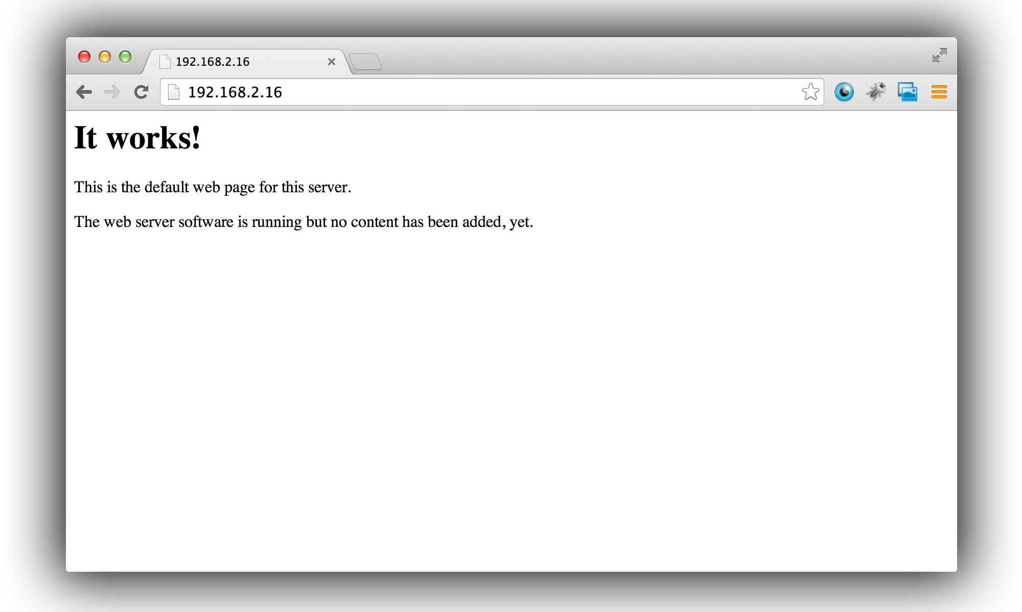

Want to tweak it? Visit the index.html page on your Pi:

cd /var/www/

sudo nano index.html

Try changing the words around, saving the file, and navigating back to the Pi’s local address again to watch your changes take form.

**Install MySQL**

1. 1

**To install MySQL, install a few packages with the following command:**

sudo apt-get install mysql-server mysql-client php5-mysql

**Install FTP**

1. 1

**We will now install FTP to allow transferring files to and from your Raspberry Pi.**

1. 2

**Take ownership of the web root:**

sudo chown -R pi /var/www

1. 3

**Next, install vsftpd:**

sudo apt-get install vsftpd

1. 4

**Edit your vsftpd.**conf file:

sudo nano /etc/vsftpd.conf

1. 5

**Make the following changes:**

* + anonymous_enable=YES **to** anonymous_enable=NO
  + Uncomment **local_enable=YES** and **write_enable=YES** by deleting the **#** symbol in front of each line
  + then go to the bottom of the file and add **force_dot_files=YES**.

1. 6

**Now save and exit the file by pressing CTRL-O, CTRL-X.**

1. 7

**Now restart vsftpd:**

sudo service vsftpd restart

1. 8

**Create a shortcut from the Pi user's home folder to /var/www:**

ln -s /var/www/ ~/www

1. 9

**You can now FTP using the Pi user and access the /var/www folder via a shortcut that should appear on login.**