**NB IoT tutorial-features,Spectrum,applications of NB IoT**

This basic NB IoT tutorial covers features of NB IoT (NarrowBand Internet of Things). It mentions frequency specrums and applications or use cases of NB-IoT. It provides difference between **NB-IoT** with earlier LTE versions i.e. Cat-1,Cat-0 and Cat-M.

**What is NB IoT?**

• NB-IoT stands for Narrowband-IoT.   
• It is specified in LTE Rel.13. It is successor to LTE Cat-M version specified in Rel.12.  
• It has been developed to meet the requirements of LPWA (Low Power Wide Area) type of networks.  
• NB-IoT has geo-graphical coverage better compare to LTE-M with lower data rates.  
• This allows long battery life (about 10 years).  
• The NB-IoT devices support narrower frequency spectrum of bandwidth 180 KHz to 200 KHz and hence the name.

**Features of NB IoT**

Following table mentions features of NB IoT (i.e. LTE Cat-NB).

|  |  |
| --- | --- |
| **Specifications** | **NB-IoT Support** |
| **Extended Coverage and distance** | 20dB better compare to GSM/GPRS, covers about less than 22 Km from cell |
| **Frequency Spectrum** | 700MHz, 800MHz, 900MHz |
| **Bandwidth** | 180 KHz to 200 KHz |
| **Capacity-Number of Connections** | 50K connections per cell, supports about 40 devices per household |
| **Power Consumption** | very low power comsumption and hence extends battery life to 10 years |
| **Latency** | less than 10 seconds (uplink) |
| **Data rate** | 200 Kbps |
| **Transmit Power** | +20 dBm or +23 dBm |
| **device Cost** | low, which is under $5 per module |

**NB IoT Frequency Spectrum**

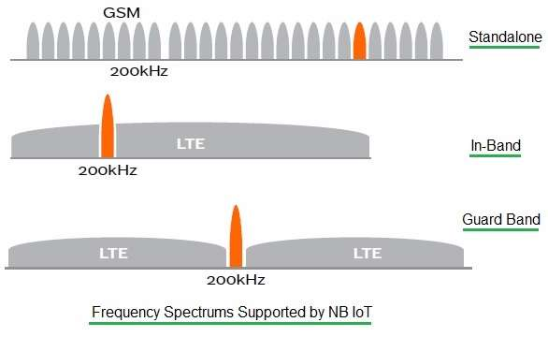

The figure-1 depicts types of frequency spectrums supported by NB IoT. As shown it supports Standalone, In-Band and Guard Band.   
• The standalone deployment type utilizes new bandwidth.   
• The guard band deployment type uses bandwidth reserved in the guard band of existing LTE network.  
• The in-Band deployment type uses same RBs (resource blocks) in LTE carrier of existing LTE network bands.

**NB IoT Applications | NB IoT Use cases**

Following are the use cases or applications of NB IoT:   
• Personal use: Wearables, smart bicycle, tracking of kids and elders   
• Public use: Examples include smart metering, alarms and event detectors, smart garbage bins,   
• IoT appliances: Refrigerators, temperature sensing smart devices etc.   
• Industrial use: Examples include logistics tracking, asset tracking, smart agriculture,

**Difference between NB IoT (LTE Cat-NB), LTE Cat-1, LTE Cat-0, LTE Cat-M**

Following table mentions difference between NB IoT (LTE Cat-NB), LTE Cat-1, LTE Cat-0 and LTE Cat-M.

|  |  |  |  |  |
| --- | --- | --- | --- | --- |
| **Specifications** | **LTE Cat-1** | **LTE Cat-0** | **LTE Cat-M** | **LTE Cat-NB** |
| 3GPP Release | Rel.8 | Rel.12 | Rel.12 | Rel.13 |
| Bandwidth | 20 MHz | 1.4 MHz | 1.08 MHz | 180 KHz |
| Data rate | 10 Mbps | 1 Mbps | 1 Mbps | 200 Kbps |
| Frequency Spectrum | LTE In Band Only | | | LTE In-Band, Guard Band, Standalone |
| Coverage | Same as LTE coverage, LTE Cat-M has deeper penetration | | | +20dB than LTE, <22 Km |