Cumulative improvements in iterated problem solving

As compared to other animals, humans are particularly skilled at using and improving tools and other solutions to problems that were first discovered by other people. Although the human capacity for cumulative cultural evolution is well-known, the effectiveness of inheritance as a form of problem solving is an area in need of further research. We report an experiment designed to understand how effectively solutions to problems accumulate over generations of problem solving. Using a tool-discovery game, we found that participants were consistently able to discover more tools in a 25 minute session than their ancestors. Participants who inherited more tools required more time to recreate them, but their rate of new tool discovery was not slowed. In addition, we show that participants were able to recreate the tools they inherited more efficiently than their ancestors, but that inheritance did not confer any improvement in future problem solving. We discuss the limitations of this work, and motivate future directions.

# Introduction

Humans are effective problem solvers, having solved a wide range of problems related to foraging, hunting, and preparing food, while surviving predators, each other, and a large range of terrestrial environments (Boyd 2018; Fernández-Armesto 2001). What has enabled our success in being able to solve such a diverse set of problems? Some have suggested that the answer lies more in our ability to inherit knowledge from others than our ability to make discoveries by ourselves (Richerson and Boyd 2005; Henrich 2015; Boyd 2018). Humans possess a number of advanced social learning abilities including teaching through verbal instruction and imitation that provide reliable ways of transferring problem solving knowledge across individuals (Dean et al. 2012). If problem solving knowledge can be acquired via social learning, then future generations can adapt and improve it, allowing cultures to accumulate technological complexity over generations.

However, the ability to learn socially from others is not sufficient to explain cumulative cultural evolution. Although social learning was once thought to be rare in the animal kingdom (e.g., Thorndike 1898), it has now been documented in a range of species from chimps (Whiten et al. 1999) to fish (Laland and Williams 1997) and even bees (Alem et al. 2016). If cumulative cultural evolution depended simply on social learning, we might expect these species to likewise show evidence of cumulative cultural evolution, yet such evidence is notably lacking (Dean et al. 2012; Tennie, Call, and Tomasello 2009; but see Hunt and Gray 2003; Sanz, Call, and Morgan 2009).

Humans, in contrast, have demonstrated a remarkable ability to adapt and improve the tools and other innovations discovered by others. The history of human technology is argued to be better understood as a process of gradual refinement and repurposing rather than punctuated advances brought by the discoveries of rare geniuses (Basalla 1988; Solé et al. 2013). Rapid refinement of inherited innovations has not always been the case over the course of human history, as demonstrated by the long periods in the archaeological record of slow or stagnant growth in stone tool complexity (Torre 2011; Lycett and Gowlett 2008). Since then, as humans evolved more robust ways of transmitting cultural information, future generations were able to more quickly learn the skills honed by their ancestors, thus giving them more time to make improvements to those technologies (Sterelny 2012; Kaplan and Robson 2002). On this view, human cultural evolution has been defined not by our ability to copy the skills of our ancestors, but by the ability to exceed and improve them.

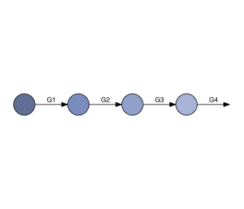

Figure 1 Iterated problem solving paradigm. Participants were assigned to generations within chains. Each participant completed the same problem solving task for 25 minutes. Participants in generations after the first began the problem solving task with the solutions that were discovered by the previous generation.

We investigated the human propensity to exceed our ancestors in a problem solving task using a transmission chain paradigm (Fig. 1). Previous research using this paradigm has found that problem solving performance can accumulate over generations (Caldwell and Millen 2008; Wasielewski 2014; Zwirner and Thornton 2015). These experiments however typically investigate individuals’ performance about a single problem (such as building paper airplanes or baskets). Yet, cumulative cultural evolution allows humans to solve more diverse and ever larger sets of problems. Larger set of problems can only be solved when larger amounts of information are transmitted between generations, which is likely to result in increasing acquisition costs for learners (Mesoudi, 2011). Despite its pivotal importance, the effects of increasing amount of information on learners’ performance have not been investigated experimentally.

Here we allowi future generations to inherit symbolic information (“recipes”) about how to recreate the tools that had been discovered by an ancestor and measure the ability of participants to recreate and exceed the tools they inherited.In addition to asking whether participants were able to exceed the total number of tools discovered by their ancestor, we also asked whether inheritance influenced the way in which future problems were solved. To answer this question, we analyzed whether participants who inherited more tools from their ancestors were more or less effective at discovering new tools. We also analyzed the guessing strategies used by participants who benefited from inheritance as compared to first generation participants who did not inherit from any ancestor. These analyses are used to address potential downstream consequences to iteratively inheriting from a previous generation.

# Methods

To understand how solutions to problems accumulate through vertical transmission, we used a transmission chain paradigm where participants were assigned to a single generation within a four-generation chain. Each participant attempted the same tool discovery task for 25 minutes. The recipes for how to create the tools that each participant had discovered by the end of the session were passed on to be inherited by a participant in the next generation of the chain. Thus, participants assigned to generations after the first began the experiment with information about how to create the tools inherited from the previous generation.

Participants played the “Totem” game adapted from Derex and Boyd (2015). Their task was to discover how to build tools with the ultimate goal of creating “a sacred totem to appease the gods.” To build a totem, participants first needed to construct an axe out of three independently discovered tools: a refined stick used as a handle, a sharpened rock for the blade, and a string wound from bark fibers for binding (Fig. 2). More advanced tools produce larger and more intricate totems.

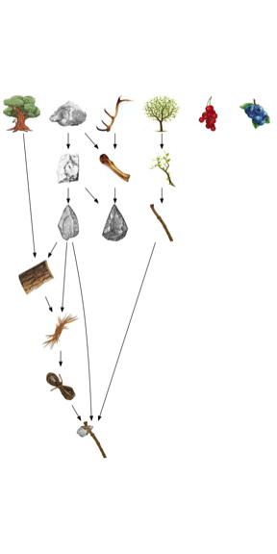

Figure 2 A sample of the solution landscape. The top row of 6 items were available to participants at the start of the game. Tools could be produced through the combination of different items (more than one arrow points to the item) or the combination of the same items (a single arrow points to the item). The axe is required to construct the first totem pole.

Participants discovered new tools by combining existing items. Participants could refine individual items, or combine up to four items at a time (with replacement), meaning the initial six items could form a total of 209 combinations. Of all possible combinations, very few resulted in new items. For example, of all the guesses that could be formed from the initial items, only three (1.4%) yielded new tools.

As tools are accumulated, the number of possible combinations that can be made with those tools increases exponentially such that the discovery of later tools was less likely to happen by chance alone. Based on previous research using this task, we know that participants are far more likely to make some guesses than others, indicating they are using common knowledge acquired outside the lab to generate combinations. For example, once discovering an axe, participants quickly discover that they can use the axe to chop down a tree, regardless of the other tools they may have at the time. At the same time, participants do not find all tools equally intuitive, and the difference in combinatorial complexity should not be ignored. In our results, we report performance based on both measures.

Once a tool was discovered, the recipe for its production—a list of the items that had to be combined in order to produce the tool—was recorded in an innovation record. Participants could review their past innovations and see the recipes for their previous discoveries. Participants assigned to generations after the first inherited the innovation record of the previous generation participant. From the beginning of the experiment, these participants could review the recipes for all the innovations that had been discovered by their ancestor. Note that the participants inherited the recipes, but not the tools themselves. In order use these tools in further combinations, the tools and all of their constituent parts first had to be recreated.

## Participants

Participants were recruited from the UW-Madison student body and received course credit in exchange for participation. Each participant was assigned to a single generation of a four-generation chain. Data was collected for a total of 42 complete chains (N=168 participants).

# Results

Our results are presented in three sections. First we report the total number of tools discovered by each generation along chains. Second we report the number of new tools discovered relative to the number of tools inherited (as opposed to generation). In the second section, we also quantify the amount of time each participant spent recreating inherited tools versus discovering new ones, and test whether the number of tools inherited had an impact on the rate of new tool discovery. In the last section, we compare first generation participants who did not inherit from anyone to participants in generations 2-4 who inherited at least some tools from an ancestor in an attempt to understand whether inheritance confers any benefit to problem solving beyond the inherited solutions.

## Tools by generation

We found that participants in later generations were able to discover more tools in the same amount of time than their ancestors (Fig. 3). To quantify these gains, we fit a hierarchical regression model to the number of tools discovered in each generation with polynomial contrasts for generation and random effects for chain. On average, second generation participants were able to discover 3.3 more tools than first generation participants, *b* = 3.27 (SE = 0.65), *t* = 5.04. This effect decreased by -0.4 each generation for third and fourth generation participants, *b* = -0.39 (SE = 0.20), *t* = -2.00.

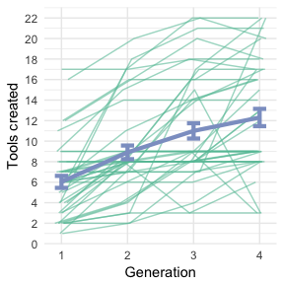

Figure 3 Tools by generation. Each of the thin green lines is a chain. The thick blue line is the model predictions with ±1 standard error.

It is worth noting that as tools are accumulated, the number of possible combinations that can be produced increases exponentially. As a consequence, the discovery of later tools was less likely to happen by chance alone. To take the size of the combinatorial space into account, rather than scoring each tool equally, we instead scored each tool based on the size of the combinatorial space at the time it was discovered. Refitting the same hierarchical regression model as above, this time predicting the sum of tool scores discovered in each generation, we again found that tool scores increased linearly with each generation, *b* = 0.04 (SE = 0.01), *t* = 4.92, but in this model, the improvement in tool score was not found to decrease for later generations, *b* = -0.0001 (SE = 0.0059), *t* = -0.01.

## Tools by inheritance size

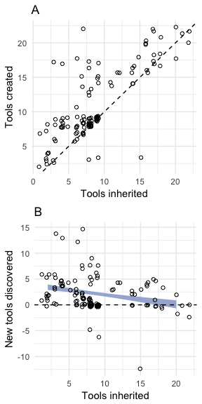

Figure 4 Tools by inheritance size. A. Number of tools created relative to those inherited. The dotted line is a reference with slope=1 such that points above the line indicate future generations exceeding their ancestors. B. Number of new tools relative to those inherited. The same reference line is now shown horizontally. The error ranges specify the model predictions with ±1 standard error.

Because there is no difference between a second generation participant who inherits 10 tools and a fourth generation participant who inherits the same tools, we also looked at problem solving performance relative to the number of tools that were inherited regardless of generation (Fig. 4). As the number of inherited tools increased, the number of new tools discovered decreased, *b* = -0.18 (SE = 0.06), *t* = -2.92 (Fig. 4B).

Participants who inherited more tools also required more time to recreate those tools. Participants took on average 8.2 minutes of the 25 minute session (32.8%) to recreate the inherited tools—a portion of the experiment we refer to as the learning period. The length of the learning period correlated positively with the number of inherited tools, *r* = 0.6 (Fig. 5).

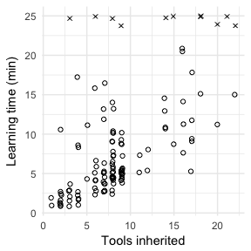

Figure 5 Learning rates. Correlation between the number of tools inherited and the time it took to recreate the inherited items. Outliers who were appear unwilling or unable to recreate the inherited items are shown as X’s, but included in all analyses.

We next asked whether inheriting more tools had an impact on the rate of new tool discovery, controlling for the length of time spent recreating inherited tools. We fit a hierarchical regression model predicting the number of new tools discovered relative to the amount of time out of the 25 minute session available to discover new tools (Fig. 6). The overall discovery rate was 5.6 minutes per tool (0.18 innovations per minute), *b* = 0.18 (SE = 0.04), *t* = 4.06. This rate was not found to vary based on the number of inherited tools, as revealed by comparing a model predicting novel tools from discovery time alone to one predicting novel tools from the interaction between discovery time and inheritance size, $χ^{2}$ (2) = 0.5430, *p* = 0.762.

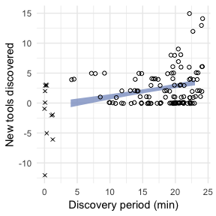

Figure 6 New tool discovery rates. Discovery time is the amount of time out of a 25 minute session dedicated to discovering new innovations that were not discovered by an ancestor. The line shows the predictions of the hierarchical regression model with ±1 standard error. The slope of this line did not significantly vary based on the number of inherited tools. Participants marked with X’s are the same as in Fig. 5.

## Guesses per tool

In this section, we compared first generation participants who did not inherit from anyone to participants in generations 2-4 who inherited at least some tools from an ancestor. We compared these two groups in terms of the number of guesses required to discover each tool.

To count the number of guesses that were required for each tool, we tallied all guesses made from the moment in which a new tool was eligible for discovery until that tool was discovered. A new tool was eligible for discovery once all of the items required to produce the new tool had been discovered.

We fit a hierarchical linear model predicting the number of guesses per tool based on generation (Generation 1, Generations 2-4) with random effects by tool. Tools that have been produced by Generations 2-4 were assigned to one of two classes: those that were inherited from an ancestor and those that were discovered through a trial and error process. This allowed us to test whether the benefit to inheritance was restricted to reducing the number of guesses for inherited items, or whether inheritance had any effect on future guessing behaviors.

As expected, participants from generations 2-4 on average made fewer guesses per tool than when the same tools were attempted in the first generation, *b* = 15.36 (SE = 4.92), *t* = 3.12. This effect demonstrates the benefit of inheriting from a previous generation in providing a shortcut to discovering these tools.

However, we did not find any evidence that inheritance had an effect on the number of guesses per new tool, *b* = -3.97 (SE = 4.77), *t* = -0.83 (Fig. 7). This finding suggests that although inheritance benefits participants in recreating inherited solutions, it does not confer any benefits to future problem solving.

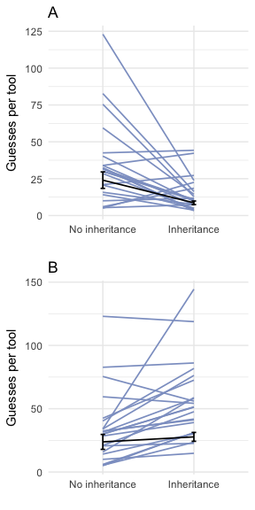

Figure 7 Guesses per tool by inheritance condition. Each line is the average number of guesses it took to discover a particular tool in either inheritance condition. Error bars show ±1 standard of the model predictions. A. Inherited tools. B. Novel tools.

# Discussion

We found that participants were consistently able to solve more problems in a single 25 minute session than their ancestors, and thus were able to cumulatively improve upon the solutions they inherited. All participants were expected to be able to recreate the tools they inherited, but whether they could discover new tools, beyond those inherited, was unknown. Given the combinatorial complexity of the solution landscape, participants were unlikely to strike upon beneficial combinations by guessing at random. Because of this, some participants were unable to discover any new tools. But most did discover new tools, even when inheriting an already large number of previously discovered tools.

We also explored the impact of inheriting solutions on problem solving performance. We found that participants who inherited more tools tended to discover fewer new tools than their ancestors, suggesting that later generation participants had a harder time exceeding their ancestors. Part of the reason is that later generation participants needed more time to recreate the tools they inherited. Controlling for the amount of time each participant had to discover new tools (as opposed to recreating inherited tools) did not reveal an effect of inheritance size on the rate of new tool discovery. Finally, we investigated whether the benefit of inheritance in terms of guesses per tool extended beyond the inherited tools, and found that although inheritance clearly reduced the number of guesses required for inherited tools, it did not confer any benefit to future problem solving performance.

Our conclusions are limited by the design of the solution landscape in the Totem game, and the restriction in our methods to a single problem solving strategy. The sparsity of the solution landscape, where many combinations can be made but very few yield new tools, indicates that in order to succeed participants must use prior knowledge to help form combinations that are most likely to yield new tools. This challenges the notion that the difficulty of a particular tool is directly related to its combinatorial complexity. In addition, we believe the accumulation of problem solving knowledge over generations must be compared with the accumulation of problem solving knowledge through other forms of problem solving that do not involve vertical transmission.

More than any other animal, humans are particularly skilled at inheriting and improving tools and other solutions to problems, but whether the ability to inherit from others has effects on problem solving beyond giving a head start to individual learning is not known. Although much work is still needed to fully understand the human propensity for cumulative cultural evolution, we believe our research is a valuable contribution to ongoing efforts to understand how and why human culture is so integrally cumulative.

Alem, Sylvain, Clint J Perry, Xingfu Zhu, Olli J Loukola, Thomas Ingraham, Eirik Søvik, and Lars Chittka. 2016. “Associative Mechanisms Allow for Social Learning and Cultural Transmission of String Pulling in an Insect.” *PLoS Biology* 14 (10):e1002564–28.

Basalla, George. 1988. *The evolution of technology*. Cambridge University Press.

Boyd, Robert. 2018. *A Different Kind of Animal*. How Culture Transformed Our Species. Princeton, NJ: Princeton University Press.

Caldwell, Christine A, and A E Millen. 2008. “Experimental models for testing hypotheses about cumulative cultural evolution.” *Evolution and Human Behavior* 29 (3):165–71.

Caldwell, Christine A, and Ailsa E Millen. 2009. “Social learning mechanisms and cumulative cultural evolution. Is imitation necessary?” *Psychological Science* 20 (12):1478–83.

Dean, Lewis G, R L Kendal, S J Schapiro, B Thierry, and K N Laland. 2012. “Identification of the Social and Cognitive Processes Underlying Human Cumulative Culture.” *Science* 335 (6072):1114–8.

Derex, Maxime, and Robert Boyd. 2015. “The foundations of the human cultural niche.” *Nature Communications* 6 (September):1–7.

Derex, Maxime, Bernard Godelle, and Michel Raymond. 2013. “Social Learners Require Process Information to Outperform Individual Learners.” *Evolution; International Journal of Organic Evolution* 67 (3):688–97.

Fernández-Armesto, Felipe. 2001. *Civilizations: culture, ambition, and the transformation of nature*. Simon; Schuster.

Henrich, Joseph. 2015. *The secret of our success: how culture is driving human evolution, domesticating our species, and making us smarter*. Princeton University Press.

Hunt, G R, and R D Gray. 2003. “Diversification and cumulative evolution in New Caledonian crow tool manufacture.” *Proceedings. Biological Sciences / the Royal Society* 270 (1517):867–74.

Kaplan, Hillard S, and Arthur J Robson. 2002. “The emergence of humans: the coevolution of intelligence and longevity with intergenerational transfers.” *Proceedings of the National Academy of Sciences of the United States of America* 99 (15):10221–6.

Laland, KN, and K Williams. 1997. “Shoaling generates social learning of foraging information in guppies.” *Animal Behaviour* 53 (6):1161–9.

Lycett, Stephen J, and John A J Gowlett. 2008. “On questions surrounding the Acheulean ‘tradition’.” *World Archaeology* 40 (3):295–315.

Morgan, Thomas J H, N T Uomini, L E Rendell, L Chouinard-Thuly, S E Street, H M Lewis, C P Cross, et al. 2015. “Experimental evidence for the co-evolution of hominin tool-making teaching and language.” *Nature Communications* 6 (January):6029–8.

Richerson, Peter J, and Robert Boyd. 2005. *Not by genes alone: How culture transformed human evolution*. University of Chicago Press.

Sanz, C, J Call, and D Morgan. 2009. “Design complexity in termite-fishing tools of chimpanzees (Pan troglodytes).” *Biology Letters* 5 (3):293–96.

Solé, Ricard V, Sergi Valverde, Marti Rosas Casals, Stuart A Kauffman, Doyne Farmer, and Niles Eldredge. 2013. “The Evolutionary Ecology of Technological Innovations.” *Complexity* 18 (4):15–27.

Sterelny, Kim. 2012. *The Evolved Apprentice*. The MIT Press.

Tennie, C, J Call, and M Tomasello. 2009. “Ratcheting up the ratchet: on the evolution of cumulative culture.” *Philosophical Transactions of the Royal Society B: Biological Sciences* 364 (1528):2405–15.

Thorndike, E L. 1898. “Animal Intelligence.” *The Psychological Review* 2:1–113.

Torre, I de la. 2011. “The origins of stone tool technology in Africa: a historical perspective.” *Philosophical Transactions of the Royal Society B: Biological Sciences* 366 (1567):1028–37.

Wasielewski, Helen. 2014. “Imitation Is Necessary for Cumulative Cultural Evolution in an Unfamiliar, Opaque Task.” *Human Nature (Hawthorne, N.Y.)* 25 (1):161–79.

Whiten, A, J Goodall, W C McGrew, T Nishida, V Reynolds, Y Sugiyama, CEG Tutin, R W Wrangham, and C Boesch. 1999. “Cultures in chimpanzees.” *Nature* 399 (6737):682–85.

Zwirner, Elena, and Alex Thornton. 2015. “Cognitive requirements of cumulative culture: teaching is useful but not essential.” *Scientific Reports* 5 (1):1–8.