Cumulative improvements in iterated problem solving

Humans are able to use and improve solutions to problems including tools and other technology that were inherited from others like no other species of animal. What is the impact of inheritance—starting off a problem solving task with partial solutions inherited from someone else—on future problem solving ability? Does inheritance provide a reliable shortcut to individual learning without affecting underlying problem solving ability, or does inheritance change the way future problems are solved? To begin to answer these questions, we measured changes in problem solving ability over four generations of iterated problem solving, where the solutions discovered by one generation are inherited to be used and improved by the next generation. We found that through four generations of iterated problem solving, problem solvers were consistently able to solve more problems in a single 25 minute session than their predecessors, even as problems became more difficult to solve. We investigated whether the size of the inheritance had an impact on future problem solving ability, and found mixed results: larger inheritances were harder to exceed, but they also allowed individuals to solve more difficult problems than they would have on their own. We also found no evidence that a larger inheritance negatively impacted the rate at which new problems were solved. We discuss the limitations of this work, and motivate future directions.

# Introduction

Humans are effective problem solvers, having solved a wide range of problems related to foraging, hunting, and preparing food, while surviving predators, each other, and a large range of terrestrial environments (Boyd 2017; Fernández-Armesto 2001). What has enabled our success in being able to solve such a diverse set of problems? One suggestion is that the answer lies more in our ability to inherit knowledge from others than our ability to solve problems as individuals (Richerson and Boyd 2008; Henrich 2015; Boyd 2017). As problem solvers, humans are particularly adept at using, reproducing, and, in some cases, improving cultural products including tools and other solutions to problems that were first created by other people, a phenomena generally known as the ratchet effect (Tomasello, Kruger, and Ratner 1993; Tennie, Call, and Tomasello 2009). The purpose of this research was to better understand the human propensity for cumulative cultural inheritance using an iterated problem solving paradigm (Fig. 1).

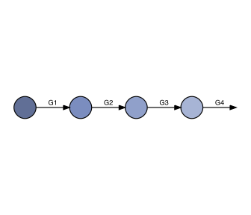

A shematic of an iterated problem solving paradigm we used. Participants were assigned to four-person teams. Each participant completed the same problem solving task for 25 minutes. Participants in generations after the first began the problem solving task with the solutions that were discovered by the previous generation.

Cumulative cultural evolution requires at minimum the ability to copy the innovations of others, and the ability to improve or adapt them in some way. These abilities are often distinguished as being the products of social learning and individual learning, respectively. Computational models of the cultural evolutionary process demonstrate that social learning is evolutionarily advantageous as compared to adaptions that improve individual learning capacities when the environment is stable, so that innovations that are beneficial in one generation are likely to continue to be beneficial in the next generation, and individual learning is costly; under these conditions, social learning provides a valuable shortcut to individual learning (Boyd and Richerson 1985; Rendell et al. 2010; Thompson et al., n.d.). Additional constraints on the benefits to social learning include knowing whom to copy (Enquist et al. 2010; Rendell et al. 2011) and having high-fidelity transmission mechanisms (Lewis and Laland 2012).

Although social learning is widely considered to be an important aspect of what allows human cultures to accumulate improvements in technologies and other solutions to problems (Dean et al. 2013), social learning is not unique to humans, and a growing number of species have been identified as being able to inherit learned behaviors from observing or interacting with others. Cultural traditions sustained through social learning have been identified in primates, monkeys, dolphins, whales, and birds (see Whiten 2017 for a recent review). Experimental evidence of social learning has been observed in a wider array of species, including rats, fish, and even some insects (see Laland 2017). Given that social learning is at least possible in diverse taxa, it is somewhat surprising that only a few cases have been argued to show any evidence of accumulation or improvement in inherited innovations. New Caledonian crows have been argued to have improved the design plans for the grub-skewers they cut out from pandanus leaves (Hunt and Gray 2003), and at least one population of chimpanzees has evolved a more advanced termite probe (Sanz, Call, and Morgan 2009). For the most part, however, tool use in animals has remained largely unchanged (Mercader et al. 2007).

Humans, in contrast, have demonstrated a remarkable ability to reproduce, adapt, and improve the innovations of others. Despite the popular focus on individual geniuses creating inventions without precedent, human progress is much more accurately characterized as a process of continual refinement and repurposing (Basalla 1988; Solé et al. 2013). Moore’s Law, the observation and prediction that computer chip efficiency would double every two years (1965), is a well-known example of regular and monotonic growth in a technological domain, but there are many other examples, such as improvements in information storage, bandwidth, and processing speed, most of which have even steeper growth curves than Moore’s integrated circuits (Nagy et al. 2011). Of course, superexponential growth has not been true for all of human history, as demonstrated by the period of nearly 1.5 million years known as the Acheulean tradition during which our ancestors were seemingly unable to invent more complicated stone tools than simple handaxes, and yet even during this time, incremental improvement have been argued to have occured as the handaxes grew more symmetrical in design (Lycett and Gowlett 2008). What these observations suggest is that, more than our ability to learn socially from others, our ability to improve upon existing innovations, in however small an increment, characterizes human problem solving.

Experimental models of the cumulative cultural evolutionary process have demonstrated that incremental improvements can accrue through a variety of social learning mechanisms. Caldwell and Millen (2008) found that chains of problem solvers could iteratively improve the distance flown by paper airplanes and the height of towers constructed from dry spaghetti noodles and modeling clay. Interestingly, improvements were equally likely to accrue whether social transmission occured via imitation, emulation, or guided instruction of one generation to the next (Caldwell and Millen 2009).

Our research adds to these efforts to understand cumulative cultural evolution specifically by striving to understand the impact of inheritance on future problem solving. We used an iterated learning paradigm to measure the effectiveness of problem solving organized around inheritance. Specifically, we were interested in understanding how the solutions inherited from previous generations impacted the problem solving of subsequent generations of participants. To preface our findings, we found that problem solving based around inheritance was able to cumulatively improve the number of problems each generation could solve in a 25 minute session, even as the problems became more difficult. As for whether this inheritance had an impact on future problem solving, we found that larger inheritances were harder to exceed, but they allowed individuals to solve more difficult problems than they would have been likely to solve on their own. We also did not find any evidence that larger inheritances had a detrimental effect on future problem solving. From these results, we motivate future research aimed at more directly understanding the impact of inheritance on problem solving.

# Methods

We used a iterated learning paradigm where participants are assigned to generations within chains (Caldwell and Millen 2008). To emphasize that participants in each chain are working together cooperatively on a problem solving task rather than engaging in unguided repetition (cf. Bartlett 1932; Kirby, Cornish, and Smith 2008; Edmiston, Lupyan, and Perlman 2017) we refer to the transmission chains as *diachronic teams*. We tested the problem solving ability of diachronic teams over four generations of problem solving, where each generation attempted the same problem solving task for 25 minutes. Diachronic problem solvers after the first generation began the problem solving task with the solutions created by the previous generation.

Participants played the “Totems” game adapted from Derex and Boyd (2015). Their task was to discover how to build tools with the ultimate goal of creating “a sacred totem to appease the gods.” To build a totem, participants first needed to construct an axe out of three independently discovered tools: a refined stick used as a handle, a sharpened rock for the blade, and a string wound from bark fibers for binding (Fig. 2). More advanced tools produce larger and more intricate totems, resulting in higher performance scores. Participants in each generation after the first began the problem solving task by inheriting aspects of the the solution discovered by the previous participant (generation) within their chain.

## Participants

Participants were recruited from the UW-Madison student body and received course credit in exchange for participation. Each participant was assigned to a single generation of a four-person team (Table 1). Data was collected for a total of 42 teams (N=168 participants).

## Procedure

Participants played the Totems game for 25 minutes. To play the game, participants generated guesses (combinations of items) by dragging items one at a time into a workshop panel. The panel had space for four items (with replacement), meaning the initial six resources could be combined for a total of 1554 unique guesses. Of the possible combinations, very few resulted in new items. For example, of all the guesses that could be formed from the initial items, only three (0.2%) yielded new tools (Fig. 2). As problem solvers accumulate solutions, the combinatorial complexity of the problem space increases exponentially such that the discovery of more complex tools is less likely to happen by chance.

Once a tool was discovered, the recipe for its creation was recorded in a separate history panel. Participants could review their history and see the recipes for their previous discoveries, even items they had discarded. The history panel was also how diachronic inheritance was implemented. Diachronic problem solvers after the first generation began the problem solving task with an additional tab in the history panel that, when selected, listed all of the recipes for the items created by the previous generation.

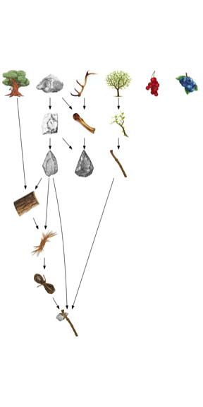

A sample of the solution landscape. The axe is required to construct the first totem pole.

# Results

Participants who inherited the solutions discovered by the previous generation took on average 8.2 minutes of the 25 minute session (32.8%) to recreate the inherited tools---a portion of the experiment we refer to as *the learning stage*. The length of the learning stage correlated positively with the size of the inheritance, *b* = 0.78 (SE = 0.04), *t*(114.0) = 21.32, *p* < 0.001 (Fig. 3). A small group of participants (N=11) took disproportionately long to recreate the tools they inherited perhaps because they were confused by the game interface. These participants are identified by X’s in all figures and are not included in any statistical analyses.

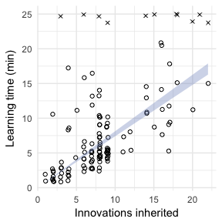

Learning rates. Correlation between the number of innovations inherited and the time it took to recreate the inherited items. Outliers who were unwilling or unable to recreate the inherited items are shown as X’s, and excluded from analysis.

After completing the learning stage, participants entered the discovery stage, where they attempted to create new tools not discovered by their predecessors. Most participants (60.8%) were able to exceed the number of innovations that they inherited *b* = 0.41 logodds (SE = 0.19), *z* = 2.13, *p* = 0.033 (Fig. 4). Using Page’s trend test (a repeated measures test for monotonicity), we found that iterated problem solving resulted in cumulative improvements in the number of problems that could be solved in 25 minutes (Fig. 5).

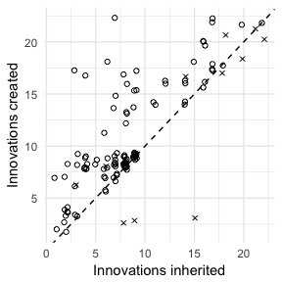

Number of innovations created relative to those inherited. The dotted line is a reference with slope=1 such that points above the line indicate future generations exceeding their ancestors.

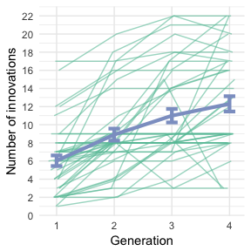

Number of innovations discovered by each generation. Each of the thin green lines is a team. The thick blue line is the model predictions with ±1 standard error.

We next measured the change in innovations over generations within each team by fitting a hierarchical regression model to the total innovations achieved in each generation with nested effects (intercepts and slopes) for teams. On average, second generation participants were able to discover 3.3 more innovations than first generation participants, *b* = 3.27 (SE = 0.65), *t* = 5.04. This effect decreased by -0.4 each generation for third and fourth generation participants, *b* = -0.39 (SE = 0.20), *t* = -2.0---a diminishing return. A model comparison of hierarchical regression models fit with linear and quadratic components revealed that a quadratic fit was significantly better than a linear fit alone. This result suggests that accumulated inheritance had a diminishing return on future problem solving.

We next consider explanations for the diminishing return of diachronic inheritance on problem solving. First, we tested whether larger inheritances had a detrimental effect on future problem solving. We found that an increase in the number of inherited innovations was negatively associated with a decrease in the number of new innovations discovered by future generations of problem solvers, *b* = -0.13 (SE = 0.07), *t* = -1.91 (Fig. 4). This finding preliminarily suggests that inheritance has a measurable influence on problem solving beyond simply providing a shortcut to individual learning. In this case, the impact appears to be negative, such that inheriting more solutions appears to *decrease* problem solving ability.

However, an alternative explanation, not having to do with inheritance negatively affecting problem solving ability, is that as more items are accumulated, additional items are less likely to be discovered by chance. Discoveries become rarer as the low-hanging fruit of discovery is picked. If true, we would expect problem solving to slow down regardless of what was inherited. To control for this combinatorial complexity (how low the fruit is hanging), we created an alternative outcome measure that, rather than counting all innovations equally, weighted each innovation relative to the number of guesses that could be made from the items present at the time at which the innovation was discovered.

Fig. 6 shows the change in accumulated difficulty score based on the number of innovations that were inherited. In contrast to the analysis that treated all innovations equally, when innovations are weighted by combinatorial complexity, the effect of inheritance does not decrease over time, such that larger inheritances result in higher accumulated difficulty scores, *b* = 0.0047 (SE = 0.0015), *t* = 3.22.

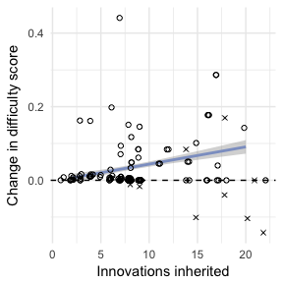

Change in accumulated difficulty score by inheritance. Accumulated difficulty scores are sums of discovered innovations weighted by the combinatorial complexity of the possible choices available to the participant when the innovation was discovered. The outcome measure is the difference between the accumulated difficulty scores of subsequent generations. The line shows the predictions of a hierarchical regression model with ±1 standard error.

The final explanation we consider regarding whether inheritance affected problem solving ability is that larger inheritances take more time to recreate, thus leaving less time for future problem solving. Even if inheritance did not affect problem solving ability, participants who inherit more innovations may not discover as many future innovations simply because they used up most of their time recreating the items that were inherited. To investigate, we looked at problem solving rates controlling for the amount of time spent recreating the inherited items.

Problem solvers who spend more time in the learning stage conversely have less time in the **discovery stage**, where new innovations are tried and discovered. Fig. 7 shows the problem solving rates for diachronic problem solvers based on the length of the discovery stage. The overall rate of problem solving in the discovery stage was 8.3 minutes per new innovation (0.12 innovations per minute), *b* = 0.12 (SE = 0.07), *t* = 1.77. This rate was not found to vary based on the size of the inheritance, as revealed by a model comparison comparing a model predicting unique innovations from playing time alone to one predicting unique innovations from the interaction between playing time and inheritance size, . This result suggests that inheriting more items did not have an effect on the rate at which new problems are solved when discovery time is controlled.

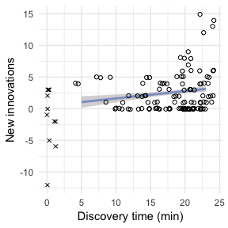

Problem solving rate in the discovery stage. Discovery time is the amount of time out of a 25 minute session dedicated to discovering new innovations that were not discovered by an ancestor. The line shows the predictions of the hierarchical regression model with ±1 standard error. The slope of this line did not significantly vary based on the size of the inheritance.

# Discussion

We measured problem solving performance of four-person diachronic teams. Later generations were consistently able to cumulatively improve upon the solutions they inherited. Although this finding is perhaps not surprising, given that participants in effect started a problem solving task with some of the problems already solved, it is exactly this ability, so easy for humans to engage in, that is believed to be rare or non-existent among non-human animals, and fundamental to human cultural evolution.

In our experiment, problem solvers past the first generation first had to recreate all of the inherited solutions, which took time and effort. Once recreated, some participants were unable to solve any new problems. Others were unable even to recreate all of their inherited solutions in the 25-minute session—although this behavior is likely attributable to misunderstanding of the task. Nonetheless, the presence of these outliers highlights that in our experiment, performance is not guaranteed to improve cumulatively, which is why we first establish that performance does reliably accumulate.

We also attempted to determine whether inheritance had a measurable impact on future problem solving ability. We primarily tested this question in this experiment by investigating the relationship between inheritance size and the number of unique innovations contributed by each generation. We found multiple, conflicting results. The impact of inheritance on problem solving appeared to diminish such that later generation problem solvers were less able to exceed the number of solutions discovered by their ancestors, but if the combinatorial complexity of the solutions was taken into account, the effect of inheritance was not found to decrease. If the amount of time problem solvers have to solve new problems not solved by their ancestors is taken into account, future generations of problem solvers progress at the same rate regardless of the number of items inherited.

In the face of conflicting results, we propose better experiments, some of which are already underway. We argue that the only way to truly understand whether inheritance impacts future problem solving is to compare diachronic problem solving based around inheritance to alternative strategies for solving the same set of problems, but without diachronic inheritance. Although more work on this topic is clearly required, we believe extending the iterated learning paradigm to answer questions about the impact of inheritance on problem solving is a valuable contribution.

Bartlett, Frederic Charles. 1932. *Remembering: A study in experimental and social psychology*. Cambridge University Press.

Basalla, George. 1988. *The evolution of technology*. Cambridge University Press.

Boyd, Robert. 2017. *A Different Kind of Animal*. How Culture Transformed Our Species. Princeton, NJ: Princeton University Press.

Boyd, Robert, and Peter J Richerson. 1985. *Culture and the evolutionary process*. University of Chicago Press.

Caldwell, Christine A, and A E Millen. 2008. “Experimental models for testing hypotheses about cumulative cultural evolution.” *Evolution and Human Behavior* 29 (3):165–71.

Caldwell, Christine A, and Ailsa E Millen. 2009. “Social learning mechanisms and cumulative cultural evolution. Is imitation necessary?” *Psychological Science* 20 (12):1478–83.

Dean, Lewis G, Gill L Vale, Kevin N Laland, Emma Flynn, and Rachel L Kendal. 2013. “Human cumulative culture: a comparative perspective.” *Biological Reviews* 89 (2):284–301.

Derex, Maxime, and Robert Boyd. 2015. “The foundations of the human cultural niche.” *Nature Communications* 6 (September):1–7.

Edmiston, Pierce, Gary Lupyan, and Marcus Perlman. 2017. “The emergence of words from vocal imitations.” *bioRxiv*, June, 1–23.

Enquist, Magnus, Pontus Strimling, Kimmo Eriksson, Kevin Laland, and Jonas Sjostrand. 2010. “One cultural parent makes no culture.” *Animal Behaviour* 79 (6):1353–62.

Fernández-Armesto, Felipe. 2001. *Civilizations: culture, ambition, and the transformation of nature*. Simon; Schuster.

Henrich, Joseph. 2015. *The secret of our success: how culture is driving human evolution, domesticating our species, and making us smarter*. Princeton University Press.

Hunt, G R, and R D Gray. 2003. “Diversification and cumulative evolution in New Caledonian crow tool manufacture.” *Proceedings. Biological Sciences / the Royal Society* 270 (1517):867–74.

Kirby, Simon, Hannah Cornish, and Kenny Smith. 2008. “Cumulative cultural evolution in the laboratory: an experimental approach to the origins of structure in human language.” *Proceedings of the National Academy of Sciences* 105 (31):10681–6.

Laland, Kevin N. 2017. *Darwin’s Unfinished Symphony: How Culture Made the Human Mind*. Princeton University Press.

Lewis, H M, and K N Laland. 2012. “Transmission fidelity is the key to the build-up of cumulative culture.” *Philosophical Transactions of the Royal Society B: Biological Sciences* 367 (1599):2171–80.

Lycett, Stephen J, and John A J Gowlett. 2008. “On questions surrounding the Acheulean ‘tradition’.” *World Archaeology* 40 (3):295–315.

Mercader, Julio, Huw Barton, Jason Gillespie, Jack Harris, Steven Kuhn, Robert Tyler, and Christophe Boesch. 2007. “4,300-year-old chimpanzee sites and the origins of percussive stone technology.” *Proceedings of the National Academy of Sciences of the United States of America* 104 (9):3043–8.

Moore, Gordon E. 1965. “Cramming more components onto integrated circuits.” *Electronics* 86 (1):114–17.

Nagy, Béla, J Doyne Farmer, Jessika E Trancik, and John Paul Gonzales. 2011. “Superexponential long-term trends in information technology.” *Technological Forecasting and Social Change* 78 (8):1356–64.

Rendell, L, Robert Boyd, D Cownden, M Enquist, K Eriksson, M W Feldman, L Fogarty, S Ghirlanda, T Lillicrap, and K N Laland. 2010. “Why Copy Others? Insights from the Social Learning Strategies Tournament.” *Science* 328 (5975):208–13.

Rendell, Luke, Laurel Fogarty, William J E Hoppitt, Thomas J H Morgan, Mike M Webster, and Kevin N Laland. 2011. “Cognitive culture: theoretical and empirical insights into social learning strategies.” *Trends in Cognitive Sciences* 15 (2):68–76.

Richerson, Peter J, and Robert Boyd. 2008. *Not by genes alone: How culture transformed human evolution*. University of Chicago Press.

Sanz, C, J Call, and D Morgan. 2009. “Design complexity in termite-fishing tools of chimpanzees (Pan troglodytes).” *Biology Letters* 5 (3):293–96.

Solé, Ricard V, Sergi Valverde, Marti Rosas Casals, Stuart A Kauffman, Doyne Farmer, and Niles Eldredge. 2013. “The Evolutionary Ecology of Technological Innovations.” *Complexity* 18 (4):15–27.

Tennie, C, J Call, and M Tomasello. 2009. “Ratcheting up the ratchet: on the evolution of cumulative culture.” *Philosophical Transactions of the Royal Society B: Biological Sciences* 364 (1528):2405–15.

Thompson, B, Simon Kirby, K Smith Proceedings of the, and 2016. n.d. “Culture shapes the evolution of cognition.” *Proceedings of the National Academy of Sciences*.

Tomasello, M, A C Kruger, and H H Ratner. 1993. “Cultural Learning.” *Behavioral and Brain Sciences* 16 (3):495–511.

Whiten, Andrew. 2017. “A second inheritance system: the extension of biology through culture.” *Interface Focus* 7 (5):20160142–16.