Cumulative improvements in iterated problem solving

As compared to other animals, humans are particularly skilled at using and improving tools and other solutions to problems that were first discovered by other people. Although the human capacity for cumulative cultural evolution is well-known, the effectiveness of inheritance as a form of problem solving is an area in need of further research. We report an experiment designed to understand how effectively problem solving knowledge accumulates over generations of problem solving. We found that problem solvers were consistently able to solve more problems in a 25 minute session than their ancestors. In investigating whether the number of inherited solutions had an impact on future problem solving performance, we found that larger inheritances were harder to exceed, but they also allowed individuals to solve more complex problems than they would have solved on their own. We discuss the limitations of this work, and motivate future directions.

# Introduction

Humans are effective problem solvers, having solved a wide range of problems related to foraging, hunting, and preparing food, while surviving predators, each other, and a large range of terrestrial environments (Boyd 2017; Fernández-Armesto 2001). What has enabled our success in being able to solve such a diverse set of problems? Some have suggested that the answer lies more in our ability to inherit knowledge from others than our ability to solve problems as individuals (Richerson and Boyd 2008; Henrich 2015; Boyd 2017). Cultural inheritance enables problem solving to extend over generations, far longer than any single lifetime, allowing future generations of problem solvers to benefit from solutions to problems that they could not have discovered on their own. However, what is unclear is how effectively individual problem solvers are able to benefit from inherited solutions at shorter timescales. To better understand the extent to which future generations of problem solvers are able to benefit from inherited problem solving knowledge, we investigated the accumulation of problem solving knowledge over generations of problem solving (Fig. 1).

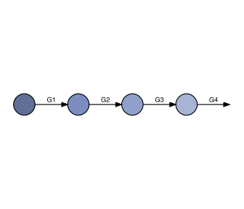

Iterated problem solving paradigm. Participants were assigned to generations within chains. Each participant completed the same problem solving task for 25 minutes. Participants in generations after the first began the problem solving task with the solutions that were discovered by the previous generation.

The accumulation of problem solving knowledge is thought to be enabled by a number of social learning abilities that facilitate transmission of problem solving knowledge with high fidelity across individuals. These include teaching through verbal instruction, prosociality, and advanced imitation abilities (Dean et al. 2012). These skills for high fidelity social learning are argued to benefit problem solvers by providing a reliable shortcut to individual (asocial) learning (Boyd and Richerson 1985). Rather than having individuals struggle to solve a problem on their own through trial-and-error learning, social learners can inherit solutions that have already been discovered by others. Over generations, these shortcuts accumulate, giving populations of social learners to get a head start on future problem solving, and allowing them to solve problems that no individual learner would be able to solve on their own and in a single lifetime.

However, the ability to learn socially from others is not sufficient to explain cumulative cultural evolution. Although social learning was once thought to be rare in the animal kingdom (e.g., Thorndike 1898), it has now been documented in a range of species from chimps (Whiten et al. 1999) to fish (Laland and Williams 1997) and even bees (Alem et al. 2016). If cumulative cultural evolution depended simply on social learning, we might expect these species to likewise show evidence of cumulative cultural evolution, yet such evidence is notably lacking (Dean et al. 2012; Tennie, Call, and Tomasello 2009). There are a few exceptions: New Caledonian crows have been argued to have improved the grub-skewers they craft from pandanus leaves (Hunt and Gray 2003), and at least one population of chimpanzees has evolved a more advanced termite probe (Sanz, Call, and Morgan 2009), but for the most part tool use in animals has remained largely unchanged (cf. Mercader et al. 2007).

Humans, in contrast, have demonstrated a remarkable ability to reproduce, adapt, and improve the innovations of others, so much so that the history of human technology has been argued to be better understood as a process of gradual refinement and repurposing rather than punctuated advances brought by the discoveries of rare geniuses (Basalla 1988; Solé et al. 2013). Rapid refinement of inherited innovations has not always been the case over the course of human history, as demonstrated by the long periods in the archaeological record of slow or stagnant growth in stone tool complexity (Torre 2011; Lycett and Gowlett 2008), raising the question of what it was that allowed our ancestors to begin to develop more complex tools. An answer that has been proposed is that humans evolved more robust ways of transmitting problem solving knowledge to the next generation, allowing future generations of problem solvers to more quickly learn the skills honed by their ancestors, and thus giving them more time to make improvements to those technologies. This raises the question of how effectively human problem solvers are able to accumulate problem solving knowledge over generations. Is cumulative cultural evolution only visible at the levels of populations and human lifetimes, or are human problem solvers able to accumulate problem solving knowledge effectively even at shorter timescales?

Previous investigations of the accumulation of problem solving knowledge via vertical transmission have found that problem solvers benefit the most from previous generations when high fidelity transmission mechanisms such as verbal instruction are available (Morgan et al. 2015). However, although verbal instruction improves the fidelity of the transmission process, vertical transmission alone is not guaranteed to result in the cumulative improvement in problem solving performance. What are the minimal requirements for observing reliable improvements in problem solving knowledge over generations?

Here we investigated the accumulation of problem solving knowledge where the solutions generated by one generation are precisely transmitted to the next generation. Our experiment was designed to test the hypothesis that high fidelity vertical transmission is sufficient to allow for the accumulation of problem solving knowledge. More importantly than simply demonstrating that problem solving knowledge *can* accumulate, we also sought to determine how effectively future generations can capitalize on the advancements of the previous generation. Finally, we also sought to understand whether inheriting solutions from a previous generation had any influence on future problem solving ability. Does the benefit to inheriting solutions diminish as the size of the inheritance increases, or does inheritance provide a reliable improvement in problem solving performance regardless of size?

# Methods

To understand how problem solving knowledge accumulates through vertical transmission, we used a transmission chain paradigm where participants were assigned to a single generation within a four-generation chain. Each participant attempted the same problem solving task for 25 minutes. The solutions that each participant had discovered by the end of the session were passed on to be inherited by a participant in the next generation of the chain. Thus, participants assigned to generations after the first began the problem solving task with solutions inherited from the previous generation.

Participants played the “Totems” game adapted from Derex and Boyd (2015). Their task was to discover how to build tools with the ultimate goal of creating “a sacred totem to appease the gods.” To build a totem, participants first needed to construct an axe out of three independently discovered tools: a refined stick used as a handle, a sharpened rock for the blade, and a string wound from bark fibers for binding (Fig. 2). More advanced tools produce larger and more intricate totems, resulting in higher performance scores.

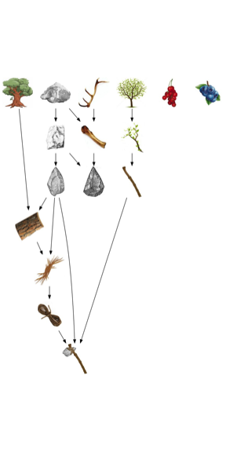

A sample of the solution landscape. The top row of 6 items were available to problem solvers at the start of the game. New items could be produced through the combination of different items (more than one arrow points to the item) or through the refinement of a single item (a single arrow points to the item). The axe is required to construct the first totem pole.

Participants discovered new tools by combining existing items. Participants could combine up to four items at a time (with replacement), meaning the initial six items could form a total of 1554 combinations. Of all possible combinations, very few resulted in new items. For example, of all the guesses that could be formed from the initial items, only three (0.2%) yielded new tools (Fig. 2). As participants accumulate solutions, the combinatorial complexity of the problem space increases exponentially such that the discovery of more complex tools is less likely to happen by chance.

Once a tool was discovered, the recipe for its creation—a list of the items that had to be combined in order to create the tool—was recorded in an innovation record. Participants could review their past innovations and see the recipes for their previous discoveries. **Participants assigned to generations after the first inherited the innovation record of the previous generation participant.** From the beginning of the experiment, these participants could review the recipes for all the innovations that had been discovered by their ancestor. Note that the participants inherited the recipes, but not the tools themselves. In order use these tools in futher combinations, the tools and all of their constituent parts first had to be recreated.

## Participants

Participants were recruited from the UW-Madison student body and received course credit in exchange for participation. Each participant was assigned to a single generation of a four-generation chain. Data was collected for a total of 42 teams (N=168 participants).

# Results

Participants who inherited the tools discovered by the previous generation took on average 8.2 minutes of the 25 minute session (32.8%) to recreate the inherited tools— a portion of the experiment we refer to as the learning period. The length of the learning period correlated positively with the number of inherited tools, *b* = 0.78 (SE = 0.04), *t*(114.0) = 21.32, *p* < 0.001 (Fig. 3). A small group of participants (N=11) took disproportionately long to recreate the tools they inherited perhaps because they were confused by the game interface. These participants are identified by X’s in all figures and are not included in any statistical analyses.

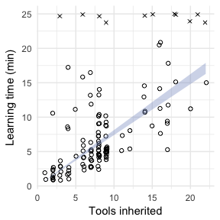

Learning rates. Correlation between the number of tools inherited and the time it took to recreate the inherited items. Outliers who were unwilling or unable to recreate the inherited items are shown as X’s, and excluded from analysis.

After recreating all inherited tools, participants attempted to discover new tools not discovered by their ancestor. Most participants (60.8%) were able to exceed the number of tools that they inherited *b* = 0.41 logodds (SE = 0.19), *z* = 2.13, *p* = 0.033 (Fig. 5A). Using Page’s trend test (a repeated measures test for monotonicity) we found that iterated problem solving resulted in cumulative improvements in the number of tools that could be discovered in 25 minutes along each transmission chain, Page’s *L* = 1193, $χ^{2}$ = 234, *p* < 0.001 (Fig. 4).

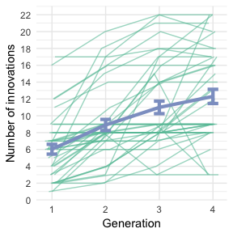

Number of innovations discovered by each generation. Each of the thin green lines is a chain. The thick blue line is the model predictions with ±1 standard error.

We next tested whether the benefit to inheritance changed over generations. We fit a hierarchical regression model to the number of tools discovered in each generation with these effects nested by chain. On average, second generation participants were able to discover 3.3 more tools than first generation participants, *b* = 3.27 (SE = 0.65), *t* = 5.04. This effect decreased by -0.4 each generation for third and fourth generation participants, *b* = -0.39 (SE = 0.20), *t* = -2.00—a diminishing return. In line with this result, we also found that an increase in the number of inherited tools was associated with a decrease in the number of new tools discovered by future generations of problem solvers, *b* = -0.13 (SE = 0.07), *t* = -1.91 (Fig. 5B). Together, these findings suggest that inheritance has a measurable influence on problem solving beyond providing a shortcut to individual learning. In this case, the impact appears to be negative, such that inheriting more solutions appears to *decrease* problem solving ability.

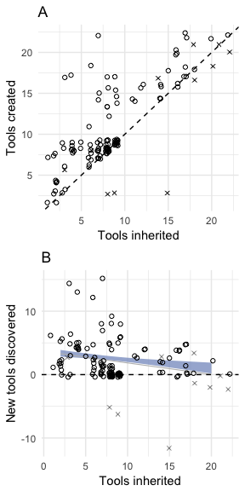

A. Number of tools created relative to those inherited. The dotted line is a reference with slope=1 such that points above the line indicate future generations exceeding their ancestors. B. Number of new tools relative to those inherited. The same reference line is now shown horizontally. The error range specifies the model predictions ±1 standard error. The thin gray line shows the regression line when outliers, shown as X’s, are included.

However, an alternative explanation, not having to do with inheritance negatively affecting problem solving ability, is that as more tools are accumulated, additional tools are less likely to be discovered by chance, meaning that problem solving might slow down regardless of what was inherited. To control for combinatorial complexity, we created an alternative outcome measure that, rather than counting all tools equally, instead weighted each tool relative to the number of guesses that could be made out of the items present at the time at which the tool was discovered. Fig. 6 shows the change in accumulated complexity score based on the number of tools that were inherited. In contrast to the analysis that treated all tools equally, when tools are weighted by combinatorial complexity, inheriting more tools was associated with an ever-larger improvement in total complexity score than inheriting fewer tools, *b* = 0.0047 (SE = 0.0015), *t* = 3.22.

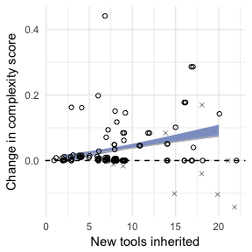

Change in accumulated complexity score by inheritance. Accumulated complexity scores are sums of discovered tools weighted by the combinatorial complexity of the possible choices available to the participant when the tool was discovered. The outcome measure is the difference between the accumulated complexity scores of subsequent generations. The line shows the predictions of a hierarchical regression model with ±1 standard error.

Participants who inherited more tools also took longer to recreate those tools (Fig. 3), leaving less time to discover new tools, To determine whether inheriting more tools had an impact on the rate at which new tools were discovered, we first report overall rates of new tool discovery, and then test whether the discovery rate is influenced by the number of inherited tools.

Fig. 7 shows problem solving rates based on the length of the discovery period. The overall rate of problem solving was 8.3 minutes per new innovation (0.12 innovations per minute), *b* = 0.12 (SE = 0.07), *t* = 1.77. This rate was not found to vary based on the number of inherited tools, as revealed by a model comparison comparing a model predicting unique innovations from playing time alone to one predicting unique innovations from the interaction between playing time and inheritance size. This suggests that the number of inherited tools did not meaningly influence the rate of future discovery.

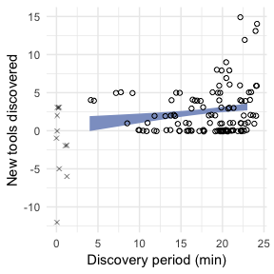

Problem solving rate in the discovery stage. Discovery time is the amount of time out of a 25 minute session dedicated to discovering new innovations that were not discovered by an ancestor. The line shows the predictions of the hierarchical regression model with ±1 standard error. The slope of this line did not significantly vary based on the size of the inheritance.

# Discussion

The ability to accumulate a body of socially learned problem solving knowledge is visible in all human cultures (Boyd 2017; Fernández-Armesto 2001). Although the capacity for cumulative improvement is believed to be integral to human cultural evolution, we do not fully understand how effectively problem solving knowledge can be utilized by future generations of problem solvers. How effective are human problem solvers at ratcheting up the tools and other solutions to problems that were discovered by previous generations? To answer this question, we investigated the ability of problem solvers to accumulate problem solving knowledge over four generations of iterated problem solving.

In contrast to previous research that has investigated how social learning strategies such as verbal instruction play a role in high fidelity transmission of problem solving knowledge, here we examined the likelihood that problem solving knowledge would accumulate given that problem solving knowledge could be effectively transferred to the next generation. Participants in our study inherited the solutions that had been discovered by their ancestor, and we measured their ability to recreate and extend this body of problem solving knowledge.

We found that problem solvers were consistently able to solve more problems in a single 25 minute session than their ancestors, and thus were able to cumulatively improve upon the solutions they inherited. All participants were expected to be able to recreate the tools they inherited, but whether they could discover new tools, beyond those inherited, was unknown. Given the combinatorial complexity of the solution landscape, participants were highly unlikely to strike upon a beneficial combination by chance alone. Because of this, some participants were unable to discover any new tools, but most did discover new tools, even when inheriting an already large number of previously discovered tools.

We also explored the impact of inherited solutions on future problem solving performance. Here our results were mixed. We found that problem solvers who inherited more tools tended to discover fewer new tools than their ancestors, suggesting that inheritance has a diminishing return on future problem solving performance. However, if the combinatorial complexity of the solutions is taken into account, we found that these problem solvers were able to accumulate more complex tools than they would have been likely to discover on their own. In addition, we found that controlling for the amount of time each participant had to discover new tools (as opposed to recreating inherited tools) failed to reveal an effect of inheritance size on the rate of problem solving.

Our conclusions are limited by the nature of the solution landscape in the Totems game, and the restriction in our methods to a single problem solving strategy. The sparsity of the solution landscape, where many thousands of possible combinations can be made but far less than 1% yield new tools, indicates that participants must use tacit knowledge to help form combinations that are most likely to yield new tools. For example, once an axe was discovered, its combination with the tree to create a totem was very likely. This challenges the notion that the difficulty of a particular tool is directly related to its combinatorial complexity. In addition, we believe the accumulation of problem solving knowledge through vertical transmission must be compared with the accumulation of problem solving knowledge through other forms of problem solving that do not involve vertical transmission. We are conducting additional experiments on the Totems game with isolated individuals who play the game for the same total time as multi-generation chains, as well as groups of problem solvers who play the Totems game in parallel, and thus share information through horizontal transmission. Results indicate that problem solving knowledge accumulated over generations is as effective as assembling problem solving knowledge using these alternative forms of collaboration.

More than any other animal, humans are particularly skilled at inheriting and improving tools and other solutions to problems, but whether the ability to inherit from others has effects on problem solving beyond giving a head start to individual learning is not known. Although much work is still needed to fully understand the human propensity for cumulative cultural evolution, we believe our research is a valuable contribution to ongoing efforts to understand how and why human culture is so integrally cumulative.

Alem, Sylvain, Clint J Perry, Xingfu Zhu, Olli J Loukola, Thomas Ingraham, Eirik Søvik, and Lars Chittka. 2016. “Associative Mechanisms Allow for Social Learning and Cultural Transmission of String Pulling in an Insect.” *PLoS Biology* 14 (10):e1002564–28.

Basalla, George. 1988. *The evolution of technology*. Cambridge University Press.

Boyd, Robert. 2017. *A Different Kind of Animal*. How Culture Transformed Our Species. Princeton, NJ: Princeton University Press.

Boyd, Robert, and Peter J Richerson. 1985. *Culture and the evolutionary process*. University of Chicago Press.

Dean, Lewis G, R L Kendal, S J Schapiro, B Thierry, and K N Laland. 2012. “Identification of the Social and Cognitive Processes Underlying Human Cumulative Culture.” *Science* 335 (6072):1114–8.

Derex, Maxime, and Robert Boyd. 2015. “The foundations of the human cultural niche.” *Nature Communications* 6 (September):1–7.

Fernández-Armesto, Felipe. 2001. *Civilizations: culture, ambition, and the transformation of nature*. Simon; Schuster.

Henrich, Joseph. 2015. *The secret of our success: how culture is driving human evolution, domesticating our species, and making us smarter*. Princeton University Press.

Hunt, G R, and R D Gray. 2003. “Diversification and cumulative evolution in New Caledonian crow tool manufacture.” *Proceedings. Biological Sciences / the Royal Society* 270 (1517):867–74.

Laland, KN, and K Williams. 1997. “Shoaling generates social learning of foraging information in guppies.” *Animal Behaviour* 53 (6):1161–9.

Lycett, Stephen J, and John A J Gowlett. 2008. “On questions surrounding the Acheulean ‘tradition’.” *World Archaeology* 40 (3):295–315.

Mercader, Julio, Huw Barton, Jason Gillespie, Jack Harris, Steven Kuhn, Robert Tyler, and Christophe Boesch. 2007. “4,300-year-old chimpanzee sites and the origins of percussive stone technology.” *Proceedings of the National Academy of Sciences of the United States of America* 104 (9):3043–8.

Morgan, Thomas J H, N T Uomini, L E Rendell, L Chouinard-Thuly, S E Street, H M Lewis, C P Cross, et al. 2015. “Experimental evidence for the co-evolution of hominin tool-making teaching and language.” *Nature Communications* 6 (January):6029–8.

Richerson, Peter J, and Robert Boyd. 2008. *Not by genes alone: How culture transformed human evolution*. University of Chicago Press.

Sanz, C, J Call, and D Morgan. 2009. “Design complexity in termite-fishing tools of chimpanzees (Pan troglodytes).” *Biology Letters* 5 (3):293–96.

Solé, Ricard V, Sergi Valverde, Marti Rosas Casals, Stuart A Kauffman, Doyne Farmer, and Niles Eldredge. 2013. “The Evolutionary Ecology of Technological Innovations.” *Complexity* 18 (4):15–27.

Tennie, C, J Call, and M Tomasello. 2009. “Ratcheting up the ratchet: on the evolution of cumulative culture.” *Philosophical Transactions of the Royal Society B: Biological Sciences* 364 (1528):2405–15.

Thorndike, E L. 1898. “Animal Intelligence.” *The Psychological Review* 2:1–113.

Torre, I de la. 2011. “The origins of stone tool technology in Africa: a historical perspective.” *Philosophical Transactions of the Royal Society B: Biological Sciences* 366 (1567):1028–37.

Whiten, A, J Goodall, W C McGrew, T Nishida, V Reynolds, Y Sugiyama, CEG Tutin, R W Wrangham, and C Boesch. 1999. “Cultures in chimpanzees.” *Nature* 399 (6737):682–85.