Demo 3 - Targeting other formats

We now have a variable indicating the data-set to load:

filename <- "./got_avgs.csv"

Load some data:

Print the first 10 rows of the data as a table:

|  |  |  |  |  |  |  |
| --- | --- | --- | --- | --- | --- | --- |
| Series | Season | EpNum | OverallEp | Episode | Rating | Votes |
| Game of Thrones | 1 | 1 | 1 | Winter Is Coming | 9.0 | 22920 |
| Game of Thrones | 1 | 2 | 2 | The Kingsroad | 8.8 | 17473 |
| Game of Thrones | 1 | 3 | 3 | Lord Snow | 8.7 | 16565 |
| Game of Thrones | 1 | 4 | 4 | Cripples, Bastards, and Broken Things | 8.8 | 15783 |
| Game of Thrones | 1 | 5 | 5 | The Wolf and the Lion | 9.1 | 16744 |
| Game of Thrones | 1 | 6 | 6 | A Golden Crown | 9.2 | 16520 |
| Game of Thrones | 1 | 7 | 7 | You Win or You Die | 9.2 | 16864 |
| Game of Thrones | 1 | 8 | 8 | The Pointy End | 9.0 | 15389 |
| Game of Thrones | 1 | 9 | 9 | Baelor | 9.6 | 21999 |
| Game of Thrones | 1 | 10 | 10 | Fire and Blood | 9.5 | 19417 |

The data in a plot:

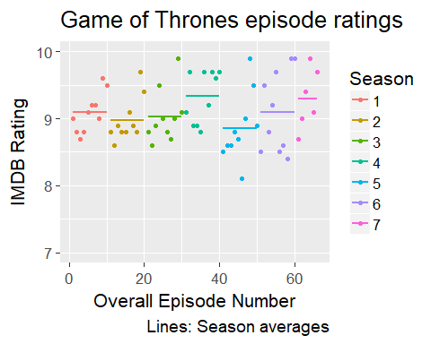

The highest rated episode of *Game of Thrones* is "Battle of the Bastards" with a rating of 9.9 from 147461 votes.