Computer programming

Final Project

Report

I.E.S. San Vicente
San Vicente del Raspeig (Alicante)
2015/2016

Teacher:
José Ignacio Cabanes

Student:
Pedro Antonio Pérez Paterna

1. Introduction
Project name
Review of highschool subject: Physics
Made by
Pedro Antonio Pérez Paterna

Short description of the project
This is a review of some fundamental constants and solver of some problems about physics as well as some theoretical concepts that the student must don’t forget.

2. Functionality of the project
After entering the program, an introduction screen will we displayed, where there are some buttons to go to next screens that allow some features of the proyect. The options at the buttons are:

• Show fundamental concepts of physics.
• Show constants with his name, symbol and value.
• Solve an equation of initial position, acceleration, energy, Hmax, velocity. Also an option to plot the result of the equation at a graph.
• Show historical of all the solved problems.
• Ability to save and load solutions, problems and concepts.
• Bilingual program mode, allows to change language between Spanish and English.

In this proyect the user it’s allowed to put an easy equation of position(initial and final), acceleration, hMax, force, parabolic shoot, energy… as well as it plots their graphs in case of initial position equation, final position equation, parabolic equation and hMax.

3. Screen prototype
The review of physics main screen will look like this:

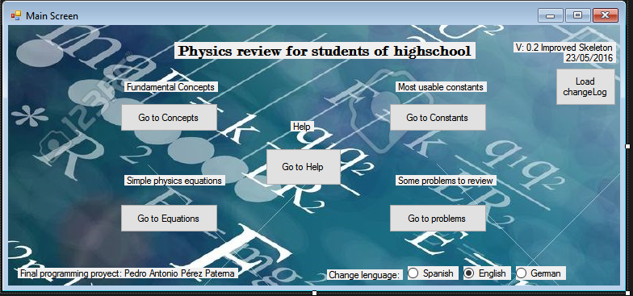

4.Analysis

4a. Requisites
Requisite | Date achieved
Functional skeleton of the program with all the windows linked one to another with some initial text and decoration. | 13/05/2016
Improved skeleton of the proyect, added changelog screen, improved equationsWF class and put constants table at ConstantsWF class | 23/05/2016
Load concepts from a file as an example ,zoom text of concepts when you click zoom+ and zoom- buttons.Also calculate acceleration and velocity and reedited Equations.cs. | 24/05/2016
Simplified all the equations by one per each class and added export option to export all the solutions of the equations. | 25/05/2016
Corrected export acceleration result option, load historical of acceleration results, first attempt to embed a youtube video, more equations methods implemented(velocity and hmax and Vo). | 27/05/2016

4b. Basic pseudocode

Main program screen
Click on a button
If button == equations → Go to equations window
If button == constants → Go to constants window
If button == problems → Go to problems solver window
If button == concepts → Go to basic concepts window
Program windows
If window == equation Name
Wait till the user enter equation at the textbox and proceed
Obtain the textbox values and operate using the method for solve the equation
Show solution at read only textbox.
If plot == yes
Plot a graph
If window == concepts
Show a listbox with basic concepts and a button to search by word.
If option == Load
Load a file with some concepts stored at it.
If option == Save
Save actual items of the listbox to a file
If window == constants
Show a table layout with constant name, symbol, value and unit
Save constants to a file
Load constants from file
Add constants to the table layout
If window == problems
Show a problem to solve
Input a problem to solve
Load problems from file
Save solutions to a file
Show historical of problems solved
Solve a problem
Use a constant value of the textbox at the table layout of the window of constants

4c. Classes diagram
Need some extra modifications and attributes, not finished yet.

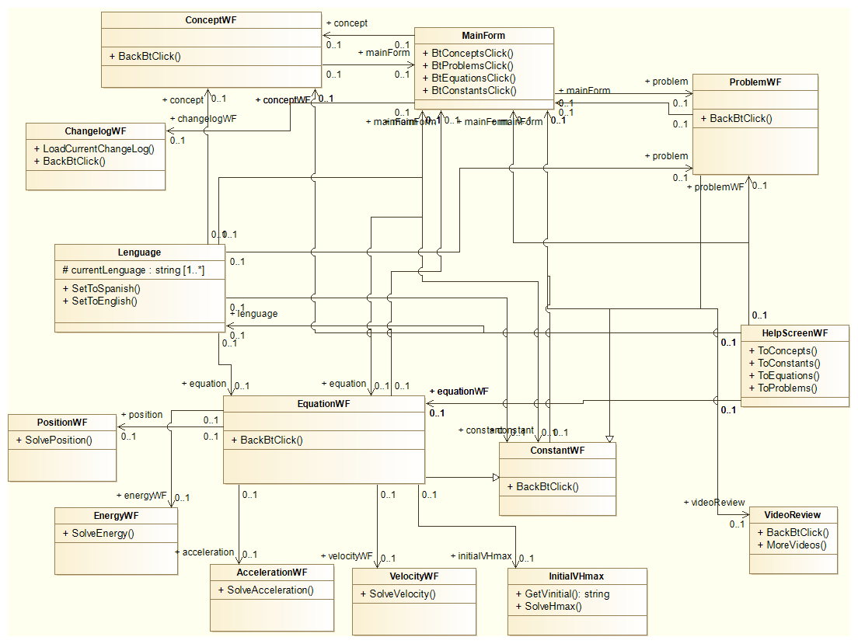

5. Initial planning and expected deliveries

5a. Expected deliveries

1º Delivery: Create the empty skeleton with navigation between the varioues fomrs of the proyect and also add some text in each and many options to choose at each form.
2º Delivery : Creating a display window with my name , the current version and the current changelog. Also put content to each window as important terms and concepts of physics.
3ª Delivery: Add the values ​​of the constants , so if the user press the button with the text : " Go see constant ... " ,the user goes to a new form with all the constants and have the ability to search the desired constant.
4º Delivery: Make small equations as initial position , final position , Hmax , acceleration. The user enters in a textbox the known values ​​from which will be calculated equations . The result will be visible through another textbox marked as readonly . In addition, be safe that the user inputs correctly values at the textboxes.
5º Delivery: Make the load historical of acceleration equations solved, to load the file, use “openfiledialog” and to show the data use a richtextbox. Fill position class, energy class, velocity clas and initialVHmax with textboxes,labels and code of each equation(More information commented at the acceleration class). Add more complex equations as parabolic shoot, cinetic energy, volume and pressure(Grab an image of each formula and put it into a picture box,then show the picture box as an info for the user).
6º Delivery: At the same form of the equation, there will be an option to choose if the user wants to plot a graph of the equation.
7º Delivery: Once the result of the equation is obtained, a button will appear with the text: “Export solution to a file” and the solution will be exported to a plain text document (.phy) extension.
8º Once the equation to solve is choosen and the user is at the form of the equation, one option at a menustrip is to load the values from a file and put into a textbox. The external document must contains the values as exactly the same order of the equation. IE: if you want to load a file with a final position equation to solve, the format must be the same as the formula of final position: “xf = 4+8*t+1/2*9*2^2”. The program will ignore the first term and the equal and sum symbol and will catch all the numbers ordened.
9º Delivery: Make a dropdown with the history of problems that has been solved.
10º Delivery: Make a bilingual program with a button to change between Spanish and English lenguage.
11º Delivery: Continue of the 11º delivery.
12º Delivery: Grant to the user the option to download physic problems from a web.
13º Delivery: Expand the equations part with new topics such as termodynamics, momentum, angular acceleration and period and frecuency.
14º Delivery: Interaction with the user, the user prompts the result of a problema and the program tells if it’s the correct solution or not by drawing a green tick or red tick.
15º Delivery: Final adjustements of all the parts up to the date of the proyect and check the correct functions of all the things at the proyect.

5b. Real deliveries
- Version 1 (May 13): Skeleton of the program with all the windows linked one to another with some initial text and decoration. Functional but not do anything yet.
- Version 2(May 23): Improved skeleton with added constants table layout, improved equationsWF and can load changelog text file of the history of all changelogs of the proyect.
- Version 3(May 24): Load concepts from a file as an example ,zoom text of concepts. Now can calculate acceleration and velocity equations and reedited Equations.cs ( more reedit work to do for the next delivery of the equations class, splitting on individual forms ).
- Version 4(May 25): Simplified the weight of all the labels, equations and methods of equations.cs to individual classes in order to be more organized. Also added export function to export to a file an historical of solved equations(TODO: Make functional the export to a file method, by now does not generate any file).

6. File formats

6a. Plain files format
The program uses his own file format, that’s .phy. Only this program can load these files and manipulate.

For concepts:
Concept name: Definition

Concept name: Definition

For historical of equations solved:
Using appendalltext method.
Variable1value: 2 | Variable2value = 7 | Resultvalue = 9

6b. Entity-Relationship Diagram (If needed)
(…)

7. Problems found and solutions
I started with visibility of the elements at the Equations form, at the 0.03 version there is only 1 form for equations and there are a lot of elements so I started to split it to diferent individual windows forms to simplify the problem and the caotic initial form. At the version 0.04 this issue was solved and everything went fine. If you want to solve an acceleration equation, then you click on acceleration button at EquationsWF and it goes to a new form that is dedicated only to solve that equation, it’s the same procedure for other equations.
Reorganized classes diagram adding more classes and making it more reasonable to my real classes of the proyect.

8. Improvements or restrictions to the starting design
I have had time enough to include the effect of animation when the pieces fall (…)

I have not been able to implement (…) because of (…)

9. Screenshots of the final project
(…)

10. Source code of the final project
(…)

