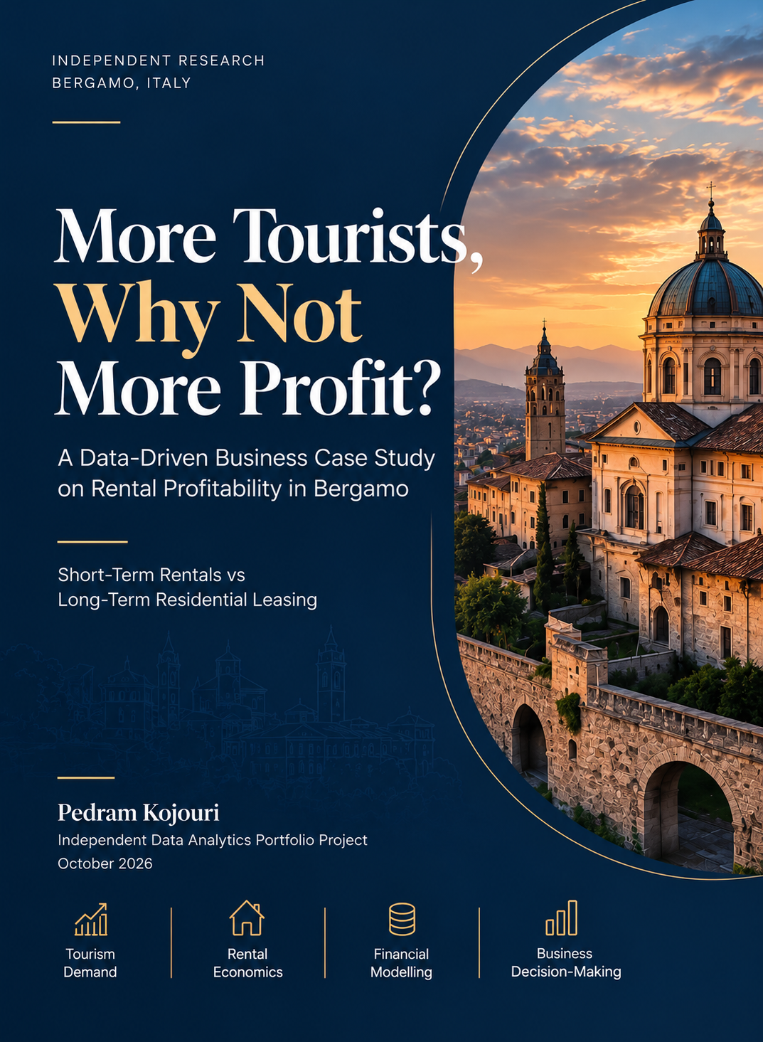
Business
Decision-Making
Financial
Modelling
Rental
Economics
Tourism
Demand
October 2026
Independent Data Analytics Portfolio Project
Pedram Kojouri
Short-Term Rentals vs
Long-Term Residential Leasing
A Data-Driven Business Case Study
on Rental Profitability in Bergamo
More Profit?
Why Not
More Tourists,
INDEPENDENT RESEARCH
BERGAMO, ITALY

