
Business
Decision-Making
Financial
Modelling
Rental
Economics
Tourism
Demand
October 2026
Independent Data Analytics Portfolio Project
Pedram Kojouri
Short-Term Rentals vs
Long-Term Residential Leasing
A Data-Driven Business Case Study
on Rental Profitability in Bergamo
More Profit?
Why Not
More Tourists,
INDEPENDENT RESEARCH
BERGAMO, ITALY

Executive Summary
More Tourists, Why Not More Profit?
A Data-Driven Business Case Study on Rental Profitability in Bergamo
Pedram Kojouri | October 2026

Main business finding
More tourists do not automatically mean more profit for property owners. This study asks whether a vacant apartment in Bergamo would retain more annual cash as a short-term tourist rental (STR) or a long-term residential lease (LTR).
Financial comparison
Under the owner-operated, sample-mean illustration:
- STR: €6,544.50 annual net cash
- LTR: €6,677.83 annual net cash
- Difference: €133.33 per year in favour of LTR
Annual net cash is what remains after the cash costs and tax included in the model. It is not comprehensive economic profit or a complete investment return. The gap is too small relative to input uncertainty to establish a decisive advantage. These are conditional scenario results, not observed city-wide average profits.
What does this mean for property owners?
Converting a vacant apartment into tourist accommodation is not necessarily a better financial decision than finding a long-term tenant. Platform fees, owner-paid cleaning, utilities and other operating costs reduce the cash retained from gross short-term revenue. Guest turnover, uncertain bookings and management requirements also matter; not all are fully priced in this comparison.
Evidence and limitations
A manual review of online rental listings reconstructed 96 candidate rows: 21 original records, 20 preliminary leads and 55 additional advertisements. These overlapping inputs are not 96 independent apartments. Reviewed identity decisions and strict comparable-property criteria produced 14 primary properties, with mean monthly asking rent €894.29 and median €850. The target of 20 was not reached; the selected sample is not representative of all Bergamo, and asking rents are not signed contracts.
The illustration uses the unrounded primary mean, holding other assumptions fixed. STR assumes 180 booked nights out of 330 available and €115 gross nightly revenue, which is not a verified comparable realised rate. LTR assumes 12 paid months. Eligible tax treatment must be checked. Operating costs include estimated allowances, rather than verified property-specific expenditure. Owner time is unpriced; acquisition, financing and professional management are excluded. Incremental preparation is tested separately through five-year simple recovery. The historical €900 monthly-rent scenario remains separate, with €6,732 annual LTR net cash; it likewise does not establish a decisive market-wide ranking.
Decision implication
The base case does not demonstrate that conversion is financially superior to long-term leasing. Before deciding, an owner needs achievable prices and bookings, a credible long-term alternative, verified operating and compliance costs, and an assessment of preparation investment and management time. Stronger property-specific performance could change the comparison; tourism growth alone is insufficient.

Contents
Main business finding 1
1 Introduction and analytical scope 3
Geography and evidence 3
Definitions and validation 3
2 Tourism demand and competing supply 4
Source reconciliation 4
Supply and geography 4
2.1 The role of Bergamo Airport in tourism demand 5
2.2 Airport and city growth compared 6
3 Short-term performance and seasonality 7
Monthly allocation and its limits 8
Neighbourhood differences 8
4 The long-term rental comparison 9
Study scope and comparable-property criteria 9
Candidate reconciliation and property identity 10
Price normalisation and source reconciliation 11
Primary and secondary rental statistics 11
Rental distribution and comparable offers 12
Independent benchmarks and measurement differences 13
Historical and evidence-informed financial scenarios 14
Updated sensitivity and break-even thresholds 15
Conversion thresholds under the new rent 16
5 Revenue, Costs and Net Cash Income 17
Fixed-cost budget and uncertainty 18
Regulatory feasibility 19
6 Sensitivity and preparation costs 19
Break-even and calculation checks 19
Long-term rent and differential-cost sensitivity 20
Additional preparation changes the threshold 21
7 Research methodology and challenges 22
Reproducibility and review 22
8 Conclusions and limitations 23
Supported findings 23
Unresolved evidence 23
References 24
Appendix A Rental registry audit 27
Appendix B Complete rental candidate reconciliation 28
Original C records 28
Preliminary A leads 29
Additional N advertisements 29
Rental evidence references 32

1 Introduction and analytical scope
The project began with an apparent opportunity: more visitors might mean more rental income. Historic Città Alta and access to BGY provided a reason to investigate, but were not treated as proof of profitability. The research question became: under what conditions would short-term renting retain more annual cash than a residential lease?
The investigation moved through three questions. Is accommodation demand growing? Is rental performance improving after allowing for available nights and competing supply? How much revenue remains after tax and operating expenses? The last question introduces long-term renting as an opportunity cost rather than comparing a nightly price directly with monthly rent.

Geography and evidence
Comune di Bergamo, ISTAT code 016024, is the principal unit. Province-wide totals and municipalities near the airport are context only. Airport passengers are not unique overnight visitors to the city. Events and holidays may explain variations, but no event revenue premium or airport-to-booking conversion is assumed.
Official regional data support the historical city series; local official reports supplement annual context. FULL research supplies historical Airbnb estimates derived from AirDNA. Asking-rent listings illustrate alternatives, not executed contract prices. FULL and AirDNA are not independent corroborating sources. Scenario calculations are kept separate from observations.

Definitions and validation
Measure | Interpretation
Arrivals | Recorded guest arrivals; not necessarily unique people.
Guest nights | One guest for one night. Three people for two nights produce six guest nights but two apartment booked nights.
Booked nights | Nights reserved for a listing.
Occupancy | Booked nights divided by available nights, not automatically by 365.
ADR | Provider-defined revenue per booked night; included cleaning charges and fee deductions must be checked.
Net cash income | Revenue less modelled cash costs and tax, not total investment return.

Monthly observations for 2019–2024 were filtered to the city, checked for twelve distinct months and reconciled to the regional annual dataset. All six years reconcile within that source. Reference years and geography remain explicit. Financial formulas are checked separately from market interpretation. [1–2]

2 Tourism demand and competing supply
Regional city data show 791,353 guest nights in 2019 and 1,208,189 in 2024, approximately 52.7% growth. Arrivals rose from 414,871 to 601,824. The 2025 official local report records 666,254 city arrivals and 1,359,923 guest nights. This indicates growth beyond the pre-pandemic level, although the 2025 total comes from a separate release. [1–4]
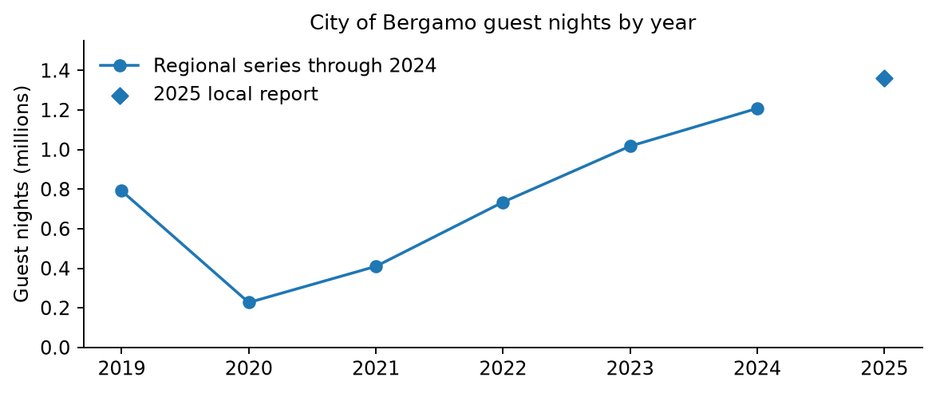
Figure 1 City guest nights from 2019 to 2025
The line uses the reconciled regional series through 2024. The separate diamond identifies the 2025 local-report total. Growth measures aggregate guest demand, not income or profit per listing. Sources [1–4].

Source reconciliation
The May 2025 local release gives 601,825 arrivals and 1,208,193 guest nights for 2024, compared with 601,824 and 1,208,189 in the regional extract. October differs by 27 guest nights: 123,433 versus 123,460. The cause is not confirmed. The report uses the regional series consistently for historical calculations rather than silently blending releases. [1–3]

Supply and geography
The Province recorded 3,359,760 guest nights in 2025, approximately 38% above 2019. Its non-hotel establishment count increased from 3,443 to 4,405 between 2024 and 2025. These counts cannot establish a shortage or saturation in the city: the geography differs and establishments are not beds or open days. National coverage of private non-business rentals has changed; the effect on the local series still needs validation. [4, 6]
FULL reports 1,884 city Airbnb listings active for at least one day in 2024, up 74.3% from 2017. Booked nights rose 182.8% over that period. Availability, listing mix, prices and costs prevent a direct conclusion that every host’s return improved. [5, pp. 12–18]

2.1 The role of Bergamo Airport in tourism demand
BGY adds a large regional access channel to the business story. We joined Assaeroporti annual passenger totals to city arrivals and guest nights by calendar year for 2019–2025. For each year, the January–December passenger total was selected, rather than the December-only row. The annual summary and passenger-detail tables agree. City values through 2024 use the reconciled regional extract; 2025 uses the separately identified provincial publication. [1–4, 37–43]
Year | BGY passenger movements | City arrivals | City guest nights
2019 | 13,857,257 | 414,871 | 791,353
2020 | 3,833,063 | 101,948 | 226,903
2021 | 6,467,296 | 197,642 | 409,696
2022 | 13,155,806 | 368,024 | 734,334
2023 | 15,974,451 | 513,659 | 1,017,202
2024 | 17,353,573 | 601,824 | 1,208,189
2025 | 16,937,976 | 666,254 | 1,359,923

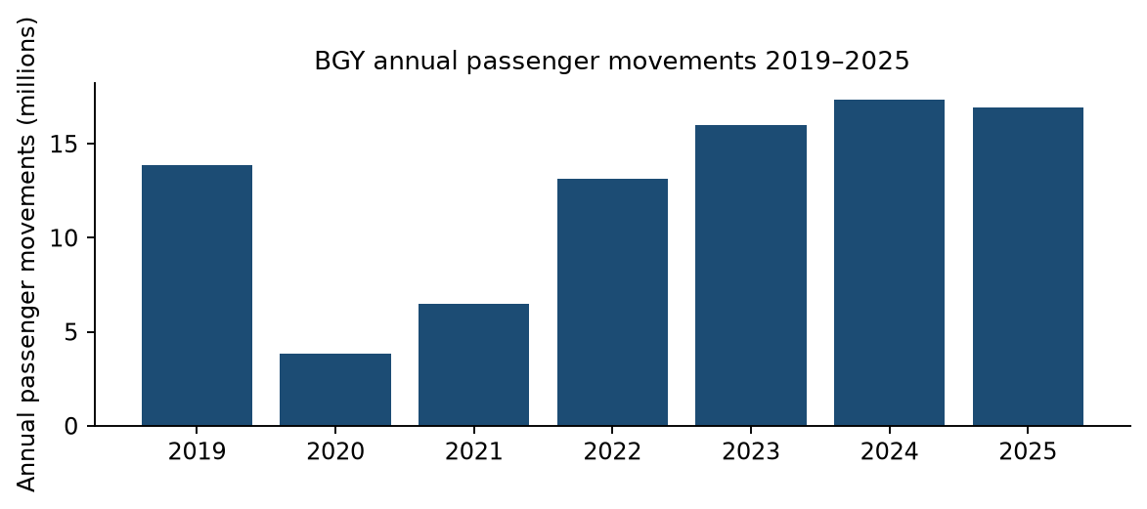
Figure 2 BGY annual passenger movements
Source: Assaeroporti, January–December cumulative passenger totals, 2019–2025. [37–43] This airport activity metric counts passenger movements rather than unique tourists staying in Bergamo. The 2020–2021 decline and later recovery affect comparisons across the full window.

2.2 Airport and city growth compared
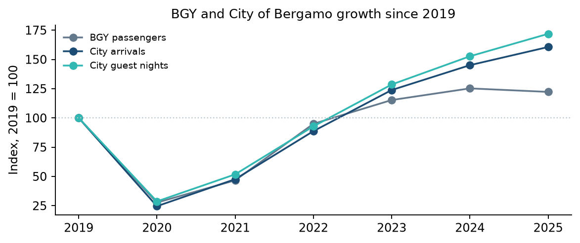
Figure 3 Indexed annual airport and city trends
Each series is divided by its 2019 value and multiplied by 100. Indexing compares relative growth across different units without treating passengers, arrivals and guest nights as equivalent counts. Sources: [1–4, 37–43]. The 2025 city value comes from a separate release.
Year | BGY passenger movements (%) | City arrivals (%) | City guest nights (%)
2020 | -72.3% | -75.4% | -71.3%
2021 | +68.7% | +93.9% | +80.6%
2022 | +103.4% | +86.2% | +79.2%
2023 | +21.4% | +39.6% | +38.5%
2024 | +8.6% | +17.2% | +18.8%
2025 | -2.4% | +10.7% | +12.6%

Relative to 2019, BGY passengers were 25.2% higher in 2024 and 22.2% higher in 2025. City guest nights grew by 52.7% and 71.8% respectively. In 2025, airport passengers fell 2.4%, while city arrivals grew 10.7% and guest nights grew 12.6%. The city therefore continued expanding even when airport activity declined. The series share a recovery period but do not move in lockstep.
This is a descriptive comparison of seven annual observations. Pandemic disruption, accommodation supply, event calendars and wider travel trends can move both series. We do not estimate a causal effect or a passenger-to-stay conversion rate. Airport passengers include departing and arriving trips and travellers whose destination may lie outside the city. Accommodation also serves visitors using other transport. Dividing city arrivals by airport passengers would not identify the share staying locally.
Business implication: airport access deserves attention when considering guest segments, arrival times and average stay length, but the airport trend does not justify increasing the 180-night assumption or adding a location premium. One-night airport stays could increase cleaning turnovers; this remains a hypothesis. Neighbourhood effects, airline-specific traffic and net profit attributable to BGY require matched property and guest-origin evidence.

3 Short-term performance and seasonality
FULL reports overall Airbnb occupancy falling from 57.8% in 2023 to 54.0% in 2024, a reduction of 3.8 percentage points. Entire apartments in 2024 show 54.9% occupancy and approximately EUR 115 ADR. Across all listing types, average annual bookings were 134 nights and average revenue EUR 14,182. The all-listing figure is not an entire-apartment benchmark. [5, pp. 16–20]
The financial model uses EUR 115 as illustrative gross nightly revenue before the assumed host fee and income tax. It is not a validated direct import of provider ADR. AirDNA includes cleaning charges and may adjust service fees; revenue definitions must be reconciled to avoid subtracting a fee twice. Multiplying separately averaged price and occupancy also need not reproduce average listing revenue. [7–8]
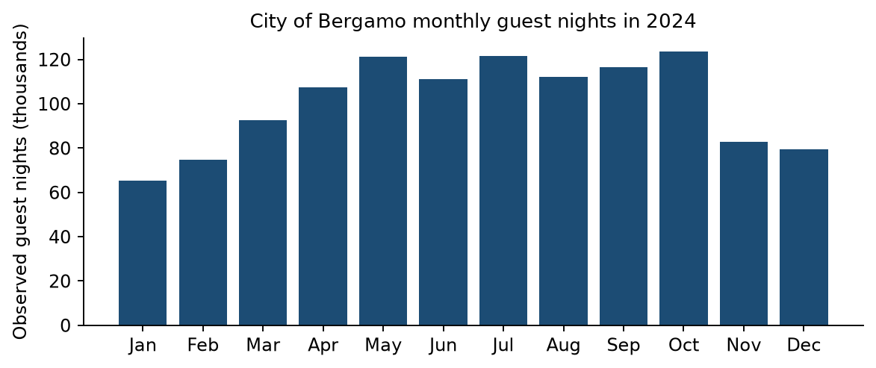
Figure 4 Observed monthly city guest nights in 2024
October leads the guest-night series shown here; July leads arrivals, which are not plotted. The bars include hotels and non-hotels. They identify the city’s seasonal demand, not Airbnb occupancy or fully booked apartments. Source [1].
April–October accounts for 65.5% of city guest nights in 2019, 67.3% in 2022, 67.4% in 2023 and 67.3% in 2024. October leads guest nights in each of those years. High demand does not mean full occupancy: FULL reports a 2024 overall monthly maximum of 69% in May and a minimum of 34% in January. [1, 5]

Monthly allocation and its limits
For each reference year, monthly daily guest nights are divided by that year’s annual daily mean. The indices are averaged equally across 2019, 2022, 2023 and 2024, multiplied by non-leap-year month lengths and normalised into shares. Largest-remainder rounding preserves the annual scenario total. The calendar calculation is not observed 2025 data.
Annual totals of 150, 180 and 210 booked nights are sensitivity assumptions, not confidence intervals. The 180-night base implies 54.5% occupancy only if 330 nights are available. Availability and annual bookings remain assumptions. The method estimates distribution, not the correct annual total.
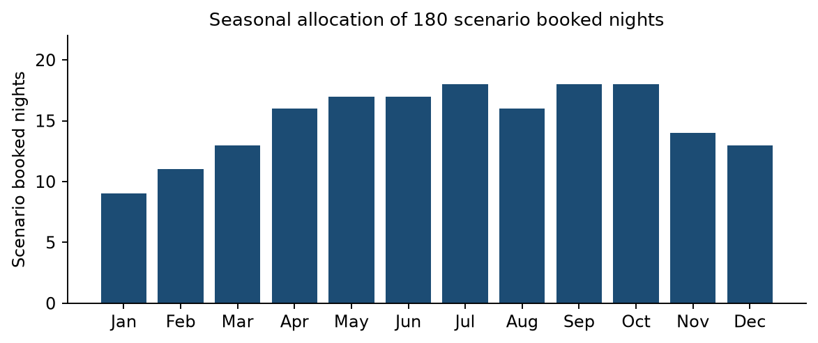
Figure 5 Monthly allocation of the 180-night scenario
January receives nine nights; July, September and October receive eighteen each. April–October receives 120 nights or 66.7%. These are allocations, not reservations observed on Airbnb. Tourism seasonality is an unvalidated proxy for short-term seasonality. Derived from [1].
With a constant price and constant per-booked-night costs, changing the monthly distribution does not change annual net cash. The allocation improves the description of timing; seasonal prices and stay lengths would be needed to measure its financial effect. Allocating annual fixed costs evenly across months is reporting, not actual payment timing.

Neighbourhood differences
Area | Reported annual revenue per listing (EUR, 2024)
Centro–Papa Giovanni | EUR 21,829
Città Alta | EUR 19,712
Centro–Pignolo | EUR 17,321
Centro–Sant’Alessandro | EUR 14,976
Borgo Palazzo | EUR 14,740

These averages are unadjusted descriptive comparisons, not a profitability ranking. Size, capacity, quality, available days and acquisition costs may differ. No causal location premium is estimated. A table is used instead of a league-chart presentation to avoid implying a superior investment area. [5, pp. 28–32]

4 The long-term rental comparison
The rental evidence was reconstructed through a manual review of online rental listings on 14 October 2026. The 96 candidate rows contain the original 21 records, 20 preliminary leads and 55 additional advertisements actually investigated. These input sets overlap. They do not establish 96 independent apartments. Source content, contract terms and base prices were checked where accessible, with unresolved leads retained in the audit.
The strict selected sample contains 14 distinct comparable advertisement-based property groups, with arithmetic mean EUR 894.29 per month and median EUR 850.00. Its recorded base rents sum to EUR 12,520.00. The target of 20 primary properties was not reached. This is a convenience sample of source-verified offers, not a representative city rent or a confirmation that all apartments remain available. The historical EUR 900 model is retained separately.

Study scope and comparable-property criteria
The operational selection uses Comune di Bergamo advertisements labelled Centro or Sant'Alessandro, or explicitly located at Piazzetta Santo Spirito. These are source-defined central urban labels, not an official polygon or an invented radius. Stazione, San Paolo, Canovine, Borgo Palazzo and other labels alone are outside this selected scope. Source labels can differ across portals and do not replace property-level geocoding. OMI B2 is used only as an external reference; the sample is not claimed to occupy that single zone.
Primary criterion | Rule
Property | Entire furnished apartment; two rooms and one bedroom
Size | 40–65 advertised m² inclusive
Contract | Explicit ordinary 4+4; a documented 4+4 option may qualify
Price | Monthly base asking rent; separately billed charges excluded
Evidence | Source details reviewed; no unresolved identity or material feature/price conflict

A separate secondary cohort retains central furnished one-bedroom offers of 40–80 advertised m² with larger size or annual/free/unspecified ordinary residential duration. Temporary and serviced offers, inaccessible historical-only records and material contradictions do not enter either cohort. The geographic and size criteria were not loosened to reach the target. The data dictionary and source register document every decision. [R01–R03]

Candidate reconciliation and property identity
Stage | Count and interpretation
Original / preliminary / additional rows | 21 / 20 / 55
Total rows / distinct source URLs | 96 / 89
Confirmed duplicate clusters / rows removed | 2 / 2
Canonical groups including unresolved identities | 94
Probable duplicate review pairs | 6
Primary / secondary properties | 14 / 11
Excluded canonical groups including unresolved | 69
Unresolved candidate rows | 18
Total independent physical apartments | Unknown for unresolved leads and probable matches

Exact URL repeats merge input rows. Different URLs merge only after a reviewed match using distinctive description, floor, size, contract and advertiser signals. Torquato Tasso 75 is the same recovered advertisement in C13 and A05. Sant'Orsola 25 is a confirmed cross-platform apartment match, but its EUR 850 and EUR 900 headlines disagree, so the cluster is excluded rather than selecting a preferred price. Canonical groups include provisional identities and are not a verified physical-property census.
Borfuro 9 remains a probable cross-platform match: distinctive annual-renewable wording, second floor and EUR 110 charges agree, but 50/55 m² and EUR 1,200/1,000 disagree. Two third-floor Camozzi offers may differ only by a EUR 150 parking option; both are excluded pending unit confirmation. Conversely, Zambianchi 2 versus 3 and Sant'Orsola 2 versus 25 have different civic numbers and property attributes. The old Quarenghi/Borfuro price overlap did not justify treating them as a duplicate. [R03]
Origin reconciliation: two original properties and two newly eligible preliminary leads contribute to the primary cohort, alongside 10 additional properties. A05 overlaps the original C13 and does not add a new apartment. The source registry retains all original links and the six unresolved exact-URL leads.
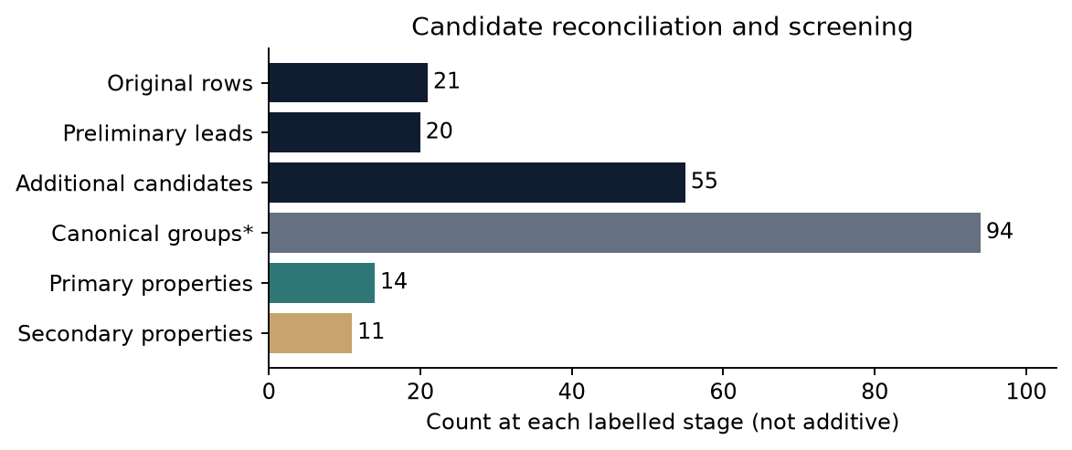
Figure 6 Candidate reconciliation and screening
Stage counts describe different sets and are not additive. Canonical groups include unresolved identities; they are not a physical-property total. Source: candidate registry and reviewed identity decisions.

Price normalisation and source reconciliation
The original CSV is unchanged: 17 recorded numeric rents total EUR 17,240 and have a descriptive mean EUR 1,014.12, while four prices remain missing in that historical snapshot. The 20 preliminary lead prices total EUR 17,185 and average EUR 859.25. Neither raw statistic describes 20 or 21 independently verified comparable properties. Four historical missing prices were recovered as new observations: Broseta 10 EUR 1,300, Moroni 237 EUR 1,000, Paleocapa EUR 700 and Mazzini 24 EUR 1,300. All four remain outside the primary cohort by contract, property or location criteria.
At Broseta 44, the retrieved source advertises a EUR 900 package including utilities and condominium, alongside a separate EUR 120 condominium field. It does not corroborate the proposed EUR 590 base plus EUR 120 charges plus EUR 190 services split. No base rent is inferred and the transitory offer is excluded. At Pignolo 23, the source explicitly distinguishes EUR 850 base rent and EUR 50 reimbursement, EUR 900 total. The EUR 850 headline is already base rent and is not reduced again. Deposits, optional garages and tenant-billed charges do not become owner rent. [R02]
A supplied Cucchi bilocale link now displays a studio near Piazza Sant'Anna, so it does not verify A03. Partigiani 4 conflicts with Torretta 10 in the same advertisement. One central offer's narrative says furnished one-bedroom while its structured fields say unfurnished and zero bedrooms. These contradictions are recorded and excluded. Expired advertisements and older search-cache details remain in the audit without being relabelled as current comparables.

Primary and secondary rental statistics
Measure (rent statistics in EUR/month) | Primary | Secondary
Property count | 14 | 11
Arithmetic mean / month | EUR 894.29 | EUR 979.09
Median / month | EUR 850.00 | EUR 900.00
Sample standard deviation | EUR 180.59 | EUR 227.40
Minimum / maximum | EUR 650.00 / EUR 1,200.00 | EUR 700.00 / EUR 1,500.00
Quartiles Q1 / Q3 | EUR 755.00 / EUR 987.50 | EUR 825.00 / EUR 1,110.00
Interquartile range | EUR 232.50 | EUR 285.00

Means use unrounded individual base rents, standard deviation uses n−1 and quartiles use inclusive linear interpolation. Secondary observations are not pooled into the primary mean. The historical six-record subgroup remains a separate snapshot with mean EUR 1,000 and median EUR 900; neither statistic is the new sample result.

Rental distribution and comparable offers
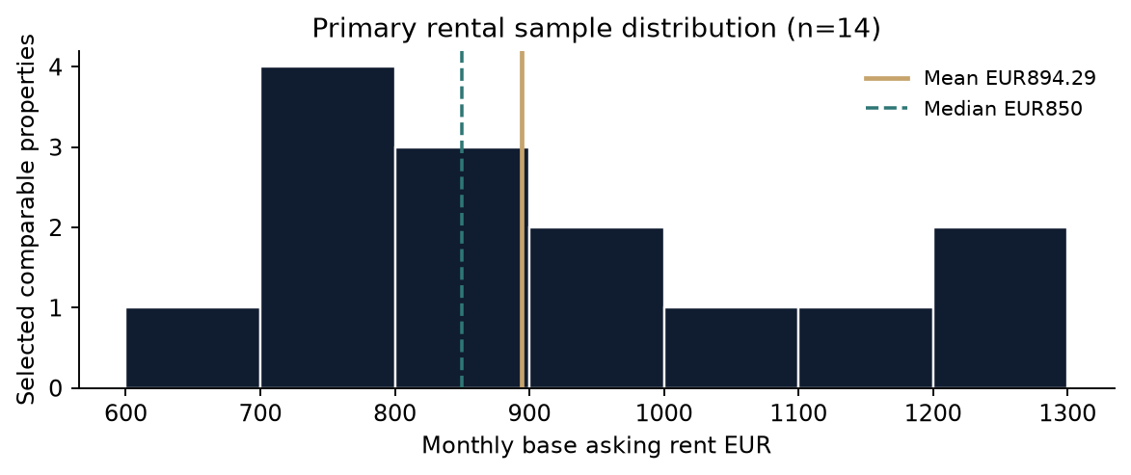
Figure 7 Primary monthly base-rent distribution
14 selected properties; mean EUR 894.29, median EUR 850.00. The distribution shows sample dispersion, not population uncertainty or a representative market range. Source: primary-comparable-sample.csv.
Property group | Location | Base EUR/month | Advertised m²
P-A01 | via Sant'Orsola 2 | 950 | 50
P-A05 | via Torquato Tasso 75 | 850 | 45
P-A07 | via Ezio Zambianchi 3 | 850 | 40
P-C14 | via Antonio Locatelli 37 | 1,100 | 60
P-N05 | via Sant'Alessandro 65 | 1,200 | 60
P-N11 | via Broseta 14 | 1,000 | 45
P-N18 | via Giuseppe Garibaldi | 750 | 50
P-N20 | via San Lazzaro 7 | 1,200 | 64
P-N25 | via Broseta 18 | 950 | 51
P-N27 | via San Lazzaro | 700 | 41
P-N39 | via Pignolo 17 | 700 | 56
P-N41 | Centro; street not stated | 650 | 45
P-N45 | piazza Pontida | 770 | 65
P-N54 | Via Pignolo 23 Piazzetta Santo Spirito | 850 | 65

These are public research identifiers. Source links, floors, charges and contract evidence are in the canonical registry and source register. Included garages, condition and floor differences remain. Some advertisements have old update dates; retrieval on the review date does not verify uninterrupted availability. No executed-rent panel, property inspection or advertiser confirmation was obtained.

Independent benchmarks and measurement differences
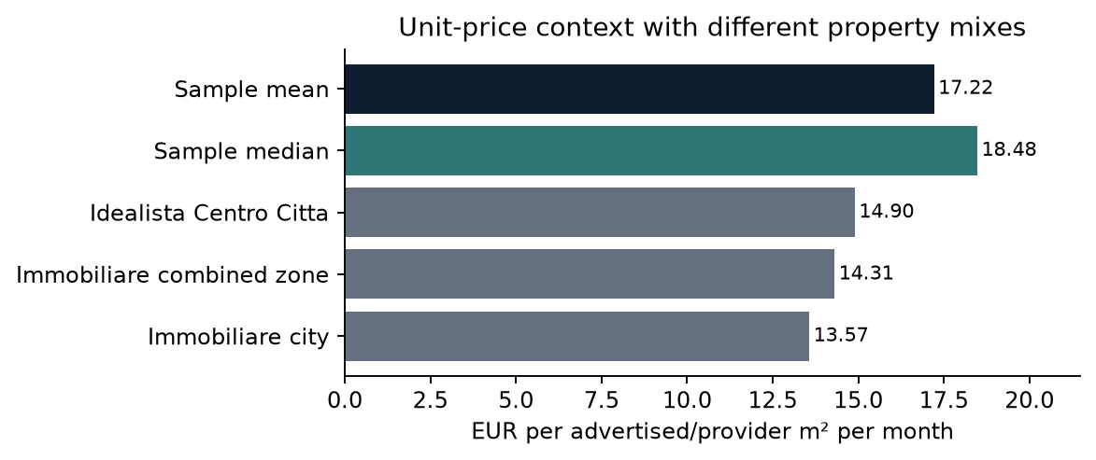
Figure 8 Rental unit-price context
Primary values average individual base-rent/advertised-area ratios. Provider indicators cover different housing mixes and zone boundaries; the bars are contextual, not comparable property valuations. Benchmarks: September 2026 provider reports. OMI net-area ranges are stated separately.
The primary mean is EUR 17.22 and median EUR 18.48 per advertised m² per month. Advertising areas may include weighted gardens, terraces or other accessories. These denominators differ from OMI's net-area basis. Source platform and contract counts are reproducible in rental-market-analysis.json; the primary sample contains 13 Immobiliare.it offers and one Subito offer, all with an explicit 4+4 branch.
Source and period | Geography and rental metric (EUR/m²/month)
Idealista September 2026 | City EUR 14.20/m²; Centro Città EUR 14.90/m²
Immobiliare.it September 2026 | City EUR 13.57/m²; combined Borgo Palazzo/Centro/Stazione EUR 14.31/m²
OMI 2025 second semester | B2 civil dwellings, normal: EUR 9.70–12.50 per net m²/month
OMI 2025 second semester | B2 civil dwellings, excellent: EUR 12.00–15.00 per net m²/month

Idealista's July 2026 revision describes filtered and deduplicated advertisements, microzone medians and weighted geographic aggregation. Immobiliare's retrieved page reports broad residential averages without the detailed weighting specification. The previously suggested EUR 14.28 Centro value was not reproduced: the retrieved combined-zone value is EUR 14.31. These indicators are not the arithmetic mean of furnished bilocali. [R04–R06]
The official interactive OMI table displayed 2025/2 for Bergamo A794 zone B2, Centrale Via Verdi/Via dei Partigiani/Via Tasso. Its semiannual condition-specific ranges are not September–October 2026 asking-rent indices or a valuation of the sampled apartments. They are not multiplied by a chosen size to replace the sample rent. The source-register benchmark links and data dictionary preserve period, property category, methodology and surface basis. [R07]

Historical and evidence-informed financial scenarios
The evidence-informed illustration uses the new primary arithmetic mean EUR 894.29, carried at full precision, and preserves every other model input. LTR net = 12 × monthly base rent × (1 − 0.21) − 1,800. It assumes 12 paid months and eligible tax, not observed vacancy-free income. No monetary owner-time deduction, financing or acquisition costs are introduced.
Measure | Historical EUR 900/month rent | Sample-mean illustration
Monthly base rent | EUR 900.00 | EUR 894.29
LTR gross (EUR/year) | EUR 10,800.00 | EUR 10,731.43
LTR net cash (EUR/year) | EUR 6,732.00 | EUR 6,677.83
STR net cash (EUR/year) | EUR 6,544.50 | EUR 6,544.50
STR minus LTR (EUR/year) | EUR -187.50 | EUR -133.33

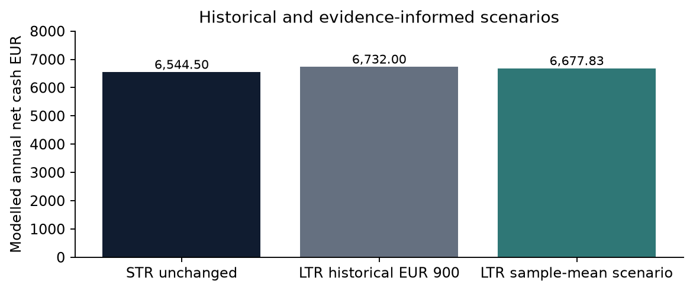
Figure 9 Annual net cash by scenario
Only monthly LTR base rent changes between the historical and sample-mean illustrations; all other model inputs remain fixed. The unrounded sample mean drives the new LTR calculation; rounding is for display only. The amounts are conditional annual net cash estimates, not comprehensive economic profit. Owner time is unpriced, and actual property-specific expenses may differ from the modelled allowances.
The new rent is only EUR 5.71 below the historical assumption. LTR remains higher by EUR 133.33 per year under the stated base. Such a small gap does not establish market superiority. At the new mean, eleven paid months reduce LTR net to EUR 5,971.34; changing payment continuity alone can reverse the ranking.

Updated sensitivity and break-even thresholds
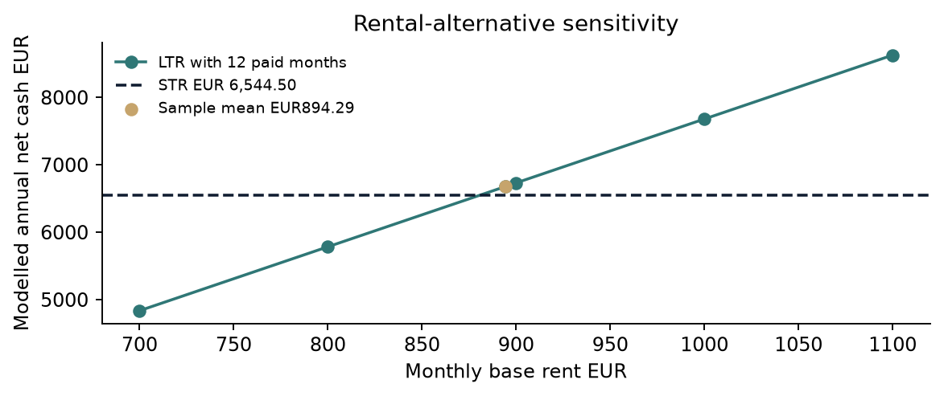
Figure 10 Rent sensitivity and sample-mean scenario
Rent sensitivity isolates the rental alternative while STR stays at EUR 6,544.50. It does not predict attainable rent or occupancy. Source: shared financial formulas and canonical sample mean.
STR additional fixed EUR/year | Historical STR−LTR (EUR/year) | Sample-mean STR−LTR (EUR/year)
600 | EUR 412.50 | EUR 466.67
1200 | EUR -187.50 | EUR -133.33
1800 | EUR -787.50 | EUR -733.33

Reducing STR-specific fixed costs raises STR relative cash; changing common costs equally for both strategies leaves the gap unchanged. Price, bookings and costs interact in practice, so these isolated tests are conditional. The existing EUR 100/115/130 nightly-price and 150/180/210 booked-night grid is preserved and compared against the new rental alternative in the results JSON.

Conversion thresholds under the new rent
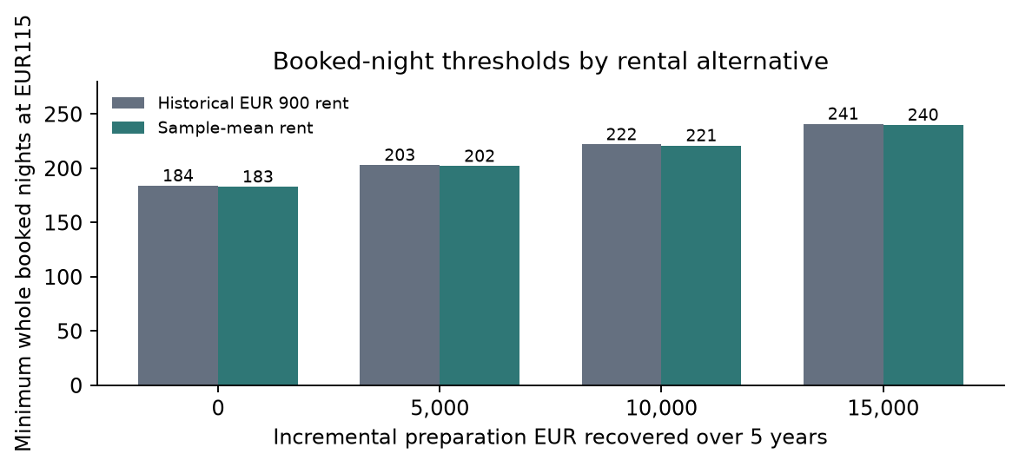
Figure 11 Booked nights required by rental alternative
EUR 115 gross nightly revenue; incremental preparation recovered over five years. Required nights use the ceiling function, never conventional rounding. These are cash-equivalence requirements, not occupancy forecasts or proof of overall economic superiority; the required booked nights or nightly price must be achievable for the same property.
Extra setup (EUR) | Historical booked nights/year | Sample-mean booked nights/year | Sample-mean price at 180 nights (EUR/night)
0 | 184 | 183 | EUR 116.17
5,000 | 203 | 202 | EUR 124.92
10,000 | 222 | 221 | EUR 133.66
15,000 | 241 | 240 | EUR 142.41

Without extra setup, the new comparison requires 183 booked nights at EUR 115, or EUR 116.17 gross per night at 180 booked nights. With EUR 15,000 additional preparation and five-year recovery, it requires 240 nights or EUR 142.41 at 180 booked nights. The historical thresholds remain 184/203/222/241. A required surplus still has to be achievable in the same property.

5 Revenue, Costs and Net Cash Income
This chapter retains the historical operating scenario. Chapter 4 provides the separate comparison using the new rental mean; neither scenario represents observed property profit.
The base rental is owner-operated and already suitable for guests. Cleaning is entirely owner-paid, with no cleaning charge collected separately. No hypothetical cost for the owner’s time is deducted. Professional management would be an additional cash expense.
Input | Base value and status
Bookings and availability | 180 / 330 nights; scenario assumptions
Gross nightly revenue | EUR 115; reference-informed assumption
Host fee and eligible income tax | 15.5% and 21%; scenario rates
Cleaning and stay length | EUR 30 per turnover; 3 nights; unverified
Other variable costs | EUR 10 per booked night; allowance
Annual fixed costs | EUR 3,000: common EUR 1,800 + STR-specific EUR 1,200

EUR 115 is a reference-informed modelling assumption for gross accommodation revenue before host fees and income tax. It has not been verified as an observed, directly comparable gross ADR. The scenario collects no separate cleaning charge; provider ADR definitions must be reconciled before replacing this input.
At three nights per stay, 180 nights imply sixty turnovers and EUR 1,800 cleaning expense. At two nights per stay, the same cleaning price implies EUR 2,700; at five nights per stay, EUR 1,080. Laundry, linen and materials must be assigned once, not duplicated across allowances.
The 15.5% fee is a host-paid structure assumption, not universal. Airbnb documents different structures and says displayed service fees include VAT where applicable; VAT is not added again here. Account and channel mix require verification. [13]
The 21% tax is conditional on eligibility. Equal model rates do not prove equal legal treatment. Tax is applied to model gross revenue before platform fees. Separately collected and remitted tourist tax is not retained revenue. IMU, TARI and property-specific compliance expenses are not individually priced and must be checked against the allowances. [14–16]
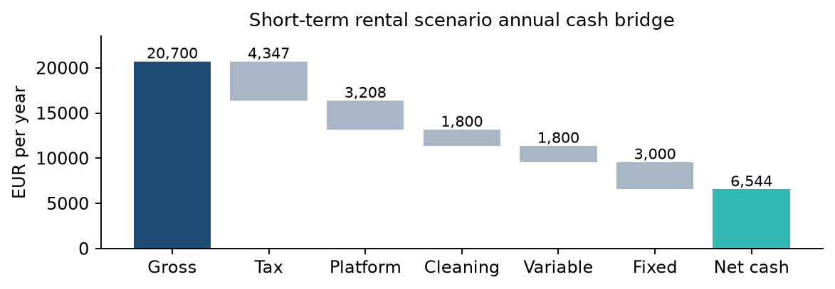
Figure 12 Historical short-term rental cash bridge
EUR 20,700 gross is reduced by EUR 4,347 tax, EUR 3,208.50 host fees, EUR 1,800 cleaning, EUR 1,800 variable costs and EUR 3,000 fixed costs. EUR 6,544.50 remains, about 31.6% of gross. These deductions include estimated cleaning, variable-cost and fixed-cost allowances. The resulting scenario margin is not an observed city margin or a complete accounting of property-level economic costs. Source: project assumptions and calculations; EUR 115 is not a verified comparable gross ADR.

Fixed-cost budget and uncertainty
Net cash = booked nights × gross nightly revenue × 0.635 − booked nights × EUR 20 − EUR 3,000. The EUR 20 combines cleaning and other variable costs. Acquisition, debt service, incremental preparation and professional management are excluded; exceptional maintenance may exceed allowances.
The following is an illustrative allocation of the existing EUR 3,000 allowance, not local supplier quotes or measured owner spending. Ranges are analyst-selected stress values, not confidence intervals. Property tax eligibility, tenant-paid charges and actual bills must replace them for a property decision. Keeping the base total unchanged isolates the effect of transparency rather than silently changing the result.
Annual item | Base EUR | Stress range EUR
Common insurance | 250 | 150–400
Common routine maintenance | 400 | 200–700
Common property-tax reserve | 800 | 0–1,300
Common owner building charges | 350 | 150–600
Common subtotal | 1,800 | 900 / 1,800 / 2,700 tested as totals
STR standing utility / internet charges | 400 | 200–650
STR administration / compliance reserve | 300 | 100–500
STR guest-wear replacement reserve | 400 | 200–700
STR marketing / miscellaneous | 100 | 0–150
STR incremental subtotal | 1,200 | 600 / 1,200 / 1,800 tested as totals

Standing charges exclude usage already charged at EUR 10 per booked night. Guest-wear replacement excludes ordinary maintenance in the common allowance. Cleaning, laundry and consumables must be assigned once within cleaning or variable expenses. A reserve is a budgeting allowance, not an observed payment; realised annual cash will differ.
Changing a truly common cost by the same amount under both strategies changes both net incomes equally and leaves their difference unchanged. STR-specific expenses change the ranking. Some charges may not be common in practice; transferability must be checked, particularly building charges, waste tax and insurance.

Regulatory feasibility
Classification, regional and municipal filings, CIN, guest reporting and safety must be checked. CIN does not establish full local compliance. Reviewed municipal provisions address building usability and installations, with additional conditions in mapped historic areas. Applicable amendments and later court decisions remain to be confirmed. Unresolved compliance costs are not silently assumed to be zero. [16–18]

6 Sensitivity and preparation costs
In the preserved historical EUR 900 scenario, short-term net cash is EUR 6,544.50 versus EUR 6,732 long-term. The EUR 187.50 difference is about 2.8% of long-term net cash. It is a mechanical model result, not a robust preference when input uncertainty is unquantified.
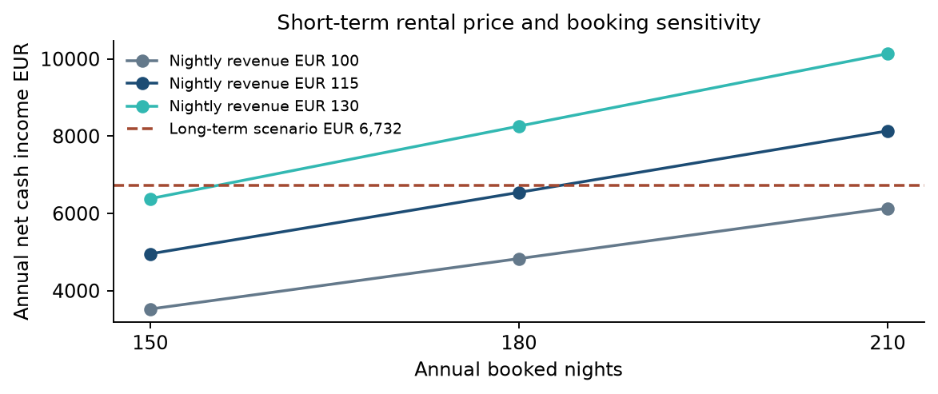
Figure 13 Historical booking and nightly-price sensitivity
The dashed line is the long-term scenario, not a market average. At 180 nights, short-term net cash ranges from EUR 4,830 at EUR 100 to EUR 8,259 at EUR 130. Higher prices may reduce reservations. The combinations are conditional calculations, not forecasts. Source: project scenario calculations.

Break-even and calculation checks
At EUR 115, each booked night contributes EUR 53.025 before fixed expenses. Matching long-term cash requires (6,732 + 3,000) / 53.025 = 183.54 nights, rounded up to 184. At 180 nights, the required price is EUR 116.64. Increasing price by EUR 1 adds EUR 114.30 annual cash, holding bookings fixed. One additional percentage point of host fee costs EUR 207; EUR 5 less cleaning per turnover saves EUR 300 across sixty turnovers.

Long-term rent and differential-cost sensitivity
Monthly rent EUR | Long-term net EUR/year | STR minus LTR EUR/year
700 | 4,836.00 | +1,708.50
800 | 5,784.00 | +760.50
900 | 6,732.00 | -187.50
1,000 | 7,680.00 | -1,135.50
1,100 | 8,628.00 | -2,083.50

All rows assume twelve paid months, eligible 21% tax and EUR 1,800 owner costs. These are scenario values, not five observed market segments. At the base short-term performance, equal cash occurs at about EUR 880.22 monthly long-term rent. The choice of alternative rent therefore matters as much as the short-term inputs.
STR additional fixed EUR/year | LTR EUR 800/month | LTR EUR 900/month | LTR EUR 1,000/month
600 | +1,360.50 | +412.50 | -535.50
1200 | +760.50 | -187.50 | -1,135.50
1800 | +160.50 | -787.50 | -1,735.50

Cells show short-term minus long-term annual net cash, in EUR. Positive cells favour short-term on cash alone; negative cells favour long-term. Common costs are held at EUR 1,800 and all other base inputs are held constant. At EUR 900 rent, changing the STR-specific budget from EUR 1,200 to EUR 600 reverses the gap from minus EUR 187.50 to plus EUR 412.50. A EUR 600 higher budget produces minus EUR 787.50. Joint price and booking feasibility remains untested.

Additional preparation changes the threshold
Only expenditure above the long-term alternative is relevant to conversion. A five-year simple recovery target adds preparation cost divided by five to the required annual surplus. It leaves operating cash unchanged and is not a market-required horizon or a discounted investment appraisal.
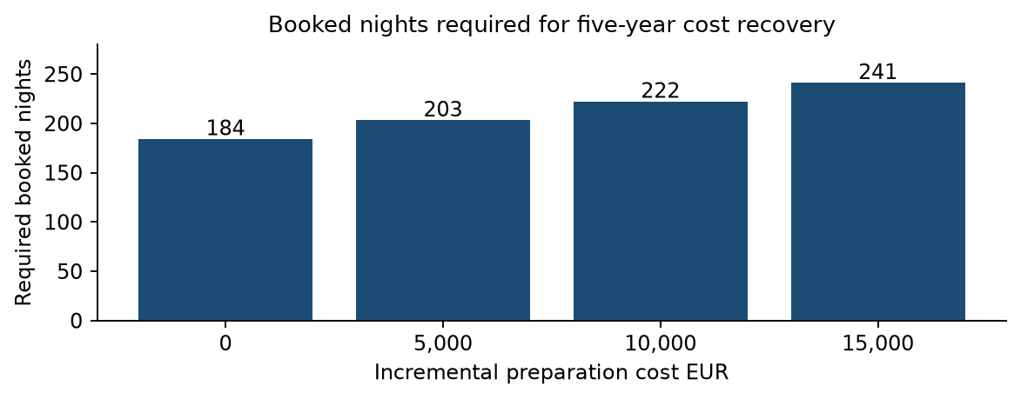
Figure 14 Historical booking threshold with five-year simple recovery
At EUR 115 nightly revenue, the model requires 184, 203, 222 and 241 nights for EUR 0, EUR 5,000, EUR 10,000 and EUR 15,000 additional preparation. The latter thresholds match long-term cash and recover the cost difference over five years. They do not predict achievable occupancy. Source: project calculations with explicit scenario inputs.
Additional preparation (EUR) | Booked nights/year at EUR 115/night | Gross price at 180 nights (EUR/night)
EUR 0 | 184 | EUR 116.64
EUR 5,000 | 203 | EUR 125.39
EUR 10,000 | 222 | EUR 134.14
EUR 15,000 | 241 | EUR 142.89

Required booked nights are always rounded UP to the next whole night using the ceiling function; conventional rounding would understate the minimum. Unrounded thresholds are 183.54, 202.40, 221.25 and 240.11 nights using the stated formula. These are scenario requirements, not occupancy forecasts.
The two performance columns are alternatives, not simultaneous improvements. Financing, inflation, discounting and residual equipment value are excluded. Already suitable properties face a close operating comparison; costly conversion requires a substantiated surplus. More visitors alone cannot justify that investment.

7 Research methodology and challenges
The investigation began with an opportunity hypothesis, then changed its emphasis as evidence challenged the assumption that more visitors necessarily improve owner profit. The workflow combines validated market observations with an explicit decision model. It stops short of identifying a causal airport effect or an average investment return.
Research challenge | Action and remaining limit
City versus province | Filter tourism to Bergamo 016024. Province supply and airport traffic remain contextual, not city apartment reservations.
Conflicting releases | Reconcile monthly and annual regional totals, retain local-release differences including 27 October guest nights. Revision cause unresolved.
Guest nights versus booked nights | Use tourism for seasonal shape. Do not convert peak months into full occupancy. The annual totals of 180 booked nights and 330 available nights remain assumptions.
Price definitions | Treat EUR 115 as a reference-informed gross model input. Provider ADR may include cleaning or fee adjustments.
Rental comparability | Reconcile 96 candidate rows, confirm 2 duplicate clusters and retain 6 probable match reviews. 14 primary properties average EUR 894.29; the 20-property target is unmet. Historical EUR 900 scenario retained separately.
Operating budgets | Itemise allowances and vary differential costs. Values are illustrative budgets, not supplier quotes. Avoid double counting cleaning and usage.
Airport aggregation | Join seven annual totals by year; check cumulative versus December-only records. Compare indexed trends and annual growth without claiming causality.
Different time windows | Identify historical 2024 short-term estimates and 2026 rental asks. No same-period matched profitability panel exists.
Decision uncertainty | Stress-test both strategies and preparation costs. Do not interpret sensitivity ranges as confidence intervals.

Reproducibility and review
The public repository includes frozen numerical inputs, listing screening decisions and executable Python calculations. Monthly sums match six annual controls. Seasonal allocation preserves annual totals. Break-even checks verify that the chosen whole-night threshold meets the target and one fewer night does not. Airport totals reconcile across two tables within each source year. Financial and airport comparison scripts run offline.
Future evidence that could change the ranking includes comparable realised price and booked nights, contract rents for the same units, supplier quotes and applicable legal costs. A larger matched dataset would permit property-level modelling. Seven annual aggregates alone do not justify causal inference or a reliable multivariable regression.

8 Conclusions and limitations
More tourists do not necessarily mean more profit. City demand and Airbnb activity have expanded, but this study does not establish a general net-income advantage for short-term renting across Bergamo. Market opportunity and an owner’s retained cash are different outcomes.
The historical EUR 900 scenarios are close: EUR 6,544.50 short-term versus EUR 6,732 long-term. The reconstructed 14-property mean of EUR 894.29 gives long-term net EUR 6,677.83, still only EUR 133.33 above the same short-term scenario. This new selected sample does not retroactively verify a 21-property mean. Stronger bookings, higher realised prices or lower expenses can reverse the result. Their joint attainability needs evidence. Preparation costs raise the requirement; buying and financing property remain a separate question.

Supported findings
The city has substantial accommodation demand and a recurring broad high-demand season. Seasonal allocation should replace a uniform description of demand. Taxes and operating expenses reduce the attraction implied by gross short-term receipts. The financial choice depends on the rental alternative, cost structure and conversion expenditure.

Unresolved evidence
The airport comparison establishes relative trends and a 2025 divergence, but does not identify local stays or a causal profit effect. The study has not measured typical city profit, optimal investment neighbourhoods, a guaranteed 180-night total, realised monthly ADR, or the return on purchased property. Monthly tourism is a proxy for reservations; 330 nights of supply remains assumed. The official monthly dataset extracted here ends in 2024; a complete 2025–2026 monthly city series is not validated.
A matched sample needs size, capacity, furnishing, condition, neighbourhood and available nights. The reconstructed 14-property primary cohort uses an explicit central-label selection and reviewed identity decisions, but remains a convenience sample below the 20-property target. Some leads are inaccessible, fees or addresses conflict and probable matches remain unresolved. The original 21-record snapshot remains historical; four missing prices were recovered in separate new observations without modifying it. Provider revenue must be reconciled before fee subtraction. The broader secondary cohort is reported separately. Actual availability, signed rents, amenity adjustments and exact boundary geocoding remain unmeasured. Monthly price and reservations should be paired within the same segment and period; unrelated averages do not support a correlation analysis.
Utilities, cleaning, maintenance, insurance, property taxes and compliance already have modelled amounts or allowances; these are not verified property-specific expenditures. Actual bills, applicable regulatory costs and exceptional repairs must be checked against those budgets. Long-term vacancy and payment continuity also need property-specific validation. Owner time is excluded by design; professional management, acquisition and financing are outside base operating cash. Incremental preparation is tested separately through five-year simple recovery rather than deducted from base operating cash. Data-release differences and revisions remain documented.
Final answer: tourism growth establishes a market opportunity, but the present model identifies a near break-even comparison of annual net cash income under its assumptions. Neither strategy has a demonstrated robust economic advantage. The evidence does not support a general recommendation to convert homes or establish comprehensive economic profit. A conclusive property-level decision requires verified realised prices and booked nights, a credible long-term rental alternative and a more complete assessment of operating costs, management effort and conversion expenditure.

References
Sources are placed at the end and cited by number in the text. Source checks and dataset retrieval took place during the project through 14 October 2026; not all source pages were re-fetched during the final review. Publication dates and coverage are distinguished. Asking-rent observations are snapshots, not a permanent live listing inventory.
[1] Regione Lombardia / PoliS. Monthly municipal tourist flows, 2019–2024; Bergamo 016024. Twelve months reconciled for every year.
https://www.dati.lombardia.it/d/mzxz-sz25
[2] Regione Lombardia / PoliS. Annual municipal tourist flows. Total city series used as control.
https://www.dati.lombardia.it/d/vyxt-7jdx
[3] Provincia di Bergamo. Tourism 2024 release, 21 May 2025. City totals and October peak; small differences from the regional extract.
https://www.provincia.bergamo.it/cnvpbgrm/po/mostra_news.php?id=2163
[4] Provincia di Bergamo. Tourism 2025 and early 2026 release, 14 May 2026. City/province separately; attached report pp. 8 and 15–21. Early 2026 figures labelled estimated.
https://www.provincia.bergamo.it/cnvpbgrm/po/mostra_news.php?area=H&id=2591
[5] Chiodelli F. and Cassiani F. (2026). Chi gestisce Airbnb a Bergamo e dintorni. FULL. Author-posted research using AirDNA; data 2017–2024. Relevant pp. 12–20 and 28–32.
https://www.researchgate.net/publication/405451146_Chi_gestisce_Airbnb_a_Bergamo_e_dintorni_L%27evoluzione_del_fenomeno_degli_affitti_brevi_tra_il_2017_e_il_2024
[6] ISPRA. Tourism infrastructure statistics and notes on private non-business rental coverage.
https://indicatoriambientali.isprambiente.it/it/infrastrutture-turistiche
[7] AirDNA Help Center. ADR definition, including cleaning charges.
https://help.airdna.co/en/articles/8062173-how-does-airdna-calculate-average-daily-rate-adr
[8] AirDNA Help Center. Data updates, fee treatment and calendar classification.
https://help.airdna.co/en/articles/9305810-airdna-data-updates
[9] Immobiliare.it. Bergamo residential asking-rent overview; September 2026 reference period.
https://www.immobiliare.it/mercato-immobiliare/lombardia/bergamo/
[10] Idealista 36732340. Calepio 47 m²; EUR 900; furnished 4+4 lease.
https://www.idealista.it/immobile/36732340/
[11] Idealista 36084937. Borfuro 55 m²; EUR 1,000 plus EUR 110; annual contract.
https://www.idealista.it/immobile/36084937/
[12] Idealista 36830219. Moroni 50 m²; EUR 700 plus EUR 50; temporary 12-month lease.
https://www.idealista.it/immobile/36830219/
[13] Airbnb Help Center. Fee structures and VAT treatment.
https://www.airbnb.com/help/article/1857
[14] Agenzia delle Entrate. Building-income instructions; gross short-let receipts and eligible rate guidance. The 2026 return covers 2025 income.
https://infoprecompilata.agenziaentrate.gov.it/portale/sl/web/guest/semplificata-mod-fabbricati
[15] Regione Campania SURAP. Updated tax-guide notice, 16 April 2026; identifies 2026 threshold change.
https://surap.regione.campania.it/index.php/notizie/1096-locazioni-brevi-pubblicata-la-nuova-guida.html
[16] Ministero del Turismo. BDSR FAQ; CIN and safety, separate from local compliance.
https://www.ministeroturismo.gov.it/faq-banca-dati-strutture-ricettive-bdsr/
[17] Comune di Bergamo. Official mapping metadata for regulation 124/2025; not a complete legal clearance.
https://territorio.comune.bergamo.it/arcgis/rest/services/AtlanteBG/AppartamentiTuristici_Rif_PDR05_RegCom124_2025/MapServer
[18] Municipal regulation reproduced by Studio Buzzanca, December 2025; articles 1 and 4–8. Current official text and subsequent decisions require verification.
https://www.studiobuzzanca.com/wp-content/uploads/2025/12/regolamento-comunale-sui-requisiti-qualitativi-per-le-strutture-ricettive-non-alberghiere-.pdf
[19] Expanded listing 132189102; 4+4; garage bundled; 60 dwelling / 70.5 commercial; factual snapshot, 13 October 2026.
https://www.immobiliare.it/annunci/132189102/
[20] Expanded listing 133410334; Affitto, transitorio; factual snapshot, 13 October 2026.
https://www.immobiliare.it/annunci/133410334/
[21] Expanded listing 132644842; 4+4; optional garage excluded; factual snapshot, 13 October 2026.
https://www.immobiliare.it/annunci/132644842/
[22] Expanded listing 70888294; factual snapshot, 13 October 2026.
https://www.immobiliare.it/annunci/70888294/
[23] Expanded listing 80219117; Affitto, transitorio; factual snapshot, 13 October 2026.
https://www.immobiliare.it/annunci/80219117/
[24] Expanded listing 130803940; Affitto, 4+4; factual snapshot, 13 October 2026.
https://www.immobiliare.it/annunci/130803940/
[25] Expanded listing 132502222; Affitto, 4+4; factual snapshot, 13 October 2026.
https://www.immobiliare.it/annunci/132502222/
[26] Expanded listing 133336888; 4+4 offered; alternative temporary contract also offered; factual snapshot, 13 October 2026.
https://www.immobiliare.it/annunci/133336888/
[27] Expanded listing 129790224; Affitto; factual snapshot, 13 October 2026.
https://www.immobiliare.it/annunci/129790224/
[28] Expanded listing 127707676; Affitto, transitorio; factual snapshot, 13 October 2026.
https://www.immobiliare.it/annunci/127707676/
[29] Expanded listing 124638879; factual snapshot, 13 October 2026.
https://www.immobiliare.it/annunci/124638879/
[30] Expanded listing 133410286; factual snapshot, 13 October 2026.
https://www.immobiliare.it/annunci/133410286/
[31] Expanded listing 120078316; Affitto; factual snapshot, 13 October 2026.
https://www.immobiliare.it/annunci/120078316/
[32] Expanded listing 132219784; 4+4; factual snapshot, 13 October 2026.
https://www.immobiliare.it/annunci/132219784/
[33] Expanded listing 73676006; Affitto, libero; factual snapshot, 13 October 2026.
https://www.immobiliare.it/annunci/73676006/
[34] Expanded listing 121511946; factual snapshot, 13 October 2026.
https://www.immobiliare.it/annunci/121511946/
[35] Expanded listing 111380853; Affitto, transitorio; factual snapshot, 13 October 2026.
https://www.immobiliare.it/annunci/111380853/
[36] Expanded listing 132513280; 4+4; optional garage excluded; later re-fetch failed; factual snapshot, 13 October 2026.
https://www.immobiliare.it/annunci/132513280/
[37] Assaeroporti. 2019 December traffic tables, January–December cumulative total for Bergamo. Summary and passenger-detail totals reconcile. Retrieved 13 October 2026.
https://assaeroporti.com/statistiche/?month=12&selectedYear=2019
[38] Assaeroporti. 2020 December traffic tables, January–December cumulative total for Bergamo. Summary and passenger-detail totals reconcile. Retrieved 13 October 2026.
https://assaeroporti.com/statistiche/?month=12&selectedYear=2020
[39] Assaeroporti. 2021 December traffic tables, January–December cumulative total for Bergamo. Summary and passenger-detail totals reconcile. Retrieved 13 October 2026.
https://assaeroporti.com/statistiche/?month=12&selectedYear=2021
[40] Assaeroporti. 2022 December traffic tables, January–December cumulative total for Bergamo. Summary and passenger-detail totals reconcile. Retrieved 13 October 2026.
https://assaeroporti.com/statistiche/?month=12&selectedYear=2022
[41] Assaeroporti. 2023 December traffic tables, January–December cumulative total for Bergamo. Summary and passenger-detail totals reconcile. Retrieved 13 October 2026.
https://assaeroporti.com/statistiche/?month=12&selectedYear=2023
[42] Assaeroporti. 2024 December traffic tables, January–December cumulative total for Bergamo. Summary and passenger-detail totals reconcile. Retrieved 13 October 2026.
https://assaeroporti.com/statistiche/?month=12&selectedYear=2024
[43] Assaeroporti. 2025 December traffic tables, January–December cumulative total for Bergamo. Summary and passenger-detail totals reconcile. Retrieved 13 October 2026.
https://assaeroporti.com/statistiche/?month=12&selectedYear=2025
Reproducible analysis: https://github.com/pedramkj/bergamo-rental-strategy-analysis. The repository provides Python calculations, validation checks, data snapshots, the listing registry and a README. No personal documents or full copyrighted listing text are included.
Project inputs are retained in data/validated-monthly-analysis.json, data/validation.json and data/seasonal-booking-estimate.json. Financial and break-even calculations are in results/analysis.json; airport comparisons are in results/airport-comparison.json. The present model uses exactly 180 nights, replacing the earlier fractional 181.5-night illustration. No owner-time deduction is included. The figures are generated from those observations and explicit assumptions.

Appendix A Rental registry audit
All 21 source records are retained. Prices below are parsed recorded values, not freshly verified executed rents. Missing means no usable price is saved. Contract group labels describe the earlier registry and do not certify eligibility for a city-centre average. Fees and study-area membership remain insufficiently documented for a pooled residential statistic. Source URLs and existing notes are preserved in data/listings.csv and results/listing-review.json.
Listing ID | EUR/month | Recorded area | Historical registry group
132189102 | 1,400 | San Paolo | primary
133410334 | 790 | Not recorded | temporary
132644842 | 850 | Canovine | primary
70888294 | Missing | Not recorded | excluded
80219117 | 1,000 | Not recorded | excluded
130803940 | 1,200 | Not recorded | excluded
132502222 | 1,000 | Not recorded | excluded
133336888 | 750 | Canovine | primary
129790224 | 900 | Not recorded | duration_unknown
127707676 | 1,200 | Not recorded | excluded
124638879 | Missing | Not recorded | excluded
133410286 | Missing | Not recorded | excluded
120078316 | 850 | Not recorded | duration_unknown
132219784 | 1,200 | Centro | primary
73676006 | 1,200 | Not recorded | excluded
121511946 | Missing | Not recorded | excluded
111380853 | 1,400 | Not recorded | excluded
132513280 | 900 | Borgo Palazzo | primary
36732340 | 900 | Borgo Palazzo | primary
36084937 | 1,000 | Centro | annual
36830219 | 700 | Moroni | temporary

Arithmetic mean = sum of the recorded numeric rents / number of numeric rents = EUR 17,240 / 17 = EUR 1,014.12. The missing four records are not counted as zero. The sample standard deviation uses n minus one. These statistics describe the heterogeneous recorded values and cannot verify a mean of 21 eligible long-term city-centre offers. The intended arithmetic mean of approximately EUR 900 remains unverified.

Appendix B Complete rental candidate reconciliation
All supplied candidates and every additional advertisement investigated are retained below. Base EUR records a source-specific base price when identified, including explicitly labelled historical-index values; it does not imply cohort eligibility or current availability. P groups identify advertisement-based reviewed properties; U groups are unresolved. The exact URLs, locations, floor, contract, fees, recorded historical prices and detailed reasons remain in data/rental/master-listing-registry.csv and the complete linked Rental_Listing_Investigation.md table. No personal advertiser contacts are published.

Original C records
Candidate | Group | Base EUR/month | Advertised m² | Contract | Disposition
C01 | P-C01 | 1,400 | 60 | 4+4 | excluded; verified_advertisement
C02 | P-C02 | 790 | 60 | temporary | excluded; verified_advertisement
C03 | P-C03 | 850 | 53 | 4+4 | excluded; verified_advertisement
C04 | P-C04 | Unknown | 50 | mid_term | excluded; verified_advertisement
C05 | P-C05 | Unknown | 48 | mid_term | excluded; verified_advertisement
C06 | P-C06 | 1,000 | 55 | 4+4 | excluded; verified_advertisement
C07 | P-C07 | 1,000 | 66 | 4+4 | excluded; verified_advertisement
C08 | U-C08 | Unknown | Unknown | duration_unspecified | excluded; unresolved
C09 | P-C09 | 900 | 60 | duration_unspecified | excluded; verified_advertisement
C10 | P-C10 | Unknown | 62 | mid_term | excluded; verified_advertisement
C11 | P-C11 | Unknown | 74 | mid_term | excluded; verified_advertisement
C12 | P-C12 | 700 | 37 | temporary | excluded; verified_advertisement
C13 | P-A05 | 850 | 45 | 4+4 | primary; verified_advertisement
C14 | P-C14 | 1,100 | 60 | 4+4 | primary; verified_advertisement
C15 | P-C15 | Unknown | 50 | mid_term | excluded; verified_advertisement
C16 | P-C16 | Unknown | 50 | mid_term | excluded; verified_advertisement
C17 | P-C17 | Unknown | 48 | mid_term | excluded; verified_advertisement
C18 | U-C18 | 900 | 60 | 4+4 | excluded; historical_index
C19 | U-C19 | Unknown | Unknown | duration_unspecified | excluded; unresolved
C20 | P-C20 | 1,000 | 55 | annual_renewable | excluded; verified_advertisement
C21 | U-C21 | Unknown | Unknown | duration_unspecified | excluded; unresolved

Preliminary A leads
Candidate | Group | Base EUR/month | Advertised m² | Contract | Disposition
A01 | P-A01 | 950 | 50 | 4+4 | primary; verified_advertisement
A02 | P-A02 | 850 | 78 | 4+4 | excluded; verified_advertisement
A03 | U-A03 | 700 | 40 | duration_unspecified | excluded; verified_wrong_property
A04 | U-A04 | Unknown | Unknown | duration_unspecified | excluded; unresolved
A05 | P-A05 | 850 | 45 | 4+4 | primary; verified_advertisement
A06 | P-A06 | 835 | 65 | concordato | excluded; verified_advertisement
A07 | P-A07 | 850 | 40 | 4+4 | primary; verified_advertisement
A08 | U-A08 | Unknown | Unknown | Unresolved | excluded; unresolved
A09 | U-A09 | Unknown | Unknown | Unresolved | excluded; unresolved
A10 | P-A10 | 800 | 50 | duration_unspecified | excluded; verified_advertisement
A11 | P-A11 | 800 | 55 | duration_unspecified | secondary; verified_advertisement
A12 | P-A12 | 800 | 70 | 4+4 | secondary; verified_advertisement
A13 | P-A13 | Unknown | 42 | mid_term | excluded; verified_advertisement
A14 | U-A14 | 800 | 66 | 4+4 | excluded; historical_index
A15 | U-A15 | Unknown | Unknown | Unresolved | excluded; unresolved
A16 | U-A16 | Unknown | Unknown | duration_unspecified | excluded; unresolved
A17 | P-A17 | 900 | 61 | duration_unspecified | excluded; verified_advertisement
A18 | U-A18 | Unknown | Unknown | Unresolved | excluded; unresolved
A19 | U-A19 | Unknown | Unknown | Unresolved | excluded; unresolved
A20 | U-A20 | Unknown | Unknown | Unresolved | excluded; unresolved

Additional N advertisements
Candidate | Group | Base EUR/month | Advertised m² | Contract | Disposition
N01 | P-N01 | 850 | 45 | 4+4 | excluded; verified_advertisement
N02 | P-N02 | Unknown | 48 | mid_term | excluded; verified_advertisement
N03 | P-N03 | 1,150 | 73 | temporary | excluded; verified_advertisement
N04 | P-N04 | Unknown | 80 | duration_unspecified | excluded; verified_advertisement
N05 | P-N05 | 1,200 | 60 | 4+4 | primary; verified_advertisement
N06 | P-N06 | Unknown | 70 | duration_unspecified | excluded; verified_advertisement
N07 | P-N07 | 1,200 | 45 | temporary | excluded; verified_advertisement
N08 | P-N08 | 1,000 | 80 | duration_unspecified | excluded; verified_advertisement
N09 | P-N09 | Unknown | 50 | mid_term | excluded; verified_advertisement
N10 | P-N10 | 1,800 | 115 | 4+4 | excluded; verified_advertisement
N11 | P-N11 | 1,000 | 45 | 4+4 | primary; verified_advertisement
N12 | U-N12 | Unknown | Unknown | duration_unspecified | excluded; unresolved
N13 | P-N13 | 850 | 50 | 4+4 | excluded; verified_advertisement
N14 | P-N14 | 1,000 | 55 | duration_unspecified | excluded; verified_advertisement
N15 | P-N15 | 850 | 70 | duration_unspecified | secondary; verified_advertisement
N16 | P-N16 | 1,400 | 105 | 4+4 | excluded; verified_advertisement
N17 | P-N17 | 1,200 | 65 | temporary | excluded; verified_advertisement
N18 | P-N18 | 750 | 50 | 4+4 | primary; verified_advertisement
N19 | P-N19 | 900 | 54 | duration_unspecified | secondary; verified_advertisement
N20 | P-N20 | 1,200 | 64 | 4+4 | primary; verified_advertisement
N21 | P-N21 | 1,100 | 75 | temporary | excluded; verified_advertisement
N22 | P-N22 | 1,200 | 50 | annual_renewable | excluded; verified_advertisement
N23 | P-N23 | 1,500 | 75 | 4+4 | secondary; verified_advertisement
N24 | U-N24 | Unknown | Unknown | duration_unspecified | excluded; unresolved
N25 | P-N25 | 950 | 51 | 4+4 | primary; verified_advertisement
N26 | P-N26 | 1,400 | 65 | 4+4 | excluded; verified_advertisement
N27 | P-N27 | 700 | 41 | 4+4 | primary; verified_advertisement
N28 | P-N28 | 1,100 | 70 | duration_unspecified | secondary; verified_advertisement
N29 | P-N29 | 1,500 | 90 | 4+4 | excluded; verified_advertisement
N30 | P-N30 | 1,200 | 47 | temporary | excluded; verified_advertisement
N31 | P-N31 | 1,000 | 70 | 4+4 | secondary; verified_advertisement
N32 | P-N32 | 1,150 | 76 | duration_unspecified | secondary; verified_advertisement
N33 | P-N33 | 700 | 50 | duration_unspecified | excluded; verified_advertisement
N34 | P-N34 | 850 | 75 | duration_unspecified | excluded; verified_advertisement
N35 | P-N35 | 1,120 | 70 | 4+4 | secondary; verified_advertisement
N36 | P-N36 | 950 | 75 | duration_unspecified | excluded; verified_advertisement
N37 | P-N37 | 1,550 | 65 | duration_unspecified | excluded; verified_advertisement
N38 | P-N38 | 700 | 87 | temporary_or_3+2 | excluded; verified_advertisement
N39 | P-N39 | 700 | 56 | 4+4 | primary; verified_advertisement
N40 | P-N40 | 1,400 | 65 | duration_unspecified | excluded; verified_advertisement
N41 | P-N41 | 650 | 45 | 4+4 | primary; verified_advertisement
N42 | P-N42 | 950 | 50 | temporary | excluded; verified_advertisement
N43 | P-N43 | 700 | 75 | duration_unspecified | secondary; verified_advertisement
N44 | P-N44 | 1,750 | 126 | duration_unspecified | excluded; verified_advertisement
N45 | P-N45 | 770 | 65 | 4+4 | primary; verified_advertisement
N46 | P-N46 | 850 | 60 | duration_unspecified | secondary; verified_advertisement
N47 | P-N47 | 1,000 | 50 | temporary | excluded; verified_advertisement
N48 | P-N48 | Unknown | 48 | mid_term | excluded; verified_advertisement
N49 | P-N49 | 800 | 55 | temporary | excluded; verified_advertisement
N50 | P-N50 | 1,000 | 81 | duration_unspecified | excluded; verified_advertisement
N51 | U-N51 | Unknown | Unknown | duration_unspecified | excluded; unresolved
N52 | U-N52 | Unknown | Unknown | duration_unspecified | excluded; unresolved
N53 | P-A02 | 900 | 78 | 4+4 | excluded; verified_advertisement
N54 | P-N54 | 850 | 65 | 4+4 | primary; verified_advertisement
N55 | U-N55 | 850 | 74 | duration_unspecified | excluded; historical_index

Rental evidence references
[R01] Canonical source observations and candidate audit reviewed 14 October 2026
https://github.com/pedramkj/bergamo-rental-strategy-analysis/tree/main/data/rental
[R02] Complete candidate table, source links, fees and unresolved records
https://github.com/pedramkj/bergamo-rental-strategy-analysis/blob/main/reports/Rental_Listing_Investigation.md
[R03] Explicit deduplication decisions and cohort criteria
https://github.com/pedramkj/bergamo-rental-strategy-analysis/blob/main/data/rental/deduplication-decisions.csv
[R04] Idealista September 2026 Bergamo and Centro Città asking-rent indicators
https://www.idealista.it/sala-stampa/report-prezzo-immobile/affitto/lombardia/bergamo-provincia/bergamo/
[R05] Idealista July 2026 revised price-report methodology
https://st3.idealista.it/cms/archivie/static/price-indicator/it-metodologia-report-dei-prezzi-casa-2026.pdf
[R06] Immobiliare.it September 2026 residential market report
https://www.immobiliare.it/mercato-immobiliare/lombardia/bergamo/
[R07] Official OMI Bergamo A794 B2 residential table; 2025 second semester; read in browser 14 October 2026
https://www1.agenziaentrate.gov.it/servizi/geopoi_omi/stampaomi.php?A794/BG00000021/20252/R/B2/9.67338460935909/45.69869793974681
All individual advertisement URLs and short factual verification notes are preserved in source-register.csv. Observations may come from indexed pages, not direct availability confirmation. Provider terms and source rights apply. The independent market indicators use different areas, periods and surface definitions and do not enter the primary arithmetic mean.

