**TPMS PCB PROTOCOL DEFINITION**

1. **Data Frame Structure**

- Data is ASCII code and HEXA format.

- The blocks are separated with “comma” (**2C**).

- Each data frame sent by TPMS thru serial is composed by 9 main blocks, as follows:

|  |  |  |  |  |  |  |  |  |
| --- | --- | --- | --- | --- | --- | --- | --- | --- |
| **TPV** | **String Code/Reserved** | **ID1** | **ID2** | **ID3** | **Temp** | **Pressure** | **Batt status** | **Checksum+CR/LF** |

Example:

**54 50 56 2C A7 02 2C 00 0F 2C 00 61 2C 00 B4 2C 00 4F 2C 00 89 2C 00 FF 2C 00 00 0D 0A**

1. **Blocks variation:**
2. TPV > never changes, always **54 50 56**
3. Function code: **01** = low battery voltage alarm

**02** = air leaking alarm

**A7** = normal information message (no alarm)

Sensor Number: Sensor sequence number.

1. ID1 + ID2 + ID3 = sensor unique ID code, composed by 3 bytes (**00 0F + 00 61 + 00 B4**)
2. Temperature: **00 4F**-50 = 79-50 = 29⁰ Celsius.

Exception: if the value is 00 57 it should be ignored, this is not the temperature. Supplier couldn’t explain to me exactly, but it is related to code learning… The fact is that RV8 shouldn’t consider 00 57 as temperature, because it isnt.

1. Pressure: **00 89** * 0.74(fror PSI) > 137 * 0.74 = 101PSI
2. Battery Status: **00 FF** = battery OK

**00 00** = battery low

1. Checksum + CR/LF = always will be **00 00 0D 0A**.

Leak Frame:

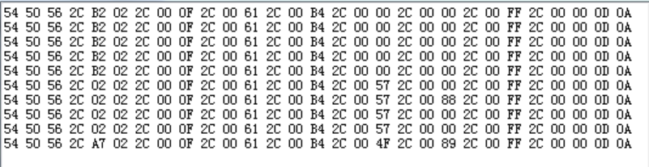

The corresponding meaning of each byte is as follows

TPV,02 02, ID1(000F), ID2(0061) , ID3(00B4), 0057,0000,00FF，00000D0A

TPV, air leak frame flag 02 tire number 02, ID1 (000F), ID2 (0061), ID3 (00B4), 0057 (fixed value of learning code), 0000,00FF (default voltage), 00000D0A

Pressure and temperature frames



The corresponding meaning of each byte is as follows

TPV,A7 02, ID1(000F), ID2(0061) , ID3(00B4), 004F,0089,00FF，00000D0A

TPV, value frame flag A7 tire number 02, ID1 (000F), ID2 (0061), ID3 (00B4), 004F (temperature value), 0089 (pressure value), 00FF (default voltage), 00000D0A

Where the actual temperature value: 0x4F-50 = 79-50 = 29 degrees Celsius

The pressure value is: 0x89 * 1.37kpa = 137 * 1.37kpa = 187.69kpa = 1.87bar.

Sensor low power frame is sent when the battery is low

The corresponding meaning of each byte is as follows:

TPV, value frame flag 01 tire number, ID1, ID2, ID3, 0000,0000,0000 (low voltage default), 00000D0A