**Pete Hoben Outcome 3**

**Stage 2 – Testing**

**Test Log**

**Database at start of testing:**

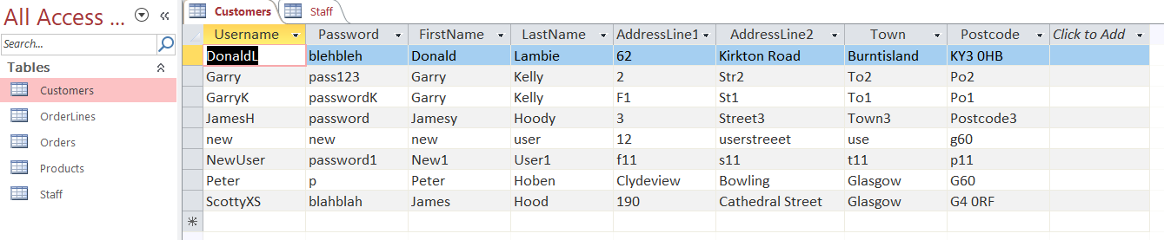

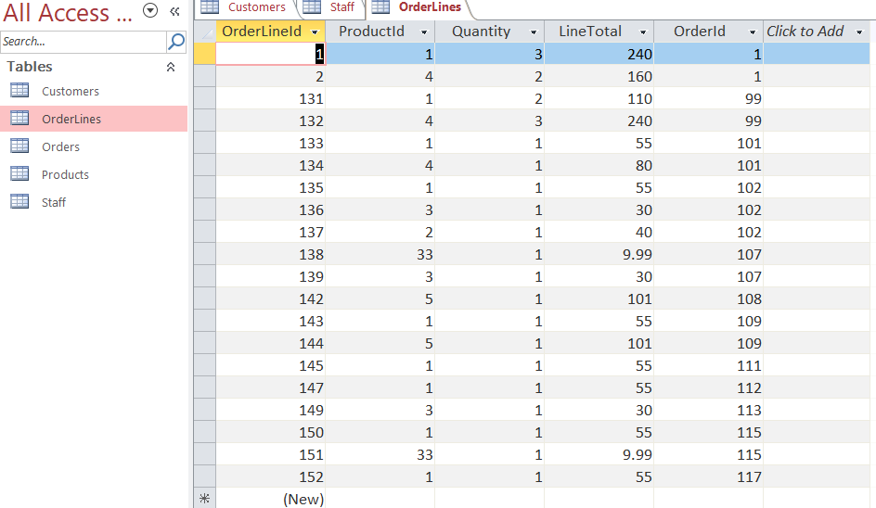

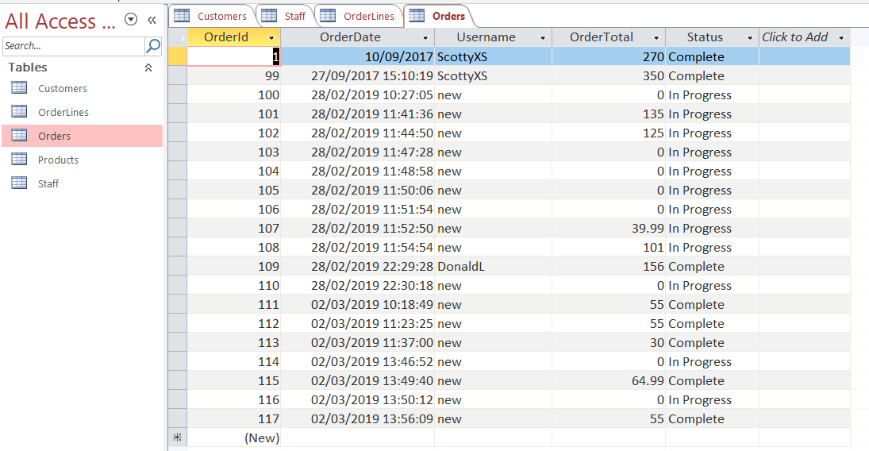

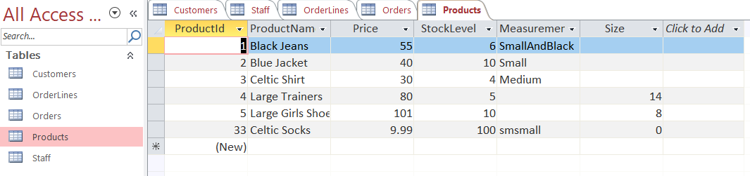

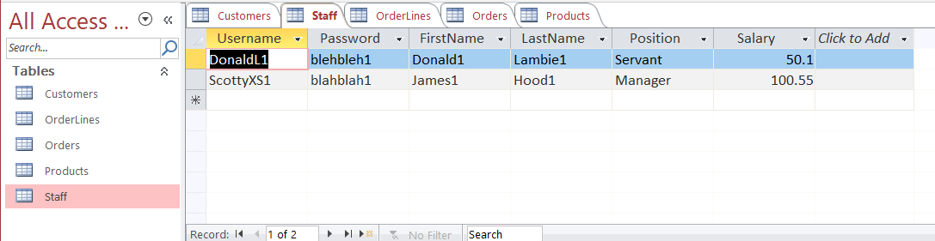

|  |  |  |  |  |  |
| --- | --- | --- | --- | --- | --- |
| **Test No.** | **Action** | **Expected Output** | **Actual Output** | **Result (Pass/Fail)** | **Screenshot** |
| 1 | Start the application. | Display the Shop Main Menu ( containing Login options, and view products option for unregistered user) | As Expected | Pass | See Image 1. |
| 2 | Click the Customer Login button on the Main Menu | Display should show the Login Options. Username and Password with a TextBox for entries. Buttons for Login, Register and Return to Main Menu should be visible. Error Message Label should be invisible at this point | As Expected | Pass | See Image 2 |
| 3 | On Customer Login Page-Enter an invalid Username and Password for any customer:  Username – Customer1  Password - PassWord  Press Login button | Username textbox will contain the value – Customer1 and password textbox will show PassWord. On Login button pressed. An error message in Red Text will display the message “Customer does not exist. Or Incorrect Username and/or Password” | As Expected | Pass | See Image 3 |
| 4 | On Customer Login Page-Enter the Username and Password of a valid customer:  Username – DonaldL  Password - blehblah  Press Login button | Customer Home will open and a message to say “welcome Donald” will appear on one line, followed on the next line by “You are logged in as a customer”. User will also be presented with buttons for Browse Products, View My Orders, Unregister from the shop & Log Out | As Expected | Pass | See image 4 |
| 5 | Click Register button on the Customer Login Page | Customer will be displayed with the Register Page. This has textboxes for user inputs of Username, Password, First Name, Last Name, House/Flat Number, Street, Town & Postcode. Buttons are also presented for SUBMIT, CLEAR & Back To Login.  An invisible label for any Error messages will not be visible to the customer but is on the page. | As Expected | Pass | See Image 5 |
| 6 | On the Customer Registration page attempt to register while missing out key pieces of information:  Username – Shopper  Password –  First Name – Jillian  Last Name – McDonald  House/Flat Number – Flat 4 3  Street – Clydeview Court  Town – Bowling  Postcode G605BL  Press Submit button | Error Message will be displayed advising the user “ Error: please complete all fields” | As Expected | Pass | See Image 6 |
| 7 | On the Customer Registration page attempt to register using the same Username as a previously registered customer.  Username – NewUser  Password – password1  First Name – New1  Last Name – User1  House/Flat number – f11  Street – s11  Town – t11  Postcode – p11  Press Submit Button | Error Message will Display “ Error: username already in use” | As Expected | Pass | See Image 7 |
| 8 | On the Customer Registration page press the “Clear” button | All Textboxes will clear the contents and become empty again. The error message will display “Previous Details Cleared” | As Expected | Pass | See Image 8 |
| 9 | On the Customer Registration page attempt to register as a valid new customer with a unique username:  Username – NewUser  Password – password1  First Name – New1  Last Name – User1  House/Flat number – f11  Street – s11  Town – t11  Postcode – p11  Press Submit Button | The textboxes will be cleared and the error message will change to display “Registration Complete”. | As Excepted | Pass | Images 9 & 10 |
| 10 | Once logged in as a Customer, on the Customer Home Page, click “Browse Products” button | User will be presented with the Products Page. This page will contain a list of categories and a list of products. A combobox will be displayed for quantity. Three buttons will also be presented – Customer Home, Add to basket & View basket | As Expected | Pass | See Image 11 |
| 11 | On the Browse Products screen (as a Customer) click on the ‘Clothing’ item on the first list box under the ‘Categories’ header. | Clothing should be highlighted in the Categories List, And then under the Products list we should see all the clothing products – Black jeans, Celtic Socks, Blue jacket, Celtic Shirt | As Expected | Pass | See Image 12 |
| 12 | On the Browse Products screen (as a Customer) click on the ‘Footwear’ item on the first list box under the ‘Categories’ header. | Footwear should be highlighted under the Categories List, and then in the Products list we should see Large Trainers and Large Girls Shoes | As Expected | Pass | See Image 13 |
| 13 | On the Browse Products screen (as a Customer) click “Add to Basket” without first selecting any Product. | Error Message should be displayed “ Error: No Product was selected | As Expected | Pass | See Image 14 |
| 14 | On the Browse Products screen (as a Customer) select a Category and Product.  Category Selected – Clothing  Product Selected – Celtic Shirt  Quantity - 5  Click “Add to Basket” with a Quantity you ATTEMPT to make too high/low for stock level | Error message should be displayed stating “Not enough Stock to complete order” | As Expected | Pass | See Image 15 & 16 |
| 15 | On the Browse Products screen (as a Customer) add valid products and quantities for a number of orderlines  Clothing Added  Black Jeans – quanity 1  Celtic Socks – quantity 2  Blue Jacket – quantity 3  Celtic Shirt – quantity 4  Footwear Added  Large Trainners – quantity 2 | Each item should confirm that it has been added to the basket and then it should be added to the orderline. | As Expected | PASS | See Image 17 |
| 16 | On the Browse Products screen (as a Customer), attempt to buy a product you already have on the basket at a quantity which should be unavailable now  Using Celtic Shirts. 5 in stock to begin with.  1 Celtic Shirt was initially added, then I have tried to add an Extra 5 to the orderLine. | Error message should state that there is not enough of the product in stock. | As Expected | Pass | See Image 18 |
| 17 | On the Browse Products screen (as a Customer) once you have entered valid entries to your Basket click on “View Basket” button | The current contents of the basket should be shown. | As expected | Pass | See Image 19 |
| 19 | On the View Basket page, click the “Remove Selected Product” button without first selecting a Product. | Error message should be displayed to advise “Error please select a product first” | As expected | Pass | See Image 20 |
| 20 | On the View Basket page, click on a  product and click “Remove Selected Product” button | The selected product should be removed from the basket and the total cost should recalculate and show the correct amount. | As Expected | Pass | See Image 21 |
| 21 | On the View Basket page, click on “Back” button in order to add more products to the basket. | Return to view products menu | As Expected | Pass | See image 22 |
| 22 | On the Browse Products screen (as a Customer) add another product which is currently already on your basket at a quantity which is still available | Error message displayed to advise the the product is (already in basket) | As Expected | Pass | See image 23 |
| 23 | On the View Basket page click “Buy” button | Confirmation screen displayed to show the order has been submitted | As Expected | Pass | See image 24 |
| 24 | On the Confirmation screen (as a Customer that has successfully placed an order) press the Home button | Customer Home screen will be displayed | As Expected | Pass | See image 25 |
| 25 | Once logged in as a Customer, on the Customer Home Page, click “View My Orders” button | Customer will be displayed the orders page where they can see their previous order. | As Expected | Pass | See Image 26 |
| 26 | On the View My Orders page, click on “View Selected Order” button without first clicking on any order from the menu. | Customer should be displayed an error message “Error : Please select an order first” | As expected | Pass | See Image 27 |
| 27 | On the View My Orders page, select an Order and then click “View Selected Order” button | Customer should see a breakdown of the order, showing productid, Product name, price of item and the quantity ordered | As Expected | Pass | See Image 28 |

Appendix

|  |  |
| --- | --- |
| Image 1 | Image 2 |
| Image 3 | Image 4 |
| Image 5 | Image 6 |
| Image 7 | Image 8 |
| Image 9 | Image 10 |
| Image 11 | Image 12 |
| Image 13 | Image 14 |
| Image 15 | Image 16 |
| Image 17 | Image 18 |
| Image 19 | Image 20 |
| Image 21 | Image 22 |
| Image 23 | Image 24 |
| Image 25 | Image 26 |
| Image 27 | Image 28 |
|  |  |