**Zabbix**

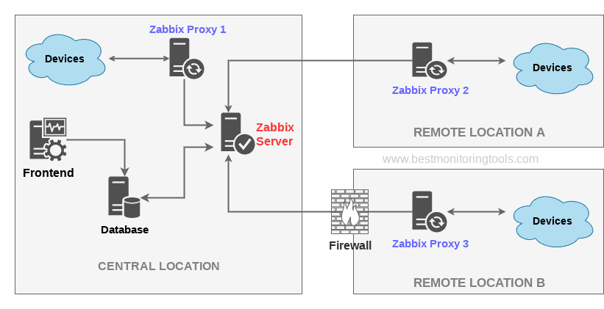

Versão 1.0

Histórico de Versões

| Version | Date | Version Author | Version Changes |
| --- | --- | --- | --- |
| 1.0 | 14/07/2022 | Pedro Akira Danno Lima | Original Zabbix document. |

Resumo do Documento

|  |  |
| --- | --- |
| Description: | This document describes the Zabbix installation and configuration processes. |
| Place of Publication: |  |
| Version Validity:: | 14/07/2022 |
| Based on the Version 1.0 Publishing Model | |

**Sumário**

**Configurações Gerais:** **Error! Bookmark not defined.**

**Configurações do Banco de Dados:** **Error! Bookmark not defined.**

**Configurações de Oracle Linux/VM:** **Error! Bookmark not defined.**

**Criação da conta Oracle** **Error! Bookmark not defined.**

# **Configurate the zabbix web after install following README.md steps**

Step 1 – open browser and put:

http://localhost/zabbix

Step 2 – click in **next step**

Step 2 – click in **next step**

Step 3 – Configure DB connection-> **Next step**

Put password: Zabbix

Step 4 –**Next step**

Step 5 –**Next step**

Step 6 – **Finish**

**LOGIN**

Username: Admin

Password: zabbix

Default page

**PostgreSQL Monitoring With ZABBIX**

Step 1 –

Click in **configuration**

Click in **hosts**

Click in **create host**

Step 2 –

In **host name** put: PostgreSQL Monitoring

**Group**: Linux servers

**Interface**: click in **add** and **agent**

Step 3 –

In **Templete** put: PostgreSQL by Zabbix agent

Click in Add/Update

Step 4 –

Click in **macros**

In {$PG.PASSWORD} put: **zabbix**

Click in add or update

**Now tour Zabbix are monitoring your PostgreSQL**

DATASHEET

**Elaboration**

Pedro Akira Danno Lima

**Collaboration**

Guilherme Augusto di Stefano

**Version Revision**

Guilherme Augusto di Stefano

**Version 1.0**

July / 2022