Projeto SD
Sistemas Distribuidos



Francisco Barão 2016238992
Pedro Ribeiro 2016218753

Index

1. Software Architecture …….…………………………....2

2. UDP
2.1 Protocol………………………………………….…3

2.2 One Answer Only……………..……………….….3

3. RMI

3.1 Interface………………………………………….…4

3.2 FailOver……………………………………………..4

3.3 Callback………………………………………..…... 5

4. Chores……………………………………………………….6

5. Software Testing……...……………………………………..7

Software Architecture
On our project, the client through the RMI Client is asked to give some input, which can be a vary of functions. After receiving an input, the program either tells the user the input is not correct or proceeds to call a remote method on the RMIServer sending the necessary arguments. Here, the program will act accordingly and translates the request into an UDP packet which will ultimately be sent to the multicast network to be received by the multicast servers. Before sending this packet, the RMIServer randomizes the multicast server which will respond and sends the packet to the network. Each Multicast Server will check if the packet contains its id and if it does, the multicast will decipher the packet into an SQL string which will then access the database using JDBC and retrieve some information.After that, multicast will rebuild the UDP packet and resend it to the RMI server which will build the objects and send them through RMI.

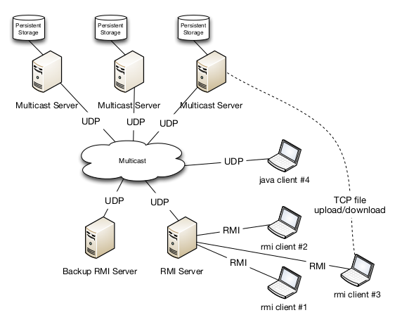

Fig1.Architecture

UDP Functionalities

Protocol

Function -> Create/Update/Delete/Search (Fig)
What -> Type (artist/album/..) (Fig)
Where -> clauses of SQL that specifies what the query will look for (Fig)
Set -> What will change on DB (Fig)
** -> Used to know when an object from a list of objects ends(Fig)

Fig2. UDP

Fig3. UDP

Fig 4.. UDP

Fig5. UDP

Fig7. UDP

Fig6. UDP

Multicast one Answer Only

When creating a multicast server, it randomly chooses one number from 1 to 200 to use as his “id”. Also, when the RMI server is starting, it asks for every connected multicast’s id. So when sending a message to the multicast server, the RMI server chooses randomly on of the possible ids and adds that information to the message, making only one server respond.

RMI Functionalities

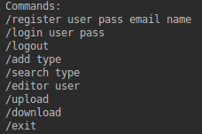
Main Menu -> Interface
/help -> Show Menu Interface
/register -> Create new User
/add type -> Allows an editor to add an artist/album/music
/search -> Allows any user to search for artist/album/music
/review -> Allows user to write/rewrite a review
Fig8. Main Menu Interface

/edit -> Allows Editor to change details about entity
/exit -> Exit option of this menu
/delete type -> Allows an Editor to delete an artist/album/music
/editor type -> Allows Editor to turn another non editor user into an editor
/upload -> Allows user to upload a music
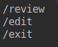
/download -> Allows user to download a music from his uploaded songs or from other people shared songs

RMI FailOver
Fig9. Other Menu Interface

Steps of RMIServer:

->Creates Registry
->Does lookup of server
->If no exception:
Server is already up so every second the server while works as backup will call a remote method (is.Alive) and will keep doing so while no exception is found. When one is found the program will retry 4 more times and after those it will start another server loading the online users info from the Object files making sure it is invisible to the users.
->Exception Fund:
Means mo main server is up so it starts a Server.

RMI Callback
As for callback, we create a client Interface which only method is liveNotifcation. When a user logs in, he then calls the method subscribe which sends the client interface and the server stores the user on the online users list(each user has their own client interface stored on the class). The user will act as a server.

Chores distribution

People  Function | Francisco Barão | Pedro Ribeiro
Register | Done | --
Login/Logout | Done | --
Add artist/album/music | Done | --
Search artist/album/music | Done | Helped
Edit artist/album/music | Done | Helped
Editor privileges | Done | --
Notifications on OnlineUsers | Helped | Done
Upload Files | -- | Done
Download/Share | -- | Done
RMI Server/Client Structure | Done | Helped
RMI Failover/online User management | DOne | --
Multicast Structure | -- | Done
UDP Protocol | Done | Done
JDBC/Database | Done | Helped
Multicast one Answer | -- | Done
Several Computer | Helped | Done
Notification Offline | Done | --

Software Testing

Function | Pass/Fail
Register user | Pass
Login/Logout | Pass
Add artist | Pass
Add album | Pass
Add music | Pass
Search artist | Pass
Search album | Pass
Search music | Pass
Edit artist | Pass
Edit album | Pass
Edit music | Pass
Write Review | Pass
ReWrite Review | Pass
Delete album | Pass
Delete artist | Pass
Delete music | Pass
Editor privileges | Pass
Notifications on Online Users | Fail on other PCs
Notifications on Offline User | Pass
Upload Files | Pass
Download/Share | Pass
RMI Failover structure | Pass
RMI Failover online management | Pass
Multicast only one answer | Pass

