**CPSC-5200 - Software Architecture and Design**

**Pedro de Almeida Voto**

**Source Code:** <https://github.com/pedroavoto/ImageProcessing>

**Image Processing**

**Overview**

The image processing application was created using HTML, JavaScript and CSS as platforms to build the client side and Java platform to build the server side. The application allows the user to make transformations on the given image such as flip horizontal, flip vertical, rotate left, rotate right, rotate any degree (any direction), resize, thumbnail, and grayscale. In addition, the user will be able to send the image and transformations through URL or via webform.

**Architecture**

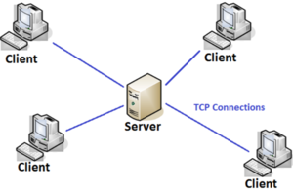

**Languages**

* API Language: Java 8 version
* Client Language: JavaScript, HTML, and CSS.
* REST API: Java library - com.sun.net.httpserver
* API: HTTP protocol

**API Design**

* API receives and creates Base64 encoded string as content type.
* The input image is sent to API as Base64 encoded string. It is the role of the client convert the image in Base64 and send to the API.
* The response back from the API is also Base64. The user would be able to convert the new image from Base64 encoded to an image.

**Sample Code Calling API:**

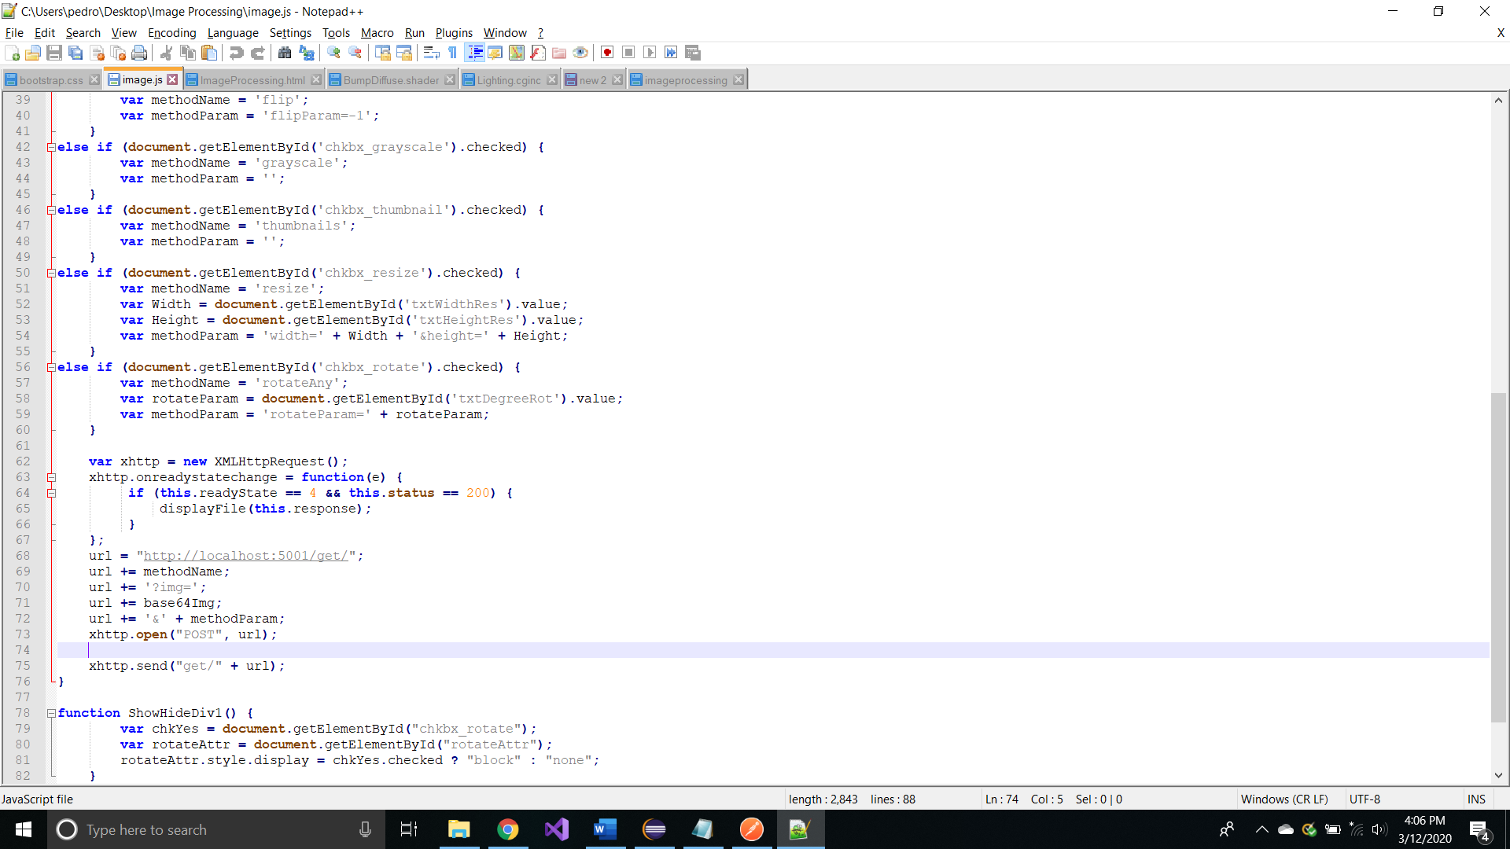

**Tutorial of Upload/Download Image URL:**

* Run the server: SimpleHttpServer.java

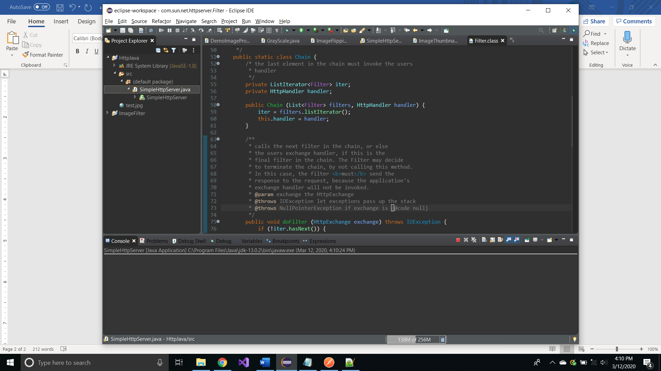

* Convert the image to Base64:
  + Online resources: <https://www.base64-image.de/>
  + Example of the Image in Base64:

/9j/4AAQSkZJRgABAQEASABIAAD/2wBDAAYEBQYFBAYGBQYHBwYIC …

* Open Postman:
  + - Select POST
    - Place “<http://localhost:5001/get/>”
    - Select Body
    - Place the transformation method and prefix image (See table below for other Methods and Parameters): “flip?img=”
    - Copy and Paste the image: /9j/4AAQSkZJRgABAQEASABIAAD/2wBDAAYEBQYFBAYGBQYHBwYIC …/
    - Ends with the parameter of the transformation: “=&flipParam=1”
    - Send it

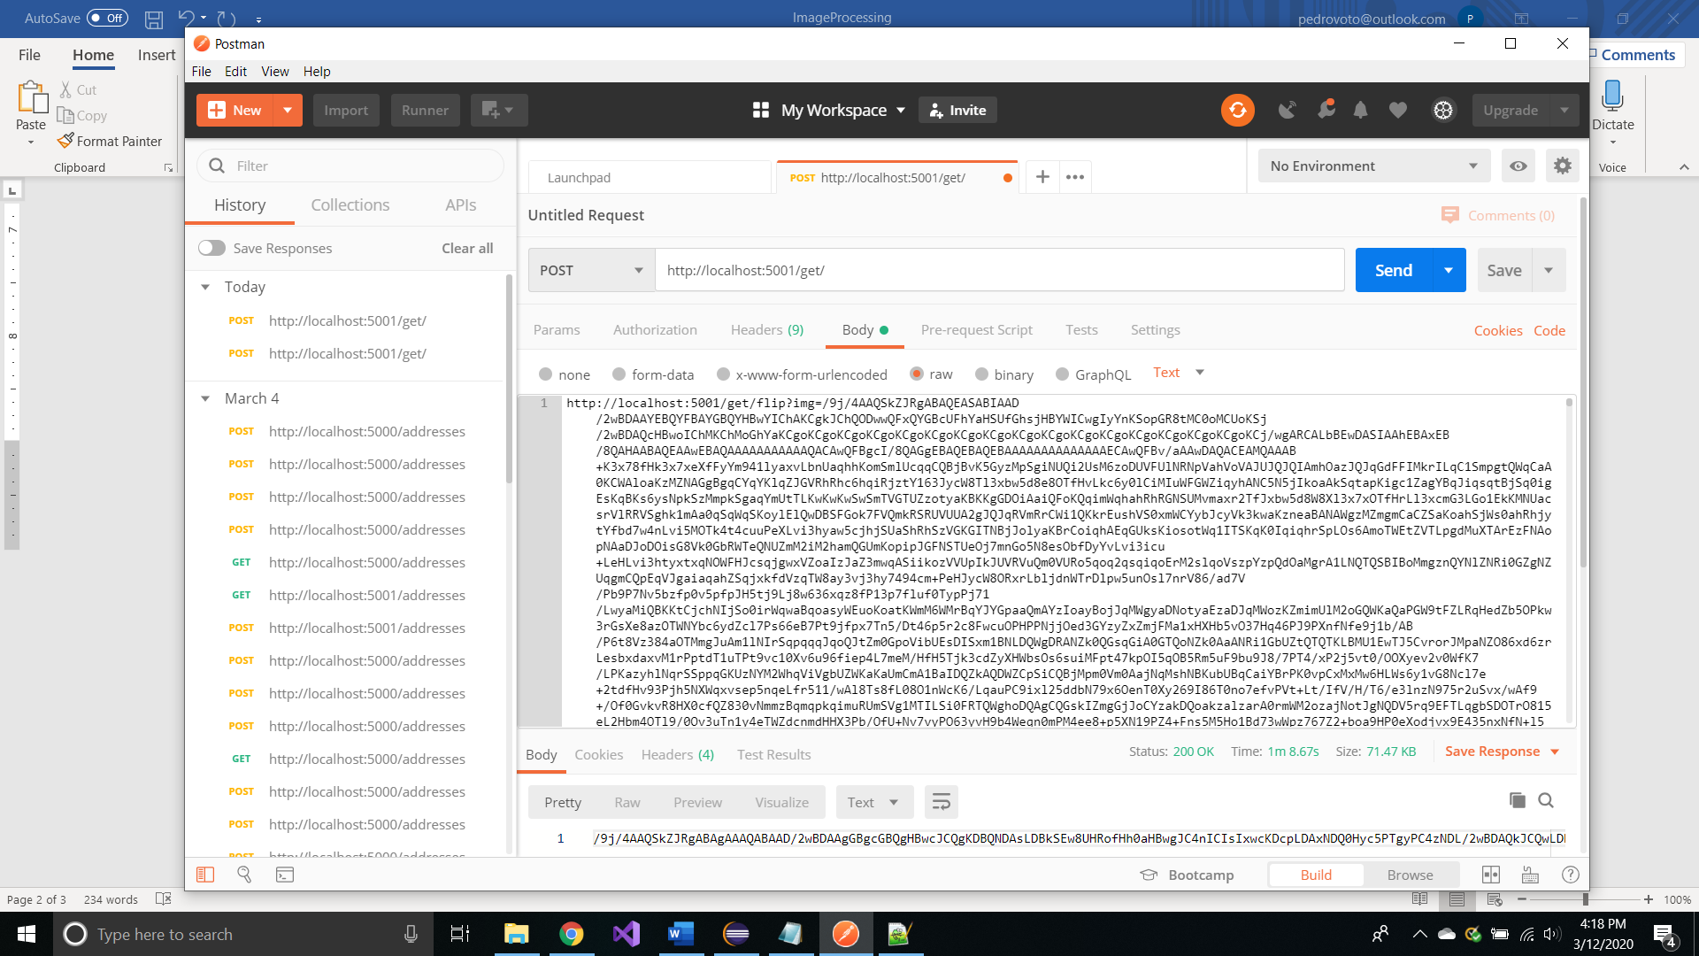

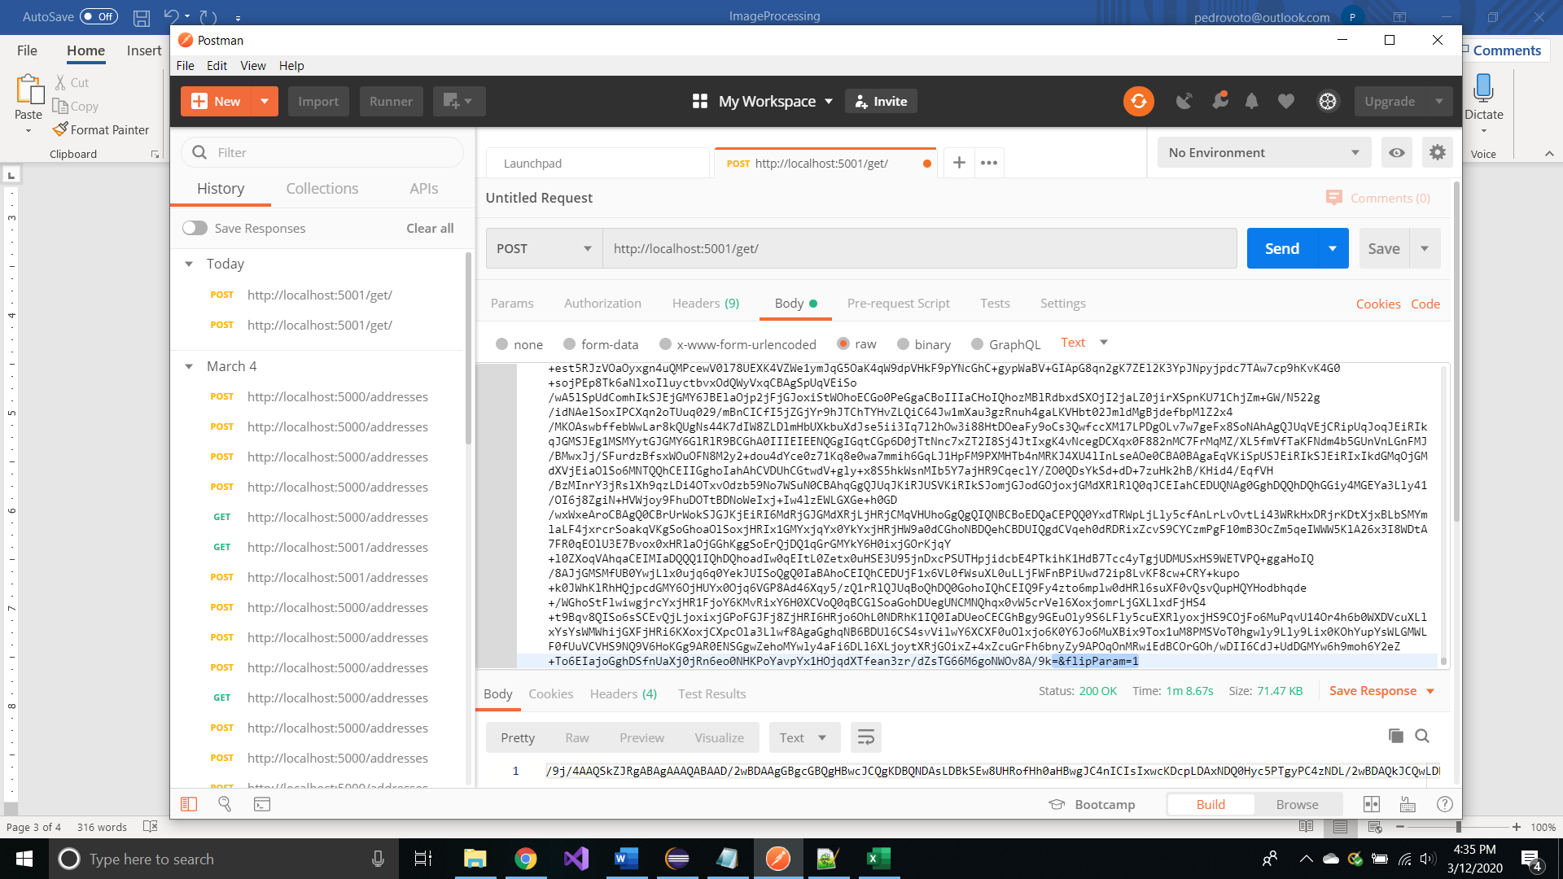

* + - List of Parameters and Methods to use:

|  |  |  |
| --- | --- | --- |
| Methods | Parameters | |
| flip | flipParam=1 | flipParam=-1 |
| rotate90 | rotate90Param=-1 | rotate90Param=1 |
| grayscale | - | - |
| thumbnails | - | - |
| resize | width= {Value} | &height={Value} |
| rotateAny | rotateParam={Value} |  |

* Open the server and get the image in Base64: The second line highlighted is the image in Base64 converted.

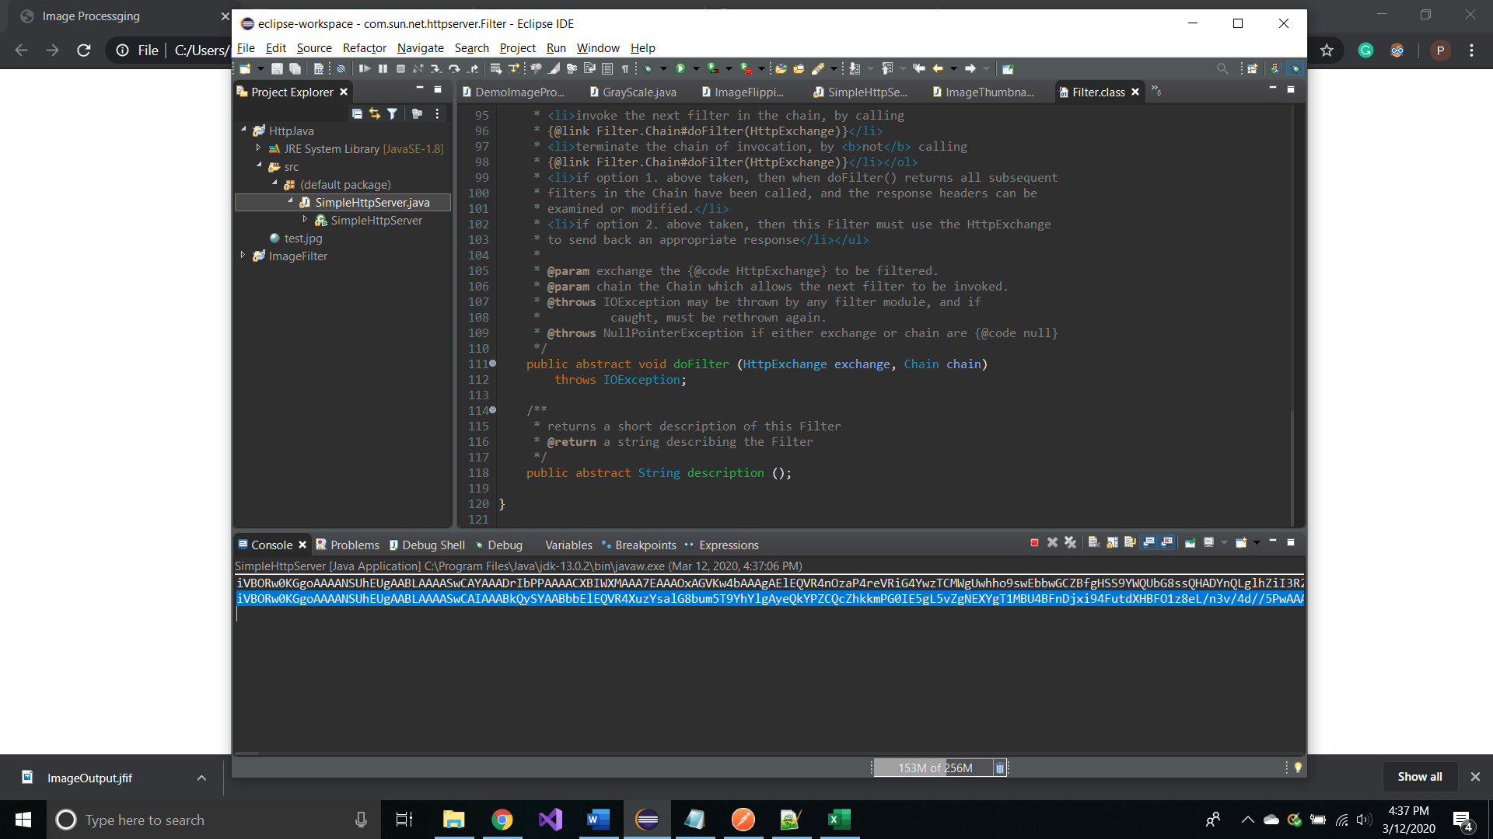

**Tutorial of Upload/Download Image WebForm:**

* Run the server: SimpleHttpServer.java



* Open WebForm:

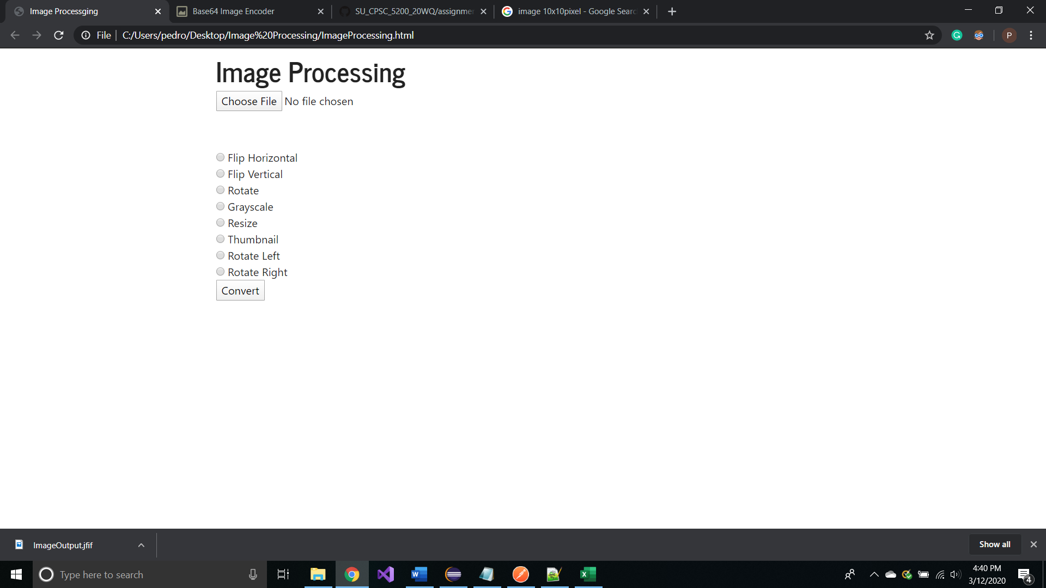

* Select your Image:

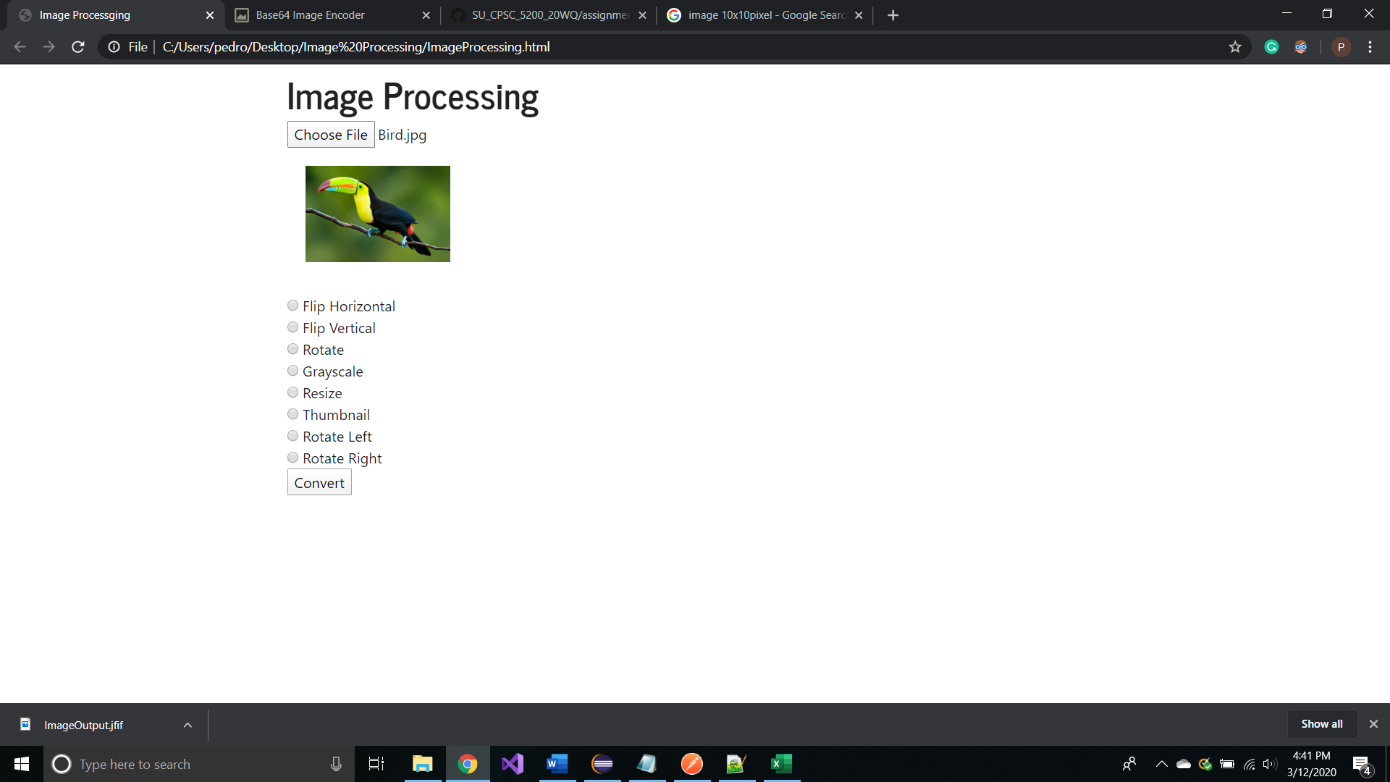

* Select Transformation and Click Convert:

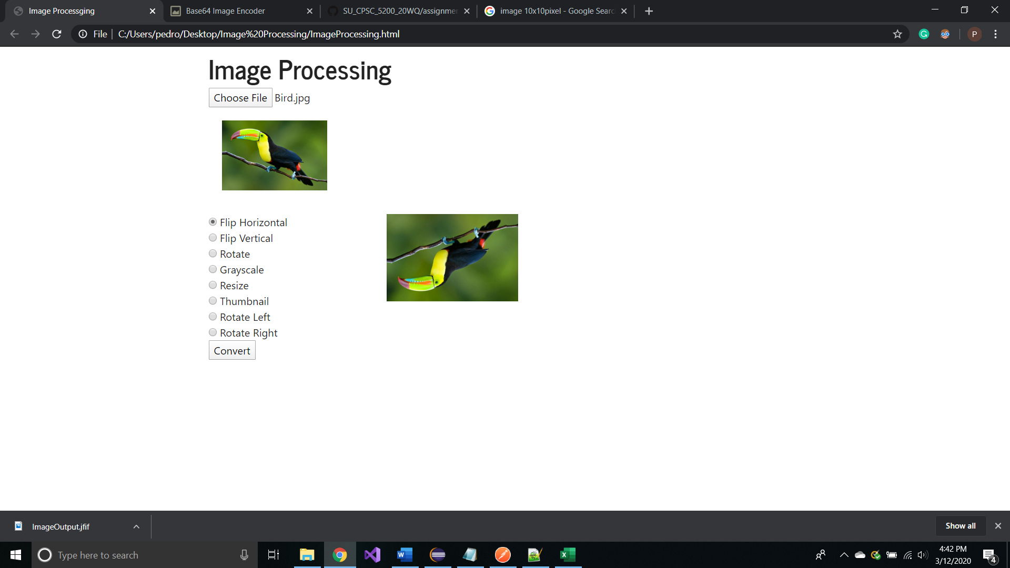

* Click and Save your Image:

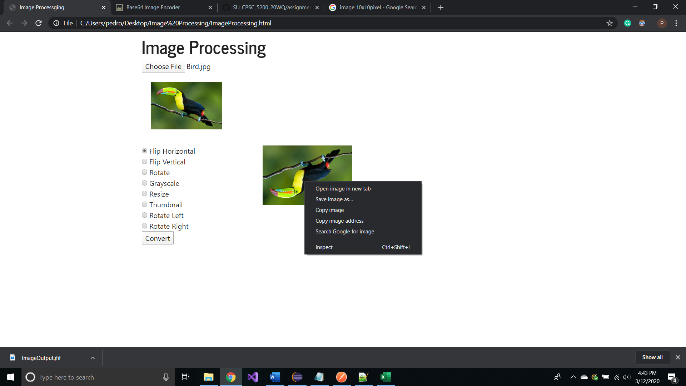

**Limitations**

The image processing application only allows images on the formats below:

* JPEG
* PNG