2) State of the art
Overflows have been observed from a long time through direct measurements (research vessels and mooring arrays). The information obtained from this sources has been very important to characterize the nature of the Denmark Strait overflow, but it remains insufficient due to the highly variable nature of the flow and the sparseness in time and space of this measurements. Furthermore, the horizontal and vertical small scale of the signature of the sea surface height makes the information coming from current satellite altimetry inadecuate to use on this purpose. The main limitations of standard nadir-looking radar altimeters are the lack of coverage (punctual data) and the spatial resolution. These missions were not able to resolve scales shorter than 200 km, but future altimetric missions like SWOT opens a new possibility. It will provide altimetric information over a 120 km wide swath with a resolution of 10 km.

Regarding overflows in models, there is a big amount of papers treating the difficulty of a good representation. In particular, the model that we use (NEMO) is a z-coordinate model, which presents different problematics:
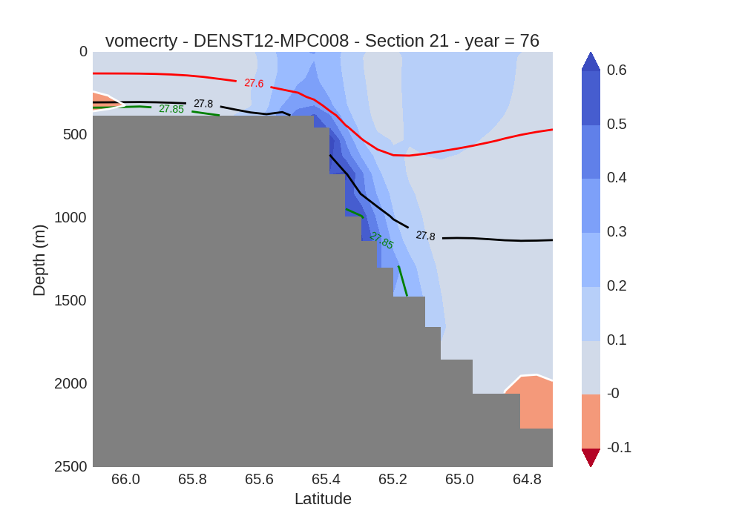

The main issue is that the model representation of the overflow remains too close at the surface, generating a distribution of currents and a distribution of the stratification that are completely unrealistic. A new way of representing this currents is now under work, which has shown very interesting results. In addition a refinement in the horizontal resolution in the region of the overflow is applied reaching values of ~1km. Finally, a set of simulations varying the vertical levels from 46 to 990 levels is also available to study the effect of the vertical resolution on this problematic. We expect to obtain a signature of the sea surface height comparable with the one that has been observed.

3) Objectives of the project
The main objective of the project is to determine if there is a correlation between the magnitude of the transport and the signature of the overflow at the sea surface height. If this is the case, a second and direct quantity observed is the center of the vein in a horizontal plain. We will also investigate until which point a change of the vertical resolution has an impact on the observability of the overflow.

4) Scientific program
a) Task description:
i) - Short and fast introduction to modeling. Interest and definition. Space and time discretizations. Model of the advection equation.
- Direct application of modeling: NEMO. Description and particularities
ii) - Diagnostics on outputs with different vertical coordinates. Tools development.
- Impact of the vertical resolution on the ssh
iii) Inverse problem: overflow path and transport from the ssh.

