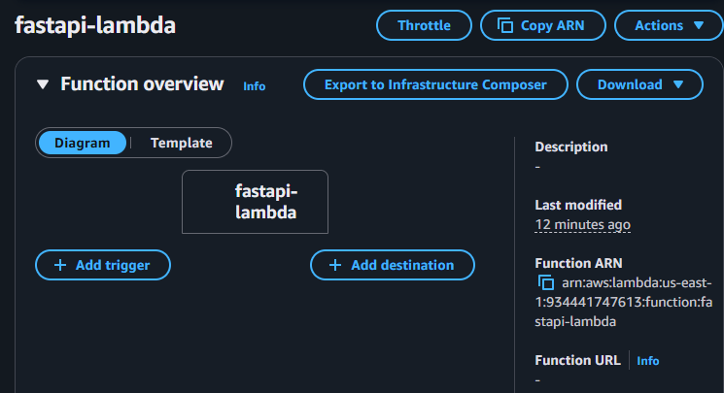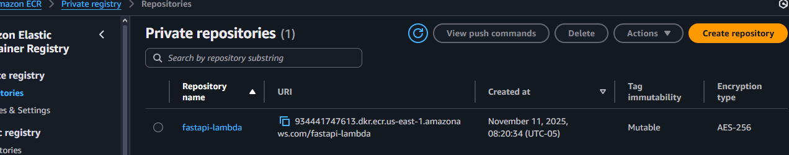
Chats:
Punto 1: https://chatgpt.com/share/69133fcf-2cb0-8007-8d20-7e196851f467
Punto 2: https://chatgpt.com/share/6913404c-d4bc-8007-96bd-6868220efb09

