Resultados

Análises exploratório dos dados.

Análises descritivo

|  |  |  |  |  |  |  |  |  |  |
| --- | --- | --- | --- | --- | --- | --- | --- | --- | --- |
| Tabla XXX. | | | | | | | | | |
|  | Min. | 1st Qu. | Mediam | Meia | Sd. | Var | 3er Qu. | Max. | N |
| PS |  |  |  |  |  |  |  |  |  |
| O |  |  |  |  |  |  |  |  |  |
|  |  |  |  |  |  |  |  |  |  |
|  |  |  |  |  |  |  |  |  |  |
|  |  |  |  |  |  |  |  |  |  |
|  |  |  |  |  |  |  |  |  |  |
|  |  |  |  |  |  |  |  |  |  |

> st.descrip_measure.toSting(db$PS)

media: 244.4533

desviacion: 3.641592

varianza: 13.2612

minimo: 238

maximo: 252.2

mediana: 244.7

rango: 238 252.2

quartiles: 238 242.125 244.7 246.475 252.2

cout: 30

kurtosis: 2.581495

skewness: 0.2543039

> st.descrip_measure.toSting(db$O)

media: 240.6921

desviacion: 6.223236

varianza: 38.72867

minimo: 223.339

maximo: 257.513

mediana: 240.57

rango: 223.339 257.513

quartiles: 223.339 237.7033 240.57 244.1467 257.513

cout: 30

kurtosis: 4.76363

skewness: -0.1043915

> st.descrip_measure.toSting(db$P)

media: 199.317

desviacion: 5.179981

varianza: 26.8322

minimo: 186.356

maximo: 208.218

mediana: 201.2465

rango: 186.356 208.218

quartiles: 186.356 198.718 201.2465 202.4005 208.218

cout: 30

kurtosis: 3.270731

skewness: -1.042919

> st.descrip_measure.toSting(db$PQ)

media: 201.3185

desviacion: 4.602298

varianza: 21.18115

minimo: 188.944

maximo: 208.175

mediana: 202.452

rango: 188.944 208.175

quartiles: 188.944 200.7473 202.452 203.4587 208.175

cout: 30

kurtosis: 4.601114

skewness: -1.28764

> st.descrip_measure.toSting(db$X700MHz)

media: 180.4543

desviacion: 3.269435

varianza: 10.6892

minimo: 172.37

maximo: 185.6

mediana: 180.955

rango: 172.37 185.6

quartiles: 172.37 179.3025 180.955 182.25 185.6

cout: 30

kurtosis: 3.342748

skewness: -0.6724401

> st.descrip_measure.toSting(db$X1100MHz)

media: 195.577

desviacion: 1.688497

varianza: 2.851022

minimo: 191.85

maximo: 198.2

mediana: 195.915

rango: 191.85 198.2

quartiles: 191.85 194.075 195.915 196.955 198.2

cout: 30

kurtosis: 2.235281

skewness: -0.4311424

> st.descrip_measure.toSting(db$X1400MHz)

media: 229.735

desviacion: 2.679919

varianza: 7.181964

minimo: 226.2

maximo: 234.5

mediana: 229.04

rango: 226.2 234.5

quartiles: 226.2 227.5075 229.04 231.845 234.5

cout: 30

kurtosis: 1.8205

skewness: 0.3496556

Verifica a suposição de normalidade

Graficos

Funsion aproximada de densidade da amostras

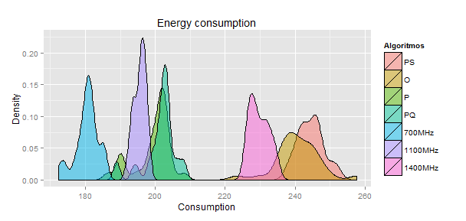

Box-plot

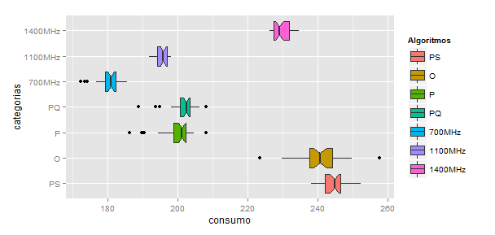

Analisis individual

ANALISIS DE PS: PowerSave

Graph: Histograma e QQ-norm

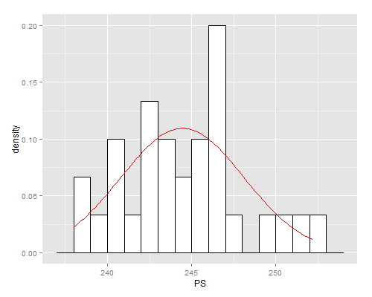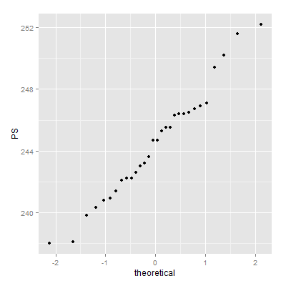

Analisis de Kurtosis/ skeweness: [ ja calculas ]

Test aderência

> test_adh = st.test.adherencia(PS)

> test_adh$shapiro Shapiro-Wilk normality test

data: X

W = 0.97328, p-value = 0.6321

> test_adh$lillie Lilliefors (Kolmogorov-Smirnov) normality test

data: X

D = 0.10034, p-value = 0.6164

> test_adh$anderson Anderson-Darling normality test

data: X

A = 0.26852, p-value = 0.658

ANALISIS DE OnDemand

Graph: hist, qq-norm

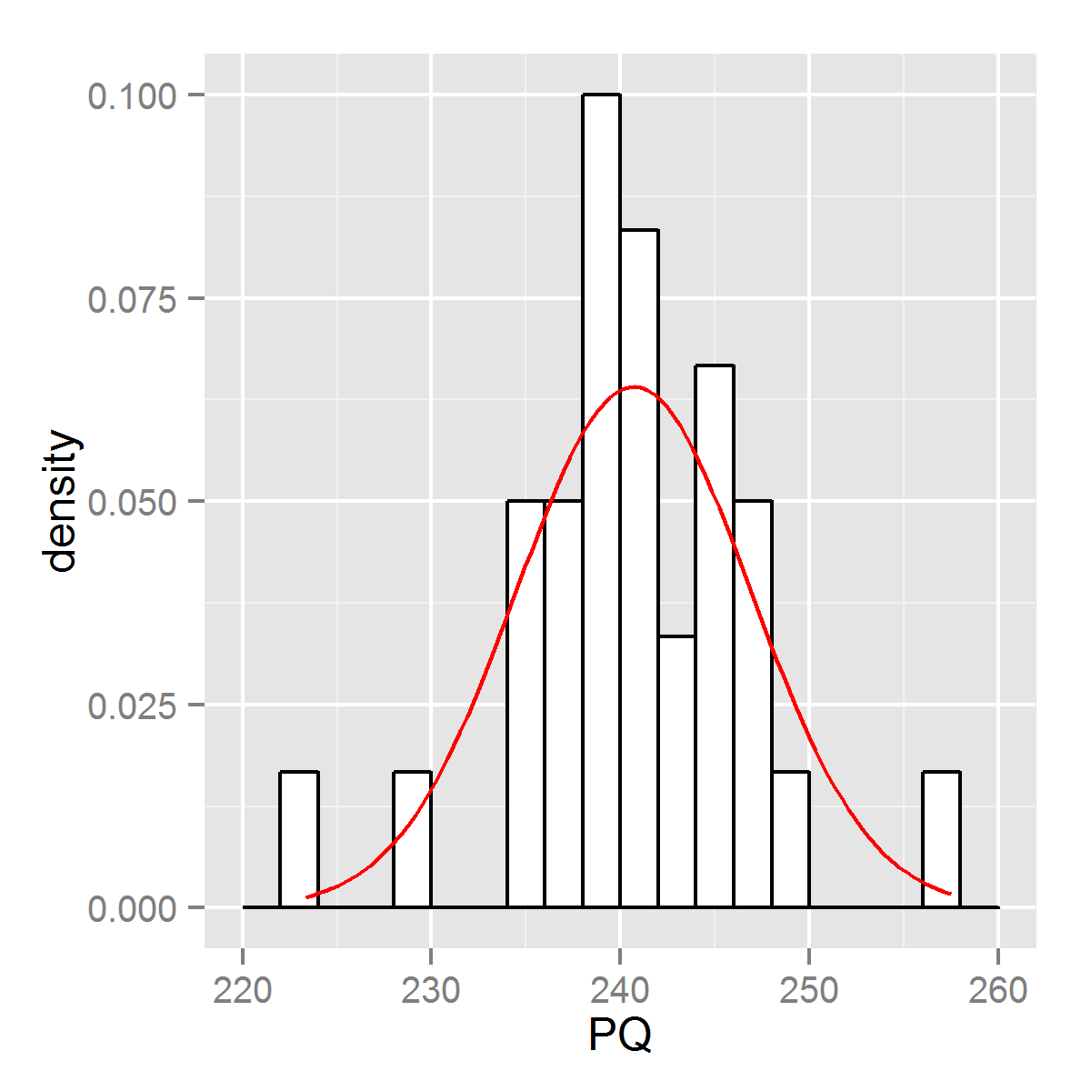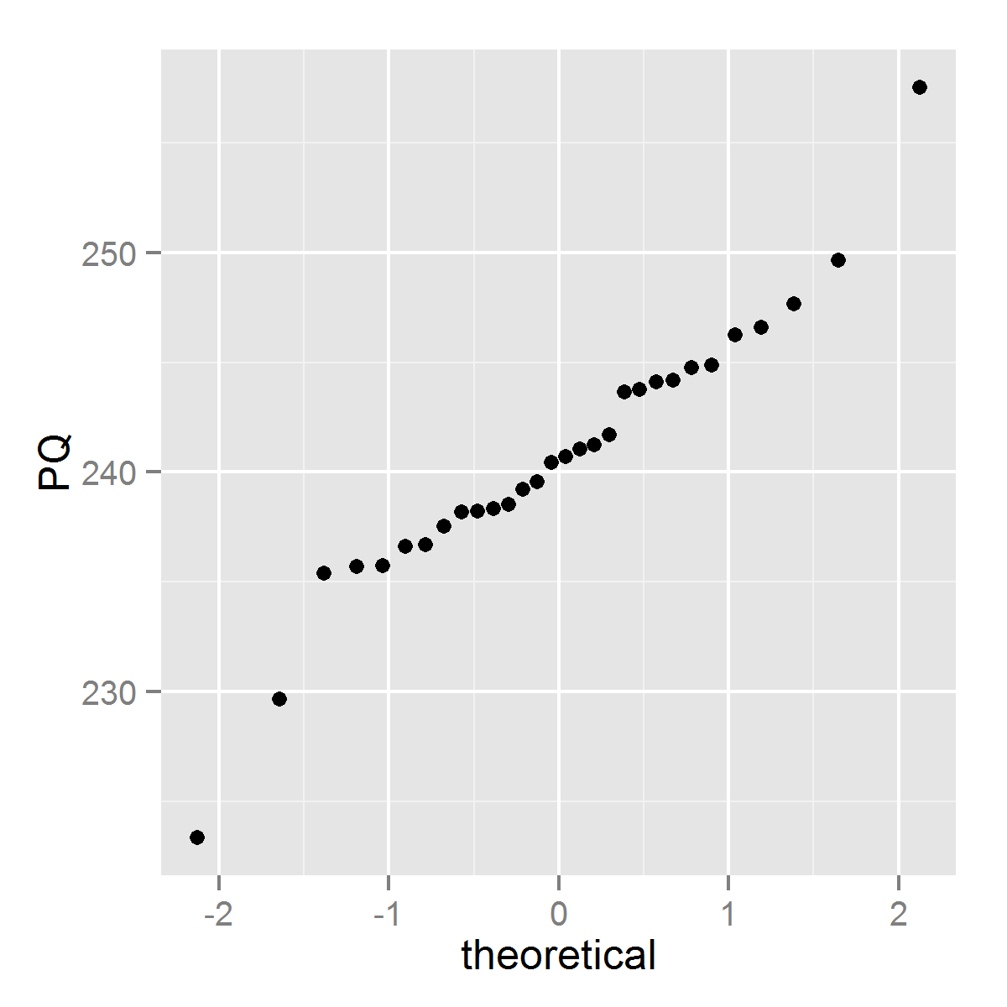

Analisis de Kurtosis/ skeweness: [ ja calculas ]

Test aderência

> test_adh = st.test.adherencia(db$O)

> test_adh$shapiro

Shapiro-Wilk normality test

data: X

W = 0.95361, p-value = 0.2109

> test_adh$lillie

Lilliefors (Kolmogorov-Smirnov) normality test

data: X

D = 0.13098, p-value = 0.2101

> test_adh$anderson

Anderson-Darling normality test

data: X

A = 0.50274, p-value = 0.19

ANALISIS DE Performance

Graph: Hist, qq-norm

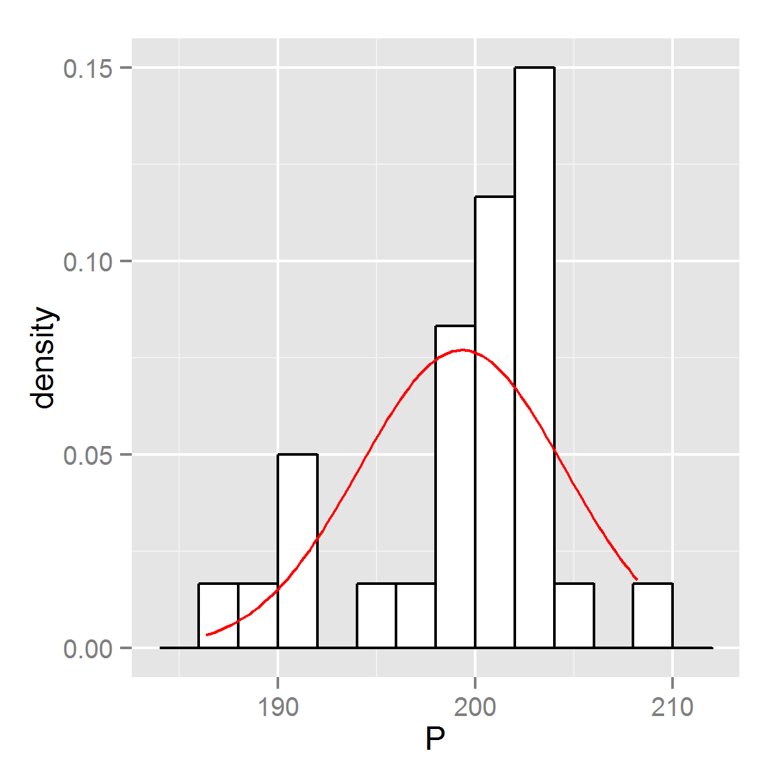

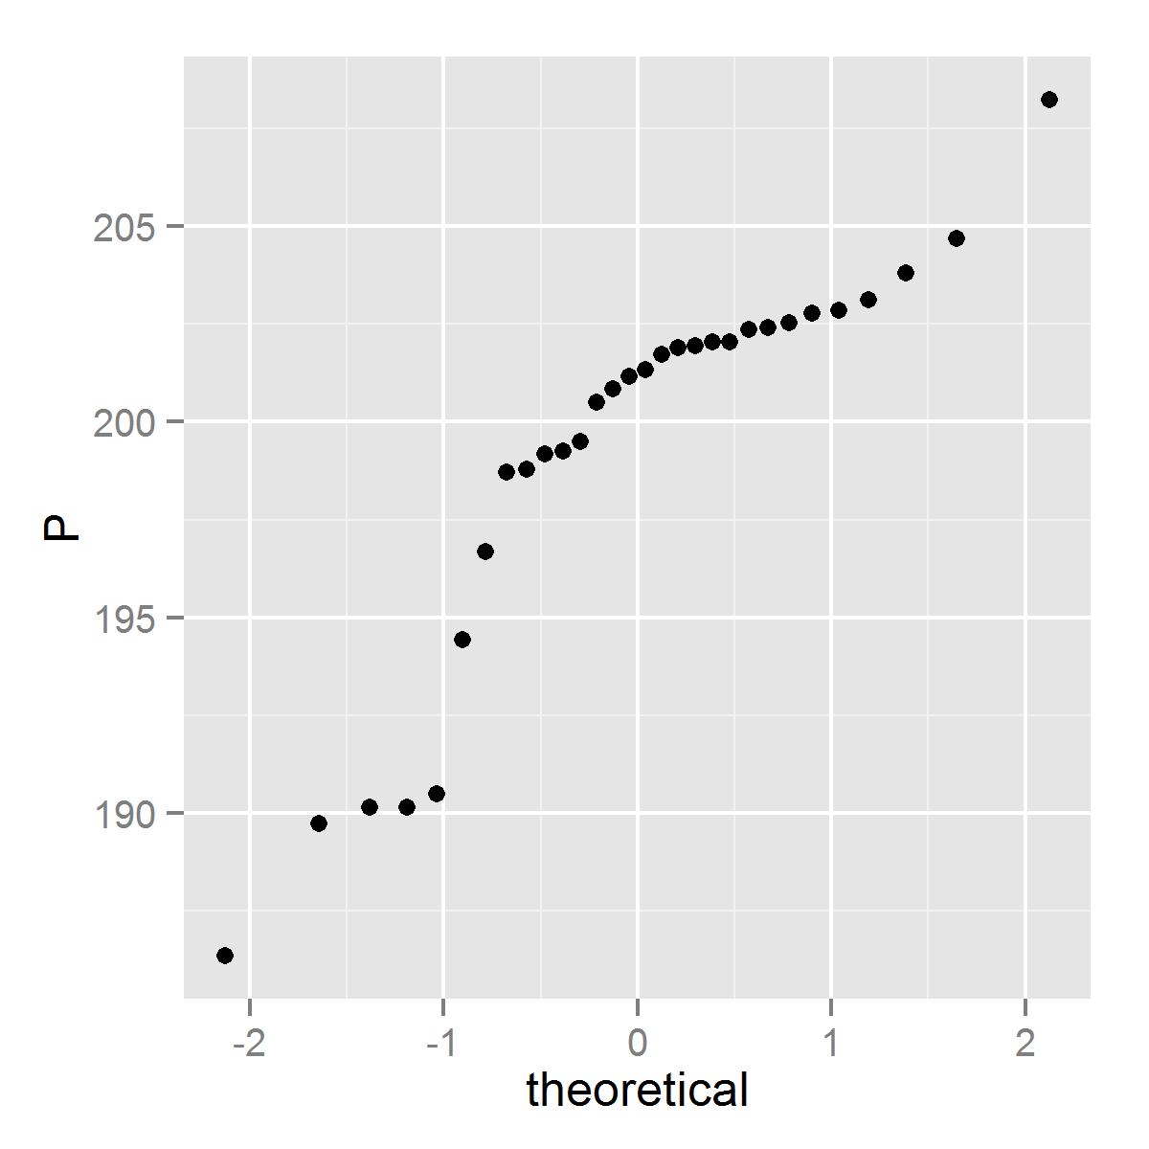

Analisis de Kurtosis/ skeweness: [ ja calculas ]

Test aderência

> test_adh = st.test.adherencia(db$P)

> test_adh$shapiro

Shapiro-Wilk normality test

data: X

W = 0.85781, p-value = 0.0009075

> test_adh$lillie

Lilliefors (Kolmogorov-Smirnov) normality test

data: X

D = 0.21918, p-value = 0.0007678

> test_adh$anderson

Anderson-Darling normality test

data: X

A = 1.969, p-value = 3.791e-05

ANALISIS DE PegasusQ

Graph: Hist, qq-norm

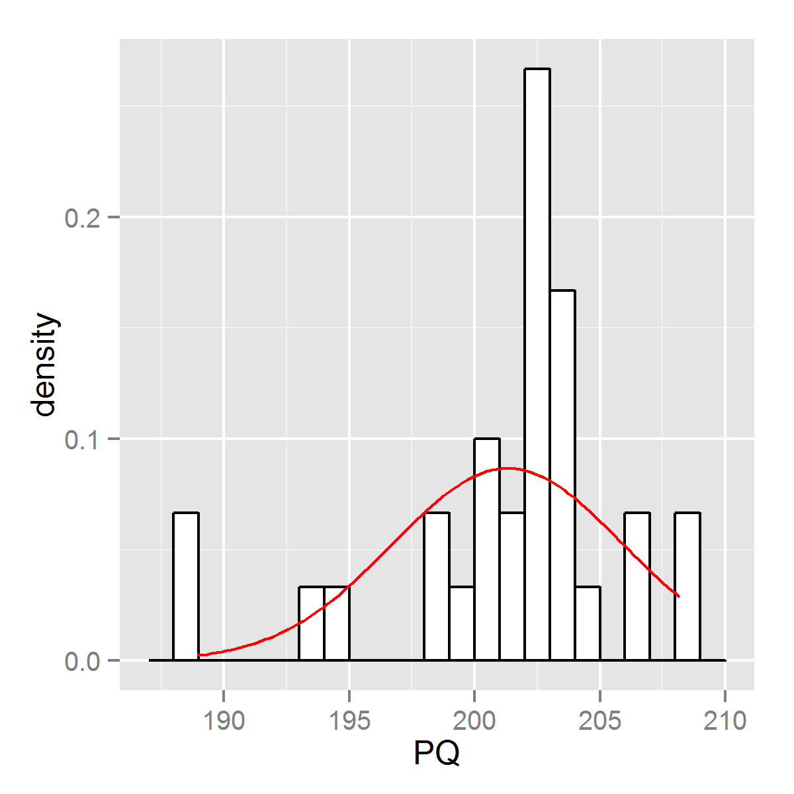

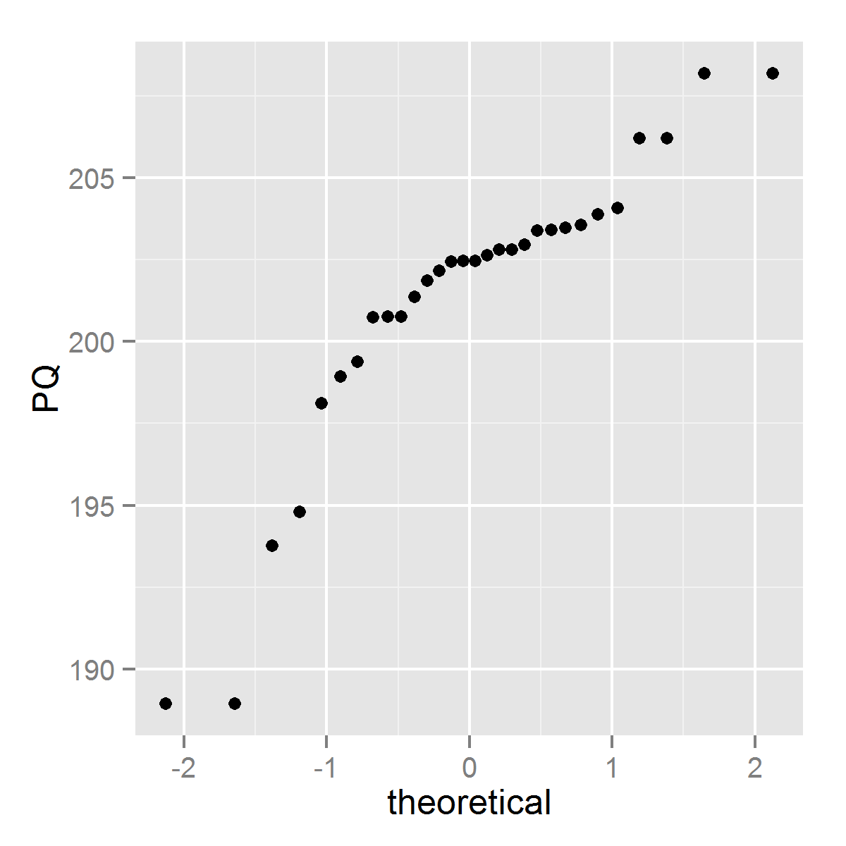

Analisis de Kurtosis/ skeweness: [ ja calculas ]

Test aderência

> test_adh = st.test.adherencia(db$PQ)

> test_adh$shapiro

Shapiro-Wilk normality test

data: X

W = 0.85685, p-value = 0.0008656

> test_adh$lillie

Lilliefors (Kolmogorov-Smirnov) normality test

data: X

D = 0.21665, p-value = 0.0009473

> test_adh$anderson

Anderson-Darling normality test

data: X

A = 1.6506, p-value = 0.0002399

ANALISIS DE 700

Graph: Hist, qq-norm

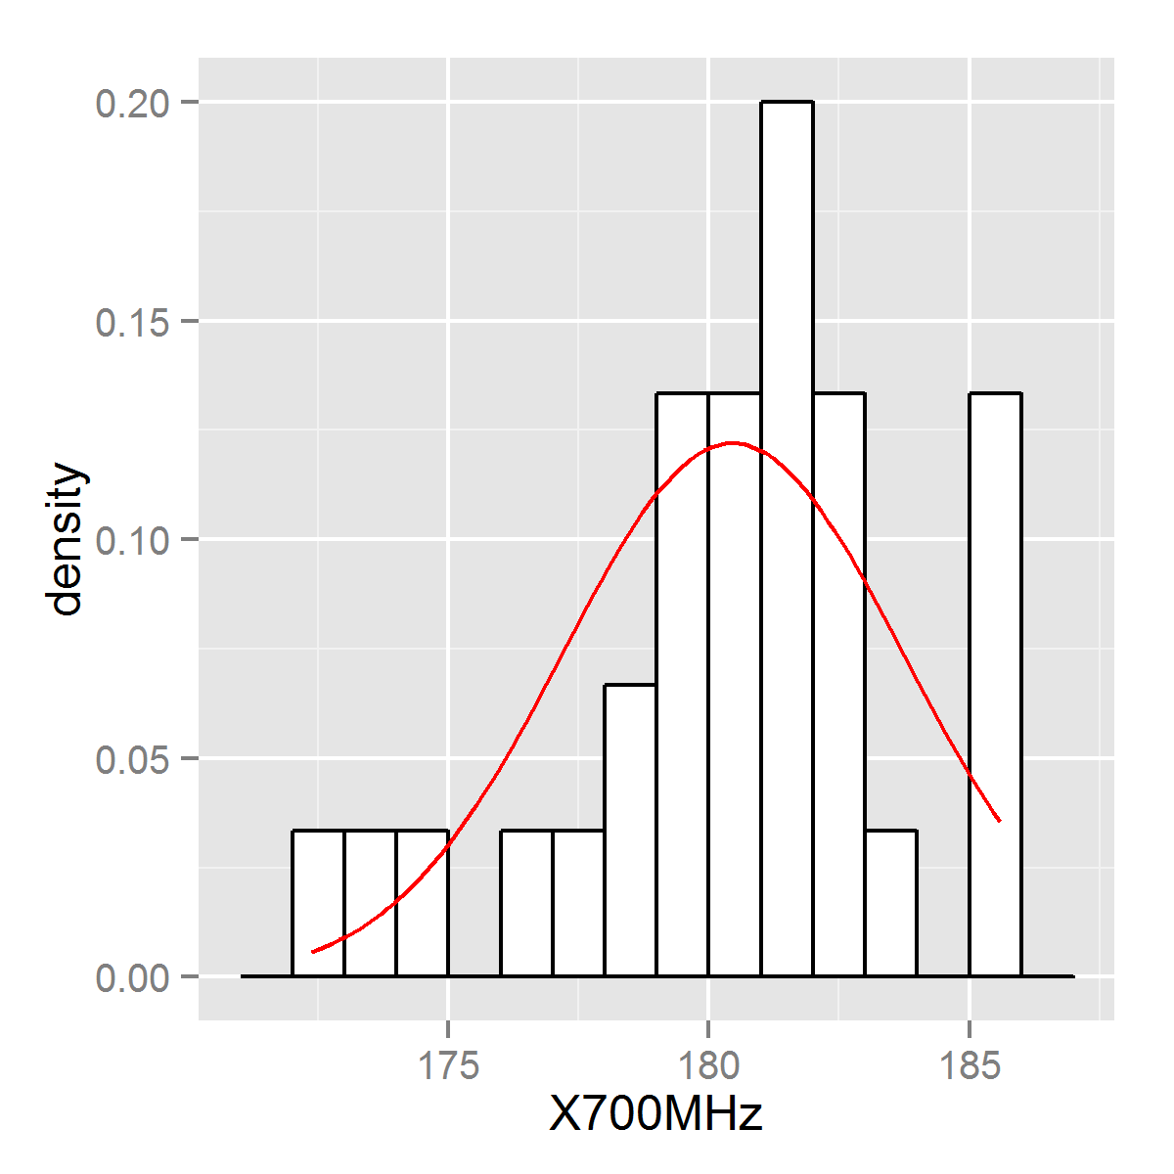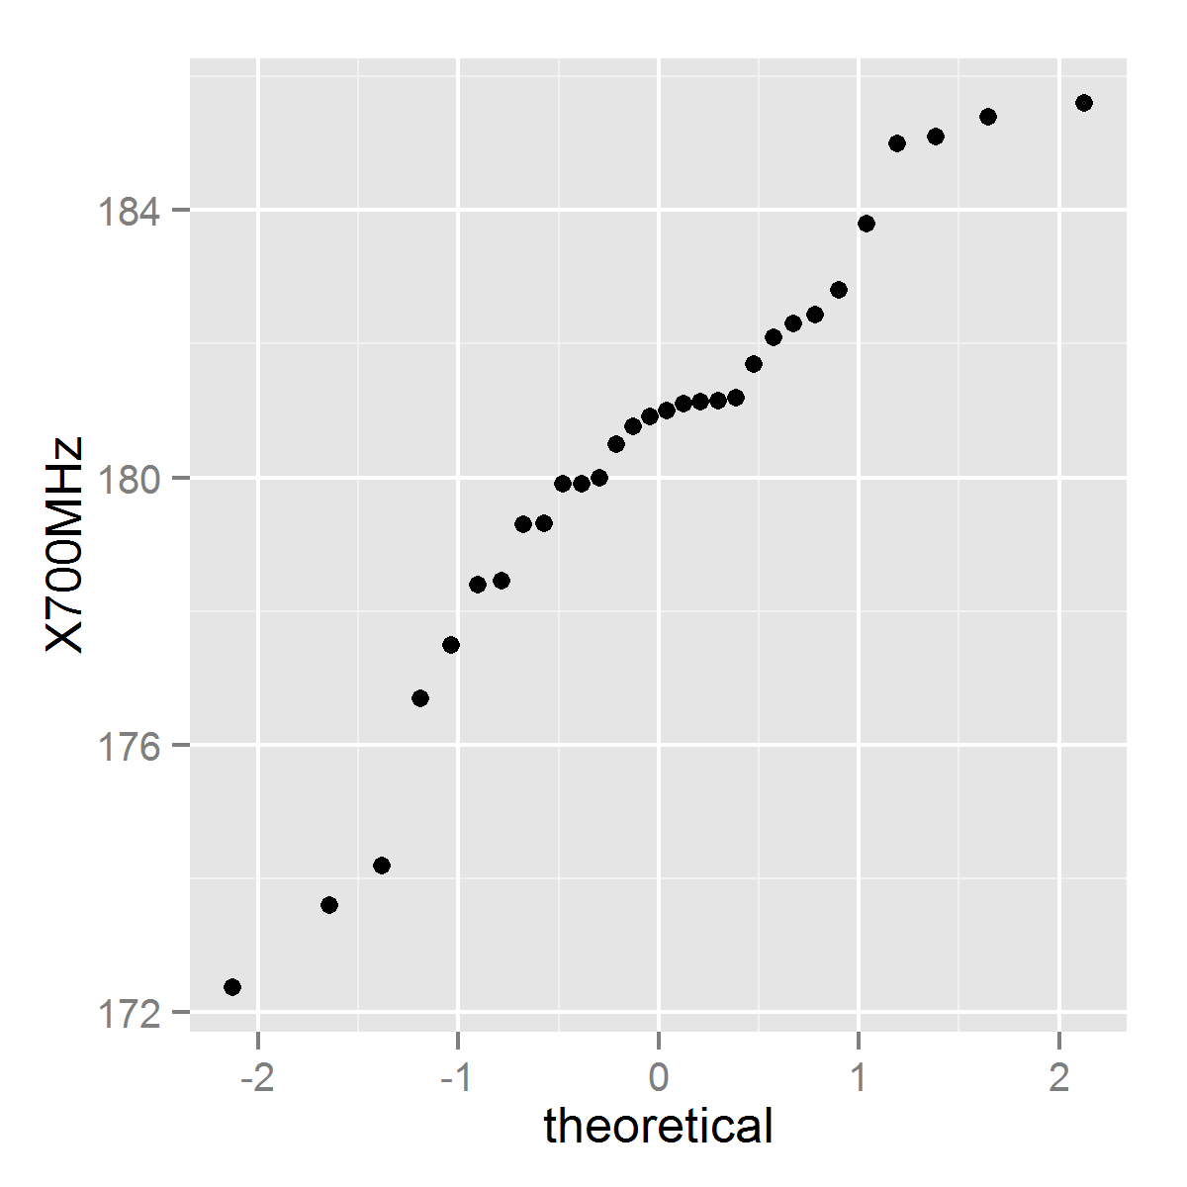

Analisis de Kurtosis/ skeweness: [ ja calculas ]

Test aderência

> test_adh = st.test.adherencia(db$X700MHz)

> test_adh$shapiro

Shapiro-Wilk normality test

data: X

W = 0.93985, p-value = 0.09014

> test_adh$lillie

Lilliefors (Kolmogorov-Smirnov) normality test

data: X

D = 0.13268, p-value = 0.195

> test_adh$anderson

Anderson-Darling normality test

data: X

A = 0.62846, p-value = 0.09208

ANALISIS DE 1100

Graph: Hist, qq-norm

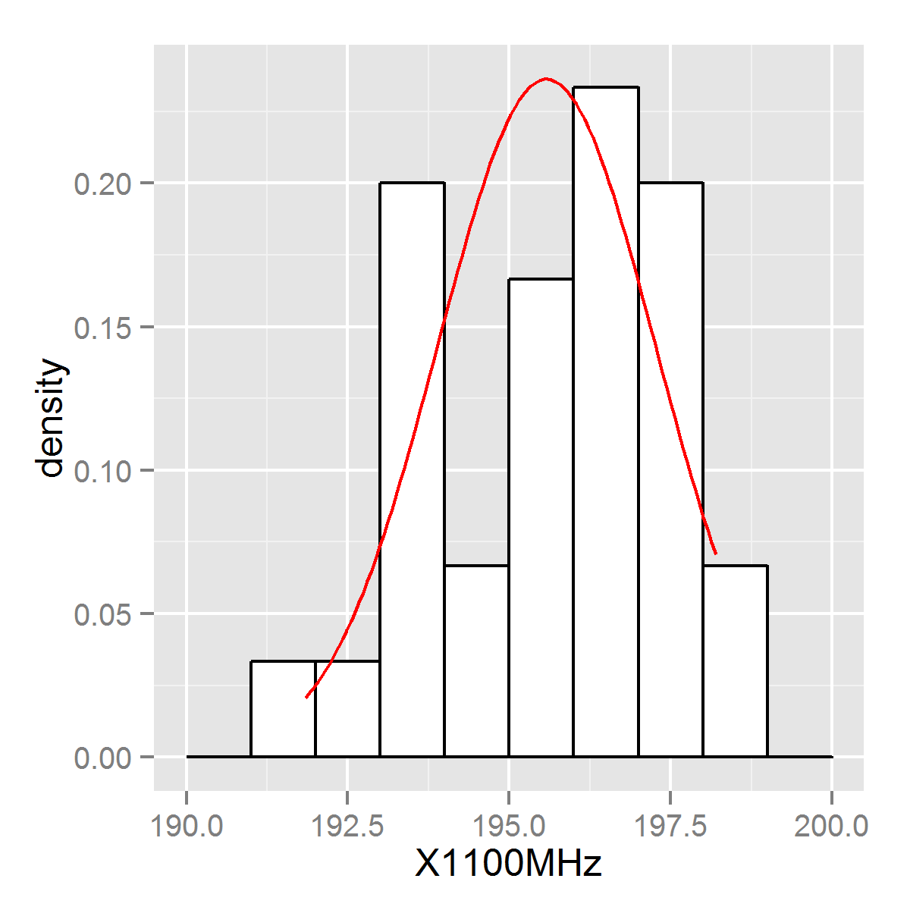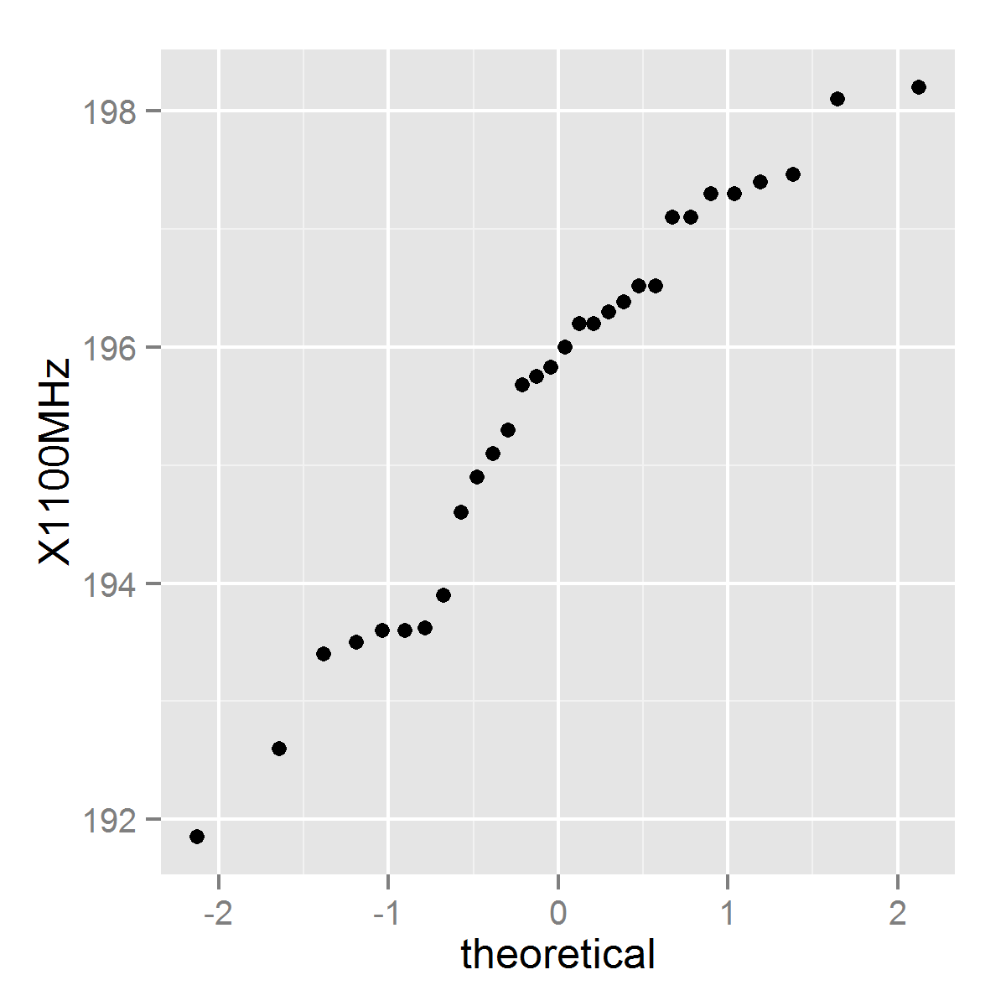

Analisis de Kurtosis/ skeweness: [ ja calculas ]

Test aderência

> test_adh = st.test.adherencia(db$X1100MHz)

> test_adh$shapiro

Shapiro-Wilk normality test

data: X

W = 0.95226, p-value = 0.1943

> test_adh$lillie

Lilliefors (Kolmogorov-Smirnov) normality test

data: X

D = 0.12432, p-value = 0.2782

> test_adh$anderson

Anderson-Darling normality test

data: X

A = 0.5437, p-value = 0.1491

ANALISIS DE 1400

Graph: Hist, qq-norm

Analisis de Kurtosis/ skeweness: [ ja calculas ]

Test aderência