Specification Sheet SDP-9

Siemens Energy AS
Ternetangen 65
N-5420 Rubbestadneset

Revision List
10221896, Rev. 01

Rev | Date | Description | Author | Reviewed | Approved
01 | 05.05.2021 | IFA | SLA | AE | JIF
TABLE OF CONTENTS
1. Introduction 4
2. Definitions 4
3. Sensor summary 4
4. General specification 5
5. DP specification 5
6. PT/TT Specification 5
6.1 Pressure Sensing Element 5
6.2 Temperature sensing element (additional component) 6
7. Mechanical specification 6
8. Electrical Specification 6
8.1 DP Sensor 6
8.2 PT/TT Sensor 6
9. Pin Configuration 7

Introduction
This document will give a summary of the specifications for Siemens Energy SDP-9 sensors.

Definitions
Abbreviation |  | Description
CR | : | Calibrated Range
DP | : | Differential Pressure
FS | : | Full Scale
HP | : | High Pressure
LP | : | Low Pressure
M | : | Metre
PT | : | Pressure Transmitter
TE | : | Temperature Element
TT | : | Temperature Transmitter
URL | : | Upper Range Limit
Total error band | : | Includes hysteresis, linearity, repeatability, zero/span effects, supply voltage sensitivity, temperature effects over calibrated temperature range.

Sensor summary
The SDP-9 sensor is designed to be used within a subsea flow measurement system.
The product consists of a subsea transmitter housing containing a DP sensor and a PT line pressure sensor.

The differential pressure is measured via the DP sensor between the remote seals.
The line pressure also utilizes the capillary system to give an additional pressure signal to the PT from either remote seal (LP or HP).

In addition to line pressure and DP measurement, the 12-pin penetrator have 2 pins dedicated to an optional remote temperature sensor.

General specification

Description | Specifications | Units
Ambient temperature: | -20 to 50 | °C
Operating temperature: | -46 to 205 (Remote seal temperature) | °C
Storage temperature: | -40 to 70 | °C
Design lifetime: | 30 | Years
Shock/Vibration/EMC: | According to API 17F 4th Ed.
Hyperbaric pressure, sensor: | 4000 | M
Hyperbaric pressure, sensor w/ cable: | According to manufactures specification
High pressure containment: | 1552 | Bar
Surface protection: | According to NORSOK M501, System 7C

DP specification
Description | Specifications
Sensing element: | Micro-capacitive silicon sensor
Differential pressure range (URL): | 0-0.32 Bar / 0-1.3 Bar / 0-5 Bar / 0-30 Bar
Line pressure range: | 0-690 Bar  0-1035 Bar
Maximum overpressure: | 1552 Bar
Accuracy: | ± 0.065 % Span
Stability (drift): | ± 0.1% of URL for 24 months
Line pressure effect, Zero, 0-1035 bar | ± 0.2% of URL/100 bar
Line pressure effect, Span, 0-1035 bar | - 0.2% of Cal. Span/100 bar
Temperature effect, 0-1035 bar | Zero: ± (0.1+0.025 x URL/Span) in % of URL / 28°C  Total: ± (0.125+0.025 x URL/Span) in % of URL / 28°C  Double effect for diaphragm in Hast. C 276 material.

PT/TT Specification

6.1 Pressure Sensing Element
Description | Specifications | Units
Sensing element: | Sputtered Thinfilm
Pressure range: | 0-690  0-1035 | Bara  Bara
Maximum overpressure: | 1552¹ | Bara
Pressure resolution: | < 0.0005 | %FS
Pressure accuracy | ± 0.025 | %FS
Pressure drift @ 25°C: | ± 0.02 | %FS/Year
Pressure drift @ 70°C: | ± 0.05 | %FS/Year

6.2 Temperature sensing element (additional component)
Description | Specifications | Units
Sensing element: | PT1000
Temperature range: | -40 to 180 | °C
Temperature accuracy: | ±0.3 | %CR
Temperature drift: | ±0.1 | %CR/year
Temperature resolution: | ≤0.08 | m°C

Mechanical specification
Description | Specifications
Process interface: | Temperature probe – Design to be agreed  Remote seals – Design to be agreed  According to NACE MR-0175/API PSL3, NORSOK M-630  For project specific info, ref. drawing.
Flange/Housing material: | Armco 17/4 PH, UNS S17400  According to NACE MR-0175/API PSL3, NORSOK M-630
Wetted parts material: | Alloy 625  According to NACE MR-0175/API PSL3, NORSOK M-630
EB welding: | According to ASME IX
Typical weight: | 30 kg in air (Canister)

Electrical Specification

8.1 DP Sensor
Description | Specifications
Protocol: | RS485 Fuji Modbus RTU
Supply Voltage: | 24 VDC (8-30 VDC)
Current consumption: | < 25 mA @ 24 VDC
Termination resistors: | 120Ω or none (project specific)
Baud rate: | 9600 baud
Sampling rate: | 8 Hz (measurement/sec)

8.2 PT/TT Sensor
Description | Specifications
Protocol: | RS485 Modbus RTU
Supply Voltage: | 24 VDC (14-30 VDC)
Current consumption: | < 15 mA @ 24 VDC
Termination resistors: | 120Ω or none (project specific)
Baud rate: | 9600 baud (default, other on request)
Sampling rate: | 1 Hz (measurement/sec) – Option for 10Hz

Pin Configuration

The assembly drawing for the project will reflect the pin configuration for the specific project which may differ from the standard configurations listed below.

(Project documentation supersedes this standard specification).

RS485 Modbus
Single PT Option
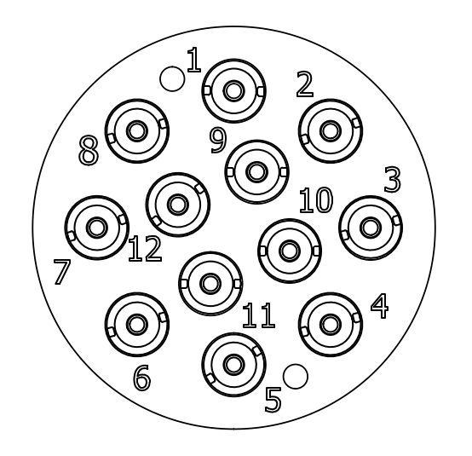

DP Com. | PIN 1: Power +24V, (Supply)
DP Com. | PIN 2: Power 0V (Supply)
DP Com. | PIN 3: TIA-485-A (A)
DP Com. | PIN 4: TIA-485-A (B)
PT Com. | PIN 5: Power +24V (Supply)
PT Com. | PIN 6: Power 0V (Supply)
PT Com. | PIN 7: TIA-485-A (A)
PT Com. | PIN 8: TIA-485-A (B)
TT Com. | PIN 9: TE (optional component)
TT Com. | PIN 10: TE (optional component)
 | PIN 11: Not used
 | PIN 12: Not used

Allowance of +5% overpressure as per API 17D.

