Question 9.1

Using the same crime data set uscrime.txt as in Question 8.2, apply Principal Component Analysis and then create a regression model using the first few principal components. Specify your new model in terms of the original variables (not the principal components), and compare its quality to that of your solution to Question 8.2. You can use the R function prcomp for PCA. (Note that to first scale the data, you can include scale. = TRUE to scale as part of the PCA function. Don’t forget that, to make a prediction for the new city, you’ll need to unscale the coefficients (i.e., do the scaling calculation in reverse)!)

Methodology

Load libraries, define helper functions to read the crime data, split into train/test, and build linear regression models with lm().

Perform PCA (with scaling) on the predictors in Crime_dataset (excluding Crime), inspect variance explained, and choose the first few principal components.

Build a regression model of Crime on selected PCs (initially PC1–PC5, then refined to PC2–PC5) and examine the model summary and fit.

Derive regression coefficients in the original variable space by combining PCA loadings, centering, and scaling, and compute a manual prediction for a new city from b0 + bᵀx (which initially gives a negative value).

Correctly project the new city into PCA space using predict(Crime_PCA, newdata = test_df) with aligned columns, then predict its crime using predict(uscrime_pc_model, newdata = PCs_newcity).

Fit a separate regression model directly on selected original variables (Ed, Po1, Ineq, Prob), predict the new city’s crime with this model, and compare its performance and interpretability to the PCA‑based model.

Result Obtained

I have used the function prcomp, to work with the PCA model, where I read the data set USCRIME and start using the results coming from the PCA model and evaluating in a linear regrations the different principal components and see how many or which PC I should be taking to achieve a reasonable level of Rsquare. I have analyzed a scree plot that basically show by number of PCs how much each of them explain the variance.
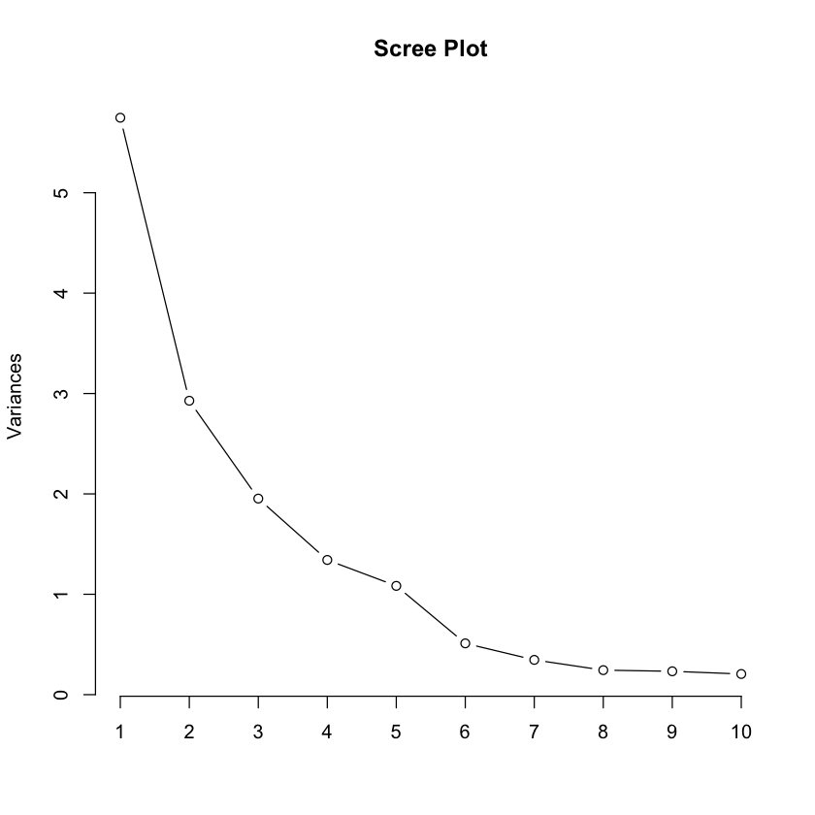

As previous videos, I use this charge to identify the elbow shape that tells me how many Principal components explain the variances, so in this case I select 4 Principal components to evaluate my regression model and see if I have the correct PCs that has a good level of Rsquare.

Call:
lm(formula = target_variable, data = train_data)

Residuals:
Min 1Q Median 3Q Max
-5.8957 -1.6208 -0.5264 1.3193 6.8741

Coefficients:
Estimate Std. Error t value Pr(>|t|)
(Intercept) 26.59792 0.41208 64.546 < 2e-16 ***
PC1 -0.02696 0.17375 -0.155 0.877
PC2 2.61430 0.24343 10.740 1.73e-13 ***
PC3 1.38798 0.29804 4.657 3.36e-05 ***
PC4 2.39330 0.35957 6.656 5.06e-08 ***
PC5 3.27820 0.40013 8.193 3.61e-10 ***
---
Signif. codes: 0 ‘***’ 0.001 ‘**’ 0.01 ‘*’ 0.05 ‘.’ 0.1 ‘ ’ 1

Residual standard error: 2.825 on 41 degrees of freedom
Multiple R-squared: 0.8584, Adjusted R-squared: 0.8411
F-statistic: 49.69 on 5 and 41 DF, p-value: 2.438e-16

I am taking the first 5 principal components having a Rsqaure of 85% and we can observe that PC1 does not have relevance or significance then we exclude that and reevaluate the model obtaining the following result:

Call:
lm(formula = target_variable, data = train_data)

Residuals:
Min 1Q Median 3Q Max
-5.8936 -1.6524 -0.5877 1.2879 6.8788

Coefficients:
Estimate Std. Error t value Pr(>|t|)
(Intercept) 26.5979 0.4073 65.309 < 2e-16 ***
PC2 2.6143 0.2406 10.867 8.86e-14 ***
PC3 1.3880 0.2946 4.712 2.70e-05 ***
PC4 2.3933 0.3554 6.735 3.49e-08 ***
PC5 3.2782 0.3955 8.290 2.21e-10 ***
---
Signif. codes: 0 ‘***’ 0.001 ‘**’ 0.01 ‘*’ 0.05 ‘.’ 0.1 ‘ ’ 1

Residual standard error: 2.792 on 42 degrees of freedom
Multiple R-squared: 0.8583, Adjusted R-squared: 0.8448
F-statistic: 63.59 on 4 and 42 DF, p-value: < 2.2e-16

Excluding that principal component did not affect much our Rsquare, so what I proceed to do next is manually built the equation Y= b0 + bX ad manually predict the new line of data provided in the previous homework and then see the prediction done using the parameter from the linear regression coming from the PCA coefficient and we can observe that the amount predicted is 1887 Crimes.

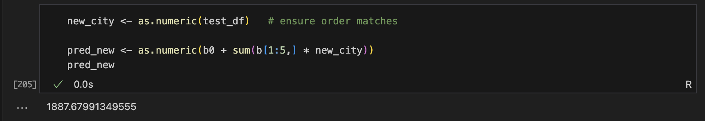

Then after this I re run the model from previous homework and also fit the model to compare the prediction done for this PCA Linear regression model and the Linear Regression using the original Data dimensionality.

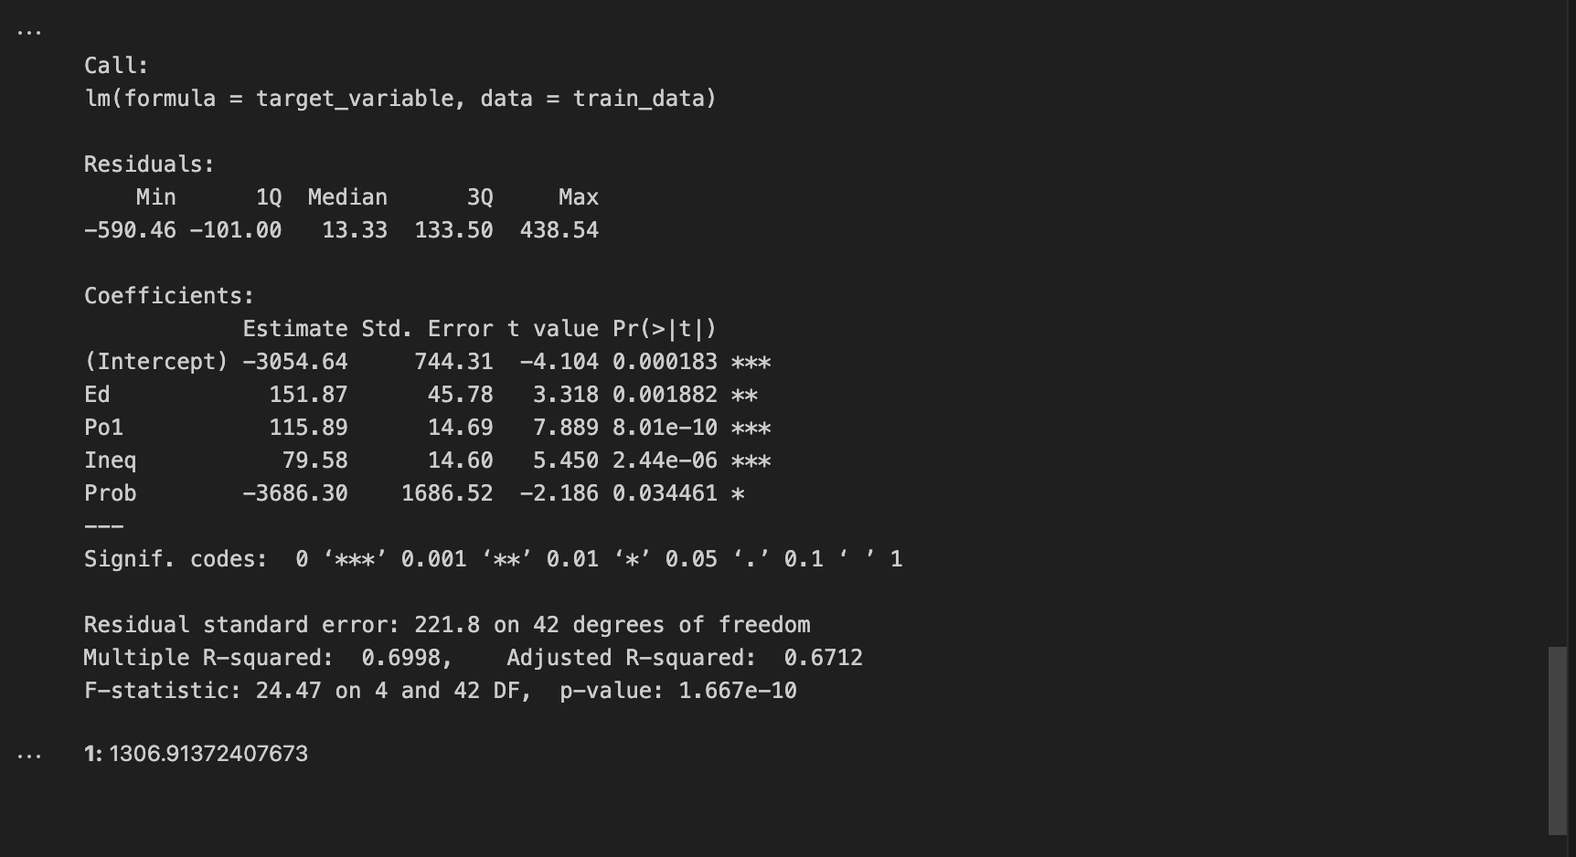

Previous Regression model has a 69% R Square and compares with this new model using PCA parameter we obtained a 85% of Rsquare that we can see that there is a difference of 581 crimes. If we increase the Rsquare for the model Using the original dimensionality of data, then we could have a closer result in terms of number of crimes predicted.

