Question 10.1

Using the same crime data set uscrime.txt as in Questions 8.2 and 9.1, find the best model you can using
(a) a regression tree model, and
(b) a random forest model.
In R, you can use the tree package or the rpart package, and the randomForest package. For each model, describe one or two qualitative takeaways you get from analyzing the results (i.e., don’t just stop when you have a good model, but interpret it too).

Methodology:

- First read the uscrime data set and load a Dataframe.
- Generate the first model using rpart as is requested in the question 10.1.
- Generate result of rpart function to interpret.
- Create Random Forest model using default settings.
- Print the output to understand the report and interpret.
Results

After loading in a data frame the data set uscrime, I started creating the model for Classification tree using the package rpart and function rpart() that I have obtained the following result using 100% of the data set:

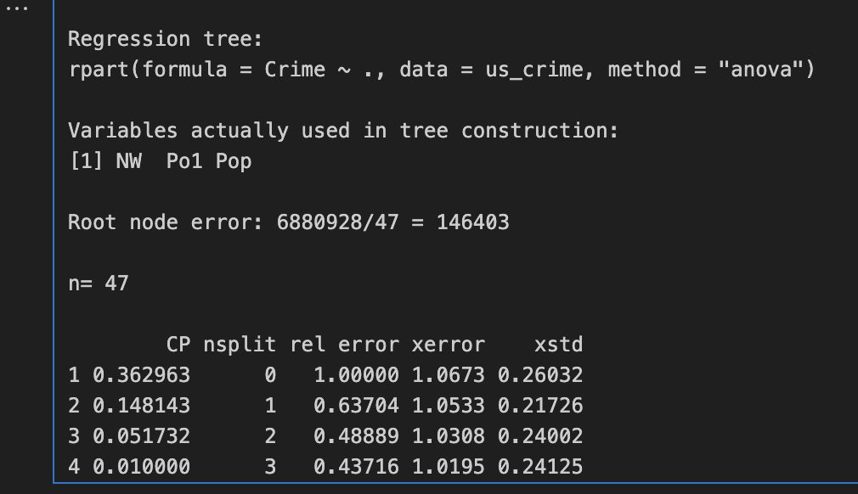

Where I had to read the documentation around this function so that I can interpret the output. On the top we can see the formula set up with the paramaters, that can be observed that I am trying to predict the Crime variable using all the features in my data set us_crime, in method we have the parameter “anova” because that indicate that I want the Regression Classification Tree. In the scond section states that only three variables were used to generate the Classification tree which those are NW, Po1 and Pop. Then in the table we can observe that the when nsplits increase (this is the number of splits that the data has), the Rel erro decrease but after the nsplit=2 does not decrease significantly which means this data set does not get benefit of getting smaller Error in training data.

Then I run the function rsq.rpart() that create the following chart:
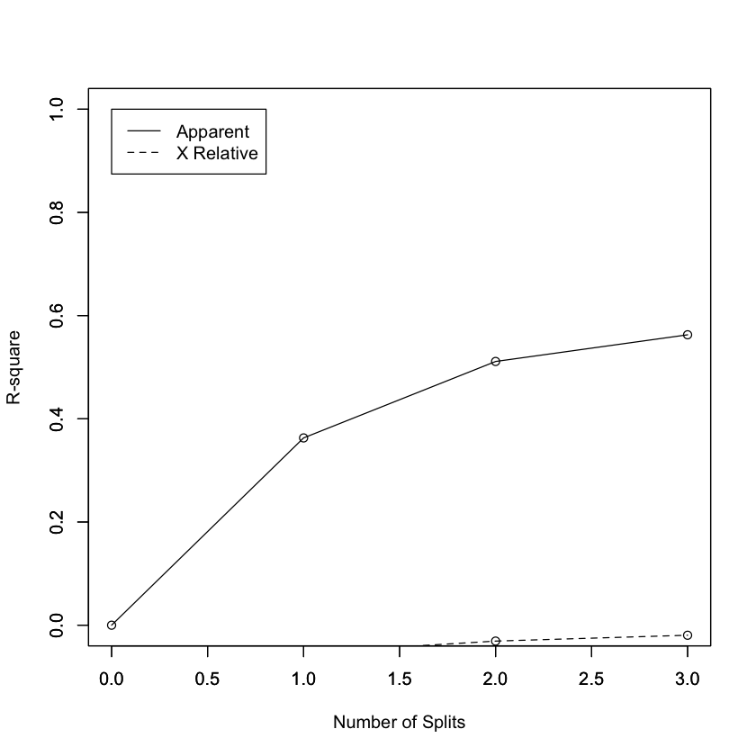
We can observe what we were explaining in the previous paragraph, that this model does not get benefit of getting split and make the data smaller to improve the performance and obtains the best model possible, in this case when we increase the number of splits then the R2 get stuck below 60%.

Now we run the random forest model using 100% of the uscrime data set, I did not split in training or test to understand better how the model shows the number and interpret the numbers. First ran Random Forest with their default values and obtained the following output:

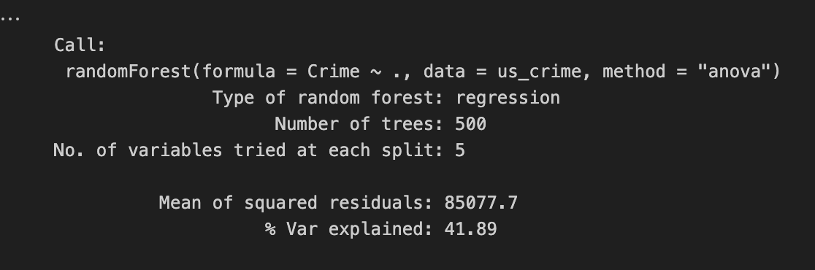

We can observe that the number of trees generated were 500 and number of variables used for each split are 5 then we have the MSE and the last the % of explainability of the variables which is 41.89% (R2). The Performance is not huge as in other datasets, in this case is only 41% of R2 which is in the neighbor of the Classification Tree model that we describe here as well.

If I Decrease the number of trees, the performance is getting even worst:
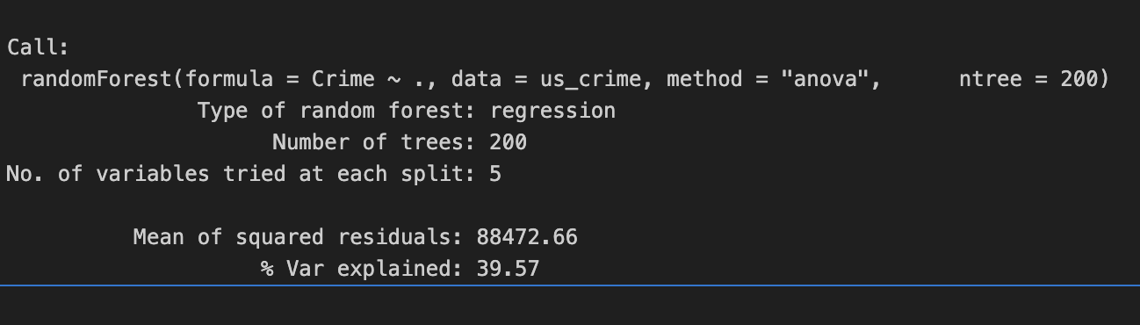

And if I increase the performance get closer to the first one 500 trees but below that:
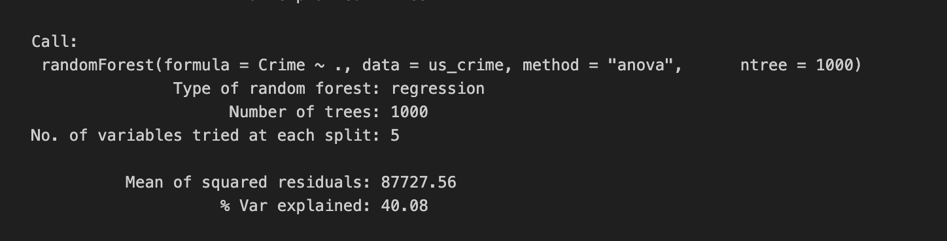

Conclusion

In conclusion I can take the two takeaways from these models by using in a very broad way:

we can observe that both type of models have similar Performance around 40%-60% using all the features for default to predict which is not Ideal but is a first start to understand and interpret the output of each model.

I can observer that smaller trees are better than bigger trees which means that we want to reduce of number of leaf so avoid over fitting of the models and in both models, we can see that increasing the size of the trees or number of trees which is the case for the random forest, does not improve performance.
I would work more on select also the columns to split and get better results instead of taking all the fields for default.

Question 10.2

Describe a situation or problem from your job, everyday life, current events, etc., for which a logistic regression model would be appropriate. List some (up to 5) predictors that you might use.

Answer:
Example 1. I can use logistic regression for investment decision like I have a project or investment and need to decide if invest or not. The data or information that I would use:

Return on Assets
- Return on Equity
- Net Present Value of the investment or project.
- Market cap
- Total Debt

Example 2. I have also another example, which is classify Handball Players per positions and the output is going to be yes or no based on a training data set that are going to be data from old known players:
- Stature
- Weight
- Speed
- Jump
- Ball speed
And other parameters that can decide if that player can be classified in that position.

Question 10.3

Using the GermanCredit data set germancredit.txt from https://archive.ics.uci.edu/static/public/144/statlog+german+credit+data.zip/ (description at https://archive.ics.uci.edu/dataset/144/statlog+german+credit+data ), use logistic regression to find a good predictive model for whether credit applicants are good credit risks or not. Show your model (factors used and their coefficients), the software output, and the quality of fit. You can use the glm function in R. To get a logistic regression (logit) model on data where the response is either zero or one, use family=binomial(link=”logit”) in your glm function call.

- Because the model gives a result between 0 and 1, it requires setting a threshold probability to separate between “good” and “bad” answers. In this data set, they estimate that incorrectly identifying a bad customer as good, is 5 times worse than incorrectly classifying a good customer as bad. Determine a good threshold probability based on your model.

Methodology

Read the german credit dataset and perform some data cleansing over the columns and the Target field to predict.
- Split the data in Training and test so that with training I can decide what fields I would choose as features that are relevant for the model to obtain maximum level of accuracy or performance.
- Run model using all the fields as features and evaluate the relevant fields and exclude the non relevant ones.
- Re run model over few relevant fields over the training data set and then later fit the model.
- Fit the model using test data set and predict the values.
- Calculate Accuracy, specificity and Sensitivy as well as Cost of Misclassification.

Results obtained

I start by Splitting the data set in 70% training and 30% test data, I just keep it simple and then directly run my logistic regression model requested by the first point of this excersice where I observe the features that are mostly relevant for the model.

Call:

glm(formula = V21 ~ ., family = binomial(link = "logit"), data = train_data)

Coefficients:

Estimate Std. Error z value Pr(>|z|)

(Intercept) -9.951e-02 1.364e+00 -0.073 0.941838

V1A12 -5.170e-01 2.641e-01 -1.958 0.050257 .

V1A13 -1.460e+00 4.986e-01 -2.929 0.003400 **

V1A14 -1.761e+00 2.849e-01 -6.182 6.35e-10 ***

V2 3.840e-02 1.151e-02 3.336 0.000850 ***

V3A31 4.944e-01 6.785e-01 0.729 0.466225

V3A32 -1.022e-01 5.482e-01 -0.186 0.852066

V3A33 -5.942e-01 5.974e-01 -0.995 0.319921

V3A34 -1.233e+00 5.556e-01 -2.220 0.026419 *

V4A41 -1.754e+00 4.679e-01 -3.748 0.000178 ***

V4A410 -3.563e-01 9.095e-01 -0.392 0.695220

V4A42 -7.213e-01 3.225e-01 -2.237 0.025302 *

V4A43 -1.090e+00 3.136e-01 -3.476 0.000509 ***

V4A44 -5.227e-01 8.272e-01 -0.632 0.527499

V4A45 -8.579e-01 7.332e-01 -1.170 0.241967

V4A46 4.111e-02 4.762e-01 0.086 0.931214

V4A48 -1.576e+01 5.489e+02 -0.029 0.977097

V4A49 -1.199e+00 4.362e-01 -2.749 0.005977 **

V5 1.455e-04 5.380e-05 2.705 0.006828 **

V6A62 -5.542e-01 3.616e-01 -1.533 0.125323

V6A63 -4.306e-01 5.084e-01 -0.847 0.397028

V6A64 -1.632e+00 7.257e-01 -2.249 0.024494 *

V6A65 -1.215e+00 3.328e-01 -3.650 0.000262 ***

V7A72 -3.942e-01 5.191e-01 -0.759 0.447592

V7A73 -7.290e-01 4.989e-01 -1.461 0.143982

V7A74 -9.156e-01 5.438e-01 -1.684 0.092195 .

V7A75 -5.654e-01 5.008e-01 -1.129 0.258877

V8 3.958e-01 1.127e-01 3.512 0.000445 ***

V9A92 1.422e-02 4.966e-01 0.029 0.977161

V9A93 -6.662e-01 4.861e-01 -1.371 0.170480

V9A94 -3.152e-01 5.839e-01 -0.540 0.589294

V10A102 3.958e-01 5.458e-01 0.725 0.468311

V10A103 -7.936e-01 5.147e-01 -1.542 0.123102

V11 -5.414e-02 1.061e-01 -0.510 0.609830

V12A122 3.016e-01 3.151e-01 0.957 0.338502

V12A123 2.997e-01 3.055e-01 0.981 0.326600

V12A124 1.070e+00 5.164e-01 2.072 0.038265 *

V13 -2.266e-02 1.160e-02 -1.954 0.050760 .

V14A142 -6.050e-03 5.062e-01 -0.012 0.990464

V14A143 -5.765e-01 2.978e-01 -1.936 0.052888 .

V15A152 -5.414e-01 2.930e-01 -1.848 0.064614 .

V15A153 -1.322e+00 5.843e-01 -2.262 0.023681 *

V16 5.362e-01 2.461e-01 2.179 0.029316 *

V17A172 6.823e-01 8.370e-01 0.815 0.414972

V17A173 5.230e-01 8.036e-01 0.651 0.515165

V17A174 4.748e-01 8.107e-01 0.586 0.558077

V18 3.212e-01 3.179e-01 1.010 0.312349

V19A192 -3.655e-01 2.461e-01 -1.485 0.137428

V20A202 -1.388e+00 7.956e-01 -1.745 0.080996 .

---

Signif. codes: 0 ‘***’ 0.001 ‘**’ 0.01 ‘*’ 0.05 ‘.’ 0.1 ‘ ’ 1

(Dispersion parameter for binomial family taken to be 1)

Null deviance: 853.51 on 699 degrees of freedom

Residual deviance: 598.05 on 651 degrees of freedom

AIC: 696.05

Number of Fisher Scoring iterations: 14

Then I select just a few features from the first run of the model to re-run it and then use to predict the values over the Test data set:

Later fit the data and start to evaluate the accuracy, Sensitivity, Specificity and the Cost of Misclassification using the model above. First, I run with a threshold over my logistic regression fitting model output of 0.4 which means that if the probability is greater than 0.4 then classify as 1 then 0.

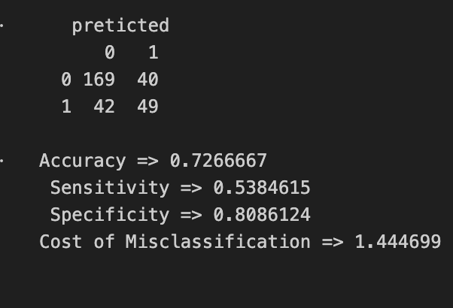

We can observe that we have an accuracy of 73%, but based on the second point of the exercise is asking to evaluate the cost of Misclassification and chose a threshold that minimize that cost. According to the second question of the exercise the cost of classifying a bad client as good is 5 times worst then classifying a good as bad. So with that I have created the following formula:

Cost of misclassification= P(FN)*1 + P(FP)*5

That is going to give me the cost and what we need to do is test and try different levels of threshold and minimize the Cost. I run the same result ,showed before for a threshold of 0.4, also run for 0.6, 0.9 obtaining the following results:

Threshold = 0.6

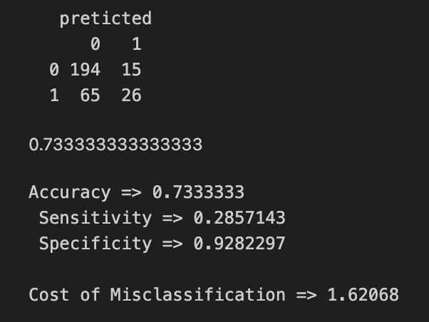

Threshold =0.9

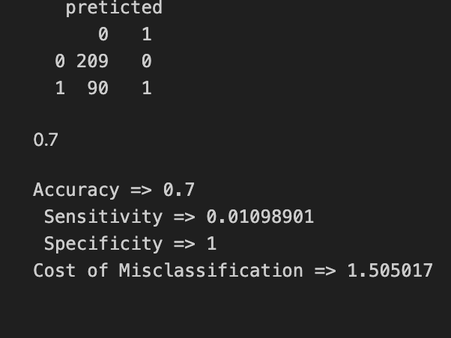

So we should use the threshold equal to 0.9 to minimize our cost of misclassifying a client, Which make sense the confusion matrix above because it cost more classifying a Bad client as Good than Classifying a Good client as Bad.

Conclusion

Answer to question 1

Model used

And the coefficients are:

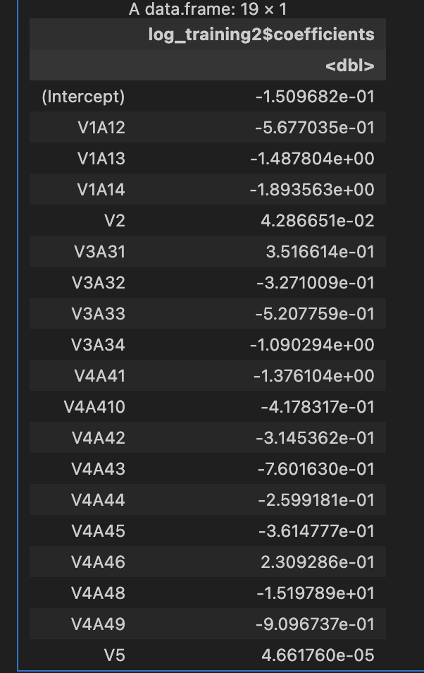

Answer question 2 is that the Threshold that should be used to minimize the cost is 0.9 because cost more classify bad clients as good than good as bad.

