Question 11.1

Using the crime data set uscrime.txt from Questions 8.2, 9.1, and 10.1, build a regression model using:

Stepwise regression
- Lasso
- Elastic net
For Parts 2 and 3, remember to scale the data first – otherwise, the regression coefficients will be on different scales and the constraint won’t have the desired effect.

For Parts 2 and 3, use the glmnet function in R.

Notes on R:
- For the elastic net model, what we called λ in the videos, glmnet calls “alpha”; you can get a range of results by varying alpha from 1 (lasso) to 0 (ridge regression) [and, of course, other values of alpha in between].
- In a function call like glmnet(x,y,family=”mgaussian”,alpha=1) the predictors x need to be in R’s matrix format, rather than data frame format. You can convert a data frame to a matrix using as.matrix – for example, x <- as.matrix(data[,1:n-1])
- Rather than specifying a value of T, glmnet returns models for a variety of values of T.

Methodology

Read data set USCRIME and scale the data.

Split the data in training data set and test dataset.

Build linear regression models using cv.glmnet for lasso and elastic net, and step() for stepwise regression, applying cross-validation on the training data.

Fit the model, using the lambda that minimize the square error.

Predict the model and print coefficients.

Results

I started Building a linear regression model using the three requested approach to select variable, so that I can obtain better performance using the right number of variables. Mentioned above the data has been partitioned in training set and test set, later I scale the data as per is suggested in the instruction of the exercise.

First start using the function CV.glmnet to cross validate and train my model later I fit the model and then later predict and evaluate the model calculating the RSME, I repeat the same steps for Lasso and Elastic net approach by changing the alpha value. I just call the minimum lambda obtained from the cross validation and fit the data set with that, the reason is because that supposed to be the value that minimize the square error which is what we are looking for to obtain the maximum or optimum Rsquare.

The minimum lambda for Lasso that I have obtained is 98.920002920 and I have obtained the following features included in my model as well as the Lasso MSE (Square Error).

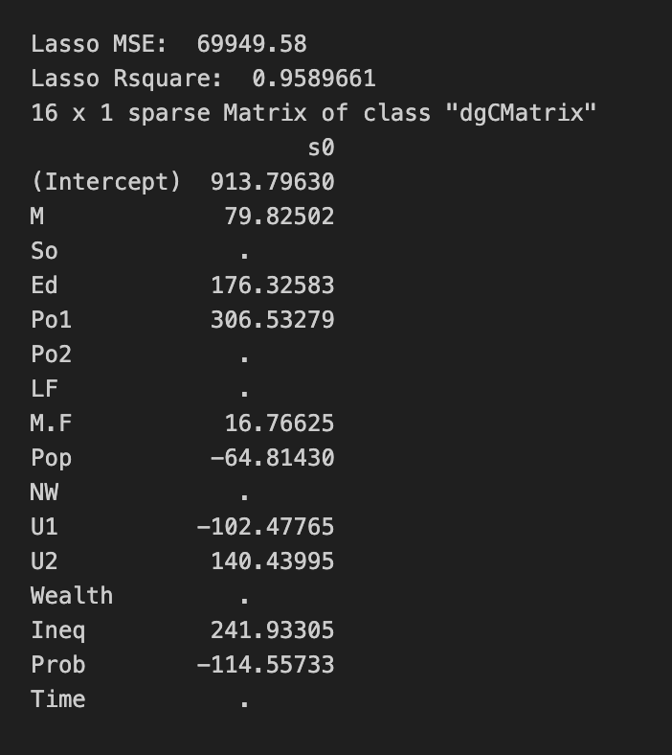

Then this is the result for Elastic net using a lambda of 17.2071193481599

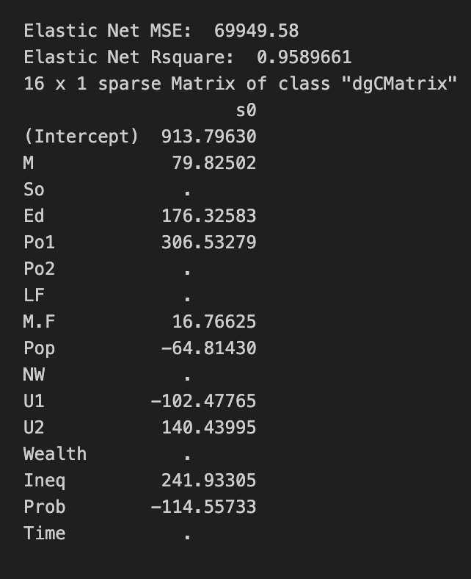

We can observe that Lasso and Elastic net returns the same results which means that each approach is proposing the same shrinkage of coefficient which leads to identical fitted models.
I also wanted to observe how the Square error behave by changing the lambda and plot in a charge where we can observe that we increase the value of lambda and the Square error get reduced to a minimum, but later if I continue increasing the value for Lambda then the error start increasing again exponentially.

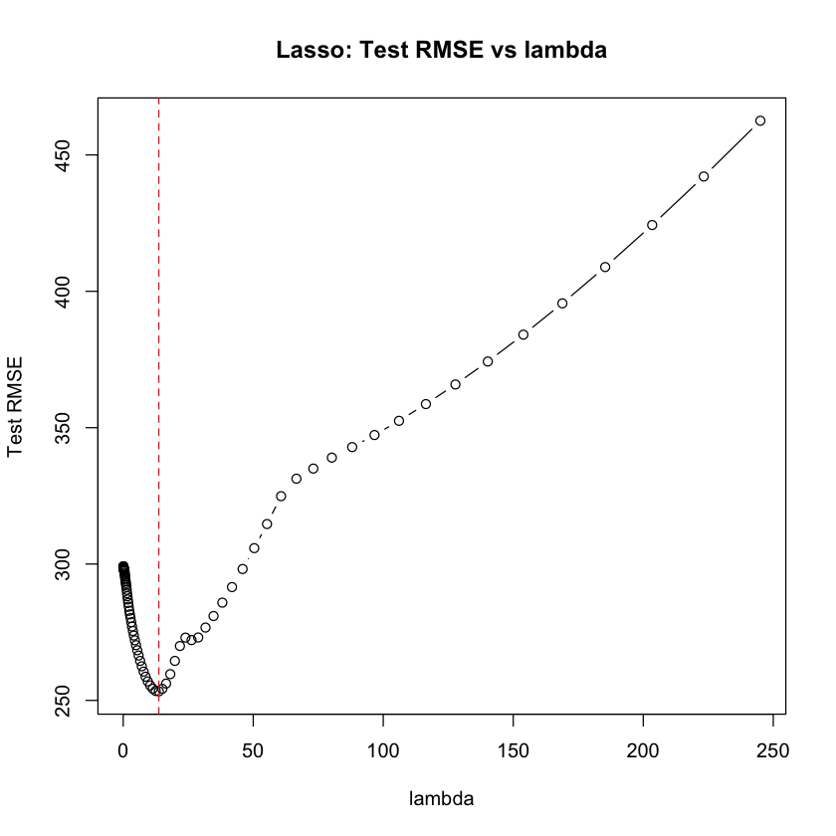

This was using the Lasso approach. This pattern is analogous to the elbow rule to choose the number of cluster in k means model where we look for the region where additional regularization no longer improves performance. In practice, cv.glmnet() evaluates a grid of lambda values and chooses the one that gives the smallest cross-validated mean squared error (or a slightly larger value within one standard error of the minimum), so we do not have to solve the underlying Lagrange-multiplier optimization by hand.

Then last approach is the stepwise where I obtain the following result:

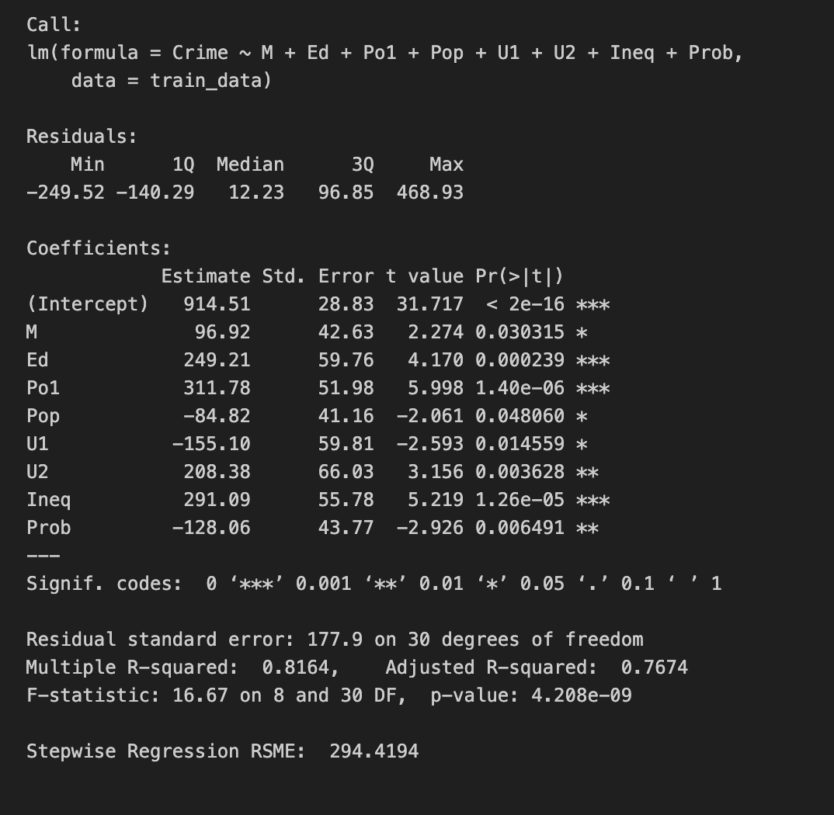

The square error is a lot less than Lasso and Elastic net approach, obtaining a 81.64% of accuracy and selects less coefficient for the model.

Conclusion

After applying all three variable-selection methods, the stepwise model achieved a much lower test mean squared error (294.41) than the Lasso and Elastic Net models (both around 69,945), and it also used fewer predictors. Given its substantially better predictive accuracy and more parsimonious set of variables, I would choose the coefficients from the stepwise regression model for this dataset.

