Question 12.1

Describe a situation or problem from your job, everyday life, current events, etc., for which a design of experiments approach would be appropriate.

Answer 12.1:

Example 1

My Previous role at my work was Product owner proxy. As a product owner, I had to prepare and collect all the data from the testing events when we were releasing a new future for an analytics application that my company was developing.

I think this is a great example where we can apply AB testing, so that during the testing we can decide what features is better to get released, or if we continue with the old version. The way that we can design this is have one group that is going to test a version A of the new features, and then another group receive a version B with certain layout changes, rearrange of elements, and change in color as well as the way that the features is executed. Based on this testing, users generate metrics that can help us decide which option was able to achieve the attraction or understanding of the user.
AB test is a frequent Analysis used for these types of things in software development.

Example 2:

Reduce emergency room wait time, the factors for this are going to be 1)number of triage nurses run per shift 2) use availability of the lab, this is to respond to the output average patients time in emergency room.

Question 12.2

To determine the value of 10 different yes/no features to the market value of a house (large yard, solar roof, etc.), a real estate agent plans to survey 50 potential buyers, showing a fictitious house with different combinations of features. To reduce the survey size, the agent wants to show just 16 fictitious houses. Use R’s FrF2 function (in the FrF2 package) to find a fractional factorial design for this experiment: what set of features should each of the 16 fictitious houses have? Note: the output of FrF2 is “1” (include) or “-1” (don’t include) for each feature.

Answer 12.2

This this time I used python to resolve this, I used a library called pyDOE3 that contains a series of function that can be used to create random experiment tables, in this case I have created a table of factors and trial using 4 factor and then I created the rest of the 6 factors using the combination of the first 4 ones.

The reason of why I make it in that way is because the function fracfact() creates the number of runs based of the number of factors that want to be included. I needed just 16 runs representing the 16 houses and then create the rest of the 6 factors missing to complete in total 10 factor. With this I have created a table of 16 rows x 10 columns and the features selected for this experiment are:
- Large yard
- Solar roof panels
- Swimming pool
- Two-car garage
- Finished basement
- Modern/remodeled kitchen
- Fireplace
- Dedicated home office
- Walk-in closet in primary bedroom
- Short walking distance to public transit

This is the result of the table

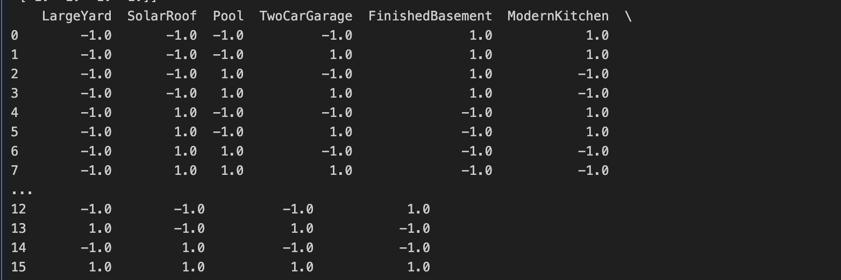

Question 13.1

For each of the following distributions, give an example of data that you would expect to follow this distribution (besides the examples already discussed in class).

Binomial

Geometric

Poisson

Exponential

Weibull

Answer 13.1

Binomial: almost every book gives as example the flip coin where you have 50% probability for each side, now I will give as example a production process where we want to model the defectiveness rate of a product when it gets produced at the end of the assembly line. I am adding here an image simulating 20 products (See the code in the notebook)

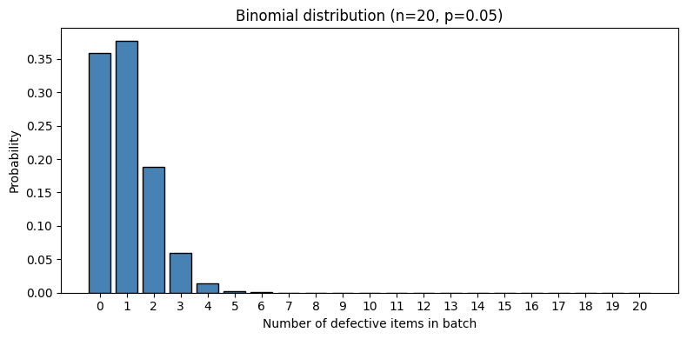

Geometric: this should be an example that basically always is the time that need to wait until something fails or success, in this case I will give the example of a raise car, how many raises a raise car need to run until the car fails in some of their components. This is a good distribution to have for a raise car manufacturing. I have created a distribution with a fail probability of 0.4.
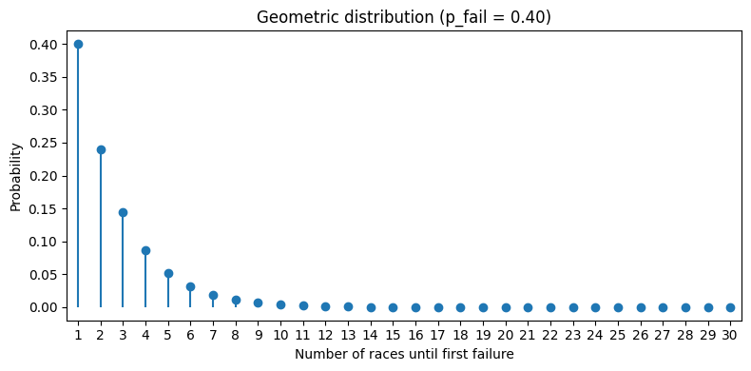

Poisson: this example could be in a basketball team and see the distribution of the probability of complete N passes in 2 second that can help the couch with the assistant to design more tactics for the game. Here I created a chart with that distribution.:

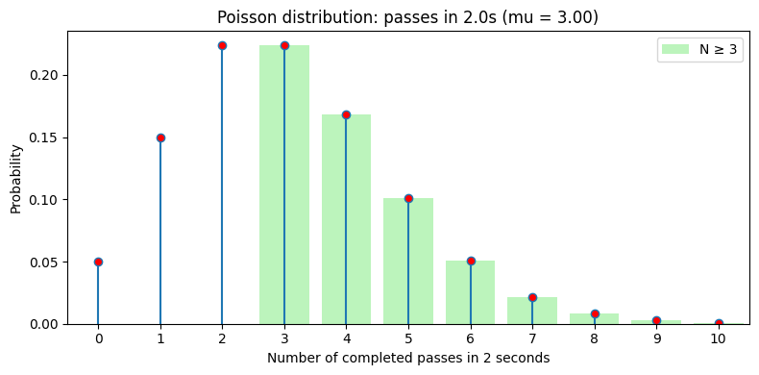
- Exponential: like the geometric distribution, this also measure the probability of success or failure in a certain period, the only difference is that exponential distribution is more for continuous random variables and geometrics is more for discrete trials. My example for this is time that is running until the next cyber attach happen, and again I am sharing the chart for this distribution.
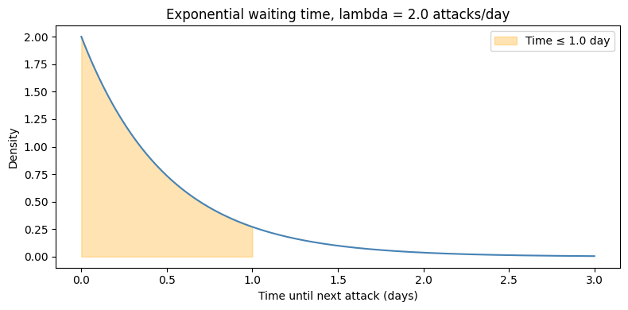

Weibull: this distribution has as parameter β that if is equal to 1 then we have our exponential model, but That parameter can be change to greater than 1, equal to one or less than one. In This case I would say that should be greater than 1 and the example is how long should pass until the heart of a person start to fail from the moment of the doctor diagnostic.

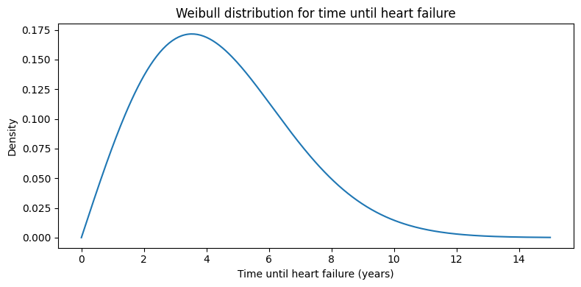
Question 13.2

In this problem you, can simulate a simplified airport security system at a busy airport. Passengers arrive according to a Poisson distribution with λ₁ = 5 per minute (i.e., mean interarrival rate μ₁ = 0.2 minutes) to the ID/boarding-pass check queue, where there are several servers who each have exponential service time with mean rate μ₂ = 0.75 minutes. [Hint: model them as one block that has more than one resource.] After that, the passengers are assigned to the shortest of the several personal-check queues, where they go through the personal scanner (time is uniformly distributed between 0.5 minutes and 1 minute).
Use the Arena software (PC users) or Python with SimPy (PC or Mac users) to build a simulation of the system, and then vary the number of ID/boarding-pass checkers and personal-check queues to determine how many are needed to keep average wait times below 15 minutes. [If you’re using SimPy, or if you have access to a non-student version of Arena, you can use λ₁ = 50 to simulate a busier airport.]

Answer 13.2

Methodology

Understanding of the process.
- Identify the distribution and use as part of the process.
- Apply understanding to the python code and use parameter suggested.
- Obtain results and findings.

Process

I have created the simulation using python, for that this is the flow followed
Repeat until finish the time of the simulation
Wait for Passenger scan

Passenger scanned
Passenger Arrival Poisson Distribution
Passenger check Service

Wait for passenger check

Passenger Arrival Poisson Distribution

This process Begins from waiting the passenger, then the check officer waits for the passenger, after that the passenger go through check, after that then pass through the scanner and repeat the process until finish the time of the simulation.

I used the parameter given in the exercise, with λ₁ = 5 for the Poisson and μ₂ = 0.75 for the exponential distribution, then I have iterated the number of checkers and scanners so that I can meet the average wait of less than or equal to 15 min.

Parameter | Value | Interpretation
λ₁ (arrival rate) | 5 per minute | Average of 5 passengers arrive each minute
μ₁ (interarrival time) | 0.2 minutes | Mean time between arrivals = 1/λ₁
μ₂ (ID service time) | 0.75 minutes | Mean time per ID check (exponential)
Scanner time | Uniform(0.5, 1.0) | Scanner processing: 0.5 to 1.0 minutes
Simulation duration | 480 minutes | 8-hour operational period

Results and Conclusion

First I just give a first run to simulate with 1 to 3 checkers and scanners, but it was not enough, in any of the cases the wait time in line was getting reduced to 15 minutes. Then I increased to try 6 checkers (officer performing the checks) and 4 scanners, with this we obtained the following results.

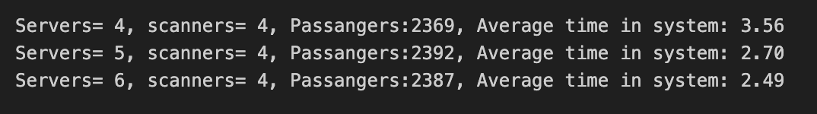

According to this, the airport should work always with at least 4 scanners and 4 Checkers/Servers, so that the wait time is not more than 15 minutes. If I increase lambda to 50 for a more busy airport where arrive 50 people per minutes, we have to increase the number of checkers and scanners to at least 35 in total, from 5 to 50 there is a big difference that requires a bunch of new scanners and resources to reduce the average wait time.

