Core
Verification Guide

Version #: 0.4
Revision date: AUG 16, 2010

Version Control
Revision | Authors | Date | Comments | Revisors
0.1 | Dino Cassel, Harney Abrahim | 11/aug/2010 | Initial beta version | -
0.2 | Dino Cassel, Harney Abrahin | 13/aug/2010 | Added FSM block data | -
0.3 | Dino Cassel | 13/aug/2010 | Added ALU block data | -
0.4 | Lizbeth | 16/aug/2010 | Added Register Control block data | Vinícius Amaral

Table of Contents

Core 6
1. Introduction 6
1.1 Verification Strategy 6
1.2 Verification Flow 6
1.3 Random Simulation 7
2. References 7
3. Verification Plan 7
3.1 Design Details 7
3.2 Feature List 8
3.3 Verification List 8
3.4 FSM Description 10
3.4.1 FSM.F1 Description 10
3.4.1.1 Verification Steps for FSM.F1.V1 10
3.4.2 FSM.F2 Description 10
3.4.2.1 Verification Steps for FSM.F2.V1 10
3.4.2.2 Verification Steps for FSM.F2.V2 10
3.4.2.3 Verification Steps for FSM.F2.V3 11
3.5 ALU Description 11
3.5.1 ALU.F1 Description 11
3.5.1.1 Verification Steps for.ALU.F1.V1 11
3.5.1.2 Verification Steps for ALU.F1.V12 11
3.5.2 ALU.F2 Description 11
3.5.2.1 Verification Steps for.ALU.F2.V1 11
3.5.2.2 Verification Steps for ALU.F2.V2 11
3.5.2.3 Verification Steps for.ALU.F2.V2 11
3.6 REG_C Description 12
3.6.1 REG_C.F1 Description 12
3.6.1.1 Verification Steps for REG_C.F1.V1 12
3.6.1.2 Verification Steps for REG_C.F1.V1 12
3.6.2 REG_C.F2 Description 12
3.6.2.1 Verification Steps for REG_C.F2.V1 12
3.6.2.2 Verification Steps for REG_C.F2.V2 12
3.6.2.3 Verification Steps for REG_C.F2.V3 12
3.6.3 REG_C.F3 Description 12
3.6.3.1 Verification Steps for REG_C.F3.V1 13
3.6.4 REG_C.F4 Description 13
3.6.4.1 Verification Steps for REG_C.F4.V1 13
3.6.5 REG_C.F6 Description 13
3.6.5.1 Verification Steps for REG_C.F6.V1 13
3.7 MEM_C Description 13
3.7.1 MEM_C.F1 Description 13
3.7.1.1 Verification Steps for MEM_C.F1.V1 13
3.7.1.2 Verification Steps for MEM_C.F1.V2 14
3.7.2 MEM_C.F2 Description 14
3.7.2.1 Verification Steps forMEM_C.F1.V2 14
3.8 TOP Description 14
3.8.1 TOP.F1 Description 14
3.8.1.1 Verification Steps for TOP.F1.V1 14
3.8.1.2 Verification Steps for TOP.F1.V1 14
4. Testbench 14
4.1 Testbench Overview 15
4.2 Partitioning 15
4.2.1 FSM verification testbench architecture 16
4.2.2 FSM verification testbench architecture 16
4.2.3 Register Control verification testbench architecture 17
4.2.1 Memory control verification testbench architecture 17
4.3 Global Routines 17
4.4 External Interface Functions 17
4.5 Memory Map 18
4.6 Verification and Debug Registers 18
4.7 Clocking 18
4.8 Reset 18
4.9 Termination 18
5. Drivers and Monitors 18
5.1 Driver and Monitor Overview 18
5.2 Driver/Monitor Description 18
5.2.1 Driver/Monitor Functional Overview 18
5.2.2 Driver/Monitor Commands 18
5.2.3 Driver/Monitor Arguments 18
5.2.4 Driver/Monitor Configuration 19
6. Models 19
6.1 Functional Models 19
The verification is 19
6.1.1 FSM Reference model 19
6.1.2 ALU Reference Model 19
6.1.3 Register Control Reference Model 19
6.1.4 Memory Control Reference Model 19
6.2 Memory Models 19
6.3 Stub Models 20
6.4 IO and PADs 20
7. Additional Information 20

Core

- Introduction

This document provides a guideline about verification of Core block for EMC08 project. The next sections show the detailed plan and strategy to do the verification. First, some sections introduce the strategy used. Finally, the detailed block verification plan is shown.

  - Verification Strategy

The methodology used is the eRM (e Reuse Methodology) that provides a template for partitioning the environment. This way, a common environment is adopted to each module. This strategy codifies the best practice for developing e-based verification and ensures consistency, reusability and extensibility.

  - Verification Flow

The DUT (Design Under Test) is the block that we want to verify. The following figure illustrates the diagram of verification flow.

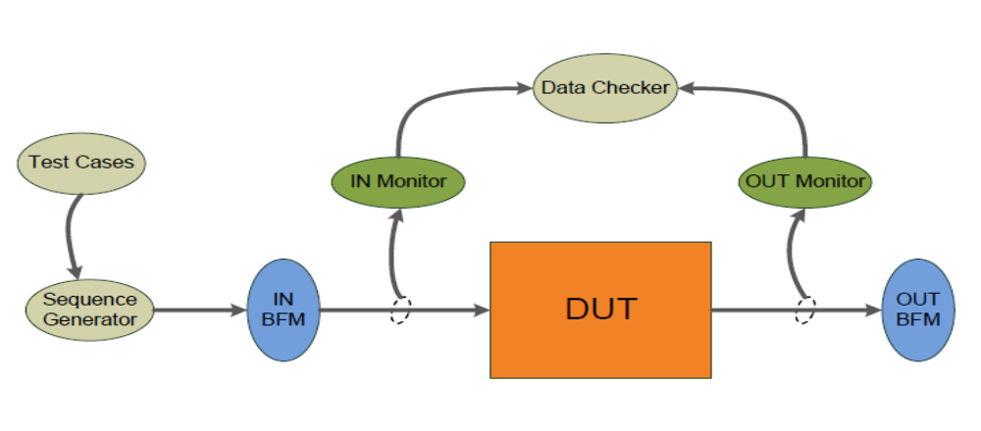
Figure 1 - Verification Flow Block Diagram

The DUT receives stimulus from input BFM (Bus Functional Model) and sends outputs to output BFM. These stimulus are generated by Sequence Generator according to whished Testcase that can control the order of sequences, types of stimulus, number of repetitions and so on. There are two monitors that sample input and output DUT signals. They are passive units that do not change the values of signals. Monitors send sampled signals to Data Checker that compares DUT outputs with expected answers and gives a DUT error if it doesn’t mismatch.
The following figure shows the verification flow inside Data Checker sub-block. A reference model receives the inputs from IN Monitor, calculates the expected results and compares these results with DUT outputs, send to Data Checker by OUT Monitor. So, Data Checker compares DUT’s results with expected results from reference model and creates illegal buckets when they mismatch. The illegal buckets generate a DUT error.

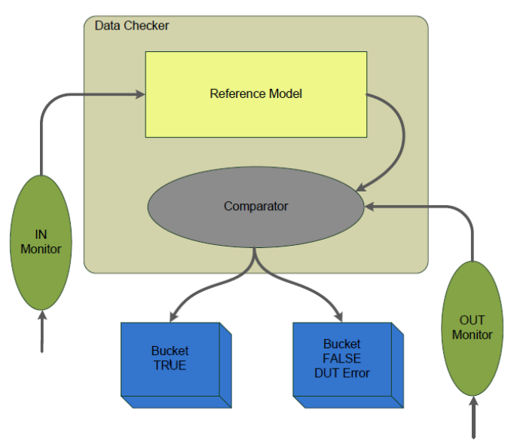
Figure 2 – Data Checker model

  - Random Simulation

The verification of the core will be done through the external random instructions generation. It is intended to use a simulator to create the set of random inputs. This simulator, that will be used to create the random inputs, was not yet defined.

- References

The references used for this documentation are:
- EMC08 project – Core Block Guide, version 1.0
- Cadence. "Specman® Elite Basics for Verification Environment Developers." Lecture Manual, 2007.
- Prentice Hall, Design Verification with e – Samir Palnitkar

- Verification Plan

The Verification Plan describes the verification process that will be followed to verify the Core block. It details a list of required verifications that must be accomplished to validate the design specification.

  - Design Details

This section describes basic details about verification plan and the design that will be verified. The Table 1 gives this information.

Component | Feature Description
Document Name | Core Verification Plan
Verification Methodology | Bottom-up
Verification Methods | Simulation
Simulation Components
Application | Cadence Specman® Elite Version 6.1
Language | e language
Testcase file | EMC08/Core/verification/testbench/emc08_core_*.e
Table 1 – Design Details

  - Feature List

The Table 2, shown below, lists the critical features of design that must be verified, including a description of the expected functional and the priority of each feature.

Feature Number | Feature Description | Testing Priority
EMC.Core.FSM.F1 | State machine should transition through all valid states and must have just legal transitions | 10
EMC.Core.FSM.F2 | State machine needs to do the correct functionality for each input, generating the right output | 10
EMC.Core.ALU.F1 | All the operation types need to be stimulated | 10
EMC.Core.ALU.F2 | All the operations (mult, div, add, …) must give a correct result | 5
EMC.Core.REG_C.F1 | The registers control defines by priority or time who has access to registers bank. These priorities among blocks must be accomplished | 10
EMC.Core.REG_C.F2 | The registers control allows reading and writing of the other blocks as the FSM, ALU, and external modules, in the registers banks. These operation must be done correctly | 10
EMC.Core.REG_C.F3 | In the registers bank has 16 bytes of address, allowing access (WR/RD), some addresses are directed to bits or bytes | 8
EMC.Core.REG_C.F4 | The registers control is used to control access to the registers bank, If there are anything possible (WR/RD) of FSM and other modules, the register control decides who goes first going to develop the (WR/RD) | 10
EMC.Core.REG_C.F5 | Reset must be property functional | 5
EMC.Core.MEM_C.F1 | All inputs need to written/read in the memory | 10
EMC.Core.MEM_C.F2 | The write and read cannot be active at the same time | 8
EMC.Core.TOP.F1 | The flow execution of each instruction of all instruction set must be accomplished correctly | 10
Table 2 – Feature List

  - Verification List

The verification list, described on Table 3, defines how the features (on Table 2) will be verified. This list contains all verifications that must be run to verify expected features.

Verif. Number | Description | Method | Level | Features Verified | Prio  Rity | Owner | Completion
EMC.EMC.Core.FSM. F1.V1 | Verify coverage in 100 % of legal states | Simulation | Unit | EMC.EMC.Core.FSM.F1 | 10 | Dino, Harney | 0 %
EMC.Core.FSM. F2.V1 | Verify the functionality of each instruction input, and see if the output is right | Simulation | Unit | EMC.Core.FSM.F2 | 10 | Dino, Harney | 0 %
EMC.Core.FMS.F2.V2 | Verify if the output is correct set to the right block | Simulation | Unit | EMC.Core.FSM.F2 | 10 | Dino, Harney | 0 %
EMC.Core.FSM.F2.V3 | Verify if some instruction out of the instruction set is treated as a valid instruction | Simulation | Unit | EMC.Core.FSM.F2 | 8 | Dino, Harney | 0 %
EMC.Core.ALU. F1.V1 | Verify if the code of operation in the selector correspond to the right operation | Simulation | Unit | EMC.Core.ALU.F1 | 10 | Dino, Harney | 0 %
EMC.Core.ALU. F1.V2 | Verify if the selector code indentify when there is a no valid instruction | Simulation | Unit | EMC.Core.ALU.F1 | 7 | Dino, Harney | 0 %
EMC.Core.ALU. F2.V1 | Verify if each function are generating correct output | Simulation | Unit | EMC.Core.ALU.F2 | 10 | Dino, Harney | 0 %
EMC.Core.ALU. F2.V2 | Verify if the BDC block has the right conversion to one or two operands as inputs | Simulation | Unit | EMC.Core.ALU.F2 | 4 | Dino, Harney | 0 %
EMC.Core.ALU. F2.V3 | Verify the CY, AC, OV bits | Simulation | Unit | EMC.Core.ALU.F2 | 4 | Dino, Harney | 0 %
EMC.Core. REG_C.F1.V1 | Test the priority, there are several reading requests at the same time for the several modules | Simulation | Unit | EMC.Core.REG_C.F1 | 10 | Lizbeth | 0 %
EMC.Core. REG_C.F1.V2 | Test the priority, there are several writing requests at the same time for the several modules | Simulation | Unit | EMC.Core. REG_C.F1 | 10 | Lizbeth | 0 %
EMC.Core. REG_C.F2.V1 | Test if the data input are address or data program | Simulation | Unit | EMC.Core. REG_C .F2 | 8 | Lizbeth | 0 %
EMC.Core. REG_C.F2.V2 | Verify that all data is reading correctly at address marked | Simulation | Unit | EMC.Core. REG_C.F2 | 8 | Lizbeth | 0 %
EMC.Core. REG_C.F2.V3 | Verify that all data is writing correctly at address marked | Simulation | Unit | EMC.Core. REG_C.F2 | 8 | Lizbeth | 0 %
EMC.Core. REG_C.F3.V1 | Verify if the data are read, is for bit or byte. (Check the operation flag.) | Simulation | Unit | EMC.Core. REG_C.F3 | 8 | Lizbeth | 0 %
EMC.Core. REG_C.F4.V1 | Test all possible cases where an application to read or write in the same record at the same time, for the several modules | Simulation | Unit | EMC.Core. REG_C.F4 | 8 | Lizbeth | 0 %
EMC.Core. REG_C.F5.V1 | Check the RESET for this block | Simulation | Unit | EMC.Core. REG_C.F6 | 8 | Lizbeth | 0 %
EMC.Core.MEM_C.F1.V1 | Verify if the complete set of address is accessible to write/read in memory | Simulation | Unit | EMC.Core.MEM_C.F1 | 10 | Felipe | 0 %
EMC.Core.MEM_C.F1.V2 | Verify if the write/read bit or byte mode of operation in memory RAM and read from ROM in memory | Simulation | Unit | Core.MEM_C.F1 | 10 | Felipe | 0 %
EMC.Core.MEM_C.F2.V1 | Verify write and read signals at the same time is not conflicting | Simulation | Unit | Core.MEM_C.F2 | 8 | Felipe | 0%
EMC.Core.TOP.F1.V1 | Verify the connections among the core internal blocks | Simulation | Unit | EMC.Core.TOP.F1 | 10 | Dino, Harney | 0 %
EMC.Core.TOP.F1.V2 | Verify the timing among the blocks | Simulation | Unit | EMC.Core.TOP.F1 | 10 | Dino, Harney | 0 %
Table 3 – Verification List

  - FSM Description

The FSM module represents the finite state machine responsible to manage instructions fetched from memory or another peripheral and send control signals depending on which sub-module must be activated.
Data instructions and jump instructions are managed by FSM while arithmetical, logical and Boolean instructions are managed by ALU.

    - FSM.F1 Description

This feature is intended to verify the coverage of all states of the FSM. State machine should transition through all valid states and must have just legal transitions.

      - Verification Steps for FSM.F1.V1

The test case “FSM.F1.V1” aim to verify the coverage of all legal transition states of the FSM. If any illegal transition occurs, them the test case needs to show it. The internal variable state needs to be monitored in this specific test case.

    - FSM.F2 Description
This feature is intended to analyze the correct functionality of the FSM according to the valid instruction set of inputs, generating the expected result.

      - Verification Steps for FSM.F2.V1

The test case “FSM.F2.V1” is responsible to verify the functionality of each instruction input, and see if the output is right. The test need to stimulate the FSM according to the pre-defined instruction set and the FSM behavior need to be accomplished if the specification.

      - Verification Steps for FSM.F2.V2

The test case “FMS.F2.V2” is responsible to verify if the output is correct set to the right block. Since the FSM generate a result, this response need to set the right signal according to the specification and functionality.

      - Verification Steps for FSM.F2.V3

The test case “FSM.F2.V3” is responsible to verify if some instruction out of the instruction set is treated as a valid instruction. Since the specification has a pre-defined instruction set, an invalid instruction could not generate any output or change the system.

  - ALU Description

The ALU is the module responsible for any Boolean or arithmetic operation needed by the core. It’s divided into six sub-modules: Selector, Mult, Div, Add/Sub, Boolean and BCD Setting. The Selector sub-module will receive the instruction opcode and operands from the FSM and decide what unit is the responsible for the desired operation. The operation will be executed and the result will be returned to the FSM for future usage or storage.

    - ALU.F1 Description

This feature is intended to analyze if all the operation of ALU are coverage.

      - Verification Steps for.ALU.F1.V1

The test case “ALU.F1.V1” verify if the code of operation in the selector correspond to the right operation. Since the selector is functional, then all the operations are coverage. This test need to stimulate the selector with all possible operations. This way, all operations need to be generated.

      - Verification Steps for ALU.F1.V12

The test case “ALU.F1.V2” verify if the selector code indentify when there is a no valid instruction. Since it occurs, the ALU must not realize any operation. This test case need generate a invalid code to the selector. Since it wrong value is passed, the selector must treat it as a invalid input and not generate any valid operation.

    - ALU.F2 Description

This feature is intended to analyze if all the ALU operation are functional according to the specification.

      - Verification Steps for.ALU.F2.V1

The test case “ALU.F2.V1” verify if each function are generating correct output. Since there is a specification to each operation, the output needs to be accomplished with the expected result.

      - Verification Steps for ALU.F2.V2

The test case “ALU.F2.V2” verify if the BDC block has the right conversion to one or two operands as inputs. Since this operation can work with one or two operands inputs, the BCD operation needs to work according to the specification to each different case.

      - Verification Steps for.ALU.F2.V2

The test case “ALU.F2.V3” verify the Carry (CY), Auxiliary Carry (AC) and Over-flow (OV) bits are activated according to the operation necessity. This test need stimulate these signals and see if the operation mode is ok.

  - REG_C Description

The Special Function Registers consists of 128 8-Bit registers used for configuration, temporary storage and internal control. The read/write access to these registers is controlled by the FSM. Some of these registers can be written or/and read by more than one external module.
Every module has free access to read any register .The FSM must decide when each module should write the data to the registers according to the actual Core configuration, type of instruction being executed or through time windows.

    - REG_C.F1 Description

The registers control defined by priority (or time) is who has access to registers bank, check that this priority (or time) be given between the FSM, ALU and the others outside modules to the core.

      - Verification Steps for REG_C.F1.V1

Test the priority, there are several reading requests at the same time for the several modules.
It is generated stimulus of the reading request for the several modules, it comes of the core and the external modules of the core (Serial, timers, interrupters, etc.) this creates access conflicts of the reading for the checking the priority control or management of time for all the requests that will be attended.

      - Verification Steps for REG_C.F1.V1

Test the priority and several applications of writing at the same time by different modules in the same and different addresses for it to be monitored and see if this operation is correct.

    - REG_C.F2 Description

The registers control allows reading and writing of the other blocks as the FSM, ALU, and external modules, in the registers banks. It checks that the reading or writing was correct.

      - Verification Steps for REG_C.F2.V1

Test if the data input are address or data program, generate patterns of address and data for them to be sent and acknowledged.

      - Verification Steps for REG_C.F2.V2

Verify that all data is reading correctly at address marked. It is greeted for different address with content known to read and verify the read data is correct.

      - Verification Steps for REG_C.F2.V3

Verify that all data is writing correctly at marked address. They are generated for the different applications of writing and check the written data is correct and in place.

    - REG_C.F3 Description

In the registers bank has 16 bytes of address, allowing access (WR/RD), some addresses are directed to bits or bytes. It has to check if there are reading or writing and this is correct.

      - Verification Steps for REG_C.F3.V1

Verify if the read data is through bit or byte mode. (Check the operation of the flag). Define stimulus of requests for reading and writing through the bit or byte mode.

    - REG_C.F4 Description

The registers control is used to control access to the registers bank, If there are anything possible (WR/RD) of FSM and other modules, the register control decides who goes first going to perform the WR/RD operations.

      - Verification Steps for REG_C.F4.V1

Test all possible cases where an application read or write in the same record at the same time, for the several modules.

    - REG_C.F6 Description

Check the reset for the register control module.

      - Verification Steps for REG_C.F6.V1

Check the RESET for this block. It defines the input values or baseline data and created a display to reset the control registers.

  - MEM_C Description

The overall function of the Memory Control unit is receiving addresses from the FSM and decides where to look up the data. There are three types of memory avaiable: Data Memory, Program Memory and Special Function Registers that utilizes RAMs, ROMs and Registers, respectively, for storage. The FSM will identify if the desired data is stored in the Data Memory or Program Memory and send signals requesting the data from the Memory Control.
There are 128 Bytes of RAM, 4Kbytes of ROM and 128 8-Bit registers internally to the Core. The address space for Data and Program memory are different, but is shared between Data and SFR. Two modes of addressing are used: Direct and Indirect. The same address can represent different memory locations depending on the mode it’s addressed.
All internal memories are direct accessed by the Memory Control. If the requested data is located at external RAM or ROM, the Memory Control must transfer the request to the Bus Control module.

    - MEM_C.F1 Description

This feature is intended to analyze that all inputs need to written/read in the memory according to the specification.

      - Verification Steps for MEM_C.F1.V1

The test case “MEM_C.F1” verify if the complete set of address is accessible to write/read in memory. Since the MEM_C controls the access to the correct memory address, it must provide the correct data flow.

      - Verification Steps for MEM_C.F1.V2

The test case “MEM_C.F1.V2” verify if the complete set of address of is accessible to write/read BIT OR BYTE MODE OF OPERATION in memory RAM and read from ROM in memory. Since the MEM_C controls the access to the correct memory address, it must provide the correct data flow.

    - MEM_C.F2 Description

This feature is intended to analyze if more than on signal is active, since it could not happen for the write and read signals.

      - Verification Steps forMEM_C.F1.V2

The test case “MEM_C.F2.V1” verifies if write and read signals at the same time from internal/external memory support is not conflicting.

  - TOP Description

The core is a group of sub-modules which have arithmetic, logical and data manipulation capabilities. These capabilities will be activated by software or hardware demand. Mainly these software-based instructions resize in an internal ROM but may reside in an external ROM or even internal/external RAM.
The communication between CORE and other modules may differ from one module to another. Some of them will interact with CORE only by reading/writing special flags stored in SFR space, while orders may need an additional flags (register) inside the module which hold a status of the signal and/or operation

    - TOP.F1 Description

This feature is intended to analyze if all the instruction set must be accomplished correctly according to the specification.

      - Verification Steps for TOP.F1.V1

The test case “TOP.F1.V1” verify the block connections. Since there are many blocks, the test case must analyze the correct wire connections among these blocks.

      - Verification Steps for TOP.F1.V1

The test case “TOP.F1.V2” verify the timing among the blocks. Since there are many blocks, it Reference models must be synchronized on according to the DUT.

- Testbench

The testbench for Core will adopt the bottom-up methodology where the internal block will be verified first. After, the TOP level will be verified exhaustively.
The environment testbench for each block will have internal monitors, agents, sequence generators, test cases and reference models. Then, these environments will be connected to create a TOP level testbench. The TOP level environment will access all the monitors of each block, and this way, check all the wire connections and the system synchronism. Added, in the TOP level testbench will be added the same structures of each internal blocks.

  - Testbench Overview

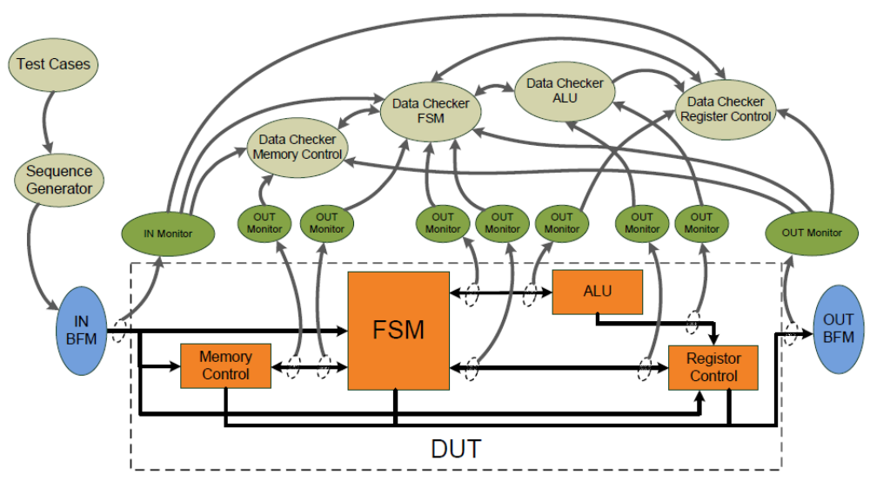
Figure 3 – Block diagram of the testbench

  - Partitioning

The Core module is partition in four smaller sub-modules, each sub-module will be verified individually, but with the same verification strategy. To follow sections will show the sub-modules diagrams. The figure below shows an environment diagram that will be used for all modules.

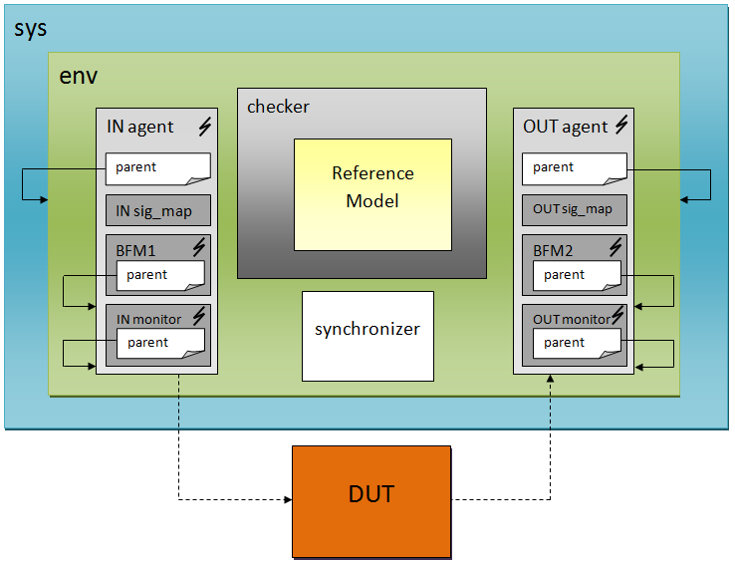
Figure 4 - Diagram of the Environment Structure testbench

    - FSM verification testbench architecture

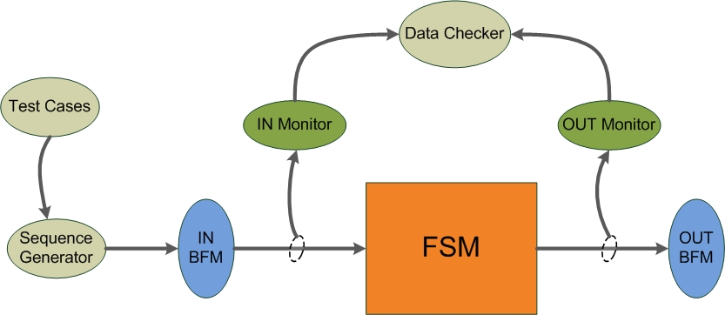
Figure 5 - Block diagram of the FSM sub-module testbench

    - FSM verification testbench architecture

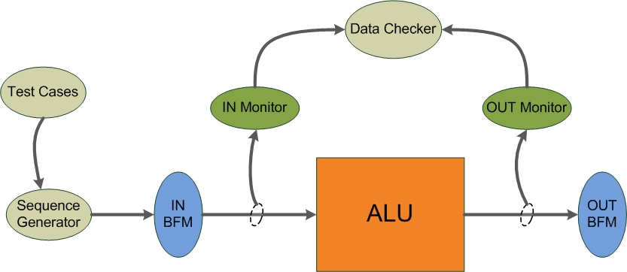
Figure 6 - Block diagram of the ALU sub-module testbench

    - Register Control verification testbench architecture

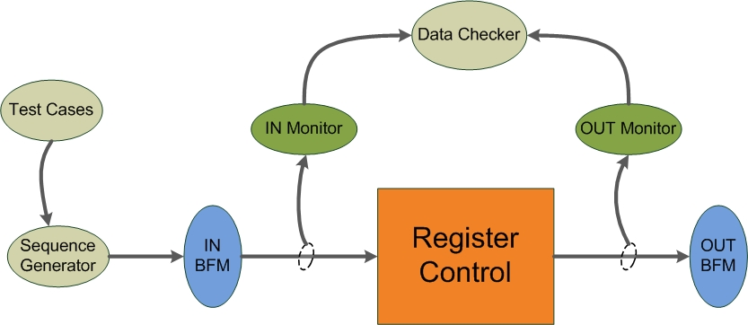
Figure 7 - Block diagram of the Register Control sub-module testbench

    - Memory control verification testbench architecture

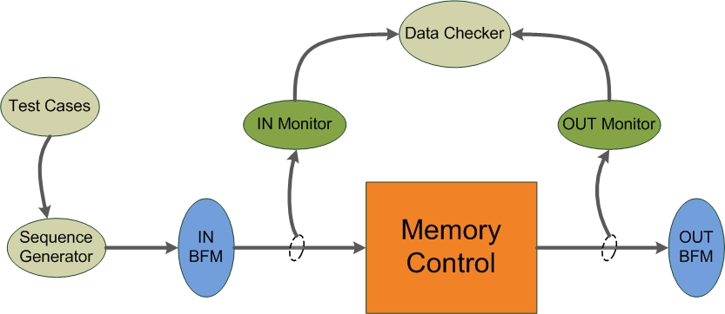
Figure 8 - Block diagram of the Memory Control sub-module testbench

  - Global Routines

T.B.D.

Global Routine | Parameter | Description
Table 4 – Global Routines

  - External Interface Functions

N.A.

  - Memory Map

N.A.

  - Verification and Debug Registers

T.B.D.

  - Clocking

T.B.D.

  - Reset

In this project the reset will be fall activate and all verification methods are based in this specification.

  - Termination

N.A.

- Drivers and Monitors

T.B.D.

  - Driver and Monitor Overview

T.B.D.

  - Driver/Monitor Description

T.B.D

    - Driver/Monitor Functional Overview

T.B.D

    - Driver/Monitor Commands

T.B.D

Command | Arguments | Description
Table 5 – Interface Monitor Commands

    - Driver/Monitor Arguments

T.B.D.

Argument | Range | Direction | Description
Table 6 – Interface Driver Arguments

Argument | Range | Direction | Description
Table 7 – Interface Monitor Arguments

    - Driver/Monitor Configuration

T.B.D

Configuration Description | Implementation | Configuration Selection Method
Table 8 – Configurations

- Models

It is intended to this project to create references models to all blocks in a bottom-up approach. Since the verifications structures are full defined yet, this section will be fulfilled in the future.

T.B.D.

  - Functional Models

The verification is

    - FSM Reference model

T.B.D

    - ALU Reference Model

T.B.D

    - Register Control Reference Model

T.B.D

    - Memory Control Reference Model

T.B.D

  - Memory Models

N.A.

  - Stub Models

N.A.

  - IO and PADs

N.A.

- Additional Information

N.A.

