Interrupt Controller

Block Guide

Version #: 2.0
Last revision date: OCT 27, 2010

Version Control
Revision | Date | Author | Comments | Revisors
0.1 | 09/08/2010 | Hugo Kakisaka  Marcelo Mamoru Ono | Initial beta version | Hugo Kakisaka  Marcelo Mamoru Ono
1.0 | 16/08/2010 | Hugo Kakisaka  Marcelo Mamoru Ono | Revised | Vinicius Amaral
1.1 | 08/09/2010 | Hugo Kakisaka  Marcelo Mamoru Ono | Change figure1  Change table 6 | Hugo Kakisaka  Marcelo Mamoru Ono
2.0 | 27/10/2010 | Hugo Kakisaka  Marcelo Mamoru Ono | Change figure 1  Change table 6 | Hugo Kakisaka  Marcelo Mamoru Ono

Summary

1 Preface 6
1.1 Conventions 6
1.2 Bibliography 7
1.3 Acronyms and Abbreviations 8
1.4 Glossary 9
2 Introduction 10
3 Overview 11
4 Features 11
4.1 Level/Edge External Interrupt Flag Generator 12
4.2 Control 12
4.3 IER - Interrupt Execute Registers 13
4.4 Priority Level Structure 13
5 Modes of Operation 14
6 External Signal Description 14
7 Detailed Signal Descriptions 15
8 Memory Map and Register Definition 18
8.1 Memory Map 18
8.2 Register Description 18
8.2.1 IP – Interrupt Priority 19
8.2.2 IE – Interrupt Enable 19
8.2.3 SCON – Serial Control 20
8.2.4 TCON – Timer/ Counter Control 21
8.2.5 TCON2 – Timer/ Counter Control 21
8.2.6 P3EN – Port 3 Enable 22
9 Functional Description 22
9.1 Modes of Operation 22
9.2 Functional Description Sub Item 24
9.2.1 Functional Description Sub Item 24
9.3 External Interrupts 24
10 Initialization Information 25
11 Application information 25

Index of Tables

Table 1: Conventions 6
Table 2: Acronyms and Abbreviations 8
Table 3: Glossary 9
Table 4: Port Description 12
Table 5: Priority Level 14
Table 6: Interface Description 15
Table 7: Memory Map 18
Table 8: Bit Address 18
Table 9: Interrupt Address 23

Index of Figures

Figure 1: Interrupt Controller Block Diagram 10
Figure 2: Interrupt Controller Algorithm Model 11

Interrupt Control

Preface
The interrupt block has a total of seven interrupt vectors: two external interrupts (INT0 and INT1), three timer interrupts (Timers 0, 1, and 2), serial port interrupt (TX and RX), and transceiver interrupt (TXRX).
Each of these interrupt sources can be individually enabled or disabled by setting or clearing a bit in Special Function Register IE. IE also contains a global disable bit, EA, which disables all interrupts at once.

Conventions
Table 1: Conventions
Convention | Description
Version Control  #<nun1>.<nun2> | Beta and initial version are started with <nun1> = 0.  Intent version, usually after customer approval, is numbered increasing.  <num1> indicate that version has much updates.  <num2> indicate that version has few updates.
The signal name must be composed in the following way | <top level name>_<signal_name>_<suffixes>
Signal - Suffixes | _b = Active low  _i = Input  _o = Output  _sync = Synchronous
Signal - Special Function Registers | reg_<register name>_<flag name>_<suffixes>

Bibliography
The bibliography sources for this documentation are:
- 80C51 Family datasheet - 80C51 family architecture - March 1995 - public information provided by Philips Semiconductors.
- Atmel 8051 datasheet - Atmel 8051 Microcontrollers Hardware Manual - public information provided by Atmel Corporation.
- AT89S8253 datasheet- Atmel 8-bit Microcontroller with 12k Bytes, Flash and 2k Bytes EEPROM - public information provided by Atmel Corporation.
- MCS 51 Microcontroller Family User's Manual- February 1994 - public information provided by Intel Corporation.
- Microcontrolador 8051 Detalhado - Denys E. C. Nicolosi - 6ª edição - Érica.
- Embedded Microprocessor Systems: Real World Design - Stuart R. Ball. P. E - 3ª edition Newnes

Acronyms and Abbreviations
Table 2: Acronyms and Abbreviations
Term | Meaning
IE | Interrupt Enable
IP | Interrupt Priority
SCON | Serial Control
TCON | Timer/ Counter Control
TCON2 | Timer/ Counter Control 2
P3EN | Port 3 Enable
RETI | Return from Interrupt routine
RET | Return from Subroutine
IER | Interrupt Execute Registers
LCALL | Long Call
PSW | Program Word High
PC | Program Counter
CPU | Control Process Unit
REGS | Registers
I/O | Input/ Output
R/W | Read/ Write
VC | Virtual Component.
N/A | Not Applicable

Glossary
Terms and definitions for Interrupt Controller:
Table 3: Glossary
Term | Definition
Active low | The signal is asserted when it changes to logic-level zero.
Active high | The signal is asserted when it changes to logic-level one.
Asserted | Discrete signal is in active logic state.
Negated | A discrete signal is in inactive logic state.
Duty Cycle | Fraction of time that a system is in high level.
High level | Signal with logic level one.
Low level | Signal with logic level zero
flag | A bit field to store a set of boolean datatype.
- | Reserved
? | Indefinite
Pin | External physical connection.
Port | Internal physical connection.
Signal | Electronic construct whose state or changes in state convey information.
Set | To establish logic- level one on a bit or bits.
Reset | To establish logic level zero on a bit or bits.

Introduction
This block is responsible to generate an interrupt request to CPU. It evaluate the priority of different interrupts sources which can occur at same time and decides what is the interrupt that should be executed by CPU.

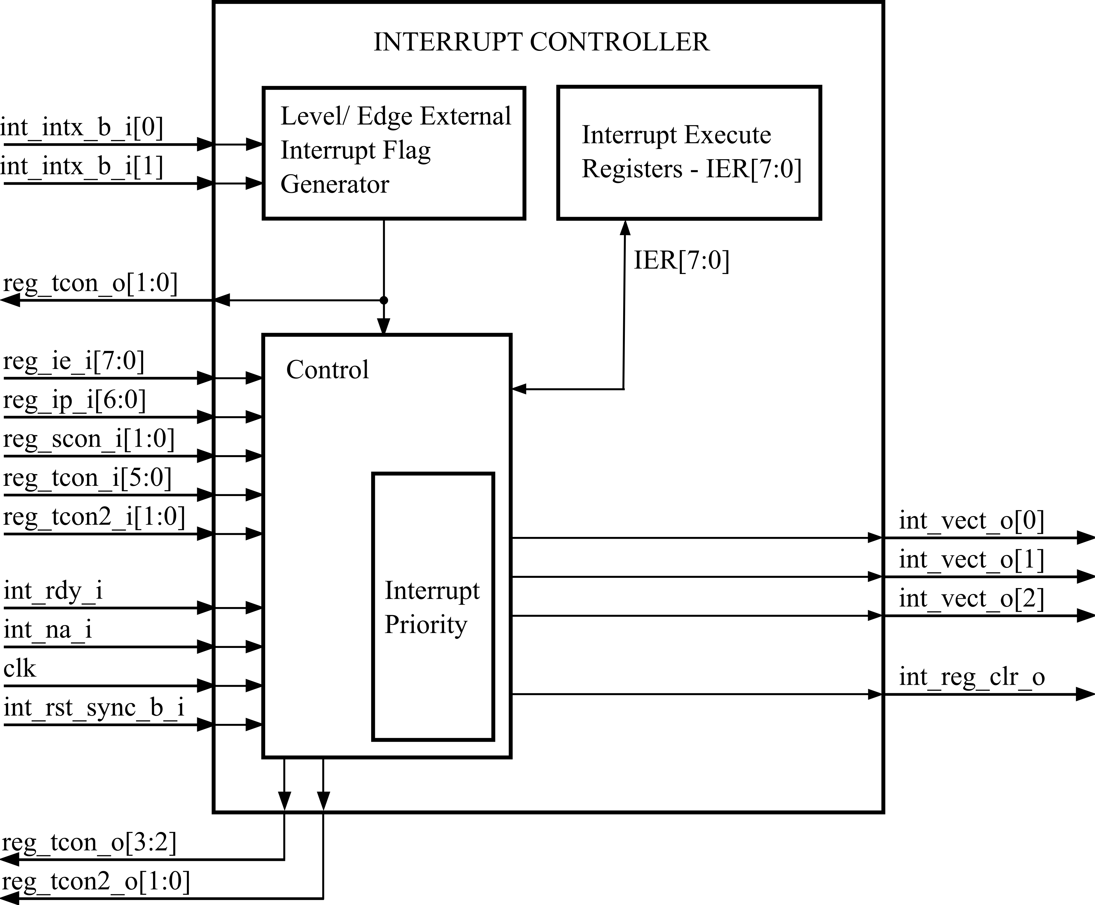
Figure 1: Interrupt Controller Block Diagram

Overview
The Interrupt Controller module evaluate and decides whether an interrupt request must be generated to CPU.
This module can monitor up to 8 interrupt sources. These sources are Timer 0, Timer 1, Timer 2 , Serial Communication Port (transmit and receive), External Pin 0, External Pin 1 and Transceiver.
Interrupt sources can be individually configurable through IE and IP registers.

Features
The EMC08 provides 8 interrupt sources and 7 vectors. The Figure 2 shows how the IE and IP registers and the polling sequence work to determine which if any interrupt will be serviced.
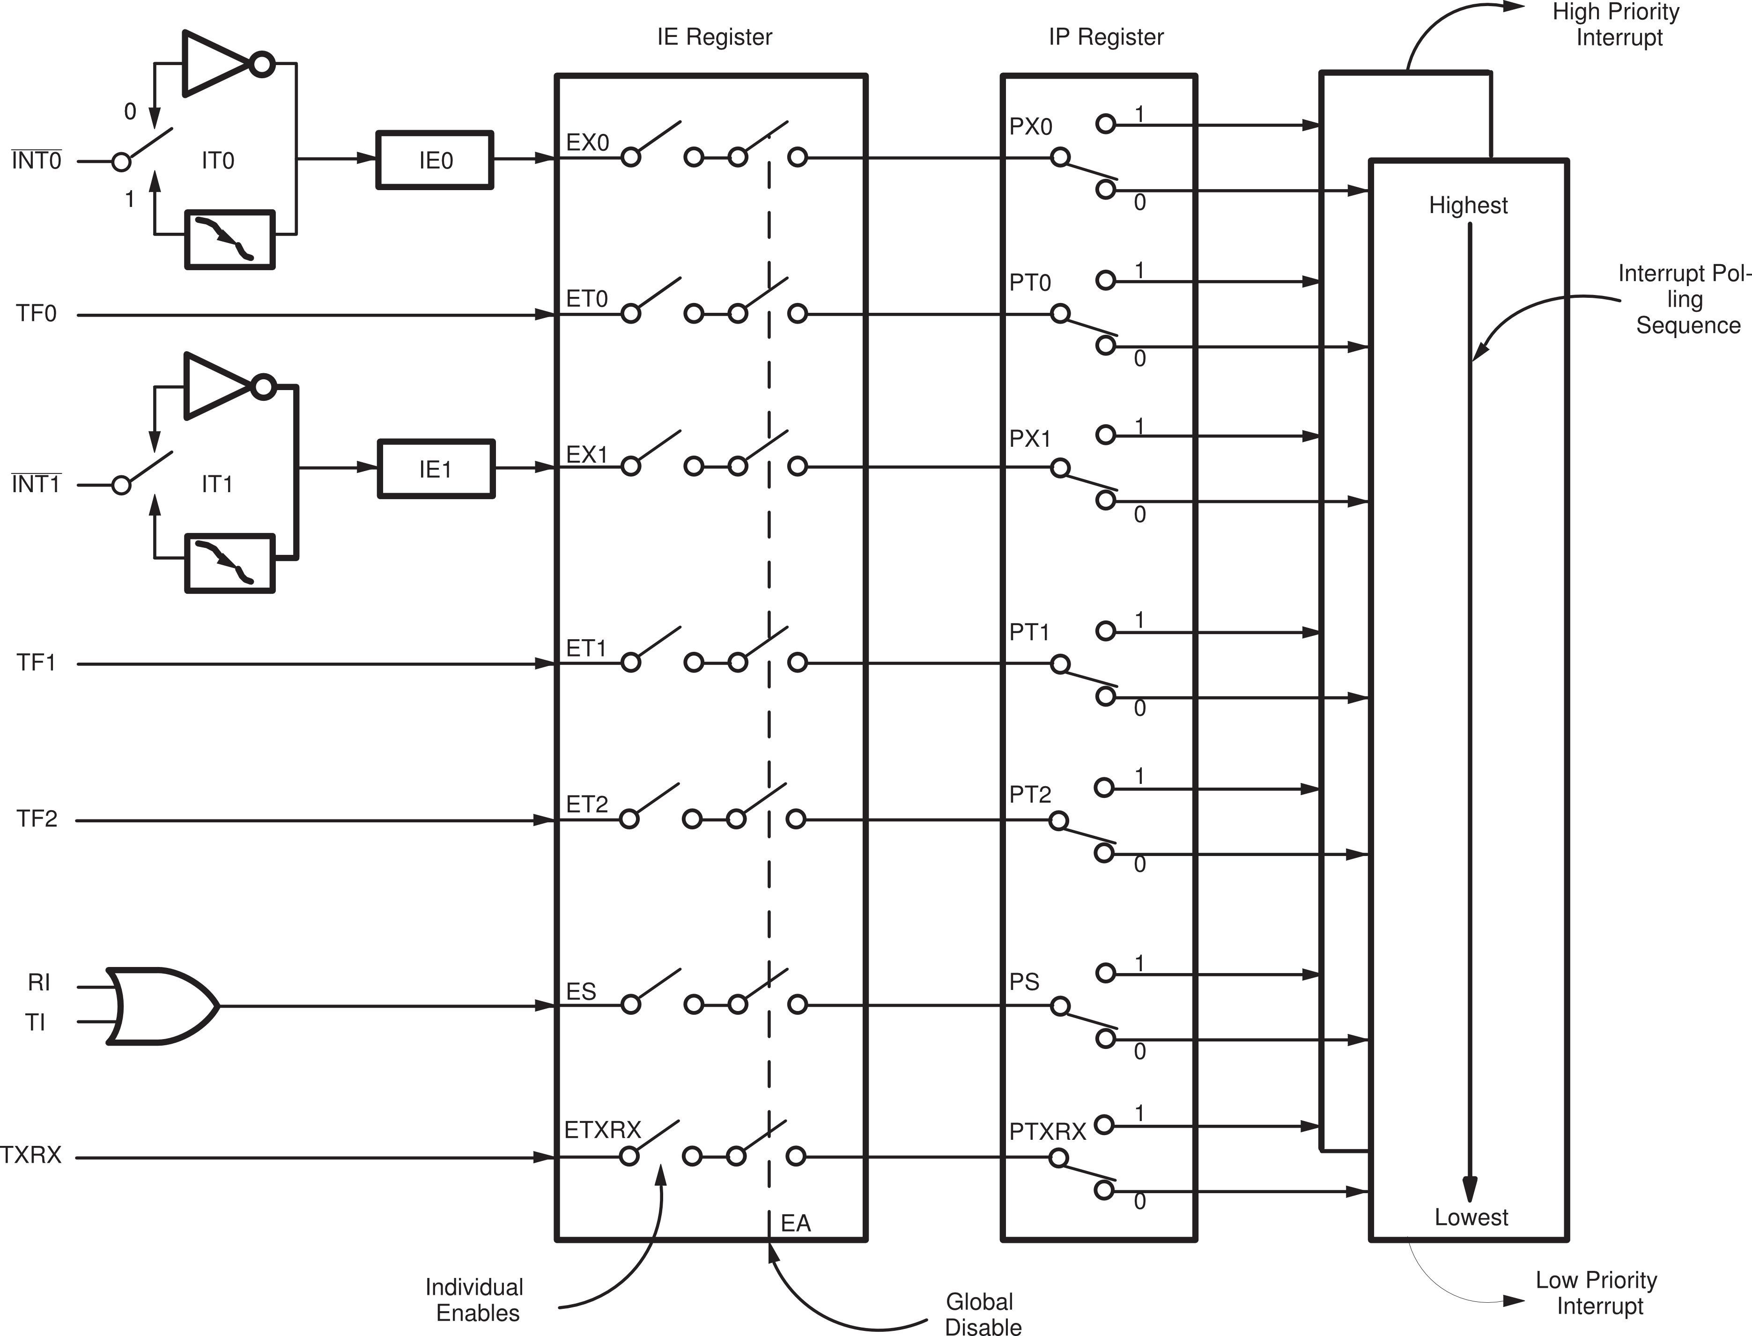
Figure 2: Interrupt Controller Algorithm Model

The External Interrupts INT0 and INT1 can each be either level activated or transition-activated, depending on bits IT0 and IT1 in Register TCON. The flags that actually generate these interrupts are cleared by the hardware when the service routine is vectored to only if the interrupt was transition-activated. If the interrupt was level-activated, then the external requesting source is what controls the request flag, rather than the on-chip hardware.
The Timer 0, Timer 1 and Timer 2 Interrupts are generated by TF0, TF1 (TCON) and TF2 (TCON2) which are set by a rollover in their respective Timer registers. When a timer interrupt is generated, the flag that generated it is cleared by the on-chip hardware when the service routine is vectored to.
The Serial Port Interrupt is generated by the logical OR of RI and TI. Neither of these flags is cleared by hardware when the service routine is vectored to. In fact, the service routine will normally have to determine whether it was RI or TI that generated the interrupt, and the bit will have to be cleared in software.
All of the bits that generate interrupts can be set or cleared by software, with the same result as though it had been set or cleared by hardware. That is, interrupts can be generated or pending interrupts can be canceled in software.
Each of these interrupt sources can be individually enabled or disabled by setting or clearing a bit in Special Function Register IE. IE contains also a global disable bit, EA, which disables all interrupts at once. Refers to REGS section for IE register details.

Level/Edge External Interrupt Flag Generator
The block verify if the IE is set (EX0 and EX1), whether the EX0 or EX1is 1 the generator set the pin 3.3 and 3.2 as input (P3EN).
Other function of this block is check if the external interrupt is generate by level or edge, see section 9.3 .

Control
The control block verify all input and the IER to decide if the interrupt will be generate.
Table 4: Port Description
int_rdy_i | int_na_i | Description
0 | 0 | Interrupt accept
0 | 1 | Interrupt not accept
1 | 0 | Interrupt done, RETI
1 | 1 | -

If the interrupt is not accepted the core block set the input int_na_i and when the core block finish a interrupt routine the input int_rdy_i is set.

IER - Interrupt Execute Registers
This registers show which interrupt is executing by core, the control block can read and write this register each machine cycle.
Bit | 7 | 6 | 5 | 4 | 3 | 2 | 1 | 0
R | RTXRX | RS | RT2 | RT1 | RX1 | RT0 | RX0 | -
W
Reset | 0 | 0 | 0 | 0 | 0 | 0 | 0 | 0

Field | Description
RTXRX | Executing Tranceiver interrupt bit.
RS | Executing Serial interrupt bit.
RT2 | Executing Timer 2 interrupt bit.
RT1 | Executing Timer 1 interrupt bit.
RX1 | Executing External Interrupt bit.
RT0 | Executing Timer 0 interrupt bit.
RX0 | Executing External Interrupt 0 bit.

Priority Level Structure
Each interrupt source can also be individually programmed to one of two priority levels by setting or clearing a bit in Special Function Register IP. A low-priority interrupt can itself be interrupted by a high-priority interrupt but not by another low-priority interrupt. A high-priority interrupt can’t be interrupted by any other interrupt source.
If two requests of different priority levels are received simultaneously, the request of higher priority level is serviced. If requests of the same priority level are received simultaneously, an internal polling sequence determines which request is serviced. Thus within each priority level there is a second priority structure determined by the polling sequence, as follows:

Table 5: Priority Level
Source | Priority within level
/INT0 | 1
TF0 | 2
/INT1 | 3
TF1 | 4
TF2 | 5
RI + TI | 6
TXRX | 7

Note that the priority within level structure is only used to resolve simultaneous requests of the same priority level.

Modes of Operation
The Interrupt Controller module is always powered on. There is not low power consumption modes.

External Signal Description
Interrupt Controller module can be externally triggered, through external pins /INT0 and /INT1.

Detailed Signal Descriptions
The complete interface description is presented in the Table 6. The interface description includes both internal port and external pins:
Table 6: Interface Description
Signal | I/O | Description |  | Reset
int_int_b_i[0] | I | External Interrupt input 0 |  | ?
int_int_b_i[0] | I | State Meaning | Asserted: A transition from high to low or a low level of /INT0 triggers set correspondent external interrupt flag.  Negated: A transition from low to high has no effect.  In level mode, high level clears correspondent interrupt flag. | ?
int_int_b_i[0] | I | Timing | Assertion: an input high or low should be hold for at least one machine cycle to ensure sampling  Negated: an input low to high should be hold for at least one machine cycle to ensure sampling | ?
int_int_b_i[1] | I | External Interrupt input 1 |  | ?
int_int_b_i[1] | I | State Meaning | Asserted: A transition from high to low or a low level of /INT1 triggers set correspondent external interrupt flag.  Negated: A transition from low to high has no effect.  In level mode, high level clears correspondent interrupt flag. | ?
int_int_b_i[1] | I | Timing | Assertion: an input high or low should be hold for at least one machine cycle to ensure sampling  Negated: an input low to high should be hold for at least one machine cycle to ensure sampling | ?
clk | I | Register Interrupt Clock |  | ?
clk | I | State Meaning | Asserted: n/a  Negated: n/a | ?
clk | I | Timing | Assertion: Duty Cycle 50 %  Negation: Duty Cycle 50 % | ?
int_rst_sync_b_i | I | Synchronous reset |  | ?
int_rst_sync_b_i | I | State Meaning | Asserted: Chip in reset state  Negated: Normal Operation | ?
int_rst_sync_b_i | I | Timing | Assertion: Can be asynchronously asserted  Negation: May occur at any time, synchronous to internal clock | ?
int_na_i | I | Interrupt Not Accepted |  | ?
int_na_i | I | State  Meaning | Asserted: High level indicates a not accepted interrupt by core  Negated: Low level indicates a accepted interrupt by core | ?
int_na_i | I | Timing | Assertion: an input high should be hold for at least one machine cycle to ensure sampling  Negated: an input low should be hold for at least one machine cycle to ensure sampling | ?
reg_ie_i[7:0] | I | Interrupt Enable Register Bus - IE[7:0] |  | 0
reg_ie_i[7:0] | I | State  Meaning | Asserted: Data Registers  Negated: Data Registers | 0
reg_ie_i[7:0] | I | Timing | Assertion: Synchronous with internal clock  Negation: Synchronous with internal clock | 0
reg_ip_i[6:0] | I | Interrupt Priority Register Bus – IP[6:0] |  | 0
reg_ip_i[6:0] | I | State  Meaning | Asserted: Data Registers  Negated: Data Registers | 0
reg_ip_i[6:0] | I | Timing | Assertion: Synchronous with internal clock  Negation: Synchronous with internal clock | 0
reg_scon_i[1:0] | I | Interrupt Flag Register – SCON[1:0] |  | 0
reg_scon_i[1:0] | I | State  Meaning | Asserted: Data Registers  Negated: Data Registers | 0
reg_scon_i[1:0] | I | Timing | Assertion: Synchronous with internal clock  Negation: Synchronous with internal clock | 0
reg_tcon_i[5:0] | I | Interrupt Flag Register – TCON[5:0] |  | 0
reg_tcon_i[5:0] | I | State  Meaning | Asserted: Data Registers  Negated: Data Registers | 0
reg_tcon_i[5:0] | I | Timing | Assertion: Synchronous with internal clock  Negation: Synchronous with internal clock | 0
reg_tcon2_i[1:0] | I | Interrupt Flag Register - TCON2[1:0] |  | 0
reg_tcon2_i[1:0] | I | State  Meaning | Asserted: Data Registers  Negated: Data Registers | 0
reg_tcon2_i[1:0] | I | Timing | Assertion: Synchronous with internal clock  Negation: Synchronous with internal clock | 0
int_rdy_i | I | Interrupt Ready |  | ?
int_rdy_i | I | State  Meaning | Asserted: High level indicates interrupt routine finished by core  Negated: Low level indicates an interrupt routine still executed by core | ?
int_rdy_i | I | Timing | Assertion: an input high should be hold for at least one machine cycle to ensure sampling  Negated: an input low should be hold for at least one machine cycle to ensure sampling | ?
int_vect_o[2:0] | O | Interrupt Address Vector – int_vect[2:0] |  | 0
int_vect_o[2:0] | O | State  Meaning | Asserted: Interrupt Address Vector  Negated: Interrupt Address Vector | 0
int_vect_o[2:0] | O | Timing | Assertion: Synchronous with internal clock  Negation: Synchronous with internal clock | 0
reg_tcon_o[3:0] | O | Interrupt Flag Register – TCON[3:0] |  | 0
reg_tcon_o[3:0] | O | State  Meaning | Asserted: Data Registers  Negated: Data Registers | 0
reg_tcon_o[3:0] | O | Timing | Assertion: Synchronous with internal clock  Negation: Synchronous with internal clock | 0
reg_tcon2_o[1:0] | O | Interrupt Flag Register – TCON2[1:0] |  | 0
reg_tcon2_o[1:0] | O | State  Meaning | Asserted: Data Registers  Negated: Data Registers | 0
reg_tcon2_o[1:0] | O | Timing | Assertion: Synchronous with internal clock  Negation: Synchronous with internal clock | 0
int_reg_clr_o | O | Interrupt Register Clear |  | 0
int_reg_clr_o | O | State  Meaning | Asserted: Set when has new registers values  Negated: Clear when has no new register values | 0
int_reg_clr_o | O | Timing | Assertion: Synchronous with internal clock  Negation: Synchronous with internal clock | 0

Memory Map and Register Definition
The memory map for Interrupt Controller module registers consists of 8 bit registers with no special requirements. The memory map and registers details are in the following sections.

Memory Map
Table 7: Memory Map
Address/Offset | Register | Access | Reset Value | Section
D8H | TCON2 | R/W | 0x00h | 8.2.5
B8H | IP | R/W | 0x00h | 8.2.1
B0H | P3EN | R/W | 0x00h | 8.2.6
A8H | IE | R/W | 0x00h | 8.2.2
98H | SCON | R/W | 0x00h | 8.2.3
88H | TCON | R/W | 0x00h | 8.2.4

Table 8: Bit Address
Register | Bit Address |  |  |  |  |  |  |  | Byte Address
TCON2 | DF | DE | DD | DC | DB | DA | D9 | D8 | D8H
IP | - | BE | BD | BC | BB | BA | B9 | B8 | B8H
P3EN | B7 | B6 | B5 | B4 | B3 | B2 | B1 | B0 | B0H
IE | AF | AE | AD | AC | AB | AA | A9 | A8 | A8H
SCON | 9F | 9E | 9D | 9C | 9B | 9A | 99 | 98 | 98H
TCON | 8F | 8E | 8D | 8C | 8B | 8A | 89 | 88 | 88H

Register Description
This section details Interrupt Controller registers format and their meaning.

IP – Interrupt Priority
Bit | 7 | 6 | 5 | 4 | 3 | 2 | 1 | 0
R | - | PTXRX | PT2 | PS | PT1 | PX1 | PT0 | PX0
W
Reset | 0 | 0 | 0 | 0 | 0 | 0 | 0 | 0

Field | Description
PTXRX | Tranceiver interrupt priority bit.
PT2 | Timer 2 interrupt priority bit.
PS | Serial port interrupt priority bit.
PT1 | Timer 1 interrupt priority bit.
PX1 | External Interrupt 1 priority bit.
PT0 | Timer 0 interrupt priority bit.
PX0 | External Interrupt 0 priority bit.

IE – Interrupt Enable
Bit | 7 | 6 | 5 | 4 | 3 | 2 | 1 | 0
R | EA | ETXRX | ET2 | ES | ET1 | EX1 | ET0 | EX0
W
Reset | 0 | 0 | 0 | 0 | 0 | 0 | 0 | 0

Field | Description
EA | Enable all interrupts. If EA=0, no interrupt will be acknowledged. If EA=1, each EA interrupt source is individually enabled or disabled by setting or clearing its enable bit.
ETXRX | Transceiver interrupt enable bit.
ET2 | Timer 2 interrupt enable bit.
ES | Serial port interrupt enable bit.
ET1 | Timer 1 overflow interrupt enable bit.
EX1 | External interrupt 1 enable bit.
ET0 | Timer 0 overflow interrupt enable bit.
EX0 | External interrupt 0 enable bit.

SCON – Serial Control
Bit | 7 | 6 | 5 | 4 | 3 | 2 | 1 | 0
R | SM0 | SM1 | SM2 | REN | TB8 | RB8 | TI | RI
W
Reset | 0 | 0 | 0 | 0 | 0 | 0 | 0 | 0

Field | Description
SM[7:6] | Serial ports mode specify.
SM[7:6] | SM0 | SM1 | Mode | Description | Baud Rate
SM[7:6] | 0 | 0 | 0 | Shift register | Fosc/12
SM[7:6] | 0 | 1 | 1 | 8- bit UART | Variable
SM[7:6] | 1 | 0 | 2 | 9- bit UART | Fosc/64 or Fos/32
SM[7:6] | 1 | 1 | 3 | 9- bit UART | Variable
SM2 | Enables the multiprocessor communication feature in modes 2 and 3. In mode 2 or 3, if SM2=1 then RI will not be active if the received 9th data bit (RB8) is 0. In mode 1, if SM2=1 then RI will not be activated if a valid stop bit was not received. In mode 0, SM2 should be 0.
REN | Set/Cleared by software to enable/disable reception.
TB8 | The 9th bit will be transmitted in modes 2 and 3. Set/cleared by software.
RB8 | In modes 2 and 3, is the 9th data bit was received. In mode 1, if SM2=0, RB8 is stop bit that was received. In mode 0, RB8 is not used.
TI | Transmit interrupt flag. Set by hardware at the end of the 8th bit time in mode 0, or halfway through the stop bit time in the other modes (except see SM2).
RI | Receive interrupt flag. Set by hardware at the end of the 8th bit in mode 0, or halfway through the stop bit time in the other modes (except see SM2). Must be cleared by software.

TCON – Timer/ Counter Control

Bit | 7 | 6 | 5 | 4 | 3 | 2 | 1 | 0
R | TF1 | TR1 | TF0 | TR0 | IE1 | IT1 | IE0 | IT0
W | - | TR1 | - | TR0 | - | IT1 | - | IT0
Reset | 0 | 0 | 0 | 0 | 0 | 0 | 0 | 0

Field | Description
TF1 | Timer 1 overflow flag. Set by hardware when the Timer 1 overflows. Cleared as processor vectors to the interrupt service routine.
TR1 | Timer 1 run control bit. Set/cleared by software to turn Timer 1 ON/OFF.
TF0 | Timer 0 overflow flag. Set by hardware when the Timer 0 overflows. Cleared as processor vectors to the interrupt service routine.
TR0 | Timer 0 run control bit. Set/cleared by software to turn Timer 0 ON/OFF.
IE1 | External Interrupt 1 edge flag. Set by hardware when External Interrupt edge is detected. Cleared by hardware when interrupt is processed.
IT1 | Interrupt 1 type control bit. Set/cleared by software to specify falling edge/low level triggered External Interrupt.
IE0 | External Interrupt 0 edge flag. Set by hardware when External Interrupt edge is detected. Cleared by hardware when interrupt is processed.
IT0 | Interrupt 0 type control bit. Set/cleared by software to specify falling edge/low level triggered External Interrupt.

TCON2 – Timer/ Counter Control
Bit | 7 | 6 | 5 | 4 | 3 | 2 | 1 | 0
R | TXRX | TR2 | TF2 | DSP |  |  | DFSEL | EDGSEL
W
Reset | 0 | 0 | 0 | 0 | 0 | 0 | 0 | 0

Field | Description
TXRX | Transceiver interrupt
TR2 | Timer 2 run control bit. Set/cleared by software to turn Timer 2 ON/OFF.
TF2 | Timer 2 overflow flag. Set by hardware when the Timer 2 overflows. Cleared as processor vectors to the interrupt service routine.
DFP[4:2] | Digital Filter Clock Period
DFSEL | Digital Filter Sampling Selection
DFSEL | [0] DF output Sampling S2 selected
DFSEL | [1] DF output Sampling S3 selected
EDGSEL | Rise-Fall Edge selection
EDGSEL | [0] Fall edge selection
EDGSEL | [1] Rise edge selection

P3EN – Port 3 Enable
Bit | 7 | 6 | 5 | 4 | 3 | 2 | 1 | 0
R | FF | FE | FC | FB | FC | FA | F9 | F8
W
Reset | 0 | 0 | 0 | 0 | 0 | 0 | 0 | 0

Field | Description
F[F:8] | I/O Port3 Enable Bit.
F[F:8] | [1] Configured Bit Port3 as Output.
F[F:8] | [0] Configured Bit Port3 as Input.

Functional Description

Modes of Operation
The interrupt flags are sampled at every machine cycle. The samples are polled during the following machine cycle. If one of the flags was in a set condition at preceding cycle, the polling cycle will find it and the core block will generate an LCALL to the appropriate service routine, provided this hardware-generated LCALL is not blocked by any of the following conditions:

    - An interrupt of equal or higher priority level is already in progress.
    - The current (polling) cycle is not the final cycle in the execution of the instruction in progress.
    - The instruction in progress is RETI or any write to the IE or IP registers.
Any of these three conditions will block the generation of the LCALL to the interrupt service routine. Condition 2 ensures that the instruction in progress will be completed before vectoring to any service routine. Condition 3 ensures that if the instruction in progress is RETI or any access to IE or IP, then at least one more instruction will be executed before any interrupt is vectored to.
The polling cycle is repeated with each machine cycle and the values polled are the value that were present at previous machine cycle. Note then that if an interrupt flag is active but not being responded to for one of the above conditions, and is not still active when the blocking condition is removed, the denied interrupt will not be serviced. In other words, the fact that the interrupt flag was once active but not serviced is not remembered. Every polling cycle is new.
Thus the processor acknowledges an interrupt request by executing a hardware-generated LCALL to the appropriate service in routine. In some cases it also clears the flag that generated the interrupt, and in other cases it doesn’t. It never clears the Serial Port or Timer 2 flags. This has to be done in the user’s software. It clears an external interrupt flag (IEO or IE1) only if it was transition-activated. The hardware-generated LCALL pushes the contents of the Program Counter onto the stack (but it does not save the PSW) and reloads the PC with an address that depends on the source of the interrupt being vectored to, as shown bellow.
Table 9: Interrupt Address
Source | Vector Address
IE0 | 0003H
TF0 | 000BH
IE1 | 0013H
TF1 | 001BH
TF2 | 0023H
RI + TI | 002BH
TXRX | 0033H

Execution proceeds from that location until the RETI instruction is encountered. The RETI instruction informs the processor that this interrupt routine is no longer in progress, then pops the top two bytes from the stack and reloads the program Counter. Execution of the interrupted program continues from where it left off.
Note that a simple RET instruction would also have returned execution to the interrupted program, but it would have left the interrupt control system thinking an interrupt was still in progress.

Functional Description Sub Item
N/A – There is no sub item.

Functional Description Sub Item
N/A – There is no sub item.

External Interrupts
The external sources can be programmed to be level-activated or transition-activated by setting or clearing bit IT1 or IT0 in Register TCON. If ITx = 0, external interrupt x is triggered by a detected low at the INTx pin. If ITx = 1, external interrupt x is edge-triggered. In this mode if successive samples of the INTx pin show a high in one cycle and a low in the next cycle, interrupt request flag IEx in TCON is set. Flag bit IEx then requests the interrupt.
Since the external interrupt pins are sampled once each machine cycle, an input high or low should hold for at least one machine cycle to ensure sampling. If the external interrupt is transition-activated, the external source has to hold the request pin high for at least one machine cycle, and then hold it low for at least one machine cycle to ensure that the transition is seen so that interrupt request flag IEx will be set. IEx will be automatically cleared by the CPU when the service routine is called.
If the external interrupt is level-activated, the external source has to hold the request active until the requested interrupt is actually generated. Then it has to deactivate the request before the interrupt service routine is complete or else another interrupt will be generated.

Initialization Information
The reset is synchronous and active low. This signal clears all bits in the internal register, IER[7:0] and sets the output int_vect[2:0]_o to logic level 0.

Application information
N/A -

