Interrupt Controller
Creation Guide
Version #: 0.1
Revision date: Dec 06, 210

Version Control
Revision | Date | Author | Comments | Revisors
0.1 | 06/12/2010 | Hugo Kakisaka  Marcelo Mamoru Ono | Inicitial version | Hugo Kakisaka  Marcelo Mamoru Ono
Summary

1 Introduction 6
2 Module History 6
3 Features 7
4 Design Assumptions 9
5 Architecture and Design Hierarchy 10
5.1 Interrupt Control - Signals 12
5.2 Interrupt Control - Theory of Operation 16
5.3 Interrupt Control – Implementation 18
5.3.1 Level/ Edge External Interrupt Flag Generator 18
5.3.2 Interrupt Execute Register 19
5.3.3 Control 19
5.3.4 Interrupt Priority 19
5.4 Interrupt Control - Configuration Parameters 20
5.4.1 IP – Interrupt Priority 20
5.4.2 IE – Interrupt Enable 21
5.4.3 SCON – Serial Control 21
5.4.4 TCON – Timer/ Counter Control 22
5.4.5 TCON2 – Timer/ Counter Control 23
5.4.6 P3EN – Port 3 Enable 24
5.5 Interrupt Control - Performance 25
5.6 Interrupt Control - Design Trade-offs 25
5.7 Interrupt Control - Reuse Issues 25
6 Design Methodology 25
7 Simulation Strategy and Results 26
8 Tools Flow 26
9 Design for Test 26
10 Patent Disclosures 26

Index of Tables

Table 1: Module History Example 6
Table 2: Interrupt Address 11
Table 3: Interface Description 12
Table 4: Port Description 16
Table 5: Interrupt Vector 17
Table 6: Priority Level 20

Index of Figures

Figure 1: Interrupt Controller Algorithm Model 7
Figure 2: Timing diagram. 9
Figure 3: Block Diagram 18
Figure 4: LEC 26
Figure 5: RTL- Compiler 26

Interrupt Control

Introduction
This block is responsible to generate an interrupt request to CPU. It evaluate the priority of different interrupts sources which can occur at same time and decides what is the interrupt that should be executed by CPU.

Module History
Table 1 lists the history of the module versions and implementations.
Table 1: Module History Example
Module Version | Derived From | 1st Implemented On | Headline
R567 | - | EMC08 | Initial project
R719 | R567 | EMC08 | Change int_vect_o, it is not registered.
R761 | R719 | EMC08 | External interrupt modified.
R901 | R761 | EMC08 | Add register in state s4.
R926 | R901 | EMC08 | Change priority level, serial and TF2.
R990 | R926 | EMC08 | External interrupt is only executed when EA = 1
R1010 | E990 | EMC08 | Fix output when EA = 1.
R1041 | R1010 | EMC08 | Fix flag_out[x] when EA[x] = 1
R1047 | R1041 | EMC08 | Fix flag_out when EA[7] = 1
R1057 | R1047 | EMC08 | Fix EA, int_vect_o and flag_out.
R1357 | R1275 | EMC08 | Add register, flag_out[0] and flag_out[2].
R1822 | R1764 | EMC08 | Reorder code.
R2257 | R1822 | EMC08 | Change IE0 and IE1.
R2416 | R2257 | EMC08 | Change flag_ier_nor[3:2].

Features
The EMC08 provides 8 interrupt sources and 7 vectors. The Figure 1 shows how the IE and IP registers and the polling sequence work to determine which if any interrupt will be serviced.
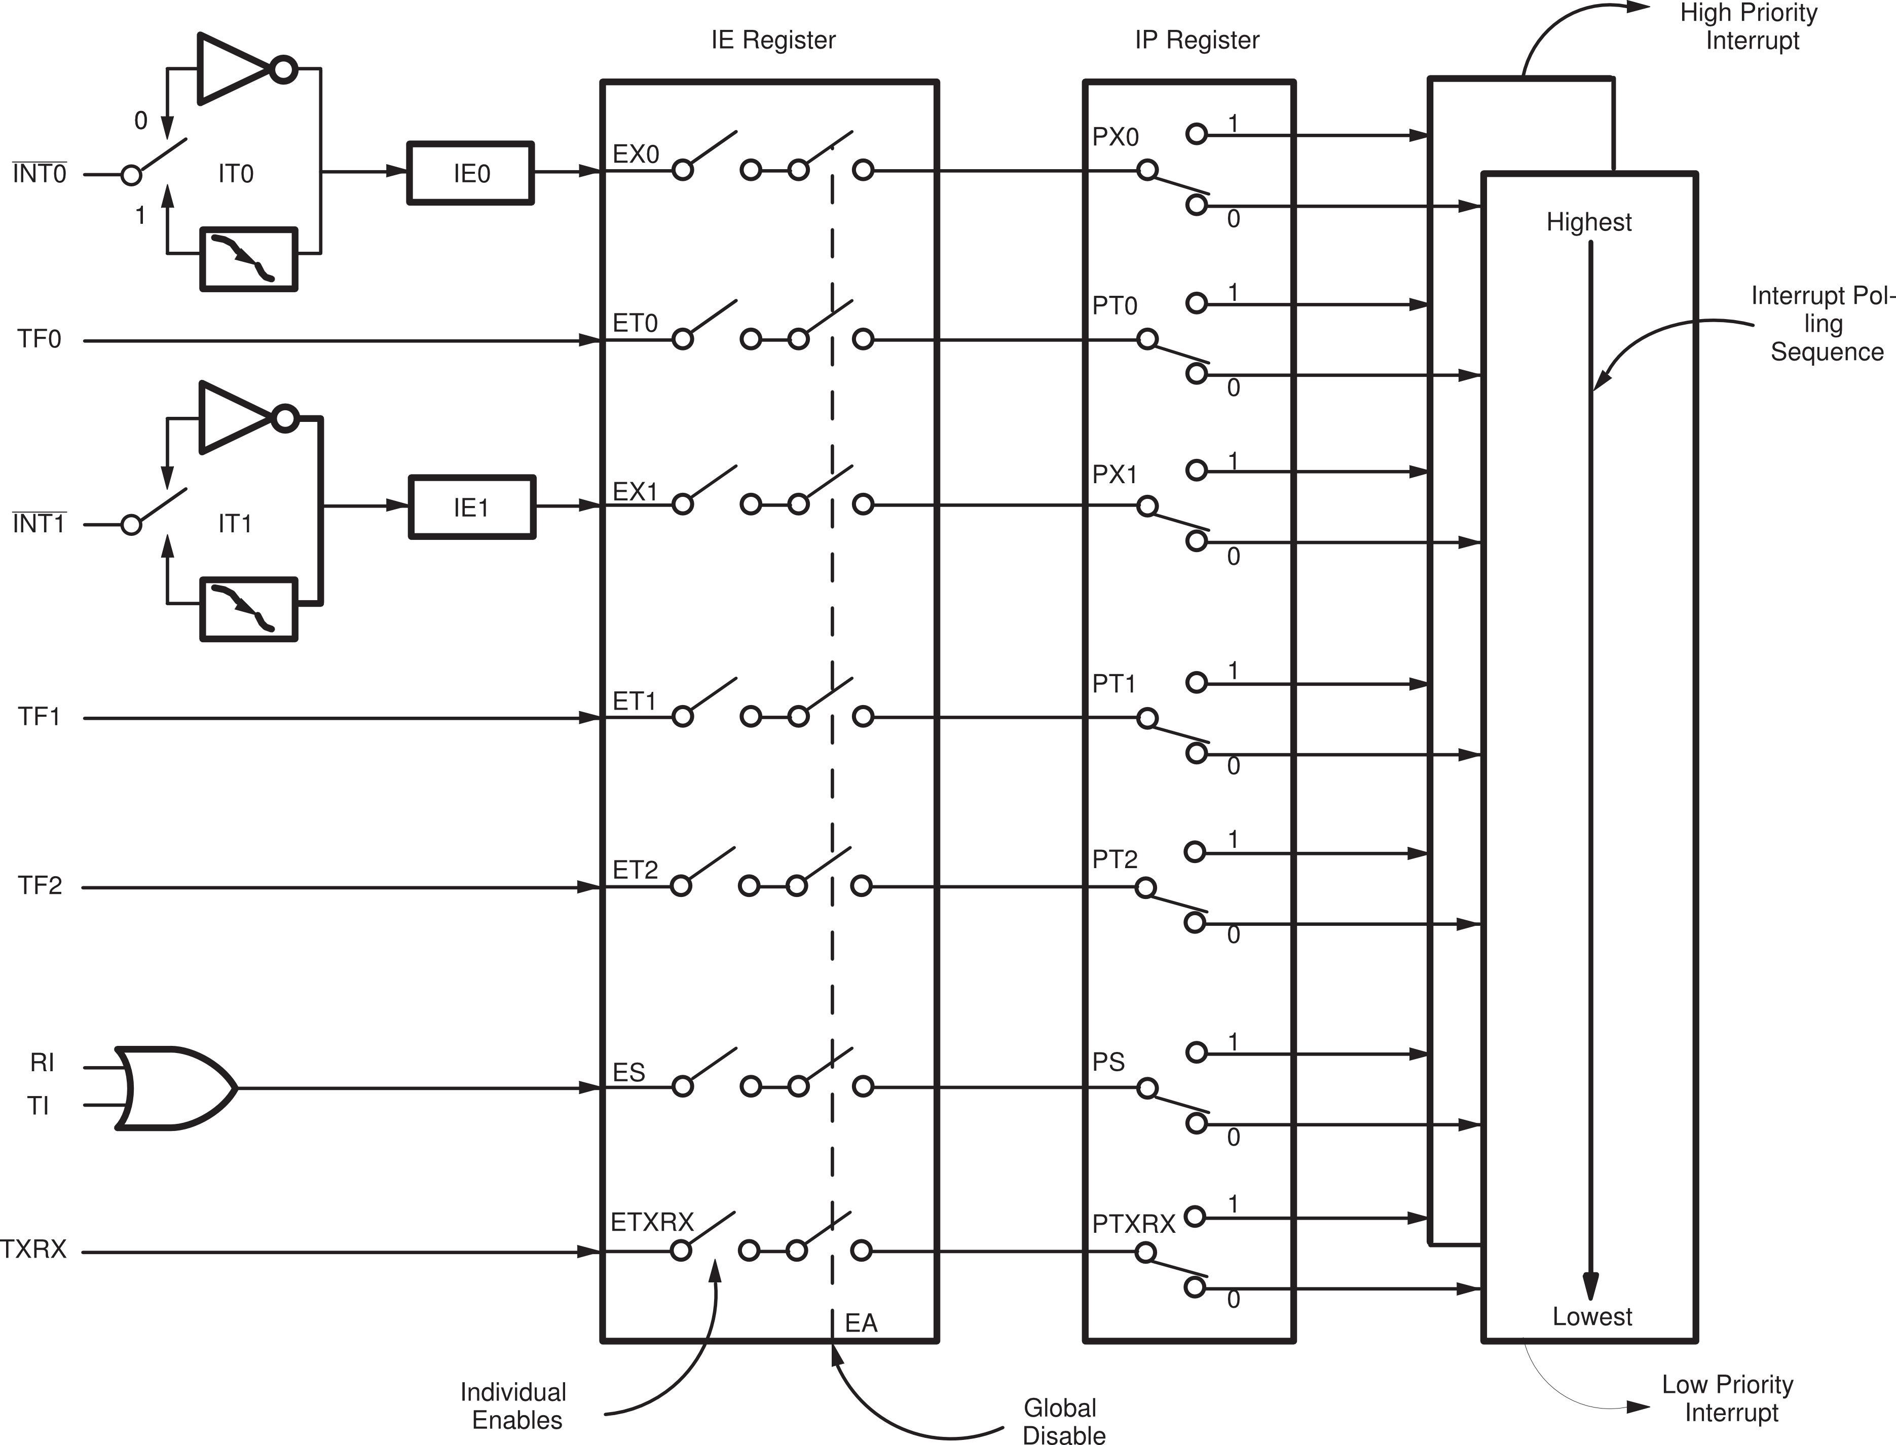
Figure 1: Interrupt Controller Algorithm Model

The External Interrupts INT0 and INT1 can each be either level activated or transition-activated, depending on bits IT0 and IT1 in Register TCON. The flags that actually generate these interrupts are cleared by the hardware when the service routine is vectored to only if the interrupt was transition-activated. If the interrupt was level-activated, then the external requesting source is what controls the request flag, rather than the on-chip hardware.
The Timer 0, Timer 1 and Timer 2 Interrupts are generated by TF0, TF1 (TCON) and TF2 (TCON2) which are set by a rollover in their respective Timer registers. When a timer interrupt is generated, the flag that generated it is cleared by the on-chip hardware when the service routine is vectored to.
The Serial Port Interrupt is generated by the logical OR of RI and TI. Neither of these flags is cleared by hardware when the service routine is vectored to. In fact, the service routine will normally have to determine whether it was RI or TI that generated the interrupt, and the bit will have to be cleared in software.
All of the bits that generate interrupts can be set or cleared by software, with the same result as though it had been set or cleared by hardware. That is, interrupts can be generated or pending interrupts can be canceled in software.
Each of these interrupt sources can be individually enabled or disabled by setting or clearing a bit in Special Function Register IE. IE contains also a global disable bit, EA, which 2 disables all interrupts at once. Refers to REGS section for IE register details.

Design Assumptions
The design have to follow the sequence as described, .

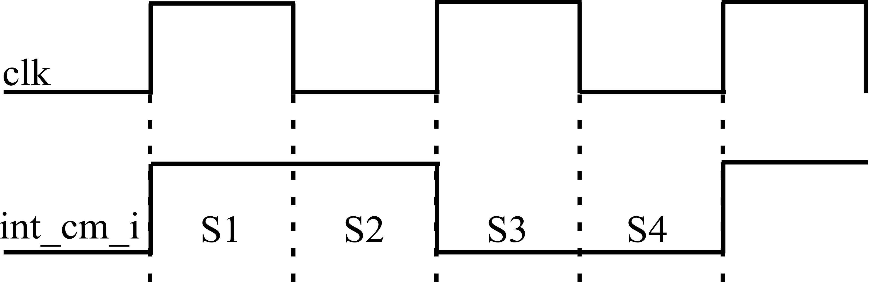
Clk = 10 MHz

int_cm_i = 5 MHz
Figure 2: Timing diagram.

S1: Verify external interrupt, 1° sample.
Verify int_rdy_i and int_na_i (send by core).
Send new register value and set int_reg_clr_o when has changes.
S2: Clear all output, SFR and int_reg_clr_o.
S3: Verify external interrupt, 2° sample.
Polling, send int_vect_o.
S4: Generate external interrupt.

Architecture and Design Hierarchy
The interrupt flags are sampled at every machine cycle. The samples are polled during the following machine cycle. If one of the flags was in a set condition at preceding cycle, the polling cycle will find it and the core block will generate an LCALL to the appropriate service routine, provided this hardware-generated LCALL is not blocked by any of the following conditions:
    - An interrupt of equal or higher priority level is already in progress.
    - The current (polling) cycle is not the final cycle in the execution of the instruction in progress.
    - The instruction in progress is RETI or any write to the IE or IP registers.
Any of these three conditions will block the generation of the LCALL to the interrupt service routine. Condition 2 ensures that the instruction in progress will be completed before vectoring to any service routine. Condition 3 ensures that if the instruction in progress is RETI or any access to IE or IP, then at least one more instruction will be executed before any interrupt is vectored to.
The polling cycle is repeated with each machine cycle and the values polled are the value that were present at previous machine cycle. Note then that if an interrupt flag is active but not being responded to for one of the above conditions, and is not still active when the blocking condition is removed, the denied interrupt will not be serviced. In other words, the fact that the interrupt flag was once active but not serviced is not remembered. Every polling cycle is new.
Thus the processor acknowledges an interrupt request by executing a hardware-generated LCALL to the appropriate service in routine. In some cases it also clears the flag that generated the interrupt, and in other cases it doesn’t. It never clears the Serial Port or Timer 2 flags. This has to be done in the user’s software. It clears an external interrupt flag (IEO or IE1) only if it was transition-activated. The hardware-generated LCALL pushes the contents of the Program Counter onto the stack (but it does not save the PSW) and reloads the PC with an address that depends on the source of the interrupt being vectored to, as shown bellow.
Table 2: Interrupt Address
Source | Vector Address
IE0 | 0003H
TF0 | 000BH
IE1 | 0013H
TF1 | 001BH
TF2 | 0023H
RI + TI | 002BH
TXRX | 0033H

Execution proceeds from that location until the RETI instruction is encountered. The RETI instruction informs the processor that this interrupt routine is no longer in progress, then pops the top two bytes from the stack and reloads the program Counter. Execution of the interrupted program continues from where it left off.
Note that a simple RET instruction would also have returned execution to the interrupted program, but it would have left the interrupt control system thinking an interrupt was still in progress.Interrupt Control – Description
The Interrupt Controller module evaluate and decides whether an interrupt request must be generated to CPU.
This module can monitor up to 8 interrupt sources. These sources are Timer 0, Timer 1, Timer 2 , Serial Communication Port (transmit and receive), External Pin 0, External Pin 1 and Transceiver.
Interrupt sources can be individually configurable through IE and IP registers.

Interrupt Control - Signals
The complete interface description is presented in the Table 3. The interface description includes both internal port and external pins:
Table 3: Interface Description
Signal | I/O | Description |  | Reset
int_int_b_i[0] | I | External Interrupt input 0 |  | ?
int_int_b_i[0] | I | State Meaning | Asserted: A transition from high to low or a low level of /INT0 triggers set correspondent external interrupt flag.  Negated: A transition from low to high has no effect.  In level mode, high level clears correspondent interrupt flag. | ?
int_int_b_i[0] | I | Timing | Assertion: an input high or low should be hold for at least one machine cycle to ensure sampling  Negated: an input low to high should be hold for at least one machine cycle to ensure sampling | ?
int_int_b_i[1] | I | External Interrupt input 1 |  | ?
int_int_b_i[1] | I | State Meaning | Asserted: A transition from high to low or a low level of /INT1 triggers set correspondent external interrupt flag.  Negated: A transition from low to high has no effect.  In level mode, high level clears correspondent interrupt flag. | ?
int_int_b_i[1] | I | Timing | Assertion: an input high or low should be hold for at least one machine cycle to ensure sampling  Negated: an input low to high should be hold for at least one machine cycle to ensure sampling | ?
clk | I | Register Interrupt Clock |  | ?
clk | I | State Meaning | Asserted: n/a  Negated: n/a | ?
clk | I | Timing | Assertion: Duty Cycle 50 %  Negation: Duty Cycle 50 % | ?
int_rst_sync_b_i | I | Synchronous reset |  | ?
int_rst_sync_b_i | I | State Meaning | Asserted: Chip in reset state  Negated: Normal Operation | ?
int_rst_sync_b_i | I | Timing | Assertion: Can be asynchronously asserted  Negation: May occur at any time, synchronous to internal clock | ?
int_na_i | I | Interrupt Not Accepted |  | ?
int_na_i | I | State  Meaning | Asserted: High level indicates a not accepted interrupt by core  Negated: Low level indicates a accepted interrupt by core | ?
int_na_i | I | Timing | Assertion: an input high should be hold for at least one machine cycle to ensure sampling  Negated: an input low should be hold for at least one machine cycle to ensure sampling | ?
reg_ie_i[7:0] | I | Interrupt Enable Register Bus - IE[7:0] |  | 0
reg_ie_i[7:0] | I | State  Meaning | Asserted: Data Registers  Negated: Data Registers | 0
reg_ie_i[7:0] | I | Timing | Assertion: Synchronous with internal clock  Negation: Synchronous with internal clock | 0
reg_ip_i[6:0] | I | Interrupt Priority Register Bus – IP[6:0] |  | 0
reg_ip_i[6:0] | I | State  Meaning | Asserted: Data Registers  Negated: Data Registers | 0
reg_ip_i[6:0] | I | Timing | Assertion: Synchronous with internal clock  Negation: Synchronous with internal clock | 0
reg_scon_i[1:0] | I | Interrupt Flag Register – SCON[1:0] |  | 0
reg_scon_i[1:0] | I | State  Meaning | Asserted: Data Registers  Negated: Data Registers | 0
reg_scon_i[1:0] | I | Timing | Assertion: Synchronous with internal clock  Negation: Synchronous with internal clock | 0
reg_tcon_i[5:0] | I | Interrupt Flag Register – TCON[5:0] |  | 0
reg_tcon_i[5:0] | I | State  Meaning | Asserted: Data Registers  Negated: Data Registers | 0
reg_tcon_i[5:0] | I | Timing | Assertion: Synchronous with internal clock  Negation: Synchronous with internal clock | 0
reg_tcon2_i[1:0] | I | Interrupt Flag Register - TCON2[1:0] |  | 0
reg_tcon2_i[1:0] | I | State  Meaning | Asserted: Data Registers  Negated: Data Registers | 0
reg_tcon2_i[1:0] | I | Timing | Assertion: Synchronous with internal clock  Negation: Synchronous with internal clock | 0
int_rdy_i | I | Interrupt Ready |  | ?
int_rdy_i | I | State  Meaning | Asserted: High level indicates interrupt routine finished by core  Negated: Low level indicates an interrupt routine still executed by core | ?
int_rdy_i | I | Timing | Assertion: an input high should be hold for at least one machine cycle to ensure sampling  Negated: an input low should be hold for at least one machine cycle to ensure sampling | ?
int_vect_o[2:0] | O | Interrupt Address Vector – int_vect[2:0] |  | 0
int_vect_o[2:0] | O | State  Meaning | Asserted: Interrupt Address Vector  Negated: Interrupt Address Vector | 0
int_vect_o[2:0] | O | Timing | Assertion: Synchronous with internal clock  Negation: Synchronous with internal clock | 0
reg_tcon_o[3:0] | O | Interrupt Flag Register – TCON[3:0] |  | 0
reg_tcon_o[3:0] | O | State  Meaning | Asserted: Data Registers  Negated: Data Registers | 0
reg_tcon_o[3:0] | O | Timing | Assertion: Synchronous with internal clock  Negation: Synchronous with internal clock | 0
reg_tcon2_o[1:0] | O | Interrupt Flag Register – TCON2[1:0] |  | 0
reg_tcon2_o[1:0] | O | State  Meaning | Asserted: Data Registers  Negated: Data Registers | 0
reg_tcon2_o[1:0] | O | Timing | Assertion: Synchronous with internal clock  Negation: Synchronous with internal clock | 0
int_reg_clr_o | O | Interrupt Register Clear |  | 0
int_reg_clr_o | O | State  Meaning | Asserted: Set when has new registers values  Negated: Clear when has no new register values | 0
int_reg_clr_o | O | Timing | Assertion: Synchronous with internal clock  Negation: Synchronous with internal clock | 0

Interrupt Control - Theory of Operation
The operation of the block is shown in Figure 2.
S1: Verify external interrupt, 1° sample.
Verify int_rdy_i and int_na_i (send by core).
If the core set the int_rdy_i, the interrupt block knows when the interrupt, executed by core, finish and clear highest interrupt flag in the internal register (IER or IER_CTR).
If the core set the int_na_i, the interrupt block knows that the core didn't accept the2 interrupt sent.
Table 4: Port Description
int_rdy_i | int_na_i | Description
0 | 0 | Interrupt accept
0 | 1 | Interrupt not accept
1 | 0 | Interrupt done, RETI
1 | 1 | -

Send new register value and set int_reg_clr_o when has changes.
The new register value is sent by port reg_tcon_o[3:0] and reg_tcon2_o[1:0]. The core check the int_reg_clr_o, is the int_reg_clr_o is high the core take the new register values and up date the SFR.
S2: Clear all output, SFR and int_reg_clr_o.
S3: Verify external interrupt, 2° sample.
Polling, send int_vect_o.
The int_vect_o show which interrupt is generated.

Table 5: Interrupt Vector
Source | Interrupt Vector
IE0 | 1
TF0 | 2
IE1 | 3
TF1 | 4
TF2 | 5
RI + TI | 6
TXRX | 7

S4: Generate external interrupt.

Interrupt Control – Implementation
Figure 3: Block Diagram
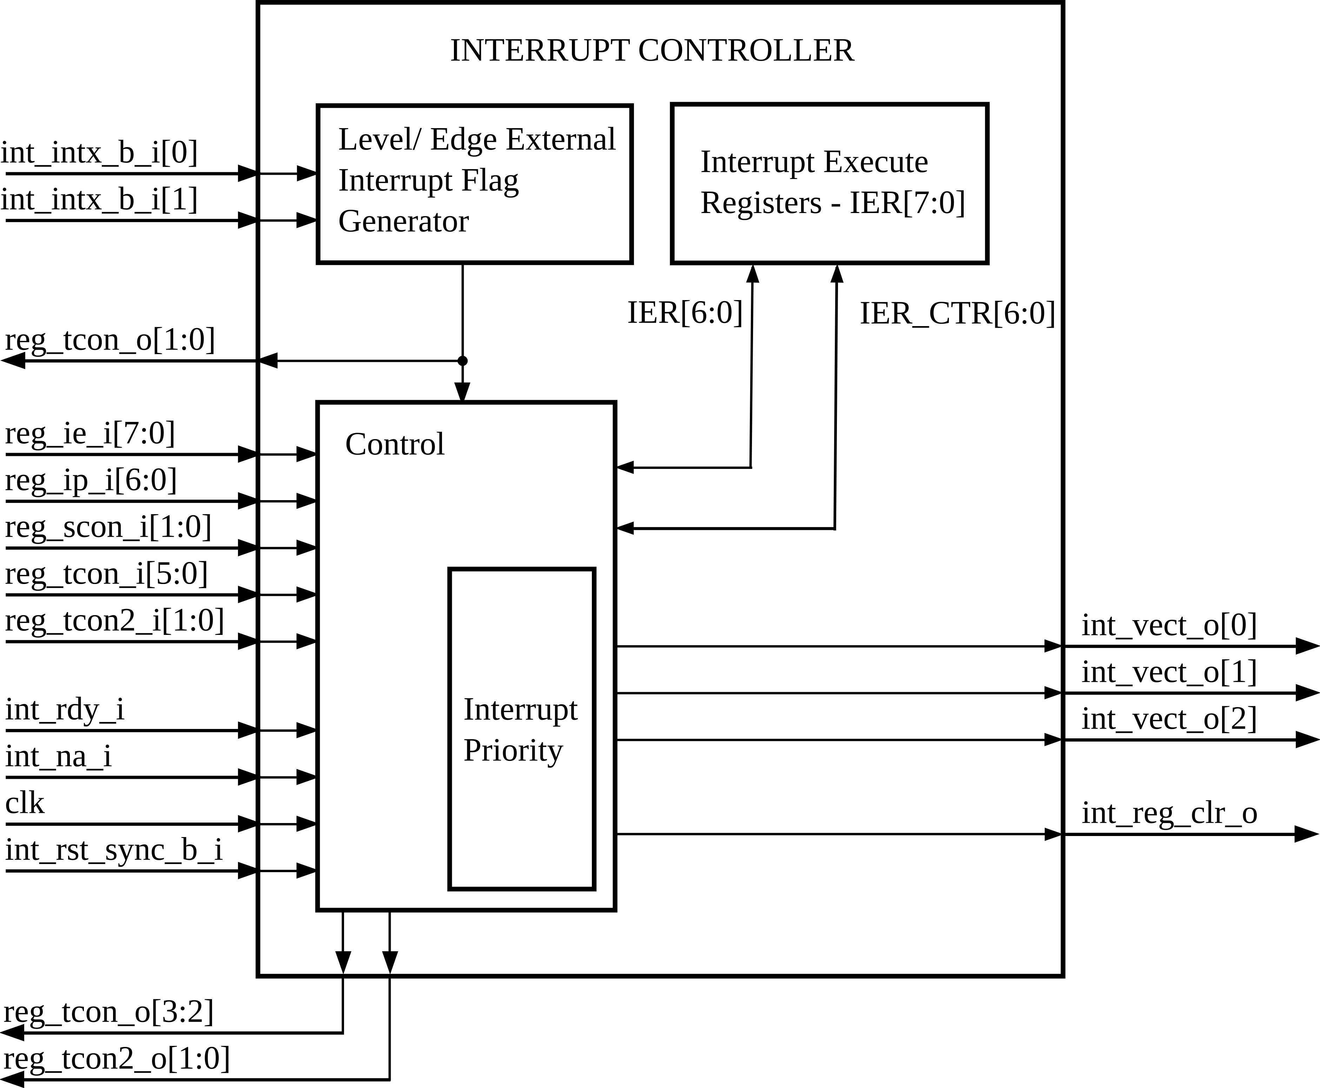

Level/ Edge External Interrupt Flag Generator
This block is responsible to generate the flag IE0, external interrupt 0, and IE1, external interrupt 1, register TCON.
The external sources can be programmed to be level-activated or transition-activated by setting or clearing bit IT1 or IT0 in Register TCON. If ITx = 0, external interrupt x is triggered by a detected low at the INTx pin. If ITx = 1, external interrupt x is edge-triggered. In this mode if successive samples of the INTx pin show a high in one cycle and a low in the next cycle, interrupt request flag IEx in TCON is set. Flag bit IEx then requests the interrupt.

Since the external interrupt pins are sampled once each machine cycle, an input high or low should hold for at least one machine cycle to ensure sampling. If the external interrupt is transition-activated, the external source has to hold the request pin high for at least one machine cycle, and then hold it low for at least one machine cycle to ensure that the transition is seen so that interrupt request flag IEx will be set. IEx will be automatically cleared by the CPU when the service routine is called.
If the external interrupt is level-activated, the external source has to hold the request active until the requested interrupt is actually generated. Then it has to deactivate the request before the interrupt service routine is complete or else another interrupt will be generated.

Interrupt Execute Register
There are two register, IER[6:0] and IER_CTR[6:0], these registers shows which interrupt is executed by core, the IER store the low priority interrupt and the IER_CTR store the high priority interrupt.

Control
The Interrupt Controller module evaluate and decides whether an interrupt request must be generated to CPU.
This module can monitor up to 8 interrupt sources. These sources are Timer 0, Timer 1, Timer 2 , Serial Communication Port (transmit and receive), External Pin 0, External Pin 1 and Transceiver.
Interrupt sources can be individually configurable through IE and IP registers.

Interrupt Priority
Each interrupt source can also be individually programmed to one of two priority levels by setting or clearing a bit in Special Function Register IP. A low-priority interrupt can itself be interrupted by a high-priority interrupt but not by another low-priority interrupt. A high-priority interrupt can’t be interrupted by any other interrupt source.
If two requests of different priority levels are received simultaneously, the request of higher priority level is serviced. If requests of the same priority level are received simultaneously, an internal polling sequence determines which request is serviced. Thus within each priority level there is a second priority structure determined by the polling sequence, as follows:
Table 6: Priority Level
Source | Priority within level
/INT0 | 1
TF0 | 2
/INT1 | 3
TF1 | 4
TF2 | 5
RI + TI | 6
TXRX | 7

Describe how the block actually performs the theory of operation. Provide detail concerning specific circuits or components that are critical to operation and performance. Describe in greater detail the block partitioning. Describe implementation using truth tables, algorithms, state diagrams and timing diagrams.

Interrupt Control - Configuration Parameters
This section details Interrupt Controller registers format and their meaning.

IP – Interrupt Priority
Bit | 7 | 6 | 5 | 4 | 3 | 2 | 1 | 0
R | - | PTXRX | PT2 | PS | PT1 | PX1 | PT0 | PX0
W
Reset | 0 | 0 | 0 | 0 | 0 | 0 | 0 | 0

Field | Description
PTXRX | Tranceiver interrupt priority bit.
PT2 | Timer 2 interrupt priority bit.
PS | Serial port interrupt priority bit.
PT1 | Timer 1 interrupt priority bit.
PX1 | External Interrupt 1 priority bit.
PT0 | Timer 0 interrupt priority bit.
PX0 | External Interrupt 0 priority bit.

IE – Interrupt Enable
Bit | 7 | 6 | 5 | 4 | 3 | 2 | 1 | 0
R | EA | ETXRX | ET2 | ES | ET1 | EX1 | ET0 | EX0
W
Reset | 0 | 0 | 0 | 0 | 0 | 0 | 0 | 0

Field | Description
EA | Enable all interrupts. If EA=0, no interrupt will be acknowledged. If EA=1, each EA interrupt source is individually enabled or disabled by setting or clearing its enable bit.
ETXRX | Transceiver interrupt enable bit.
ET2 | Timer 2 interrupt enable bit.
ES | Serial port interrupt enable bit.
ET1 | Timer 1 overflow interrupt enable bit.
EX1 | External interrupt 1 enable bit.
ET0 | Timer 0 overflow interrupt enable bit.
EX0 | External interrupt 0 enable bit.

SCON – Serial Control
Bit | 7 | 6 | 5 | 4 | 3 | 2 | 1 | 0
R | SM0 | SM1 | SM2 | REN | TB8 | RB8 | TI | RI
W
Reset | 0 | 0 | 0 | 0 | 0 | 0 | 0 | 0

Field | Description
SM[7:6] | Serial ports mode specify.
SM[7:6] | SM0 | SM1 | Mode | Description | Baud Rate
SM[7:6] | 0 | 0 | 0 | Shift register | Fosc/12
SM[7:6] | 0 | 1 | 1 | 8- bit UART | Variable
SM[7:6] | 1 | 0 | 2 | 9- bit UART | Fosc/64 or Fos/32
SM[7:6] | 1 | 1 | 3 | 9- bit UART | Variable
SM2 | Enables the multiprocessor communication feature in modes 2 and 3. In mode 2 or 3, if SM2=1 then RI will not be active if the received 9th data bit (RB8) is 0. In mode 1, if SM2=1 then RI will not be activated if a valid stop bit was not received. In mode 0, SM2 should be 0.
REN | Set/Cleared by software to enable/disable reception.
TB8 | The 9th bit will be transmitted in modes 2 and 3. Set/cleared by software.
RB8 | In modes 2 and 3, is the 9th data bit was received. In mode 1, if SM2=0, RB8 is stop bit that was received. In mode 0, RB8 is not used.
TI | Transmit interrupt flag. Set by hardware at the end of the 8th bit time in mode 0, or halfway through the stop bit time in the other modes (except see SM2).
RI | Receive interrupt flag. Set by hardware at the end of the 8th bit in mode 0, or halfway through the stop bit time in the other modes (except see SM2). Must be cleared by software.

TCON – Timer/ Counter Control

Bit | 7 | 6 | 5 | 4 | 3 | 2 | 1 | 0
R | TF1 | TR1 | TF0 | TR0 | IE1 | IT1 | IE0 | IT0
W | - | TR1 | - | TR0 | - | IT1 | - | IT0
Reset | 0 | 0 | 0 | 0 | 0 | 0 | 0 | 0

Field | Description
TF1 | Timer 1 overflow flag. Set by hardware when the Timer 1 overflows. Cleared as processor vectors to the interrupt service routine.
TR1 | Timer 1 run control bit. Set/cleared by software to turn Timer 1 ON/OFF.
TF0 | Timer 0 overflow flag. Set by hardware when the Timer 0 overflows. Cleared as processor vectors to the interrupt service routine.
TR0 | Timer 0 run control bit. Set/cleared by software to turn Timer 0 ON/OFF.
IE1 | External Interrupt 1 edge flag. Set by hardware when External Interrupt edge is detected. Cleared by hardware when interrupt is processed.
IT1 | Interrupt 1 type control bit. Set/cleared by software to specify falling edge/low level triggered External Interrupt.
IE0 | External Interrupt 0 edge flag. Set by hardware when External Interrupt edge is detected. Cleared by hardware when interrupt is processed.
IT0 | Interrupt 0 type control bit. Set/cleared by software to specify falling edge/low level triggered External Interrupt.

TCON2 – Timer/ Counter Control
Bit | 7 | 6 | 5 | 4 | 3 | 2 | 1 | 0
R | TXRX | TR2 | TF2 | DSP |  |  | DFSEL | EDGSEL
W
Reset | 0 | 0 | 0 | 0 | 0 | 0 | 0 | 0

Field | Description
TXRX | Transceiver interrupt
TR2 | Timer 2 run control bit. Set/cleared by software to turn Timer 2 ON/OFF.
TF2 | Timer 2 overflow flag. Set by hardware when the Timer 2 overflows. Cleared as processor vectors to the interrupt service routine.
DFP[4:2] | Digital Filter Clock Period
DFSEL | Digital Filter Sampling Selection
DFSEL | [0] DF output Sampling S2 selected
DFSEL | [1] DF output Sampling S3 selected
EDGSEL | Rise-Fall Edge selection
EDGSEL | [0] Fall edge selection
EDGSEL | [1] Rise edge selection

P3EN – Port 3 Enable
Bit | 7 | 6 | 5 | 4 | 3 | 2 | 1 | 0
R | FF | FE | FC | FB | FC | FA | F9 | F8
W
Reset | 0 | 0 | 0 | 0 | 0 | 0 | 0 | 0

Field | Description
F[F:8] | I/O Port3 Enable Bit.
F[F:8] | [1] Configured Bit Port3 as Output.
F[F:8] | [0] Configured Bit Port3 as Input.

Interrupt Control - Performance
This block was develop to operate in 10 MHz and cycle machine iqual 2 periods. No other test performance was made.

Interrupt Control - Design Trade-offs
Describe internal trade-offs and design details. This subsection is intended to provide a greater level of detail than the Integration Guide

Interrupt Control - Reuse Issues
This block can be reuse but can't change the relationship between period and cycle machine.
The timing have to follow exactly as show in Figure 2.

Design Methodology
Not Applicable. There are no design methodology used in this block.

Simulation Strategy and Results
Figure 4: LEC
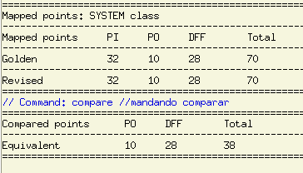

Figure 5: RTL- Compiler
Type Instances Area Area %
---------------------------------------------
sequential 29 1423.622 39.2
inverter 20 120.976 3.3
logic 151 2087.790 57.5
---------------------------------------------
total 200 3632.387 100.0
NA2JIXI = 9.2232 um^2
Gate Equivalent: 394

Tools Flow
The tools used in this project was provide by Candence, ncvlog 06.11, ncelab 06.11, ncsim 06.11 and encounter rtl compiler v07.20.

Design for Test
Not Applicable, DFT implementation only in back end.

Patent Disclosures
Not Applicable.

