Interrupt Controller
Verification Guide

Version #: 2.0
Revision date: Sep 29, 2010

Version Control
Revision | Authors | Date | Comments | Revisors
0.1 | Vinícius Amaral | 12/Aug/2010 | Initial version | -
1.0 | Jonatas Ferrari | 13/Aug/2010 | Features 3 to 6 added | Dino Cassel
2.0 | Vinícius Amaral | 29/Sep/2010 | Updating following sections, after complete all verification:  1.3 – Random Simulation  3 – Verification Plan  4 – Testbench  5 – Drivers and Monitors | -

Table of Contents

Interrupt Controller 5
1. Introduction 5
1.1 Verification Strategy 5
1.2 Verification Flow 5
1.3 Random Simulation 6
2. References 6
3. Verification Plan 7
3.1 Design Details 7
3.2 Feature List 7
3.3 Verification List 7
3.4 Interrupt Feature 1 Description 8
3.4.1 Verification Steps for verification F1.V1 8
3.4.2 Verification Steps for verification F1.V2 8
3.5 Interrupt Feature 2 Description 8
3.5.1 Verification Steps for verification F2.V1 9
3.6 Interrupt Feature 3 Description 9
3.6.1 Verification Steps for verification F3.V1 9
3.7 Interrupt Feature 4 Description 9
3.7.1 Verification Steps for verification F4.V1 9
4. Testbench 10
4.1 Testbench Overview 10
4.2 Partitioning 10
4.3 Global Routines 10
4.4 External Interface Functions 10
4.5 Memory Map 11
4.6 Verification and Debug Registers 11
4.7 Clocking 11
4.8 Reset 11
4.9 Termination 11
5. Drivers and Monitors 11
5.1 Driver and Monitor Overview 11
6. Models 11
6.1 Functional Models 11
6.2 Memory Models 12
6.3 Stub Models 12
6.4 IO and PADs 12
7. Additional Information 12

Interrupt Controller

- Introduction

This document provides a guideline about verification of Interrupt Controller block for EMC08 project. The next sections show the detailed plan and strategy to do the verification. First, some sections introduce the strategy used. Finally, the detailed block verification plan is shown.

  - Verification Strategy

The methodology used is the eRM (e Reuse Methodology) that provides a template for partitioning the environment. This way, a common environment is adopted to each module. This strategy codifies the best practice for developing e-based verification and ensures consistency, reusability and extensibility.

  - Verification Flow

The DUT (Design Under Test) is the block that we want to verify. The following figure illustrates the diagram of verification flow.

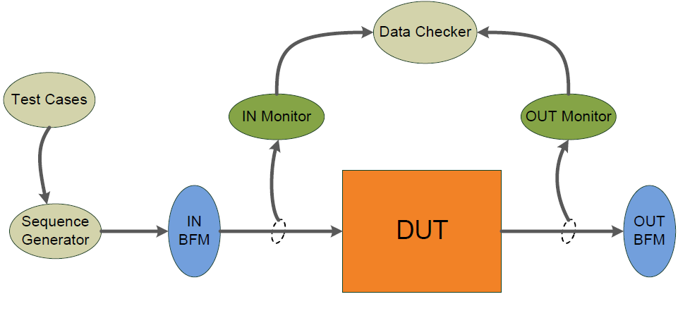
Figure 1 - Verification Flow Block Diagram
The DUT receives stimulus from input BFM (Bus Functional Model) and sends outputs to output BFM. These stimulus are generated by Sequence Generator according to whished Testcase that can control the order of sequences, types of stimulus, number of repetitions and so on. There are two monitors that sample input and output DUT signals. They are passive units that do not change the values of signals. Monitors send sampled signals to Data Checker that compares DUT outputs with expected answers and gives a DUT error if it doesn’t mismatch.
The following figure shows the verification flow inside Data Checker sub-block. A reference model receives the inputs from IN Monitor, calculates the expected results and compares these results with DUT outputs, send to Data Checker by OUT Monitor. So, Data Checker compares DUT’s results with expected results from reference model and creates illegal buckets when they mismatch. The illegal buckets generate a DUT error.

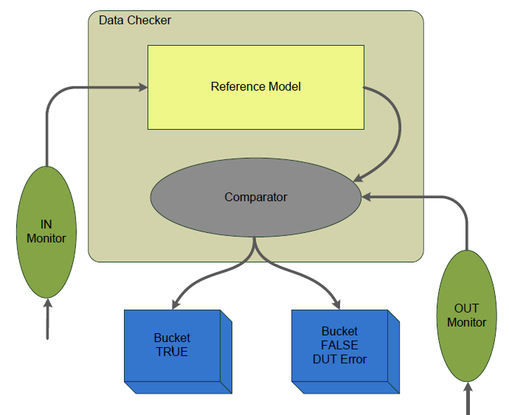
Figure 2 – Data Checker model

  - Random Simulation

The testcases are generated using a set of sequences. Depending on feature to be verified, the testcase controls the generation order of these sequences. The following table shows the action executed by each sequence.

Sequence | Action executed
SEQ_RESET | Generates a reset stimulus with a random delay
SEQ_RAND_IP  SEQ_RAND_IE  SEQ_RAND_SCON  SEQ_RAND_TCON  SEQ_RAND_TCON2  SEQ_RAND_INTEXT | Each of these sequences generates random values to a specified register input and hold the previously values of others inputs. The values generated don’t change at least for one cycle machine.
SEQ_RAND_NA | Generates an output pulse of NA (interrupt not applicable) to inform interrupt module that an interrupt is not applicable.
SEQ_RAND_RDY | Generates an output pulse of READY (interrupt are ready) to inform interrupt module that an interrupt was finished.
SEQ_NOP | Wait one cycle machine without change inputs
Table 1 – Sequences
Not always every sequence is generated in the same order, the testcase can generate any number of sequences in a random order.

- References

The references used for this documentation are:
- EMC08 project – Interrupt Controller Block Guide, version 0.1
- Cadence. "Specman® Elite Basics for Verification Environment Developers." Lecture Manual, 2007.

- Verification Plan
The Verification Plan describes the verification process that will be followed to verify Interrupt Controller block. It details a list of required verifications that must be accomplished to validate the design specification.

  - Design Details

This section describes basic details about verification plan and the design that will be verified. The Table 2 gives this information.

Component | Feature Description
Document Name | Interrupt Controller Verification Plan
Verification Methodology | Top-down
Verification Methods | Simulation
Simulation Components
Application | Cadence Specman® Elite Version 6.1
Language | e language
Testcase file | EMC08/Interrupt Controller/verification/testbench/int_test*.e
Bus Functional Model | EMC08/Interrupt Controller/verification/testbench/int_bfm*.e
Table 2 – Design Details
  - Feature List

The Table 3, shown below, lists the critical features of design that must be verified, including a description of the expected functional and the priority of each feature.

Feature Number | Feature Description | Testing Priority
EMC.Interrupt.F1 | Interrupt Enable register (IE) must enables or disables interruptions | 10
EMC.Interrupt.F2 | Interrupt Priority register (IP) gives high or low priority for each interrupt and outputs must observe these priorities and the interrupts that are being handled by the core. | 10
EMC.Interrupt.F3 | The External Interrupts can each be either level activated or transition-activated | 8
EMC.Interrupt.F4 | Reset signal clears all outputs | 6
Table 3 – Feature List
  - Verification List

The verification list, described on Table 4, defines how the features (on Table 3) will be verified. This list contains all verifications that must be run to verify expected features.

Verif. Number | Description | Features Verified | Prio  rity | Owner | Complet.
EMC.Interrupt.F1.V1 | Set and reset bit EA of register IE and verify if it disables all interruptions (clear all outputs) | EMC.Interrupt.F1 | 10 | Vinícius Amaral | 100 %
EMC.Interrupt.F1.V2 | Set and reset each other bit of register IE and verify if them enable or disable each interruption and produce correct output for it. | EMC.Interrupt.F1 | 10 | Vinícius Amaral | 100 %
EMC.Interrupt.F2.V1 | Give random values to IP register and to interrupt flags, keeping all interrupts enabled, and verify if priorities have been respected | EMC.Interrupt.F2 | 10 | Vinícius Amaral | 100 %
EMC.Interrupt.F3.V1 | Set external interrupts as transition-activated or level-activated randomly, and generate external interrupts and verify if activation is done correctly. | EMC.Interrupt.F3 | 10 | Vinícius Amaral | 100 %
EMC.Interrupt.F4.V1 | Generate a pulse of reset with random delay and verify if all outputs are clear after this. | EMC.Interrupt.F4 | 10 | Vinícius Amaral | 100 %
Table 4 – Verification List

  - Interrupt Feature 1 Description

There is a register in SFR (Special Function Register) called IE (Interrupt Enable). There are seven interrupt sources. These sources are Timer 0, Timer 1, Timer 2, Serial Communication Port, External Pin 0, External Pin 1 and Transceiver. Each one can be individually enabled or disabled by setting or clearing a bit in IE register. IE also contains a global disable bit, EA, which disables all interrupts at once.
Feature 1 intends to verify if Interrupt Controller enables or disables interruptions according to IE register.

    - Verification Steps for verification F1.V1

The testcase generates 100,000 sequences randomly.
The IE register receives a random value during SEQ_RAND_IE execution. Verification F1.V1 observes value of bit EA of IE register and verifies if it disables all interrupts when set. So the output vector can’t generate any interruption, and other outputs must be cleared.

    - Verification Steps for verification F1.V2

The testcase generates 100,000 sequences randomly.
The IE register receives a random value during SEQ_RAND_IE execution, keeping EA bit set in 90% of cases.
Verification F1.V2 observes values of each bit of IE register, except EA bit, and verifies if they disable each interrupt when set.
So the output vector can’t generate the interruption that is disabled and the output register of this interrupt must be cleared.

  - Interrupt Feature 2 Description

There is a register in SFR called IP (Interrupt Priority). Each interrupt source can also be individually programmed to one of two priority levels by setting or clearing a bit in IP. A low-priority interrupt can itself be interrupted by a high-priority interrupt but not by another low-priority interrupt. A high-priority interrupt can’t be interrupted by any other interrupt source.
If two requests of different priority levels are received simultaneously, the request of higher priority level is serviced. If requests of the same priority level are received simultaneously, an internal polling sequence determines which request is serviced. Thus within each priority level there is a second priority structure determined by the polling sequence.
Feature 2 intends to verify if Interrupt Controller gives the correct priority level to interrupts according to IP register.

    - Verification Steps for verification F2.V1

All interrupts are kept enabled. The testcase generates 100,000 sequences randomly.
The IP register receives a random value during SEQ_RAND_IP execution, keeping interrupts with high priority just in 30% of cases.
Verification F2.V1 observes priority levels of each interrupt, interrupts in execution and interrupts flags, and calculates if a new interrupt needs be generated.

  - Interrupt Feature 3 Description

The external sources can be programmed to be level-activated or transition-activated by setting or
clearing bit IT1 or IT0 in register TCON. If ITx = 0, external interrupt x is triggered by a detected low
at the INTx pin. If ITx = 1, external interrupt x is edge-triggered. In this mode if successive samples
of the INTx pin show a high in one cycle and a low in the next cycle, interrupt request flag IEx in TCON is set. Flag bit IEx then requests the interrupt.
Since the external interrupt pins are sampled once each machine cycle, an input high or low should
hold for at least one machine cycle to ensure sampling. If the external interrupt is transition-activated, the external source has to hold the request pin high for at least one machine cycle, and
then hold it low for at least one machine cycle to ensure that the transition is seen so that interrupt
request flag IEx will be set. IEx will be automatically cleared by the CPU when the service routine is
called.
Feature 3 intends to verify if external interrupts are correctly activated by transition or level.

    - Verification Steps for verification F3.V1

All interrupts are kept enabled. The testcase generates 100,000 sequences randomly.
The TCON register (bits IT0 and IT1) and IE register receives random stimulus during sequence SEQ_RAND_TCON. This sequence is configured to enable one or two external interrupts and set them as transition or level-activated (randomly). And SEQ_RAND_INTEXT is configured to generate external interrupt stimulus for level or transition detection. Then, verification F3.V1 checks whether if activation is done correctly.

  - Interrupt Feature 4 Description

Reset signal sets the output int_vect[2:0] and all others outputs to logic level 0. This feature goal is to verify the behavior of the block after a reset.

    - Verification Steps for verification F4.V1

The sequence SEQ_RESET is called and generates a reset pulse with random delay. Then, verification F4.V1 checks if all outputs were cleared.

- Testbench

The testcases are generated using a set of sequences. Depending on feature to be verified, the testcase controls the generation order of these sequences.

  - Testbench Overview

The following diagram illustrates a top-level view of testbench environment. This diagram shows the relationships of DUT, agents, monitors, BFMs and other models. A more complete description of these modules will be available in future versions of this document.

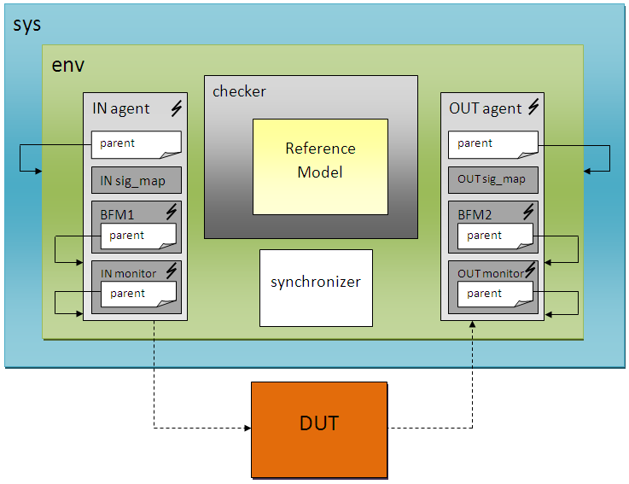
Figure 3 – Block diagram of the testbench

  - Partitioning

Not applicable. The interrupt module can be verified without subdivisions.

  - Global Routines

Not applicable. Global routines were not used.

  - External Interface Functions

The eRM methodology defines all external interface functions.

  - Memory Map

Not applicable. Memory is not used in Interrupt block.

  - Verification and Debug Registers

All input and output ports can be monitored by monitors for debug proposes. Moreover, verification registers were created to store some values and can be monitored by monitors too.

  - Clocking

The main clock was used (frequency of 20 MHz) and a cycle machine was produced with a half of clock frequency.

  - Reset

A reset pulse was produced with random delay, keeping this delay greater than 50 ns. All inputs signals are set to initial condition after reset.

  - Termination

The eRM methodology defines all termination tasks.

- Drivers and Monitors

The eRM methodology defines all drivers and monitors.

  - Driver and Monitor Overview

See eRM methodology.

- Models
The Interrupt block does not use memories, IOs and PADs. However, a Reference Model is used to reproduce DUT behavior and to calculate expected answers.

  - Functional Models

A reference model is used in this verification environment reproduce DUT behavior specific to each feature and to check expected answers. Data Checker receives the inputs from IN Monitor and sends to Reference Model that checks the expected results. So, Data Checker compares these results with DUT outputs. Figure 2, previously presented, shows the flow diagram of Data Checker and Reference Model. A more complete description of these models will be available in future versions of this document.

  - Memory Models

Not applicable. Memory is not used in Interrupt block.

  - Stub Models

Not applicable. Stub Models are not necessary for this block.

  - IO and PADs

Not applicable. IO and PADs are not used in Interrupt block.

- Additional Information

No additional information is needed in this version.

