Memories
Verification Guide

Version #: 0.1
Revision date: AUG 16, 2010

Version Control
Revision | Authors | Date | Comments
0.1 | Thiago Santos | 16/Aug/2010 | Initial version

Table of Contents

Memories 5
1. Introduction 5
1.1 Verification Strategy 5
1.2 Verification Flow 5
1.3 Random Simulation 6
2. References 6
3. Verification Plan 6
3.1 Design Details 6
3.2 Feature List 7
3.3 Verification List 7
3.4 Feature 1 Description 7
3.5 Feature 2 Description 8
3.6 Feature 3 Description 8
3.7 Feature 4 Description 8
3.8 Verification Steps for EMC08.Memories.V1 8
3.9 Verification Steps for EMC08.Memories.V2 8
4. Testbench 8
4.1 Testbench Overview 8
4.2 Partitioning 9
4.3 Global Routines 9
4.4 External Interface Functions 9
4.5 Memory Map 9
4.6 Verification and Debug Registers 9
4.7 Clocking 9
4.8 Reset 10
4.9 Termination 10
5. Drivers and Monitors 10
5.1 Driver and Monitor Overview 10
5.2 Driver Description 10
5.2.1 Driver Functional Overview 10
5.2.2 Driver Commands 10
5.2.3 Driver Arguments 10
5.3 Monitor Description 10
5.3.1 Monitor Functional Overview 10
5.3.2 Driver Commands 10
5.3.3 Driver Arguments 11
6. Models 11
6.1 Functional Models 11
6.2 Memory Models 11
6.3 Stub Models 11
6.4 IO and PADs 11

Memories

- Introduction

This document provides a guideline about verification of block Memories for EMC08 project. The sections below will describe the detailed verification plan and strategy.

  - Verification Strategy

The methodology used is the eRM (e Reuse Methodology) that provides a template for partitioning the environment. This strategy codifies the best practice for developing e-based verification and ensures consistency, reusability and extensibility.

  - Verification Flow

The DUT (Design Under Test) is the block that we want to verify. The following figure illustrates the diagram of verification flow.

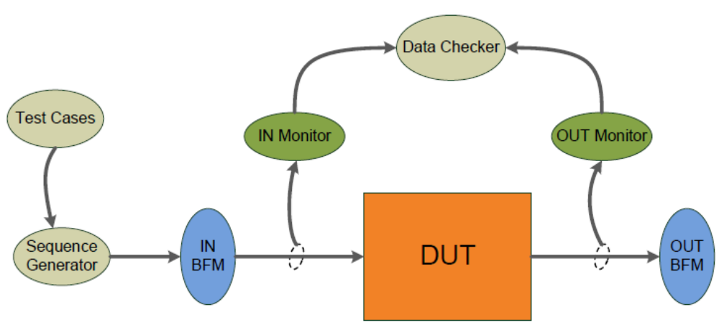
Figure 1 - Verification Flow Block Diagram
The DUT receives stimulus from input BFM (Bus Functional Model) and compute the outputs to output BFM. These stimulus are generated by Sequence Generator according to whished Testcase that can control the order of sequences, types of stimulus, number of repetitions and so on. There are two monitors that sample input and output DUT signals. They are passive units that do not change the values of signals. Monitors send sampled signals to Data Checker that compares DUT outputs with expected answers and gives a DUT error if it doesn’t mismatch.

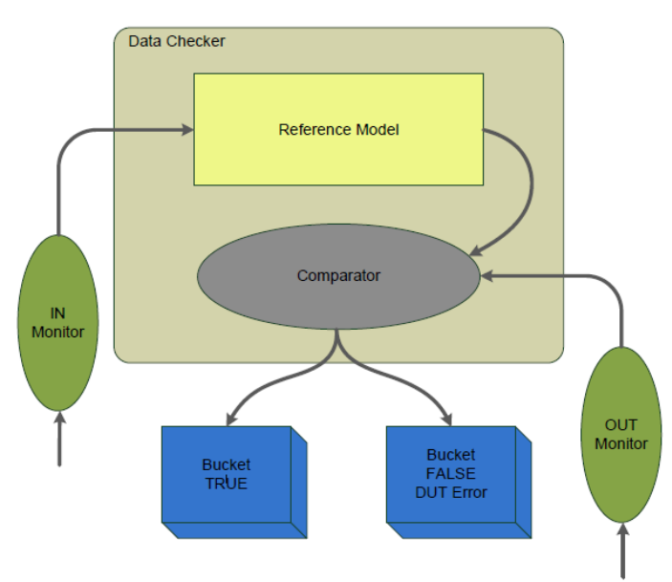
Figure 2 – Data Checker model
  - Random Simulation

The data that will be written to the memories are generated randomly. The control signals (ENB, WEB, OEB) are generated according to the desired behavior, and the address space is completely stimulated.

- References

The references used for this documentation are:
- EMC08 project – Memories Block Guide, version 0.2
- Cadence. "Specman® Elite Basics for Verification Environment Developers." Lecture Manual, 2007.

- Verification Plan

The Verification Plan describes the verification process that will be followed to verify and validate the block specification, describing features to be verified and how this process will be made.

  - Design Details

This section describes basic details about verification plan and the design that will be verified. The Table 1 gives this information.

Component | Feature Description
Document Name | Memories Verification Plan
Verification Methodology | Top-Down
Verification Methods | Simulation
Simulation Components
Application | Cadence Specman® Elite Version 6.1
Language | e language
Testcase files | EMC08/memories/verification/ emc_ram.e EMC08/memories/verification/ emc_rom.e
Bus Functional Model | EMC08/memories/verification/pkt_bfm1.e
Table 1 – Design Details
  - Feature List

The Table 2, shown below, lists the critical features of design that must be verified, including a description of the expected functional and the priority of each feature.

Feature Number | Feature Description | Testing Priority
EMC08.Memories.F1 | Memory module is enabled by setting the ENB pin to low level | 10
EMC08.Memories.F2 | Setup and Hold times must be respected | 10
EMC08.Memories.F3 | Writes are made writing the desired address at ADR pin, data at D bus and setting WEB pin to low level | 10
EMC08.Memories.F4 | Reads are made writing the desired address at and setting OEB pin to low level, the data output will be available at Q bus | 10
Table 2 – Feature List
  - Verification List

The verification list, described on Table 3, defines how the features (on Table 2) will be verified. This list contains all verifications that must be run to verify expected features.

Verif. Number | Description | Method | Level | Features Verified | Priority | Owner | Completion
EMC08.Memories.V1 | Write and Read random values to/from all positions of the RAM Memory | Simulation | Unit | EMC08.Memories.F1  EMC08.Memories.F2  EMC08.Memories.F3  EMC08.Memories.F4 | 10 | Thiago Santos | 100 %
EMC08.Memories.V2 | Load a binary file into the ROM memory and read all positions | Simulation | Unit | EMC08.Memories.F1  EMC08.Memories.F2  EMC08.Memories.F4 | 10 | Thiago Santos | 50 %
Table 3 – Verification List

  - Feature 1 Description

The memory has an enable pin (ENB) that controls the status of the memory. If this pin is set to high level, the memory enters in a mode to prevent unnecessary power consumption. When the ENB pin is at high level, the outputs are maintained in high impedance level and write or read operations are disabled. When the ENB pin is low level, the memory is in normal operation, write and read operations can be made.

  - Feature 2 Description

The provided memories have different setup and hold times for each input. These times must be respected to guarantee the correct operation of the module. If any of this times are violated the required operation can provide a wrong result or don’t be recognized.

  - Feature 3 Description

Write operations apply only to RAM memories. This operation is made by writing the desired data and address, respectively to D and ADR buses, and setting the WEB pin to low level. This operation is evaluated synchronous to the clock, so the setup and hold times must be respected in relation to the clock.

  - Feature 4 Description

Read operations apply both to RAM and ROM memories. This operation is made by writing the desired address to the ADR bus, and setting the OEB pin to low level. This operation is not synchronous to the clock. It is treated as the OEB pin is set to low. The setup and hold times must be respected in relation to the moment that OEB pin is set to low level.

  - Verification Steps for EMC08.Memories.V1

This verification procedure will cover all features related to the RAM memory, like memory enable, write and read operations and setup/hold times. It will be made by made successive writes and read to the entire RAM memory space. Some test will be made to verify the correct behavior of the memory when ENB pin is at high level. The write/read tests will write random values to all memory positions. This data will be stored also in a structure inside the reference model. When a red operation is requested, the output of the DUT will be compared to the data stored in the reference model.

  - Verification Steps for EMC08.Memories.V2

Different from RAM, the ROM memory don’t permit write operations. Its contents are already stored in memory positions. The provided IP give a possibility to load a binary file that will act as the content of the memory. The same file loaded into the ROM will be used as input to the reference model. The test sequence will make successive read operation to the entire ROM space. The read data will be compared to the one loaded to the reference model. The same way as for the RAM memory, the test sequence will try to make read operations when the memory is disabled to check the correct behavior.

- Testbench

The testcases will generate sequences of write and read operation that will cover the entire memory spaces. The written data will be generated randomly.

  - Testbench Overview

The following diagram illustrates a top-level view of testbench environment. This diagram shows the relationships of DUT, agents, monitors, BFMs and other models.

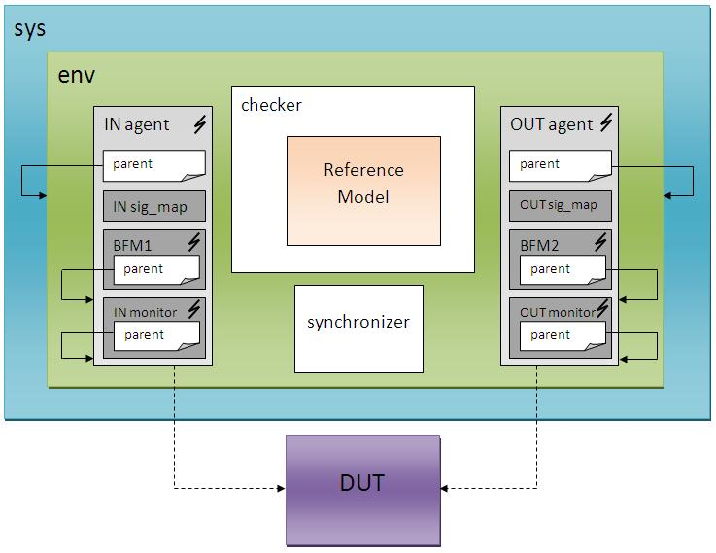
Figure 3 – Block diagram of the testbench

  - Partitioning

The memories module is divided into RAM and ROM IPs. Each one will be submitted to the applicable tests as mentioned above.

  - Global Routines

Not applicable. Global routines were not used.

  - External Interface Functions

Not applicable. External interface functions and calls were not used.

  - Memory Map

Not applicable. Memory map is not used in the memories block.

  - Verification and Debug Registers

Not applicable. Debug registers were not used.

  - Clocking

The RAM and ROM memories IPs uses one simple clock. The clock frequency used in the tests is 20MHz, same as the entire project.

  - Reset

The provided IPs doesn’t have a reset state. The memories start working immediately after their power up. The only restriction that must be followed is that there is as idle state of 250ns in the beginning of operation. During this period, no operation should be executed.

  - Termination

The termination of the simulation occurs after all positions in the memory spaces were written and/or read.

- Drivers and Monitors

  - Driver and Monitor Overview

The verification environment implements one driver and one monitor

  - Driver Description

The verification environment implements one simple driver, called pkt_driver_u, which has the function of receive the generated sequence and send data to the Bus Functional Model once at a time.

    - Driver Functional Overview

The driver function is receive the generated sequence and sends the data, one at a time, to the Bus Functional Model. The BFM will be the responsible to drive each signal to the DUT inputs.

    - Driver Commands

Not applicable.

    - Driver Arguments

Not applicable.

  - Monitor Description

The verification implements one monitor, called pkt_mon_u. The function of the monitor is permanently watch the bus looking for specific events.

    - Monitor Functional Overview

The monitor function is watch the bus looking for specific signals that will trigger the reference model. The expected events are write and read signals. The write event occurs when the WEB signal is in low level at the clock rising edge. The read event occurs when the OEB signal is switched to low level.

    - Driver Commands

Not applicable.

    - Driver Arguments

Not applicable.

- Models

  - Functional Models

A memory is a continuous space for data storage, so the functional model used is a simple fixed size list. In case of the RAM memory, when a write operation is detected, the list will be updated in the indicated position. For the ROM test, as there is no write operation, this model will be loaded with the same data loaded into the ROM model. A read operation will compare the stored reference data with the output from the DUT.

  - Memory Models

Not applicable. Other memory models is not used in the memories block.

  - Stub Models

Not applicable. Stub Models are not necessary for this block.

  - IO and PADs

Not applicable. IO and PADs are not used in this block.

- Additional Information

No additional information is needed in this version.

