Ports

Block Guide
Version 1: 0.5
Last revision date: Oct 27, 2010

Version Control

Table 1 – Version control
Revision | Date | Author | Comments | Revisors
0.1 | 10/Aug/2010 | Lizbeth L. Paredes A.  Julierme Silva de Araujo | Initial beta version | Vinicius de Carvalho Amaral
0.2 | 11/Aug/2010 | Lizbeth L. Paredes A.  Julierme Silva de Araujo | Describe major changes from previous version | Vinicius de Carvalho Amaral
0.3 | 01/Set/2010 | Lizbeth L. Paredes A.  Julierme Silva de Araujo | Describe new changes from previous version | Vinicius de Carvalho Amaral
0.4 | 05/Oct/2010 | Lizbeth L. Paredes A.  Julierme Silva de Araujo | Actualizations in the Ports Block design - Ports PXEN | Vinicius de Carvalho Amaral
0.5 | 27/Oct/2010 | Lizbeth L. Paredes A.  Julierme Silva de Araujo | Actualizations in the Ports Block design -  Mode Test | Vinicius de Carvalho Amaral

Summary

Ports 1
Block Guide 1
Version Control 2
1. Preface 4
1.1 Conventions 4
1.2 Bibliography 4
1.3 Acronyms and abbreviations 5
1.4 Glossary 5
2. Introduction 5
3. Overview 7
4. Features 7
4.1 Considerations important 8
5. Modes of operation 8
5.1 I/O PADs Configurations 8
5.2 Circuit Configuration 9
5.3 Mode Test 11
6. External signal description 11
7. Detailed signal descriptions 12
8. Memory map and register definition 13
8.1 Memory map 13
8.2 Registers Description of qualification of ports 14
8.3 I/O Ports Registers Description 14
9. Functional Description 15
10. Extra Information 15
11. Initialization Information 15
12. Application Information 15

Ports

- Preface

The EMC08 project is the microcontroller of 8 bits for specific automotive system application, the project was proposed by CT2 – EMC08 SOW as part of training for the development of integrated circuits, in their different fields: Analog, Digital and Radio Frequency.

The EMC08 chip for the digital area is projected from the stage front-end (specification, coding, synthesis, etc.) to step back-end (the floorplaning, placement, place and route, tape-out, etc.) and to develop the total project was divided into different modules and sub-steps.
This document aims to assist in the development of the block of ports which is a sub-block EMC08 8bit microcontroller, has features such as specifications and features for the beginning of the implementation (coding).

  - Conventions

Table 2 – Conventions
Convention | Description
I/O (input/output) | is the collection of interfaces that different functional devices
I/O ports | The digital I/O ports are the means by which the microcontroller interfaces to the environment.
Digital I/O | A digital I/O port can be realized using a number of D type Flip-Flops.  Digital I/O tends to be grouped into byte wide ports (8 digital bits) that can be configured as either input bits or output bits.
Output Port | The inputs are connected to the data bus whilst the outputs are connected to whatever output interface is to be controlled.
Input Port | The input port, allows outside world inputs to be stored in the data latches so they can be read by the microprocessor via the data bus

  - Bibliography

- CT2-EMC08 SOW, Statement of the Work, Project Definition, Version 1.0, Revision date, July 27, 2010.
- Zelenovsky Ricardo, Micro-Controladores MCS-51,
- INTEL , MCS’51 Microcontroller, Family User’s Manual, February 1994.
- ATMEL, Atmel 8051 Microcontrollers, Hardware Manual, Janeiro 2007.

  - Acronyms and abbreviations

Table 3 – Acronyms and Abbreviations
Term | Meaning
Tx/Rx | Transmission/reception
I/O | Input /output
Y | Output
PO | Negative Output
PI | Access Negative Output enable
EN | output Enable
A | Data for the write

  - Glossary

Terms and definitions for Ports IP:
Table 4 – Glossary
Term | Definition
Pull-up | The basic function of a pull-up resistor is to insure that given no other input, a circuit assumes a default value.
Pull-down | A pull-up and a pull-down. Their function is the same, to create a default value for a circuit, but one pulls the line high, the other pulls it low

- Introduction

The EMC08 microcontroller 8 bit is composed of several blocks like to see in the figure 1, one being the block ports that will be introduced in this document. The block ports consistency of the 4 ports of the 8 bits bidirectional (P0-P3) and one unidirectional port (P4) 8 bits too, like show in the figure 2. The port 3 (P3) is multifunctional and it can have several configurations.
All ports can be configured as inputs or outputs. Accordingly, in total of 32 input/output pins and 8 outputs more enabling the microcontroller to be connected to peripheral devices are available for use. Pin configuration, i.e. whether it is to be configured as an input (1) or an output (0), depends on its logic state defined for the P0EN-P4EN registers. In order to configure a pin microcontroller as an input, it is necessary to apply a zero logic (0) to appropriate I/O port bit. In this case, voltage level on appropriate pin will be 0.

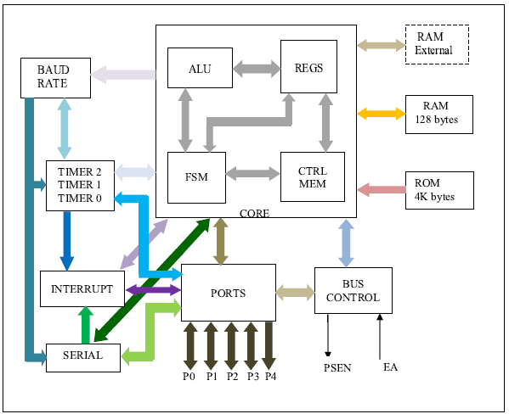
Figure 1 – Digital top block diagram
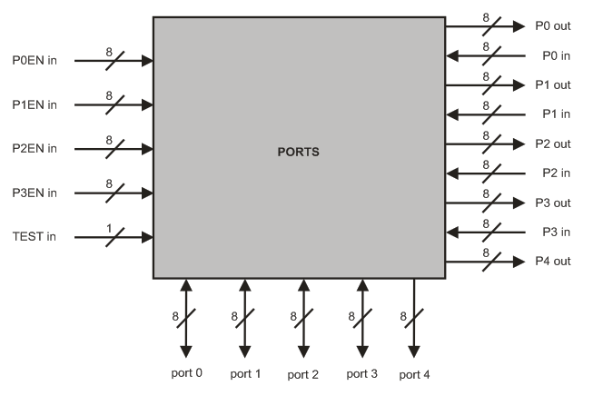
Figure 2 – Ports block diagram

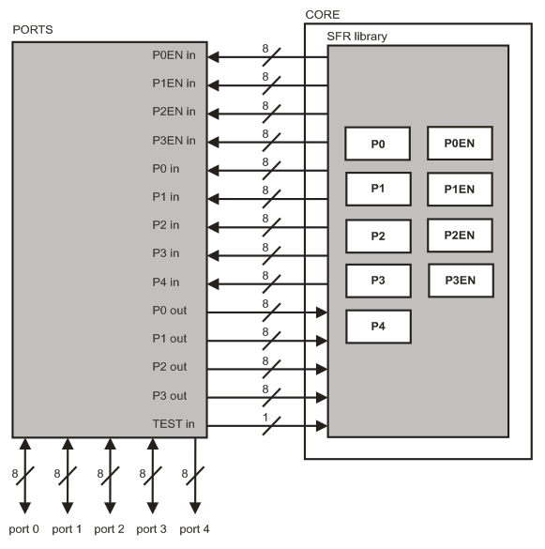
Figure 3 – Relation between the PORTS block and CORE block
- Overview

Functionality:
Setting: The block has the functionality to configure ports each pin input/output (I/O) to be used by different blocks in the Tx/Rx data information or addresses.
Control: Ports Block don’t has control functionality, it is solely responsible for configuring the ports as I/O, their decision inputs or outputs will be the responsibility of other blocks (interrupts, Tx, Rx serial access memory).

The figure 4 is showed the several ports with their several functionalities.

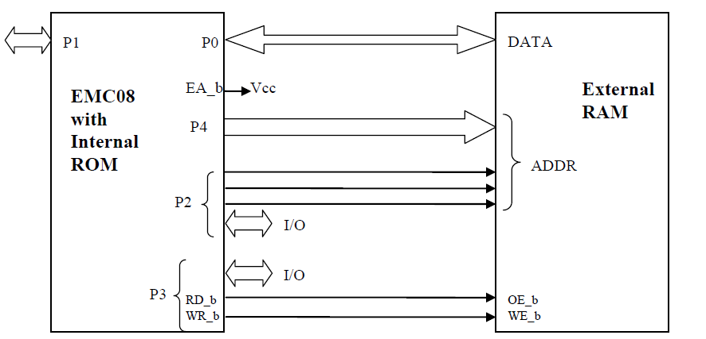
Figure 4 – Ports block diagram

- Features

Ports Block is connected right the blocks: interrupts, serial and Bus Control (access to external memory). Each of these blocks will be responsible for setting the bits of records that each port has, making possible the flow of data.

It can be seen in Table 5 records the settings of P [3:0] EN for each port to behave as I/O (input or output).

- Ports Block is a module completely passive, them it is dependent on the changes performed by other modules system.
- It has the functionality to be prepared to configure the ports so that events involving the flow of data (Tx/Rx) for these ports will assist.
- No functionality block ports making any kind of access control and/or data type.

  - Considerations important

- When needed, access to the external memory, input buffers on port 0 and output drives to ports 0, 2, 4 are used:
  - In this case, the data bus in port 0 is bidirectional;
  - The port 2 has an output byte in the most significative address byte of the external memory when the address is 16 bits. In other words, the port 2 pins continue emitting the contents of SFR.
- The drive from the port 0 can be:
  - The bus data from external memory;
  - Or the I/O general purpose.
- The port 2 can be changed to:
  - The high address bus;
  - Or the I/O general purpose.
- The output drivers of Ports 0 can be switchable to DATA BUS or General Purpose I/O and Port 2 can be switchable to HIGHER ADDRESS BUS to General Purpose I/O by an internal CONTROL signal for its external memory access.
  - The port 4 is the address bus down. During the access to external memory the rest of special registers P0/P2 remain unchanged.
- Each port of the I/O can be independently used as input to the output by P [3:0] configured for records.
- (Ports 0 and Ports 2 can’t be used for I/O general purpose when it is used as address or data bus).

- Modes of operation

In the EMC08 SOW the Ports Block in study say that this block has two configurations modes and anything can be input or output. These configurations are the following:

  - I/O PADs Configurations

- Considering that each port is as follows:

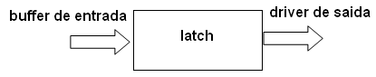
Figure 5 – Parts ports block
- Port configuration.

In the figure 6 are showed the diagram functional of a I/O buffer pins on each of the ports.
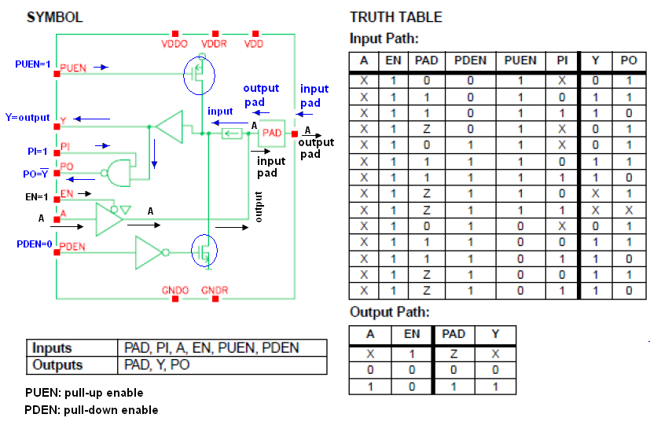
Figure 6 – I/O Circuits of the PADs

  - Circuit Configuration

Input/Output (I/O) pin:
Figure above illustrates a simplified schematic of all circuits within the microcontroller connected to one of its pins. It refers to all the pins except those of the P0 port which do not have pull-up resistors built-in.

- How does work the input port microcontroller?

  - When PUEN (Pull-up is in enable = 1) then the transistor is biased and allows the power circuit, and enables the output Y. In another circuit would be in open circuit.
  - When PDEN (Pull-down is not in enable = 0) for the presence of the denied buffer transistor is polarized and closes the circuit.
    - The output Y can be used as denied that activating the input (PI = 1).
    - If PI = 0, only if Y is the output only.

Input pin

A logic one (1) is applied to a bit of the P register. The output FE transistor is turned off and the appropriate pin remains connected to the power supply voltage over a pull-up resistor of high resistance.

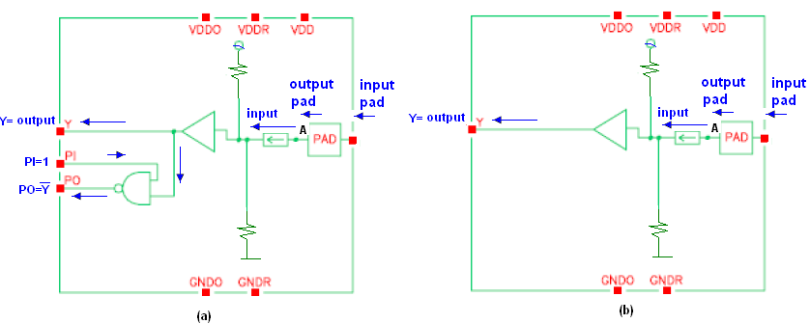
Figure 7 – Circuit for the Input PADs configurations

Table 5 – Inputs and Outputs for the INPUT PADs
Inputs | EN = 0  PUEN = 1  PDEN = 0  If PI = 1 them figure (a)  If PI = 0 them figure (b) | Output | If PI = 1 them output = Y and PO  If PI = 0 them output = Y

- How does work the output port microcontroller?

  - If EN = 0 in this case the output would be high impedance (Z).
  - If EN = 1 in the case allows the pitch of the A signal that is sent to the PAD.

Logic zero (0) is applied to a bit of the P register. The output EN transistor is turned on, thus connecting the appropriate pin to ground.

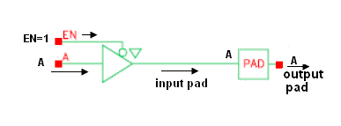
Figure 8– Circuit for the output configurations

Table 6 – Inputs and Ou1=tputs for the OUTPUT PADs
Inputs | EN = 1  PUEN = 0  PDEN = 1  A(Data) | Outputs | A (data)

The Ports Block will configure the PAD cells of each pin through pin EN of this cell. When the Ports Block configures the pin EN with value equal to 0 (zero) the PAD cell will be configured to receive data coming from the Ports Block through pin A. When the Ports Block configures the pin EN with value equal to 1 (one) the PAD cell will be configured to receive data from the external environment and send these data to the Ports Block through pin Y.

  - Mode Test

This operation mode is related with the test of Ports block. When the TEST in Port is set to 1, the test mode is being activated. At this moment the p0 and p1 ports are set as output and p2 port as input. To set the TEST in port with value equal to zero disables the block test mode.

- External signal description

Four ports of the EMC08 are bidirectional (P0-P3). Each of these ports consists of a latch (Special Function Registers P0 through P3), an output driver and an input buffer. Port 4 is the output of the address bus. The I/O ports (P0-P3) are bit configured by SRF registers (P[3:0]EN) and the P3.1 has an special bit configuration in PCON register (P3SEL) to select the output source from TXD (Serial) or P3.1 register.

Hence, each port can be configured as input or output, them this module can be considered as a sub-module of the ports block like show in the figure 9.

The figure 9 shows an example of the ports module configuration, with pad 0 as input and pad 7 as output for port 0. It indicates the right values for EN, PUEN, PDEN, PI, etc. As well as, the figure 7 and 8 and tables 5 and 6 show the same information.

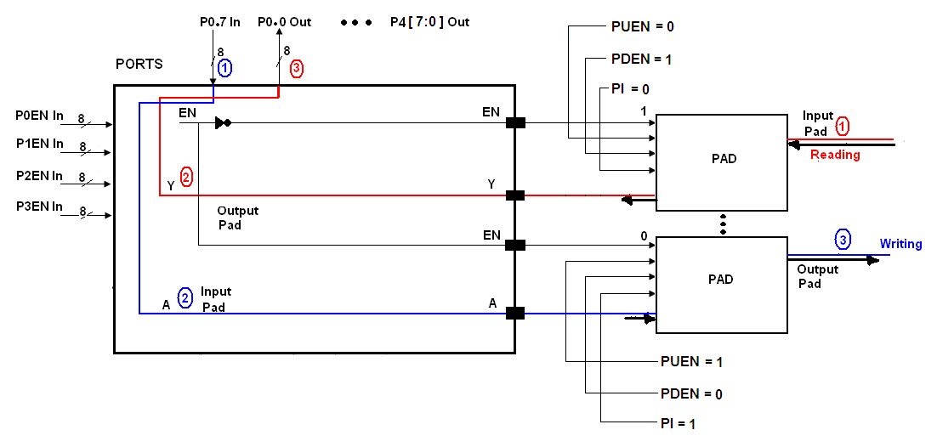
Figure 9 – Example for the Input/Output Configurations Port0

- Detailed signal descriptions

Table 7 – Detailed signal descriptions
Registers | Pins | Bit (s) | I/O | Description
P0 | [7:0] | 8 | I/O | Special Function Register for the store of data
P1 | [7:0] | 8 | I/O | Special Function Register for the store of data
P2 | [7:0] | 8 | I/O | Special Function Register for the store of data
P3 | [7:0] | 8 | I/O | Special Function Register for the store of data
P4 | [7:0] | 8 | I/O | Special Function Register for the store of data
P0EN | [7:0] | 8 | I | Enable port 0 ( POEN=0 input RD )  ( POEN=1 output WR )
P1EN | [7:0] | 8 | I | Enable port 1 ( P1EN=0 input RD )  ( P1EN=1 output WR )
P2EN | [7:0] | 8 | I | Enable port 2 ( P2EN=0 input RD )  ( P2EN=1 output WR )
P3EN | [7:0] | 8 | I | Enable port 3 ( P3EN=0 input RD )  ( P3EN=1 output WR )
Port O | [7:0] | 8 | I/O | RD/WR dados da memória externa
Port 1 | [7:0] | 8 | I/O | RD/WR of generally proposed
Port 2 | [7:0] | 8 | I/O | Higher address [15:8] external memory
Port 4 | [7:0] | 8 | I/O | Lower address [7:0] bus output
Port 3 | [7:0] | 8 | I/O | Generally proposed
Port 3 | P3.0 | 1 | I | RXD (serial input port)
Port 3 | P3.1 | 1 | I | TXD (serial output port)
Port 3 | P3.2 | 1 | I | INT1 (External interrup.)
Port 3 | P3.3 | 1 | I | INT0 (External interrup.)
Port 3 | P3.4 | 1 | I | Generally proposed
Port 3 | P3.5 | 1 | I | Generally proposed
Port 3 | P3.6 | 1 | I | WR_b external data memory write strobe
Port 3 | P3.7 | 1 | I | RD_b external data memory read strobe

- Memory map and register definition

For the memory map for the Ports interface registers consists of the 8 bytes registers with no special requirements. The memory map and registers details are in the following sections.

  - Memory map

Table 8 – Detailed signal descriptions
Register Address | Registers | Access | Reset Value | Section
C0 | P0EN | R | 0x00h | 8.2.1
C8 | P1EN | R | 0x00h | 8.2.1
E8h | P2EN | R | 0x00h | 8.2.1
F8h | P3EN | R | 0x00h | 8.2.1
80h | PO | R/W | 0x00h | 8.3.1
90h | P1 | R/W | 0x00h | 8.3.1
A0h | P2 | R/W | 0x00h | 8.3.1
B0h | P3 | R/W | 0x00h | 8.3.1
AFh | P4 | R | 0x00h | 8.3.2

  - Registers Description of qualification of ports

Registers responsible for enabling o the ports to I/O are:

    - P[3:0]EN

Bit | 7 | 6 | 5 | 4 | 3 | 2 | 1 | 0
R | P[3:0]EN.7 | P[3:0]EN.6 | P[3:0]EN.5 | P[3:0]EN.4 | P[3:0]EN.3 | P[3:0]EN.2 | P[3:0]EN.1 | P[3:0]EN.0
W
Reset | 0 | 0 | 0 | 0 | 0 | 0 | 0 | 0

Table 9 – P[3:0]EN Description
Field | Description
P[3:0]EN.[7:0] | 0: Pin set as input.  1: Pin set as output.

  - I/O Ports Registers Description

    - P[3:0]

Bit | 7 | 6 | 5 | 4 | 3 | 2 | 1 | 0
R | P[3:0].7 | P[3:0].6 | P[3:0].5 | P[3:0].4 | P[3:0].3 | P[3:0].2 | P[3:0].1 | P[3:0].0
W
Reset | 1 | 1 | 1 | 1 | 1 | 1 | 1 | 1

Table 11 – P[3:0] Description
Field | Description
P[3:0].[7:0] | 0: Low level Output/Input.  1: High Level Output/Input.

    - P4
Bit | 7 | 6 | 5 | 4 | 3 | 2 | 1 | 0
R
W | P4.7 | P4.6 | P4.5 | P4.4 | P4.3 | P4.2 | P4.1 | P4.0
Reset | 0 | 0 | 0 | 0 | 0 | 0 | 0 | 0

Table 12 – P4 Description
Field | Description
P4.[7:0] | 0: Low level Output.  1: High level Output.

- Functional Description

The ports module will utilize for everything modules for the transmission or reception information govern for his.
The single functionality for the module ports is to configure e port like input or output, that going to work depended of the P0EN, P1EN, P2EN and P3EN registers.
It verifies the operation mode in the item 5.2 in this document.

- Extra Information

There is not information extra additional with respect this module.

- Initialization Information

The ports will be initialized on writing mode after receive a reset stimuli.

- Application Information

The ports module does not control any information that pass through it, the usage of this information depend of others modules that are being used this module.

