PORTS
Verification Guide

Version 1: 0.3
Revision date: Sep 29, 2010

Version Control

Table 1 – Version Control
Revision | Authors | Date | Comments
0.1 | Pedro Fausto R. Leite Jr.  Valéria Aparecida Pereira | 13/Aug/2010 | Initial Version
0.2 | Pedro Fausto R. Leite Jr.  Valéria Aparecida Pereira | 16/Aug/2010 | More details were added
0.3 | Jonatas Valentim Ferrari  Valéria Aparecida Pereira | 29/Sep/2010 | Removed the feature of the reset

Table of Contents

1. Introduction 5
1.1 Verification Strategy 5
1.2 Verification Flow 5
1.3 Random Simulation 6
2. References 7
3. Verification Plan 7
3.1 Design Details 7
3.2 Feature List 7
3.3 Verification List 8
3.4 Ports Feature 1 Description 8
3.4.1 Verification Steps for verification F1.V1 8
3.5 Ports Feature 2 Description 9
3.5.1 Verification Steps for verification F2.V1 9
3.6 Ports Feature 3 Description 9
3.6.1 Verification Steps for verification F3.V1 9
4. Testbench 9
4.1 Testbench Overview 10
4.2 Partitioning 10
4.3 Global Routines 10
4.4 External Interface Functions 10
4.5 Memory Map 10
4.6 Verification and Debug Registers 10
4.7 Clocking 10
4.8 Reset 10
4.9 Termination 11
5. Drivers and Monitors 11
5.1 Driver and Monitor Overview 11
5.2 <Driver/Monitor X> Description 11
5.2.1 <Driver/Monitor X> Functional Overview 11
5.2.2 <Driver/Monitor X> Commands 11
5.2.3 <Driver/Monitor X> Arguments 11
5.2.4 <Driver/Monitor X> Configuration 11
6. Models 11
6.1 Functional Models 11
6.2 Memory Models 11
6.3 Stub Models 12
6.4 IO and PADs 12
7. Additional Information 12

PORTS

- Introduction

The purpose of this document is present a verification guide for Ports module of the EMC08 microcontroller. The verification of this module will be made to identify errors during coding, improving performance of the block. Will present some important topics for verification, such as: strategy used, verification flow, verification plan, testbench, drivers and monitors, and types of models. The next sections show the detailed plan and strategy to do the verification. First, some sections introducing the strategy used. Finally, the detailed block verification plan is shown.

  - Verification Strategy

The methodology that will be used to verify the Ports module is the eRM (e Reuse Methodology) that provides a template for partitioning the environment. Therefore, a common environment is adopted to each module. This strategy codifies the best practice for developing e-based verification and ensures consistency, reusability and extensibility.
The Ports module is a simple module, i.e., it is a small module that has no sub-modules, and then will use to verify this module the top-down strategy.
The top-down strategy is best suited for flat designs and smaller designs, and verifies the design as a whole, not breaking the design into smaller modules for individual verification.

  - Verification Flow

The verification flow will start with the write of the testbench in Verilog and simulation using the SimVision simulator and Incisive Comprehensive Coverage tool to check if all lines of code were stimulated. To do this the testbench, a vector of test will be created to check if the responses obtained from the DUT matches with the expected responses.
After this initial test, using the language e in Specman an environment of verification to test the functionality of the block, to do this, will be generated values of output that will be checked and monitored to verify the correct functionality.
The block that we want to verify is the DUT (Design Under Test) of the Ports module. The Figure 1 shows the diagram of verification flow.

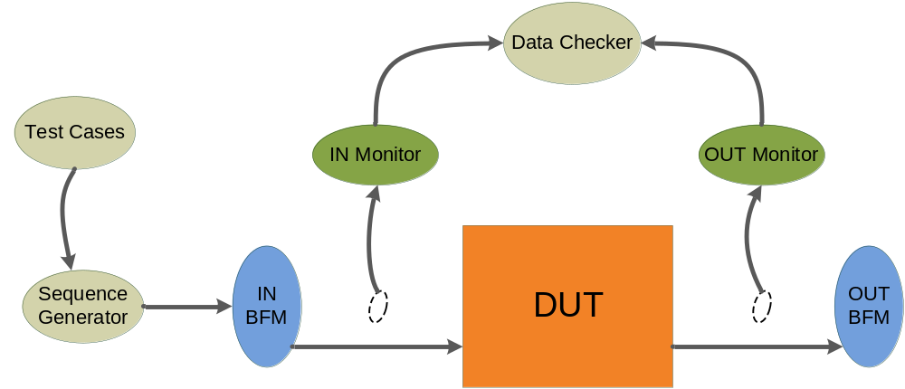

Figure 1 - Verification Flow Block Diagram.

The DUT receives stimulus from input BFM (Bus Functional Model) and sends outputs to output BFM. Theses stimulus are generated by Sequence Generator according to whished testcase that can control the order of sequences, types of stimulus, number of repetitions and so on. There are two monitors that sample input and output DUT signals. They are passive units that do not change the values of signals. Monitors send sampled signals to Data Checker that compares DUT outputs with expected answers and gives a DUT error if it doesn’t mismatch.
The following figure shows the verification flow inside Data Checker sub-block. A reference model receives the inputs from IN Monitor, calculates the expected results and compares these results with DUT outputs, send to Data Checker by OUT Monitor. So, Data Checker compares DUT’s results with expected results from reference model and creates illegal buckets when they mismatch. The illegal buckets generate a DUT error.

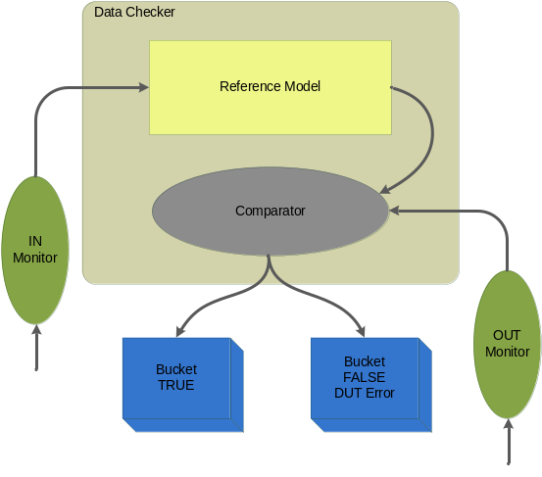
Figure 2 – Data Checker model.

  - Random Simulation

Using the eRM, random testcases will be generated automatically by Specman. Constraints will be added to the random testcases to improve the coverage of the test.
The P3 [7:0] pin is a multifunctional pin, i.e., each port of this pin will have a different function, as showed in Table 2.
Table 2 –Pin P3[7:0] functions.
P3.0 | RXD (serial input port)
P3.1 | TXD (serial output port)
P3.2 | INT0 (external interrupt, *)
P3.3 | INT1 (external interrupt, *)
P3.4 | -
P3.5 | -
P3.6 | WR_b (external data memory write strobe, *)
P3.7 | RD_b (external data memory read strobe, *)

Soon, the P3EN register will hold the bit-to-bit information to enable these eight ports. So, we will have 2⁸ possible combinations that will enable these ports as input or output. These combinations will be made applying stimulus randomly in P3EN. In addition, the ports P[2:0] and P4 will be randomly stimulated.

- References

- Finco, Saulo; Salviano, Oscar; Moretti, Cleber. “EMC08 SOW – Statement of the Work”. Phase 2 of CI Brazil Program, Campinas, 2010.
- Araújo, Julierme S.; Aguilar, Lizbeth P. “Ports - Block Guide”, version 0.1, Aug 04, 2010.
- Cadence. “BD02 – Digital IC Design”, version 1.1, Sep 23, 2008.
- Cadence. “Specman Elite Basics for Verification Environment Developers” Lecture Manual, version 6.1.1, Nov 06, 2008.

- Verification Plan

A verification plan is required to describe what is being verified and how it will be verified. It should address the three aspects of verification: coverage measurement, stimulus generation, and response checking.
This Verification Plan describes the verification process that will be followed to verify Ports module. It details a list of required verifications that must be accomplished to validate the design specification.

  - Design Details

This section describes basic details about verification plan and the design that will be verified. The Table 3 shows the verification environment for Ports module.

Table 3 – Verification Environment.
Component | Feature Description
Document Name | Verification Guide of Ports Module
Verification Methodology | top-down
Verification Methods | Simulation
Simulation Components
Application | Cadence Specman® Elite Version 6.1
Language | e language
Testcase file | EMC08/Ports/verification/testbench/emc_test*.e
Bus Functional Model | EMC08/ Ports /verification/testbench/emc_bfm.e

  - Feature List

The Table 4, shown below, lists the critical features of design that must be verified, including a description of the expected functional and the priority of each feature.

Table 4 – Feature List
Feature Number | Feature Description | Testing Priority
EMC.Ports.F1 | The P3, P2, P1 and P0 ports are enabled as input or output regarding the P3EN, P2EN, P1EN, P0EN values. | 10
EMC.Ports.F2 | It is possible to have any data incoming when the port is enabled as input. | 10
EMC.Ports.F3 | It is possible to have any data leaving the port when is enabled as output. | 10
  - Verification List

The verification list, described on Table , defines how the features (on Table ) will be verified. This list contains all verifications that must be run to verify expected features.

Table 5 – Verification List
Verif. Num. | Description | Method | Level | Features Verified | Prior | Owner | Completion
EMC.Ports.F1.V1 | Send random P[3:0]EN registers values to the module and verify if the PDEN, PUEN pins for input and EN pin for input and output are enable correctly. | Simulation | Unit | EMC.Ports.F1 | 10 | Valéria Apª Pereira | 0 %
EMC.Ports.F2.V1 | When the port is enabled as input we will send random values to the PAD input pin, and verify the Y output pin. | Simulation | Unit | EMC.Ports.F2 | 10 | Valéria Apª Pereira | 0 %
EMC.Ports.F3.V1 | When the port is enabled as output we will send random values to the A input pin, and verify the PAD output pin. | Simulation | Unit | EMC.Ports.F3 | 10 | Valéria Apª Pereira | 0 %

  - Ports Feature 1 Description

Every bit of the P0EN register corresponds to one port of the P0 pin. This is similar to the others pins (P1, P2 and P3). By setting these bits with logic value 1 we are setting the pin’s port as output and otherwise we are setting the pin’s port as input. To enable the pin’s port as input or output the internal pins of each port (PDEN, PUEN and EN) must be set accordingly to the follow tables.

Input/output (I/O) pin:

Table 6 – Inputs and Outputs for the INPUT PADs.
Inputs | PUEN = 1  PDEN = 0  EN = 0  If PI = 1 them figure (a)  If PI = 0 them figure (b) | Output | If PI = 1 them output = Y and PO  If PI = 0 them output = Y

Table 7 – Inputs and Outputs for the OUTPUT PADs
inputs | EN = 1 | Outputs | A (data)

    - Verification Steps for verification F1.V1

Random bits will be sent to each port of Ports block, these ports are responsible for observing the SFR. The ports PUEN, PDEN will be verified for input and EN will be verified for both input as output. This verification will be made for each port of each pin. The inputs and outputs will be evaluated according to the Tables 7 and 8.

  - Ports Feature 2 Description

By setting the EN, PDEN, PUEN to enable the port as input (see table 7), PAD can be used as input to our data and the outgoing data must be fetched from the output Y, which obey the input path section of the truth table from the figure 3 .

    - Verification Steps for verification F2.V1

Random bits will be sent to each pin’s port of this block, which are responsible for observing the SFR. Random values will be sent to the PAD and the output Y will be observed.

  - Ports Feature 3 Description

By setting the EN to enable the port as output (see table 8), A can be used as input to our data and the outgoing data must be fetched from the output PAD, which obey the output path section of the truth table from the figure 3.

    - Verification Steps for verification F3.V1

Random bits will be sent to each port of Ports block, these ports are responsible for observing the SFR. Random values will be sent to the input port A and the PAD will be observed.

- Testbench

To verify the Ports module the methodology chosen is eRM (e Reuse Methodology).
Using the methodology of eRM, several testbenches written in language e will be used to check all features and will be used to do functional coverage. For these testbenches, the testcases will be generated automatically and randomly by Specman. Through a driver and BFM these testcases will be instantiated in the DUT, generating output values. Monitors will be used to monitor and compare these output values with a model of data pre-defined.
To create the environment of methodology eRM, the testbenches will be composed of several functional components, including: testcases, drivers, BFM, monitors and Data-Checker (data model pre-defined).

  - Testbench Overview

The following diagram illustrates a top-level view of testbench environment. This diagram shows the relationships of DUT, agents, monitors, BFMs and other models. A more complete description of these modules will be available in future versions of this document.

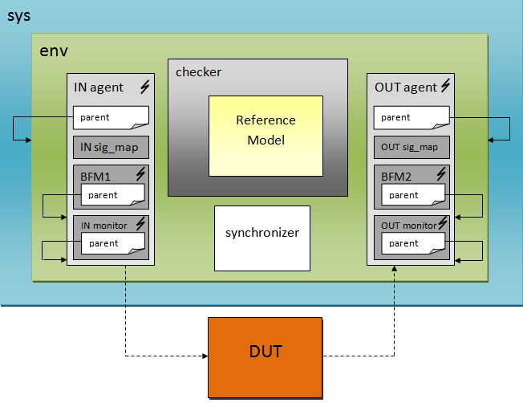
Figure 3 – Block Diagram of the Testbench.
  - Partitioning

Not applicable. The Ports module can be verified without subdivisions.

  - Global Routines

Not applicable. Global routines were not defined yet.

  - External Interface Functions

Not applicable. External interface functions and calls were not defined yet.

  - Memory Map

Not applicable. Memory is not used in Ports block.

  - Verification and Debug Registers

Not applicable. Debug registers were not defined yet.

  - Clocking

The Ports block is a combinational block, so it has no clock.

  - Reset

Due to the block ports do not have clock, it also will not have the reset pin.

  - Termination

With the end of the simulation will be generated reports and log files that show all the simulation results, and from these results the verification process will be analyzed. From this analysis will be possible to measure the quality, coverage and effectiveness of the verification process as a whole, concluding that the process was successful.

- Drivers and Monitors

Not applicable. This entire section will be defined later, during verification codification.

  - Driver and Monitor Overview

N.A.

  - <Driver/Monitor X> Description

N.A.

    - <Driver/Monitor X> Functional Overview

N.A.

    - <Driver/Monitor X> Commands

N.A.

    - <Driver/Monitor X> Arguments

N.A.

    - <Driver/Monitor X> Configuration

N.A.

- Models

The Ports block does not use memories, IOs and PADs. However, a Functional Model is used to reproduce DUT behavior and to calculate expected answers.

  - Functional Models

A reference model is used in this verification environment reproduce DUT behavior and to calculate expected answers. Data Checker receives the inputs from IN Monitor and sends to Reference Model that calculates the expected results. So, Data Checker compares these results with DUT outputs. Figure 2, previously presented, shows the flow diagram of Data Checker and Reference Model.

  - Memory Models

Just Core it will use.

  - Stub Models

It will be explained in the future.

  - IO and PADs

Just top it will use.

- Additional Information

N.A.

