Serial
Verification Guide

Version #: 0.2
Revision date: 08 12, 2010

Version Control
Revision | Authors | Date | Comments
0.1 | Inácio Mendonça / Eloi Magalhães | 16/Aug/2010 | Initial Version

Table of Contents

Serial 5
1. Introduction 5
1.1 Verification Strategy 5
1.2 Verification Flow 5
1.3 Random Simulation 6
2. References 6
3. Verification Plan 7
3.1 Design Details 7
3.2 Feature List 7
3.3 Verification List 8
3.4 Serial Feature 1 8
3.4.1 Verification Steps for EMC.SERIAL.F1.V1 9
3.4.2 Verification Steps for EMC.SERIAL.F1.V2 9
3.5 Serial Feature 2 9
3.5.1 Verification Steps for EMC.SERIAL.F2.V1 9
3.5.2 Verification Steps for EMC.SERIAL.F2.V2 9
3.6 Serial Feature 3 9
3.6.1 Verification Steps for EMC.SERIAL.F3.V1 9
3.7 Serial Feature 4 9
3.7.1 Verification Steps for EMC.SERIAL.F4.V1 10
4. Testbench 10
4.1 Testbench Overview 10
4.2 Partitioning 10
4.3 Global Routines 10
4.4 External Interface Functions 11
4.5 Memory Map 11
4.6 Verification and Debug Registers 11
4.7 Clocking 11
4.8 Reset 11
4.9 Termination 11
5. Drivers and Monitors 11
5.1 Driver and Monitor Overview 12
5.2 <Driver/Monitor X> Description 12
5.2.1 <Driver/Monitor X> Functional Overview 12
5.2.2 <Driver/Monitor X> Commands 12
5.2.3 <Driver/Monitor X> Arguments 12
5.2.4 <Driver/Monitor X> Configuration 12
6. Models 13
6.1 Functional Models 13
6.2 Memory Models 13
6.3 Stub Models 13
6.4 IO and PADs 13
7. Additional Information 13

Serial

- Introduction

This document provides a guideline about verification of block Serial for EMC08 project. The next sections show the detailed plan and strategy to do the verification. First, some sections introduce the strategy used. Finally, the detailed block verification plan is shown.

  - Verification Strategy

The methodology used is the eRM (e Reuse Methodology) that provides a template for partitioning the environment. This way, a common environment is adapted to each module. This strategy codifies the best practice for developing e-based verification and ensures consistency, reusability and extensibility.

  - Verification Flow

The DUT (Design Under Test) is the block that we want to verify. The following figure illustrates the diagram of verification flow.

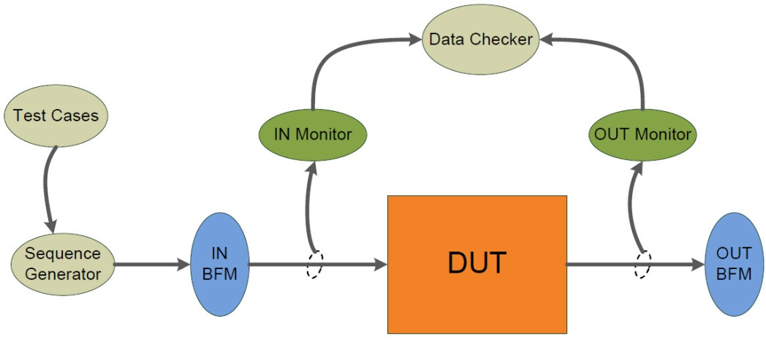
Figure 1 - Verification Flow Block Diagram
The DUT receives stimulus from input BFM (Bus Functional Model) and sends outputs to output BFM. These stimulus are generated by Sequence Generator according to whished Testcase that can control the order of sequences, types of stimulus, number of repetitions and so on. There are two monitors that sample input and output DUT signals. They are passive units that do not change the values of signals. Monitors send sampled signals to Data Checker that compares DUT outputs with expected answers and gives a DUT error if it doesn’t mismatch.
The following figure shows the verification flow inside Data Checker sub-block. A reference model receives the inputs from IN Monitor, calculates the expected results and compares these results with DUT outputs, send to Data Checker by OUT Monitor. So, Data Checker compares DUT’s results with expected results from reference model and creates illegal buckets when they mismatch. The illegal buckets generate a DUT error.

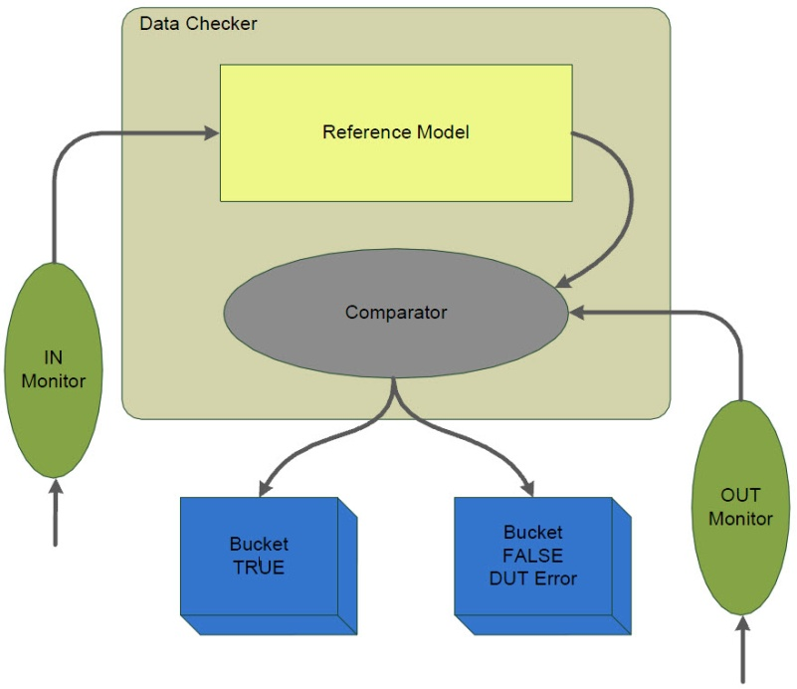
Figure 2 – Data Checker model

  - Random Simulation

The test will not be randomly, only the data bits that compose a package to be serially sent will be generated, the control bits will added in the features for every operation mode, in other words, each mode will have a feature that generates a determined amount of tests for that mode.

- References

The references used for this documentation are:
- EMC08 project – Serial Block Guide, version 0.1
- Cadence. "Specman® Elite Basics for Verification Environment Developers." Lecture Manual, 2007.

- Verification Plan

The Verification Plan describes the verification process that will be followed to verify Serial block. It details a list of required verifications that must be accomplished to validate the design specification.

  - Design Details

This section describes basic details about verification plan and the design that will be verified. The Table 1 gives this information.

Component | Feature Description
Document Name | Serial Verification Plan
Verification Methodology | Top-Down
Verification Methods | Simulation
Simulation Components
Application | Cadence Specman® Elite Version 6.1
Language | e language
Testcase file | EMC08/Serial/verification/testbench/emc_test*.e
Bus Functional Model | EMC08/Serial/verification/testbench/emc_bfm.e
Table 1 – Design Details
  - Feature List

The Table 2, shown below, lists the critical features of design that must be verified, including a description of the expected functional and the priority of each feature.

Feature Number | Feature Description | Testing Priority
EMC.SERIAL.F1 | In operation mode 0, the serial port must work synchronously sending the clock through the port TXD and also sending and receiving data through the port RXD. | 10
EMC. SERIAL.F2 | In operation mode 2, the serial port must work asynchronously sending packages to the input of RXD and TXD. | 10
EMC. SERIAL.F3 | The 9th transmission bit in mode 2 of operation must be equal to the bit SCON.3 in transmission and to the bit SCON.2 in reception. | 10
EMC. SERIAL.F4 | In both modes of operations, the serial port generates 2 flags of interruption, one in transmission and other in reception. | 10
Table 2 – Feature List

  - Verification List

The verification list, described on Table 3, defines how the features (on Table 2) will be verified. This list contains all verifications that must be run to verify expected features.

Verif. Number | Description | Method | Level | Features Verified | Priority | Owner | Completion
EMC.SERIAL.F1.V1 | Stimulate the input Rx with data packets corresponding to the mode 0 operation to verify that the data was correctly received synchronously from port RXD. | Simulation | Unit | EMC.SERIAL.F1 | 10 | Inacio | 0%
EMC.SERIAL.F1.V2 | Stimulate the input Rx with data packets corresponding to the mode 0 operation and check if the shift clock is transmitted in port TXD. | Simulation | Unit | EMC.SERIAL.F1 | 10 | Inacio | 0%
EMC.SERIAL.F2.V1 | Stimulate the input Rx with data packets corresponding to the mode 2 operation to verify that the data was correctly received asynchronously from port RXD. | Simulation | Unit | EMC.SERIAL.F2 | 10 | Eloi | 0%
EMC.SERIAL.F2.V2 | Stimulate the input Tx with data packets corresponding to the mode 2 operation to verify that the data was correctly received asynchronously from port TXD. | Simulation | Unit | EMC.SERIAL.F2 | 10 | Eloi | 0%
EMC.SERIAL.F3.V1 | Generate the package with the 9th bit equal to SCON.3 to transmmit. Check the SBUF output if it is equal to SCON.2 in reception. | Simulation | Unit | EMC.SERIAL.F3 | 10 | Eloi | 0%
EMC.SERIAL.F4.V4 | Check if the bits were correctly interrupt generated by serial block. | Simulation | Unit | EMC.SERIAL.F4 | 10 | Inacio | 0%
Table 3 – Verification List

  - Serial Feature 1

In operation mode 0, the serial port must work synchronously sending the clock through the port TXD and also sending and receiving data through the port RXD.
    - Verification Steps for EMC.SERIAL.F1.V1
Stimulate the Rx input with data packets corresponding to the mode 0 operation to verify that the data was correctly received synchronously from port RXD. The implementation of this task is performed by sending packets generated by testcases features.
    - Verification Steps for EMC.SERIAL.F1.V2
Stimulate the input RXD with data packets corresponding to the mode 0 operation and check if the shift clock is transmitted in port TXD.
  - Serial Feature 2
In operation mode 2, the serial port must work asynchronously sending packages to the input of RXD and TXD.
    - Verification Steps for EMC.SERIAL.F2.V1
Stimulate the input Rx with data packets corresponding to the mode 2 operation to verify that the data was correctly received asynchronously from port RXD
    - Verification Steps for EMC.SERIAL.F2.V2
Stimulate the input Tx with data packets corresponding to the mode 2 operation to verify that the data was correctly received asynchronously from port TXD.
  - Serial Feature 3
The 9th transmission bit in mode 2 of operation must be equal to the bit SCON.3 in transmission and to the bit SCON.2 in reception.
    - Verification Steps for EMC.SERIAL.F3.V1
Generate the package with the 9th bit equal to SCON.3 to transmmit. Check the SBUF output if it is equal to SCON.2 in reception.
  - Serial Feature 4
In both modes of operations, the serial port generates 2 flags of interruption, one in transmission and other in reception.

    - Verification Steps for EMC.SERIAL.F4.V1
Check if the bits were correctly interrupt generated by serial block.

- Testbench

The testbench will be created to generate stimulus for all input signals, clock, baud rate, Rx, Tx, reset, SFR's, and verify the behavior of the block into output. Packets are generated random data and supplemented with the configuration bits to cover all modes of operation.

  - Testbench Overview

The following diagram illustrates a top-level view of testbench environment. This diagram shows the relationships of DUT, agents, monitors, BFMs and other models. A more complete description of these modules will be available in future versions of this document.

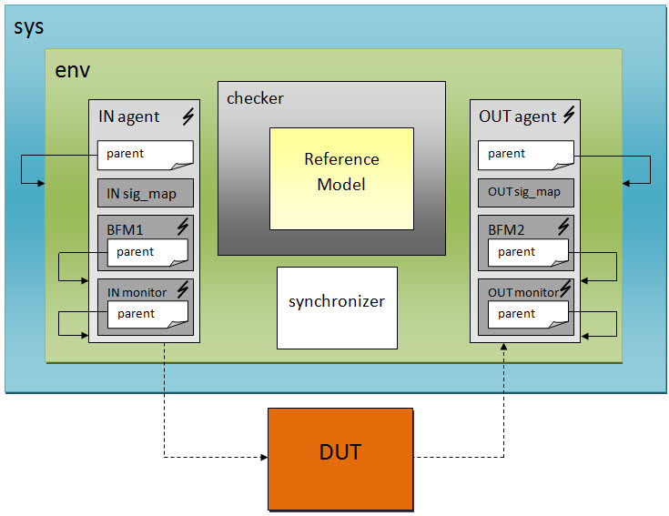
Figure 3 – Block diagram of the testbench

  - Partitioning

Not applicable. The interrupt module can be verified without subdivisions.
  - Global Routines

Not applicable. Global routines were not defined yet..
Table 1 – Global Routines
Global Routine | Parameter | Description

  - External Interface Functions

Not applicable. External interface functions and calls were not defined yet.

  - Memory Map

Not applicable.

Table 2 – Testbench Memory Map
Address | Testbench Routine

  - Verification and Debug Registers

Not applicable. Debug registers were not defined yet.

  - Clocking

Not applicable. It was not defined how many clock domains we will use.

  - Reset

Not applicable. It was not defined types of reset.

  - Termination

With the end of the simulation will be generated reports and log files that show all the simulation results, and from these results the verification process will be analyzed. From this analysis will be possible to measure the quality, coverage and effectiveness of the verification process as a whole, concluding that the process was successful.

- Drivers and Monitors

This entire section will be defined later, during verification codification.

  - Driver and Monitor Overview

  - <Driver/Monitor X> Description

    - <Driver/Monitor X> Functional Overview

    - <Driver/Monitor X> Commands

Table 3 – Interface Monitor Commands
Command | Arguments | Description

    - <Driver/Monitor X> Arguments

Table 4 – Interface Driver Arguments
Argument | Range | Direction | Description

Table 5 – Interface Monitor Arguments
Argument | Range | Direction | Description

    - <Driver/Monitor X> Configuration

Table 6 - Configurations
Configuration Description | Implementation | Configuration Selection Method

- Models

The Serial block does not use memories, IOs and PADs. However, a Functional Model is used to reproduce DUT behavior and to calculate expected answers.
  - Functional Models

Not applicable. Functional model was not defined yet

  - Memory Models

Not applicable. Memory is not used in Serial block.

  - Stub Models

Not applicable. Stub Models are not necessary for this block.

  - IO and PADs

Not applicable. IO and PADs are not used in Serial block.

- Additional Information

No additional information is needed in this version.

