Timer
Verification Guide

Version #: 1.0
Revision date: AUG 16, 2010

Version Control
Revision | Authors | Date | Comments
1.0 | Hugo Kakisaka  Marcelo Mamoru Ono | 16/Aug/2010 | Initial Beta Version
- | - | - | -
- | - | - | -

Table of Contents

TIMER 6
1. Introduction 6
1.1 Verification Strategy 6
1.2 Verification Flow 6
1.3 Random Simulation 7
2. References 7
3. Verification Plan 8
3.1 Timer 0 / Timer 1 / Timer 2 Description 8
3.2 Design Details 8
3.3 Feature List 9
3.4 Verification List 10
3.5 Timer 0 Feature 1 Description 14
3.5.1 Verification Steps for F1.V1 14
3.6 Timer 0 Feature 2 Description 14
3.6.1 Verification Steps for F2.V1 14
3.6.2 Verification Steps for F2.V2 14
3.7 Timer 0 Feature 3 Description 14
3.7.1 Verification Steps for F3.V1 14
3.7.2 Verification Steps for F3.V2 15
3.7.3 Verification Steps for F3.V3 15
3.8 Timer 0 Feature 4 Description 15
3.8.1 Verification Steps for F4.V1 15
3.8.2 Verification Steps for F4.V2 15
3.9 Timer 0 Feature 5 Description 15
3.9.1 Verification Steps for F5.V1 15
3.9.2 Verification Steps for F5.V2 16
3.10 Timer 1 Feature 1 Description 16
3.10.1 Verification Steps for F1.V1 16
3.11 Timer 1 Feature 2 Description 16
3.11.1 Verification Steps for F2.V1 16
3.11.2 Verification Steps for F2.V2 16
3.12 Timer 1 Feature 3 Description 16
3.12.1 Verification Steps for F3.V1 17
3.12.2 Verification Steps for F3.V2 17
3.12.3 Verification Steps for F3.V3 17
3.13 Timer 1 Feature 4 Description 17
3.13.1 Verification Steps for F4.V1 17
3.13.2 Verification Steps for F4.V2 17
3.14 Timer 1 Feature 5 Description 17
3.14.1 Verification Steps for F5.V1 18
3.14.2 Verification Steps for F5.V2 18
3.15 Timer 2 Feature 1 Description 18
3.15.1 Verification Steps for F1.V1 18
3.16 Timer 2 Feature 2 Description 18
3.16.1 Verification Steps for F2.V1 18
3.16.2 Verification Steps for F2.V2 18
3.17 Timer 2 Feature 3 Description 19
3.17.1 Verification Steps for F3.V1 19
3.18 Timer 2 Feature 4 Description 19
3.18.1 Verification Steps for F4.V1 19
3.18.2 Verification Steps for F4.V2 19
3.19 Timer 2 Feature 5 Description 19
3.19.1 Verification Steps for F5.V1 19
3.19.2 Verification Steps for F5.V2 20
3.20 Timer 2 Feature 6 Description 20
3.20.1 Verification Steps for F6.V1 20
4. Testbench 20
4.1 Testbench Overview 20
4.2 Partitioning 21
4.3 Global Routines 21
4.4 External Interface Functions 21
4.5 Memory Map 21
4.6 Verification and Debug Registers 21
4.7 Clocking 22
4.8 Reset 22
4.9 Termination 22
5. Drivers and Monitors 22
5.1Driver and Monitor Overview 22
5.2 <Driver/Monitor X> Description 22
5.3 <Driver/Monitor X> Functional Overview 22
5.4 <Driver/Monitor X> Commands 22
5.5 <Driver/Monitor X> Arguments 22
5.6 <Driver/Monitor X> Configuration 22
6. Models 22
6.1 Functional Models 22
6.2 Memory Models 23
6.3 Stub Models 23
6.4 IO and PADs 23
7. Additional Information 23

TIMER

- Introduction

This document provides a guideline about verification of TIMER block for EMC08 project. The next sections show the detailed plan and verification strategy. First, some sections introduce the strategy used. Finally, the detailed block verification plan is shown.

1.1 Verification Strategy

The methodology used is the eRM (e Reuse Methodology) that provides a template for partitioning the environment. This way, a common environment is adopted to each module. This strategy codifies the best practice for developing e-based verification and ensures consistency, reusability and extensibility.

  - Verification Flow

The DUT (Design Under Test) is the block that we want to verify. The following figure illustrates the diagram of verification flow.

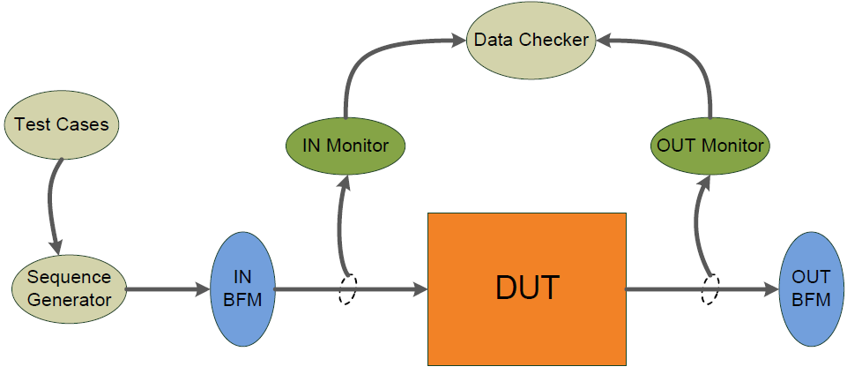
Figure 1 - Verification Flow Block Diagram
The DUT receives stimulus from input BFM (Bus Functional Model) and sends stimulus to BFM’s output. These stimulus are generated by Sequence Generator according to desired Testcase which can control the order of sequences, types of stimulus, number of repetitions and so on. There are two monitors that sample input and output DUT signals. They are passive units that do not change the values of signals. Monitors send sampled signals to Data Checker that compares DUT outputs with expected answers and gives a DUT error if it doesn’t mismatch. The following figure shows the verification flow inside Data Checker sub-block. A reference model receives the inputs from IN Monitor, calculates the expected results and compares these results with DUT outputs, send to Data Checker by OUT Monitor. So, Data Checker compares DUT’s results with expected results from reference model and creates illegal buckets when they mismatch. The illegal buckets generate a DUT error.

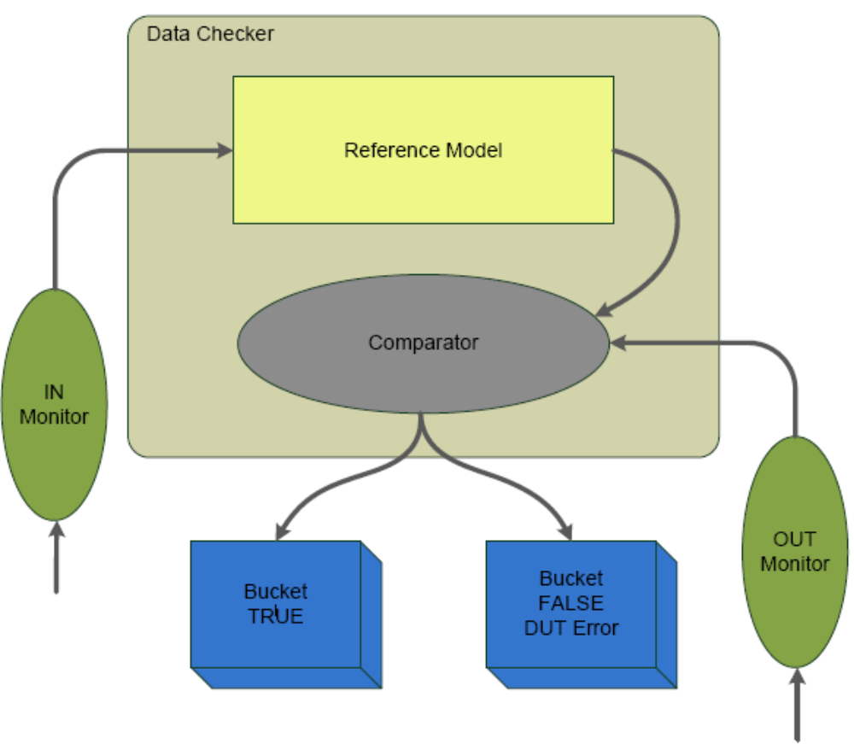
Figure 2 – Data Checker model
1.3 Random Simulation

For TIMER block, random stimulus can be utilized to set a value on counter registers (THX,TMX,TLX).
This random value stimulates the DUT and the same value will be computed on reference model, to calculate the expected DUT’s registers output.

- References

The references used for this documentation are:
- EMC08 project - TIMER Block Guide, version 0.1
- Cadence. "Specman® Elite Basics for Verification Environment Developers." Lecture Manual, 2007.

- Verification Plan

The Verification Plan describes the verification process that will be utilized to verify TIMER block. It details a list of required verifications steps which must be executed to validate the design specification.

  - Timer 0 / Timer 1 / Timer 2 Description

Timer 0 and Timer 1 are 24 bit counter register incremented every machine cycle. Since a machine cycle consists of 1 oscillator period, the count rate is 1/N of the oscillator frequency.
Timers 0 and 1 have two operating modes which are selected by bit-pairs (M1, MO) in TMOD.
These modes are UP COUNTER and DOWN COUNTER.
Setting GATE = 1 allows the Timer to be controlled by external input INTX, to facilitate pulse width measurements.TRX is a control bit which starts/stops timer counting.

Timer 2 is a special 24 bit counter register module, composed by the following sub-blocks:

- Synchronizer – SYNC
- Prescaler Digital Clock Filter – PDCF
- Programmable Digital Filter – PDF
- Digital Filter Selection – DFS
- Edge Detector – ED
- Angle Clock Generator – ACG
- Angle Counter Register – ACR

The following sections describes the specifics tests for all those modules.

3.2 Design Details

This section describes basic details about verification plan and the verified design. Table 1 gives this information.

Component | Feature Description
Document Name | TIMER Verification Plan
Verification Methodology | Bottom-up
Verification Methods | Simulation
Simulation Components
Application | Cadence Specman® Elite Version 6.1
Language | e language
Testcase file | EMC08/TIMER/verification/testbench/emc_test*.e
Bus Functional Model | EMC08/TIMER/verification/testbench/emc_bfm.e
Table 1 – Design Details

3.3 Feature List

Table 2, lists the critical features of design which must be verified, including a description of the expected functional and priority of each feature.

Feature Number | Feature Description | Priority
EMC.Timers.Timer_0.F1 | When reset is asserted all internal registers must initialize in a known value. | 10
EMC.Timers.Timer_0.F2 | When bit TR0=0 Timer-Counter is in stop mode  When bit TR0=1 Timer-Counter is in run mode | 9
EMC.Timers.Timer_0.F3 | When bits M[1:0] =00 Timer-Counter is in up-counting mode.  When bits M[1:0] =11 Timer-Counter is in down-counting mode.  When bits M[1:0] =01 or M[1:0] =10 Timer-Counter is in stop mode. | 8
EMC.Timers.Timer_0.F4 | When Timer-Counter rolls-over from FFFFFF H to 000000 H or from 000000 H to FFFFFF H TF0 bit must be set at logic level 1. | 7
EMC.Timers.Timer_0.F5 | When GATE=1, external source counter functionality must be activated. | 6
- | - | -

Table 2 – Timer 0 Feature List

Feature Number | Feature Description | Priority
EMC.Timers.Timer_1.F1 | When reset is asserted all internal registers must initialize in a known value. | 10
EMC.Timers.Timer_1.F2 | When bit TR1=0 Timer-Counter is in stop mode  When bit TR1=1 Timer-Counter is in run mode | 9
EMC.Timers.Timer_1.F3 | When bits M[1:0] =00 Timer-Counter is in up-counting mode.  When bits M[1:0] =11 Timer-Counter is in down-counting mode.  When bits M[1:0] =01 or M[1:0] =10 Timer-Counter is in stop mode. | 8
EMC.Timers.Timer_1.F4 | When Timer-Counter rolls-over from FFFFFF H to 000000 H or from 000000 H to FFFFFF H TF1 bit must be set at logic level 1. | 7
EMC.Timers.Timer_1.F5 | When GATE=1, external source counter functionality must be activated. | 6
- | - | -

Table 3 – Timer 1 Feature List

Feature Number | Feature Description | Priority
EMC.Timers.Timer_2.F1 | When reset is asserted all internal registers must initialize in a known value. | 10
EMC.Timers.Timer_2.F2 | When bit TR2=0 Timer-Counter is in stop mode  When bit TR2=1 Timer-Counter is in run mode | 9
EMC.Timers.Timer_2.F3 | When Timer-Counter rolls-over from FFFFFF H to 000000 H, TF2 bit must be set at logic level 1. | 9
EMC.Timers.Timer_2.F4 | When bit EDGSEL=0, select fall edge  When bit EDGSEL=1, select rise edge | 8
EMC.Timers.Timer_2.F5 | When bit DFSEL=0, filter uses 2 samples mode  When bit DFSEL=1, filter uses 3 samples mode | 8
EMC.Timers.Timer_2.F6 | When bit DFP[4:2]=000, prescaler rate equal to 1:1  When bit DFP[4:2]=001, prescaler rate equal to 1:2  When bit DFP[4:2]=010, prescaler rate equal to 1:4  When bit DFP[4:2]=011, prescaler rate equal to 1:8  When bit DFP[4:2]=100, prescaler rate equal to 1:16  When bit DFP[4:2]=101, prescaler rate equal to 1:32  When bit DFP[4:2]=110, prescaler rate equal to 1:64  When bit DFP[4:2]=111, prescaler rate equal to 1:128 | 8
- | - | -

Table 4 – Timer 2 Feature List

3.4 Verification List

The verification list, defines how the features will be verified. This list contains all verifications that must be run to verify expected features.

Verif. Number | Description | Method |  | Level | Features Verified | Prio  rity | Owner | Completion
TIMER 0
EMC.Timers.Timer_0.F1.V1 | Assert Reset input and verify if Timer 0 module initializes correctly. |  | Simulation | Unit | EMC.Timers.Timer_0.F1 | 10 | Hugo  Marcelo | 0 %
EMC.Timers.Timer_0.F2.V1 | Set TR0 bit at logic level 0 , set TH0,TM0 and TL0 registers at 000000H, pulse CLK input at 1/N machine cycle rate. Verify if values on registers TH0,TM0 and TL0 remains the same after clock pulses. |  | Simulation | Unit | EMC.Timers.Timer_0.F2 | 9 | Hugo  Marcelo | 0 %
EMC.Timers.Timer_0.F2.V2 | Set TR0 bit at logic level 1 , set TH0,TM0 and TL0 registers at 000000H, pulse CLK input. Verify if registers T0,TM0 and TL0 increment or decrement ( depending of M1,M0 bits) at 1/N rate ( N = clocks /machine cycle). |  | Simulation | Unit | EMC.Timers.Timer_0.F2 | 9 | Hugo  Marcelo | 0 %
EMC.Timers.Timer_0.F3.V1 | Set UP COUNTER mode (M[1:0]=00), set TH0,TM0 and TL0 registers at a known value (000000H for example), assert 24 clock pulses. Verify if the value at registers is 000002H. (Assuming a N = 12 clocks /machine cycle). |  | Simulation | Unit | EMC.Timers.Timer_0.F3 | 8 | Hugo  Marcelo | 0 %
EMC.Timers.Timer_0.F3.V2 | Set reserved mode (M[1:0]=01 or M[1:0]=10). Verify if Timer 0  remains stopped, or stop immediately if running previously. |  | Simulation | Unit | EMC.Timers.Timer_0.F3 | 8 | Hugo  Marcelo | 0 %
EMC.Timers.Timer_0.F4.V1 | Set TF0 flag at logic level 0, set TH0,TM0 and TL0 registers at a known value (FFFF88H for example). Set UP counter mode. Assuming 12 clocks/machine cycle, we expect TF0 flag will be set at logic level 1, 1440 clock pulses after TR0 bit is set to logic level 1 ( timer starts counting ). |  | Simulation | Unit | EMC.Timers.Timer_0.F4 | 7 | Hugo  Marcelo | 0 %
EMC.Timers.Timer_0.F5.V1 | Set TR0 bit at logic level 1, set TH0,TM0 and TL0 registers at 000000H, set GATE bit at logic level 1, set INT0 pin at logic level 1 and hold it for 1440 clock pulses, after that ,set INT0 pin at logic level 0 and checks if registers value is 000078H. |  | Simulation | Unit | EMC.Timers.Timer_0.F5 | 6 | Hugo  Marcelo | 0 %

Table 4 – Timer 0 Verification List

Verif. Number | Description | Method |  | Level | Features Verified | Prio  rity | Owner | Completion
TIMER 1
EMC.Timers.Timer_1.F1.V1 | Assert Reset input and verify if Timer 1 module initializes correctly. |  | Simulation | Unit | EMC.Timers.Timer_1.F1 | 10 | Hugo  Marcelo | 0 %
EMC.Timers.Timer_1.F2.V1 | Set TR1 bit at logic level 0 , set TH1,TM1 and TL1 registers at 000000H, pulse CLK input at 1/N machine cycle rate. Verify if values on registers TH1,TM1 and TL1 remains the same after clock pulses. |  | Simulation | Unit | EMC.Timers.Timer_1.F2 | 9 | Hugo  Marcelo | 0 %
EMC.Timers.Timer_1.F2.V2 | Set TR1 bit at logic level 1 , set TH1,TM1 and TL1 registers at 000000H, pulse CLK input. Verify if registers TH1,TM1 and TL1 increment or decrement ( depending of M1,M0 bits) at 1/N rate ( N = clocks /machine cycle). |  | Simulation | Unit | EMC.Timers.Timer_1.F2 | 9 | Hugo  Marcelo | 0 %
EMC.Timers.Timer_1.F3.V1 | Set UP COUNTER mode (M[1:0]=00), set TH1,TM1 and TL1 registers at a known value (000000H for example), assert 24 clock pulses. Verify if the value at registers is 000002H. (Assuming a N = 12 clocks /machine cycle). |  | Simulation | Unit | EMC.Timers.Timer_1.F3 | 8 | Hugo  Marcelo | 0 %
EMC.Timers.Timer_1.F3.V2 | Set reserved mode (M[1:0]=01 or M[1:0]=10). Verify if Timer 0  remains stopped, or stop immediately if running previously. |  | Simulation | Unit | EMC.Timers.Timer_1.F3 | 8 | Hugo  Marcelo | 0 %
EMC.Timers.Timer_1.F4.V1 | Set TF1 flag at logic level 0, set TH1,TM1 and TL1 registers at a known value (FFFF88H for example). Set UP counter mode. Assuming 12 clocks/machine cycle, we expect TF0 flag will be set at logic level 1, 1440 clock pulses after TR1 bit is set to logic level 1 ( timer starts counting ). |  | Simulation | Unit | EMC.Timers.Timer_1.F4 | 7 | Hugo  Marcelo | 0 %
EMC.Timers.Timer_1.F5.V1 | Set TR1 bit at logic level 1, set TH1,TM1 and TL1 registers at 000000H, set GATE bit at logic level 1, set INT1 pin at logic level 1 and hold it for 1440 clock pulses, after that ,set INT1 pin at logic level 0 and checks if registers value is 000078H. |  | Simulation | Unit | EMC.Timers.Timer_1.F5 | 6 | Hugo  Marcelo | 0 %

Table 5 – Timer 1 Verification List

Verif. Number | Description | Method |  | Level | Features Verified | Prio  rity | Owner | Completion
TIMER 2
EMC.Timers.Timer_2.F1.V1 | Assert Reset input and verify if Timer 2 module initializes correctly. |  | Simulation | Unit | EMC.Timers.Timer_2.F1 | 10 | Hugo  Marcelo | 0 %
EMC.Timers.Timer_2.F2.V1 | Set TR2 bit at logic level 0 , set ACR register at 000000H, pulse SENSOR input at 1/N machine cycle rate. Verify if values on ACR register remains the same after SENSOR pulses. |  | Simulation | Unit | EMC.Timers.Timer_2.F2 | 9 | Hugo  Marcelo | 0 %
EMC.Timers.Timer_2.F2.V2 | Set TR2 bit at logic level 1 , set ACR register at 000000H, pulse SENSOR input. Verify if ACR register increment (refers to angle clock generator algorithm). |  | Simulation | Unit | EMC.Timers.Timer_2.F2 | 9 | Hugo  Marcelo | 0 %
EMC.Timers.Timer_2.F3.V1 | Set TF2 flag at logic level 0, set ACR registers at a known value (FFFF88H for example). We expect TF2 flag will be set at logic level 1, according to angle clock generator algorithm). |  | Simulation | Unit | EMC.Timers.Timer_2.F3 | 8 | Hugo  Marcelo | 0 %
EMC.Timers.Timer_2.F4.V1 | Set EDGSEL bit at logic level 0. Pulse SENSOR input. Verify if ACR register increment according selected edge and angle clock generator algorithm. |  | Simulation | Unit | EMC.Timers.Timer_2.F4 | 8 | Hugo  Marcelo | 0 %
EMC.Timers.Timer_2.F4.V2 | Set EDGSEL bit at logic level 1. Pulse SENSOR input. Verify if ACR register increment according selected edge and angle clock generator algorithm. |  | Simulation | Unit | EMC.Timers.Timer_2.F4 | 8 | Hugo  Marcelo | 0 %
EMC.Timers.Timer_2.F5.V1 | Set DFSEL bit at logic level 0. Generate a pulse at SENSOR input. Verify if ACR register increment according selected edge and angle clock generator algorithm. |  | Simulation | Unit | EMC.Timers.Timer_2.F5 | 8 | Hugo  Marcelo | 0 %
EMC.Timers.Timer_2.F5.V2 | Set DFSEL bit at logic level 1. Generate a pulse at SENSOR input. Verify if ACR register increment according selected edge and angle clock generator algorithm. |  | Simulation | Unit | EMC.Timers.Timer_2.F5 | 8 | Hugo  Marcelo | 0 %
EMC.Timers.Timer_2.F6.V1 | Generate stimulus on DFP[4:2] bits. Generate a pulse at SENSOR input. Verify if ACR register increments according selected prescaler rate and angle clock generator algorithm. |  | Simulation | Unit | EMC.Timers.Timer_2.F5 | 8 | Hugo  Marcelo | 0 %

Table 6 – Timer 2 Verification List

3.5 Timer 0 Feature 1 Description

There are internal registers at Timer 0 module. To Timer 0 work properly, these registers must be correctly initialized.

3.5.1 Verification Steps for F1.V1

Assert Reset input at logic level 0, hold it for 1 CM , set Reset input at logic level 1 and verify if Timer 0 module initializes correctly.

3.6 Timer 0 Feature 2 Description

Bit TR0 controls if Timer 0 is in counting or stopped mode. When TR0=0, timer-counter is in stopped mode. When TR0=1, timer-counter is in running mode.

3.6.1 Verification Steps for F2.V1
Bit TR0 is set at logic level 0. TH0, TM0 and TL0 are loaded with a known value. Clock pulses are injected at CLK input. Assuming a N = 1 CM/12 clock cycle, TH0, TM0 and TL0 registers are observed. When TR0 = 0, registers can’t increment their values.

3.6.2 Verification Steps for F2.V2
Bit TR0 is set at logic level 1. TH0, TM0 and TL0 are loaded with a known value. Clock pulses are injected at CLK input. Assuming a N = 1 CM/12 clock cycle, TH0, TM0 and TL0 registers are observed. When TR0 = 1, registers must have to increment their values at N rate.

3.7 Timer 0 Feature 3 Description

Bits M[1:0] controls if Timer 0 works in up counting or down counting mode. When M[1:0] = 00 timer is in up-counting mode. When M[1:0] = 11 timer is in down-counting mode. When M[1:0] = 01 or M[1:0] = 10 Timer 0 changes to stop mode.

3.7.1 Verification Steps for F3.V1

Set bits M[1:0]=00. TH0, TM0 and TL0 are loaded with a known value. Set bit TR0 = 1. Assuming a N = 1 CM/12 clock cycle, clock pulses are injected at CLK input. TH0, TM0 and TL0 registers are observed. TH0, TM0 and TL0 registers must have to increment their values at N rate.

3.7.2 Verification Steps for F3.V2

Set bits M[1:0]=11. TH0, TM0 and TL0 are loaded with a known value. Set bit TR0 = 1. Assuming a N = 1 CM/12 clock cycle, clock pulses are injected at CLK input. TH0, TM0 and TL0 registers are observed. TH0, TM0 and TL0 registers must have to decrement their values at N rate.

3.7.3 Verification Steps for F3.V3

A random sequence for M[1:0] is generated. TH0, TM0 and TL0 are loaded with a known value. Set bit TR0 = 1. Assuming a N = 1 CM/12 clock cycle, clock pulses are injected at CLK input. TH0, TM0 and TL0 registers are observed. Since M[1:0] bits changes their values to M[1:0]=01 or M[1:0]=10, TH0, TM0 and TL0 registers can’t increment their values.

3.8 Timer 0 Feature 4 Description

TF0 bit is set when there is a counter overflow. Every time counter rolls-over from FFFFFF H to 000000 H, TF0 bit is set. TF0 bit remains on logic level 1 till it will be cleared by hardware (through an interrupt routine execution) or software.

3.8.1 Verification Steps for F4.V1

Set bit TF0=0. Set bits M[1:0]=00, for up counting mode. TH0, TM0 and TL0 are loaded with a random known value. Set bit TR0 = 1. Assuming a N = 1 CM/12 clock cycle, clock pulses are injected at CLK input. TF0 flag is observed. We expect TF0 flag will be set at logic level 1 in a proportional clock pulse rate N when counter rolls-over from FFFFFF H to 000000 H.

3.8.2 Verification Steps for F4.V2

Set bit TF0=0. Set bits M[1:0]=11, for down counting mode. TH0, TM0 and TL0 are loaded with a random known value. Set bit TR0 = 1. Assuming a N = 1 CM/12 clock cycle , clock pulses are injected at CLK input. TF0 flag is observed. We expect TF0 flag will be set at logic level 1 in a proportional clock pulse rate N when counter rolls-over from 000000 H to FFFFFF H.

3.9 Timer 0 Feature 5 Description

Timer 0 allows external pulse width measurement, through external input /INT0, when GATE=1 and TR0=1.

3.9.1 Verification Steps for F5.V1

Set bit GATE=1. Set bit TF0=0. Set bits M[1:0]=00, for up counting mode. TH0, TM0 and TL0 are loaded with a random known value. Set bit TR0 = 1. Assuming a N = 1 CM/12 clock cycle , clock pulses are injected at CLK input. Well known stimulus must be injected at /INT0 input. TH0, TM0 and TL0 and TF0 flag can be observed. We expect TF0 flag will be set at logic level 1 in a proportional clock pulse rate N, controlled by external stimulus at /INT0 input, when counter rolls-over from FFFFFF H to 000000 H.

3.9.2 Verification Steps for F5.V2

Set bit GATE=1. Set bit TF0=0. Set bits M[1:0]=11, for down counting mode. TH0, TM0 and TL0 are loaded with a random known value. Set bit TR0 = 1. Assuming a N = 1 CM/12 clock cycle , clock pulses are injected at CLK input. Well known stimulus must be injected at /INT0 input. TH0, TM0 and TL0 and TF0 flag can be observed. We expect TF0 flag will be set at logic level 1 in a proportional clock pulse rate N, controlled by external stimulus at /INT0 input, when counter rolls-over from 000000 H to FFFFFF H.

3.10 Timer 1 Feature 1 Description

There are internal registers inside Timer 1 module. To work properly, these registers must be correctly initialized.

3.10.1 Verification Steps for F1.V1

Assert Reset input at logic level 0, hold it for 1 CM , set Reset input at logic level 1 and verify if Timer 1 module initializes correctly.

3.11 Timer 1 Feature 2 Description

Bit TR1 controls if Timer 0 is in counting or stopped mode. When TR1=0, timer-counter is in stopped mode. When TR1=1, timer-counter is in running mode.

3.11.1 Verification Steps for F2.V1
Bit TR1 is set at logic level 0. TH1, TM1 and TL1 are loaded with a known value. Clock pulses are injected at CLK input. Assuming a N = 1 CM/12 clock cycle , TH1, TM1 and TL1 registers are observed. When TR1 = 0, registers can’t increment their values.

3.11.2 Verification Steps for F2.V2
Bit TR1 is set at logic level 1. TH1, TM1 and TL1 are loaded with a known value. Clock pulses are injected at CLK input. Assuming a N = 1 CM/12 clock cycle , TH1, TM1 and TL1 registers are observed. When TR1 = 0, registers can’t increment their values. When TR1 = 1, registers must have to increment their values at N rate.

3.12 Timer 1 Feature 3 Description

Bits M[1:0] controls if Timer 1 works in up counting or down counting mode. When M[1:0] = 00 timer is in up-counting mode. When M[1:0] = 11 timer is in down-counting mode. When M[1:0] = 01 or M[1:0] = 10 Timer 1 changes to stop mode.

3.12.1 Verification Steps for F3.V1

Set bits M[1:0]=00. TH1, TM1 and TL1 are loaded with a known value. Set bit TR1 = 1. Assuming a N = 1 CM/12 clock cycle , clock pulses are injected at CLK input. TH1, TM1 and TL1 registers are observed. TH1, TM1 and TL1 registers must have to increment their values at N rate.

3.12.2 Verification Steps for F3.V2

Set bits M[1:0]=11. TH1, TM1 and TL1 are loaded with a known value. Set bit TR1 = 1. Assuming a N = 1 CM/12 clock cycle , clock pulses are injected at CLK input. TH1, TM1 and TL1 registers are observed. TH1, TM1 and TL1 registers must have to decrement their values at N rate.

3.12.3 Verification Steps for F3.V3

A random sequence for M[1:0] is generated. TH1, TM1 and TL1 are loaded with a known value. Set bit TR1 = 1. Assuming a N = 1 CM/12 clock cycle , clock pulses are injected at CLK input. TH1, TM1 and TL1 registers are observed. Since M[1:0] bits changes their values to M[1:0]=01 or M[1:0]=10, TH1, TM1 and TL1 registers can’t increment their values.

3.13 Timer 1 Feature 4 Description

TF1 bit is set when there is a counter overflow. Every time counter rolls-over from FFFFFF H to 000000 H , TF1 bit is set. TF1 bit remains on logic level 1 till it will be cleared by hardware (through an interrupt routine execution ) or software.

3.13.1 Verification Steps for F4.V1

Set bit TF1=0. Set bits M[1:0]=00, for up counting mode. TH1, TM1 and TL1 are loaded with a random known value. Set bit TR1 = 1. Assuming a N = 1 CM/12 clock cycle , clock pulses are injected at CLK input. TF1 flag is observed. We expect TF1 flag will be set at logic level 1 in a proportional clock pulse rate N when counter rolls-over from FFFFFF H to 000000 H.

3.13.2 Verification Steps for F4.V2

Set bit TF1=0. Set bits M[1:0]=11, for down counting mode. TH1, TM1 and TL1 are loaded with a random known value. Set bit TR1 = 1. Assuming a N = 1 CM/12 clock cycle , clock pulses are injected at CLK input. TF1 flag is observed. We expect TF1 flag will be set at logic level 1 in a proportional clock pulse rate N when counter rolls-over from 000000 H to FFFFFF H.

3.14 Timer 1 Feature 5 Description

Timer 1 allows external pulse width measurement, through external input /INT1, when GATE=1 and TR1=1.

3.14.1 Verification Steps for F5.V1

Set bit GATE=1. Set bit TF1=0. Set bits M[1:0]=00, for up counting mode. TH1, TM1 and TL1 are loaded with a random known value. Set bit TR1 = 1. Assuming a N = 1 CM/12 clock cycle , clock pulses are injected at CLK input. Well known stimulus must be injected at /INT1 input. TH1, TM1 and TL1 and TF1 flag can be observed. We expect TF1 flag will be set at logic level 1 in a proportional clock pulse rate N, controlled by external stimulus at /INT1 input, when counter rolls-over from FFFFFF H to 000000 H.

3.14.2 Verification Steps for F5.V2

Set bit GATE=1. Set bit TF1=0. Set bits M[1:0]=11, for down counting mode. TH1, TM1 and TL1 are loaded with a random known value. Set bit TR0 = 1. Assuming a N = 1 CM/12 clock cycle , clock pulses are injected at CLK input. Well known stimulus must be injected at /INT1 input. TH1, TM1 and TL1 and TF1 flag can be observed. We expect TF1 flag will be set at logic level 1 in a proportional clock pulse rate N, controlled by external stimulus at /INT1 input, when counter rolls-over from 000000 H to FFFFFF H.

3.15 Timer 2 Feature 1 Description

There are internal registers at Timer 2 module. To work properly, these registers must be correctly initialized.

3.15.1 Verification Steps for F1.V1

Assert Reset input at logic level 0, hold it for 1 CM , set Reset input at logic level 1 and verify if Timer 2 module initializes correctly.

3.16 Timer 2 Feature 2 Description
Bit TR2 controls if Timer 2 is in counting or stopped mode. When TR2=0, timer-counter is in stopped mode. When TR2=1, timer-counter is in running mode.

3.16.1 Verification Steps for F2.V1

Set TR2 bit at logic level 0 , set ACR register at a known value (000000 H for example). Insert well known pulses at SENSOR input. The maximum frequency of this signal is about 135 Hz. We expect that values on ACR register remains the same after SENSOR pulses.

3.16.2 Verification Steps for F2.V2

Set TR2 bit at logic level 1 , set ACR register at a known value (000000 H for example). Insert well known pulses at SENSOR input. The maximum frequency of this signal is about 135 Hz. We expect that values on ACR register increments according angle clock generator algorithm.

3.17 Timer 2 Feature 3 Description
TF2 bit is set when there is a counter overflow. Every time ACR register rolls-over from FFFFFF H to 000000 H, TF2 bit is set. TF2 bit remains at logic level 1 until it will be cleared by hardware (through an interrupt routine execution ) or software.

3.17.1 Verification Steps for F3.V1

Set bit TF2=0. ACR register is loaded with a random known value. Set bit TR2 = 1. Set prescaler bits DFP[4:2]=000 (1:1 rate). Set bit DFSEL=0 (2 samples filter). Insert well known pulses at SENSOR input. The maximum frequency of this signal is about 135 Hz. We expect TF2 flag will be set at logic level 1 in a proportional pulse rate and according to angle clock generator algorithm.

3.18 Timer 2 Feature 4 Description
Timer 2 is able to configure the edge of signal input, through EDGSEL bit. It can be rise to fall or fall to rise sensitive edge.

3.18.1 Verification Steps for F4.V1

Set bit TF2=0. ACR register is loaded with a random known value. Set bit TR2 = 1. Set prescaler bits DFP[4:2]=000 (1:1 rate). Set bit DFSEL=0 (2 samples filter). Set bit EDGSEL=0 (fall edge mode). Insert well known pulses at SENSOR input. The maximum frequency of this signal is about 135 Hz. We expect TF2 flag will be set at logic level 1 in a proportional pulse rate and according to angle clock generator algorithm and according to selected edge of signal input.

3.18.2 Verification Steps for F4.V2

Set bit TF2=0. ACR register is loaded with a random known value. Set bit TR2 = 1. Set prescaler bits DFP[4:2]=000 (1:1 rate). Set bit DFSEL=0 (2 samples filter). Set bit EDGSEL=1 (rise edge mode). Insert well known pulses at SENSOR input. The maximum frequency of this signal is about 135 Hz. We expect TF2 flag will be set at logic level 1 in a proportional pulse rate and according to angle clock generator algorithm and according to selected edge of signal input.
3.19 Timer 2 Feature 5 Description
Timer 2 utilizes a digital filter block (PDF). This block can operate in 2 modes. These are 2 sample and 3 sample modes configured by DFSEL bit. At 2 sample mode, PDF compares two consecutive input samples. If both have the same value, the digital filter output follow the input logic state, otherwise output has no logic state changes. At 3 sample mode, PDF compares three consecutive input samples, if all three have the same logic state, the digital filter output follow the input logic state, otherwise output has no logic state changes.

3.19.1 Verification Steps for F5.V1

ACR register is loaded with a random known value. Set bit TR2 = 1. Set prescaler bits DFP[4:2]=000 (1:1 rate). Set bit DFSEL=0 (2 samples mode). Insert well known pulses at SENSOR input, to simulate a faulty signal . The signal width must be calculated properly . The maximum frequency of this signal is about 135 Hz. Set EDGSEL bit at logic level 0. Pulse SENSOR input. We expect ACR register doesn’t increments on false signal inputs.

3.19.2 Verification Steps for F5.V2

ACR register is loaded with a random known value. Set bit TR2 = 1. Set prescaler bits DFP[4:2]=000 (1:1 rate). Set bit DFSEL=0 (2 samples mode). Insert well known pulses at SENSOR input, to simulate a good signal. The signal width must be calculated properly. The maximum frequency of this signal is about 135 Hz. Set EDGSEL bit at logic level 0. Pulse SENSOR input. We expect values on ACR register increments according to angle clock generator algorithm.

3.20 Timer 2 Feature 6 Description
Timer 2 has a programmable digital divider (prescaler), configurable from 1:1 to 1:128 clock rate (PDCF). This function is programmed through DFP[4:2] bits.

3.20.1 Verification Steps for F6.V1

ACR register is loaded with a random known value. Set bit TR2 = 1. Set bit DFSEL=0 (2 samples mode). Generate a random sequence for DFP[4:2] bits. Insert well known pulses at SENSOR input. The signal width must be calculated properly. The maximum frequency of this signal is about 135 Hz. Set EDGSEL bit at logic level 0. We expect ACR register increments at selected rate according to angle clock generator algorithm and according to prescaler clock rate.

- Testbench

The test cases are generated using a set of sequences. Depending on feature to be verified, the test case controls the generation order of these sequences.

  - Testbench Overview

The following diagram illustrates a top-level view of testbench environment. This diagram shows the relationships of DUT, agents, monitors, BFMs and other models. A more complete description of these modules will be available in future versions of this document.
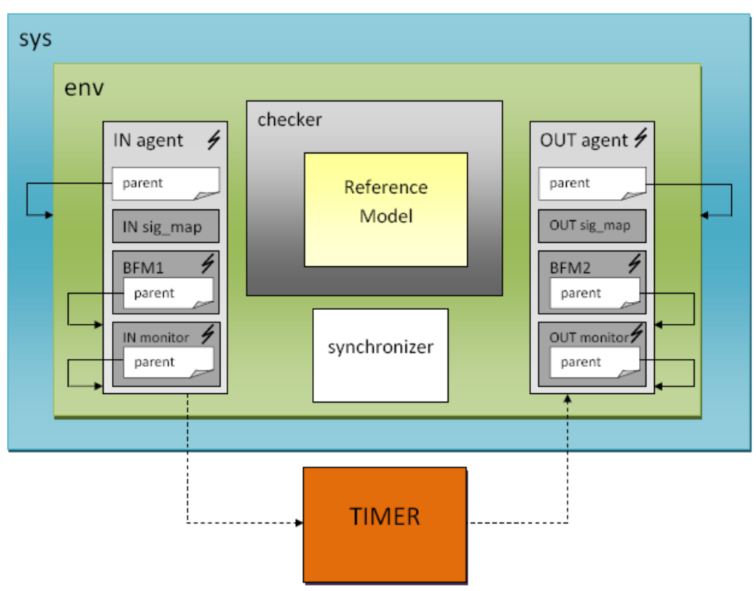

Figure 3 – Block diagram of the testbench
4.2 Partitioning

The test for Timer module will be partitioned in 3 parts. Timer 0, Timer 1 and Timer 2 partitions.

  - Global Routines

Not applicable. Global routines were not defined yet.

  - External Interface Functions

Not applicable. External interface functions and calls were not defined yet.

  - Memory Map

Not applicable. Memory is not used in Timer Module.

  - Verification and Debug Registers

Not applicable. Debug registers were not defined yet.

  - Clocking

Not applicable. It was not defined how many clock domains will be utilized.

  - Reset

Not applicable. It was not defined types of reset.

  - Termination

Not applicable. Termination tasks are not needful for timer module.

- Drivers and Monitors

Not applicable. This entire section will be defined later, during verification codification.

5.1Driver and Monitor Overview

  - <Driver/Monitor X> Description

  - <Driver/Monitor X> Functional Overview

  - <Driver/Monitor X> Commands

  - <Driver/Monitor X> Arguments

  - <Driver/Monitor X> Configuration

- Models
The Timer Module does not use memories, IOs and PADs. However, a Reference Model is used to reproduce DUT behavior and to calculate expected answers.

  - Functional Models

A reference model is used in this verification environment reproduce DUT behavior and to calculate expected answers. Data Checker receives the inputs from IN Monitor and sends to Reference Model that calculates the expected results. So, Data Checker compares these results with DUT outputs. Figure 2, previously presented, shows the flow diagram of Data Checker and Reference Model.

  - Memory Models

Not applicable. Memory is not used in Timer Module.

  - Stub Models

Not applicable. Stub Models are not necessary for this block.

  - IO and PADs

Not applicable. IO and PADs are not used in Timer Module.

- Additional Information

No additional information is needed in this version.

