Documentation of clinic database

1. **Doctor_entity:** It contains attributes as: id,name,email,phone,speciality_id,qualification

**Id :** is a **primary key**  attribute .

**Name** : Represents name of the doctor.

**Email :** Doctor’s email address.

**Phone:** Phone number of the doctor.

**Speciality_id :** It is a foreign key attribute used to contact both **Doctor**  and **Speciality** entities. Which is important to get the speciality of the doctor.

**Qualification:** It contains data about doctor’s qualification.

**For example:** **1,** Dr.Kamal,abc@jhs.com,234-846-8478,**45**, Gynecologists

**2) Speciality_entity:** It contains attributes as:id,name,description

**Id:** is a **primary key**  attribute.

**Name:**Represents name of the speciality.

**Description:**It tells that what is the working in real life of speciality.

**For example:45,** Gynecologists,Gynecologists (OBGYNs) are medical professionals who specialize in pregnancy, childbirth and the female reproductive system. These physicians can **work** in clinics, hospitals and other medical facilities

**3) Appointment_entity:**It contains attributes as:id,**doctor_id**,**patient_id**,date/time,notes

**Id:** is a **primary key**  attribute.

**Doctor_id:**It is a foreign key attribute used to contact both **Doctor**  and **Appointment** entities. It tells that which doctor set

appointment for which patient.

**Patient_id:**It is a foreign key attribute used to contact both **patient**  and **Appointment** entities. It tells that which patient get

appointment from which doctor .

**Date/Time:**It’s for knowing the exact date as well as time of the

appointment for both patient and doctor.

**Notes:** It haves each and every information about appointment.

**Example:524, 23 , 73,** 12/05/2017-5:30 pm, this appointment is

issued by Mr. A on phone.Patient name Jack has

appointment with doctor Mr. Duston regarding stomach

Pain.

**4) Patient_entity:** It contains attributes as: id,name,address,phone,**doctor-id**

**Id:** is a **primary key**  attribute.

**Doctor_id:**It is a foreign key attribute used to contact both **Doctor**  and **Patient** entities. It tells that which doctor handles

that patient.

**Name** : Represents name of the patient.

**Address :** Patient's address ,its help full in case emergency.

**Phone:** Phone number of the patient.

**For example:** **1,** Mr.Karam,656 vankirk Brampton ,234-846-8478,**45**

**5)Medication_entity:**It contains attributes as: id,name,description,manufacturer,price

**Id:** is a **primary key**  attribute.

**Name** : Represents name of the medication.

**Description:** Explains for what the medication is useful.

**Manufacturer:** The Brand who make the medication.

**Price:** For knowing the cost of medication.

**For example:468,** tylenol, ‘headache, fever’, ‘tylenol inc’, $10.

**Insert Table Example:**

Insert into medication (id, name, description, manufacturer, price) values

(tylenol, ‘headache, fever’, ‘tylenol inc’, $10).

**6)Prescription_entity:**It contains attributes as: id,**Medication_id, Appointment_id,**

frequency,dosage

**Id:** is a **primary key**  attribute.

**Medication_id:**It is a foreign key attribute used to contact both

**Medication** and **Prescription** entities. Which shows that

which medication is prescribed to the patient by doctor.

**Appointment_id:**It is a foreign key attribute used to contact both

**Appointment** and **Prescription** entities. Which shows

that when patent can visit to doctor according to his

prescription.

**Frequency:** It contain the information that which medicine you have to

take and how many times a day.

**Dosage:** It tells that which power of the medicine is needed.

**For example: 56,43,675,**3 times a day, 500mg

**7)Patient_Profile:**It contains attributes as:id,**appointment_id**,date/time,notes.

**Id:** is a **primary key**  attribute.

**Appointment_id:**It is a foreign key attribute used to contact both

**Appointment** and **Patient_profile** entities. Which shows

that when patent can visit to doctor according to his prescription.

**Date/Time:**It’s for knowing the exact date as well as time of the appointment

for both patient and doctor.

**Notes:** It haves each and every information about patient.

**For example:57,465,**21-05-2017/02:27 pm, patient is recovering with the

Process and medicine.

**8)Pharmacist_entity:** It contains attributes as: id,name,address

**Id:** is a **primary key**  attribute.

**Name** : Represents name of the pharmacist.

**Address :** Pharmacist’s address to contact or you can say to meet him

regarding any medical information.

**For example:57,**Mr. Joraz,9875 Hellroad, Toronto

**9)Pharmacy_entity:** It contains attributes as: id,name,**Pharmacist_Id**

**Id:** is a **primary key**  attribute.

**Name** : Represents name of the pharmacy.

**Pharmacist_Id :**It is a foreign key attribute used to contact both

**Pharmacy** and **Pharmacist** entities. It tells that which

pharmacist is working at which pharmacy.

**For example:57,**Durage Mart,**768**

**10) Purchase_entity:**It contains attributes as:id, **Pharmacy_id,Pharmacist_id**,date/time,notes

**Id:** is a **primary key**  attribute.

**Pharmacy_id:**It is a foreign key attribute used to contact both

**pharmacy** and **purchase** entities. It tells that which

pharmacy is providing the drug.

**Pharmacist_id:**It is a foreign key attribute used to contact both

**pharmacy** and **purchase** entities. It tells that

Which pharmacist is purchasing the drug .

**Date/Time:**It’s for knowing the exact date as well as purchased

time of the medicine.

E-R diagram clinic database

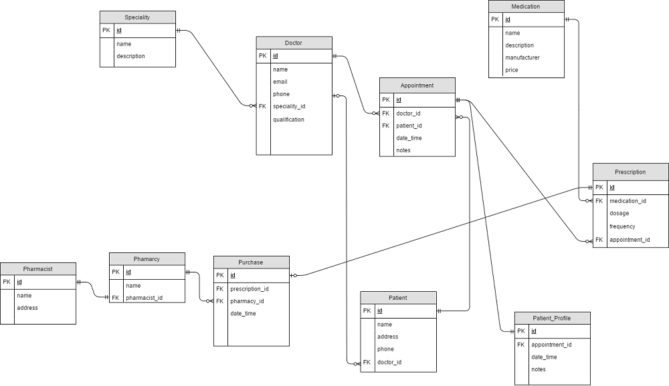

Description of relations E-R diagram:

**Business Rules**:

1. The clinic has several doctors

2. Each doctor has a speciality (GP, Cardiology, Pediatrics, Children, etc...)

* 1 doctor has 1 speciality and 1 speciality can be in zero or many doctors. To fit this requirement speciality id goes to the Doctor table.

3. Each patient has a primary doctor

4. Each patient may have several prescriptions (may take several medications)

5. If the patient's primary is not available, then any available doctor might write the prescription to this patient

6. For the Term Project, add the pharmacy's functionality as follow:

a. The clinic has only one pharmacy

b. The pharmacy may has one and only one pharmacist

c. The patient may purchase the medication(s) given in the doctor's prescription(s) from the clinic's pharmacy.

Appointment:

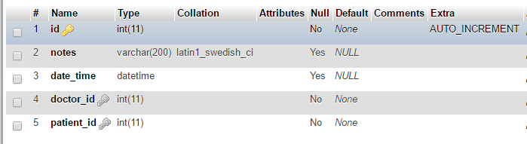

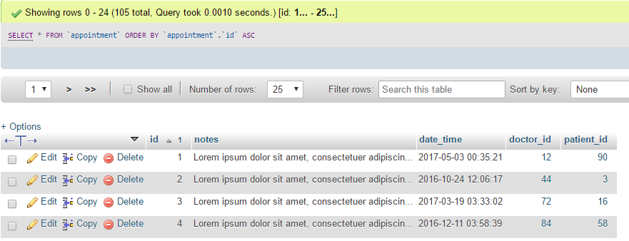

Doctor:

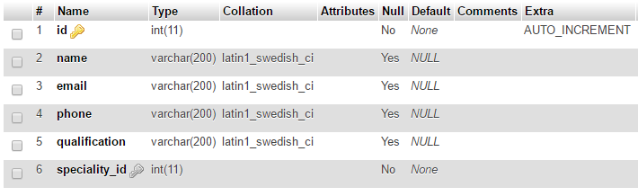

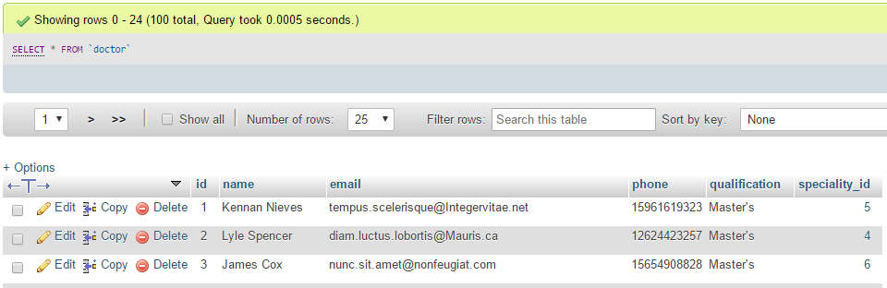

Medication:

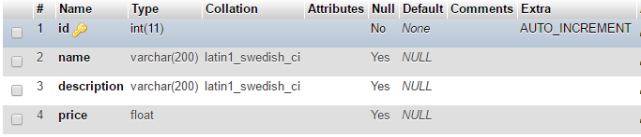

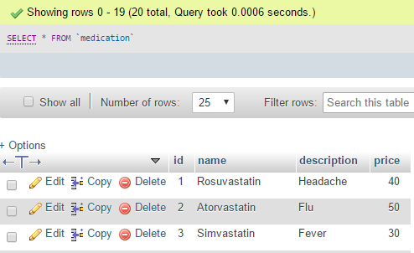

Patient:

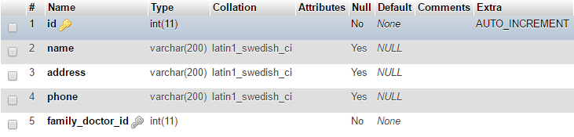

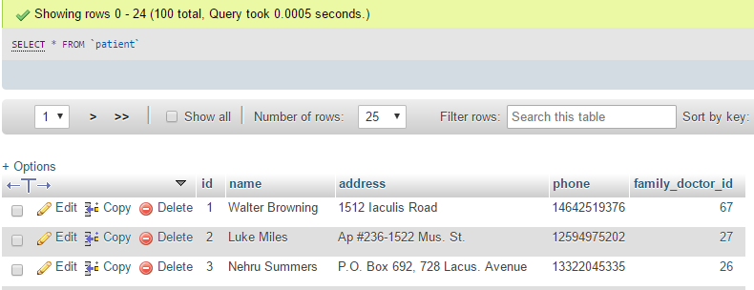

Patient_Profile: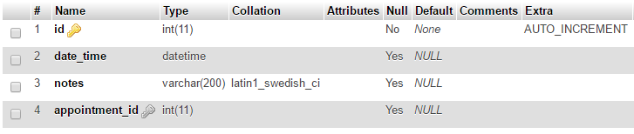

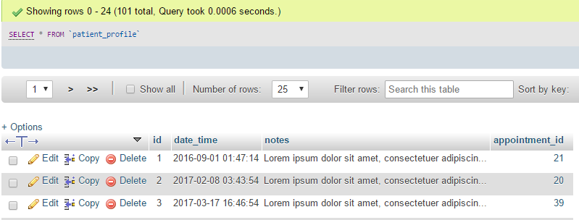

Pharmacist:

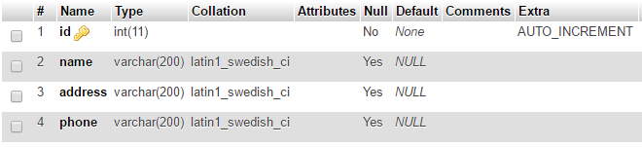

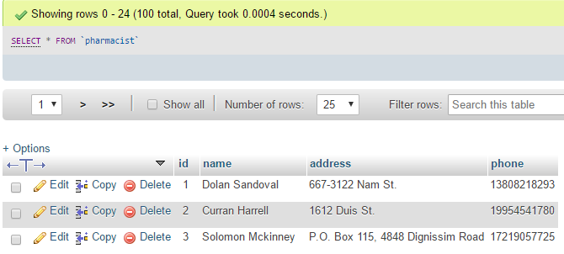

Pharmacy:

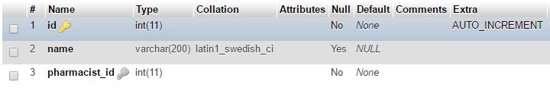

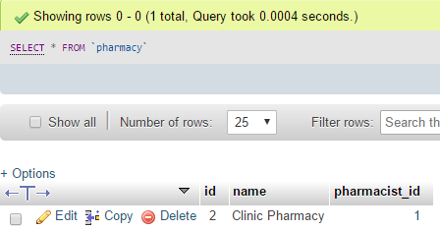

Prescription:

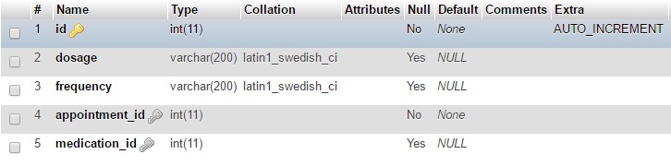

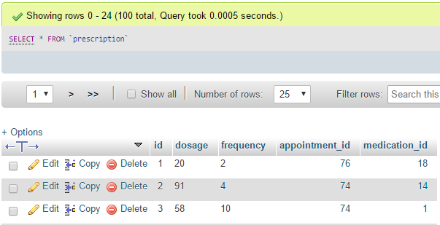

Purchase:

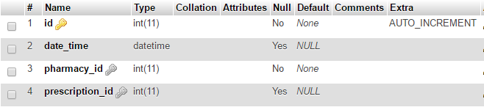

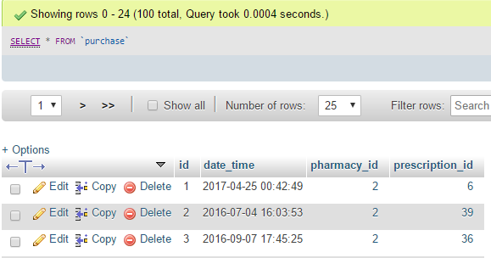

Speciality:

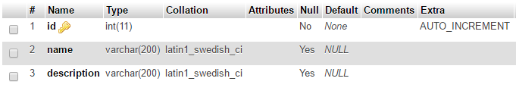

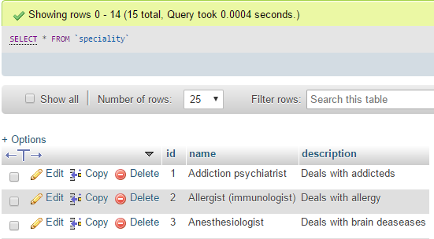

Queries:

1. Using SQL build the following views (or reports):

a. The clinic prints and distributes newsletters for its patients who are actively visiting the clinic. Active patients are identified by those who visit the clinic at least twice in the past year

SELECT p.id, p.name, p.phone, p.address, Count(p.id) as counter_visits

FROM patient_profile as pp INNER JOIN appointment as ap ON pp.appointment_id = ap.id INNER JOIN patient as p ON ap.patient_id = p.id

where pp.date_time >= DATE_SUB(NOW(), INTERVAL 1 YEAR) GROUP BY p.id HAVING counter_visits >= 2;

b. List the number of patients in each medical speciality

- Number of doctors in each medical speciality:

SELECT spec.name, COUNT(spec.id) as counter_doctor from doctor as doc INNER JOIN speciality as spec ON doc.speciality_id = spec.id GROUP BY spec.id

c. List the doctors who work in the clinic sorted in descending order by the number of visits from patients in each month

SELECT doc.id as doctor_id, doc.name as doctor_name, COUNT(app.doctor_id) as patient_counter, MONTH(app.date_time) as month, MONTHNAME(app.date_time) as month_name FROM appointment as app INNER JOIN doctor as doc ON doc.id = app.doctor_id GROUP BY app.doctor_id, month ORDER BY month ASC, patient_counter DESC

d. In a monthly basis, the clinic needs to provide a list of doctors showing how many times a doctor examined a patient during the last month, sorted in descending order by the number of exams

SELECT doc.id as doctor_id, doc.name as doctor_name, COUNT(app.doctor_id) as patient_counter, MONTH(app.date_time) as month, MONTHNAME(app.date_time) as month_name

FROM appointment as app INNER JOIN doctor as doc ON doc.id = app.doctor_id

where MONTH(app.date_time) = 1

GROUP BY app.doctor_id

ORDER BY patient_counter DESC

e. In an annual basis, the clinic needs to provide a list of doctors showing how many times a doctor examined a patient during the last year, sorted in descending order by the number of exams

SELECT doc.id as doctor_id, doc.name as doctor_name, COUNT(app.doctor_id) as appointment_counter, YEAR(app.date_time) as year

FROM appointment as app INNER JOIN doctor as doc ON doc.id = app.doctor_id

where YEAR(app.date_time) = 2017

GROUP BY app.doctor_id

ORDER BY appointment_counter DESC

f. In a monthly basis, the clinic needs to provide a list of doctors showing how many times a doctor worked in behalf of another doctor during the last month. Sort the list in descending order by the number of times

SELECT doc.id as doctor_id, doc.name as doctor_name, COUNT(app.doctor_id) as patient_counter, MONTH(app.date_time) as month, MONTHNAME(app.date_time) as month_name

FROM appointment as app

INNER JOIN doctor as doc ON doc.id = app.doctor_id

INNER JOIN patient as pat ON pat.id = app.patient_id

where MONTH(app.date_time) = 1 AND pat.family_doctor_id != doc.id

GROUP BY app.doctor_id

ORDER BY patient_counter DESC

g. In an annual basis, the clinic needs to provide a list of doctors showing how many times a doctor worked in behalf of another doctor during the last year. Sort the list in descending order by the number of times

h. In a monthly basis, the pharmacy needs to get a list of the Medication names sorted in descending order by the number of times it is prescribed by a doctor during the last month

i. In an annual basis, the pharmacy needs to get a list of the Medication names sorted in descending order by the number of times it is prescribed by a doctor during the last year

j. In a monthly basis the pharmacy needs to get a list of all medications that are not prescribed during the last month

k. In an annual basis the pharmacy needs to get a list of all medications that are not prescribed during the last year

l. Build a list showing how many prescriptions received by the pharmacy for each month starting with the current month and back to the same month last year. i.e. 13 months history