Campaigning and Political Efficacy: The Role of Electoral Communication in Shaping Democratic Engagement
Pedro Fierro, Claudia Ramírez, Andrés Scherman and Sebastián Rivera
Abstract
Research on political campaigning has primarily focused on the effectiveness of electoral interventions in shaping preferences or boosting participation. However, the potential role of campaigning in fostering democratic values has received limited attention. This study examines the relationship between exposure to electoral content, campaign-related digital participation, and political efficacy. Specifically, it explores three dimensions: beliefs in one’s own political competence (internal efficacy), perceptions of system responsiveness (external efficacy), and the sense of empowerment derived from online engagement (online political efficacy). Using the case of Chile’s first Constituent Process in 2022, we analyse panel data collected by the Millennium Nucleus for the Study of Media, Public Opinion, and Politics in Chile. First, a cross-sectional analysis reveals that the impact of electoral content exposure on political efficacy depends on both the type of content and the specific dimension of efficacy. For instance, exposure to the official Franja Electoral shows no clear relationship with higher efficacy levels, while exposure to electoral content via traditional media is positively associated with internal and online political efficacy. Second, a longitudinal analysis suggests that campaign-related digital participation is linked to greater external and online political efficacy over time. These findings highlight the broader democratic implications of electoral campaigns, extending beyond their immediate effects on voting decisions and preferences.
Keywords: Elections; political efficacy; political campaigns; Chile

- INTRODUCTION

- LITERATURE REVIEW

- DATA AND METHODS
  - Data
To test our hypotheses, we use panel data collected by the Millennium Nucleus for the Study of Media, Public Opinion, and Politics in Chile (Núcleo MEPOP). The project was conducted in Chile before and after the constitutional referendum held on 4 September 2022. For this study, we use data from wave 1, conducted between 25 August and 3 September, with a total of 2,117 responses, and wave 3, conducted between XX and XX, with a total of 902 observations. The survey was administered by the international polling company Netquest, using quotas to match the country’s distribution of gender, age, socioeconomic status (SES), and region.
  - Variables
Online Political Efficacy. Based on the literature, online political efficacy (OPE) was measured using a four-item scale with the following statements:
- (ope1) Using the internet, people like me have more political power.
- (ope2) Using the internet, I can have more voice in what the government does.
- (ope3) Using the internet, it is easier for me to understand politics.
- (ope4) Using the internet, public officials care more about what I think.
Respondents answered these items using a five-point Likert scale, where 1 = strongly disagree and 5 = strongly agree. A latent factor was created using confirmatory factor analysis (CFA) (Cronbach’s alpha, wave 1: 0.82, overall: 0.82).
Internal Political Efficacy. Internal political efficacy (IPE) was assessed using a three-item scale based on the literature:
- (intef1) In general, I do not find it difficult to take a position on political issues.
- (intef2) People like me are qualified to participate in political discussions.
- (intef3) People like me have political opinions that are worth listening to.
Responses were collected using a five-point Likert scale (1 = strongly disagree, 5 = strongly agree). A latent factor was created using CFA (Cronbach’s alpha, wave 1: 0.71, overall: 0.7).
External Political Efficacy. External political efficacy (EPE) was measured using a three-item scale:
- (extef1) Politicians do not really care what voters think.
- (extef2) Politicians waste a lot of taxpayers’ money.
- (extef3) People like me have no influence over decisions made in Parliament or government.
These negatively worded statements were reverse-coded so that 1 represents lower external efficacy and 5 represents higher external efficacy. A latent factor was created using CFA (Cronbach’s alpha, wave 1: 0.71, overall: 0.75).
Information Consumption Through Traditional Media. Respondents were asked how often they followed news about the constitutional process through the following platforms:
• Free-to-air television
• Subscription-based television
• Print newspapers
• Radio
• Online versions of legacy media
• Online-only news media
• News podcasts
• Official social media accounts of media organisations
Responses were collected using a five-point Likert scale (1 = never, 5 = very often). A latent factor was created using CFA (Cronbach’s alpha, wave 1: 0.78).
Exposure to Social Media. Respondents were asked how often they followed news about the constitutional process on the following platforms:
- Facebook
- Instagram
- Twitter
- WhatsApp
- YouTube
- TikTok
- Discord
- Twitch
Responses were recorded on a five-point Likert scale (1 = never, 5 = very often). A latent factor was created using CFA (Cronbach’s alpha, wave 1: 0.83).
Exposure to the Franja Nacional. Respondents were informed that, starting on 5 August, the Franja Nacional (official campaign broadcast) had been aired in the lead-up to the exit plebiscite. They were then asked how often they had watched it during the past week. Responses were collected using a five-point Likert scale (1 = never, 5 = very often).
Campaign-Related Digital Participation. Respondents were asked how often they had engaged in the following activities during the past 12 months:
- Discussing politics or social issues on social media or WhatsApp
- Liking a political group or activist organisation on Facebook or following them on Twitter
- Liking or supporting a funa (public call-out) on social media for political reasons
- Changing their profile picture or status on social media or WhatsApp in support of a political or social cause
- Sharing photos or videos about politics or public affairs via WhatsApp or social media
- Joining political, public, or civic causes on social media
- Expressing opinions about public issues or events on a website or social media
Responses were recorded on a five-point Likert scale (1 = never, 5 = very often). A latent factor was created using CFA (Cronbach’s alpha, wave 1: 0.89, overall: 0.89).

Political Interest. Political interest was measured through self-reported responses to the following questions:
- How interested are you in politics?
- How interested are you in the constitutional process?
- How interested are you in the exit plebiscite?
Responses were recorded on a five-point Likert scale (1 = not at all interested, 5 = very interested). A latent factor was created using CFA (Cronbach’s alpha, wave 1: 0.88).
Sociodemographic Variables. The analyses also include sociodemographic controls such as gender, education, socioeconomic status (SES), and age.
  - Analyses
This study employs two analytical approaches to test the proposed hypotheses. First, due to data availability, a cross-sectional analysis examines the relationships between campaign-related digital participation, exposure to electoral information, and political efficacy. This analysis is based on the first wave of the panel dataset, which includes 1,804 interviews.
Second, a longitudinal analysis investigates the impact of campaign-related digital participation on the development of political efficacy. For this part, waves 1 and 3 of the panel dataset are used, comprising a balanced panel of 1,264 observations (632 individuals surveyed at two points in time).

- RESULTS
  - Cross-sectional analysis
Figure 1 Electoral communication consumption and OPE
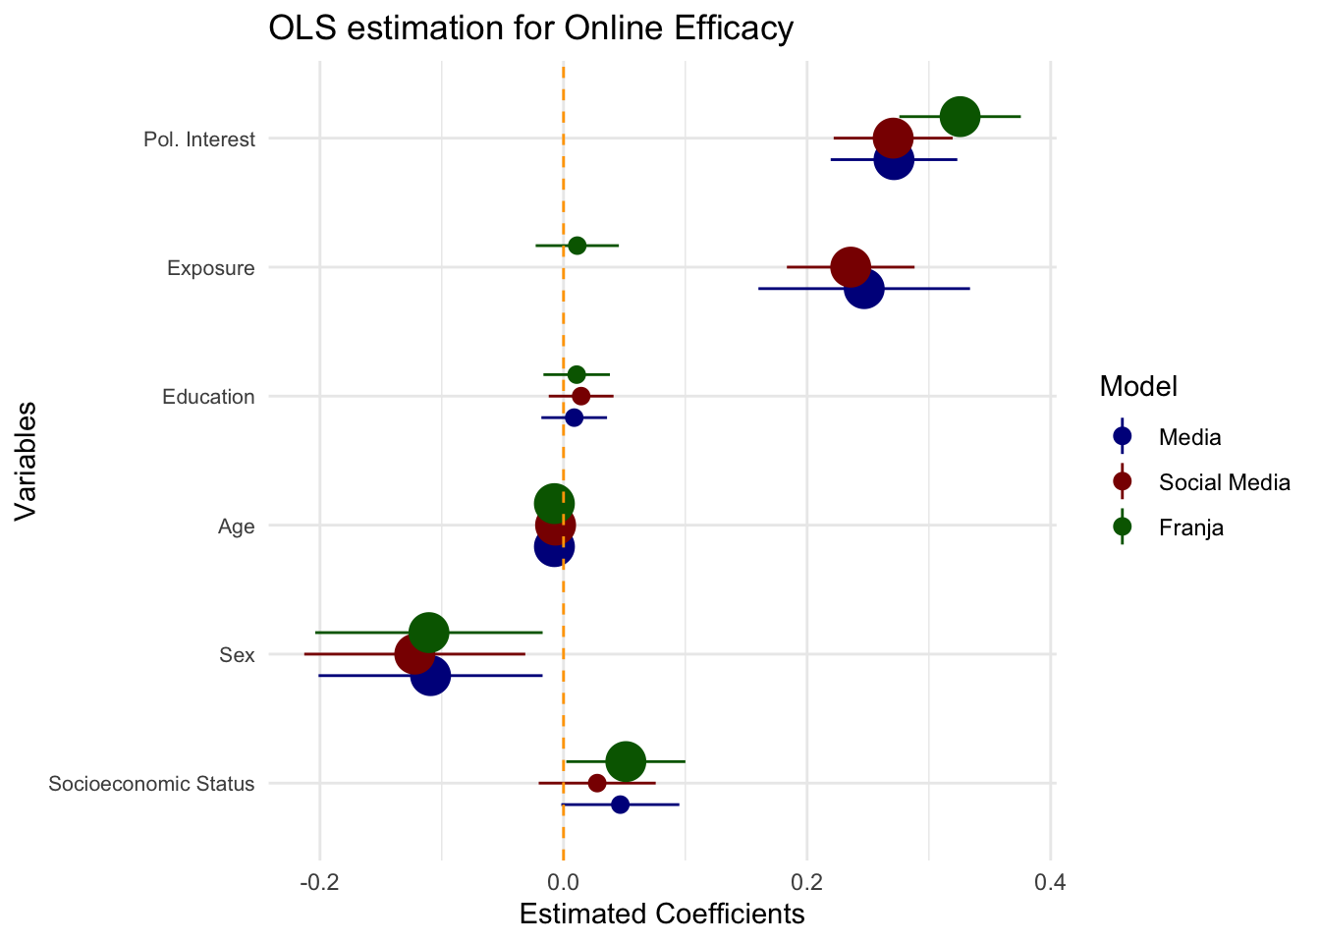
Figure 2 Electoral communication consumption and IPE

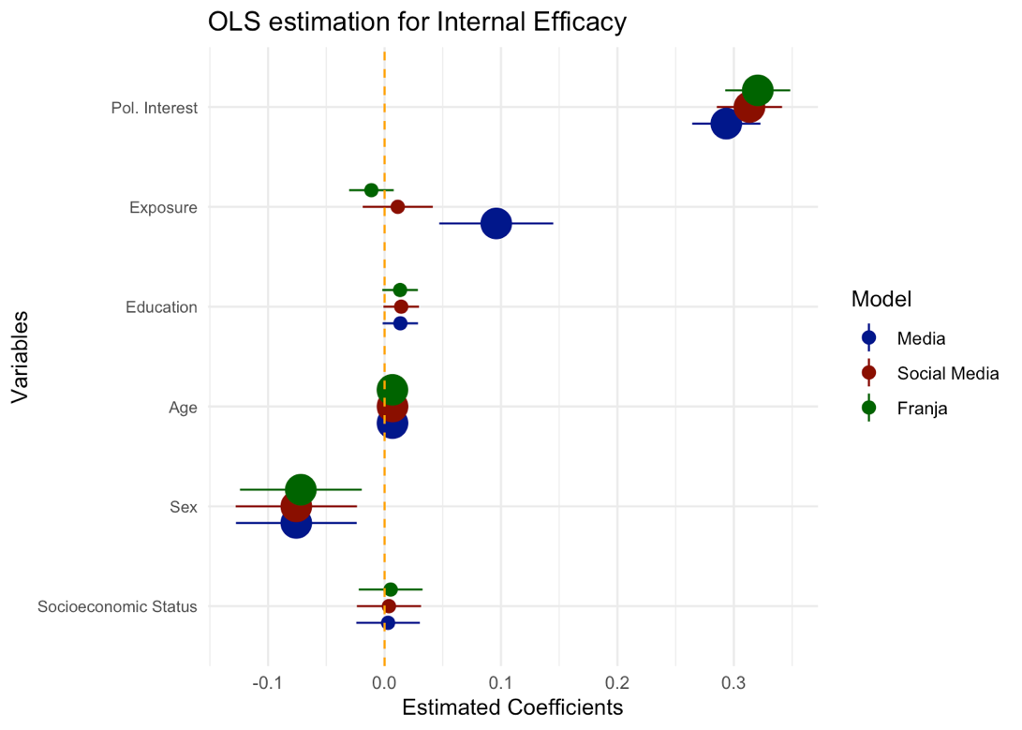

Figure 3 Electoral communication consumption and EPE
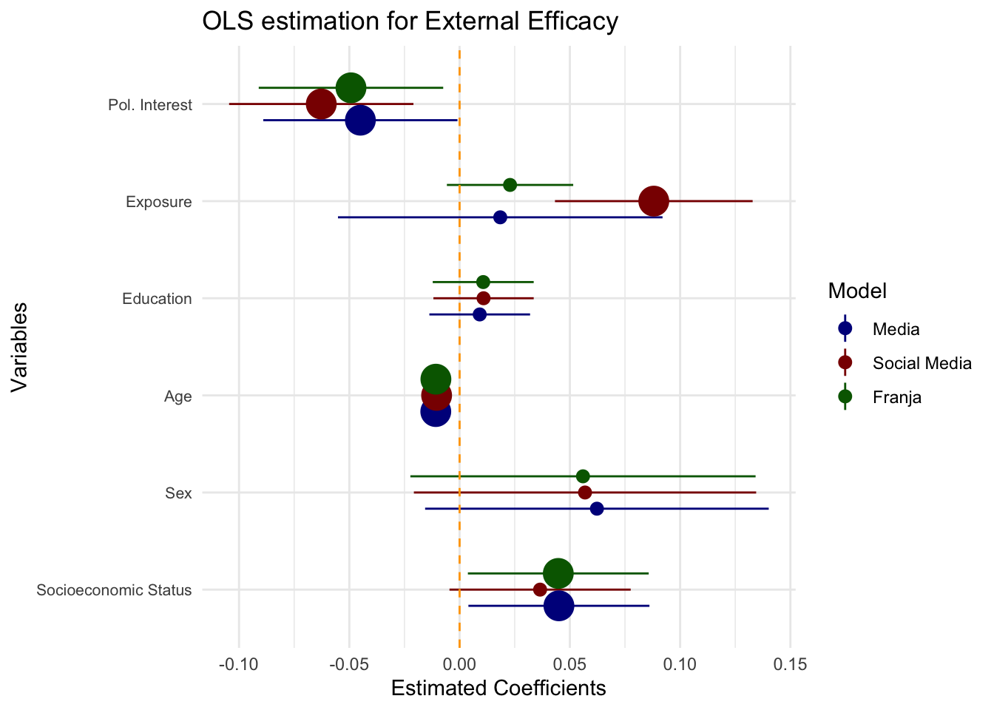

Table 1 Cross-sectional analysis. OLS estimations for political efficacies.
 | OPE | IPE | EPE
Age | -0.0063026** | 0.007002*** | -0.010072***
 | (0.0019217) | (0.001117) | (0.001646)
SES | 0.0114148 | -0.002336 | 0.022173
 | (0.0288750) | (0.016782) | (0.024738)
Education | -0.0003239 | 0.012202 | 0.003207
 | (0.0159404) | (0.009264) | (0.013657)
Gender | -0.1001032† | -0.073798* | 0.066601
 | (0.0542733) | (0.031543) | (0.046498)
Political Interest | 0.1707454*** | 0.287505*** | -0.132870***
 | (0.0326632) | (0.018983) | (0.027984)
Political Use of SM | 0.3065948*** | 0.055401** | 0.177769***
 | (0.0318763) | (0.018526) | (0.027310)
R-squared | 0.1828 | 0.3143 | 0.09258

  - Panel analysis
Table 2 Description of dependant variables in panel
Variable | Panel | Mean | Std. Dev. | Observations
OPE | Overall | 0 | 1.0040876 | N = 1264
 | Between |  | 0.8549196 | n= 632
 | Within |  | 0.5271463 | t = 2
IPE | Overall | 0 | 0.4340398 | N = 1264
 | Between |  | 0.3749179 | n= 632
 | Within |  | 0.2189485 | t = 2
EPE | Overall | 0 | 0.7932438 | N = 1264
 | Between |  | 0.680346 | n= 632
 | Within |  | 0.4083278 | t = 2

Table 3 Panel analysis. OLS estimations for political efficacies
 | OPE | IPE | EPE
Political Use of Social Media | 0.3942251*** | 0.03420092 | 0.1102612***
 | (0.0267159) | (0.02366427) | (0.0221566)
Ideology | 0.015252 | 0.00092247 | -0.0155444†
 | (0.0106178) | (0.01222762) | (0.0089000)
Socioeconomic Status | -0.0102614 | 0.01853026 | -0.007919
 | (0.0234937) | (0.03654759) | (0.0197904)
Gender | 0.0415483 | --- | 0.0798354
 | (0.0583131) | --- | (0.0495226)
Age | -0.0039471† | 0.0217873 | -0.0077897***
 | (0.0020856) | (0.04529339) | (0.0017703)
Model | RE | FE | RE
R-Squared
Overall | 0.139672916 | 0.108501833 | 0.041722937
Within | 0.074976582 | 0.004050288 | 0.018250427
Between | 0.18779291 | 0.149027404 | 0.060422532

