Supplementary Materials
1. HOTAIR Polymorphism: Funnel Plot of the Homozygous (Codominant) Model
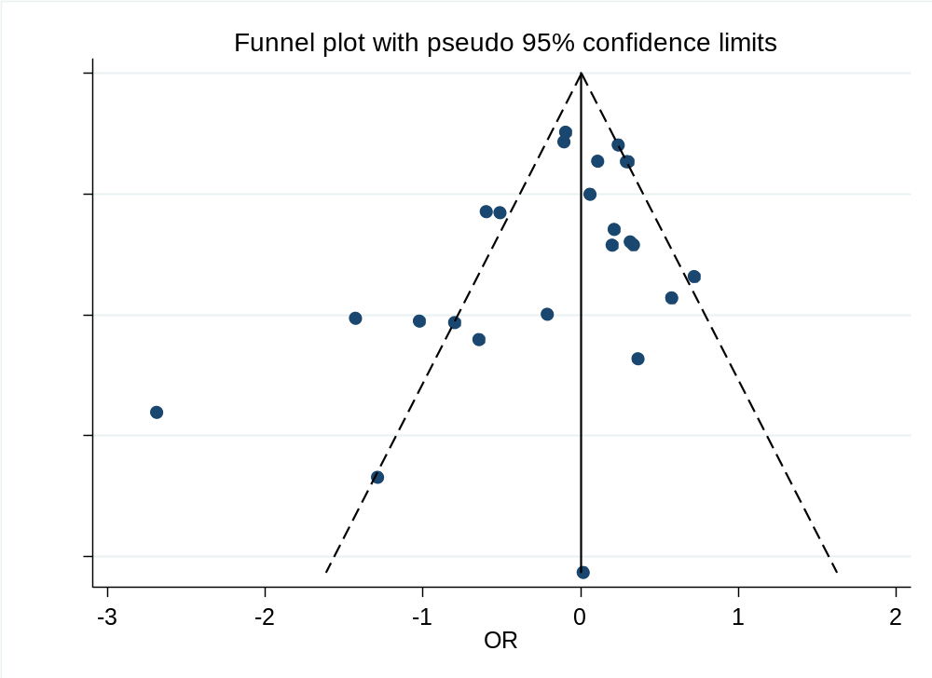
2. Funnel Plot of the HOTAIR Gene rs1899663 G>T Codominant Model
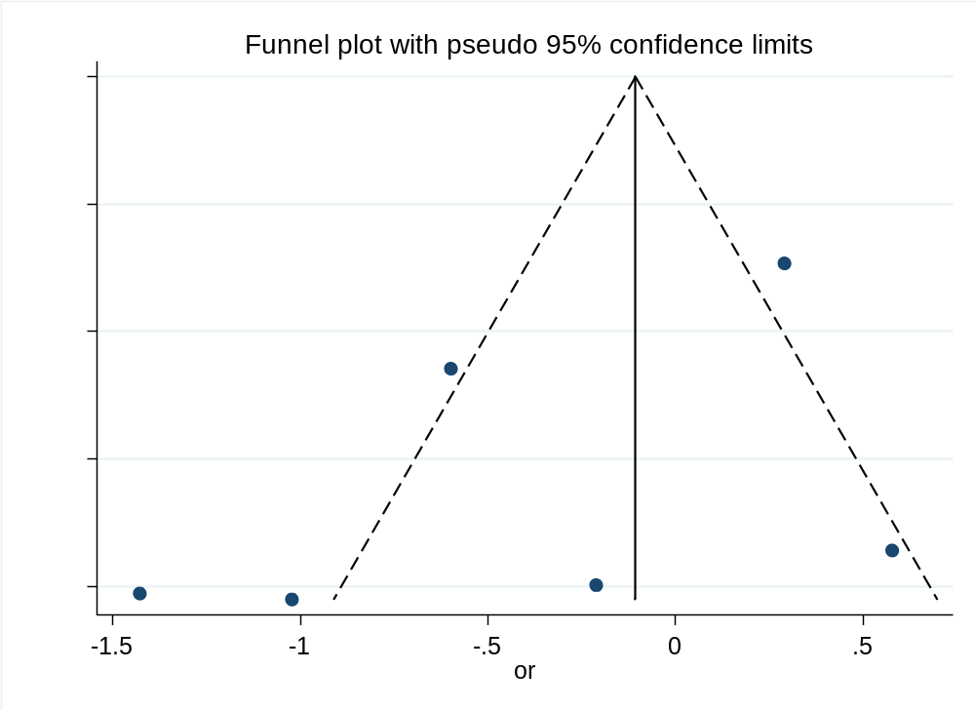
3. Funnel Plot of the HOTAIR Gene rs1899663 G>T Dominant Model
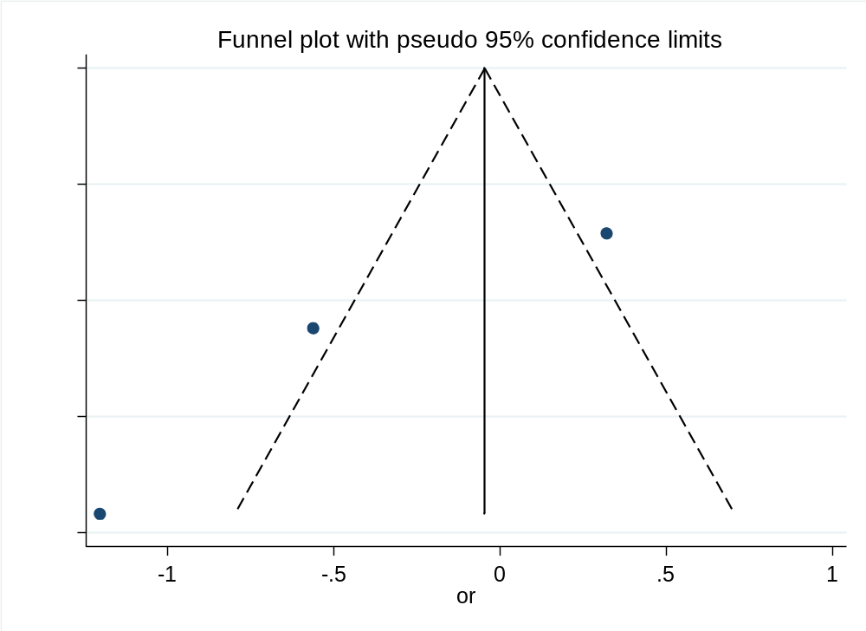
4. Funnel Plot of the HOTAIR Gene rs1899663 G>T Recessive Model
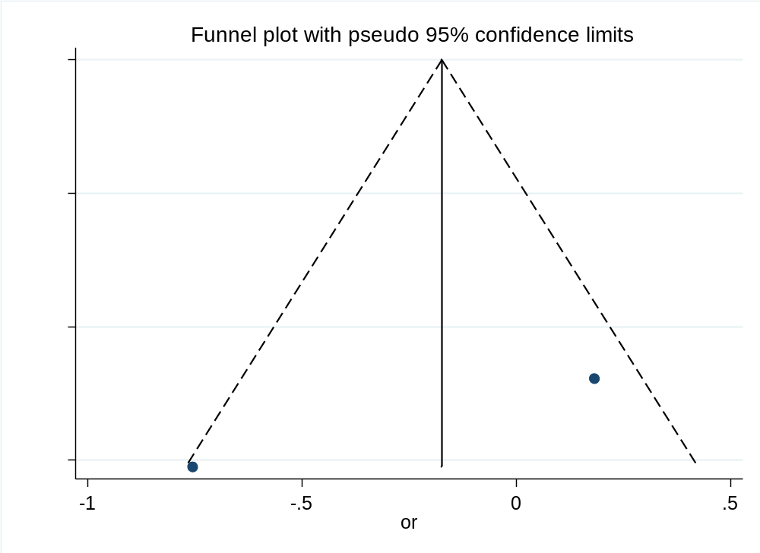
5. Funnel Plot of the HOTAIR Gene rs1899663 G>T Overdominant Model
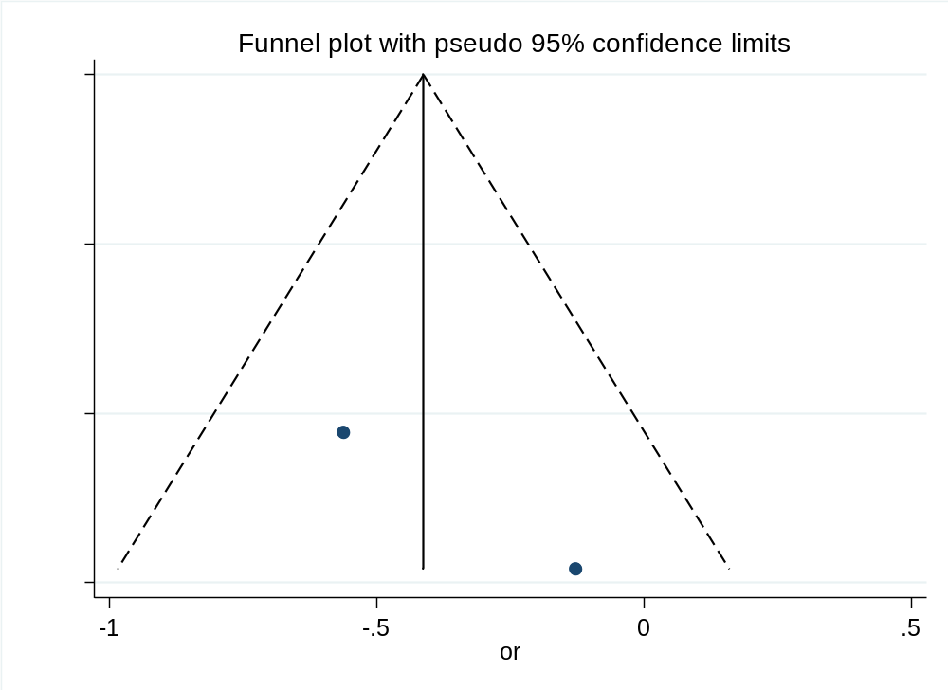
This study systematically evaluated the robustness of the meta-analysis on the association between the HOTAIR polymorphism—including both the homozygous model and rs1899663 polymorphism models—and disease risk from different genetic inheritance perspectives (codominant, dominant, recessive, and overdominant). By examining funnel plots across all these models, it can be concluded that the present study is robust against potential publication bias.
2. Meta-regression
To investigate potential sources of heterogeneity observed in the main analysis, univariable meta-regression analyses were performed. The key findings are summarized below.
2.1 HOTAIR Polymorphism Codominant Model
Variables | confficient | 95% CI | Std.Err | P value
year | -0.19 | (-0.33 , -0.04) | 0.07 | 0.014
2.2 HOTAIR Gene rs1899663 G>T Codominant Model
Variables | confficient | 95% CI | Std.Err | P value
year | -0.30 | (-0.71 , 0.10) | 0.15 | 0.108
Asian | 3.44 | (0.98 , 12.08) | 1.56 | 0.052
2.3 HOTAIR Gene rs1899663 G>T Dominant Model
Variables | confficient | 95% CI | Std.Err | P value
year | 0.74 | (0.05 , 10.18) | 0.15 | 0.380
Asian | 3.34 | (0.00 , 4923.98) | 1.92 | 0.283
non-Asian | 0.30 | (0.00 , 440.84) | 0.17 | 0.283
2.4 Data is missing for the HOTAIR gene rs1899663 G>T under the Recessive and Overdominant genetic models.
In summarizes: Meta-regression with publication year as a covariate revealed a statistically significant trend. The coefficient of -0.19 (95% CI: -0.33, -0.04; p = 0.014) indicates that the estimated effect size decreases by approximately 0.19 units per year. This suggests that more recent studies may report smaller effect sizes.
A significant association was found between the effect size and the minor allele frequency (MAF) in the control groups (coefficient = 1.85, 95% CI: 0.55, 3.15; p = 0.006). This suggests that the population-specific genetic background, reflected by the MAF, is a considerable contributor to the observed heterogeneity.

