Supplementary material
Figure S1.
General procedure
The experiment took place over three sessions. On Day 1, participants provided written informed consent and completed the LEC-5 and PCL-5 questionnaires. On Day 2, which was scheduled between two to four weeks following Day 1, participants underwent the fear conditioning and extinction phases of the protocol. On Day 3, which occurred 24 hours after Day 2, participants completed a demographic questionnaire before taking part in the extinction memory recall phase. Afterwards, they filled out the BDI-II and STAI-T questionnaires. Finally, they were debriefed about the study and compensated for their participation.
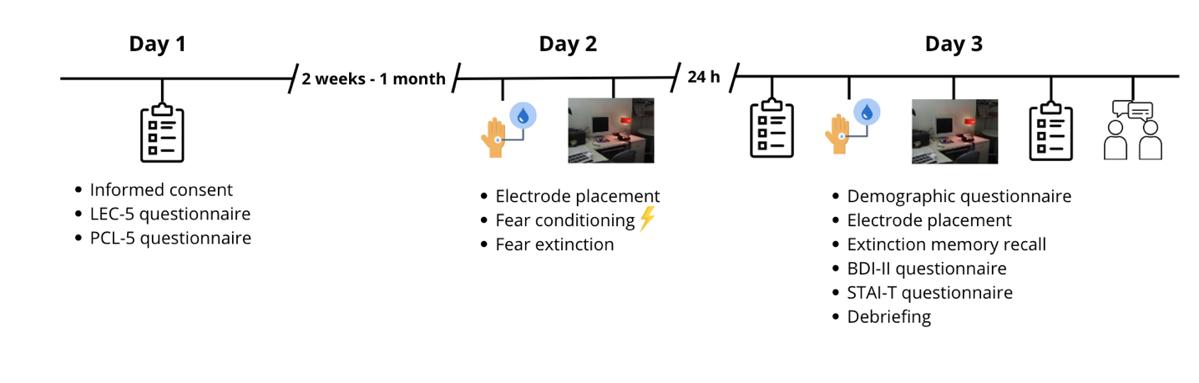

Table S1
Effects for Conditioning, Extinction, and Extinction Recall Models with the Covariates

Effect | F(df₁, df₂) | p
Conditioning
Interpersonal Trauma Subtypes | F(1, 53.92) = 0.02 | .88
Trauma Recency Score | F(35, 53.90) = 0.78 | .78
Trauma Age Group | F(2, 589.28) = 0.73 | .48
Stimulus Type | F(1, 620.02) = 0.98 | .32
Time | F(3, 620.07) = 31.83 | <.001
Trauma Age Group x Stimulus Type | F(2, 620.01) = 0.49 | .61
Trauma Age Group x Time | F(6, 620.06) = 0.76 | .60
Stimulus Type x Time | F(3, 620.03) = 4.55 | 0.004
Trauma Age Group x Stimulus Type x Time | F(6, 620.02) = 0.25 | .96
Extinction
Interpersonal Trauma Subtypes | F(1, 53.97) = 2.36 | .13
Trauma Recency Score | F(35, 53.94) = 1.11 | .36
Trauma Age Group | F(2, 53.97) = 1.66 | .20
Stimulus Type | F(1, 2093.02) = 50.37 | < .001
Time | F(3, 2093.18) = 228.09 | < .001
Trauma Age Group x Stimulus Type | F(2, 2093.01) = 2.85 | .06
Trauma Age Group x Time | F(6, 2093.16) = 2.96 | .007
Stimulus Type x Time | F(3, 2093.90) = 8.59 | < .001
Trauma Age Group x Stimulus Type x Time | F(6, 2093.00) = 0.94 | .46
Extinction memory recall
Interpersonal Trauma Subtypes | F(1, 51.98) = 0.99 | .32
Trauma Recency Score | F(35, 51.98) = 1.03 | .46
Trauma Age Group | F(2, 51.97) = 3.21 | .05
Stimulus Type | F(1, 2055.02) = 30.92 | < .001
Time | F(3, 2055.05) = 261.91 | < .001
Trauma Age Group x Stimulus Type | F(2, 2055.02) = 2.25 | .11
Trauma Age Group x Time | F(6, 2055.06) = 7.56 | < .001
Stimulus Type x Time | F(3, 2055.03) = 13.41 | < .001
Trauma Age Group x Stimulus Type x Time | F(6, 2055.02) = 1.42 | .20
Note. F = F-ratio; df = degrees of freedom.

