Comparison of Dopamine D2 Receptor Occupancy Profiles between Risperidone ISM versus Oral Risperidone and Monthly Paliperidone Palmitate Based on Population Pharmacokinetic Modelling and Simulations.

SUPPLEMENTARY MATERIAL

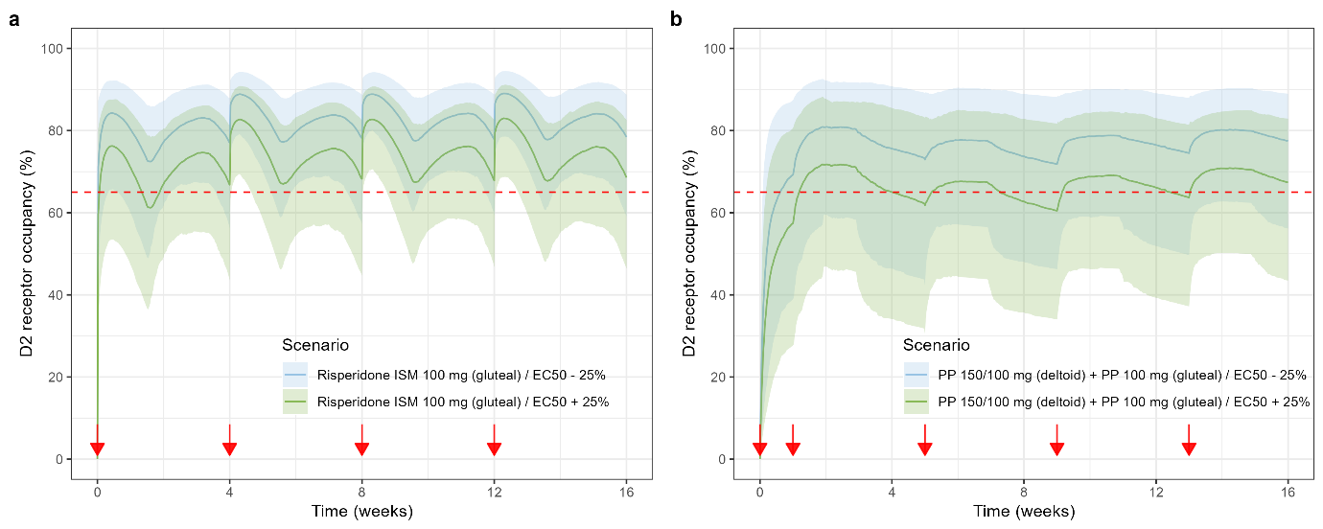

Supplementary Figure 1. Sensitivity analysis of D2RO–time profiles in 1,000 subjects during the first 16 weeks of intramuscular (IM) treatment with 100 mg Risperidone ISM® every 28 days, compared to an IM treatment with 100 mg Paliperidone Palmitate every 28 days. (a) D2RO–time profiles resulting from Risperidone ISM treatment simulated using EC₅₀ values ±25%: EC₅₀ –25% (blue) and EC₅₀ +25% (green). (b) D2RO–time profiles resulting from Paliperidone Palmitate treatment simulated using EC₅₀ values ±25%: EC₅₀ –25% (blue) and EC₅₀ +25% (green).
Notes: The first injection consisted of a deltoid injection of 150 mg Paliperidone Palmitate followed by a deltoid injection of 100 mg Paliperidone Palmitate one week later and then followed by IM injections of 100 mg Paliperidone Palmitate every 28 days. Solid lines and shaded areas represent the medians and 5th and 95th percentiles, respectively. Dashed red lines represent the critical D2RO threshold of 65% which is required for efficacy. The red arrow represents the time of drug administration.
Abbreviations: D2RO, Dopamine D2 Receptor occupancy; IM, intramuscular.

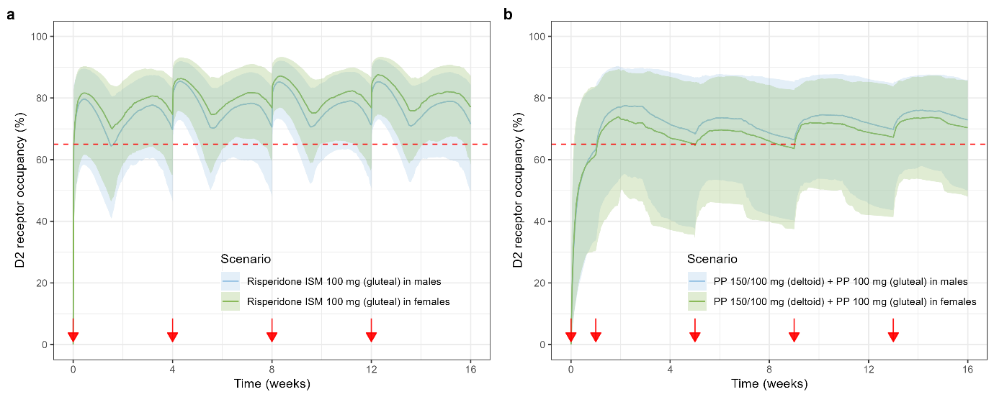
Supplementary Figure 2. Gender-stratified simulations of D2RO–time profiles in 1,000 subjects (males and females combined) during the first 16 weeks of intramuscular (IM) treatment with 100 mg Risperidone ISM® every 28 days, compared to an IM treatment with 100 mg Paliperidone Palmitate every 28 days. (a) D2RO–time profiles resulting from Risperidone ISM treatment stratified by sex: males (blue) and females (green). (b) D2RO–time profiles resulting from Paliperidone Palmitate treatment stratified by sex: males (blue) and females (green).
Notes: The first injection consisted of a deltoid injection of 150 mg Paliperidone Palmitate followed by a deltoid injection of 100 mg Paliperidone Palmitate one week later and then followed by IM injections of 100 mg Paliperidone Palmitate every 28 days. Solid lines and shaded areas represent the medians and 5th and 95th percentiles, respectively. Dashed red lines represent the critical D2RO threshold of 65% which is required for efficacy. The red arrow represents the time of drug administration.
Abbreviations: D2RO, Dopamine D2 Receptor occupancy; IM, intramuscular.

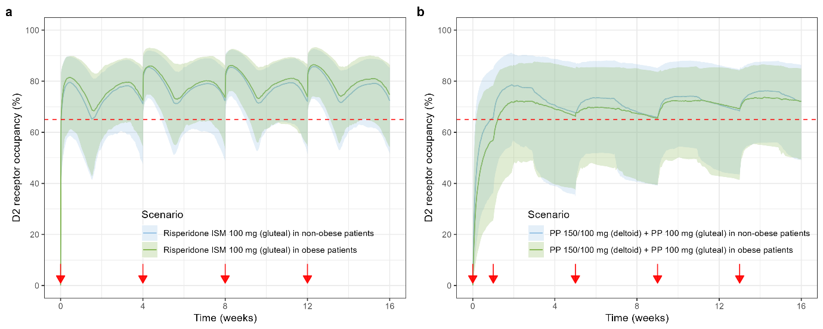

Supplementary Figure 3. BMI-stratified simulations of D2RO–time profiles in 1,000 subjects (obese and non-obese combined) during the first 16 weeks of intramuscular (IM) treatment with 100 mg Risperidone ISM® every 28 days, compared to an IM treatment with 100 mg Paliperidone Palmitate every 28 days. (a) D2RO–time profiles resulting from Risperidone ISM treatment stratified by BMI category: non-obese (blue) and obese (green). (b) D2RO–time profiles resulting from Paliperidone Palmitate treatment stratified by BMI category: non-obese (blue) and obese (green).
Notes: Patients were considered obese when the BMI was equal or greater than 30 kg/m². The first injection consisted of a deltoid injection of 150 mg Paliperidone Palmitate followed by a deltoid injection of 100 mg Paliperidone Palmitate one week later and then followed by IM injections of 100 mg Paliperidone Palmitate every 28 days. Solid lines and shaded areas represent the medians and 5th and 95th percentiles, respectively. Dashed red lines represent the critical D2RO threshold of 65% which is required for efficacy. The red arrow represents the time of drug administration.
Abbreviations: BMI, Body Mass Index; D2RO, Dopamine D2 Receptor occupancy; IM, intramuscular.

