Supplementary Material: additional results

Clinical and prognostic value of the use of biomarkers in patients with non-obstructive coronary artery disease: a systematic review and meta-analysis.

Léa Berbach MSc, PhD (c)^{1,2}, Elie Fadel MD (c) ^{2,6}, Brian J. Potter MDCM, SM^{1,2,3}, Jessica Forcillo MD-MPH, PhD^{1,2,5}, Christine Pacheco MD-MSC, FRCPC,^{1,2,3,4}

- Faculty of Medicine, Université de Montréal, Montréal, QC.
- Research Centre, Centre de Recherche du Centre hospitalier de l’Université de Montréal (CHUM), Montréal, Québec, Canada.
- Department of Medicine, Cardiology, Centre hospitalier de l’Université de Montréal (CHUM), Montréal, Québec, Canada
- Department of Surgery, Cardiac Surgery, Centre hospitalier de l’Université de Montréal (CHUM), Montréal, Québec, Canada

Author of correspondence:

Léa Berbach, MSc, PhD (c)
Centre de recherche du CHUM (CRCHUM)
Cardiac surgery, CHUM
Pavilion S, S03-334
850, rue St-Denis
Montréal, QC, Canada
H2X 0A9
lea.berbach@umontreal.ca
Tel: 514-550-9673
Tel: 514-890-8000 ext. 22648
Fax: 514-412-7519

Supplemental Results: Additional biomarkers
Other biomarkers

We have identified biomarkers that have been rarely studied and less frequently found in all the articles. These are essentially articles that conduct a study around a specific biomarker that is rarely or not at all found in basic clinical biochemical analyses.

Supplemental Table S1

Study  First Author (Yr) | Sample size  (case/tot population) | Serum biomarker levels |  |  | Assessment of microvascular dysfunction or coronary vasospasm | Assessment of biomarkers methods measurement and timing across studies
Study  First Author (Yr) | Sample size  (case/tot population) | Microvascular dysfunction or coronary vasospasm | Control | P value
Soluble urokinase-type plasminogen activator receptor (suPAR) (ng/mL)
Microvascular disease
Corban (2018)(19) | 49/79 | 10.2 (8.2, 12.7) | 9.0 (7.7, 11.0) | 0.034 | CAG, ΔCBF in response to Ach. | 48 hrs without medication affecting CV;  Human suPAR ELISA Kit; ♦
Mekonnen (2015)(31) | 30/66 | CFR<2.0:  suPAR: 3.04 (2.33-3.70) | CFR>2.0:  suPAR: 2.53 (2.00-3.25) | 0.12 | Non-invasive stress test, CAG, CFR measure | ELISA
Minoca
Hjort (2019)(63) | 97/195 | 9.33 (8.94-9.67) | 9.05 (8.75-9.41) | NA | CAG, MI criteria | Analysis done 3 months after index MI measured. PEA technology with the  Olink Proseek® Multiplex CVD I96 96 assay

Circulating progenitor cells (counts/uL)
Microvascular disease
Mekonnen (2016)(28) | 26/123 |  | CFR<2.0: CD34+:  2.44±2.15  CD34+/CD133+:  1.25±1.14 |  | CFR>2.5: CD34+:  1.62±1.36  CD34+/CD133+:  0.81±0.81 |  | 0.019  0.027 |  | CAG, CFR | Vasoactive medication to stop for 24h. fluorochrome-labeled monoclonal anti-human mouse antibodie.  flow cytometry.
Whole blood viscosity
Microvascular disease
Cekirdekci (2020)(34) | 189/573 |  | WBV at HSR (208 s⁻¹): 18.3±2.8  WBV at LSR (0.5 s⁻¹): 62.4±18 |  | WBV at HSR (208 s⁻¹):  CAD: 21±4.5  Healthy: 15.1±1.6  WBV at LSR (0.5 s⁻¹)  CAD: 72.1±27  Healthy: 37.4±14 |  | <0.001  <0.001 |  | CAG, myocardial perfusion  scintigraphy, ETT | Standards laboratory methods
Endothelial progenitor cells (CFU/well)
Microvascular disease
Huang (2007)(42) | 12/34 | EPC colony-forming units: 30(7)  EPC adhesion function:  CSX: 80(20) |  | EPC colony-forming units:  CAD:14(7)  Healthy: 41(9)  EPC adhesion function:  CAD: 65(13)  Healthy: 104(12) |  | <0.001  <0.001 |  | 2-dimensional  echocardiography,  Positive ETT, CAG |  | NA, ♦
Asymmetric demithylarginine ( μmol/L)
Microvascular disease
Haberka (2009)(92) | 43/64 |  | 0.41±0.08 |  | 0.41±0.13 |  | 0.98 |  | Positive ETT, CAG | ADMA ELISA kit;♦
Vasospastic disease
Feng (2014)(58) | 68/136 |  | 0.62±0.14 |  | 0.46±0.14 |  | <0.001 |  | Positive hyperventilation  test, CAG | High- performance liquid chromatography;♦
Serotonin (nmol/L)
Vasospastic disease
Odaka (2017)(46) | 145/198 |  | VSA: 6.8 (3.8, 10.9)  CMD: 7.7 (4.5, 14.2) |  | Non-VSA : 5.1 (3.7, 8.4)  Non-CMD : 5.6 (3.7, 9.3) |  | VSA: 0.135  CMD: 0.008 |  | CAG and Ach provocation  test | Serotonin  was separated from the pre-treated samples by HPLC using a column  switching system (HLC-725CAII; Tosoh Corp, Tokyo, Japan). Subsequently,  serotonin was converted into a fluorescent derivative with benzylamine
P-Selectin (ng/mL)
Microvascular disease
On (2005)(25) | 36/96 |  | <5 |  | CAD: >5  Healthy: <5 |  | NS |  | Positive ETT, CAG | Quantitative sandwich EIA; ♦
Malondialdehyde-Modified Low Density Lipoprotein (MDA-LDL) (U/L)
Vasospastic disease
Oumi (2017)(54) | 75/84 |  | 126.3±38.0 |  | 98.7±31.0 |  | 0.039 |  | Positive ECG, IC  vasoreactivity testing (Ach) | ELISA; ♦
Thiol (μmol/L)
Microvascular disease
Altiparmak (2016)(37) | 50/95 |  | 285.7 (267.8 - 303.7) |  | 388.2 (372.4 - 403.9) |  | <0.001 |  | CAG, positive ETT,  echocardiography. | NA; ♦
Paraoxonase (U/l)
Microvascular disease
Kayikcioglu (2007)(47) | 30/93 |  | 40.3 ±33.4 |  | Healthy: 52.3 ±32.2  CAD: 36.3±20.6 |  | 0.02 |  | Positive ETT, CAG | Standard laboratory methods
Neutrophil to lymphocyte ratio (NLR)
Microvascular disease
Altiparmak (2016)(37) | 50/95 |  | 2.20 (1.97-2.44) |  | 1.34 (1.18-1.49) |  | <0.001 |  | CAG, positive ETT,  echocardiography | NA; ♦
Pentraxin-3 (PTX-3) (ng/mL)
Microvascular disease
Buyukkaya (2013)(50) | 41/122 |  | 0.46 ±0.16 |  | 0.23 ±0.09 |  | <0.001 |  | EST, CAG, nuclear stress  test | EIA; ♦
Galectin-3 (Gal-3) (ng/mL)
Microvascular disease
Bozcali (2014)(32) | 115/189 |  | 0.90 (0.40-1.70) |  | 0.40 (0.36-0.44) |  | <0.0001 |  | Positive ETT, PET, CAG | NA; ♦
Radhakrishnan (2021)(26) | 7/22 |  | CFVR<2: 1.3 (1-1.3) |  | CFVR>2: 1.3 (1-1.4) |  | 0.791 |  | Adenosine myocardial  contrast echocardiography  Doppler (CFR), serum  multiplex immunoassay  analysis | NA
Total bilirubin (mg/dl)
Microvascular disease
Huang (2010)(40) | 20/108 |  | With events: 0.64±0.17 |  | Without events: 0.83±0.33 |  | <0.001 |  | CAG, stress test. | Hitachi 7600 autoanalyser; ♦
PDGF-B and BDNF (ng/mL)
Microvascular disease
Aslan (2020)(49) | 91/152 |  | PGDF-B: 2.82 (0.57-7.79)  BDNF: 2.41 (0.97-7.94) |  | PGDF-B: 2.27 (0.41-7.16)  BDNF: 1.92 (1.07-6.64) |  | <0.0005  0.023 |  | Positive ETT, ECG, CAG | Standard laboratory methods
Superoxide free radicals (count/s)
Microvascular disease
Lin (2003)(17) | 32/83 |  | 7689 553±66 642 431 |  | 1654 426±61 063 593 |  | <0.001 |  | CAG, positive ETT | ELISA; ♦
Humanin (ng/mL)
Microvascular disease
Widmer (2013)(33) | 20/40 |  | 1.3 (±1.1) |  | 2.2 (±1.5) |  | 0.03 |  | CAG, no clinical evidence  of IC vasoreactivity testing  (Ach) | NA
Soluble ST2 (sST2) and serum soluble CD40 ligand (sCD40L) (ng/mL)
Microvascular disease
Dominguez-Rodriguez (2010)(44) | 30/58 |  | sCD40L: 141.7 (91.2-188.8) pg/ml |  | sCD40L: 93.3 (75.2-133.8) pg/mL |  | 0.008 |  | EST, CAG. | NA
Rho-kinase activity neutrophils
Vasospastic disease
Kikuchi (2011)(13) | 33/53 |  | 1.33±0.37 |  | 0.95±0.22 |  | <0.001 |  | CAG, IC vasoreactivity  testing (Ach) | NA
Lymphocyte DNA damage (AU)
Microvascular disease
Gur (2007)(41) | 23/43 |  | 61.7±29.9 |  | 19.9±7.4 |  | <0.001 |  | CAG, Positive ETT | NA
Red blood cell distribution width (RDW) (pg/mL)
Microvascular disease
Qing (2013)(38) | 120/222 |  | 13.1±2.1 % |  | 12.3±1.8 % |  | 0.011 |  | CAG, positive EST. | NA;♦
Apolipoprotein A1/B (Apo A1; ApoB) (mg/dL)
Microvascular disease
Kayikcioglu (2007)(47) | 30/93 |  | Apo A1: 129 ±17  Apo B: 104±24 |  | Apo A1: Healthy: 132 ±14  Apo A1: CAD: 115±20  Apo B: Healthy: 98 ±14  Apo B: CAD: 107±20 |  | Apo A1: NS  Apo B: NS |  | Positive ETT, CAG | Standards techniques, NA
Lipoprotein (a)
Microvascular disease
Banszerus (2023)(93) | 238/779 |  | 45.29 nmol/L |  | Obstructive CAD: 62 nmol/L  Healthy: 40.64 nmol/L |  | 0.005 |  | CAG | CAG
Guler (2015)(30) | 50/83 |  | 36.30 mg/dl |  | Healthy: 7.24 mg/dl |  | <0.001 |  | Doppler, CAG, myocardial  perfusion scintigraphy  (Adenosine) | NA;♦
On (2005)(25) | 36/96 |  | 19±115 |  | CAD: 23±16  Healthy: 14±10 |  | NS |  | Positive ETT, CAG | Baseline (before CAG) analysis; ♦
Adiponectin
Microvascular disease
Guler (2015)(30) | 50/83 |  | 4.57 μ/mL |  | Healthy: 13.18 μ/mL |  | 0.001 |  |  | Sandwich ELISA; ♦

Cystatin-C (ng/mL)
 | Vasospastic disease
 | Funayama (2011)(52) | 59/110 | 1.00±0.18 | 0.89±0.14 | <0.001 | IC vasoreactivity testing (Ach) | Gold particle-enhanced colorimetric immunoassay
 | Lee (2015)(94) | 149/549 | 0.88 ± 0.18 | 0.76±0.17 | <0.001 | CAG, IC vasoreactivity  testing (Erg) | Latex agglutination immu- noturbidimetric method
 | Oumi (2017)(54) | 75/84 | 0.95 ± 0.70 | 0.84±0.13 | 0.644 | ECG, IC vasoreactivity testing (Ach) | Gold colloid aggregation method.

Abbreviations: AA: atherothrombotic angina , ACS: acute coronary syndrome, ANOCA: angina with non-obstructive coronary artery, AR: at rest, CAD: coronary artery disease, CAG: coronary angiogram, CFVR: coronary flow velocity reserve, CFR: coronary flow reserve, CMD: coronary microvascular disease, CMR: cardiovascular magnetic resonance, CPNCA: chest pain and normal coro-angiograms, CSX: cardiac syndrome X, CT: computed tomography, eGFR: estimated glomerular filtration rate, ETT: exercise treadmill test, ICL: insignificant coronary lesion, INOCA: ischemia with non-obstructive coronary artery, Ln : Natural log, LGE : Late gadolinium enhancement, Ln: Natural log, MACE: major adverse cardiovascular events, MCE: myocardial contrast echography, MI: myocardial infarction, MI-CAD: myocardial infarction with coronary artery disease, MINOCA: myocardial infarction with non-obstructive coronary arteries, MVA: microvascular angina, NOCAD: non-obstructive coronary artery disease, NS: non-significant, OCAD: obstructive coronary artery disease, OR: odd ratio, PEA: proximity extension essay; PET: positron emission tomography, SAP: stable angina pectoris, VAACS: vasospastic angina with acute coronary syndrome, VSA : vasospastic angina

Supplemental Figure 1: Mean difference in VCAM-1 serum concentrations (ng/mL) between patients with INOCA disease (CMD and VSA) and healthy control.
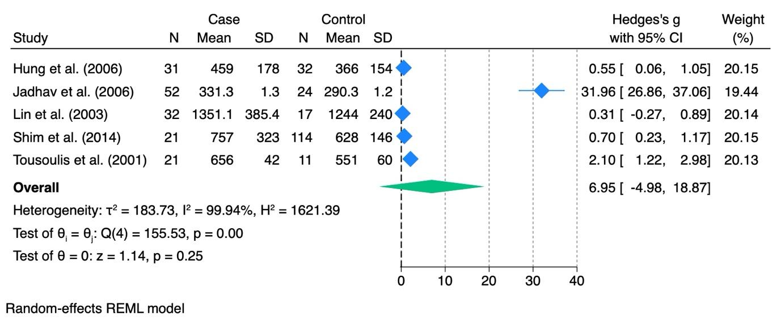

Supplemental Figure 2: Mean difference in ICAM-1 serum concentrations (ng/mL) between patients with INOCA disease (CMD and VSA) and healthy control.
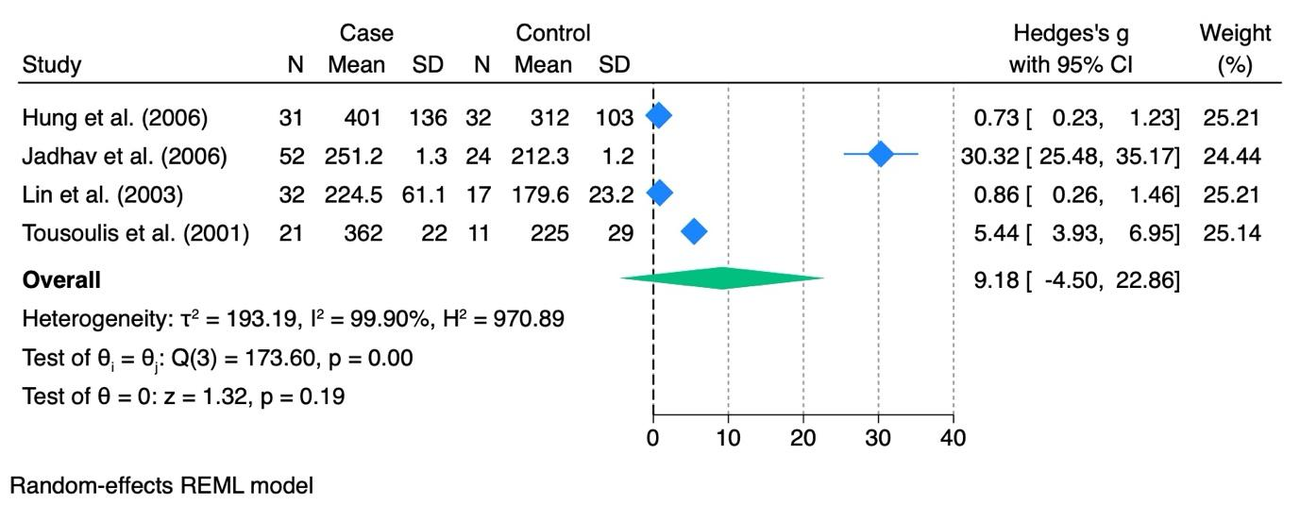

Supplemental Figure 3: Mean difference in IL-6 serum concentrations (pg/mL) between patients with INOCA disease (CMD and VSA) and healthy control.
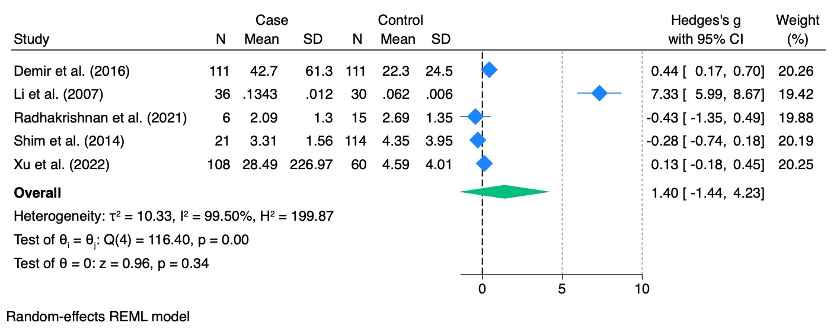
Supplemental Figure 4: Mean difference in UA serum concentrations (mg/dL) between patients with INOCA disease (CMD and VSA) and healthy control.
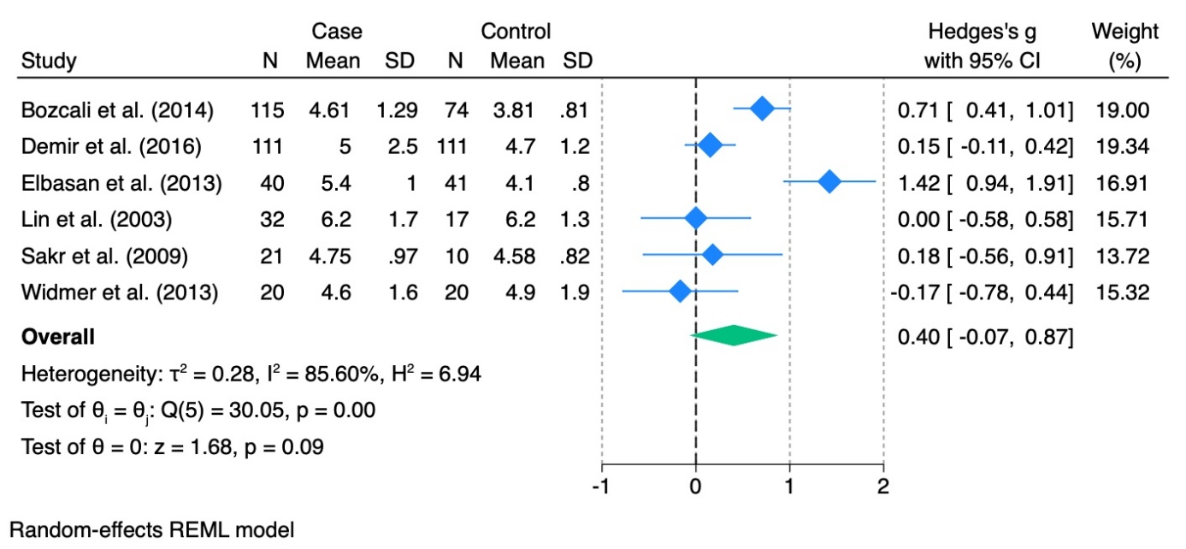

Supplemental Figure 5: Mean difference in HbA1c serum concentrations (%) between patients with INOCA disease (CMD and VSA) and healthy control.
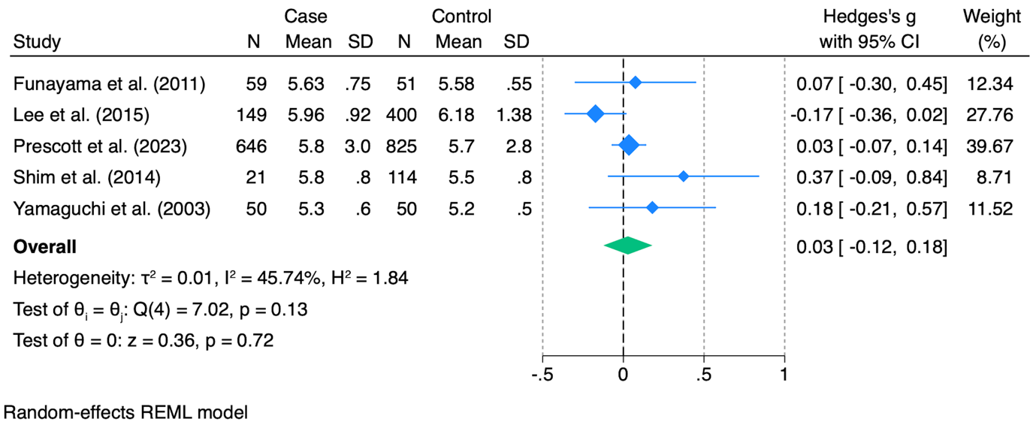

Supplemental Figure 6: Funnel Plot of CRP Levels in VSA vs. Controls: Assessing Publication Bias.
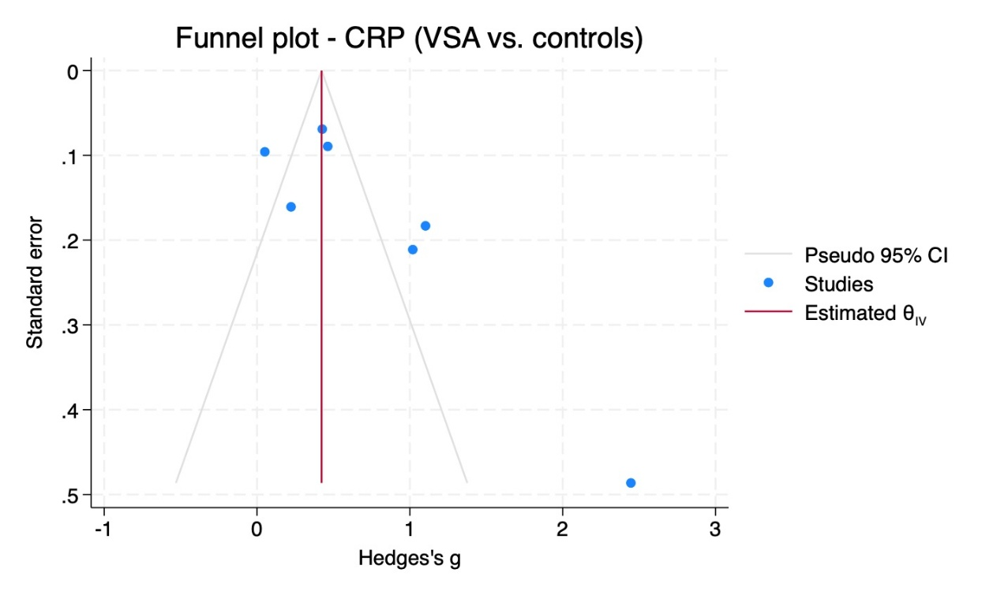
Supplemental Figure 7: Funnel Plot of CRP Levels in CMD vs. Controls: Assessing Publication Bias.
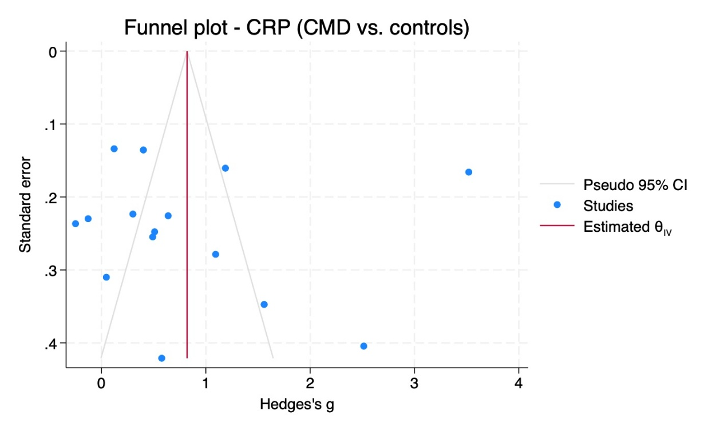
Supplemental Figure 8: Funnel Plot of VCAM-1 Levels in CMD and VSA vs. Controls: Assessing Publication Bias.
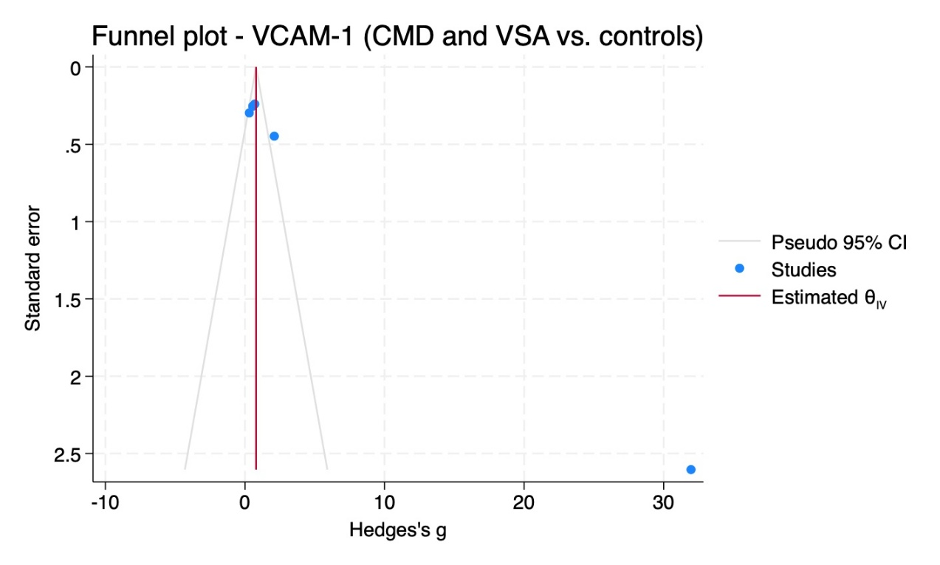
Supplemental Figure 9: Funnel Plot of VCAM-1 Levels in CMD vs. Controls: Assessing Publication Bias.
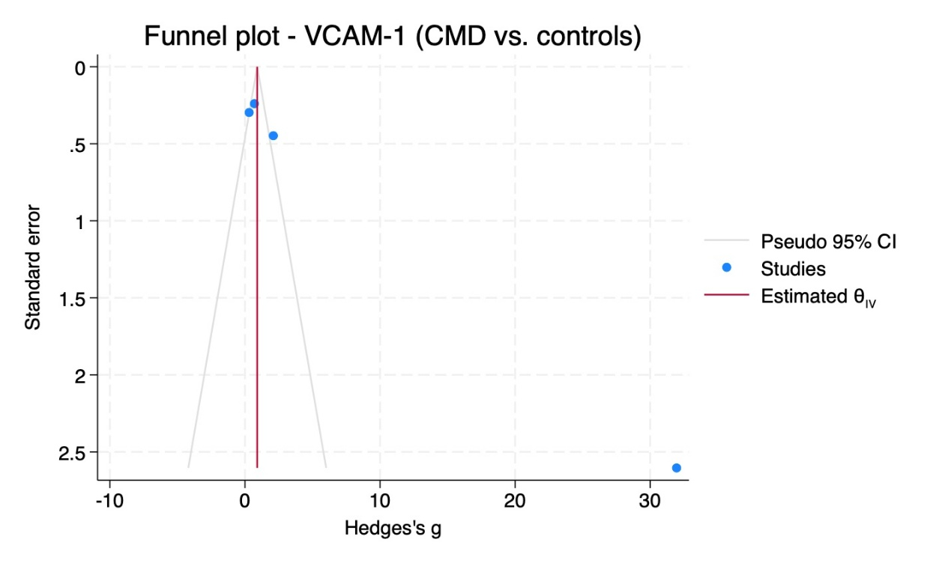
Supplemental Figure 10: Funnel Plot of UA Levels in CMD vs. Controls: Assessing Publication Bias.
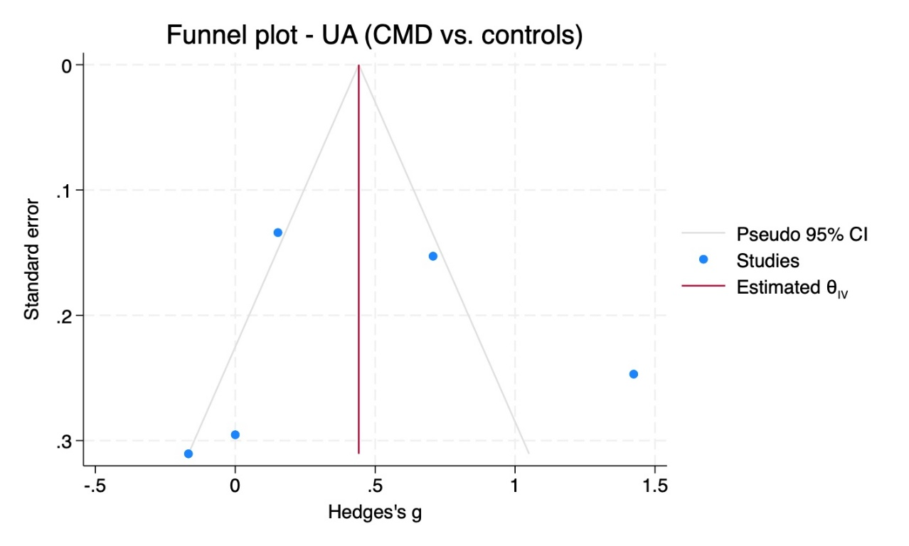
Supplemental Figure 11: Funnel Plot of UA Levels in CMD and VSA vs. Controls: Assessing Publication Bias.
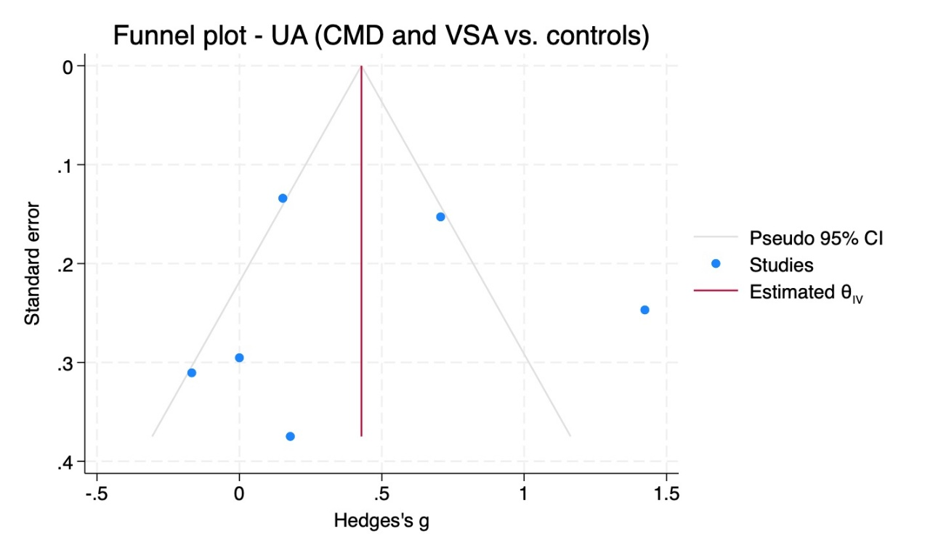
Supplemental Figure 12: Funnel Plot of IL-6 Levels in CMD vs. Controls: Assessing Publication Bias.

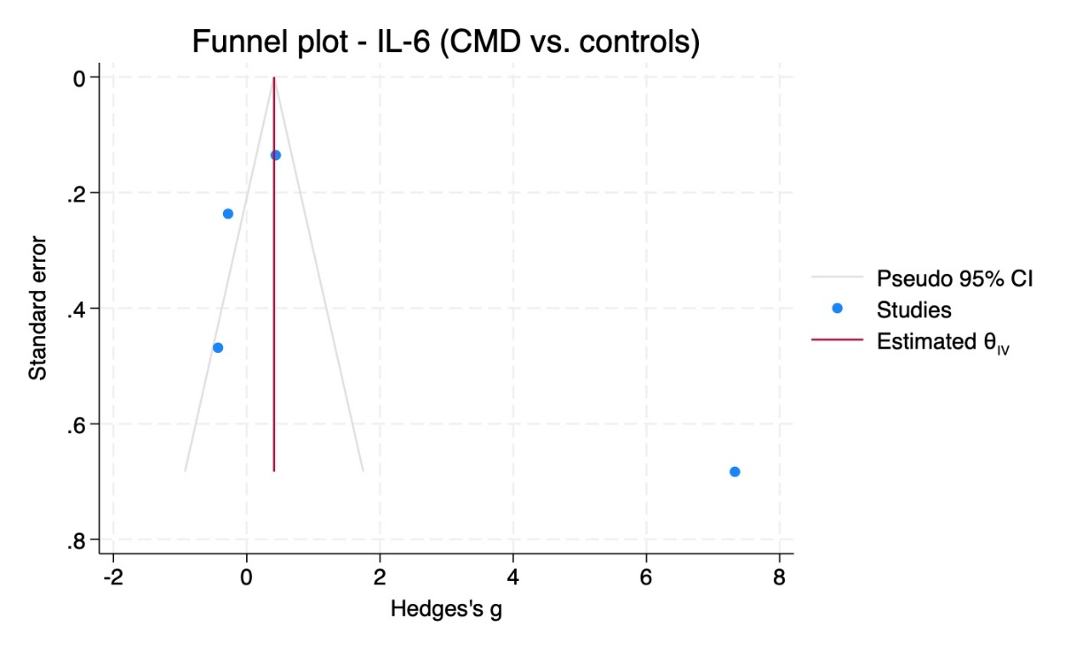
Supplemental Figure 13: Funnel Plot of IL-6 Levels in CMD and VSA vs. Controls: Assessing Publication Bias.

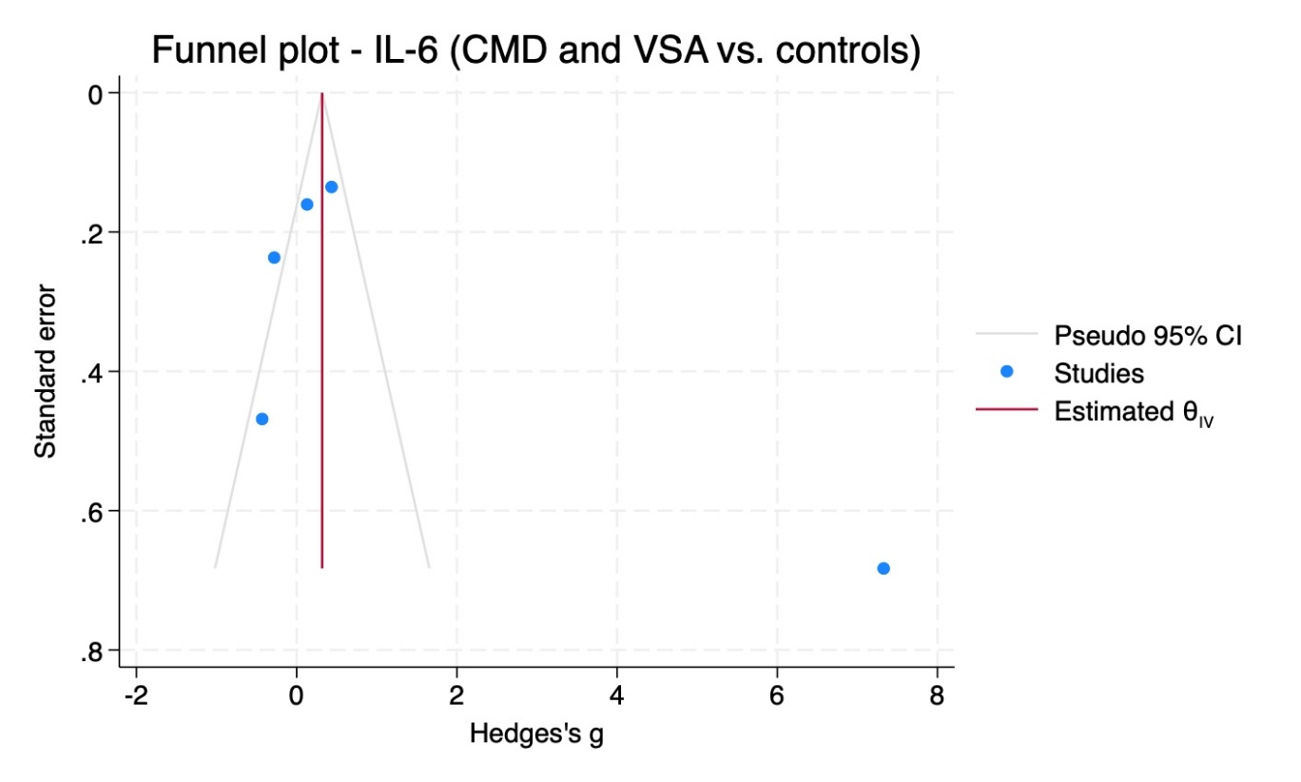
Supplemental Figure 14: Funnel Plot of ICAM-1 Levels in CMD and VSA vs. Controls: Assessing Publication Bias.

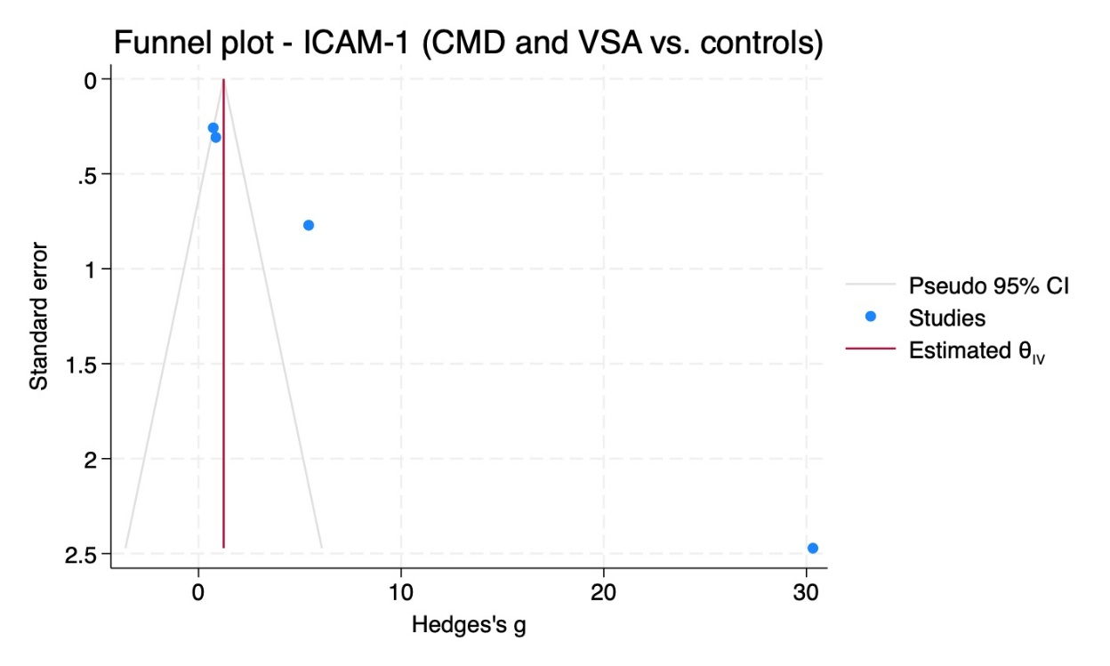
Supplemental Figure 15: Funnel Plot of ICAM-1 Levels in CMD vs. Controls: Assessing Publication Bias.
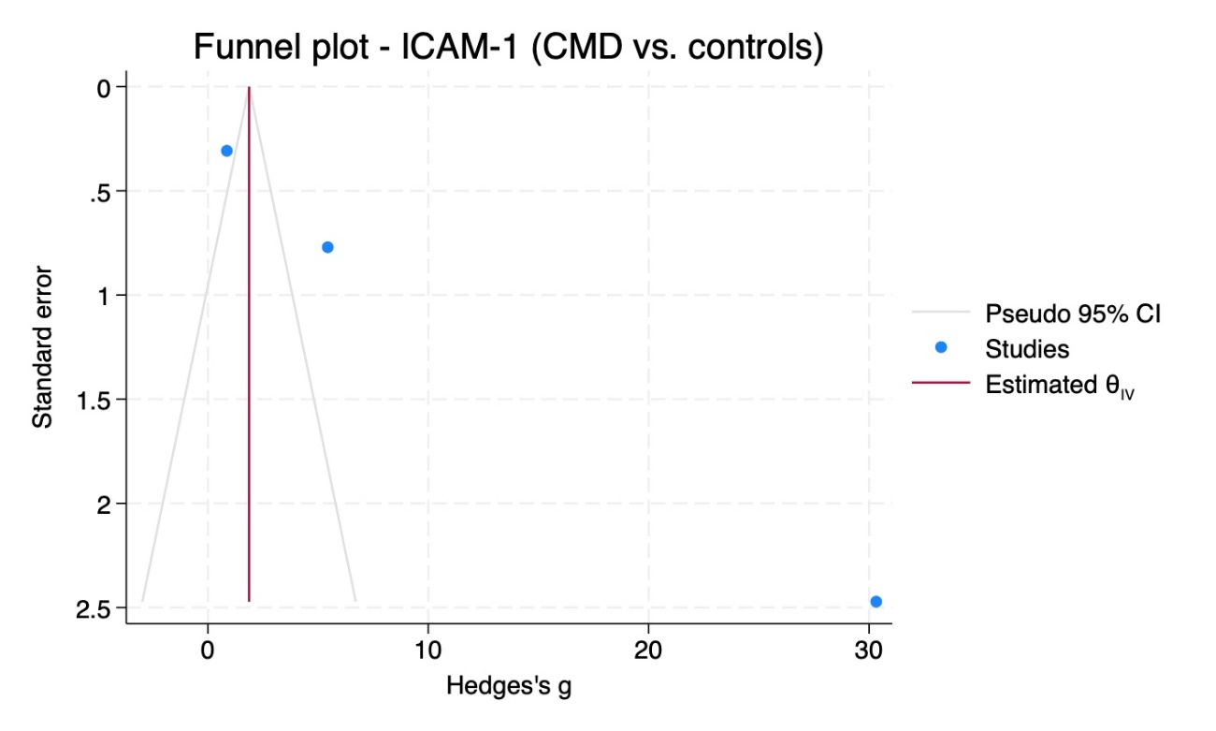
Supplemental Figure 16: Funnel Plot of HbA1c Levels in CMD and VSA vs. Controls: Assessing Publication Bias.

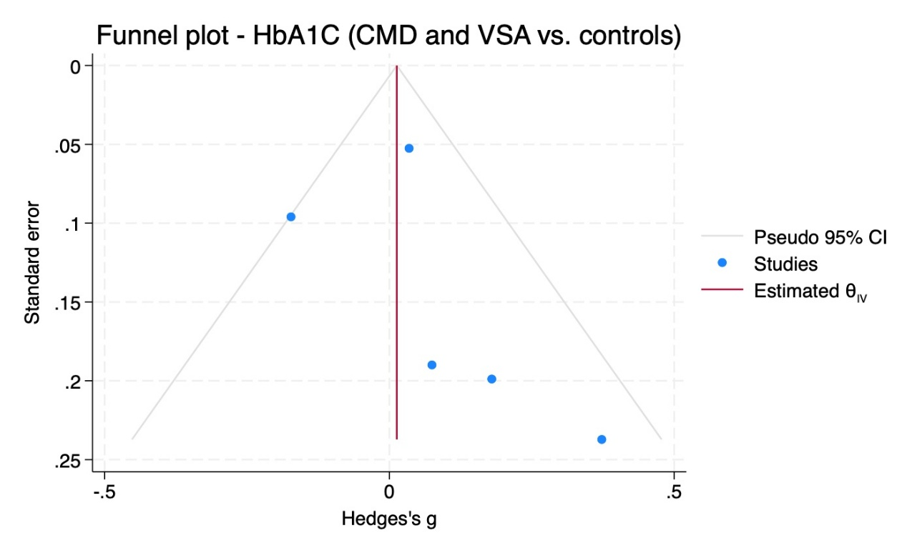

Supplemental Figure 17: Risk of Bias Assessment for Included Studies using ROBINS-I tool.
