Diverging carbonate budgets following tropicalisation of temperate reefs

Supplementary information

Methods

Calcification rate equations
Rates were normalised to the total bioactive surface area measured using geometric estimation (Table S1) [1, 2]. To determine the mass (±0.005g) of the coral in air from the buoyant weight in seawater, the following equation [3] was used:
$$M_{air}=\frac{M_{SW}ρ_{{CaCO}_{3}}}{ρ_{{CaCO}_{3}}-ρ_{SW}}$$
where M_{air} is the mass of skeletal CaCO₃, M_{sw} is the mass of the sample in seawater (buoyant weight), ρ_{CaCO3} is the density of the dominant skeletal mineral (2.93 g cm⁻³ for aragonite) and ρ_{sw} is the density of seawater. Calcification rate between two measurement times was then calculated following [3]:
$$Gnet=\frac{2∆M_{air}}{t(S_{t1}+S_{t2})}$$
where t is the number of days between two measurement times, S_{t1} and S_{t2} are the bioactive surface of the coral at the measurement t₁ and t₂. G_{net} results in the calcification rate of a sample between two sampling times of known surface area (g cm⁻² yr⁻¹)

Table S1 – Surface area measurement estimated by geometric growth group. Planar surface for plating Acropora sp and Turbinaria sp were obtained on ImageJ. SA= Surface Area; SA_{tot}= Surface Area Total; SA_{planar}= Surface Area planar obtained on ImageJ; SA_{foot}= Surface Area of the basement of Turbinaria sp.
Group | Geometric growth type | Morphometric equations to estimate the surface area rate (mgCaCO₃ cm⁻² d⁻¹)
Branching – Acropora yongei | 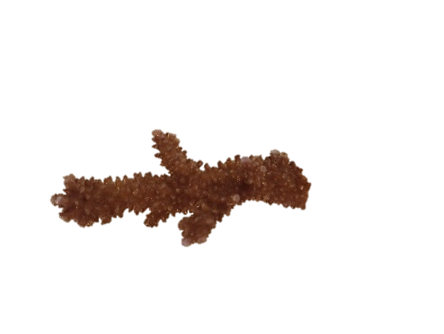  Cylindrical  r  h | SA_{branch}=2*π*r* h  SA_{tot}= SA_{branch}*n_{branch}  Where:  r = branch radius  h = height of the branch  SA= Surface Area  n= number of branchs
Plating – Acropora spp | Quadrilateral  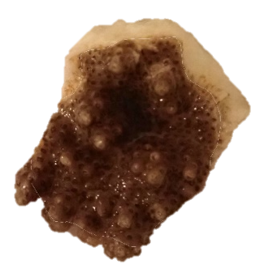  h  x3 | SA_{planar} -> Image J  SA_{branch} = $\frac{3* (2*π*r* h) }{3}$  SA_{tot} = SA_{branch} * n_{branch} + SA_{planar}*h  Where:  SA_{planar} = surface of the top of the plating coral
Plating – Turbinaria spp | 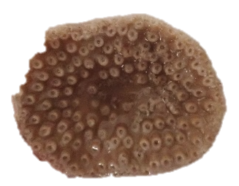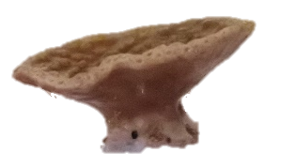 | SA_{planar} -> Image J  SA_{foot} = 2*π*r* h  SA_{tot} = SA_{planar} + SA_{foot}
Massive – Coelestra aspera | Hemisphere  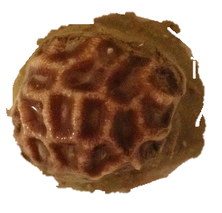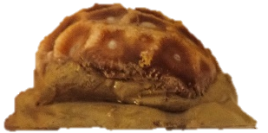  c  b  a | SA = 0.5*4π *($\frac{a^{1.6075}*b^{1.6075}+ a^{1.6075}*c^{1.6075}+b^{1.6075}*c^{1.6075}}{3}$)  SA_{tot}=${SA}^{\frac{1}{1.6075}}$

Table S2 – Calcification rates obtained by the buoyant-weight method used in this study
Species | Calcification rate (g cm⁻² yr⁻¹) | Location | Reference
CCA | 0.06 | Perth | Pessarrodona et al., 2024
Pocillopora sp | 0.23 | Rottnest Island | Ross et al. 2015
Amphiroa tribulus | 0.16 | Tank experiment | Vasquez-Elizondo and Enriquez 2016
Acropora yongei | 0.37 | Port Gregory | This study
Acropora sp (plating) | 0.54 | Port Gregory | This study
Turbinaria sp | 0.40 | Port Gregory | This study
Coelestra aspera | 0.42 | Port Gregory | This study

Table S3 – Results from pairwise comparison after fitting a GLMM (percentage cover, all calcifying organisms confounded)
Contrast | Estimate | SE | z.ratio | p.value
Temperate kelp - Transition stage | 1.773 | 0.406 | 4.368 | 0.0001
Temperate kelp - Warmer-affinity seaweeds | 2.526 | 0.427 | 5.911 | <.0001
Temperate kelp - Turf/coral | 0.828 | 0.411 | 2.015 | 0.1823
Transition stage - Warmer-affinity seaweeds | 0.753 | 0.406 | 1.854 | 0.2482
Transition stage - Turf/coral | -0.945 | 0.389 | -2.430 | 0.0715
Warmer-affinity seaweeds - Turf/coral | -1.698 | 0.412 | -4.125 | 0.0002

Table S4 – Results for the SIMPER comparing percentage cover of different organisms between states
Group | Average Contribution | Standard Deviation | Contribution Ratio | Cumulative % Contribution | p-value | Significance

Turf/coral vs Transition stage
CCA | 0.29 | 0.23 | 1.26 | 0.38 | 1.000
Encrusting | 0.15 | 0.14 | 1.10 | 0.57 | 0.001 | ***
Acropora plating | 0.12 | 0.15 | 0.82 | 0.73 | 0.001 | ***
Massive | 0.11 | 0.12 | 0.88 | 0.88 | 0.001 | ***
Turbinaria | 0.05 | 0.06 | 0.79 | 0.94 | 0.005 | **
Acropora branching | 0.02 | 0.04 | 0.43 | 0.97 | 0.001 | ***
Other branching | 0.01 | 0.03 | 0.38 | 0.98 | 0.005 | **
Articulated Macroalgae | 0.01 | 0.02 | 0.52 | 1.00 | 1.000

Turf/coral vs Warmer-affinity seaweeds
CCA | 0.22 | 0.20 | 1.09 | 0.28 | 1.000
Encrusting | 0.17 | 0.15 | 1.18 | 0.50 | 0.001 | ***
Massive | 0.14 | 0.14 | 0.97 | 0.68 | 0.001 | ***
Acropora plating | 0.14 | 0.16 | 0.85 | 0.85 | 0.001 | ***
Turbinaria | 0.06 | 0.07 | 0.81 | 0.93 | 0.008 | **
Articulated Macroalgae | 0.022 | 0.03 | 0.61 | 0.96 | 0.960
Acropora branching | 0.02 | 0.04 | 0.44 | 0.98 | 0.009 | **
Other branching | 0.01 | 0.03 | 0.36 | 1.00 | 0.106

Turf/coral vs Temperate kelp
CCA | 0.51 | 0.26 | 1.97 | 0.62 | 0.005 | **
Encrusting | 0.08 | 0.09 | 0.85 | 0.72 | 0.348
Acropora plating | 0.07 | 0.09 | 0.70 | 0.80 | 0.265
Massive | 0.05 | 0.07 | 0.76 | 0.87 | 0.887
Articulated Macroalgae | 0.05 | 0.06 | 0.90 | 0.94 | 0.015 | *
Turbinaria | 0.03 | 0.04 | 0.67 | 0.97 | 0.773
Acropora branching | 0.01 | 0.03 | 0.40 | 0.99 | 0.266
Other branching | 0.001 | 0.02 | 0.34 | 1.00 | 0.367

Transition stage vs Warmer-affinity seaweeds
CCA | 0.47 | 0.26 | 1.81 | 0.73 | 0.068 | .
Massive | 0.07 | 0.11 | 0.66 | 0.85 | 0.611
Turbinaria | 0.03 | 0.07 | 0.44 | 0.90 | 0.607
Articulated Macroalgae | 0.03 | 0.05 | 0.64 | 0.95 | 0.629
Encrusting | 0.02 | 0.05 | 0.45 | 0.99 | 1.000
Other branching | 0.002 | 0.01 | 0.19 | 1.00 | 0.850

Transition stage vs Temperate kelp
CCA | 0.59 | 0.26 | 2.22 | 0.82 | 0.001 | ***
Articulated Macroalgae | 0.07 | 0.08 | 0.89 | 0.92 | 0.001 | ***
Massive | 0.03 | 0.04 | 0.72 | 0.96 | 1.000
Turbinaria | 0.01 | 0.04 | 0.40 | 0.99 | 0.995
Encrusting | 0.005 | 0.01 | 0.34 | 0.99 | 1.000

Warmer-affinity seaweeds vs Temperate kelp
CCA | 0.68 | 0.23 | 2.86 | 0.84 | 0.001 | ***
Articulated Macroalgae | 0.08 | 0.08 | 0.93 | 0.93 | 0.001 | ***
Massive | 0.03 | 0.04 | 0.71 | 0.97 | 0.996
Turbinaria | 0.01 | 0.04 | 0.27 | 0.99 | 0.988

Table S5 – Results from the Tuckey HSD pairwise test comparing the gross production across all states
Contrast | Estimate | SE | z.ratio | p.value
Warmer-affinity seaweeds - Transition stage | -1.46 | 0.352 | -4.162 | 0.0002
Warmer-affinity seaweeds - Turf/coral | -3.68 | 0.358 | -10.280 | <.0001
Warmer-affinity seaweeds - Temperate kelp | -2.54 | 0.379 | -6.703 | <.0001
Transition stage - Turf/coral | -2.22 | 0.325 | -6.817 | <.0001
Transition stage - Temperate kelp | -1.07 | 0.345 | -3.115 | 0.0100
Turf/coral - Temperate kelp | 1.14 | 0.352 | 3.252 | 0.0063

Table S6 – Results for the SIMPER comparing the calcium carbonate production of different organisms between states
Contrast | Average Contribution | Standard Deviation | Contribution Ratio | Cumulative % Contribution | p-value | Significance

Turf/coral vs Transition stage
Acropora plating | 0.26 | 0.25 | 1.02 | 30.3% | 0.001 | ***
Massive | 0.17 | 0.17 | 1.01 | 50.5% | 0.68
Turbinaria | 0.17 | 0.18 | 0.93 | 70.7% | 0.11
Encrusting | 0.15 | 0.10 | 1.49 | 87.9% | 0.001 | ***
CCA | 0.07 | 0.10 | 0.69 | 95.7% | 1.00
Acropora branching | 0.02 | 0.05 | 0.44 | 98.3% | 0.001 | ***
Other branching | 0.01 | 0.02 | 0.35 | 99.3% | 0.33
Articulated Macroalgae | 0.01 | 0.01 | 0.47 | 100% | 1.00

Turf/coral vs Warmer-affinity seaweeds
Acropora plating | 0.28 | 0.27 | 1.03 | 29.7% | 0.001 | ***
Massive | 0.21 | 0.20 | 1.06 | 52.5% | 0.09 | .
Turbinaria | 0.20 | 0.23 | 0.88 | 73.9% | 0.03 | *
Encrusting | 0.16 | 0.11 | 1.51 | 90.9% | 0.001 | ***
CCA | 0.05 | 0.07 | 0.66 | 95.9% | 1.00
Acropora branching | 0.02 | 0.05 | 0.45 | 98.4% | 0.02 | *
Articulated Macroalgae | 0.01 | 0.02 | 0.52 | 99.2% | 1.00
Other branching | 0.01 | 0.02 | 0.31 | 100% | 0.37

Turf/coral vs Temperate kelp
Acropora plating | 0.22 | 0.23 | 0.98 | 25.8% | 0.003 | **
Massive | 0.17 | 0.15 | 1.07 | 44.9% | 0.71
CCA | 0.16 | 0.16 | 0.98 | 63.0% | 0.93
Turbinaria | 0.14 | 0.15 | 0.91 | 79.2% | 0.60
Encrusting | 0.12 | 0.09 | 1.38 | 93.6% | 0.01 | **
Articulated Macroalgae | 0.03 | 0.03 | 0.88 | 97.0% | 0.68
Acropora branching | 0.02 | 0.04 | 0.44 | 99.2% | 0.10
Other branching | 0.01 | 0.02 | 0.31 | 100% | 0.43

Transition stage vs Warmer-affinity seaweeds
CCA | 0.29 | 0.27 | 1.08 | 37.0% | 0.004 | **
Massive | 0.20 | 0.22 | 0.88 | 62.7% | 0.21
Turbinaria | 0.19 | 0.29 | 0.65 | 87.1% | 0.06 | .
Encrusting | 0.06 | 0.11 | 0.52 | 94.8% | 0.97
Articulated Macroalgae | 0.03 | 0.05 | 0.62 | 99.2% | 0.46
Other branching | 0.01 | 0.03 | 0.21 | 100% | 0.46
Acropora branching | 0.00 | 0.00 | NaN | 100% | NA | NA
Acropora tabular | 0.00 | 0.00 | NaN | 100% | NA | NA

Transition stage vs Temperate kelp
CCA | 0.36 | 0.24 | 1.50 | 48.0% | 0.001 | ***
Massive | 0.19 | 0.19 | 0.97 | 72.7% | 0.45
Turbinaria | 0.11 | 0.18 | 0.65 | 87.8% | 0.88
Articulated Macroalgae | 0.07 | 0.06 | 1.27 | 97.3% | 0.001 | ***
Encrusting | 0.02 | 0.04 | 0.43 | 99.6% | 1.00
Other branching | 0.00 | 0.02 | 0.18 | 100% | 0.77
Acropora branching | 0.00 | 0.00 | NaN | 100% | NA
Acropora tabular | 0.00 | 0.00 | NaN | 100% | NA

Warmer-affinity seaweeds vs Temperate kelp
CCA | 0.50 | 0.29 | 1.73 | 59.1% | 0.001 | ***
Massive | 0.20 | 0.23 | 0.85 | 82.5% | 0.27
Articulated Macroalgae | 0.09 | 0.07 | 1.24 | 93.5% | 0.001 | ***
Turbinaria | 0.03 | 0.12 | 0.28 | 97.2% | 1.00
Encrusting | 0.02 | 0.07 | 0.36 | 100% | 1.00
Acropora branching | 0.00 | 0.00 | NaN | 100% | NA
Acropora tabular | 0.00 | 0.00 | NaN | 100% | NA
Other branching | 0.00 | 0.00 | NaN | 100% | NA

Figure S1 – Sea surface temperature
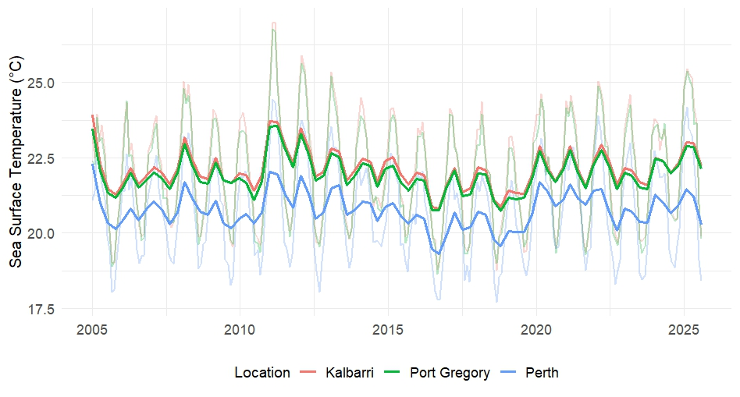
Figure S1: Monthly averaged sea surface temperature in Kalbarri, Port Gregory and Marmion from 2005 to 2024. These data are sourced from the NOAA Optimum Interpolation Sea Surface Temperature (OISST) dataset [4]

FigureS2 – In situ calcification rates
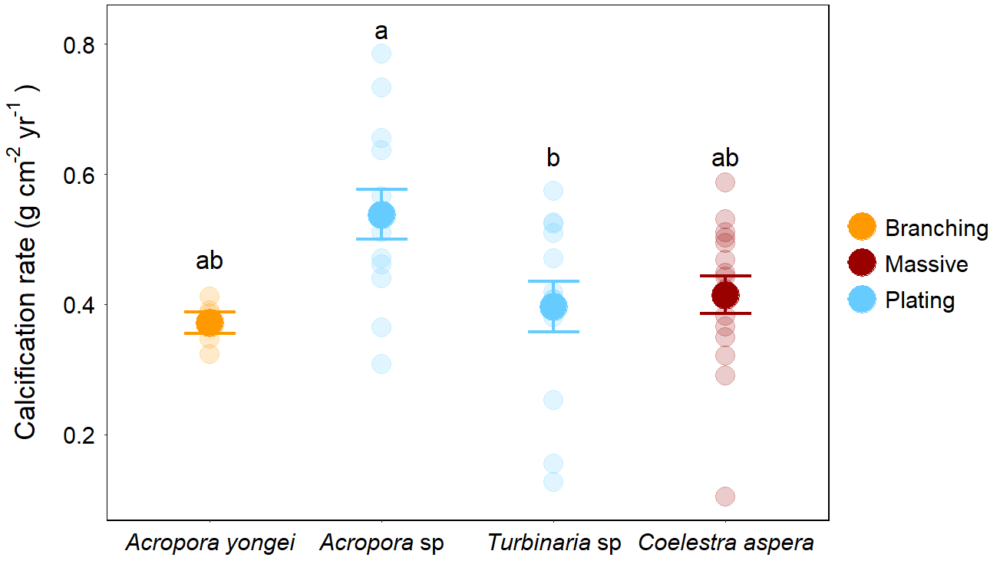
Figure S2. Comparison of calcification rates between dominant coral species. Calcification rate was normalised to the surface area (g cm⁻² yr⁻¹) of branching Acropora yongei (yellow), massive Coelestra aspera (red) and plating Acropora sp and Turbinaria sp (blue) in Port Gregory. Transparent dots show the individual-level calcification rate, opaque dots and error bars represent the mean and standard error at the species level. Letters show significant differences between species’ calcification rates from Tukey's HSD post-hoc test.

Figure S3 – Figure of the density of bioeroders across states
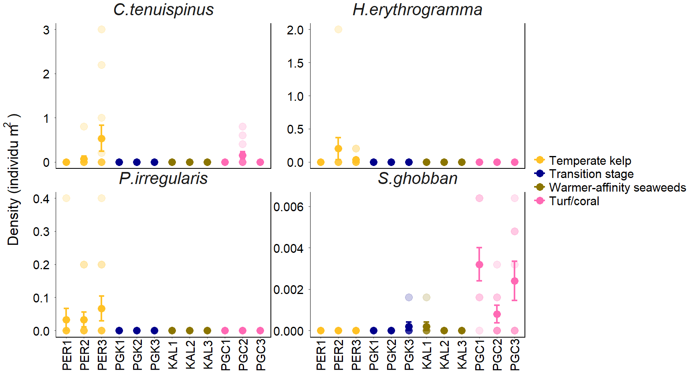
Figure S2: Density of urchins and parrotfish across sites. Transparent dots show the transect-level density (n= 12 per site) and full dots and error bars represent the mean and standard error at the site level. Colours show the different tropicalisation states.

References
[1] Naumann, M.S., Niggl, W., Laforsch, C., Glaser, C. & Wild, C. 2009 Coral surface area quantification–evaluation of established techniques by comparison with computer tomography. Coral Reefs 28, 109-117. (doi:10.1007/s00338-008-0459-3).
[2] González-Barrios, F.J. & Álvarez-Filip, L. 2018 A framework for measuring coral species-specific contribution to reef functioning in the Caribbean. Ecological Indicators 95, 877-886. (doi:10.1016/j.ecolind.2018.08.038).
[3] Jokiel, R.L., Maragos, J.E. & Franzisket, L. 1978 Coral Buoyant Weight technique. Monogr. Oceanogr. Methodol. 5, 13.
[4] Richard W. Reynolds, Viva F. Banzon & Program, N.C. 2008 NOAA Optimum Interpolation 1/4 Degree Daily Sea Surface Temperature (OISST) Analysis, Version 2. (ed. N.N.C.f.E. Information.).

