Supplementary information for ‘Cheats can boost the success of an invading population’
Luke Lear¹*, Angus Buckling¹ and Elze Hesse¹.
¹Environment and Sustainability Institute, University of Exeter, Penryn, Cornwall, United Kingdom, TR10 9FE
*Corresponding author; email: L.M.Lear@exeter.ac.uk. Address: Environment and Sustainability Institute, University of Exeter, Penryn, Cornwall, United Kingdom, TR10 9FE
Article published in Proceedings of the Royal Society B with DOI 10.1098/rspb.2025.2355

Total siderophore and pyoverdine production by the two invading strains and the community.
To quantify the siderophore production of each of the 7 strains, we carried out liquid Chrome Azurol S (CAS) assays (Schwyn & Neilands 1987) on the cell-free supernatants of each strain grown in isolation (Fig. S1A). To do this, we first grew each strain in 6mL of 1/10th KB medium for 24 hours at 28℃. We then fully homogenised each culture, before measuring the OD₆₀₀ of a 200μl sample. Next, we centrifuged 1mL of each culture at 14.8k rpm for 4 minutes before mixing 100μl of the supernatant at a 1:1 ratio with CAS solution. Siderophore production was then estimated using: (1 − (Ai/Aref))/(OD₆₀₀)), where OD₆₀₀ = optical density of the pre-centrifuged culture and Ai = absorbance at 630 nm of the assay mixture (culture + CAS) and Aref = absorbance at 630 nm of reference mixture (diluted KB + CAS). We note that for the CAS assay, slight negative values can be found when a strain does not produce any iron-binding siderophores (Hesse et al. 2021). For each of the samples, pyoverdine production was also quantified as described in the main text (Fig. S1B). Three technical replicates were carried out per strain.

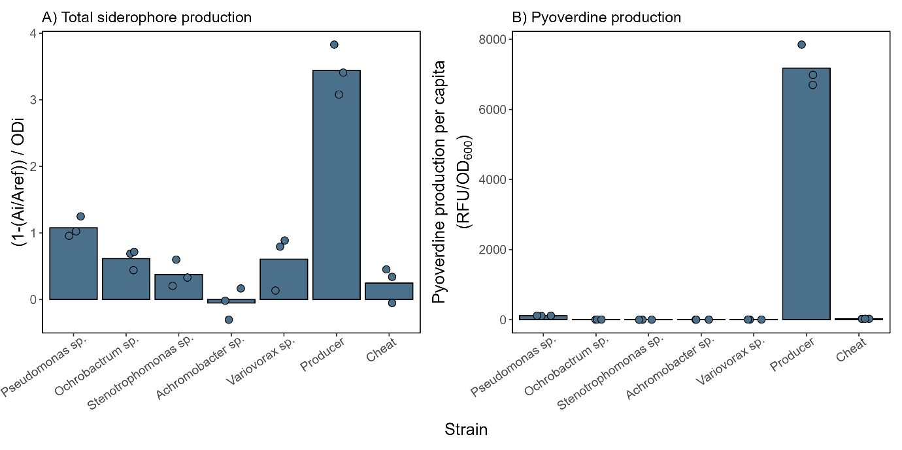
Figure S1 (A) Total siderophore production (Ai/Aref))/(OD₆₀₀)) and (B) pyoverdine production per capita (RFU/OD₆₀₀) by the seven strains used. The two invading strains – a pyoverdine producing strain and a non-producing cheat strain of Pseudomonas aeruginosa are shown as ‘producer’ and ‘cheat’, respectively. Quantification occurred after 24 hours growth in 1/10th KB medium. Circles show technical replicates (n = 3).

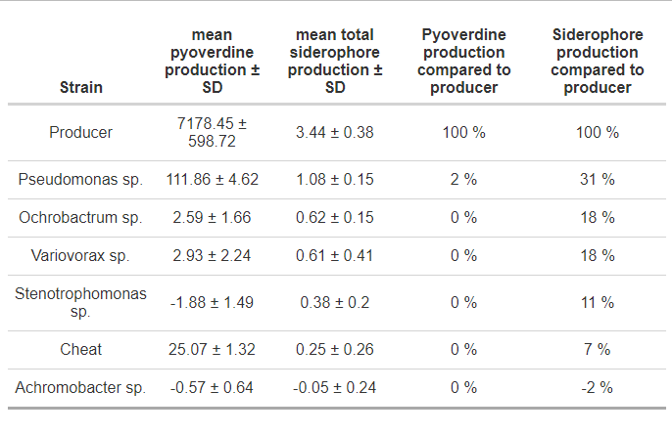

Table S1 Summary table of the pyoverdine and total siderophore production (quantified using a Chrome Azurol S (CAS) assay) of the seven ancestral strains used, ranked by total siderophore production. The Producer and Cheat are both strains of Pseudomonas aeruginosa: the producer is the wildtype and the cheat is an isogenic siderophore-deficient mutant strain that cannot produce pyoverdine, or the secondary siderophore pyochelin. Quantification occurred after 24 hours growth in 1/10th KB medium. Standard deviation (SD) is calculated from the three technical replicates.

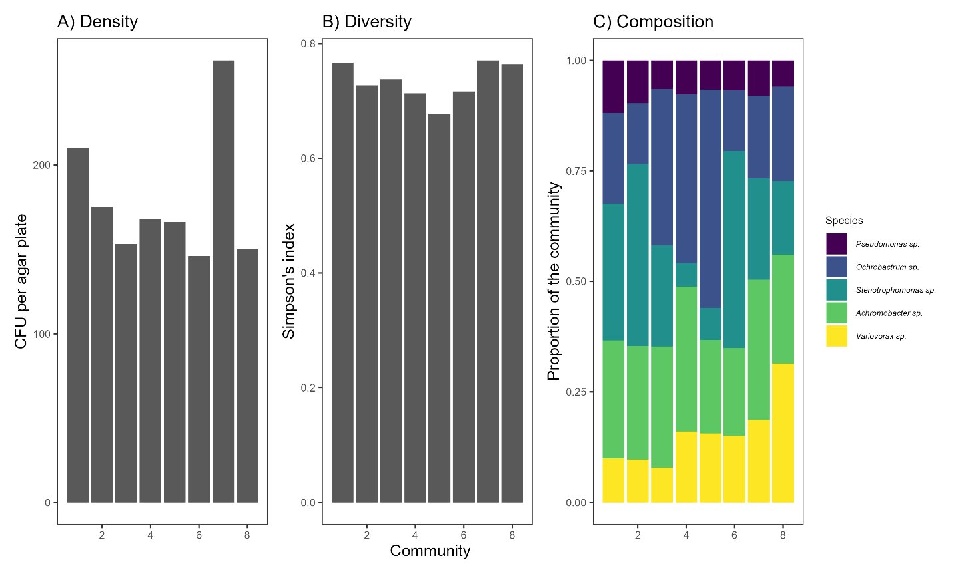
Density and composition of the 8-day resident communities pre-invasion.
Figure S2 Summary plots of the density and composition of the eight-day communities pre-invasion. The mean density ± SD on day 8 of 178.5 ± 39.2 CFU per plate is equal to 1.43 x 10⁹ per mL – only 8 CFU per plate different to the mean density on day 16 in the non-invaded copper-absent treatment of 186.6 ± 80.5.

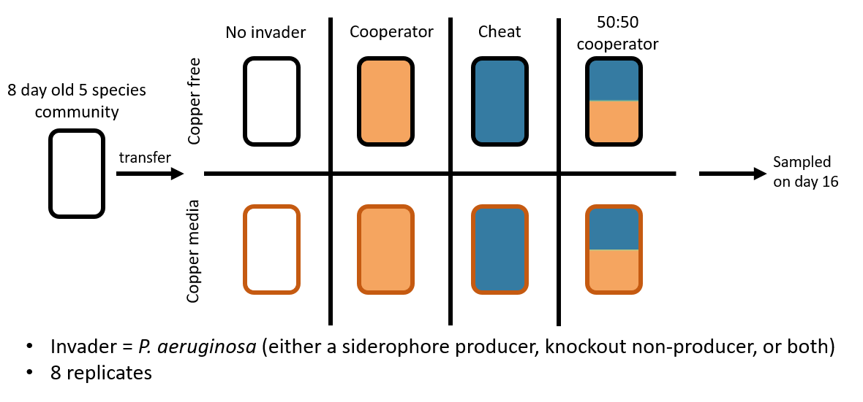
Figure S3 Schematic design used to test the importance of cooperation for the success of an invader. A community of five bacterial species was grown for eight days before being split into one of four invasion treatments (invaded with a siderophore producer, non-producer, 50:50 mix, or no invader) and two environment treatments (copper present or absent), each replicated eight times for a total of 64 microcosms. Samples were taken on day 16 by fully homogenising the cultures and freezing them.
Final densities of each resident species shown as their proportion of the community
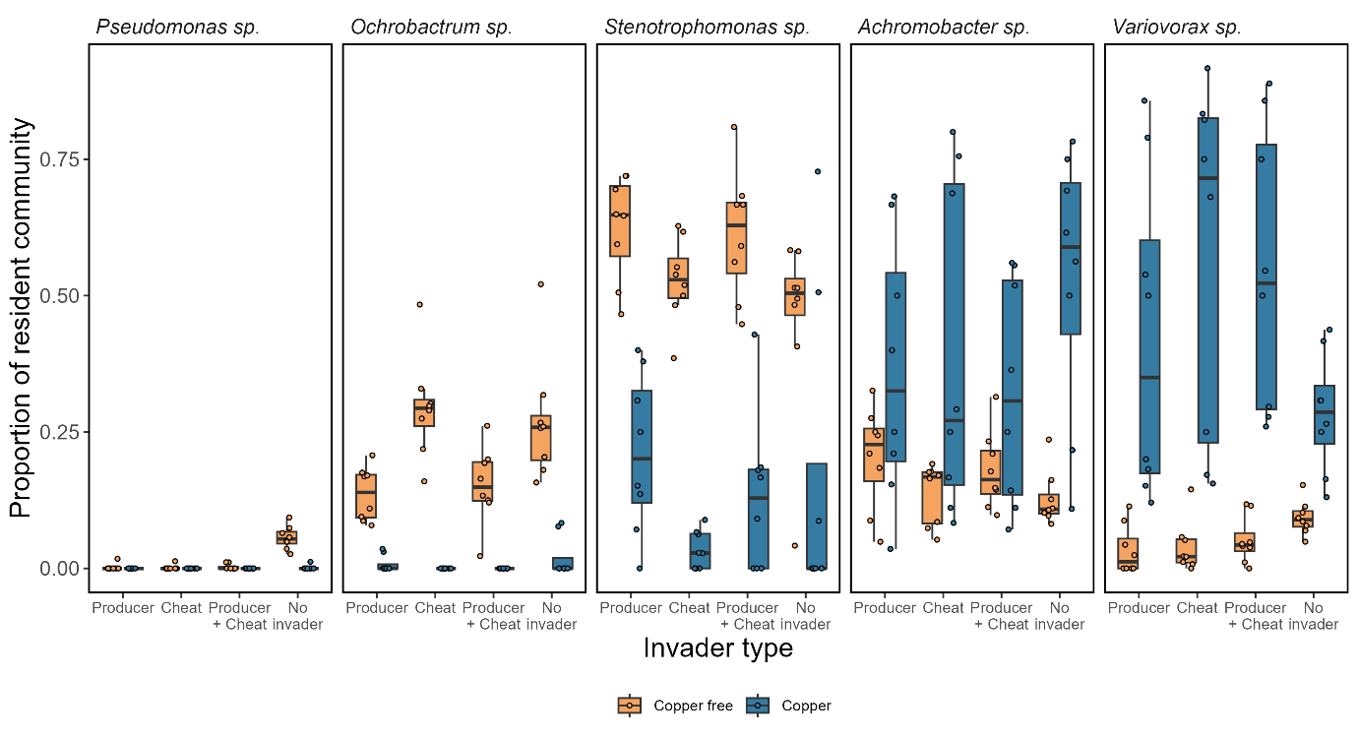
Figure S4 The proportion of each of the five resident species within the final communities (species density / total resident density). The raw CFU counts can be found in figure 5B of the main text. Invasions either took place in a copper-absent environment (orange boxes and circles) or a copper-rich environment containing 50µM of copper (blue boxes and circles). The circles show individual replicates (n=8).

References
1.
Hesse, E., O'Brien, S., Luján, A.M., Sanders, D., Bayer, F., van Veen, E.M. et al. (2021). Stress causes interspecific facilitation within a compost community. Ecology letters, 24, 2169-2177.
2.
Schwyn, B. & Neilands, J. (1987). Universal chemical assay for the detection and determination of siderophores. Analytical biochemistry, 160, 47-56.

