Original Research
Metabolic and Endurance Responses to Highly Branched Cyclic Dextrin with or without Protein During Soccer-Specific Intermittent Exercise
Ki-Tae Song¹, Ki-Woong Noh^{1, †}, Sok Park^{1,}*
¹ Institute of Exercise Medicine and Science, Kwangwoon University, Seoul 01897, Republic of Korea
Abstract
Background: Soccer match play progressively increases reliance on rapid carbohydrate turnover, while opportunities to ingest fluid and nutrients are largely confined to brief periods before kick-off and during the half-time interval. Highly branched cyclic dextrin (HBCD), a low-osmolality carbohydrate, may improve gastrointestinal tolerance and sustain exogenous carbohydrate delivery, and co-ingested protein (PRO) could further modulate metabolic regulation and fatigue. Methods: Eight male soccer players registered with the Korea Football Association completed a single-blind, randomized crossover trial with three conditions: placebo (PLA; water), HBCD alone (CHO), and isocaloric HBCD plus whey protein isolate (CHOP). Beverages (500 mL) were consumed in two equal doses before exercise and at half-time. Participants performed a treadmill-based, soccer-specific intermittent running protocol (six 15-min cycles) followed by a run-to-fatigue (RTF) bout at 80% V̇max. Respiratory exchange ratio (RER), carbohydrate and fat oxidation, heart rate (HR), rating of perceived exertion (RPE), digestive symptoms (DS), running time, and running distance were assessed using repeated-measures ANOVA with Tukey-adjusted pairwise comparisons. Results: Versus PLA, CHO produced higher RER and carbohydrate oxidation and lower fat oxidation in Cycle 6 (p < 0.05), indicating greater late-exercise carbohydrate reliance, but did not significantly improve RTF. CHOP lengthened time to exhaustion by ~120 sec compared with PLA (p < 0.05), with a similar, non-significant trend for running distance (p = 0.080), despite only modest differences in substrate use. HR, RPE, and DS were comparable among conditions, and gastrointestinal complaints remained low. Conclusion: A moderate HBCD dose before exercise and at half-time shifted substrate use toward greater carbohydrate dependence in the later stages of high-intensity intermittent running without additional cardiovascular or gastrointestinal strain, while co-ingestion of a small whey protein dose with isocaloric HBCD was associated with improved fatigue resistance in this soccer-specific setting.
Keywords
highly branched cyclic dextrin; carbohydrate supplementation; carbohydrate-protein co-ingestion; endurance capacity

Results
1. Respiratory Exchange Ratio (RER)
Across the intermittent exercise protocol, RER progressed in a predictable pattern of early stability, mid-exercise decline, and a subsequent rise toward the run-to-fatigue phase. Although most cycles did not reveal statistical differences, a significant condition effect emerged during Cycle 6 (p < 0.05), where CHO elicited higher RER than PLA. No other cycle demonstrated statistical significance, although CHO tended to show marginally elevated values relative to CHOP and PLA near the latter part of the second half (Table 1) (Fig 1).
Table 1. Descriptive statistics for RER by cycle and condition.
RER | Cycle (min) (mean ± SD)
RER | Cycle1  (0) | Cycle 2  (15) | Cycle 3  (30) | Cycle 4  (45) | Cycle 5  (75) | Cycle 6  (90) | Cycle 7  (RTF)
PLA | 0.8765  ± 0.0604 | 0.9069  ± 0.0342 | 0.9025  ± 0.0369 | 0.8892  ± 0.0377 | 0.8566  ± 0.0408 | 0.8647  ± 0.0415 | 0.8842  ± 0.0512
CHO | 0.9104  ± 0.0893 | 0.9503  ± 0.0611 | 0.9365  ± 0.0552 | 0.9207  ± 0.0539 | 0.9051  ± 0.0571 | 0.9244 *  ± 0.0517 | 0.9382  ± 0.0672
CHOP | 0.897  ± 0.0584 | 0.9158  ± 0.0281 | 0.905  ± 0.0276 | 0.8936  ± 0.0261 | 0.869  ± 0.0254 | 0.8869  ± 0.0278 | 0.9152  ± 0.0348
Values are presented as mean ± SD; n = 8. Tukey’s test was used to calculate p values. CHO test *, p < 0.05 compared with Placebo test. PLA, placebo; CHO, carbohydrate; CHOP, carbohydrate plus protein.
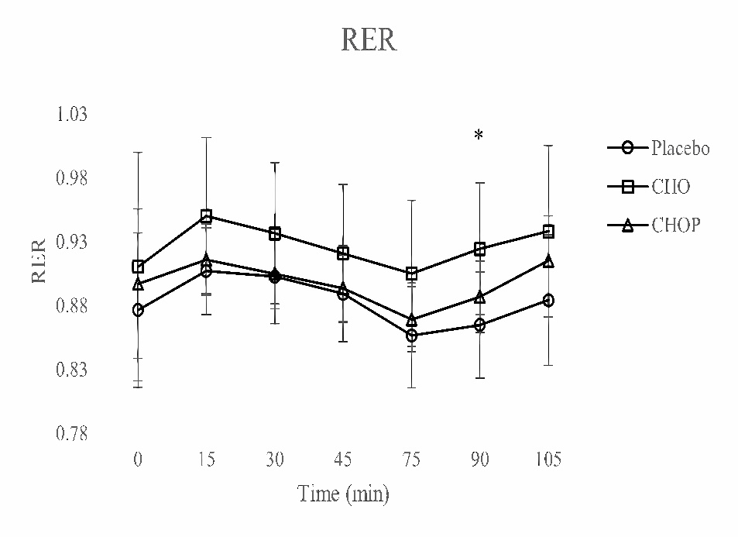
Fig 1. Between-Condition Comparison of RER (Mean ± SD) Across the Exercise Protocol. RER collected during soccer-specific intermittent exercise tests. Data are shown as mean ± SD, and a one-way analysis of variance (ANOVA) was performed. Tukey’s test was used to calculate p values. CHO test *, p < 0.05 compared with Placebo test.
2. Carbohydrate Oxidation Rate (CHOR)
Carbohydrate oxidation displayed its highest values early in exercise (Cycles 2–3), followed by a reduction around Cycle 5 and a rebound thereafter. A significant between-condition effect was identified at Cycle 6 (p < 0.05), with CHO producing markedly greater CHOR than PLA. Although CHOP showed intermediate values, only the CHO–PLA contrast reached significance. Other cycles showed no statistically meaningful differences but preserved the directional trend of CHO > CHOP > PLA during high workloads (Table 2) (Fig 2).
Table 2. Descriptive statistics for CHOR by cycle and condition.
CHOR | Cycle (min) (mean ± SD)
CHOR | C1  (0) | C2  (15) | C3  (30) | C4  (45) | C5  (75) | C6  (90) | C7  (RTF)
PLA | 58.26  ± 16.91 | 66.07  ± 9.72 | 64.97  ± 11.17 | 61.24  ± 2.05 | 51.33  ± 12.99 | 53.44  ± 13.66 | 59.91  ± 16.67
CHO | 65.23  ± 23.07 | 75.79  ± 10.87 | 73.81  ± 12.35 | 69.88  ± 13.66 | 65.53  ± 15.65 | 71.53*  ± 14.77 | 74.09  ± 16.66
CHOP | 63.78  ± 19.22 | 68.88  ± 7.89 | 66.63  ± 8.99 | 63.12  ± 8.54 | 55.25  ± 8.02 | 60.89  ± 9.01 | 70.35  ± 11.18
Values are presented as mean ± SD; n = 8. Tukey’s test was used to calculate p values. CHO test *, p < 0.05 compared with Placebo test. PLA, placebo; CHO, carbohydrate; CHOP, carbohydrate plus protein.
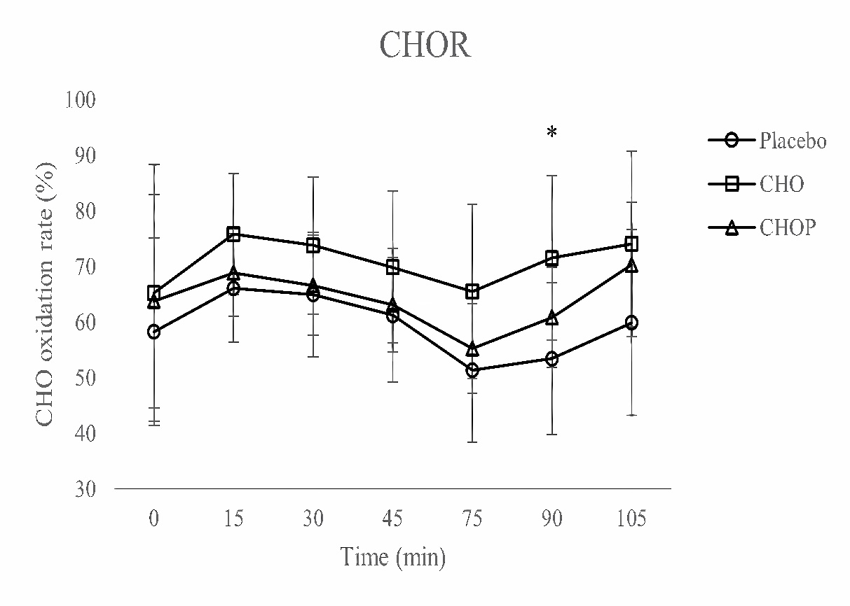

Fig 2. Between-Condition Comparison of CHOR (Mean ± SD) Across the Exercise Protocol. CHOR collected during soccer-specific intermittent exercise tests. Data are shown as mean ± SD, and a one-way analysis of variance (ANOVA) was performed. Tukey’s test was used to calculate p values. CHO test *, p < 0.05 compared with Placebo test.

3. Fat Oxidation Rate (FOR)
FOR demonstrated an inverse pattern to CHOR, decreasing sharply after Cycle 1, peaking around Cycle 5, and falling again during Cycles 6–7. A significant condition effect was observed at Cycle 6 (p < 0.05), reflecting greater fat oxidation in PLA compared with CHO. CHOP remained between the two conditions but did not differ significantly from either. No additional cycles yielded significant effects (Table 3) (Fig 3).
Table 3. Descriptive statistics for FOR by cycle and condition.
FOR | Cycle (min) (mean ± SD)
FOR | C1  (0) | C2  (15) | C3  (30) | C4  (45) | C5  (75) | C6  (90) | C7  (RTF)
PLA | 41.74  ± 16.91 | 33.93  ± 9.72 | 35.03  ± 11.17 | 38.76  ± 12.15 | 48.67  ± 12.99 | 46.56  ± 13.66 | 40.09  ± 16.67
CHO | 34.77  ± 23.07 | 24.21  ± 10.87 | 26.19  ± 12.35 | 30.12  ± 13.66 | 34.47  ± 15.65 | 28.48*  ± 14.77 | 25.91  ± 16.66
CHOP | 36.22  ± 19.22 | 31.12  ± 7.89 | 33.37  ± 7.89 | 36.88  ± 8.54 | 44.75  ± 8.02 | 39.11  ± 9.01 | 29.65  ± 11.18
Values are presented as mean ± SD; n = 8. Tukey’s test was used to calculate p values. CHO test *, p < 0.05 compared with Placebo test. PLA, placebo; CHO, carbohydrate; CHOP, carbohydrate plus protein.
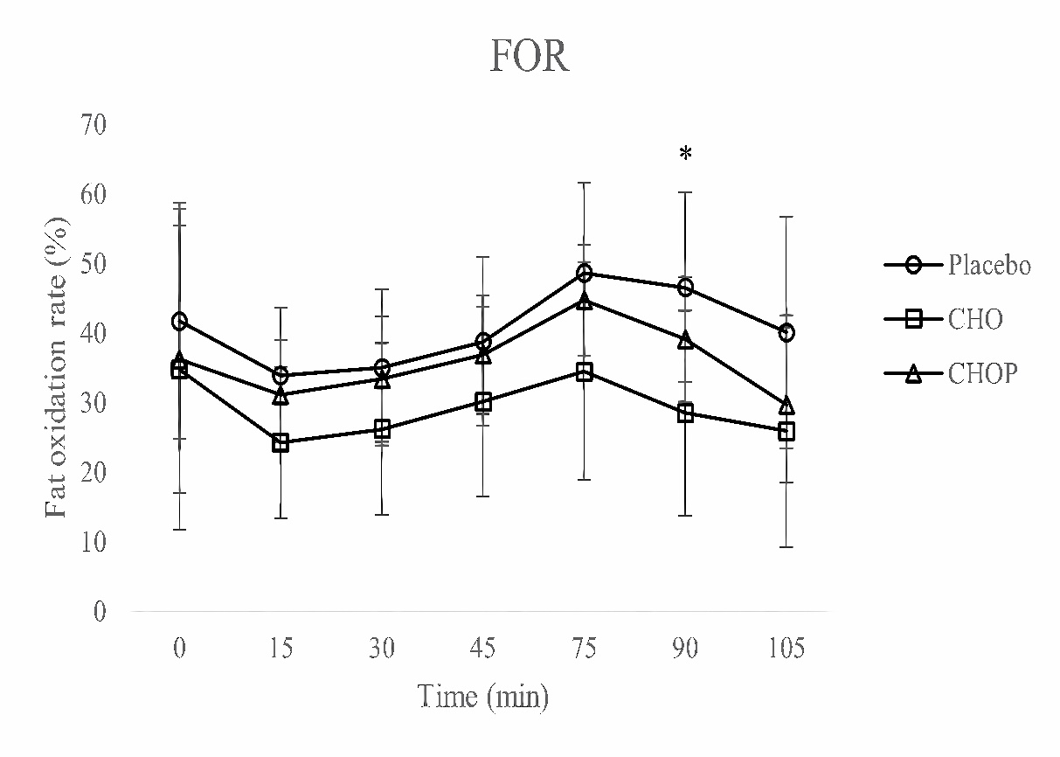

Fig 3. Between-Condition Comparison of FOR (Mean ± SD) Across the Exercise Protocol. FOR collected during soccer-specific intermittent exercise tests. Data are shown as mean ± SD, and a one-way analysis of variance (ANOVA) was performed. Tukey’s test was used to calculate p values. CHO test *, p < 0.05 compared with Placebo test.

4. Heart Rate (HR)
Heart-rate responses increased sharply at exercise onset and stabilized across the mid-exercise cycles before rising again during the fatigue run. Despite this physiologically appropriate progression, no between-condition differences emerged at any measurement point (all p > 0.05). Mean trajectories of HR across conditions overlapped closely, indicating that beverage type did not influence cardiovascular strain during standardized workloads (Table 4) (Fig 4).
Table 4. Descriptive statistics for HR by cycle and condition.
HR | Cycle (min) (mean ± SD)
HR | C1  (0) | C2  (15) | C3  (30) | C4  (45) | C5  (75) | C6  (90) | C7  (RTF)
PLA | 88.13  ± 10.41 | 146.39  ± 13.55 | 152.12  ± 14.94 | 155.4  ± 15.38 | 151.37  ± 14.94 | 157.04  ± 16.26 | 175.09  ± 12.04
CHO | 84.32  ± 11.11 | 142.89  ± 16.97 | 152.05  ± 18.48 | 156.84  ± 19.08 | 150.26  ± 18.37 | 155.8  ± 19.81 | 176.84  ± 11.09
CHOP | 88.58  ± 10.58 | 142.89  ± 12.27 | 151.61  ± 14.23 | 156  ± 15.52 | 150.27  ± 15.21 | 155.99  ± 15.85 | 179.97  ± 9.75
Values are presented as mean ± SD; n = 8. PLA, placebo; CHO, carbohydrate; CHOP, carbohydrate plus protein.
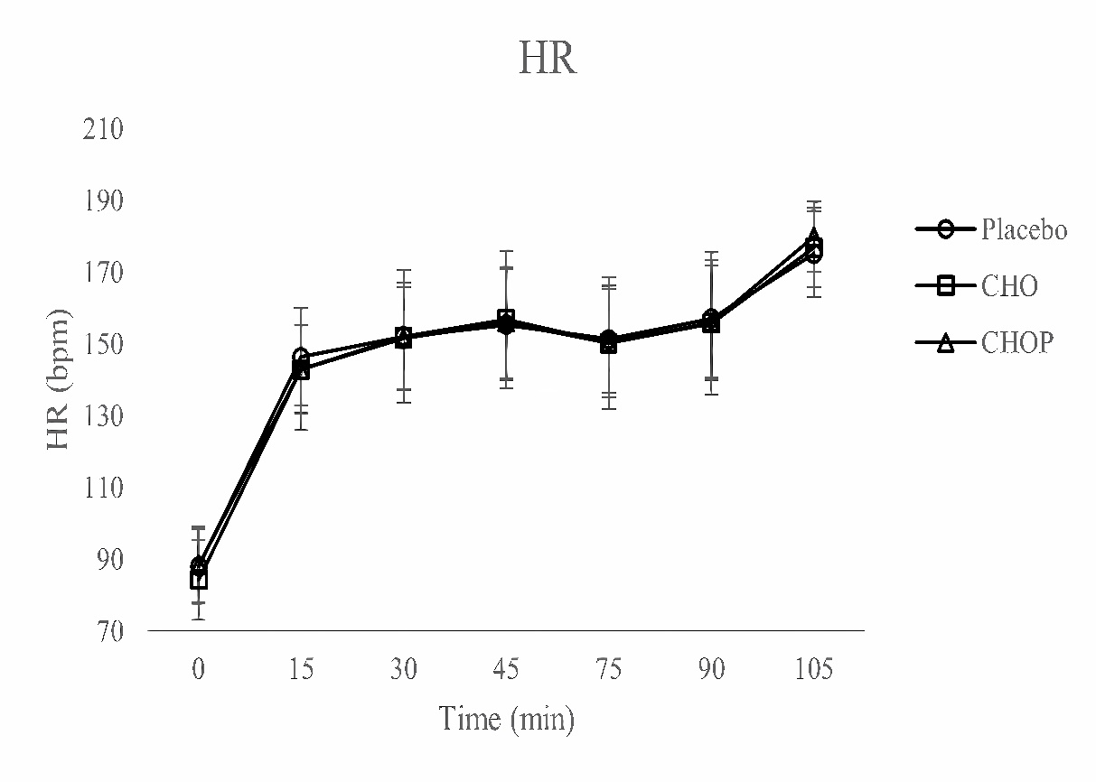

Fig 4. Between-Condition Comparison of HR (Mean ± SD) Across the Exercise Protocol. HR collected during soccer-specific intermittent exercise tests. Data are shown as mean ± SD, and a one-way ANOVA was performed.
5. Rating of Perceived Exertion (RPE)
RPE rose progressively with advancing exercise duration, briefly decreased at halftime, and escalated again during Cycles 6–7. Although descriptive values suggested that Cycle 6 RPE was highest in PLA and lowest in CHOP, none of these differences reached statistical significance (all p > 0.05). Thus, subjective exertion was broadly comparable across nutritional conditions (Table 5) (Fig 5).
Table 5. Descriptive statistics for RPE by cycle and condition.
RPE | Cycle (min) (mean ± SD)
RPE | C1  (0) | C2  (15) | C3  (30) | C4  (45) | Half-time  (60) | C5  (75) | C6  (90) | C7  (RTF)
PLA | 0.38  ± 0.74 | 4.13  ± 1.36 | 5.88  ± 1.12 | 6.75  ± 0.89 | 3.63  ± 2.13 | 6.5  ± 1.69 | 8.5  ± 1.41 | 9.25  ± 0.89
CHO | 0 | 3.13  ± 1.55 | 4.5  ± 1.07 | 6.38  ± 1.30 | 2.88  ± 1.55 | 5.63  ± 1.77 | 7.25  ± 1.58 | 9.25  ± 1.04
CHOP | 0 | 3.25  ± 1.49 | 4.63  ± 1.85 | 6  ± 1.60 | 2.88  ± 1.46 | 5.63  ± 1.6 | 6.75  ± 1.39 | 9  ± 0.93
Values are presented as mean ± SD; n = 8. PLA, placebo; CHO, carbohydrate; CHOP, carbohydrate plus protein.
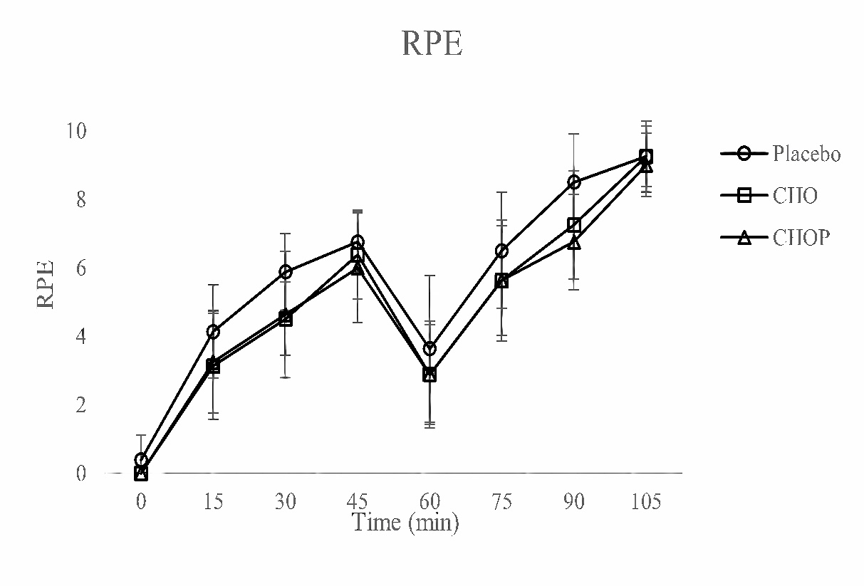
Fig 5. Between-Condition Comparison of RPE (Mean ± SD) Across the Exercise Protocol. RPE collected during soccer-specific intermittent exercise tests. Data are shown as mean ± SD, and a one-way ANOVA was performed.
6. Digestive Symptoms (DS)
DS remained minimal across all conditions and time points. All participants reported zero symptoms at Cycle 1, with only trivial increases thereafter. No statistical differences were observed at any cycle (p > 0.05), and symptom severity never reached levels indicative of compromised tolerance. This confirms that both CHO and CHOP formulations were well tolerated during prolonged intermittent exercise (Table 6) (Fig 6).
Table 6. Descriptive statistics for DS by cycle and condition.
DS | Cycle (min) (mean ± SD)
DS | C1  (0) | C2  (15) | C3  (30) | C4  (45) | Half-time  (60) | C5  (75) | C6  (90) | C7  (RTF)
PLA | 0 | 0.38  ± 0.74 | 1.5  ± 2.51 | 1  ± 2.14 | 0.38  ± 0.74 | 1.5  ± 3.12 | 2.13  ± 3.4 | 2.25  ± 2.77
CHO | 0 | 0.75  ± 1.49 | 0.88  ± 1.64 | 1.13  ± 1.25 | 0.25  ± 0.46 | 1.88  ± 2.7 | 1.13  ± 1.89 | 1.5  ± 1.69
CHOP | 0 | 0.75  ± 1.04 | 1.38  ± 2.39 | 2  ± 1.93 | 0.75  ± 1.17 | 1.88  ± 2.59 | 2.25  ± 2.66 | 2.75  ± 3.69
Values are presented as mean ± SD; n = 8. PLA, placebo; CHO, carbohydrate; CHOP, carbohydrate plus protein.
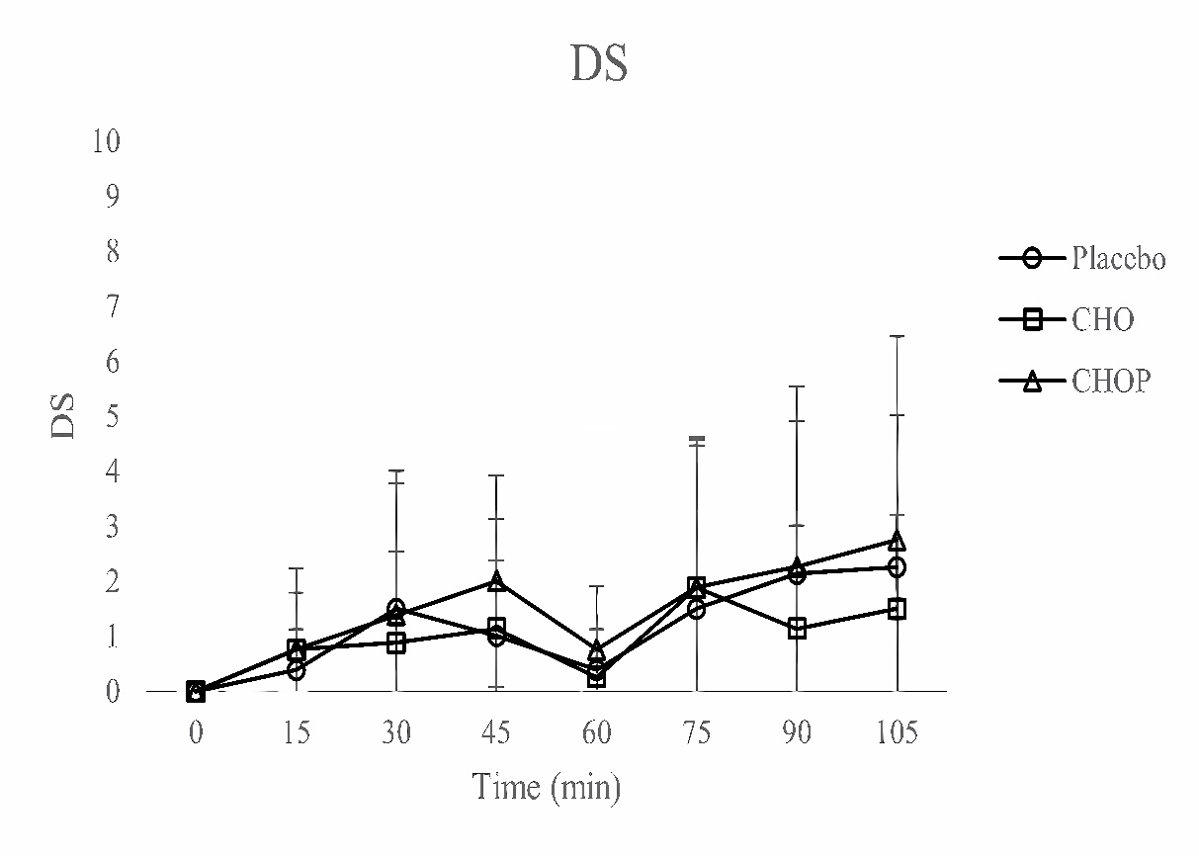
Fig 6. Between-Condition Comparison of DS (Mean ± SD) Across the Exercise Protocol. DS collected during soccer-specific intermittent exercise tests. Data are shown as mean ± SD, and a one-way ANOVA was performed.
7. Exercise Performance (running time & running distance)
Running time demonstrated a significant condition effect (p < 0.05), with CHOP extending total exercise duration relative to PLA (+119.25 s). CHO fell between the two but did not differ significantly from either. Running distance exhibited the same directional trend (CHOP > CHO > PLA), yet the overall effect did not meet statistical significance (p = 0.080) (Table 7) (Fig 7, 8).
Table 7. Descriptive statistics for exercise performance by cycle and condition.
 | PLA | CHO | CHOP
Running Time (sec) | 218.88 ± 71.04 | 265.38 ± 97.19 | 338.13 ± 99.94 †
Running Distance (meter) | 840.97 ± 304.37 | 1,020.92 ± 416.57 | 1,297.47 ± 423.37
Values are presented as mean ± SD; n = 8. Tukey’s test was used to calculate p values. CHOP test †, p < 0.05 compared with Placebo test. PLA, placebo; CHO, carbohydrate; CHOP, carbohydrate plus protein.
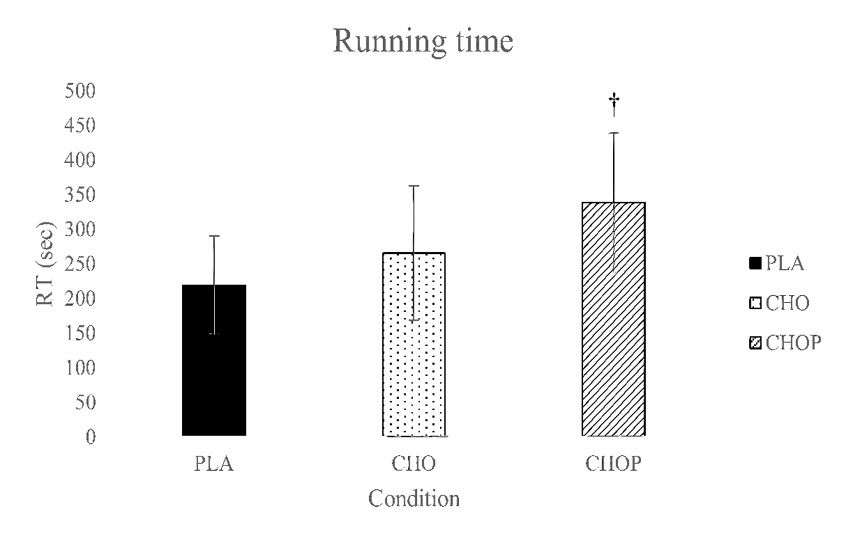

Fig 7. Between-Condition Comparison of RER (Mean ± SD) Across the RTF. Running time collected during RTF. Data are shown as mean ± SD, and one-way ANOVA was performed. Tukey’s test was used to calculate p values. CHOP test †, p < 0.05 compared with Placebo test.
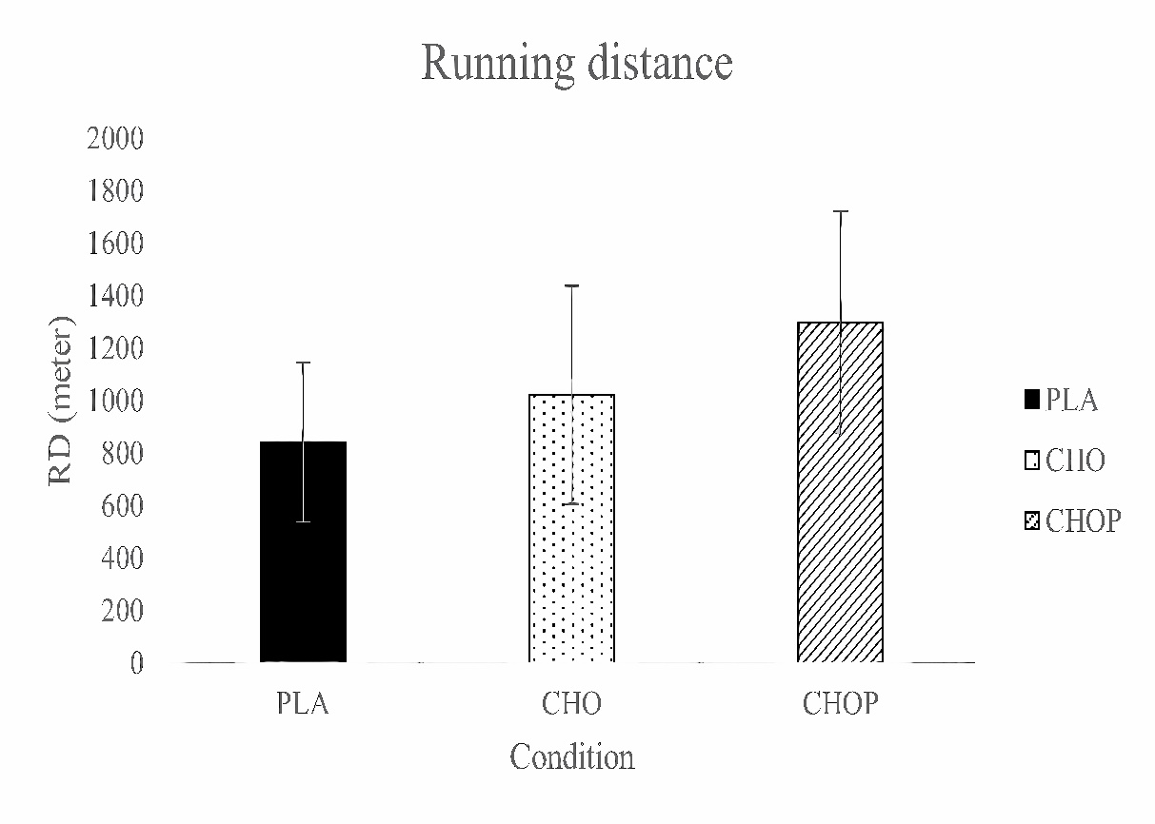

Fig 8. Between-Condition Comparison of RER (Mean ± SD) Across the RTF. Running distance collected during RTF. Data are shown as mean ± SD, and one-way ANOVA was performed.

