Supplementary material
Improved safety properties of cyclotrimethylene trinitramine through surface coating with 2,4-Dinitroanisole
Narges Zohari,^{*[a]} Seyed Mohammad Reza Mousavi ^{[a]} and Pouria Khakpour ^{[a]}

^{[a]}Faculty of Chemistry and Chemical Engineering, Malek Ashtar University of Technology, Tehran, Iran

*Corresponding author, e-mail: nargeszohari@gmail.com, nargeszohari@mut.ac.ir

1. Color Analysis of Coated and Uncoated Samples of RDX
RGB stands for Red, Green, Blue, and is an additive color model used in electronic devices like computer screens and televisions to produce a wide range of colors. In the RGB model, red, green, and blue lights are combined in varying intensities to create the desired color. Each color channel can have a value from 0 to 255, where 0 indicates no intensity and 255 represents the maximum intensity. By manipulating these values, millions of distinct colors can be achieved, allowing for a vibrant and diverse color palette in digital displays. Tables S-1 and S-2 indicate that the color spectra for both uncoated and coated RDX fall within the warm gray range, respectively. However, a noticeable color shift is observed on the surface of the coated material when considering the reported RGB values.

Table S-1. Reported Color and RGB Values for Uncoated Sample Percentages
Color | RGB | Characteristics / The percentage of color on the surface
Warm gray | 84 | 47.66
Warm gray | 102 | 31.64
Warm gray | 118 | 10.05
Warm gray | 133 | 5.17
Warm gray | 61 | 3.46
Warm gray | 150 | 1.32
Warm gray | 165 | 0.53
Warm gray | 180 | Less than 0.1
Warm gray | 204 | Less than 0.1
Warm gray | 235 | Less than 0.1

Table S-2. Reported Color and RGB Values for Sample Percentages with 10% Coverage
Color | RGB | Characteristics / The percentage of color on the surface
Warm gray | 58 | 30.51
Warm gray | 70 | 26.37
Warm gray | 87 | 24.90
Warm gray | 102 | 10.79
Warm gray | 118 | 3.58
Warm gray | 134 | 2.01
Warm gray | 150 | 1.20
Warm gray | 169 | 0.56
Warm gray | 195 | Less than 0.1
Warm gray | 216 | Less than 0.1

In the uncoated sample, the most prevalent RGB values are 84, 102, and 118, collectively accounting for nearly 80% of the color spectrum. However, upon applying the coating, these values undergo notable reductions, and new RGB values with high percentages emerge. Specifically, RGB = 84 decreases from 47.66% in the uncoated sample to 24.90% in the coated sample, shifting towards RGB = 87. RGB = 102 experiences a reduction as well, falling from 31.64% in the uncoated sample to 10.79% in the coated one. Meanwhile, RGB = 118 diminishes from 10.05% to a mere 3.58%. Conversely, RGB = 58 emerges as the highest value in the coated sample, signifying a new addition post-coating. The changes in RGB values and their respective percentages before and after coating provide clear evidence of a surface modification on the material.

2. FTIR Analysis
The FT-IR spectra of RDX, DNAN, and coated RDX with DNAN were obtained and presented in Figures S-1 to S-3. According to Figure S-3, the peak at 1160 cm⁻¹ corresponds to the stretching vibration of the nitro group in DNAN, which aligns with the structure of 2,4-dinitroanisole. Additionally, the peak at 1725 cm⁻¹ is attributed to the stretching vibration of a carbonyl group, suggesting the presence of a carbonyl moiety in the coated RDX material. This observation implies a potential interaction between RDX and DNAN, resulting in the introduction of the carbonyl group.

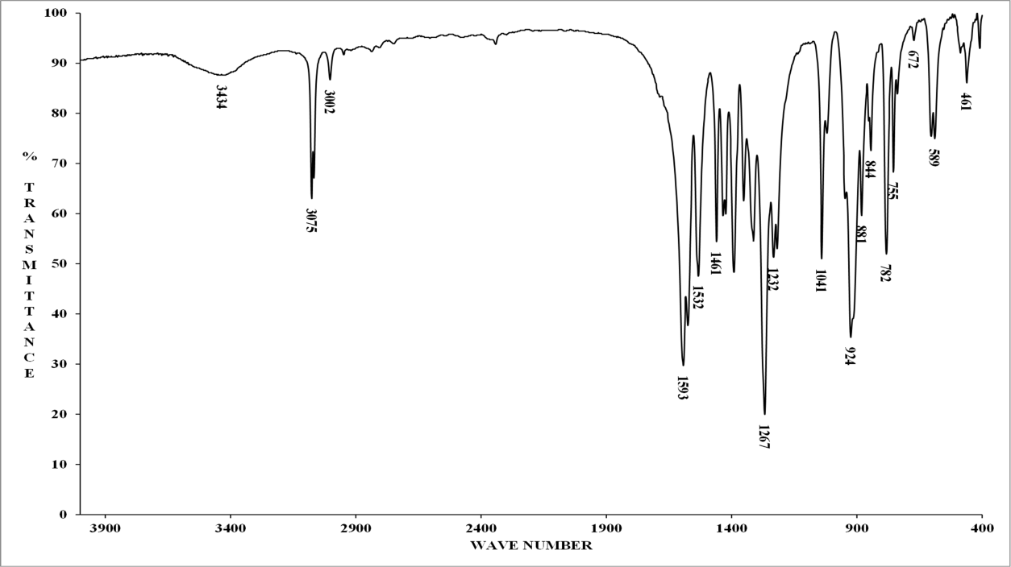
Figure S-1. FT-IR spectrum of RDX

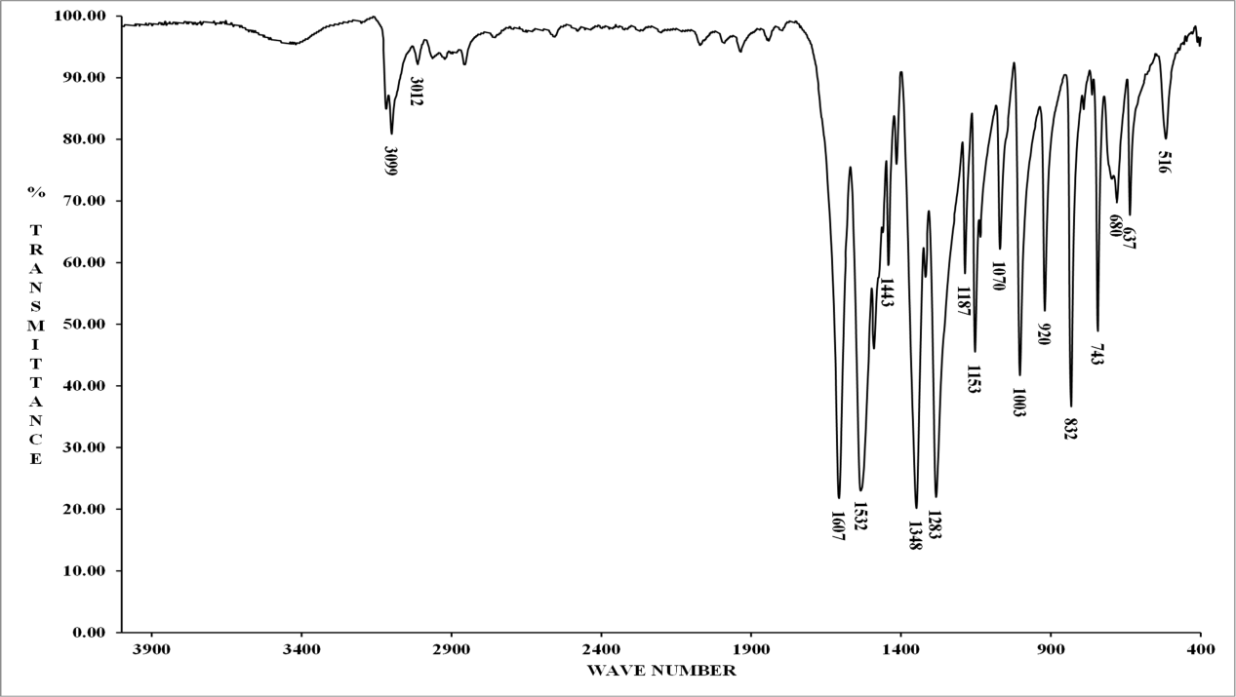
Figure S-2. FT-IR spectrum of DNAN

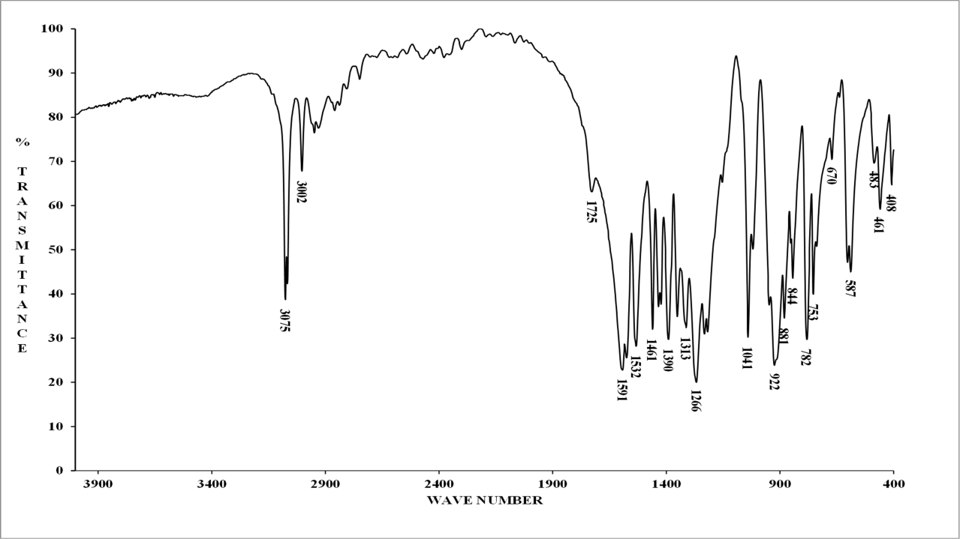
Figure S-3. FT-IR spectrum of coated RDX with DNAN
3. TG-DSC Analysis
Separate TG curves for pure RDX, pure DNAN and RDX coated with DNAN are given through Figures S-4 to S-6.
Figure S-4. TG-DSC curves of pure RDX

Figure S-5. TG-DSC curves of pure DNAN

Figure S-6. TG-DSC curves of RDX coated with DNAN

