Seasonal Variability of Low, Mid, and High Level Cloud properties over Southern Western Ghats, India: A LIDAR Ceilometer Analysis
M. Pramitha¹ , K. P. Aathira^{1,2} , K. Riya Raju^{1,2}
¹ School of Earth, Environmental and Sustainability Sciences, IISER Thiruvananthapuram, Kerala
² School of Physics, IISER Thiruvananthapuram, Kerala

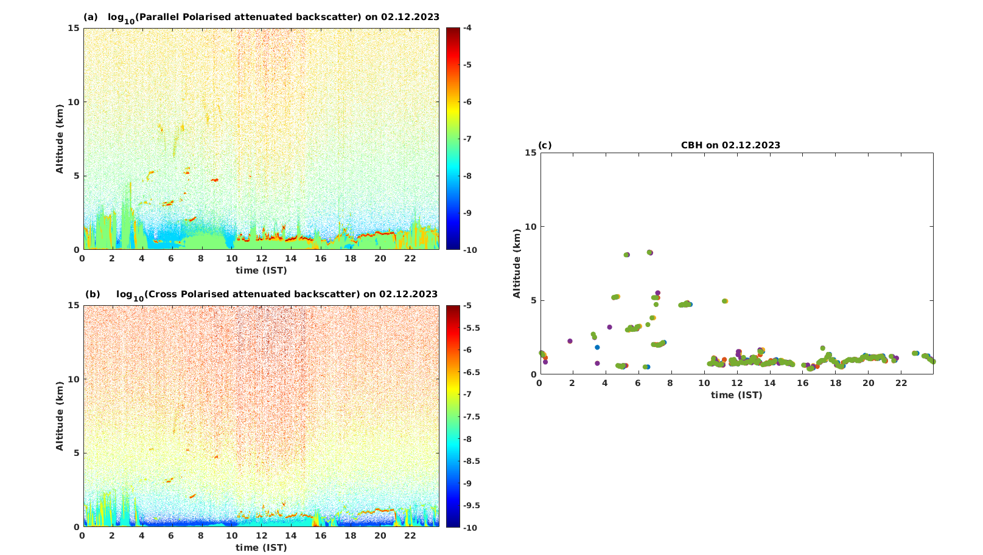
Figure S1: (a) Altitude-time variation of logarithm of parallel polarised attenuated back scatter profile for December 02, 2023 from 00:00h to 23:59h with 1 minute time interval and 4.5 m altitude interval, (b) same as (a) but for cross polarised attenuated backscatter and © the calculated CBH from the corresponding profiles..

