Supplementary Material S2: Documented Programs Read Through KMC
Supplement to: P. K. de Albuquerque, D. R. Pleffken, C. S. Cerqueira, and L. Galembeck, "Knowledge–Maturity Coevolution: A Coupled Evidence Model for Selecting Simulation and Test Activities in Constrained Engineering Development," IEEE Access.
This supplement expands Section VI-C of the article. Numbers in brackets refer to the article's reference list; the cited items are reproduced at the end. Section, table, and equation numbers without the prefix S2 refer to the article. All sources are public. The readings are retrospective and were made with the outcomes known; they illustrate whether the mechanisms of the model appear in documented decisions and do not calibrate the model or show that KMC would have changed any decision.
1. Selection and coding
Six aerospace programs with public, primary or near-primary documentation of the sequence of analyses, tests, discrepancies, and corrective actions were selected purposively: the Hyper-X Launch Vehicle (HXLV) of the X-43A program, the Saturn V all-up test decision, the F-1 combustion-instability program, Falcon 1, and the X-51A and DARPA Hypersonic Technology Vehicle 2 (HTV-2) programs. The selection is illustrative, not a representative sample of development programs.
For each program, documented events were coded by activity class (S: analysis and simulation; E: separate-effects or component testing; T: integrated ground or flight testing), by whether a test produced an epistemic shock (a negative reassessment after evidence undermined a prior claim, Section III-B), and by the evidence available before the next integrated test. No numerical K or M was assigned, because the public record does not contain criterion-level evidence for complete profiles (see 2.2 below). Where the record names a specific deficiency, it is mapped to the criteria of the operational rubric (Table 4): for K, causal coverage, mechanistic depth, coherence, uncertainty understanding, and domain definition; for M, demonstrated performance, representativeness, integration fidelity, decision robustness, and control and repeatability.
2. X-43A Hyper-X Launch Vehicle (HXLV)
2.1 Claims and documentary corpus
The case concerns the HXLV booster, not the X-43A research vehicle (HXRV); findings on one are not transferred to the other. Three claims were defined: C1, the aerodynamic and actuator models used for stability assessment; C2, the uncertainty procedure for the intended trajectory; and C3, boost control capability. C1 and C2 concern models and procedures, C3 the vehicle, and their maturity is not aggregated.
The bounded corpus comprises eight public documents dated 2000–2025: the preflight program paper [54], the mishap investigation [14], the return-to-flight review [55], two NASA releases on the second flight [56], [57], the flight-2 guidance and control paper [58], the 2004 research engineering report [59], and the NASA historical page [60]. From them, 19 parent records yield 20 observations, one of which (a conflicting release altitude) is retained only for discrepancy auditing. A 2004 incident release [61] and a lessons-learned review [62] were added later as a separately logged extension and did not change the original records.
Each document entered the epochs by its publication date: [54] in E1, [14] in E2, [55] and [56] in E3, and [57]–[59] in E4. The NASA historical page [60], updated in 2025, belongs to no epoch: it is used only to record a conflicting release altitude and never enters an assessment, so no information published after June 2006 enters any epoch.
Records were grouped in four cumulative documentary epochs: E1, preflight planning (October 2000); E2, investigation (through May 2003); E3, corrective actions (through March 2004); and E4, retrospective results (through June 2006). The epochs contain 3, 7, 14, and 19 observations; these cumulative counts organize the documents and are not independent samples. Publication dates delimit the epochs; they do not establish what individual engineers knew, and later reconstructions were excluded from earlier epochs. Repeated accounts of the same event were linked rather than counted as independent demonstrations. Conflicting values were preserved rather than averaged: the first-flight release altitude appears as about 20,000 ft [55], 24,000 ft [56], and 23,000 ft [60], and the 22,244 ft reported at failure time 13.5 s [14] is not a release altitude.
2.2 Summary of the documentary audit
The audit enumerates 120 criterion-level units, three claims × ten rubric criteria × four epochs, that is, twelve claim–epoch profiles of ten criteria each. For each unit it recorded the candidate passages, the configuration to which they apply, the missing information, and whether the evidence was sufficient to place the criterion on an anchor of Table 4. None was, so every unit remained not assessed and no profile, and hence no K or M, could be formed. Typical gaps were final model versions and complete parameter distributions (C1, C2), closure of reviews and acceptance records, repeatability, and activity-level costs (C3), and export-controlled material omitted from the public investigation [14]. The result supports the restriction of the article to qualitative readings; it does not show that the program lacked the evidence. This section summarizes the audit; the unit-level working records are not reproduced in this supplement.
2.3 Sequence
The preflight paper reported control-law refinement and Monte Carlo analysis of aerodynamic and flight-control uncertainties, and a trajectory different from that of the heritage booster [54]. After the loss of control during boost on 2 June 2001, the investigation found inaccuracies in inherited and HXLV-specific models: corrected nominal models reduced the predicted roll-axis gain margin from 8 dB to less than 2 dB against a 6 dB requirement, and reproducing the mishap required combining the model corrections with parameter uncertainty [14] (Fig. S2-1). Return to flight combined wind-tunnel and actuator tests, revised models, comparisons of independent boost simulations, stronger actuators, and propellant off-loading for a higher-altitude release that reduced exposure [55], [56]. A test-setup anomaly on 11 February 2004 exceeded the qualified actuator torque and led to replacement and investigation before the second flight [61]. On 27 March 2004 the HXLV delivered the research vehicle at 28.67 km (94,069 ft) against 28.63 km (93,932 ft) planned and at Mach 6.946 against 7.075 [57], [58]; the 2004 report states that both the Mach 7 and the Mach 10 flights delivered the research vehicle within the separation tolerances [59]. A lessons-learned review relates the accident to heritage assumptions, representative testing, stability margins, and uncertainty and dynamic modeling [62]. Fig. S2-2 separates the event dates from the dates of the documents that report them.
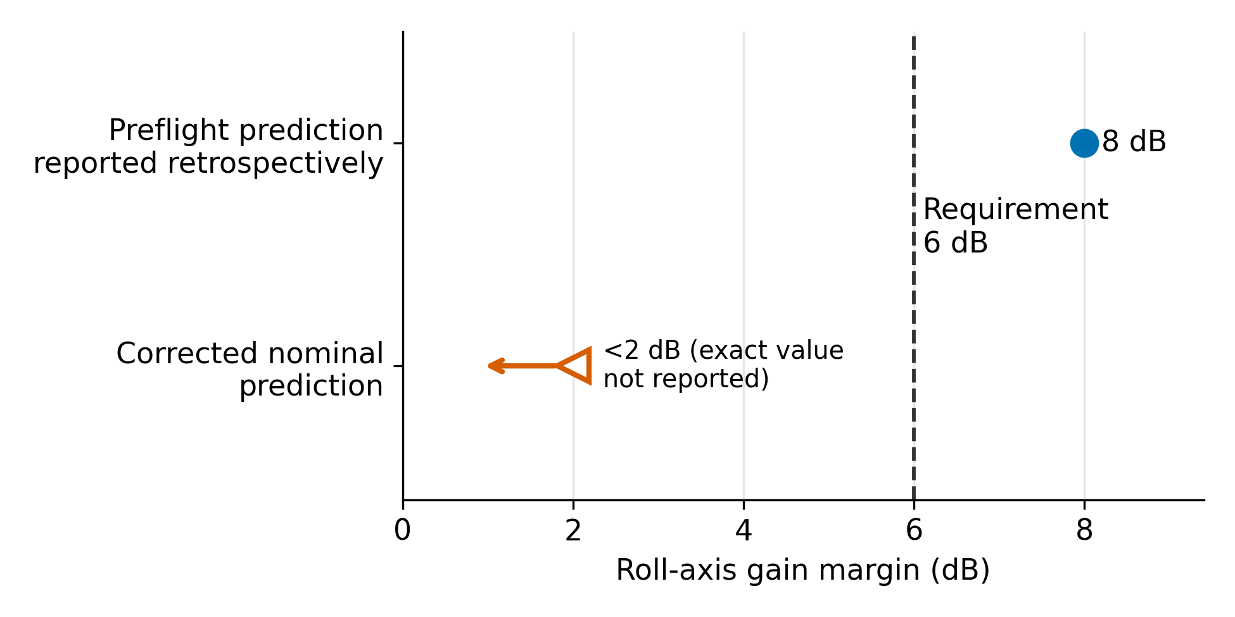
Fig. S2-1. Reported X-43A roll-axis gain margin before and after nominal model correction [14, pp. 6–7]. The corrected value is reported only as less than 2 dB (open marker: upper bound); the requirement is 6 dB. These are model predictions, not flight measurements or KMC scores.
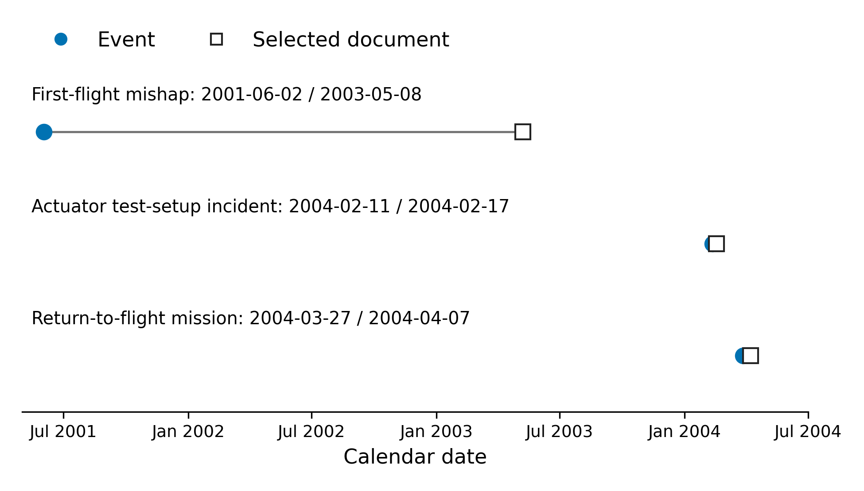
Fig. S2-2. Event dates and dates of selected documents for the first-flight mishap [14], the actuator incident [61], and the return-to-flight mission [57]. Connecting segments associate an event with a record; their lengths do not measure decision delay.
2.4 Reading through the model
The margins of Fig. S2-1 are engineering quantities: 8 dB, 6 dB, and 2 dB correspond to gain factors of about 2.5, 2.0, and 1.26, and the corrected value is only an upper bound. They are not values of K or M, and the record gives no calibrated mapping between them; terms such as headroom or K_{need} below are readings through the framework, not reconstructed states. With that caveat, an integrated test was attempted while knowledge of the configuration-specific claims rested on heritage transfer, and the result can be read as an epistemic shock on C1–C3. Recovery came from the activities the model favors after a shock: separate-effects testing, revised models, and joint-uncertainty simulation, together with reduced exposure. Table S2-1 links the main observations to rubric criteria. Table S2-2 lists the postflight findings examined in the extension, and Table S2-3 a time-bounded check that uses only documents available before each flight, with cutoffs at the end of 1 June 2001 and 26 March 2004. The preflight sources support requests for evidence about domain transfer and uncertainty adequacy, but they do not establish that the model error was detectable before flight: the program, not KMC, detected and corrected the problems, and an equally informed conventional review could reach the same questions.
Table S2-1. X-43A observations and KMC reasoning (retrospective).
Observation | Claim and rubric criteria | Implied action | Inference excluded
Corrected roll margin below requirement [14] | C1 domain definition, coherence; C2 uncertainty understanding | Reconcile model and uncertainty bounds before renewed acceptance | No numerical drop in K or M; no claim of earlier prediction
Nominal corrections alone did not reproduce the mishap [14] | C2 decision robustness | Require justified joint variations before closing the gate | Uncertainty analysis already existed [54]
Stronger actuators and modified trajectory [55], [56] | C3 representativeness | Declare the new baseline; verify changed interfaces and envelope | No automatic recovery from completing a corrective action
Actuator torque exceedance before flight 2 [61] | C3 demonstrated performance | Keep acceptance open until the replacement is verified | Program detected it without KMC
Flight-2 delivery close to target (94,069 vs 93,932 ft; Mach 6.946 vs 7.075) and reported within separation tolerances [58], [59] | C3 demonstrated performance | Credit the delivery point, not full-envelope repeatability | No transfer of HXRV results or of the Mach 10 flight as a Mach 7 repetition

Table S2-2. Postflight findings and KMC reasoning (extension PF01–PF05).
Entry and evidence | Rubric criteria | Candidate response | Inference limit
PF01: inherited and HXLV-specific model deficiencies; corrected roll margin below requirement [14, pp. 6–7], [62] | C1 domain definition, coherence; C3 representativeness | Reopen model acceptance; require configuration-specific corroboration | Post-mishap diagnosis; no demonstrated preflight signal
PF02: corrected nominal models alone did not reproduce the mishap; combined uncertainty was required [14, pp. 6–7] | C2 uncertainty understanding, decision robustness | Require justified joint variations before closing the gate | Uncertainty analysis already existed [54]; KMC does not discover omitted physics
PF03: return-to-flight actions revised models, actuators, and launch conditions [55] | C1–C3 separately: domain definition, representativeness | Rebaseline affected claims; verify the changed configuration | A design correction does not itself demonstrate recovered maturity
PF04: 11 February 2004 test-setup anomaly exceeded qualified torque; replacement and investigation required [61] | C3 demonstrated performance, representativeness | Keep actuator acceptance open pending disposition and verification | Program detected the anomaly without KMC
PF05: flight-2 HXLV separation results and HXRV response discrepancies concern distinct objects [58] | C3 demonstrated performance | Accept only the supported delivery-point claim; keep out-of-scope discrepancies separate | Success is not full-envelope repeatability; HXRV discrepancies cannot lower HXLV assessments

Table S2-3. Time-bounded documentary check before flights 1 and 2. G: evidence request; R: review trigger already recognized by the program; U: no eligible preflight indication.
ID / code | Preflight record or exclusion | KMC review implication | What is established
PR01 / G | Flight 1: trajectory different from the heritage booster [54, pp. 2–3] | Request evidence for transferring heritage models | Domain difference known; specific error not established
PR02 / G | Flight 1: uncertainty analysis already reported [54, p. 3] | Review bounds and combinations for the intended claim | Existing analysis; inadequacy not established
PR03 / G | Flight 1: tests planned in the 2000 account [54, p. 5] | Request dated completion and disposition records | No evidence that tests remained unfinished at launch
PR04 / U | Flight 1: corrected margin comes from the 2003 report [14, pp. 6–7] | Exclude hindsight from preflight diagnosis | No eligible preflight indication
PR05 / R | Flight 2: actuator qualification exceeded [61, paras. 1–2] | Require replacement and verification before closing acceptance | Program already detected and investigated
PR06 / R | Flight 2: autopilot retuning considered [61, para. 3] | Link revised parameters to verification evidence | Program already recognized the review need
PR07 / R | Flight 2: corrective models, hardware, and simulations [55, pp. 4–7] | Trace the changed configuration to evidence for each claim | Corrective work already documented; no new defect inferred

2.5 From evidence to the next activity
Two chains connect a documented observation to the choice of the next evidence-producing activity (Table S2-4). Chain A uses the investigation [14, pp. 6–7]: corrected nominal models remain stable and do not reproduce the loss of control, so coherence (C1) and uncertainty adequacy (C2) remain open, and the retained sequence couples targeted tests with joint-uncertainty simulation rather than closing on nominal stability. Chain B uses only the release of 17 February 2004 [61], before flight 2: exceeding the qualified torque removes the basis for accepting that actuator, so the retained sequence replaces and verifies it. For flight-1 boost control (C3), the record shows that the mandatory demonstrated-performance condition was not met, because control was lost. This is a failed demonstration, not the absence of one, and no anchor of Table 4 is assigned; consistently with the audit of 2.2, the criteria remain not assessed, so no (K, M) point or slope dM/dK can be computed; the criterion-based branch of the procedure remains usable where the derivative-based branch is not. In both chains the program reached the same actions without KMC; the alternatives are analytical comparisons, not a recovered historical trade study, and their costs and durations are unknown.
Table S2-4. Candidate activities after the two documented observations. "Retained" denotes a plan for obtaining evidence; acceptance remains open until its completion criteria are verified.
ID | Candidate activity | Criterion-based disposition | Evidence needed before closure
A1 | Correct nominal models only | Insufficient: does not reconcile the observed instability | Explanation of the residual discrepancy
A2 | Joint-uncertainty simulation alone | Useful but conditional: unsupported bounds cannot establish adequacy | Traceable bounds, model versions, and discriminating comparisons
A3 | Targeted tests plus coupled model and uncertainty analysis | Retained | Measured support for key dynamics; traceable joint variations; applicability limits
B1 | Keep the affected actuator because it may still function | Excluded by the documented replacement requirement [61] | Functioning alone does not dispose of the exceedance
B2 | Retune the autopilot or simulate without replacing the unit | Insufficient for the hardware qualification condition | Disposition of the installed hardware
B3 | Replace and verify the actuator; coordinate retuning and investigation | Retained, consistent with the announced parallel activities [61] | Replacement identity, acceptance results, and integrated control verification

3. Saturn V all-up testing
On 31 October 1963, Mueller directed that the first Saturn IB and Saturn V flights use all live stages and complete spacecraft, and that mission planning assume two successful flights before a crewed flight [63]. The first Saturn V flight, Apollo 4 on 9 November 1967, succeeded [17]. Apollo 6, on 4 April 1968, experienced pogo oscillations, the early shutdown of two second-stage engines, and a failed third-stage restart [17]. Engineers detuned the F-1 engines, charged the liquid-oxygen prevalve cavities with helium, and redesigned the J-2 augmented spark igniter lines, and on 27 April 1968 the third Saturn V was approved for a crew [17]. Read through the model, all-up testing concentrated maturity evidence in few expensive integrated tests, Apollo 6 exposed couplings visible only at integrated level, and diagnosis and ground-verified fixes before the next integrated test correspond to what steps 4 and 5 of Table 6 would direct; the record does not give the knowledge state that the model would assign.
4. F-1 combustion instability
Between October 1962 and September 1966, Project First, the F-1 combustion-stability program, conducted about 2000 of the roughly 3200 full-scale F-1 tests, combining fourteen injection patterns with fifteen baffle configurations and rating stability with bombs producing perturbations of about 100% of chamber pressure; full-scale test data were described as the most reliable source of design information [15]. The flight injector accumulated 703 engine tests [15]. The bomb test is a controlled-perturbation test on full-scale combustion hardware: a local perturbation whose amplitude was about that of the mean chamber pressure, after which the oscillation either decays or persists, so stability becomes observable. It is not a separate-effects test in the usual sense, because the coupled combustion phenomena are all present; whether it counts as E or T in the model depends on the claim assessed (stability margin of an injector design, or the qualified engine). Read through the model, the program sits in the weak-simulation regime of Section V-C, where discriminating physical tests replace analysis as the source of knowledge. The large number of tests documents a high experimental effort; without comparable alternatives and costs, it does not show that another sequence would have been cheaper.
5. Falcon 1
Falcon 1 failed on its first three flights, in March 2006 (fuel leak and fire), March 2007 (second-stage control lost to propellant slosh), and August 2008 (first stage recontacted the second stage after separation), and reached orbit on 28 September 2008 [16], [64]. Each failure revealed a different mode and was followed by diagnosis and correction. Flights cost about 8 million US dollars against roughly 100 million for development [16]. Read through the model, this is test-first development with integrated tests that were affordable relative to the program, and the program reached orbit after three failures. The record does not show how much each flight taught, and whether ground tests could have exposed these modes at lower cost is not established; Section VI-B of the article discusses why the launch-vehicle estimates support strong learning in flight only conditionally.
6. X-51A and HTV-2
The X-51A scramjet demonstrator flew four times. In May 2010 it flew for more than three minutes at Mach 4.88 under scramjet power [65]; in June 2011 the inlet unstarted during the transition to JP-7 fuel and restart attempts failed [66]; in August 2012 a cruiser control-fin fault caused the loss of the vehicle before scramjet ignition [65]; and on 1 May 2013 it flew for more than six minutes, three and a half under scramjet power, and reached Mach 5.1 [67]. The DARPA HTV-2 glider was lost on both of its flights. After the April 2010 flight, the engineering review board found higher-than-predicted adverse yaw coupled into roll that exceeded the available roll control [68]. That aerodynamic knowledge was incorporated into the August 2011 flight, which achieved controlled Mach 20 flight before unexpected aeroshell degradation caused upsets of increasing severity [68], [69]. The program manager stated that extrapolating from known flight regimes and relying solely on advanced thermal modeling and ground testing could not predict the Mach 20 environment [69].
Read through the model, the HTV-2 statement corresponds to a low data-limited ceiling K̄: analysis and ground testing could not provide the configuration-specific predictions the flights needed, so each flight was both a demonstration and the main source of new information, and each failure exposed a different subsystem (propulsion, control surfaces, aerodynamic coupling, thermal protection). The X-51A reached a successful flight after two failures; the HTV-2 shows learning between flights without a documented terminal success.
7. Cross-case reading
Table S2-5 (Table 9 of the article) summarizes the six cases; its third column is an interpretation through the model, not a measured state. In the five flight programs, failures followed integrated tests that exposed configuration-specific or integrated-level gaps (X-43A flight 1, Apollo 6, Falcon 1 flights 1–3, X-51A flights 2–3, both HTV-2 flights). In four of them (X-43A, Saturn V, Falcon 1, X-51A) a successful flight followed diagnosis, separate-effects testing, or analysis; the HTV-2 shows that learning after failures does not guarantee a final demonstration. In the F-1 program, the absence of predictive capability led directly to controlled-perturbation tests on full-scale hardware. The cases span the scenarios of Section V-C: costly, high-consequence integrated tests (X-43A, Saturn V), weak simulation (F-1, HTV-2, X-51A), and affordable flights (Falcon 1).
Table S2-5. Documented sequences read through the model (Table 9 of the article). The third column is an interpretation, not a measured KMC state.
Program | Documented sequence | Interpretive KMC reading | Model regime
X-43A (2001–2004) | Flight 1 lost; models, wind-tunnel and actuator tests revised; flights 2–3 successful [14], [55]–[59] | Flight on heritage models → failure; tests and revised models before the next flight (restored headroom) | Costly, risky tests
Saturn V (1963–1968) | All-up decision; Apollo 4 success; Apollo 6 pogo and J-2 failures; fixes; crewed Apollo 8 [17], [63] | Few integrated tests; integrated-level failure; diagnosis and verified fixes before the next flight | Costly, high-consequence tests
F-1 engine (1962–1966) | About 2000 full-scale tests with bomb rating; 703 tests of flight injector [15] | Analysis could not predict stability; controlled-perturbation tests on full-scale hardware (low data-limited ceiling) | Weak simulation
Falcon 1 (2006–2008) | Three failures with distinct modes; success on flight 4 [16], [64] | Affordable flights at low maturity; a different failure mode each time (test-first learning) | Cheap tests relative to program
X-51A (2010–2013) | Partial success; inlet unstart; fin fault; success on flight 4 [65]–[67] | Flights were demonstrations and the main source of new information; failures on different subsystems | Costly tests, low data-limited ceiling
HTV-2 (2010–2011) | Two losses: yaw–roll coupling, then aeroshell degradation [68], [69] | Program stated that ground tests and modeling could not predict the flight environment (low data-limited ceiling); learning without a terminal success | Costly, high-consequence tests; weak simulation

8. Limitations
The cases were selected purposively and read with the outcomes known; the coding was not blinded or preregistered. Public documents omit export-controlled material, contemporary decision records, and activity-level costs, so no numerical K or M, no cost of alternatives, and no earlier detection or avoided loss can be established. The readings show that the mechanisms of the model are visible in documented decisions; they do not calibrate the model, test its coefficients, or show that KMC would have produced better decisions than the reviews the programs carried out. Model terms used in the readings (headroom, data-limited ceiling, K_{need}) are interpretations; the observable content of each case is the documented sequence of tests, failures, and corrections.
References (numbering of the article)
[14] X-43A Mishap Investigation Board, "Report of findings: X-43A mishap, vol. I," NASA, Washington, DC, USA, May 8, 2003. Accessed: Oct. 6, 2026. [Online]. Available: https://www.nasa.gov/wp-content/uploads/2015/01/47414main_x43A_mishap.pdf
[15] J. C. Oefelein and V. Yang, "Comprehensive review of liquid-propellant combustion instabilities in F-1 engines," J. Propuls. Power, vol. 9, no. 5, pp. 657–677, Sep. 1993, doi: 10.2514/3.23674.
[16] T. Malik, "SpaceX successfully launches Falcon 1 rocket into orbit," Space.com, Sep. 29, 2008. Accessed: Oct. 6, 2026. [Online]. Available: https://www.space.com/5905-spacex-successfully-launches-falcon-1-rocket-orbit.html
[17] J. Uri, "55 years ago: NASA administrator Webb OKs flying a crew on the third Saturn V," NASA History, Apr. 27, 2023. Accessed: Oct. 6, 2026. [Online]. Available: https://www.nasa.gov/history/55-years-ago-nasa-administrator-webb-oks-flying-a-crew-on-the-third-saturn-v/
[54] V. L. Rausch, C. R. McClinton, J. Sitz, and P. Reukauf, "NASA's Hyper-X program," presented at the 51st Int. Astronaut. Congr., Rio de Janeiro, Brazil, Oct. 2–6, 2000, Paper IAF-00-V.4.01. Accessed: Oct. 6, 2026. [Online]. Available: https://ntrs.nasa.gov/citations/20010075170
[55] D. E. Reubush, L. T. Nguyen, and V. L. Rausch, "Review of X-43A return to flight activities and current status," presented at the 12th AIAA Int. Space Planes Hypersonic Syst. Technol. Conf., Norfolk, VA, USA, Dec. 2003, AIAA Paper 2003-7085. Accessed: Oct. 6, 2026. [Online]. Available: https://ntrs.nasa.gov/citations/20040040296
[56] NASA Dryden Flight Research Center, "NASA's X-43A hypersonic aircraft ready for flight," Edwards, CA, USA, Release 04-14, Mar. 24, 2004. Accessed: Oct. 6, 2026. [Online]. Available: https://www.nasa.gov/news-release/nasa-dryden-flight-research-center-news-room-news-releases-nasas-x-43a-hypersonic-aircraft-ready-for-flight/
[57] NASA Dryden Flight Research Center, "NASA's X-43A flight results in treasure trove of data," Edwards, CA, USA, Release 04-20, Apr. 7, 2004. Accessed: Oct. 6, 2026. [Online]. Available: https://www.nasa.gov/news-release/nasa-dryden-flight-research-center-news-room-news-releases-nasas-x-43a-flight-results-in-treasure-trove-of-data/
[58] C. Bahm, E. Baumann, J. Martin, D. Bose, R. E. Beck, and B. Strovers, "The X-43A Hyper-X Mach 7 flight 2 guidance, navigation, and control overview and flight test results," presented at the AIAA/CIRA 13th Int. Space Planes Hypersonic Syst. Technol. Conf., Capua, Italy, May 2005. Accessed: Oct. 6, 2026. [Online]. Available: https://ntrs.nasa.gov/citations/20050182778
[59] L. Grindle and C. Bahm, "The X-43A (Hyper-X) flies into the record books," in 2004 Research Engineering Annual Report, NASA Dryden Flight Research Center, Edwards, CA, USA, Jun. 2006. Accessed: Oct. 6, 2026. [Online]. Available: https://ntrs.nasa.gov/citations/20060056098
[60] NASA, "X-43A Hyper-X," last updated Aug. 15, 2025. Accessed: Oct. 6, 2026. [Online]. Available: https://www.nasa.gov/reference/x-43a/
[61] NASA Dryden Flight Research Center, "X-43A flight delayed," Edwards, CA, USA, Release 04-06, Feb. 17, 2004. Accessed: Oct. 6, 2026. [Online]. Available: https://www.nasa.gov/news-release/nasa-dryden-flight-research-center-news-room-news-releases-x-43a-flight-delayed/
[62] C. N. Dennehy, "GN&C lessons learned and associated best practices," presented at ESA/ESTEC, Noordwijk, The Netherlands, Jun. 6, 2017. Accessed: Oct. 6, 2026. [Online]. Available: https://ntrs.nasa.gov/citations/20200009546
[63] G. E. Mueller, "Revised manned space flight schedule," NASA memorandum M-C M 9330.186, Oct. 31, 1963. Accessed: Oct. 6, 2026. [Online]. Available: https://www.american-spacecraft.org/documents/sp-4503/document-7.html
[64] S. Clark, "Falcon 1 suffers another setback," Spaceflight Now, Aug. 3, 2008. Accessed: Oct. 6, 2026. [Online]. Available: https://spaceflightnow.com/falcon/003/failure.html
[65] Air Force Research Laboratory, "X-51A flight ends prematurely," Wright-Patterson AFB, OH, USA, Aug. 15, 2012. Accessed: Oct. 6, 2026. [Online]. Available: https://www.edwards.af.mil/News/AFMC-News/Article/153597/x-51a-flight-ends-prematurely/
[66] 95th Air Base Wing Public Affairs, "Second hypersonic flight ends prematurely, brings new flight test data," U.S. Air Force, Jun. 15, 2011. Accessed: Oct. 6, 2026. [Online]. Available: https://www.af.mil/News/Article-Display/Article/113041/second-hypersonic-flight-ends-prematurely-brings-new-flight-test-data/
[67] Boeing, "Boeing X-51A WaveRider sets record with successful 4th flight," news release, May 3, 2013. Accessed: Oct. 6, 2026. [Online]. Available: https://boeing.mediaroom.com/2013-05-03-Boeing-X-51A-WaveRider-Sets-Record-with-Successful-4th-Flight
[68] Defense Advanced Research Projects Agency, "14-F-0122 DARPA X-51 documents," FOIA release, Washington Headquarters Services FOIA Reading Room, 2014. Accessed: Oct. 6, 2026. [Online]. Available: https://www.esd.whs.mil/Portals/54/Documents/FOID/Reading%20Room/DARPA/14-F-0122_DARPA_X-51_DOCUMENTS.pdf
[69] Defense Advanced Research Projects Agency, "DARPA HTV-2 second test flight report released," SpaceRef, Apr. 20, 2012. Accessed: Oct. 6, 2026. [Online]. Available: https://spaceref.com/newspace-and-tech/darpa-htv-2-second-test-flight-report-released/

