

Medicare

Course-End Project 4

Pedro Leal | PG FSD - Full Stack Web Development Capstone Project | 01/07/2023

# Project Overview

Medicare is a company that supplies medicines and a couple of other healthcare essentials at an affordable price. It was established in 2012 in Delhi, India. It had been serving fine all these years, however, the business analysts noticed a decline in sales since 2017. They found out that online ordering of medicines with companies, such as 100mg and mfine are gaining more profits by eliminating middlemen from the equation. As a result, the team decided to hire a Full Stack developer to develop a healthcare web application with a rich and user-friendly interface.

You are hired as the Full Stack Java developer and are asked to develop the web application. The management team has provided you with the requirements and their business model so that you can easily arrange different components of the application.

**Features of the application:**

1. Registration
2. Login
3. Payment gateway
4. Searching
5. Filtering
6. Sorting
7. Dynamic data
8. Responsive and compatible with different devices

# Sprint Backlog

Number of sprints planned: 4

## Login/Signup (29/5 -7/6)

* Administrators need to login to access to access certain features
* Customers can register
* Administrators can’t access certain features without login first
* Customer cant access administrator features
* Users can logout
* Login as Administrator
* Customers can register and login
* Users can’t access certain features without logging first

## DashBoard / Medicine Listings (8/6 – 14/6)

* All users can see random products in slider
* All users can view all medicines
* All users can search medicine by name
* Customers can add a product to the cart
* Medicines have photo, description, price, category -
* All users are able to see Medicines
* Users can see latest Medicines – 22/6

## Medicine Management (15/6 – 23/6)

* Only Admins can manage medicines
* Admin can add, remove, edit medicine
* Admin can upload photo to medicine
* Admin can disable medicine
* Admins can see list, edit, show and delete users

## Payment (24/6 – 1/7)

* All users can add medicines to cart
* Customers can see their cart
* Signed in users with role customer can order medicines
* Signed in customers can confirm orders
* Signed in customers can view order sumary

# Core Concepts

## Backend

* Create Spring boot Application
* Used MV/ Rest architecture
* Object-Oriented: used to create and model objects for users and their credentials.
* Data Access Object: used to store and retrieve data.
* Data Sources: used to define a set of properties required to identify and access the database
* JpaRepository: used to provide CRUD functionality for Entity
* Spring Security / JWT: to provide authentication/authorization to frontend
* CORS: to allow communication from different port

## Frontend

* Data Binding
* Custom pipes – to get the full path of images from backend
* Guards – to protect frontend routes
* Interceptors – to send authentications to backend
* Services – to call backend api
* Local Storage – to get authenticated user

# Backend Routes

## Session

* POST /api/auth/login – Log in

## Users

* POST /api/users – Register
* GET /api/users – Get all users
* GET /api/user/:id – Show specific user
* PUT /api/user/:id – Edit user

## Medicine

* GET /api/medicine – Get all Medicine
* GET /api/medicine/:id – Show Specific Medicine
* DELETE /api/medicine/:id – Delete Specific Medicine
* POST /api/medicine – Create Medicine
* PUT /api/medicine/:id – Edit Medicine

## Images

* GET /images/:imagename – Show specific image

## Orders

* POST /api/orders – add order

# Frontend Routes

* /dashboard – slider/random medicines
* /users – list of registered users
* /form – register user
* /med-form – create medicine
* /login – authentication
* /medicare – list of medicines
* /details/:id – user details
* /medDetails/:id – medicine details
* /edit-med/:id – edit medicine
* /medicine-serach – serach medicine
* /checkout – cart/medicine ordering

# Database Architecture

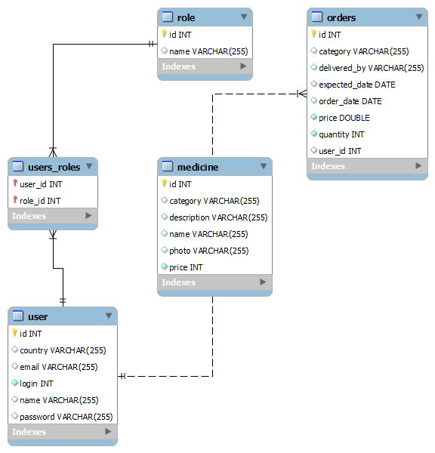

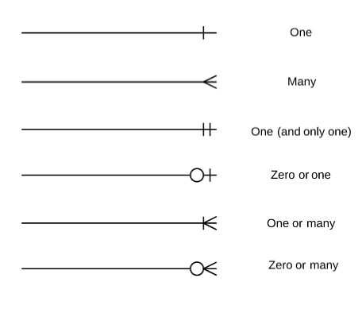

Figure 1 Database Diagram Legend

# Future Work

* Add active link to items
* Administrator can view status of logged in users
* Administrator can view orders
* User can sort medicines
* User can filter medicines by category
* Users can see details of Medicine
* Add Feature Tests
* Deploy app to aws